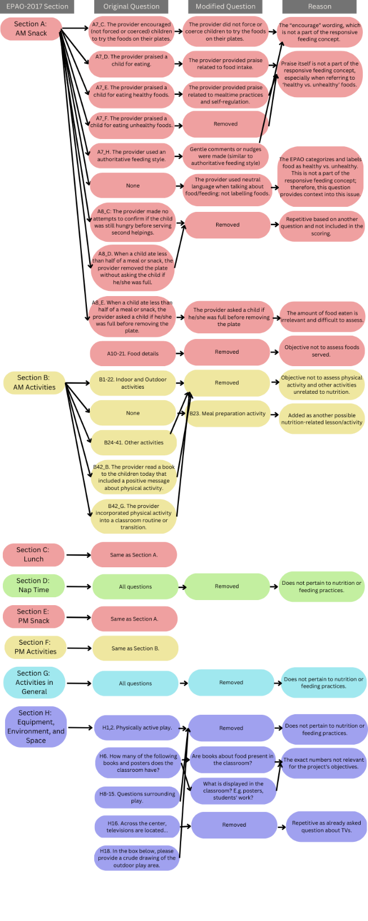

Additional file 1. Map of modifications made to EPAO-2017.

