Long-term effectiveness of banning highly hazardous pesticides on suicide mortality: A 12-year quasi-experimental study in South Korea
Supplementary Materials
Contents
eTable 1. Time series properties of monthly pesticide suicide counts
eTable 2. ARIMA model specification for pesticide suicide time series
eTable 3. Subgroup analysis of pesticide suicide following the paraquat ban
eTable 4. Comparison of count-based and rate-based ITS analysis for pesticide suicide
eTable 5. Sensitivity analysis for intervention timing
eTable 6. Sensitivity analysis for initial period length
eTable 7. Sensitivity analysis using log transformation
eTable 8. Suicide method ranking changes before and after the paraquat ban
eTable 9. Structural breakpoint analysis for gas poisoning suicide
eTable 10. Sensitivity analysis using pre-ban data only for counterfactual projection
eTable 11. A priori two-stage interrupted time series analysis of pesticide suicide, with intervention points at December 2011 (sales restriction) and November 2012 (complete ban)
eTable 12. Interrupted time series analysis for total suicide mortality
eTable 13. Exploratory difference-in-differences analysis (secondary analysis)

eFigure 1. Autocorrelation and partial autocorrelation functions for pesticide suicide time series
eFigure 2. Seasonal-trend decomposition of pesticide suicide time series
eFigure 3. Residual diagnostics for the ARIMA model
eFigure 4. Subgroup interrupted time series analyses
eFigure 5. Sensitivity analysis using pre-ban data only for counterfactual projection
eFigure 6. Exploratory difference-in-differences analysis comparing pesticide suicides with control outcomes
eFigure 7. Two-stage intervention model for pesticide suicide
eFigure 8. Interrupted time series analysis for total suicide mortality
eFigure 9. Demographic characteristics of pesticide and gas suicide decedents
eFigure 10. Structural breakpoint analysis for gas suicide

eTable 1. Time Series Properties of Monthly Pesticide Suicide Counts in South Korea, 2004–2023
Property | Value
Observations | 240 months
Mean | 145.7
SD | 93.9
Coefficient of variation | 0.644
Skewness | 0.729
Box-Cox λ | 0.358
Transformation applied | Square root
ADF test P-value | 0.01
Ljung-Box test P-value | <0.001
Abbreviations: ADF, Augmented Dickey-Fuller; SD, standard deviation.

eTable 2. ARIMA Model Specification for Pesticide Suicide Time Series
Component | Specification
Outcome | Pesticide suicide (monthly counts)
Transformation | Square root
ARIMA order | (1, 0, 2)
Seasonal order | (2, 0, 0)[12]
AICc | 550.19
Ljung-Box P-value | 0.428
Abbreviations: AICc, Akaike information criterion corrected; ARIMA, autoregressive integrated moving average.

eTable 3. Subgroup Analysis of Pesticide Suicide Following the Paraquat Ban in South Korea
Subgroup | Parameter | Wald Estimate (95% CI) | P-value | Bootstrap 95% CI
Sex
Male | Level change | −0.230 (−0.967, 0.507) | 0.540 | (−3.548, 1.726)
 | Initial slope | −0.100 (−0.137, −0.064) | <0.001 | (−0.166, 0.004)
 | Later slope | 0.009 (−0.012, 0.030) | 0.395 | (−0.032, 0.035)
Female | Level change | −0.005 (−0.528, 0.518) | 0.985 | (−1.600, 1.107)
 | Initial slope | −0.071 (−0.095, −0.047) | <0.001 | (−0.114, −0.027)
 | Later slope | 0.008 (−0.006, 0.021) | 0.259 | (−0.016, 0.020)
Age group
15–29 years | Level change | −0.515 (−1.053, 0.023) | 0.061 | (-1.650, 0.218)
 | Initial slope | 0.006 (−0.013, 0.024) | 0.548 | (-0.017, 0.043)
 | Later slope | 0.021 (0.014, 0.029) | <0.001 | (0.005, 0.030)
30–49 years | Level change | 0.005 (−0.590, 0.600) | 0.986 | (-1.420, 2.836)
 | Initial slope | −0.046 (−0.070, −0.021) | <0.001 | (-0.106, -0.014)
 | Later slope | 0.026 (0.013, 0.038) | <0.001 | (0.006, 0.035)
50–64 years | Level change | −0.017 (−0.503, 0.470) | 0.947 | (-1.535, 0.907)
 | Initial slope | −0.060 (−0.081, −0.038) | <0.001 | (-0.084, -0.001)
 | Later slope | 0.002 (−0.010, 0.013) | 0.790 | (-0.023, 0.015)
≥65 years | Level change | −0.329 (−0.964, 0.305) | 0.309 | (-4.094, 1.020)
 | Initial slope | −0.107 (−0.136, −0.078) | <0.001 | (-0.165, -0.009)
 | Later slope | −0.015 (−0.032, 0.002) | 0.094 | (-0.043, 0.009)
Region
Capital | Level change | 0.195 (−0.379, 0.769) | 0.506 | (−1.254, 1.897)
 | Initial slope | −0.048 (−0.074, −0.021) | <0.001 | (−0.086, 0.003)
 | Later slope | 0.017 (0.002, 0.032) | 0.028 | (−0.010, 0.032)
Non-capital | Level change | −0.325 (−1.076, 0.426) | 0.396 | (−4.153, 1.412)
 | Initial slope | −0.114 (−0.151, −0.076) | <0.001 | (−0.180, 0.011)
 | Later slope | 0.004 (−0.017, 0.026) | 0.702 | (−0.036, 0.033)
Occupation
AFF | Level change | −0.352 (−0.964, 0.259) | 0.259 | (−1.705, 1.362)
 | Initial slope | −0.065 (−0.093, −0.038) | <0.001 | (−0.118, −0.019)
 | Later slope | −0.014 (−0.029, 0.002) | 0.081 | (−0.044, 0.002)
Other occupations | Level change | −0.275 (−1.074, 0.524) | 0.500 | (−1.795, 0.906)
 | Initial slope | −0.044 (−0.075, −0.013) | 0.006 | (−0.079, −0.004)
 | Later slope | 0.008 (−0.005, 0.021) | 0.211 | (−0.017, 0.020)
Not specified | Level change | 0.032 (−0.625, 0.689) | 0.924 | (−3.521, 1.286)
 | Initial slope | −0.093 (−0.124, −0.063) | <0.001 | (−0.131, 0.005)
 | Later slope | 0.017 (−0.001, 0.035) | 0.067 | (−0.008, 0.042)
Abbreviations: AFF, agriculture, forestry, and fishery; CI, confidence interval.
Estimates on square root scale. Negative values indicate reduction.

eTable 4. Comparison of Count-Based and Rate-Based Interrupted Time Series Analysis for Pesticide Suicide
Panel A. ITS Parameter Estimates
Parameter | Primary: Counts (95% CI) | P-value | ASR: Wald (95% CI) | P-value | ASR: Bootstrap 95% CI
Level change | −0.204 (−0.989, 0.581) | 0.610 | −0.011 (−0.046, 0.024) | 0.528 | (−0.213, 0.102)
Initial slope | −0.122 (−0.163, −0.082) | <0.001 | −0.005 (−0.007, −0.003) | <0.001 | (−0.009, 0.000)
Later slope | 0.012 (−0.012, 0.036) | 0.332 | 0.001 (0.000, 0.002) | 0.034 | (−0.001, 0.003)

Panel B. Model Diagnostics
Outcome | ARIMA Order | Ljung-Box p | Shapiro-Wilk p | AIC | BIC
Pesticide (counts) | ARIMA(1,0,2)(2,0,0)[12] | 0.420 | 0.144 | 549.4 | 587.7
Pesticide (ASR) | ARIMA(1,0,2)(2,0,0)[12] | 0.387 | 0.329 | −512.8 | −474.5
Abbreviations: ASR, age-sex standardized rate (per 100,000); CI, confidence interval.
Standard population: 2010 Korean census. Ljung-Box test for residual autocorrelation (p > 0.05 indicates no significant autocorrelation). Shapiro-Wilk test for residual normality (p > 0.05 indicates normality satisfied). See Figure 3 for visualization.

eTable 5. Sensitivity Analysis for Intervention Timing: Pesticide Suicide
Intervention Timing | Parameter | Wald Estimate (95% CI) | P-value | Bootstrap 95% CI
December 2011 (Primary) | Level change | −0.204 (−0.989, 0.581) | 0.610 | (−4.497, 2.223)
 | Initial slope | −0.122 (−0.163, −0.082) | <0.001 | (−0.214, −0.012)
 | Later slope | 0.012 (−0.012, 0.036) | 0.332 | (−0.040, 0.049)
May 2012 (+6 months) | Level change | −1.457 (−2.230, −0.683) | <0.001 | (−7.849, 1.090)
 | Initial slope | −0.085 (−0.125, −0.045) | <0.001 | (−0.189, 0.099)
 | Later slope | 0.012 (−0.012, 0.036) | 0.317 | (−0.036, 0.049)
December 2012 (+12 months) | Level change | −1.383 (−2.418, −0.347) | 0.009 | (−6.790, −0.191)
 | Initial slope | −0.043 (−0.090, 0.003) | 0.068 | (−0.136, 0.070)
 | Later slope | 0.022 (−0.005, 0.050) | 0.112 | (−0.026, 0.053)
Abbreviations: CI, confidence interval.

eTable 6. Sensitivity Analysis for Initial Period Length: Pesticide Suicide
Initial Period | Parameter | Wald Estimate (95% CI) | P-value | Bootstrap 95% CI
6 months | Level change | 0.477 (−0.914, 1.867) | 0.502 | (−3.673, 3.537)
 | Initial slope | −0.398 (−0.710, −0.087) | 0.012 | (−1.123, 0.157)
 | Later slope | −0.009 (−0.044, 0.025) | 0.590 | (−0.067, 0.030)
12 months | Level change | 0.676 (−0.453, 1.804) | 0.241 | (−2.356, 11.946)
 | Initial slope | −0.293 (−0.420, −0.166) | <0.001 | (−1.328, −0.103)
 | Later slope | −0.003 (−0.031, 0.025) | 0.817 | (−0.064, 0.038)
24 months | Level change | 0.307 (−0.479, 1.093) | 0.444 | (−2.670, 8.863)
 | Initial slope | −0.183 (−0.231, −0.134) | <0.001 | (−0.519, −0.042)
 | Later slope | 0.007 (−0.015, 0.029) | 0.533 | (−0.048, 0.040)
36 months (Primary) | Level change | −0.204 (−0.989, 0.581) | 0.610 | (−3.978, 2.525)
 | Initial slope | −0.122 (−0.163, −0.082) | <0.001 | (−0.211, −0.003)
 | Later slope | 0.012 (−0.012, 0.036) | 0.332 | (−0.042, 0.049)
60 months | Level change | −0.540 (−1.490, 0.409) | 0.265 | (−5.073, 0.611)
 | Initial slope | −0.062 (−0.105, −0.019) | 0.005 | (−0.125, 0.020)
 | Later slope | 0.016 (−0.020, 0.051) | 0.386 | (−0.035, 0.071)
Abbreviations: CI, confidence interval.

eTable 7. Sensitivity Analysis Using Log Transformation for Pesticide Suicide
Parameter | Primary: Sqrt (95% CI) | P-value | Log: Wald (95% CI) | P-value | Direction Consistent | Significance Consistent
Level change | −0.204 (−0.989, 0.581) | 0.61 | 0.009 (−0.114, 0.132) | 0.89 | No* | Yes
Initial slope | −0.122 (−0.163, −0.082) | <0.001 | −0.023 (−0.029, −0.018) | <0.001 | Yes | Yes
Later slope | 0.012 (−0.012, 0.036) | 0.33 | −0.001 (−0.004, 0.003) | 0.72 | No* | Yes
Abbreviations: CI, confidence interval; Sqrt, square root.
*Estimates near zero; direction difference not meaningful. Log slope −0.023 = 2.3% monthly reduction.

eTable 8. Suicide Method Ranking Changes Before and After the Paraquat Ban
Method | Pre-ban N | Pre-ban % | Pre-ban Rank | Post-ban N | Post-ban % | Post-ban Rank | Rank Change
Hanging | 52,038 | 48.9 | 1 | 82,723 | 50.9 | 1 | 0
Pesticide poisoning | 23,183 | 21.8 | 2 | 11,779 | 7.2 | 4 | −2
Jumping from height | 15,001 | 14.1 | 3 | 26,716 | 16.4 | 2 | +1
Other chemical poisoning | 4,294 | 4.0 | 4 | 4,070 | 2.5 | 6 | −2
Drowning | 3,345 | 3.1 | 5 | 6,201 | 3.8 | 5 | 0
Gas poisoning | 3,300 | 3.1 | 6 | 23,562 | 14.5 | 3 | +3
Unspecified means | 1,827 | 1.7 | 7 | 589 | 0.4 | 11 | −4
Sharp object | 912 | 0.9 | 8 | 1,698 | 1.1 | 8 | 0
Smoke/fire/flames | 716 | 0.7 | 9 | 880 | 0.5 | 10 | −1
Sedative/psychotropic drug | 481 | 0.5 | 10 | 2,046 | 1.3 | 7 | +3
Other drug poisoning | 289 | 0.3 | 12 | 1,216 | 0.8 | 9 | +3
Pre-ban: Jan 2004–Nov 2011. Post-ban: Dec 2011–Dec 2023. Negative rank change = less common.

eTable 9. Structural Breakpoint Analysis for Gas Poisoning Suicide
Panel A. Breakpoint Detection Results
Parameter | Value
Method analyzed | Gas poisoning (X67)
Number of breakpoints detected | 3
First breakpoint date | August 2008
Paraquat ban date | December 2011
First breakpoint precedes ban | Yes (by 40 months)
Panel B. Mean Comparison Around First Breakpoint
Method | Pre-breakpoint Mean | Post-breakpoint Mean | Change
Gas poisoning (X67) | 32.9 | 141.2 | +108.3
Pesticide poisoning (X68) | 242.2 | 91.4 | −150.8
Bai-Perron method. First breakpoint preceded ban by 3+ years, suggesting no direct substitution.

eTable 10. Sensitivity Analysis Using Pre-ban Data Only for Counterfactual Projection
Panel A. Pre-ban Data Counterfactual Projection
Parameter | Value
Training period | 2004.01–2011.11 (95 months)
Forecast period | 2011.12–2023.12 (145 months)
ARIMA order | (0,1,4)(0,1,1)[12]
Deaths averted | 11,473
95% CI | 793 to 26,700
Panel B. Comparison with Primary Analysis
Analysis | Deaths Averted | Difference
Primary (full data) | 6,106 | —
Pre-ban only | 11,473 | +87.9%
Abbreviations: ARIMA, autoregressive integrated moving average; CI, confidence interval.
Wide CI expected due to long forecast horizon (145 months) exceeding training period (95 months).

eTable 11. A Priori Two-Stage Interrupted Time Series Analysis of Pesticide Suicide, With Intervention Points at December 2011 (Sales Restriction) and November 2012 (Complete Ban)
Panel A. Two-stage model parameters (square root scale)
Parameter | Estimate | SE | 95% CI | P-value
Level₁ (Sale restriction, 2011.12) | 0.435 | 0.607 | −0.755 to 1.624 | 0.474
Slope₁ (Stage 1) | −0.223 | 0.088 | −0.395 to −0.051 | 0.011
Level₂ (Full ban, 2012.11) | −0.953 | 0.576 | −2.081 to 0.176 | 0.098
Slope₂ (Stage 2) | 0.221 | 0.087 | 0.050 to 0.392 | 0.011
Panel B. Comparison of single-stage and a priori two-stage models
Model | AIC | BIC | Parameters
Single intervention (primary) | 549.4 | 587.7 | 10
Two-stage | 559.8 | 601.6 | 11
Δ (Two-stage − Single) | +10.4 | +13.9 | +1
Abbreviations: AIC, Akaike information criterion; BIC, Bayesian information criterion; CI, confidence interval; SE, standard error.
The two-stage model was specified a priori based on the known policy timeline: sales restriction (December 2011) followed by complete ban (November 2012).

eTable 12. Interrupted Time Series Analysis for Total Suicide Mortality in South Korea, 2004–2023
Parameter | Estimate | SE | 95% CI | P-value | % Change
Level (immediate) | −0.086 | 0.063 | −0.209 to 0.037 | 0.170 | −8.3%
Slope (0–36 months) | −0.007 | 0.003 | −0.013 to −0.001 | 0.017 | −0.70%/mo
Slope (36+ months) | −0.004 | 0.001 | −0.007 to −0.001 | 0.006 | −0.40%/mo
Abbreviations: CI, confidence interval; SE, standard error.
Model: ARIMA(1,0,0)(2,0,0)[12] with log transformation. Pesticide suicides ~15% of total.

eTable 13. Exploratory Difference-in-Differences Analysis of Pesticide-Related Suicides (Secondary Analysis)
Effect | vs. Hanging (95% CI) | P-value | vs. Non-pesticide (95% CI) | P-value
Immediate (level) | −0.236 (−0.622 to 0.150) | 0.231 | −0.262 (−0.620 to 0.095) | 0.151
Initial (slope, 1–36mo) | −0.026 (−0.040 to −0.012) | <0.001 | −0.028 (−0.041 to −0.015) | <0.001
Later (slope, 37+mo) | −0.004 (−0.008 to 0.001) | 0.088 | −0.004 (−0.008 to 0.000) | 0.032
Abbreviations: CI, confidence interval; DiD, difference-in-differences.
Parallel trend assumption violated. Interpret with caution. Primary analysis: Table 1.

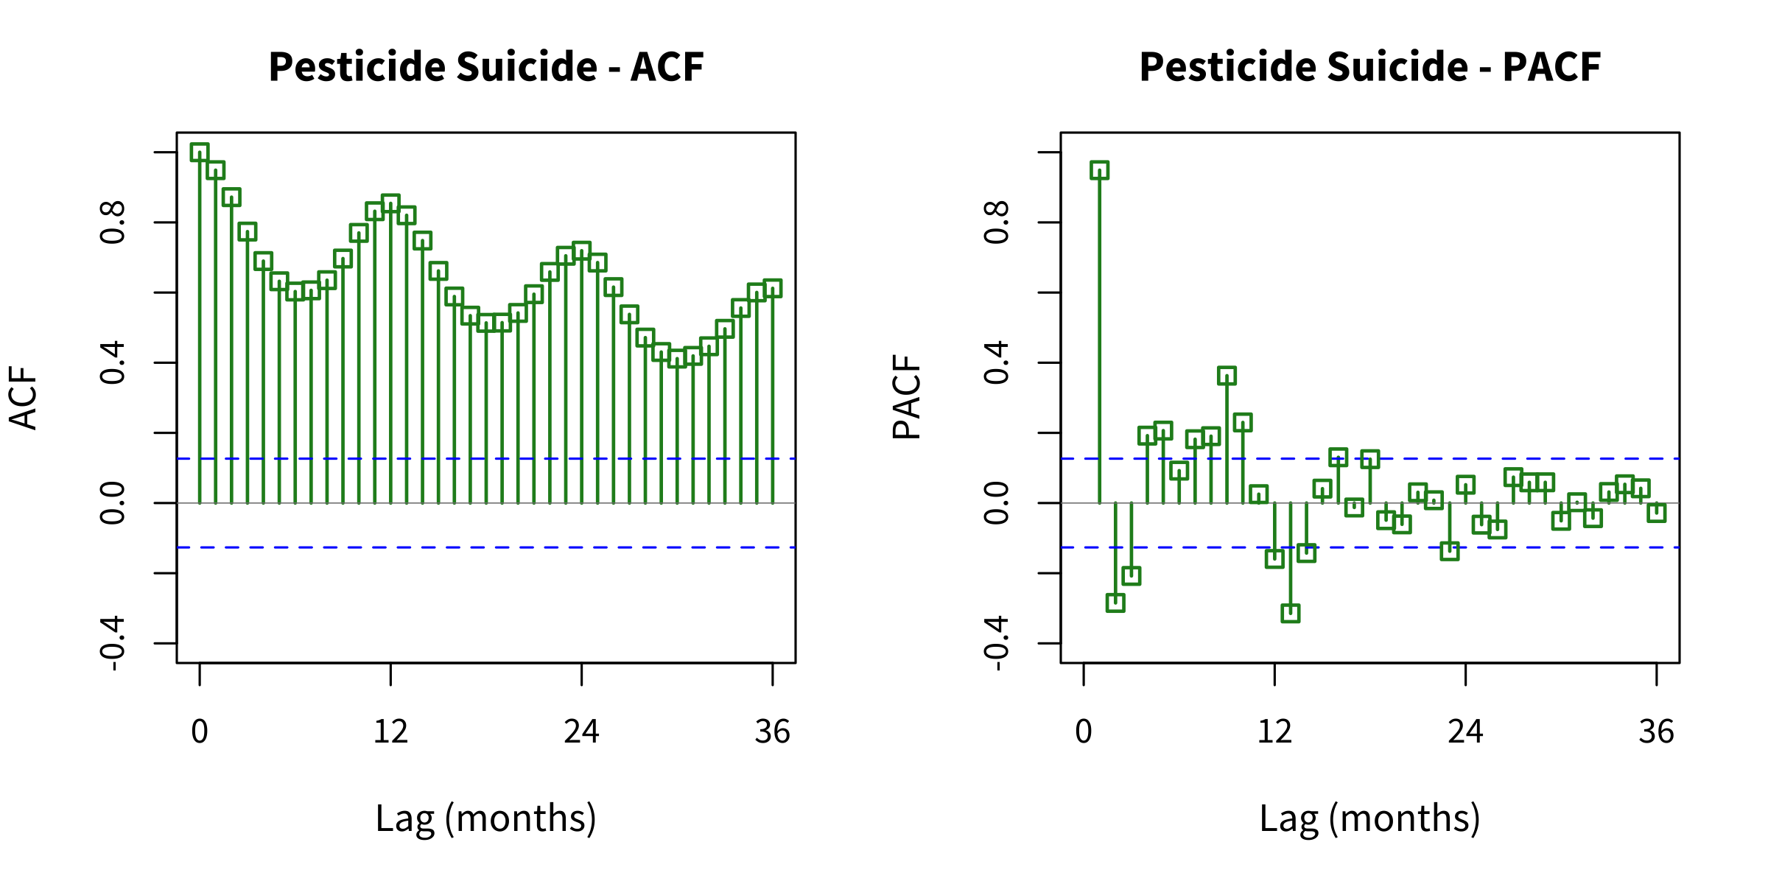
eFigure 1. Autocorrelation and Partial Autocorrelation Functions for Pesticide Suicide Time Series
ACF (left) and PACF (right) plots for monthly pesticide suicide counts after square root transformation. Blue dashed lines: 95% confidence bounds.

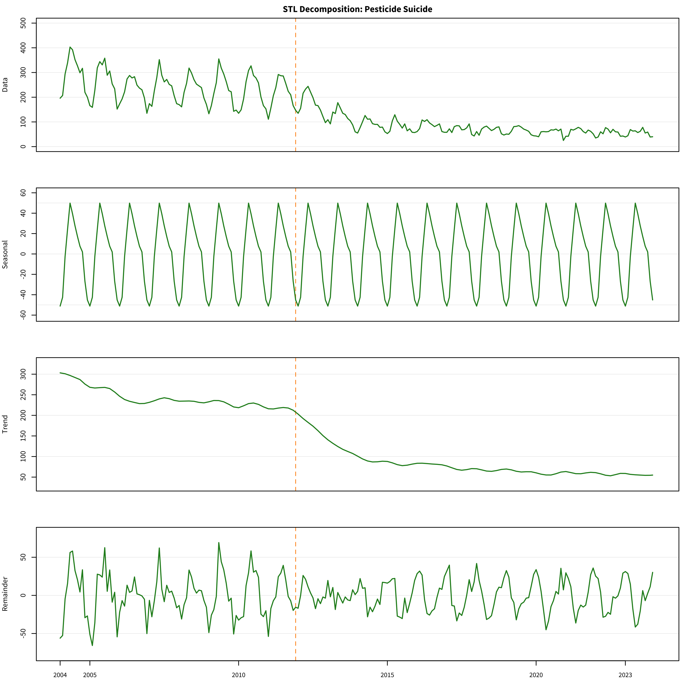
eFigure 2. Seasonal-Trend Decomposition of Pesticide Suicide Time Series
STL decomposition of monthly pesticide suicide counts. Panels from top: original data, seasonal component, trend component, remainder.

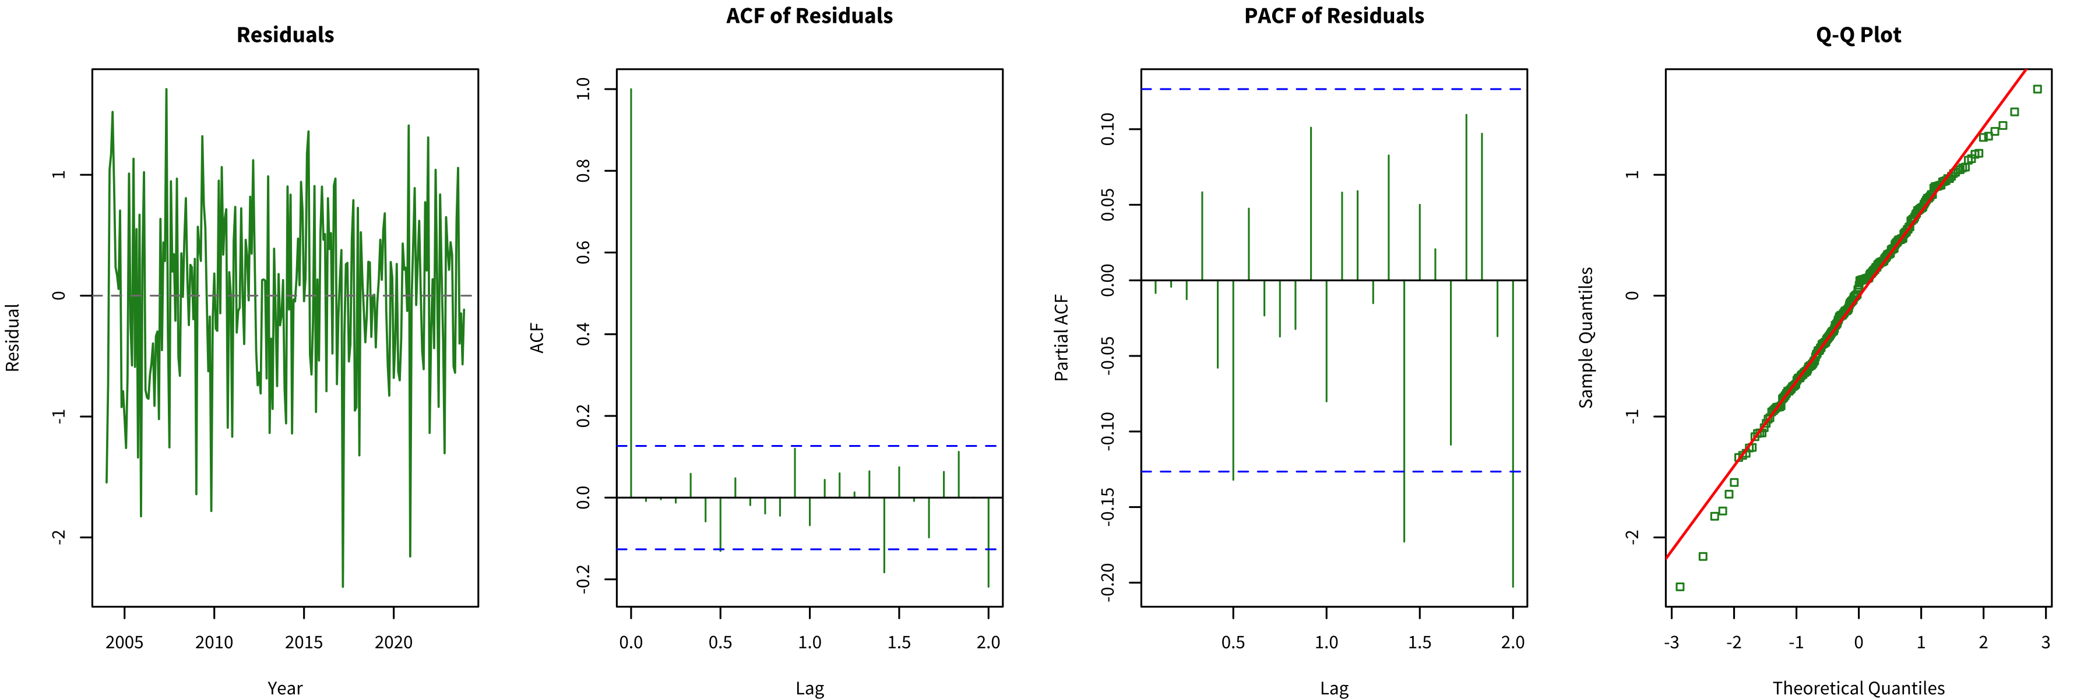
eFigure 3. Residual Diagnostics for the ARIMA Model
Diagnostic plots for the fitted ARIMA model. (A) Standardized residuals; (B) ACF of residuals; (C) Histogram of residuals; (D) Q-Q plot.

(A)
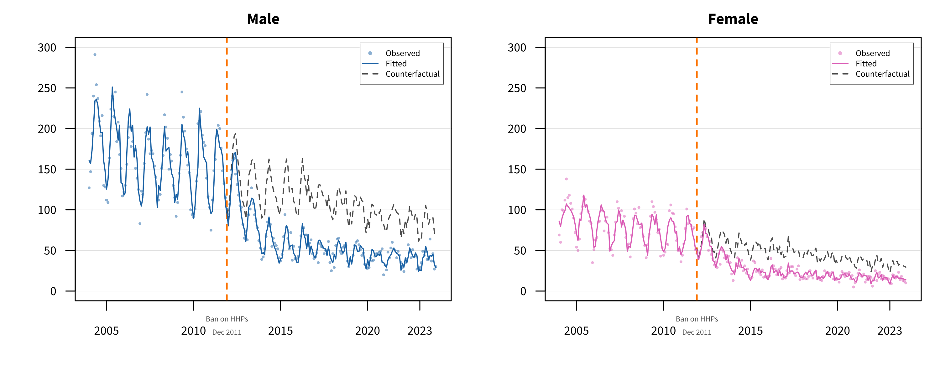
(B)
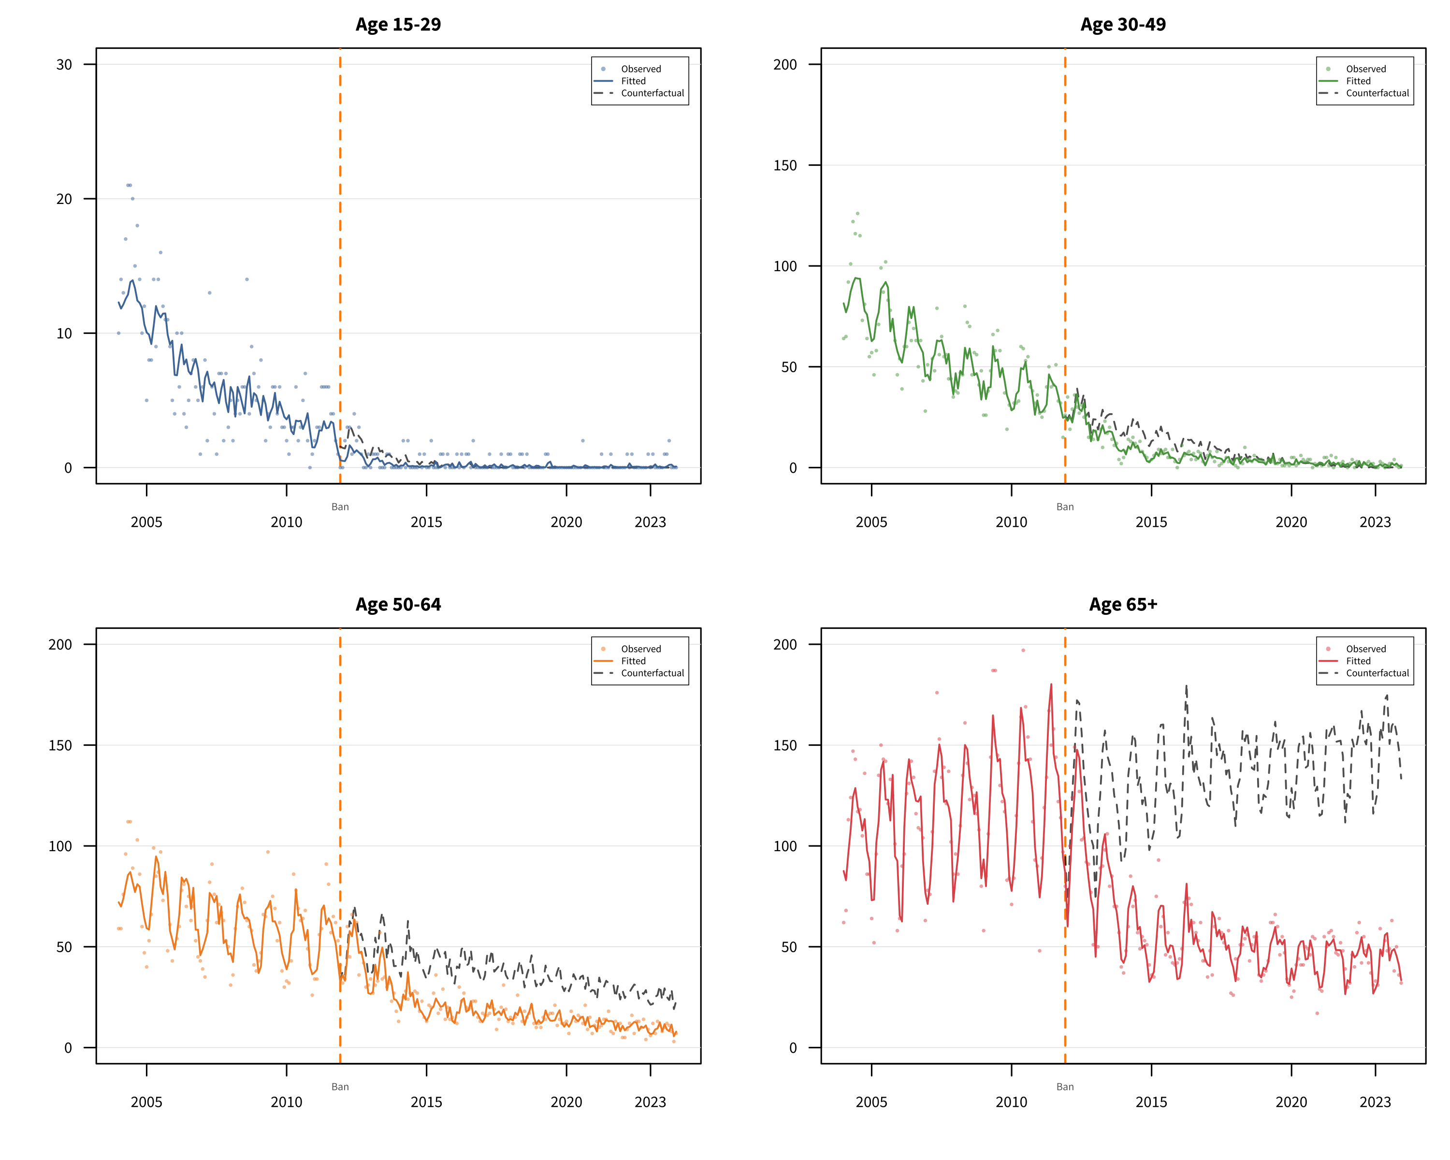
eFigure 4. Subgroup Interrupted Time Series Analyses
ITS analyses by demographic subgroups: (A) Sex; (B) Age group; (C) Region; (D) Occupation. Points: observed counts; solid lines: fitted values; dashed lines: counterfactual projections. Vertical dashed orange line: paraquat ban (December 2011). See eTable 3 for details.
(C)
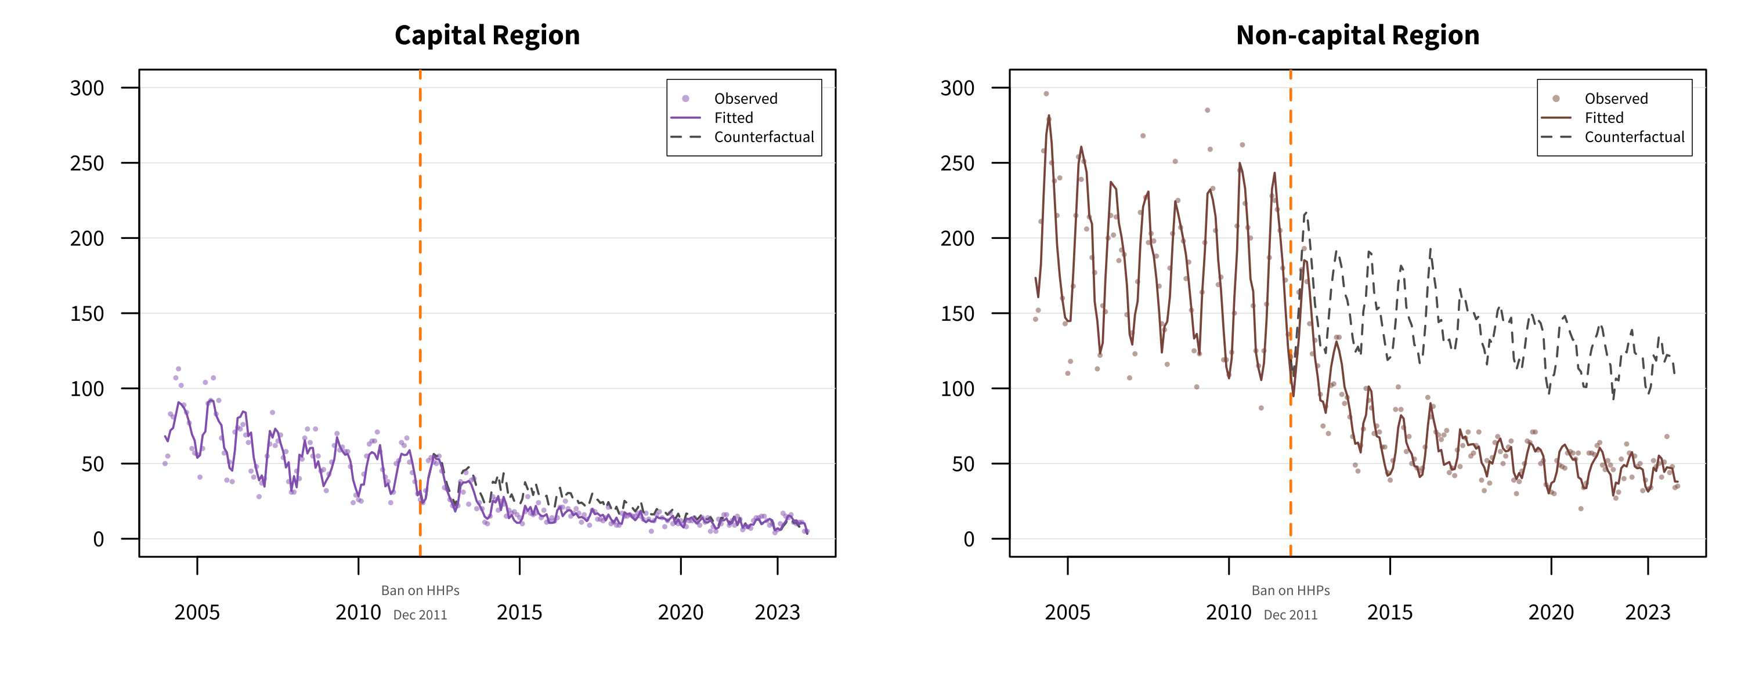
(D)
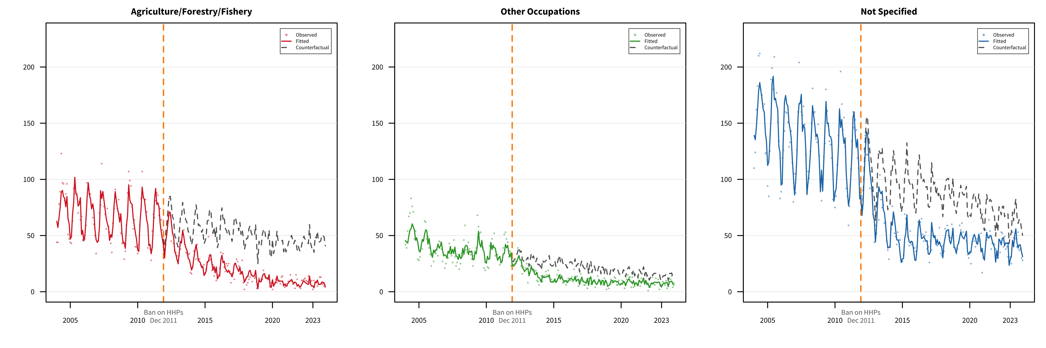
eFigure 4. Subgroup Interrupted Time Series Analyses
ITS analyses by demographic subgroups: (A) Sex; (B) Age group; (C) Region; (D) Occupation. Points: observed counts; solid lines: fitted values; dashed lines: counterfactual projections. Vertical dashed orange line: paraquat ban (December 2011). See eTable 3 for details.

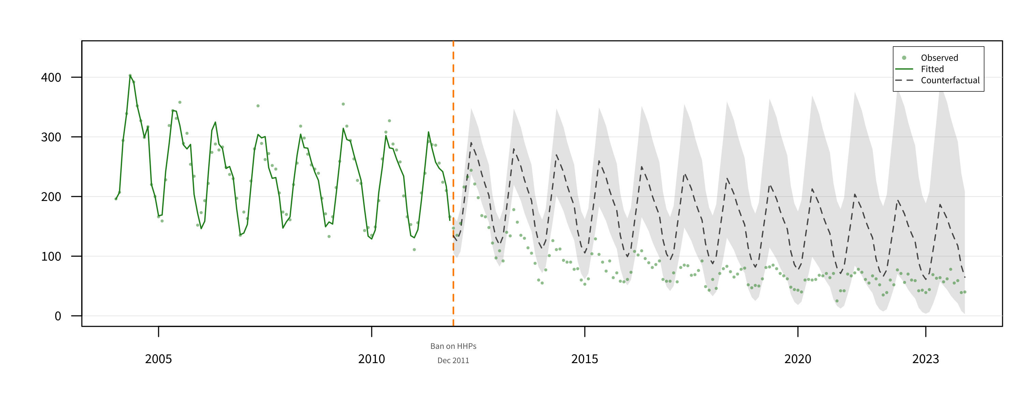
eFigure 5. Sensitivity Analysis Using Pre-Ban Data Only for Counterfactual Projection
Counterfactual projection using pre-ban data (2004–2011) only. Green points: observed values; green line: fitted values; gray dashed line: counterfactual forecast; gray shaded area: 95% prediction interval. See eTable 10 for details.

eFigure 6. Exploratory Difference-in-Differences Analysis Comparing Pesticide Suicides with Control Outcomes
Indexed monthly counts (December 2011 = 100) for pesticide suicides compared with (A) hanging and (B) non-pesticide suicides. This exploratory analysis should be interpreted with caution due to violation of the parallel trend assumption. See eTable 13 for details.
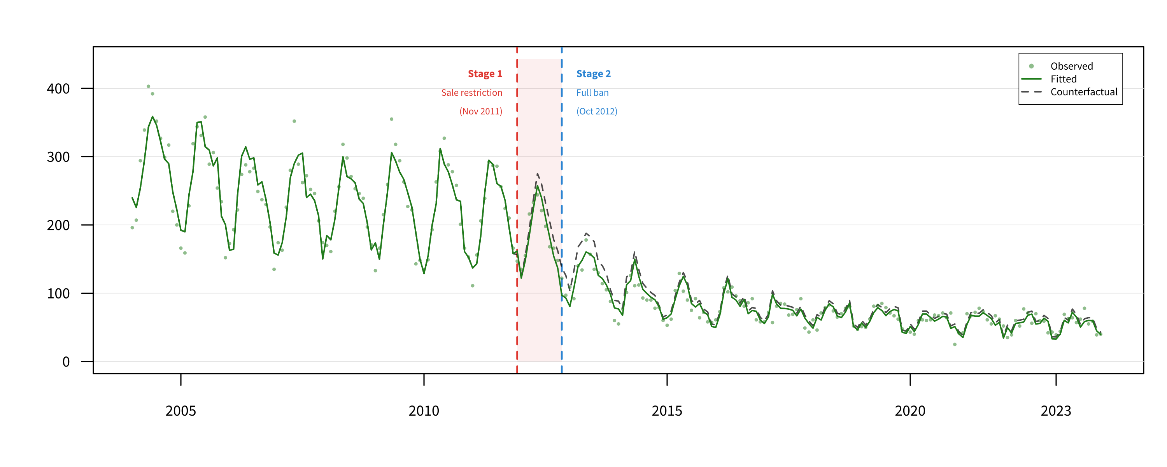
eFigure 7. Two-Stage Intervention Model for Pesticide Suicide
Interrupted time series analysis modeling the paraquat ban as two distinct intervention points: Stage 1 (sale restriction, November 2011) and Stage 2 (complete ban, October 2012). Gray points: observed monthly counts; green solid line: fitted values; gray dashed line: counterfactual projection; red dashed line: Stage 1 intervention; blue dashed line: Stage 2 intervention. The shaded region indicates the transition period between stages.

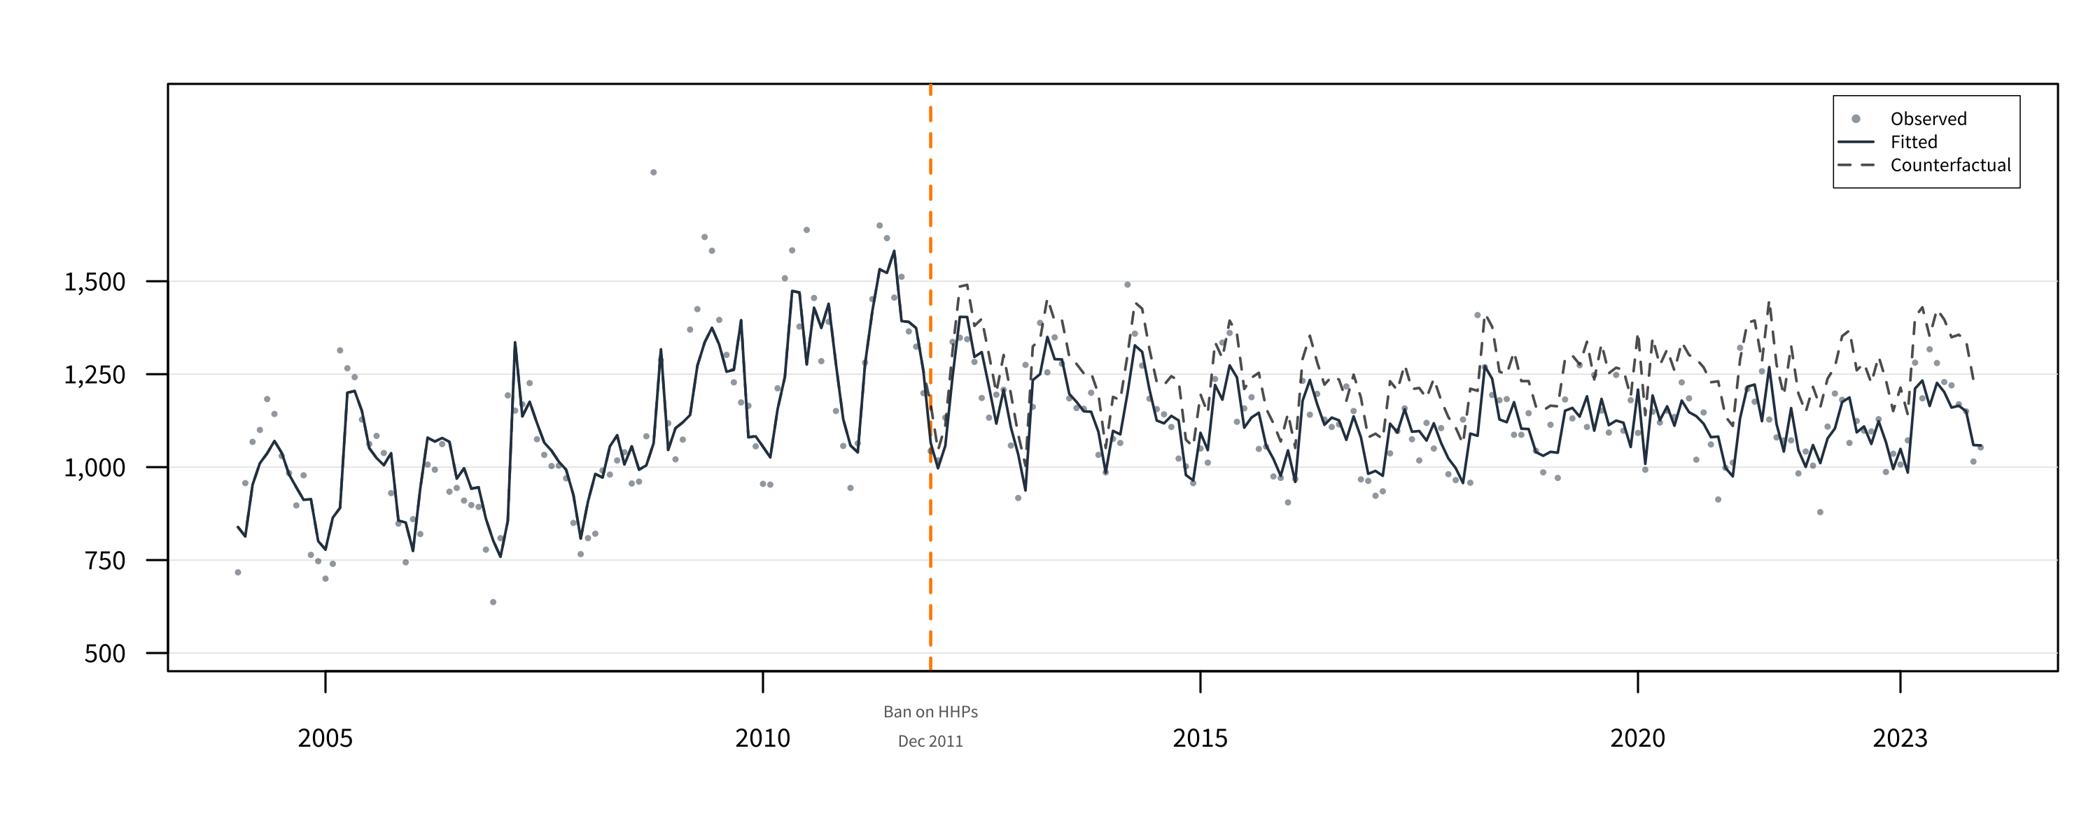
eFigure 8. Interrupted Time Series Analysis for Total Suicide Mortality
ITS analysis of overall (all-method) suicide mortality. Gray points: observed monthly counts; dark blue solid line: fitted values; gray dashed line: counterfactual projection; orange dashed line: paraquat ban (December 2011). Pesticide suicides account for approximately 15% of total suicides, limiting the detectable effect at the aggregate level.

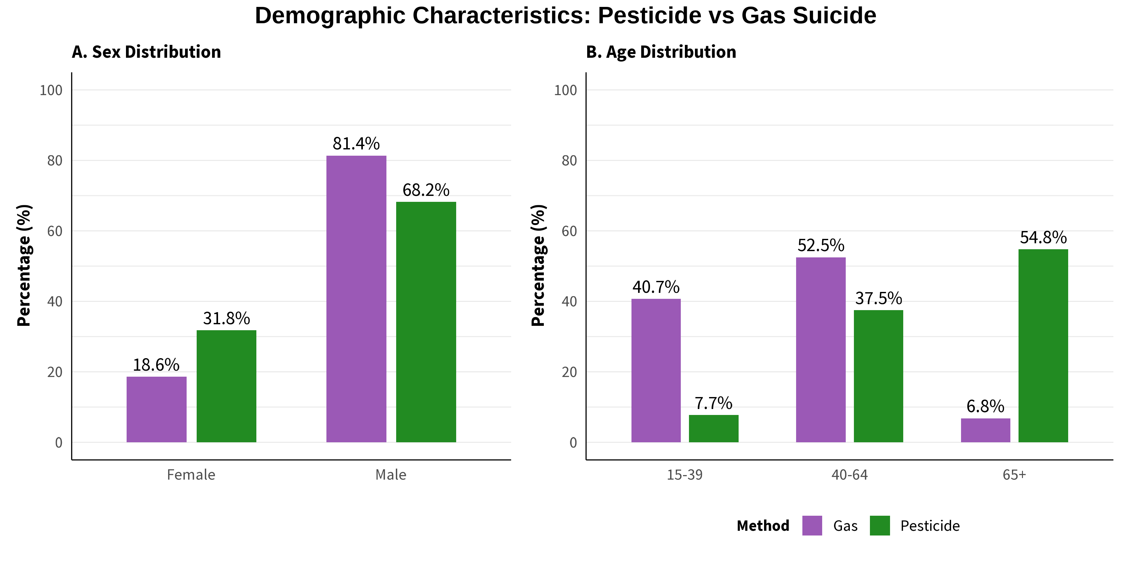
eFigure 9. Demographic Characteristics of Pesticide and Gas Suicide Decedents
Comparison of demographic profiles between pesticide suicide and gas suicide decedents. (A) Sex distribution; (B) Age distribution. Green bars: pesticide suicide; purple bars: gas suicide. The distinct demographic patterns support the interpretation that gas suicide increase was not primarily driven by substitution from pesticide suicide.

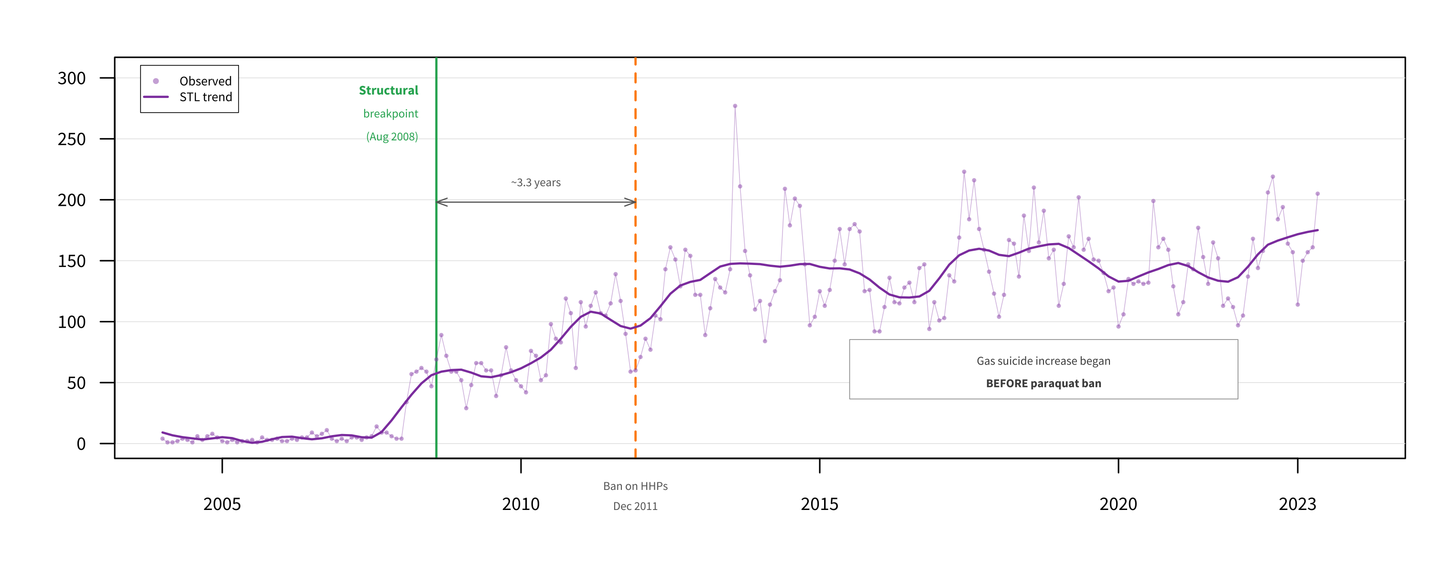
eFigure 10. Structural Breakpoint Analysis for Gas Suicide
Bai-Perron structural breakpoint analysis of monthly gas suicide (X67) counts with STL trend decomposition. Purple points and line: observed counts; dark purple line: trend component; green vertical line: structural breakpoint (August 2008); orange dashed line: paraquat ban (December 2011). The breakpoint occurred approximately 3.3 years before the paraquat ban, suggesting that the increase in gas suicides was driven by factors unrelated to pesticide regulation (e.g., charcoal availability, media effects following a high-profile celebrity suicide in 2008).

