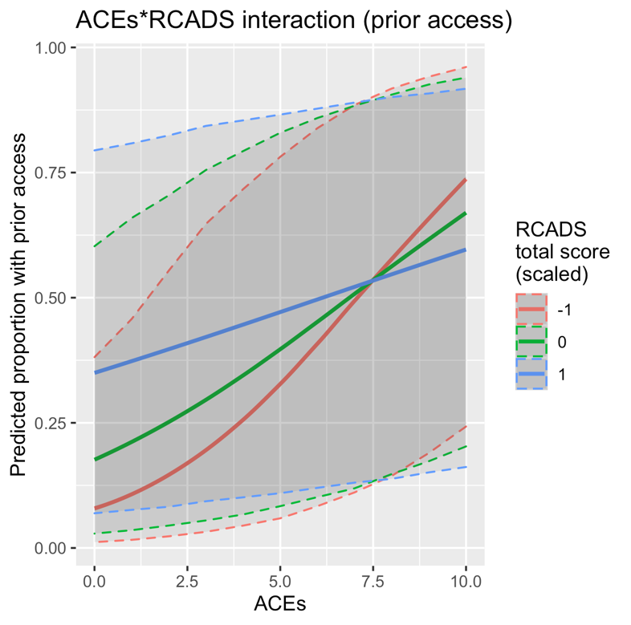
Supplementary Figure 1. Plot illustrating the interaction between number of ACEs and the scaled-RCADS total score for the prior access to mental health support. The plot shows how access to support varies across ACEs (0-10) and standard deviations of the scaled-RCADS score (-1, 0, and 1, where 0 is the mean, -1 is better mental health, and 1 is poorer mental health).

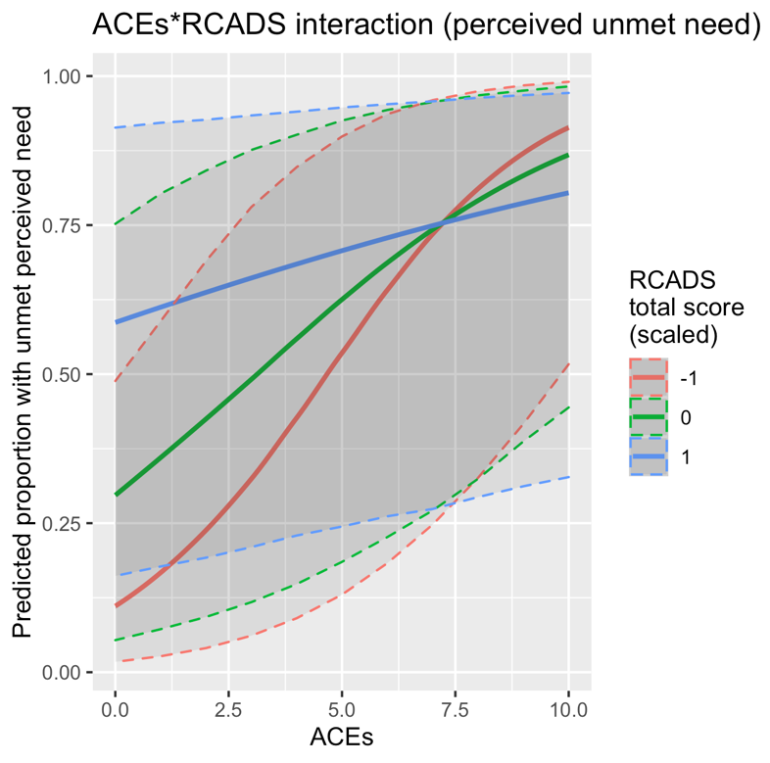
Supplementary Figure 2. Plot illustrating the interaction between number of ACEs and the scaled-RCADS total score for perceived unmet need for mental health services. The plot shows how perceived unmet need for mental health services varies across ACEs (0-10) and standard deviations of the scaled-RCADS score (-1, 0, and 1, where 0 is the mean, -1 is better mental health, and 1 is poorer mental health).

