Supplementary material

Contents Page
Fig. S1. Flowchart of selection of register data for analytical sample 2
Additional information about measures (Supplementary Table S1) 3
Additional results
Supplementary Table S2 4
Fig. S2 5
Fig. S3 6
Supplementary Table S3 7
Supplementary Table S4 8

Fig. S1. Flowchart of selection of register data for analytical sample

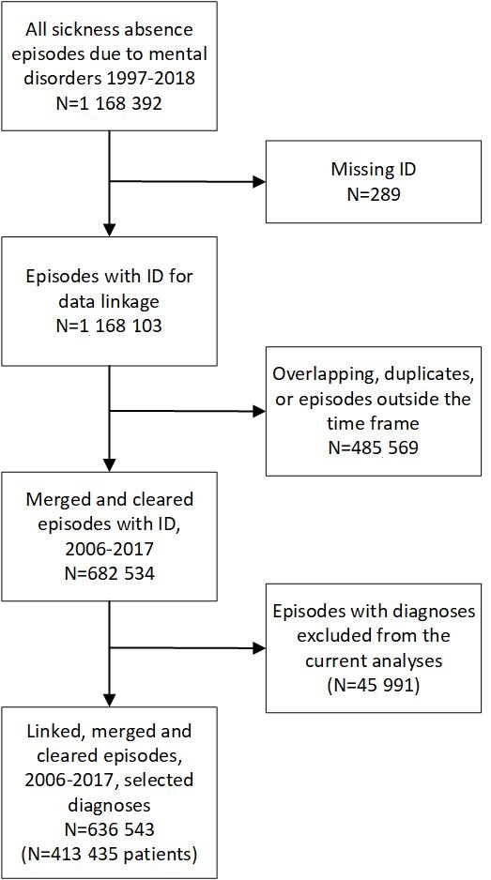

Supplementary Table S1. Photoperiods, starting and ending dates of the period, number of days in the period, mean daylength in hours (h) and mean pace of change in daylength in minutes (min) per day
Photoperiod¹ | Starting date | Ending date | Days (n) | Daylength (h)² | Pace of change (min)²
Slowly increasing | 21 Dec | 1 Mar | 71 | 7.6 | 3.9
Rapidly increasing | 2 Mar | 11 May | 71 | 13.7 | 5.4
Start of rapidly increasing | 22 Feb | 1 Apr | 39 | 11.6 | 5.5
End of rapidly increasing | 2 Apr | 11 May | 40 | 15.2 | 5.4
Slowly decreasing | 21 Jun | 30 Aug | 71 | 17.1 | –3.9
Rapidly decreasing | 31 Aug | 9 Nov | 71 | 11.1 | –5.4
Start of rapidly decreasing | 23 Aug | 30 Sep | 39 | 13.3 | –5.4
End of rapidly decreasing | 1 Oct | 9 Nov | 40 | 9.7 | –5.3
Notes: ¹The photoperiods were based on astronomical seasons (summer and winter solstices and vernal and autumnal equinoxes), daylength and pace of change in daylength; ²Daylength and pace of change in daylength are based on the sunrise and the sunset times in Helsinki, Finland (60°N). The dates of astronomical seasons and sunrise and sunset times were derived from the University of Helsinki Almanac Office.

Supplementary Table S2. Number of sickness absence episodes in each mental disorder group
Diagnosis-specific group | n (%) of episodes
Unipolar depressive episode (F32, F33) | 353,690 (55.6)
Anxiety disorders (F4) | 213,842 (33.6)
Non-organic sleep disorders (F51) | 33,357 (5.2)
Psychoactive substance use disorders (F1) | 7,872 (1.2)
Bipolar disorder, mixed/non-specified (F316-319, F31) | 15,279 (2.4)
Manic episodes of bipolar disorder (F30, F310-312) | 3,199 (0.5)
Depressive episodes of bipolar disorder (F313-315) | 9,304 (1.5)
Total | 636,543 (100.0)

Fig. S2 Smoothed LOESS time series of daily-based ratio of observed and expected diagnosis-specific sickness absence, expressed as observed–expected ratio (O/E) for: (A) unipolar depressive disorders, all; (B) mild episodes; (C) moderate episodes; (D) severe episodes without psychotic symptoms; (E) severe episodes with psychotic symptoms; and (F) depressive episodes of bipolar disorder
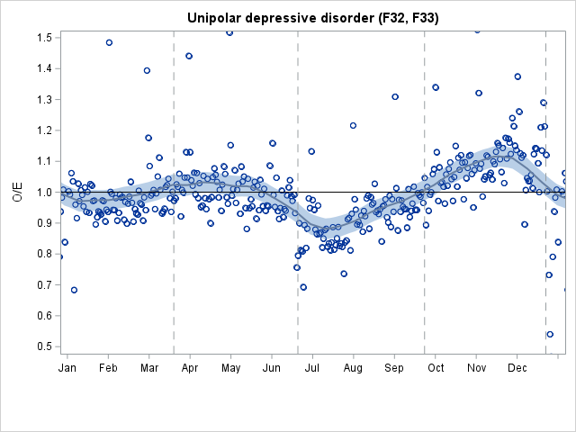
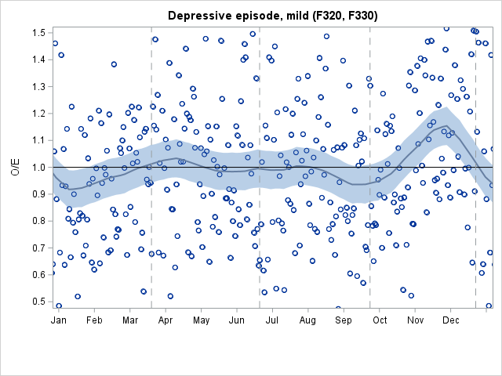
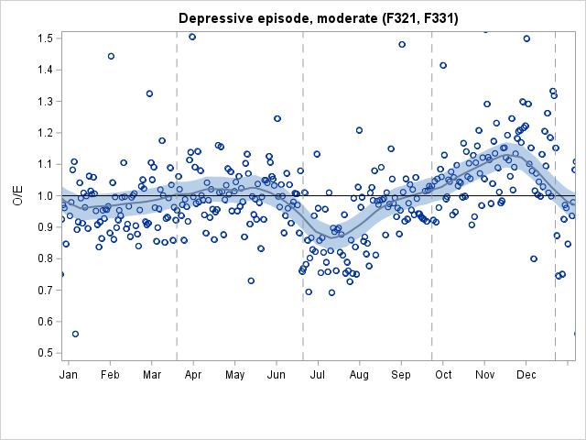
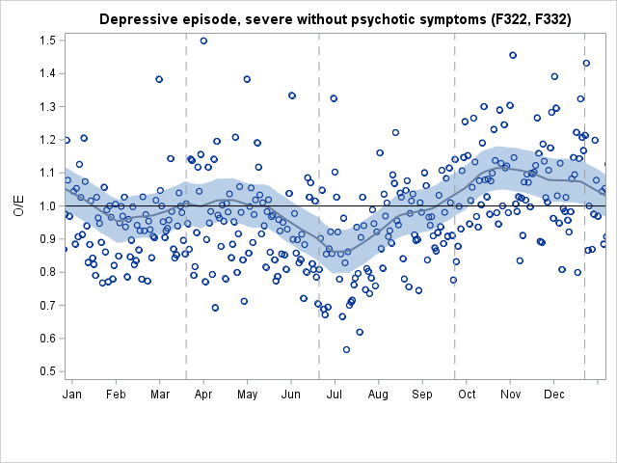
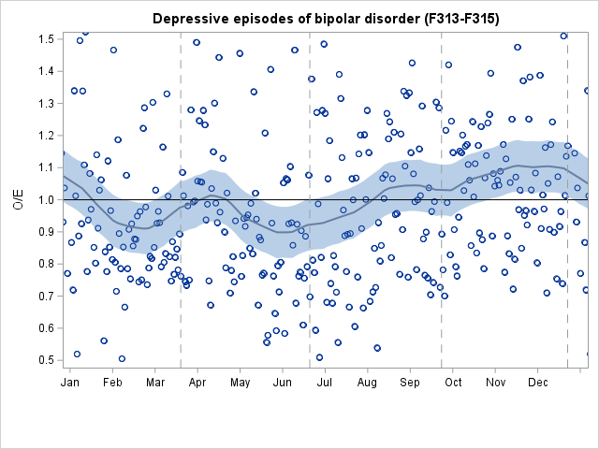
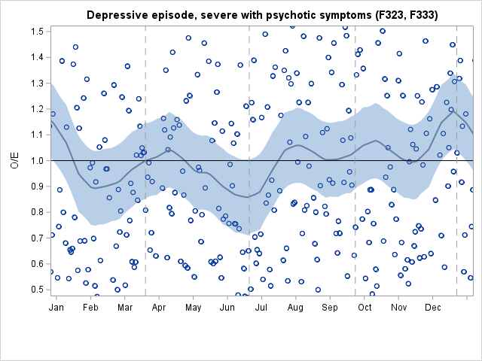
A
B
C
D
E
F

Fig. S3 Smoothed Loess time series of daily-based ratio of observed and expected diagnosis-specific sickness absence, expressed as the observed-expected ratio (O/E) for: (A) anxiety disorders; (B) non-organic sleep disorders; (C) psychoactive substance use disorders; (D) manic episodes of bipolar disorder; and (E) mixed/unspecified episodes of bipolar disorder
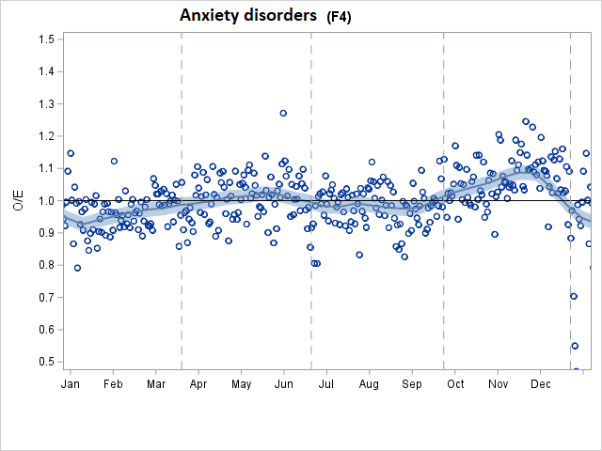
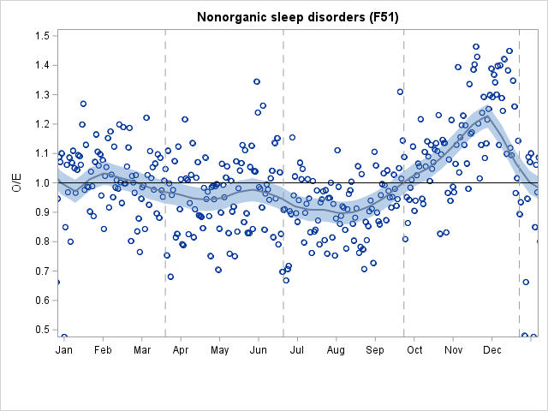
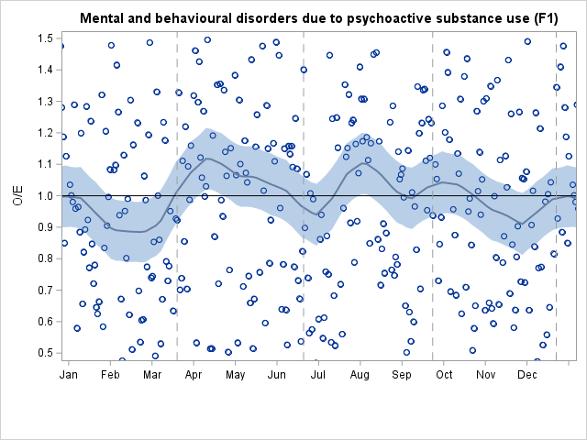
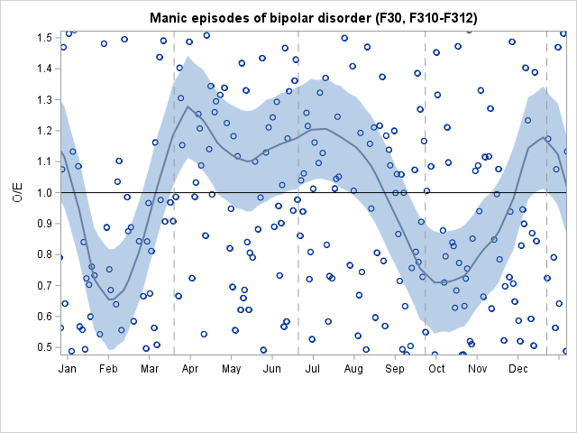
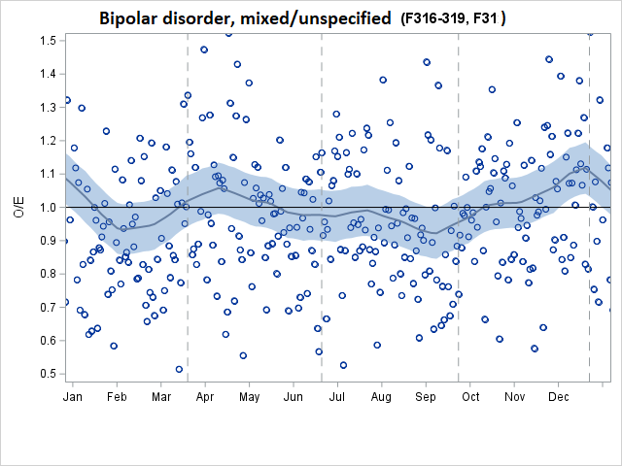
A
B
C
D
E

Supplementary Table S3. Mean standardized Z-scores for observed to expected (O/E) count (with 95% confidence intervals) of new diagnosis-specific sickness absence periods 2006–2017 (the first period only) by changing seasonal photoperiods
 | Seasonal photoperiods, later phase of the year |  | Seasonal photoperiods, earlier phase of the year
ICD-10 diagnosis for sickness absence | Slowly decreasing light | Rapidly decreasing light | Slowly increasing light | Rapidly increasing light
Unipolar depressive disorder | -0.84 (-0.97- -0.71) | 0.20 (0.02-0.38) | -0.03 (-0.35-0.29) | 0.38 (0.23-0.53)
Depressive episodes of bipolar disorder | -0.14 (-0.37-0.10) | 0.00 (-0.20-0.21) | 0.08 (-0.23-0.38) | 0.16 (-0.06-0.39)
Anxiety disorders | -0.14 (-0.34-0.06) | 0.15 (-0.03-0.33) | -0.54 (-0.78- -0.30) | 0.12 (-0.07-0.30)
Non-organic sleep disorders | -0.58 (-0.73- -0.43) | 0.21 (0.04-0.38) | -0.07 (-0.33-0.20) | -0.21 (-0.38- -0.03)
Substance use disorders | 0.08 (-0.14-0.29) | 0.07 (-0.14-0.27) | 0.07 (-0.17-0.31) | 0.10 (-0.16-0.36)
Bipolar disorder, mixed/non-specified | -0.11 (-0.32-0.09) | -0.15 (-0.35-0.04) | 0.08 (-0.26-0.42) | 0.23 (0.02-0.44)
Manic episodes of bipolar disorder | 0.28 (0.03-0.54) | -0.34 (-0.52- -0.16) | -0.24 (-0.50-0.01) | 0.21 (-0.02-0.45)
Note. Values above 0 denote higher than expected sickness absence rates and values below 0 denote lower than expected sickness absence rates.

Supplementary Table S4. Mean standardized Z-scores for observed to expected (O/E) count (with 95% confidence intervals) of new diagnosis-specific sickness absence periods (the first period only) 2006–2017 by the phases of rapidly changing seasonal photoperiods
 | Rapidly decreasing light |  | Rapidly increasing light
ICD-10 diagnosis for sickness absence | Beginning phase | End phase | Beginning phase | End phase
Unipolar depressive disorder | -0.33 (-0.51- -0.15) | 0.54 (0.31-0.76) | 0.38 (0.13-0.63) | 0.33 (0.14-0.52)
Depressive episodes of bipolar disorder | -0.07 (-0.36-0.22) | 0.03 (-0.22-0.29) | 0.19 (-0.11-0.48) | 0.10 (-0.22-0.42)
Anxiety disorders | -0.20 (-0.46-0.05) | 0.30 (0.07-0.53) | -0.05 (-0.28-0.18) | 0.20 (-0.06-0.45)
Non-organic sleep disorders | -0.30 (-0.53- -0.08) | 0.48 (0.26-0.70) | -0.18 (-0.36-0.00) | -0.27 (-0.54-0.01)
Substance use disorders | 0.01 (-0.24-0.25) | 0.13 (-0.16-0.42) | -0.12 (-0.50-0.26) | 0.29 (-0.01-0.59)
Bipolar disorder, mixed/non-specified | -0.35 (-0.57- -0.12) | -0.07 (-0.35-0.22) | 0.07 (-0.21-0.34) | 0.33 (0.03-0.64)
Manic episodes of bipolar disorder | -0.23 (-0.48-0.02) | -0.40 (-0.64- -0.16) | 0.07 (-0.30-0.45) | 0.22 (-0.04-0.48)
Note. Values above 0 denote higher than expected sickness absence rates and values below 0 denote lower than expected sickness absence rates.

