List of Supplemental Materials

Supplementary Table 1. Univariate Cox proportional hazards regression analyses of patients with second primary cancer (P2)

Supplementary Table 2. Univariate Cox proportional hazards regression analyses of patients with first primary cancer (P4)

Supplementary Table 3. Cox proportional hazards regression analyses of second primary cancer patients with female genital system (P6)

Supplementary Figure 1. Study population flow chart (P7)

Supplementary Figure 2. The proportion of deaths among second and first primary cancer patients (P8)

Supplementary Figure 3. Kaplan-Meier survival analysis of patients with first primary cancer (P9)

Supplementary Figure 4. Multivariate Cox proportional hazards regression analyses of patients with first primary cancer (P10)

Supplementary Table 1. Univariate analysis of clinical variables associated with suicide death among second primary cancer patients
Variable | HR (95%CI) |  | P
Age at Diagnosis (years)
≤39 |  | 1.00 [Reference]
40-49 |  | 0.861 (0.532-1.395) | 0.543
50-59 |  | 1.208 (0.788-1.853) | 0.386
60-69 |  | 1.478 (0.974-2.244) | 0.067
70-79 |  | 2.000 (1.315-3.043) | 0.001
80+ |  | 2.546 (1.607-4.035) | <0.001
Sex
Female |  | 1.00 [Reference]
Male |  | 5.108 (4.240-6.153) | <0.001
Race
White |  | 1.00 [Reference]
Black |  | 0.274 (0.178-0.423) | <0.001
Others |  | 0.340 (0.216-0.536) | <0.001
Marital Status
Married |  | 1.00 [Reference]
Unmarried |  | 1.279 (1.106-1.478) | <0.001
Unknown |  | 1.042 (0.803-1.352) | 0.758
Median Household Income
< $40,000 |  | 1.00 [Reference]
$40,000 - $49,999 |  | 0.746 (0.505-1.101) | 0.140
$50,000 - $59,999 |  | 0.805 (0.560-1.158) | 0.243
$60,000 - $69,999 |  | 0.621 (0.438-0.880) | 0.007
$70,000+ |  | 0.488 (0.346-0.689) | <0.001
Year of Diagnosis
2000-2004 |  | 1.00 [Reference]
2005-2009 |  | 1.353 (1.146-1.596) | <0.001
2010-2014 |  | 1.941 (1.586-2.374) | <0.001
2015-2019 |  | 2.501 (1.785-3.506) | <0.001
Grade
Well differentiated |  | 1.00 [Reference]
Moderately differentiated |  | 1.184 (0.927-1.512) | 0.177
Poorly differentiated |  | 1.265 (0.973-1.645) | 0.079
Undifferentiated |  | 2.287 (1.572-3.328) | <0.001
Other/Unknown |  | 1.287 (1.005-1.650) | 0.046
Stage
Localized |  | 1.00 [Reference]
Regional |  | 0.973 (0.816-1.159) | 0.757
Distant |  | 1.566 (1.254-1.956) | <0.001
Unknown |  | 1.326 (1.004-1.749) | 0.046
Cancer-directed Surgery
Performed |  | 1.00 [Reference]
Not performed |  | 1.709 (1.482-1.970) | <0.001
Unknown |  | 1.240 (0.514-2.991) | 0.632
Radiotherapy
Yes |  | 1.00 [Reference]
No/Unknown |  | 1.227 (1.053-1.428) | 0.009
(continued)
Chemotherapy
Yes |  | 1.00 [Reference]
No/Unknown |  | 1.141 (0.967-1.347) | 0.118

ª includes American Indian/Alaska Native and Asian/Pacific Islander.
Supplementary Table 2. Univariate analysis of clinical variables associated with suicide death among first primary cancer patients
Variable | HR (95%CI) |  | P
Age at Diagnosis (years)
≤39 |  | 1.00 [Reference]
40-49 |  | 1.356 (1.203-1.529) | <0.001
50-59 |  | 1.471 (1.320-1.640) | <0.001
60-69 |  | 1.705 (1.534-1.895) | <0.001
70-79 |  | 2.146 (1.927-2.389) | <0.001
80+ |  | 2.243 (1.984-2.535) | <0.001
Sex
Female |  | 1.00 [Reference]
Male |  | 4.887 (4.589-5.205) | <0.001
Race
White |  | 1.00 [Reference]
Black |  | 0.319 (0.280-0.364) | <0.001
Others ª |  | 0.599 (0.538-0.668) | <0.001
Marital Status
Married |  | 1.00 [Reference]
Unmarried |  | 1.392 (1.323-1.464) | <0.001
Unknown |  | 1.540 (1.418-1.673) | <0.001
Median Household Income
< $40,000 |  | 1.00 [Reference]
$40,000 - $49,999 |  | 1.052 (0.916-1.209) | 0.475
$50,000 - $59,999 |  | 0.899 (0.787-1.028) | 0.121
$60,000 - $69,999 |  | 0.779 (0.685-0.885) | <0.001
$70,000+ |  | 0.685 (0.604-0.778) | <0.001
Unknown |  | 1.473 (0.472-4.594) | 0.505
Year of Diagnosis
2000-2004 |  | 1.00 [Reference]
2005-2009 |  | 0.980 (0.921-1.042) | 0.521
2010-2014 |  | 0.958 (0.895-1.025) | 0.215
2015-2019 |  | 0.908 (0.833-0.989) | 0.028
Grade
Well differentiated |  | 1.00 [Reference]
Moderately differentiated |  | 1.547 (1.400-1.709) | <0.001
Poorly differentiated |  | 1.874 (1.692-2.076) | <0.001
Undifferentiated |  | 2.076 (1.770-2.434) | <0.001
Other/Unknown |  | 1.698 (1.539-1.875) | <0.001
Stage
Localized |  | 1.00 [Reference]
Regional |  | 1.119 (1.053-1.189) | <0.001
Distant |  | 1.741 (1.629-1.861) | <0.001
Unknown |  | 1.672 (1.527-1.832) | <0.001
(continued)
Cancer-directed Surgery
Performed |  | 1.00 [Reference]
Not performed |  | 2.020 (1.925-2.121) | <0.001
Unknown |  | 2.259 (1.810-2.819) | <0.001
Radiotherapy
Yes |  | 1.00 [Reference]
No/Unknown |  | 1.194 (1.132-1.259) | <0.001
Chemotherapy
Yes |  | 1.00 [Reference]
No/Unknown |  | 1.168 (1.105-1.234) | <0.001

ª includes American Indian/Alaska Native and Asian/Pacific Islander.

Supplementary Table 3. Cox proportional hazards regression analyses of second primary cancer patients with female genital system
Variable | HR (95%CI) |  | P
Female Genital System
Cervix Uteri |  | 1.00 [Reference]
Uterus |  | 0.477 (0.056-4.093) | 0.5
Ovary |  | 0.256 (0.033-1.985) | 0.192
Vagina |  | 0.405 (0.047-3.466) | 0.409
Vulva |  | 0.000 (0.000-1.321E+265) | 0.972
Unknown |  | 0.202 (0.013-3.238) | 0.259

Supplementary Figure 1. Study population flow chart
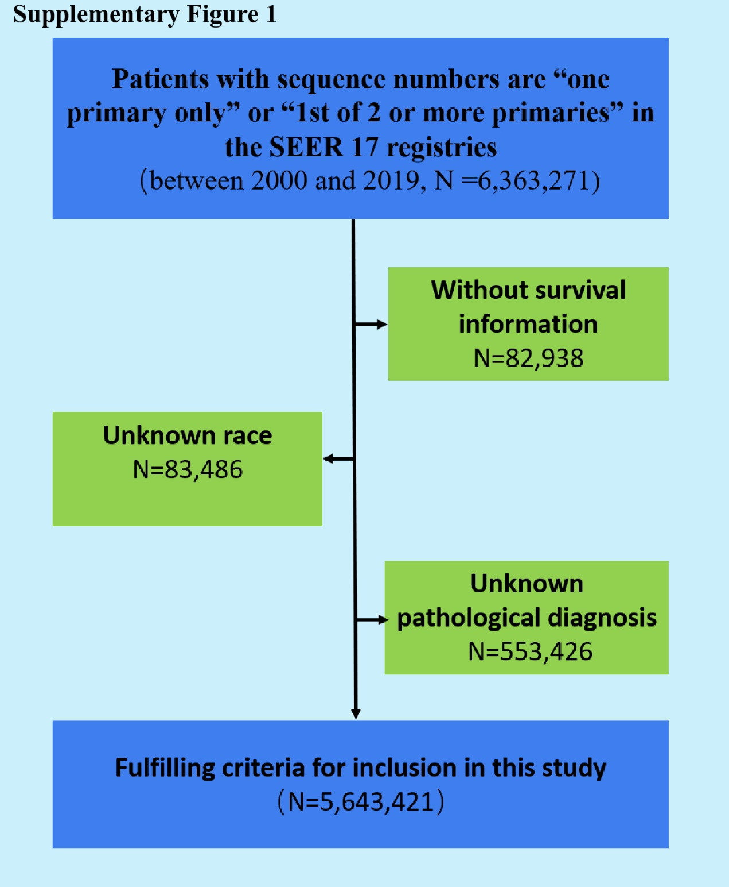

Supplementary Figure 2. The proportion of deaths among second and first primary cancer patients
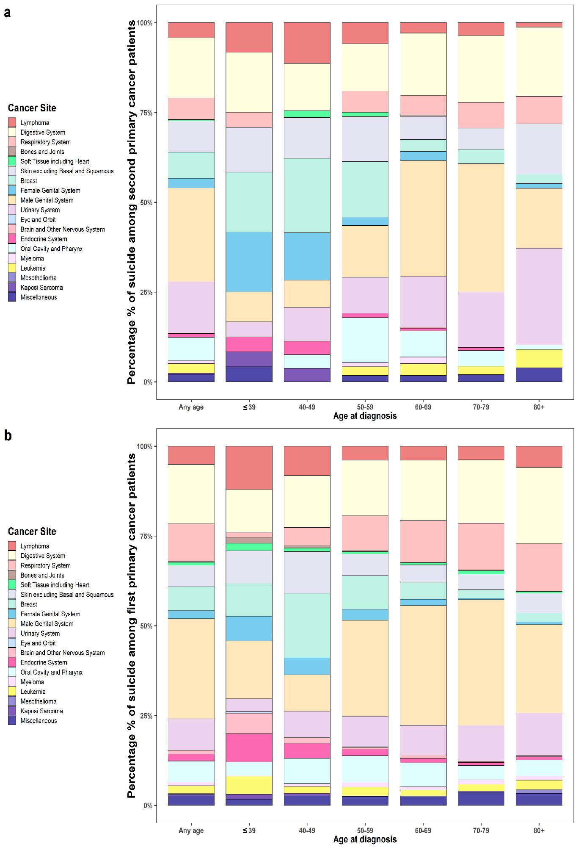
Supplementary Figure 3. Kaplan-Meier survival analysis of patients with first primary cancer
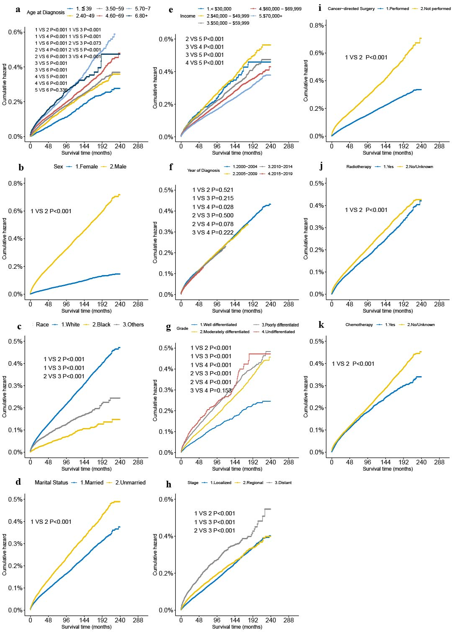

Supplementary Figure 4. Multivariate Cox proportional hazards regression analyses of patients with first primary cancer
