Supplementary Material

**Population-based assessment for major congenital malformations in the United States: smoking risk association**

Diancarlos P. de Andrade1,2; Camila M. Marques1,2; Dayane C. R. Andrade5; Henrique Laureano1, Luana Lenzi6; Cláudia S. Oliveira1,2, Meire E. Pereira1,2; Bonald C. Figueiredo1,2,3,4,*

1Instituto de Pesquisa Pelé Pequeno Príncipe, Curitiba, PR, Brazil.

2Faculdades Pequeno Príncipe, Curitiba, PR, Brazil.

3Centro de Genética Molecular e Pesquisa do Câncer em Crianças (CEGEMPAC), Universidade Federal do Paraná, Curitiba, PR, Brazil.

4Hospital Pequeno Príncipe, Curitiba, PR, Brazil.

5Hospital de Clínicas de Porto Alegre, Porto Alegre, RS, Brazil.

6Departamento de Análises Clínicas, Universidade Federal do Paraná, Curitiba, PR, Brazil.

*Correspondence: e-mail: bonaldf@yahoo.com.br

Supplementary Table 1 Features associated with mothers or newborns documented from 2000 to 2004.

|  | **2000 - N(%)a** | **2001 - N(%)a** | **2002 - N(%)a** | **2003 - N(%)b** | **2004 - N(%)c** |
| --- | --- | --- | --- | --- | --- |
| Mothers | 2,312,548 (100) | 2,292,311 (100) | 2,269,131 (100) | 2,122,442 (100) | 1,699,803 (100) |
| Birth weight |  |  |  |  |  |
| < 2500 g | 150,955 (6.53) | 153,653 (6.70) | 155,424 (6.85) | 149,206 (7.03) | 121,171 (7.13) |
| 2500-3499 g | 1,166,379 (50.44) | 1,175,549 (51.28) | 1,174,368 (51.75) | 1,114,746 (52.52) | 898,460 (52.86) |
| [≥](https://pt.wiktionary.org/wiki/≥) 3500 g | 993,597 (42.97) | 961,636 (41.95) | 938,031 (41.34) | 857,322 (40.39) | 679,330 (39.97) |
| Not declared | 1,617 (0.07) | 1,473 (0.06) | 1,308 (0.06) | 1,168 (0.06) | 842 (0.05) |
| CMd | 33,624 (1.45) | 33,334 (1.45) | 32,342 (1.43) | 28,571 (1.35) | 22,904 (1.35) |
| No_CM | 2,278,924 (98.55) | 2,258,977 (98.55) | 2,236,789 (98.57) | 2,093,871 (98.65) | 1,676,899 (98.65) |
| Age in years (mother) |  |  |  |  |  |
| 21-35 | 1,745,412 (75.48) | 1,735,882 (75.73) | 1,726,642 (76.09) | 1,619,513 (76.30) | 1,236,863 (72.77) |
| < 21 | 297,183 (12.85) | 283,162 (12.35) | 269,518 (11.88) | 244,454 (11.52) | 190,008 (11.18) |
| > 35 | 269,953 (11.67) | 273,267 (11.92) | 272,971 (12.03) | 258,475 (12.18) | 272,932 (16.06) |
| Weight gain during pregnancy |  |  |  |  |  |
| 11 – 18 kg | 416,096 (17.99) | 416,384 (18.16) | 418,376 (18.44) | 397,327 (18.72) | 310,693 (18.28) |
| > 18 kg | 949,842 (41.07) | 931,784 (40.65) | 924,325 (40.73) | 865,824 (40.79) | 681,910 (40.12) |
| ≤ 11 kg | 669,359 (28.94) | 678,323 (29.59) | 668,964 (29.48) | 621,999 (29.31) | 495,240 (29.14) |
| Unknown | 277,251 (11.99) | 265,820 (11.60) | 257,466 (11.35) | 237,292 (11.18) | 211,960 (12.47) |
| Anemia (mother) |  |  |  |  |  |
| No | 2,256,284 (97.57) | 2,237,555 (97.61) | 2,214,582 (97.6) | 2,076,410 (97.83) | 1,666,387 (98.03) |
| Yes | 45,742 (1.98) | 46,518 (2.03) | 48,155 (2.12) | 41,755 (1.97) | 30,971 (1.82) |
| Unknown | 10,522 (0.45) | 8,238 (0.36) | 6,394 (0.28) | 4,277 (0.20) | 2,445 (0.14) |
| Diabetes mellitus (mother) |  |  |  |  |  |
| No | 2,237,225 (96.74) | 2,215,737 (96.66) | 2,192,210 (96.61) | 2,054,235 (96.79) | 1,646,241 (96.85) |
| Yes | 64,801 (2.80) | 68,336 (2.98) | 70,527 (3.11) | 63,930 (3.01) | 51,117 (3.01) |
| Unknown | 10,522 (0.45) | 8,238 (0.36) | 6,394 (0.28) | 4,277 (0.2) | 2,445 (0.14) |
| Eclampsia |  |  |  |  |  |
| No | 2,294,937 (99.24) | 2,276,766 (99.32) | 2,255,530 (99.4) | 2,111,631 (99.49) | 1,692,055 (99.54) |
| Yes | 7,089 (0.31) | 7,307 (0.32) | 7,207 (0.32) | 6,534 (0.31) | 5,303 (0.31) |
| Unknown | 10,522 (0.45) | 8,238 (0.36) | 6,394 (0.28) | 4,277 (0.2) | 2,445 (0.14) |
| Tobacco use during pregnancy |  |  |  |  |  |
| No | 1,796,194 (77.67) | 1,785,608 (77.9) | 1,782,671 (78.56) | 1,670,780 (78.72) | 1,315,521 (77.39) |
| Yes | 330,973 (14.31) | 329,392 (14.37) | 314,303 (13.85) | 279,625 (13.17) | 215,509 (12.68) |
| Unknown | 185,381 (8.02) | 177,311 (7.74) | 172,157 (7.59) | 172,037 (8.11) | 168,773 (9.93) |
| Alcohol use during pregnancy |  |  |  |  |  |
| No | 2,104,990 (91.02) | 2,094,531 (91.37) | 2,076,721 (91.52) | 1,933,133 (91.08) | 1,517,658 (89.28) |
| Yes | 20,738 (0.90) | 19,438 (0.85) | 19,271 (0.85) | 16,538 (0.78) | 13,107 (0.77) |
| Unknown | 186,820 (8.08) | 178,342 (7.78) | 173,139 (7.63) | 172,771 (8.14) | 169,038 (9.94) |

a - Absent state: CA, NM;

b - Absent states: CA, NM, DE, PA, and TN;

c - Absent states: CA, NM, DE, FL, ID, KY, NH, PA, SC, TN, and WA

d – CM: Children born with congenital malformation.

**Supplementary Table 2** Incidence of cleft lip, club foot, omphalocele, and polydactyly per year in the states of Georgia, Ohio, Texas, and Virginia.

| **CM** | **State** | **Year** | **Births (N)** | **Incidence (NSM)** | **Birth of SM (N)** | **Incidence (SM)** |
| --- | --- | --- | --- | --- | --- | --- |
| Cleft Lip | Georgia | 2000 | 61,685 | 7.46 | 8,836 | 18.11 |
| 2001 | 60,402 | 9.77 | 8,904 | 13.48 |
| 2002 | 59,834 | 6.18 | 8,435 | 10.67 |
| 2003 | 60,717 | 5.43 | 8,172 | 13.46 |
| 2004 | 58,756 | 9.19 | 8,529 | 16.41 |
| Ohio | 2000 | 99,141 | 8.88 | 25,237 | 13.87 |
| 2001 | 96,264 | 10.91 | 24,605 | 13.41 |
| 2002 | 95,365 | 10.49 | 22,625 | 12.38 |
| 2003 | 95,978 | 9.89 | 21,956 | 12.75 |
| 2004 | 93,746 | 10.35 | 21,821 | 12.83 |
| Texas | 2000 | 124,856 | 7.29 | 17,286 | 13.88 |
| 2001 | 121,662 | 6.99 | 17,442 | 14.33 |
| 2002 | 120,591 | 6.72 | 17,027 | 18.79 |
| 2003 | 121,628 | 7.15 | 16,561 | 10.87 |
| 2004 | 120,760 | 6.38 | 15,508 | 13.54 |
| Virginia | 2000 | 56,940 | 7.55 | 6,588 | 13.66 |
| 2001 | 55,635 | 5.57 | 6,236 | 8.02 |
| 2002 | 55,755 | 6.99 | 5,939 | 13.47 |
| 2003 | 56,445 | 7.62 | 5,858 | 8.53 |
| 2004 | 56,274 | 5.51 | 5,658 | 21.21 |
| Club Foot | Georgia | 2000 | 61,685 | 4.54 | 8,836 | 9.05 |
| 2001 | 60,402 | 3.15 | 8,904 | 11.23 |
| 2002 | 59,834 | 5.18 | 8,435 | 10.67 |
| 2003 | 60,717 | 5.76 | 8,172 | 13.46 |
| 2004 | 58,756 | 5.12 | 8,529 | 9.38 |
| Ohio | 2000 | 99,141 | 5.75 | 25,237 | 10.7 |
| 2001 | 96,264 | 5.09 | 24,605 | 13.01 |
| 2002 | 95,365 | 8.07 | 22,625 | 8.84 |
| 2003 | 95,978 | 4.79 | 21,956 | 10.93 |
| 2004 | 93,746 | 6.08 | 21,821 | 11.46 |
| Texas | 2000 | 124,856 | 7.769 | 17,286 | 12.15 |
| 2001 | 121,662 | 7.973 | 17,442 | 10.32 |
| 2002 | 120,591 | 7.38 | 17,027 | 18.79 |
| 2003 | 121,628 | 5.509 | 16,561 | 9.66 |
| 2004 | 120,760 | 7.039 | 15,508 | 11.61 |
| Virginia | 2000 | 56,940 | 3.86 | 6,588 | 12.14 |
| 2001 | 55,635 | 5.21 | 6,236 | 3.21 |
| 2002 | 55,755 | 3.95 | 5,939 | 11.79 |
| 2003 | 56,445 | 5.49 | 5,858 | 8.53 |
| 2004 | 56,274 | 3.55 | 5,658 | 14.14 |
| Omphalocele | Georgia | 2000 | 61,685 | 2.27 | 8,836 | 5.66 |
| 2001 | 60,402 | 1.66 | 8,904 | 5.61 |
| 2002 | 59,834 | 2.34 | 8,435 | 4.74 |
| 2003 | 60,717 | 3.79 | 8,172 | 7.34 |
| 2004 | 58,756 | 2.04 | 8,529 | 8.21 |
| Ohio | 2000 | 99,141 | 1.51 | 25,237 | 3.57 |
| 2001 | 96,264 | 2.91 | 24,605 | 6.50 |
| 2002 | 95,365 | 2.41 | 22,625 | 6.19 |
| 2003 | 95,978 | 3.75 | 21,956 | 7.74 |
| 2004 | 93,746 | 2.77 | 21,821 | 7.33 |
| Texas | 2000 | 124,856 | 3.12 | 17,286 | 5.21 |
| 2001 | 121,662 | 3.29 | 17,442 | 7.45 |
| 2002 | 120,591 | 1.99 | 17,027 | 5.87 |
| 2003 | 121,628 | 2.79 | 16,561 | 3.62 |
| 2004 | 120,760 | 3.06 | 15,508 | 5.80 |
| Virginia | 2000 | 56,940 | 1.76 | 6,588 | 6.07 |
|  |  | 2001 | 55,635 | 1.26 | 6,236 | 4.81 |
| 2002 | 55,755 | 1.97 | 5,939 | 3.37 |
| 2003 | 56,445 | 2.13 | 5,858 | 6.83 |
| 2004 | 56,274 | 2.67 | 5,658 | 1.77 |
| Polydactyly | Georgia | 2000 | 61,685 | 2.27 | 8,836 | 3.39 |
| 2001 | 60,402 | 3.31 | 8,904 | 6.74 |
| 2002 | 59,834 | 2.67 | 8,435 | 7.11 |
| 2003 | 60,717 | 2.47 | 8,172 | 2.45 |
| 2004 | 58,756 | 2.89 | 8,529 | 7.04 |
| Ohio | 2000 | 99,141 | 4.34 | 25,237 | 5.55 |
| 2001 | 96,264 | 3.53 | 24,605 | 6.50 |
| 2002 | 95,365 | 4.51 | 22,625 | 7.51 |
| 2003 | 95,978 | 3.54 | 21,956 | 9.56 |
| 2004 | 93,746 | 3.63 | 21,821 | 4.12 |
| Texas | 2000 | 124,856 | 5.85 | 17,286 | 12.15 |
| 2001 | 121,662 | 6.66 | 17,442 | 8.6 |
| 2002 | 120,591 | 6.88 | 17,027 | 10.57 |
| 2003 | 121,628 | 6.33 | 16,561 | 7.25 |
| 2004 | 120,760 | 4.72 | 15,508 | 5.80 |
| Virginia | 2000 | 56,940 | 4.74 | 6,588 | 7.59 |
| 2001 | 55,635 | 4.31 | 6,236 | 9.62 |
| 2002 | 55,755 | 4.31 | 5,939 | 6.73 |
| 2003 | 56,445 | 4.96 | 5,858 | 8.53 |
| 2004 | 56,274 | 5.15 | 5,658 | 8.84 |

CM: Congenital malformation; Birth (N): Total births of non-Hispanic white Americans; Incidence (NSM): Incidence of each CM per 10,000 births from non-smoking mothers (NSM); birth of SM (N): Total births from smoking mothers (SM); Incidence (SM): Incidence of each CM per 10,000 births from smoking mothers (SM)

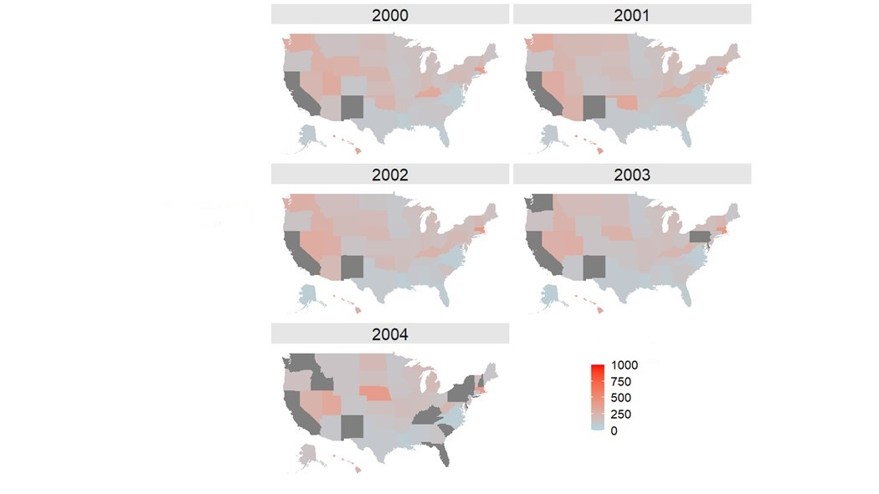

Supplementary Fig. 1. CM incidence per year (CM/10,000 births). Incidence rates are shown in spectra of colors varying from light blue to the highest rates in red. States without available data were excluded (dark gray).