**Supplemental materials** for “Harms and Sartain, Multi-year outdoor mesocosm experiment reveals differences in *Butomus umbellatus* genotype growth and response to herbicides”

S. Table 1.Statistical results of general linear models to compare growth and biomass allocation and herbicide response of *Butomus umbellatus* genotypes over a three-year outdoor mesocosm management study.

|  |  |  |  |  |  |  |
| --- | --- | --- | --- | --- | --- | --- |
|  |  | **Dependent variable** | **Independent variable** | **DF** | **F** | **p** |
| Control comparisons | Year 1 | Total DW biomass | Genotype | 3 | 5.4 | **0.014** |
| Shoot:root ratio | Genotype | 3 | 28.62 | **<0.001** |
| Number of propagules | Genotype | 3 | 42.29 | **<0.001** |
| Year 2 | Total DW biomass | Genotype | 3 | 18.07 | **<0.001** |
| Shoot:root ratio | Genotype | 3 | 3.6 | 0.05 |
| Number of propagules | Genotype | 3 | 83.31 | **<0.001** |
| Year 3 | Total DW biomass | Genotype | 3 | 47.65 | **<0.001** |
| Shoot:root ratio | Genotype | 3 | 3.52 | 0.05 |
| Number of propagules | Genotype | 3 | 61.04 | **<0.001** |
| Herbicide response | Year 2 | Total DW biomass | Genotype | 3 | 1.07 | 0.38 |
| Herbicide | 1 | 0.2 | 0.66 |
| Genotype x Herbicide | 3 | 2.55 | 0.08 |
| Shoot:root ratio | Genotype | 3 | 0.62 | 0.61 |
| Herbicide | 1 | 0.59 | 0.45 |
| Genotype x Herbicide | 3 | 0.74 | 0.93 |
| Number of propagules | Genotype | 3 | 0.15 | 0.93 |
| Herbicide | 1 | 20.91 | **0.001** |
| Genotype x Herbicide | 3 | 2.78 | 0.06 |
| Year 3 | Total dry weight biomass | Genotype | 3 | 8.44 | **<0.001** |
| Herbicide | 1 | 0.06 | 0.81 |
| Genotype x Herbicide | 3 | 7.26 | **0.001** |
| Shoot:root ratio | Genotype | 3 | 0.97 | 0.42 |
| Herbicide | 1 | 0.92 | 0.35 |
| Genotype x Herbicide | 3 | 0.76 | 0.53 |
| Number of propagules | Genotype | 3 | 12.99 | **<0.001** |
| Herbicide | 1 | 16.73 | **<0.001** |
| Genotype x Herbicide | 3 | 13.42 | **<0.001** |

S. Table 2. Statistical results for comparisons of herbicide efficacy within genotypes, as compared to control non-treated plants.

|  |  |  |  |  |  |
| --- | --- | --- | --- | --- | --- |
|  |  | **Dependent variable** | **DF** | **F** | **p** |
| GT1 | Year 2 | Total DW biomass | 2 | 2.77 | 0.12 |
| Number of propagules | 2 | 5.07 | **0.034** |
| Year 3 | Total DW biomass | 2 | 33.32 | **<0.001** |
| Number of propagules | 2 | 11.83 | **0.003** |
| GT3 | Year 2 | Total DW biomass | 2 | 2.64 | 0.13 |
| Number of propagules | 2 | 3.13 | 0.093 |
| Year 3 | Total DW biomass | 2 | 11.25 | **0.0036** |
| Number of propagules | 2 | 0.78 | 0.49 |
| GT4 | Year 2 | Total DW biomass | 2 | 0.82 | 0.47 |
| Number of propagules | 2 | 5.84 | **0.02** |
| Year 3 | Total DW biomass | 2 | 15.15 | **0.0013** |
| Number of propagules | 2 | 4.03 | 0.06 |
| GT5 | Year 2 | Total DW biomass | 2 | 2.89 | 0.11 |
| Number of propagules | 2 | 7.77 | **0.011** |
| Year 3 | Total DW biomass | 2 | 9.55 | **0.006** |
| Number of propagules | 2 | 3.68 | 0.068 |

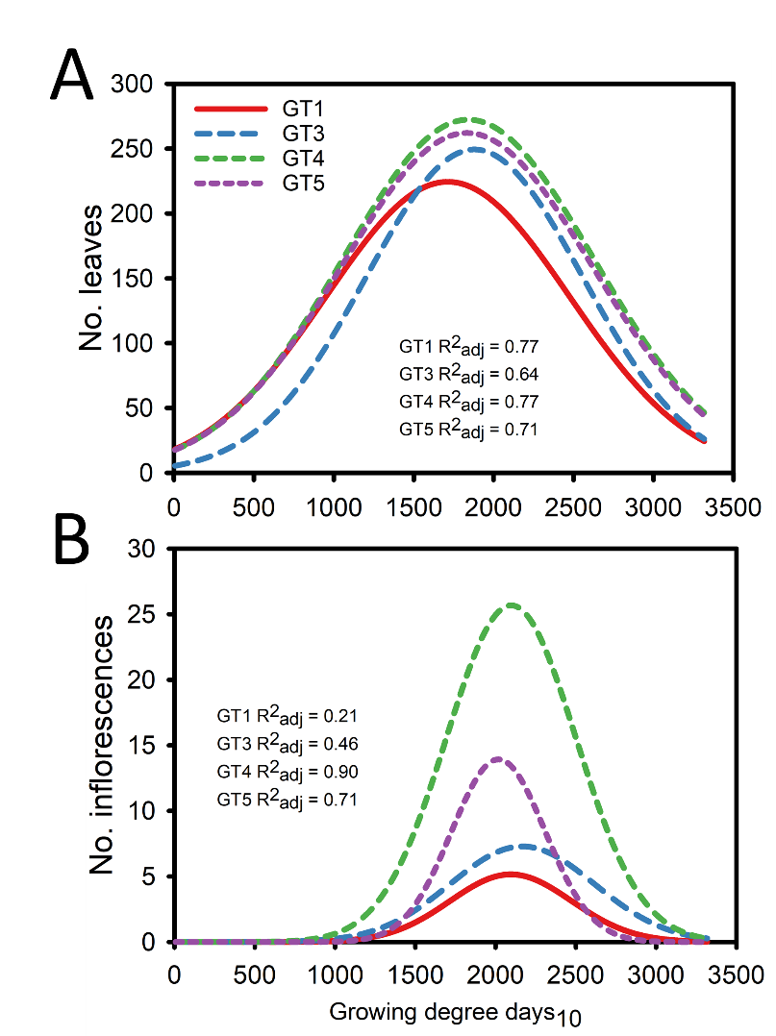

S. Figure 1. Leaf production and GDD relationship for control non-treated *B. umbellatus* genotypes (a) and flower production and growing degree day relationship (b). Curve fitting was done by non-linear regression, fitting a Gaussian three-parameter curve to data from three growing seasons for each *B. umbellatus* genotype.