Invasion alert: Lindenleaf sage (*Salvia tiliifolia*) in the Tigray highlands, Ethiopia

Jan Nyssen1,*, Rishan Haile2, Getachew Gebremedhin3, Zbelo Tesfamariam4, Jesús Guadalupe González-Gallegos5 and Tesfaalem Ghebreyohannes4

1 Professor emeritus, Department of Geography, Ghent University, Ghent, Belgium, and Guest professor, Department of Geography and Environmental Studies, Mekelle University, Mekelle, Tigray, Ethiopia; 2 Lecturer, Department of Geography and Environmental Studies, Mekelle University, Mekelle, Tigray, Ethiopia; 3 Research technician, Hagere Selam, Tigray, Ethiopia; 4 Associate professor, Department of Geography and Environmental Studies, Mekelle University, Mekelle, Tigray, Ethiopia; 5 Senior scientist, Instituto Politécnico Nacional, Centro Interdisciplinario de Investigación para el Desarrollo Integral Regional – Unidad Durango, Durango, Mexico

Author for correspondence: Jan Nyssen, Professor emeritus, Department of Geography, Ghent University, Krijgslaan 281 (S8), B-9000 Gent, Belgium. (E-mail: [jan.nyssen@ugent.be](mailto:jan.nyssen@ugent.be))

**Supplementary Figures**

**A**

**B**

Supplementary Figure S1. Since approx. 2018, *Salvia tiliifolia* (A)has appeared in the study area, where it now occupies large areas, especially where soil is reworked, such as dumped soils, roadsides (B; in Hagere Selam, along the old road to Mekelle, September 2024), building sites, but also in *Eucalyptus globulus* plantations that were opened up due to wood harvesting, and further down in fresh alluvium along rivers.

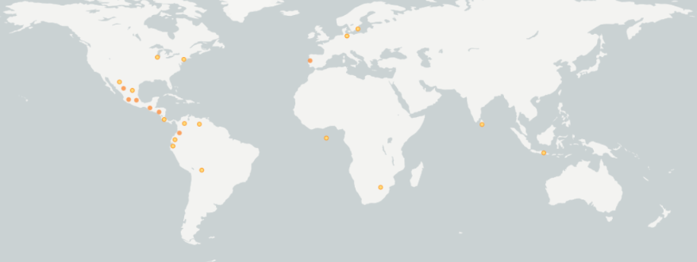

1980

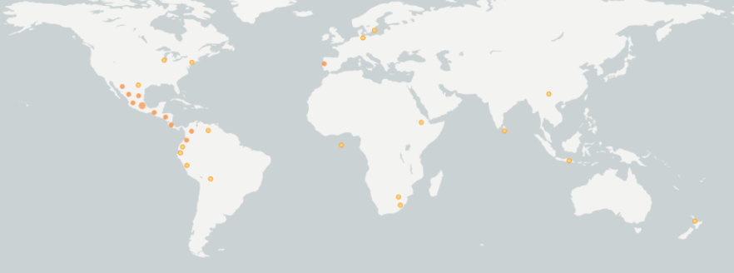

2000

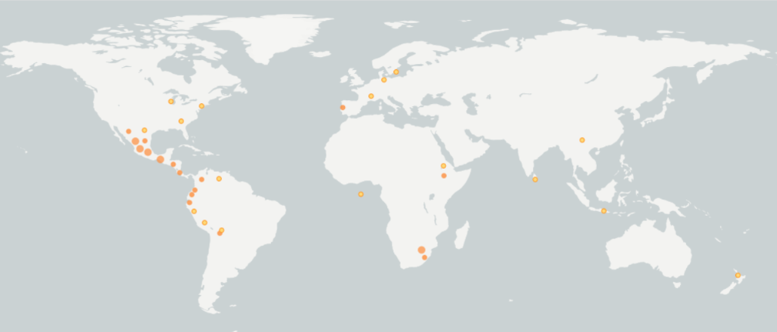

2024

Supplementary Figure S2. The *Salvia tiliifolia* observations worldwide, as reported by the Global Biodiversity Information Facility (GBIF) database [1], show its gradual expansion over all continents. Size of dots and density of shading indicate larger numbers of cumulative observations.

Supplementary Figure S3. *Salvia tiliifolia* seeds collected in Hagere Selam

Supplementary Figure S4. *Salvia tiliifolia* observations in Ethiopia, reported by the GBIF database [1]

Supplementary Figure S5. In the Gra Arho eucalypt plantation, which is at the edge of Hagere Selam town, many trees have been cut in 2021 and 2022 and livestock allowed to browse. During the Tigray War [2], most people were without income. There was almost no electricity at that time and firewood fetched good prices [3] what explains the rapid deforestation. The dominant dry brown herbs are *Salvia tiliifolia*. Photo taken in October 2023.

Supplementary Figure S6. *Salvia tiliifolia* weeded out from croplands in Addi Qolqwal and left to dry in a rocky area (October 2023)

Supplementary Figure S7. Community *Salvia tiliifolia* removal in the Gra Arho eucalyptus open woodland near Hagere Selam (2 October 2024). Laborers often organized themselves in lines, just like for weeding or harvesting cropland. On average, 45 person-days are necessary to weed one ha in this way.

Supplementary Figure S8. Exclosure near Hagere Selam (“Meles Park”), just after grass harvesting. Grasses and most herbs were collected together. Unlike *Verbascum sinaiticum* (upright, a mullein with yellow flowers in the center of the photo) and *Carduus* sp. (the thistles, right of it), *Salvia tiliifolia* was not avoided when harvesting grasses. At the middle of the photo, on the left side, rangeland, after the experimental community weeding of dense *Salvia tiliifolia* stands.

**Supplementary references**

1. GBIF. *Salvia tiliifolia, occurrence map.* [*https://www.gbif.org/occurrence/map?taxon_key=2927066*](https://www.gbif.org/occurrence/map?taxon_key=2927066). 2024 17/12/2024].

2. Plaut, M. and S. Vaughan, *Understanding Ethiopia's Tigray War*. 2023: Hurst. 392.

3. Emnet Negash, et al., *Remote sensing reveals how armed conflict regressed woody vegetation cover and ecosystem restoration efforts in Tigray (Ethiopia).* Science of Remote Sensing, 2023. **8**: p. 100108.