**Supplementary Material**

**Table S1** – Native and Non-native Species Collected in Itatiaia National Park, their family, status and abbreviation.

| **Species** | **Family** | **Status** | **Abbreviation** |
| --- | --- | --- | --- |
| *Achyrocline satureioides* | Asteraceae | Native | ach_sat |
| *Ageratum fastigiatum* | Asteraceae | Native | age_fas |
| *Andropogon leucostachyus* | Poaceae | Native | and_leu |
| *Aristida recurvata* | Poaceae | Native | ari_rec |
| *Austrolycopodium erectum* | Lycopodiaceae | Native | aus_ere |
| *Axonopus compressus* | Poaceae | Native | axo_com |
| *Axonopus fissifolius* | Poaceae | Native | axo_fis |
| *Axonopus siccus* | Poaceae | Native | axo_sic |
| *Bidens segetum* | Asteraceae | Native | bid_seg |
| *Borreria dasycephala* | Rubiaceae | Native | bor_das |
| *Bromus brachyanterus* | Poaceae | Native | bro_bra |
| *Bromus catharticus* | Poaceae | Native | bro_cat |
| *Calamagrostis viridiflavescens* | Poaceae | Native | cal_vir |
| *Callisia diuretica* | Commelinaceae | Native | cal_diu |
| *Campuloclinium parvulum* | Asteraceae | Native | cam_par |
| *Carex bonariensis* | Cyperaceae | Native | car_bon |
| *Carex fuscula* | Cyperaceae | Native | car_fus |
| *Chaptalia nutans* | Asteraceae | Native | cha_nut |
| *Chascolytrum brasiliense* | Poaceae | Native | cha_bra |
| *Chascolytrum itatiaiae* | Poaceae | Native | cha_ita |
| *Conyza bonariensis* | Asteraceae | Native | con_bon |
| *Ctenanthe setosa* | Marantaceae | Native | cte_set |
| *Cuphea ingrata* | Lythraceae | Native | cup_ing |
| *Cyperus cellulosoreticulatus* | Cyperaceae | Native | cyp_cel |
| *Cyperus hermaphroditus* | Cyperaceae | Native | cyp_her |
| *Cyperus surinamensis* | Cyperaceae | Native | cyp_sur |
| *Danthonia secundiflora* | Poaceae | Native | dan_sec |
| *Desmodium affine* | Fabaceae | Native | des_aff |
| *Dichanthelium hebotes* | Poaceae | Native | dic_heb |
| *Dichanthelium sabulorum* | Poaceae | Native | dic_sab |
| *Dichanthelium sciurotoides* | Poaceae | Native | dic_sci |
| *Dicranopteris flexuosa* | Geicheniaceae | Native | dic_fle |
| *Echinolaena inflexa* | Poaceae | Native | ech_inf |
| *Emilia coccinea* | Asteraceae | Native | emi_coc |
| *Emilia fosbergii* | Asteraceae | Native | emi_fos |
| *Eragrostis airoides* | Poaceae | Native | era_air |
| *Eriope macrostachya* | Lamiaceae | Native | eri_mac |
| *Euplassa itatiaiae* | Proteaceae | Native | eup_ita |
| *Fimbristylis dichotoma* | Cyperaceae | Native | fim_dic |
| *Galianthe brasiliensis* | Rubiaceae | Native | gal_bra |
| *Gamochaeta grazielae* | Asteraceae | Native | gam_gra |
| *Grazielia multifida* | Asteraceae | Native | gra_mul |
| *Homolepis glutinosa* | Poaceae | Native | hom_glu |
| *Hydrocotyle itatiaiensis* | Araliaceae | Native | hyd_ita |
| *Hydrocotyle quinqueloba* | Araliaceae | Native | hyd_qui |
| *Hypericum brasiliense* | Hypericaceae | Native | hyp_bra |
| *Inulopsis scaposa* | Asteraceae | Native | inu_sca |
| *Iresine diffusa* | Amaranthaceae | Native | ire_dif |
| *Juncus microcephalus* | Juncaceae | Native | jun_mic |
| *Juncus tenuis* | Juncaceae | Native | jun_ten |
| *Leptostelma maximum* | Asteraceae | Native | lep_max |
| *Luzula ulei* | Juncaceae | Native | luz_ule |
| *Microlicia isophylla* | Melastomataceae | Native | mic_iso |
| *Ocellochloa pulchella* | Poaceae | Native | oce_pul |
| *Oxalis debilis* | Oxalidaceae | Native | oxa_deb |
| *Parodiophyllochloa cordovensis* | Poaceae | Native | par_cor |
| *Paspalum melanospermum* | Poaceae | Native | pas_mel |
| *Paspalum notatum* | Poaceae | Native | pas_not |
| *Paspalum paniculatum* | Poaceae | Native | pas_pan |
| *Paspalum pilosum* | Poaceae | Native | pas_pil |
| *Paspalum polyphyllum* | Poaceae | Native | pas_pol |
| *Philodendron appendiculatum* | Araceae | Native | phi_app |
| *Phyllanthus niruri* | Phillantaceae | Native | phy_nir |
| *Plantago australis* | Plantaginaceae | Native | pla_aus |
| *Poa bradei* | Poaceae | Native | poa_bra |
| *Pseudechinolaena polystachya* | Poaceae | Native | pse_pol |
| *Rhynchospora albomarginata* | Cyperaceae | Native | rhy_alb |
| *Rhynchospora cephalotes* | Cyperaceae | Native | rhy_cep |
| *Rhynchospora edwalliana* | Cyperaceae | Native | rhy_edw |
| *Rugoloa pilosa* | Poaceae | Native | rug_pil |
| *Schizachyrium sanguineum* | Poaceae | Native | sch_san |
| *Schizachyrium spicatum* | Poaceae | Native | sch_spi |
| *Setaria parviflora* | Poaceae | Native | set_par |
| *Sida rhombifolia* | Malvaceae | Native | sid_rho |
| *Sisyrinchium micranthum* | Iridaceae | Native | sis_mic |
| *Sisyrinchium palmifolium* | Iridaceae | Native | sis_pal |
| *Sisyrinchium uliginosum* | Iridaceae | Native | sis_uli |
| *Solanum americanum* | Solanaceae | Native | sol_ame |
| *Solanum enantiophyllanthum* | Solanaceae | Native | sol_ena |
| *Sporobolus indicus* | Poaceae | Native | spo_ind |
| *Stevia crenulata* | Asteraceae | Native | ste_cre |
| *Tradescantia fluminensis* | Commelinaceae | Native | tra_flu |
| *Anthoxanthum odoratum* | Poaceae | Alien | ant_odo |
| *Bidens pilosa* | Asteraceae | Alien | bid_pil |
| *Centella asiatica* | Apiaceae | Alien | cen_asi |
| *Commelina diffusa* | Poaceae | Alien | com_dif |
| *Cosmos sulphureus* | Asteraceae | Alien | cos_sul |
| *Crocosmia crocosmiiflora* | Iridaceae | Alien | cro_cro |
| *Curcuma longa* | Zingiberaceae | Alien | cur_lon |
| *Cynodon dactylon* | Poaceae | Alien | cyn_dac |
| *Desmodium adscendens* | Fabaceae | Alien | des_ads |
| *Dracaena fragans* | Asparagaceae | Alien | dra_fra |
| *Eleusine indica* | Poaceae | Alien | ele_ind |
| *Epipremnum aureum* | Araceae | Alien | epi_aur |
| *Eragrostis cilianensis* | Poaceae | Alien | era_cil |
| *Eragrostis plana* | Poaceae | Alien | era_pla |
| *Eriochloa villosa* | Poaceae | Alien | eri_vil |
| *Galinsoga parviflora* | Asteraceae | Alien | gal_par |
| *Geranium thumbergii* | Geraniaceae | Alien | ger_thu |
| *Hedychium coronarium* | Zingiberaceae | Alien | hed_cor |
| *Houttuynia cordata* | Saururaceae | Alien | hou_cor |
| *Hydrangea macrophylla* | Hydrangeacea | Alien | hyd_mac |
| *Impatiens walleriana* | Balsaminaceae | Alien | imp_wal |
| *Musa rosaceae* | Musaceae | Alien | mus_ros |
| *Poa annua* | Poaceae | Alien | poa_ann |
| *Prunella vulgaris* | Lamiaceae | Alien | pru_vul |
| *Rubus rosifolius* | Rosaceae | Alien | rub_ros |
| *Rumex acetosella* | Polygonaceae | Alien | rum_ace |
| *Tradescantia zebrina* | Poaceae | Alien | tra_zeb |
| *Trifolium repens* | Fabaceae | Alien | tri_rep |
| *Urochloa maxima* | Poaceae | Alien | uro_max |
| *Youngia japonica* | Asteraceae | Alien | you_jap |

**Fig. S1**. Dispersion test result and simulated and observed residuals analyses plot for the absolute native species richness model with a quadratic term. 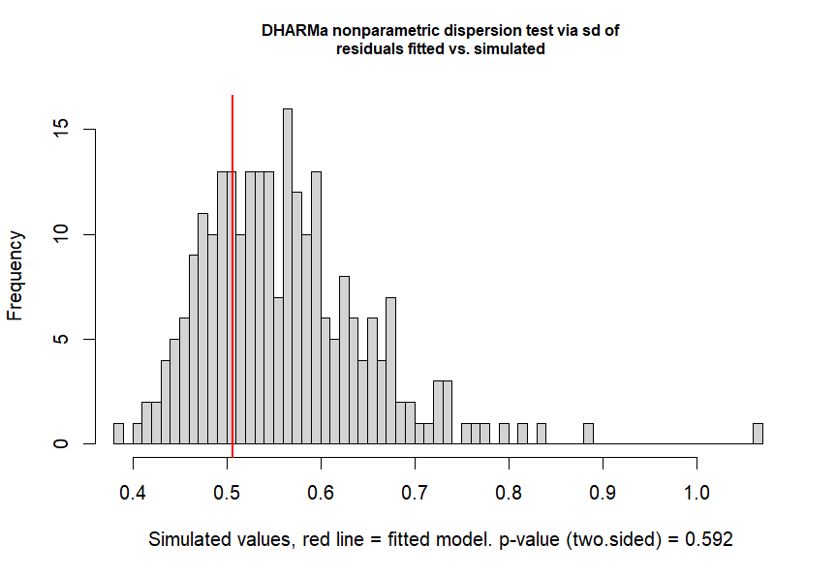

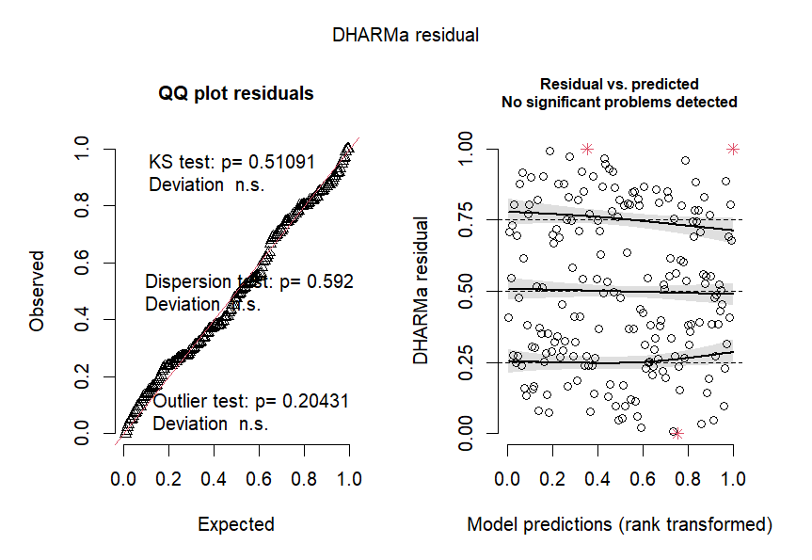

**Fig. S2**. Dispersion test result and simulated and observed residuals analyses plot for the relative native species richness model with a quadratic term. 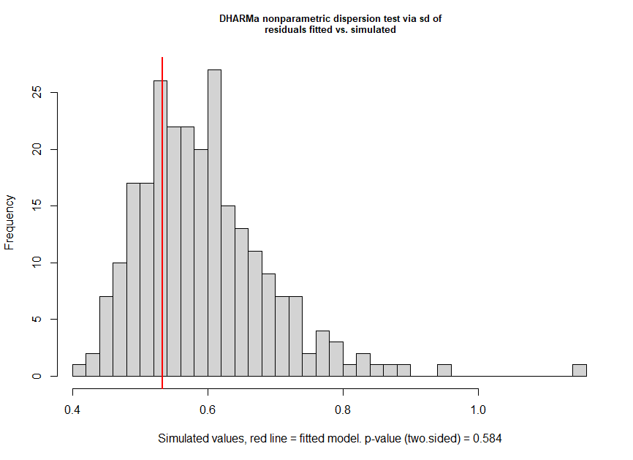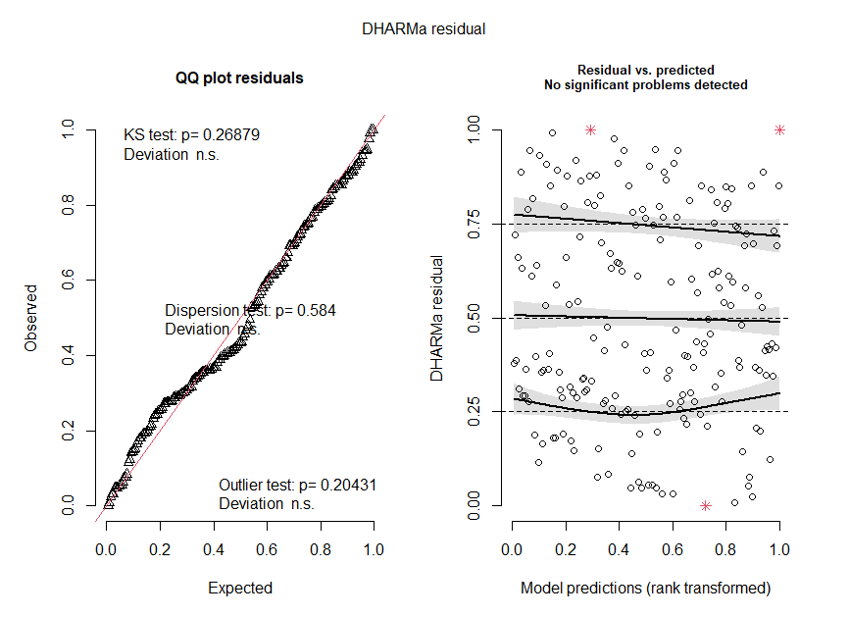

**Fig. S3**. Dispersion test result and simulated and observed residuals analyses plot for the absolute non-native species richness model with a quadratic term.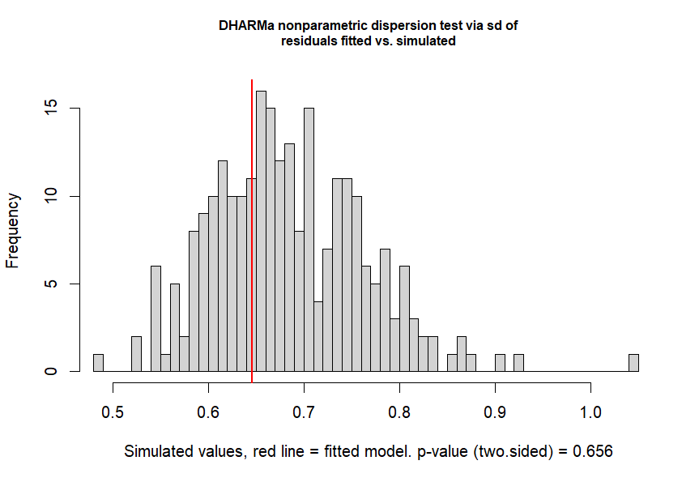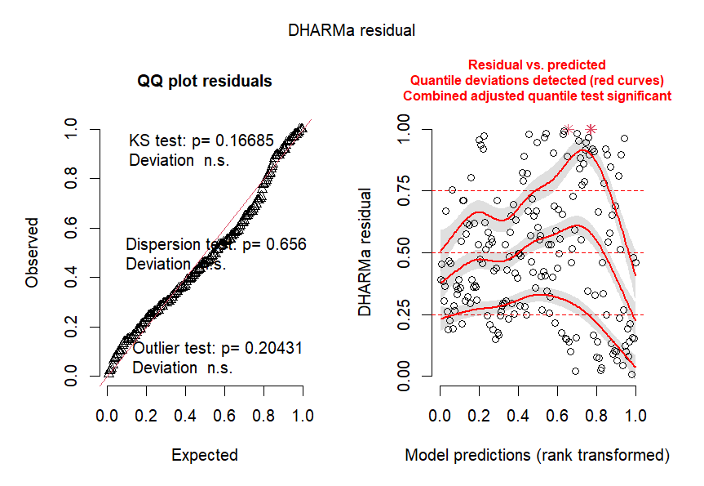

**Fig. S4**. Dispersion test result and simulated and observed residuals analyses plot for the relative non-native relative species richness model with a quadratic term.