# Supplementary Material 1

**Supplementary Table S1.** Table showing the Weeds of National Significance (WoNS). Plant taxa that are declared as invasive and illegal to cultivate, trade or transport in all Australian jurisdictions. Officially referred to as 32 taxa, the WoNS is actually comprised of a combination of subspecies, species, genera and other related groups of plants. ‘Scientific name’ column shows the accepted name standardised using the Global Biodiversity Information Facility taxonomic database (GBIF 2021). The ‘Common name or group’ column shows the 32 WoNS taxa names used in Australia and sourced from the Invasive Plants and Animals Committee (2016). N.B., *Asparagus asparagoides* is in both the ‘Asparagus weeds’ taxa group and named separately as ‘Bridal Creeper’.

|  |  |
| --- | --- |
| Scientific name | Common name or group |
| *Alternanthera philoxeroides* | Alligator weed |
| *Andropogon gayanus* | Gamba grass |
| *Annona glabra* | Pond apple |
| *Anredera cordifolia* | Madeira vine |
| *Asparagus aethiopicus* | Asparagus weeds |
| *Asparagus africanus* | Asparagus weeds |
| *Asparagus asparagoides* | Asparagus weeds & Bridal creeper |
| *Asparagus declinatus* | Asparagus weeds |
| *Asparagus scandens* | Asparagus weeds |
| *Asparagus setaceus* | Asparagus weeds |
| *Austrocylindropuntia* spp. | Opuntioid cacti |
| *Cabomba caroliniana* | Cabomba |
| *Cryptostegia grandiflora* | Rubber vine |
| *Cylindropuntia* spp. | Opuntioid cacti |
| *Cytisus scoparius* | Brooms |
| *Dolichandra unguis-cati* | Cat’s claw creeper |
| *Eichhornia crassipes* | Water hyacinth |
| *Genista linifolia* | Brooms |
| *Genista monspessulana* | Brooms |
| *Hymenachne amplexicaulis* | Hymenachne |
| *Jatropha gossypiifolia* | Bellyache bush |
| *Lantana camara* | Lantana |
| *Lycium ferocissimum* | African boxthorn |
| *Mimosa pigra* | Mimosa |
| *Nassella neesiana* | Chilean needle grass |
| *Nassella trichotoma* | Serrated tussock |
| *Opuntia* spp. (excludes O. ficus-indica) | Opuntioid cacti |
| *Osteospermum moniliferum subsp. moniliferum* | Bitou bush/boneseed |
| *Parkinsonia aculeata* | Parkinsonia |
| *Parthenium hysterophorus* | Parthenium weed |
| *Prosopis spp.* | Mesquite |
| *Rubus fruticosus agg.* | Blackberry |
| *Sagittaria platyphylla* | Sagittaria |
| *Salix spp. (excludes S. babvlonica,  S. × calendendron and S. × reichardtii)* | Willows |
| *Salvinia molesta* | Salvinia |
| *Senecio madagascariensis* | Fireweed |
| *Solanum elaeagnifolium* | Silverleaf nightshade |
| *Tamarix aphylla* | Athel pine |
| *Ulex europaeus* | Gorse |
| *Vachellia nilotica subsp. indica* | Prickly acacia |

**Supplementary Table S2.** Table showing the relevant legislation, category relating to ban of sale, source of listing for noxious weeds, and corresponding branch of government for verification purposes in each State and Territory in Australia (termed Jurisdiction). Jurisdictions are Australian Capital Territory (ACT), New South Wales (NSW), Northern Territory (NT), Queensland (Qld), South Australia (SA), Tasmania (Tas), Victoria (Vic), and Western Australia (WA).

|  |  |  |  |  |
| --- | --- | --- | --- | --- |
| Jurisdiction | Legislation | Category | Source | Correspondence |
| ACT | *Pest Plants and Animals Act 2005* | Pest Plant - Prohibited (4) | Pest Plants and Animals (Pest Plants) Declaration No 1 (2015) Pest Plants and Animals Act 2005. Australian Capital Territory. https://www.legislation.act.gov.au/di/2015-59, Australia, 2-5 pp. | Environment, Planning and Sustainable Development Directorate |
| NSW | *Biosecurity Act 2015* | State and Regional Priority Weeds | Biosecurity Regulation (2017) Biosecurity Act 2015. New South Wales, Australia, 59 pp. | Department of Primary Industries |
| NT | *Weeds Management Act 2001* | Declared Weed - Class A, B & C | Northern Territory Government (2019) Declared Weeds in the Northern Territory. https://nt.gov.au/environment/weeds/weeds-in-the-nt/A-Z-list-of-weeds-in-the-NT [accessed 4 August.2020]. | Department of Environment, Parks and Water Security |
| Qld | *Biosecurity Act 2014* | Prohibited matter, Restricted matter - Category 3 | Biosecurity Act (2014) Queensland. https://www.legislation.qld.gov.au/view/pdf/inforce/current/act-2014-007, Australia, 403-426 pp. | Department of Agriculture and Fisheries |
| SA | *Landscape South Australia Act 2019* | Declared Plants to which section 188(1) applies | Landscape South Australia Act (2019) The South Australian Government Gazette No 60. South Australia. https://governmentgazette.sa.gov.au/sites/default/files/public/documents/gazette/2020/July/2020_060.pdf, Australia, 4024-4038 pp. | Department of Primary Industries and Regions |
| Tas | *Biosecurity Act 2019* | Declared weed | Biosecurity Act (2019) Biosecurity Act 2019. Tasmania, Australia, 342 pp. | Department of Natural Resources and Environment |
| Vic | *Catchment and Land Protection Act 1994* | Noxious weeds - state prohibited, regionally prohibited, regionally controlled, and restricted | Victorian Government (2017) Victorian Noxious Weeds List - Alphabetical by Scientific Name. https://agriculture.vic.gov.au/__data/assets/pdf_file/0003/538149/Victorian-noxious-weeds-list-by-scientific-name-20-July-2017.pdf [accessed 4 August.2020]. | Department of Jobs, Precincts and Regions |
| WA | *Biosecurity and Agriculture Management Act 2007* | Declared Pest, Prohibited - s12 & Declared Pest - s22(2) | Government of Western Australia (2020) Western Australian Organism List. https://www.agric.wa.gov.au/organisms [accessed 11/08/2020]. | Department of Primary Industries and Regional Development |

**Supplementary Table S3.** Taxa declared by at least one Australian jurisdiction that could not be taxonomically resolved using the Global Biodiversity Information Facility taxonomic database (GBIF 2021). The taxa column is the name provided by the jurisdiction(s) in the declared column. Jurisdictions are South Australia (SA) and Western Australia (WA).

|  |  |
| --- | --- |
| Taxa | Declared |
| *Equisetum laevigatum × Equisetum variegatum* | WA |
| *Hieracium × stolomiflorum* | WA |
| *Megathyrsus maximus × Megathyrsus infestus* | WA |
| *Prosopis alba* × *Prosopis hassleri* | WA |
| *Prosopis chilensis* × *Prosopis alba* | WA |
| *Prosopis glandulosa* × *Prosopis velutina* | WA |
| *Prosopis hassleri* × *Prosopis ruscifolia* | WA |
| *Prosopis hybrid* | WA |
| *Prosopis juliflora* × *Prosopis velutina* | WA |
| *Salix alba* × *Salix matsudana* | SA, WA |
| *Salix alba* × *Salix × sepulcralis* | WA |
| *Salix cinerea ssp. cinerea × Salix × reichardtii* | WA |
| *Salix fragilis var. fragilis × Salix matsudana* | WA |
| *Salix fragilis × Salix nigra* | WA |
| *Salix matsudana ×* *Salix chrysochroma* | WA |
| *Salix matsudana × Salix × sepulcralis* | WA |
| *Salix myrtillus* | WA |
| *Salix nigra × Salix matsudana* | WA |
| *Salix × grahamii* | WA |
| *Salvinia raddianum* | WA |
| *Urochloa ruziziensis × Urochloa decumbens × Urochloa brizantha* | WA |

**Supplementary Table S4.** Permitted cultivars for plants declared invasive in Australian jurisdictions. A declared plant is prohibited to grow or trade and must be controlled. The cultivars in this table are permitted exceptions of the associated declared plant taxa. However, these cultivars were not considered in the analysis of our study. The ‘cultivar’ column identifies the cultivars and the ‘jurisdiction’ column indicates the jurisdictions in which the cultivar is permitted. Jurisdictions are Australian Capital Territory (ACT), South Australia (SA), and Victoria (Vic).

|  |  |
| --- | --- |
| **Cultivar** | **Jurisdiction** |
| *Acer negundo* 'Sensation' | SA |
| *Asparagus aethiopicus* 'Myersii' | SA |
| *Casuarina glauca* 'CAS01' (sold as FreeFallTM) | SA |
| *Casuarina glauca* 'Cousin It' | SA |
| *Coprosma repens* (any named cultivar) | SA |
| *Eragrostis curvula* 'Consol' | SA |
| *Fraxinus angustifolia* 'Raywood' | SA |
| *Gazania* 'GT20' (sold as Double GoldTM) | SA |
| *Gazania* 'Sugaja' (sold as Sunset JaneTM) | SA |
| *Gazania* 'Sugamo' (sold as MontezumaTM) | SA |
| *Leptospermum laevigatum* 'Fore Shore' | SA |
| *Leptospermum laevigatum* 'Shore Tuff' | SA |
| *Rubus fruticosus* 'Black satin' | ACT, SA |
| *Rubus fruticosus* 'Chehalem' | ACT |
| *Rubus fruticosus* 'Chester Thornless' | ACT |
| *Rubus fruticosus* 'Dirksen Thornless' | ACT, SA |
| *Rubus fruticosus* 'Loch Ness' | ACT |
| *Rubus fruticosus* 'Murrindindi Silvan' | ACT |
| *Rubus fruticosus* 'Silvan' | SA |
| *Rubus fruticosus* 'Smoothstem' | ACT, SA |
| *Rubus fruticosus* 'Thornfree' | ACT, SA |
| *Salix caprea* 'Pendula' | Vic |
| *Salix matsudana* 'Aurea' | Vic |
| *Salix matsudana* 'Tortuosa' | Vic |

**Supplementary Appendix S1.** Identifying noxious weed taxonomic discrepancies

We classified problematic synonyms as names that were not accepted by The Global Biodiversity Information Facility (GBIF 2021), and were used in a minority of jurisdictions. A synonym was not considered problematic if only one jurisdiction declared the taxa or if the same name was used by all jurisdictions that declare the taxa. We found eleven problematic synonyms in use across Australia for noxious weeds (Supplementary Table S5). Each of these synonyms was only used by one jurisdiction. The cause for most of the problematic synonyms is likely when a species as been updated taxonomically and the change has not been made to the relevant regulation. This is not surprising given the time, resources and official approvals required to make changes to regulations. Two of the problematic synonyms we found were due to misspellings. These simple errors were also a common problem in Australia’s National Vegetation Information System (Centre for Plant Biodiversity Research 2004). Addressing these broader taxonomic issues would help resolve the problematic synonyms we see amongst the jurisdictional noxious weed lists. This could be enabled by adopting established national databases or adopting new initiatives such as the Alien Flora of Australia, which seeks to harmonise the taxonomy of naturalised flora through an automated system (Martín-Forés et al. 2023).

**Supplementary Table S5.** Problematic synonyms identified in use for noxious weeds within Australia. The accepted name is the name used by the majority of other jurisdictions and the problematic synonym is used by the jurisdiction in the ‘Jurisdiction’ column. The ‘Description’ column identifies the issue with the problematic synonym. We identified problematic synonyms used by Australian Capital Territory (ACT), Northern Territory (NT), Queensland (Qld), Tasmania (Tas), and Victoria (Vic). We did not find any problematic synonyms for New South Wales (NSW), South Australia (SA), and Western Australia (WA). In each case only one jurisdiction was using the problematic synonym.

|  |  |  |  |
| --- | --- | --- | --- |
| Accepted name | Problematic synonym | Jurisdiction | Description |
| *Eichhornia crassipes* | *Eichornia crassipes* | ACT | Misspelt accepted name |
| *Asparagus setaceus* | *Asparagus plumosa* | ACT | Misspelt synonym |
| *Solanum linnaeanum* | *Solanum sodomaeum* | Tas | Synonym |
| *Vachellia karroo* | *Acacia karroo* | Vic | Synonym |
| *Amelichloa caudate* | *Achnatherum caudatum* | ACT | Synonym |
| *Cenchrus spinifex* | *Cenchrus incertus* | Tas | Synonym |
| *Harrisia martinii* | *Eriocereus martinii* | NT | Synonym |
| *Cenchrus macrourus* | *Pennisetum macrourum* | Vic | Synonym |
| *Cenchrus setaceus* | *Cenchrus setaceum* | Qld | Synonym |
| *Cenchrus setaceus* | *Pennisetum setaceum* | ACT | Synonym |
| *Dolichandra unguis-cati* | *Macfadyena unguis-cati* | ACT | Synonym |

**Supplementary Appendix S2. Handling noxious weed taxa declared by genus**

In our study the goal was to make comparisons in the taxa declared by each jurisdiction. Some jurisdictions declared taxa at a genus level while others only by species. To handle this difference, we gathered the daughter species of declared genera (Supplementary Table S6). However, some declared genera contained several thousands of species (e.g. there were over 8,000 species of *Hieracium*). Therefore, we opted to produce a rationalised dataset by only including species of the genera that were declared in other jurisdictions. For example, if a jurisdiction declared the genus *Opuntia*, we only recorded 17 species in the genus which were explicitly declared by other jurisdictions, rather than the 212 species recognized by GBIF. This was to avoid an overly cumbersome dataset and one that is not an accurate representation of management which is largely treating these taxa as single taxonomic unit and generally as a precautionary measure. If a taxon was only declared at the genus level, then this level was retained and no daughter taxa were included (Supplementary Table S7).

**Supplementary Table S6.** Genera expanded with daughter species.

|  |
| --- |
| Genera |
| *Acaciella* |
| *Ambrosia* |
| *Austrocylindropuntia* |
| *Cabomba* |
| *Cecropia* |
| *Chromolaena* |
| *Cortaderia* |
| *Cryptostegia* |
| *Cuscuta* |
| *Cylindropuntia* |
| *Cytisus* |
| *Datura* |
| *Equisetum* |
| *Genista* |
| *Gleditsia* |
| *Harrisia* |
| *Hieracium* |
| *Lagarosiphon* |
| *Mariosousa* |
| *Miconia* |
| *Mikania* |
| *Moraea* |
| *Onopordum* |
| *Opuntia* |
| *Orobanche* |
| *Pilosella* |
| *Prosopis* |
| *Sagittaria* |
| *Salix* |
| *Salvinia* |
| *Senegalia* |
| *Striga* |
| *Tephrocactus* |
| *Trapa* |
| *Vachellia* |
| *Xanthium* |
| *Zizania* |

**Supplementary Table S7.** Genera removed from native range analysis.

|  |
| --- |
| Genera |
| *Aegilops* |
| *Amsinckia* |
| *Aristolochia* |
| *Gazania* |
| *Lophophora* |
| *Musa* |
| *Parasenegalia* |
| *Pseudosenegalia* |
| *Sorbus* |
| *Stachytarpheta* |

**Supplementary Appendix S3. Rationale for using both the Australian Plant Census and the Global Biodiversity Information Facility taxonomic database to standardise taxonomy**

The Australian Plant Census (APC) is a distinct taxonomic standard (Australian National Herbarium 2023b), and thus is different to the Global Biodiversity Information Facility taxonomic database (GBIF). The APC excludes taxa that are only present in cultivation in Australia (have not naturalised) or are absent from Australia. This is why we did not use the APC to form the taxonomic backbone for describing taxonomic composition and comparing similarity between jurisdictions as many taxa are missing (i.e., not present in Australia). However, the taxonomy used in APC is closer to the taxonomy used by Australian jurisdictions compared to the more current taxonomy of GBIF. Therefore, to ensure accuracy of naturalisation status we opted to repeat the standardisation the names from the original 1,329 jurisdiction names for noxious weed taxa, this time using the APC and not from the GBIF standardised list.

**Supplementary Material 2.** Noxious weed taxa of Australia (1,236 taxa). Plants declared as invasive in at least one Australian jurisdiction. Provided as a MS Excel file.

**Supplementary Material 3.** Noxious weed taxa with discordant regulation (327 taxa) provided as an MS Excel file.

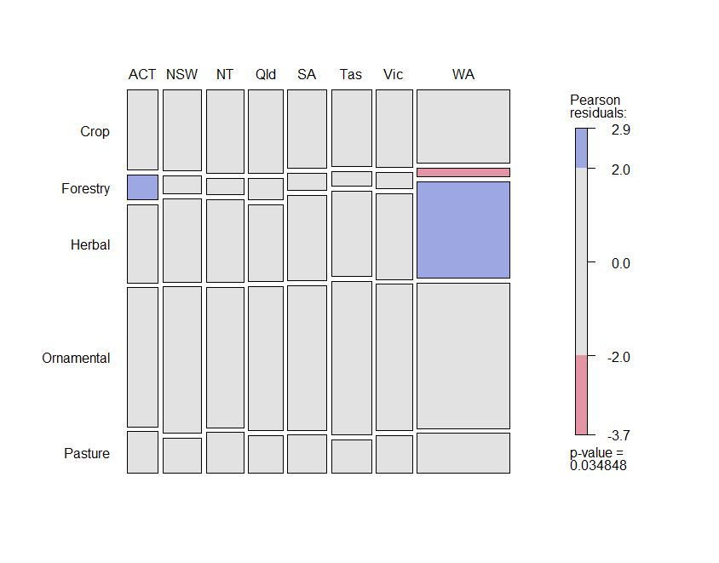

**A**

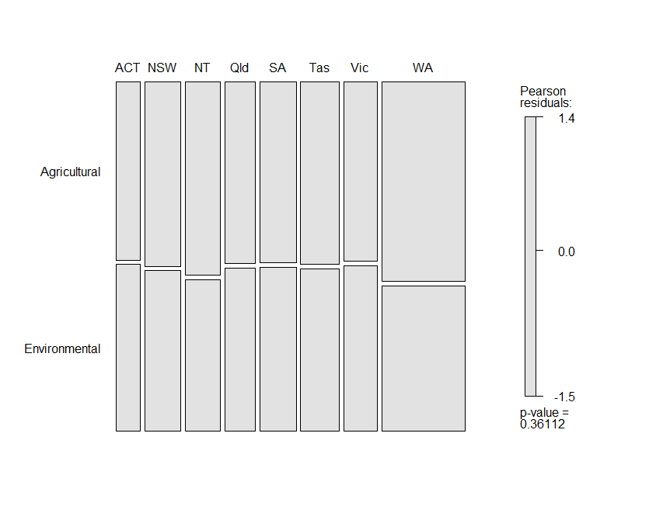

**B**

**Supplementary Figure S1.** Mosaic plots of the deviation in independence between noxious weeds declared in Australian jurisdictions and trait categories: (A) entry pathway; and (B) perceived impact. The size of each rectangle is proportional to the observed number of noxious weed taxa in each trait. The residual shading reflects the deviation of observed from expected quantities. The coloured shading indicates observed quantities that are significantly greater (blue) or significantly lower (red) than the expected quantities (α = 0.05). Grey shading indicates non-significance. Jurisdictions are Australian Capital Territory (ACT), New South Wales (NSW), Northern Territory (NT), Queensland (Qld), South Australia (SA), Tasmania (Tas), Victoria (Vic), and Western Australia (WA).