Lamb R, Keller J, Shea K. Competition reduces structural defense in an invasive thistle in the field. Invasive Plant Science and Management. Supplementary material

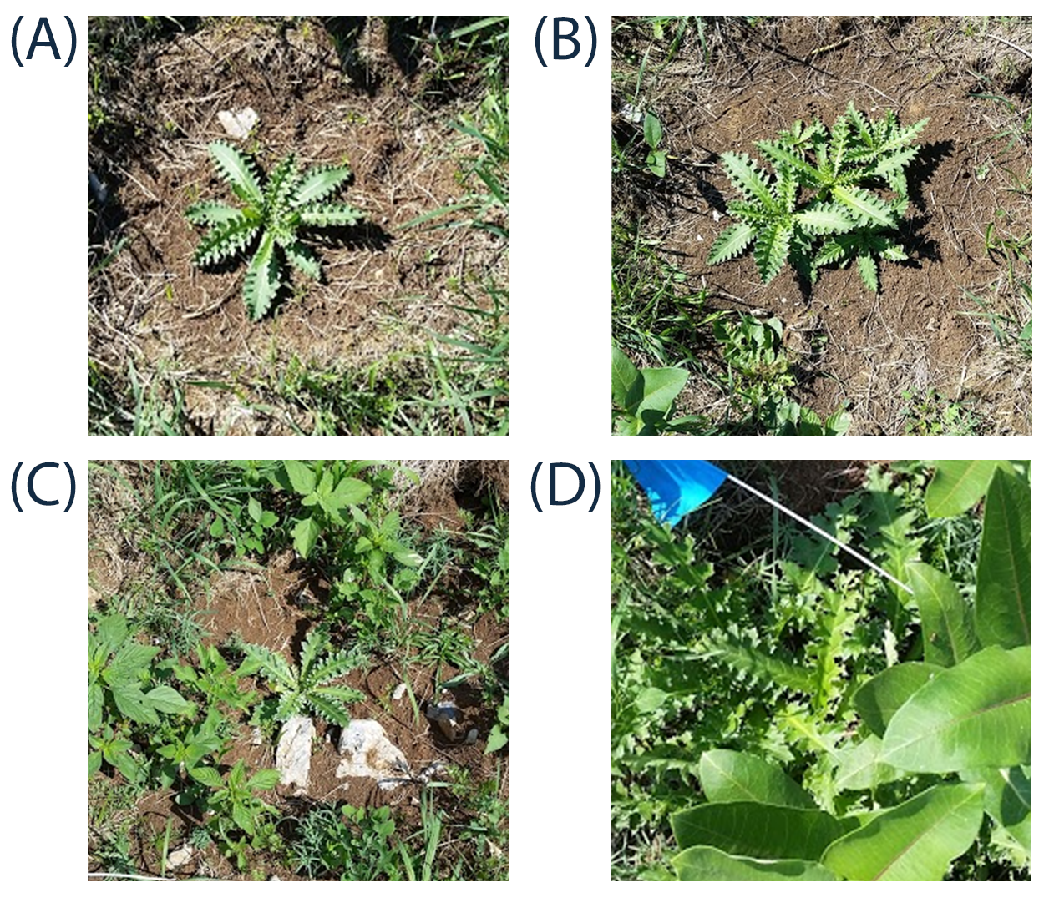

Figure S1. Carduus nutans rosettes grown in the field experiment under four treatments: (A) low thistle density, simulated grazing, (B) high thistle density, simulated grazing, (C) low thistle density, no grazing, (D) high thistle density, no grazing. In plots with high thistle density, prickles were counted on leaves from the central thistle only.

