ONLINE DATA SUPPLEMENT

Table 1A. Quantitative data collected for hyper-in-flow (HI) day for each period
Table 1A. Quantitative data collected for hyper-in-flow (HI) day for each period
Period | 01/03/19 - 31/05/19 | 01/10/19 - 31/12/19 | 01/03/20 - 31/05/20 | 01/10/20 - 31/12/20 | 01/03/21 - 31/05/21
 | A | B | X | Y | Z
Day | Day, month, and year in which the patient was present at the ED
Number of patients | Total number of patients per period
ED type | NC-ED = 0; C-ED = 1
LOS | Total minutes of permanence in the ED
TPIA | Total minutes of wait between triage and physician's visit
LWBS | Did not abandon = 0, Abandoned = 1

Table 1A. This table shows quantitative data collected for patients presenting to the general ED for both the pre-pandemic and the pandemic periods. HI = hyper-in.flow, ED = emergency department, NC-ED = COVID-FREE emergency department, C-ED = COVID emergency department, LOS = length of stay, TPIA = time-to-physician initial assessment, LWBS = left-without-being seen rates.

Figure 1A. Weekly average of new cases in the Province of Como, Lombardy, Italy

X Y Z
Figure 1A. Weekly average of confirmed new cases of COVID-19 in the Province of Como from February 2020 till May 2021.¹ Highlighted in light grey are the three COVID-19 periods considered in this study. X: March – May 2020. Y: October – December 2020. Z: March – May 2021.
Figure 2A. Average length of stay (LOS) fluctuations across the pandemic periods

Figure 2A. Differential fluctuation of LOS across the pandemic periods. LOS = length of stay (minutes), NC-ED = COVID-FREE Emergency Department; C-ED = COVID Emergency Department; ED = Emergency Department; X = March – May 2020; Y = October – December 2020; Z = March – May 2021.
Figure 3A. Average time-to-physician initial assessment (TPIA) fluctuations across the pandemic periods

Figure 3A. Fluctuations of average TPIA across the pandemic periods. TPIA = time-to-physician’s initial assessment; NC-ED = COVID-FREE Emergency Department. C-ED = COVID Emergency Department; ED = Emergency Department; X = March – May 2020; Y = October – December 2020; Z = March – May 2021.
Figure 4A. Emergency department spatial organization into COVID-ED and Non-COVID-ED

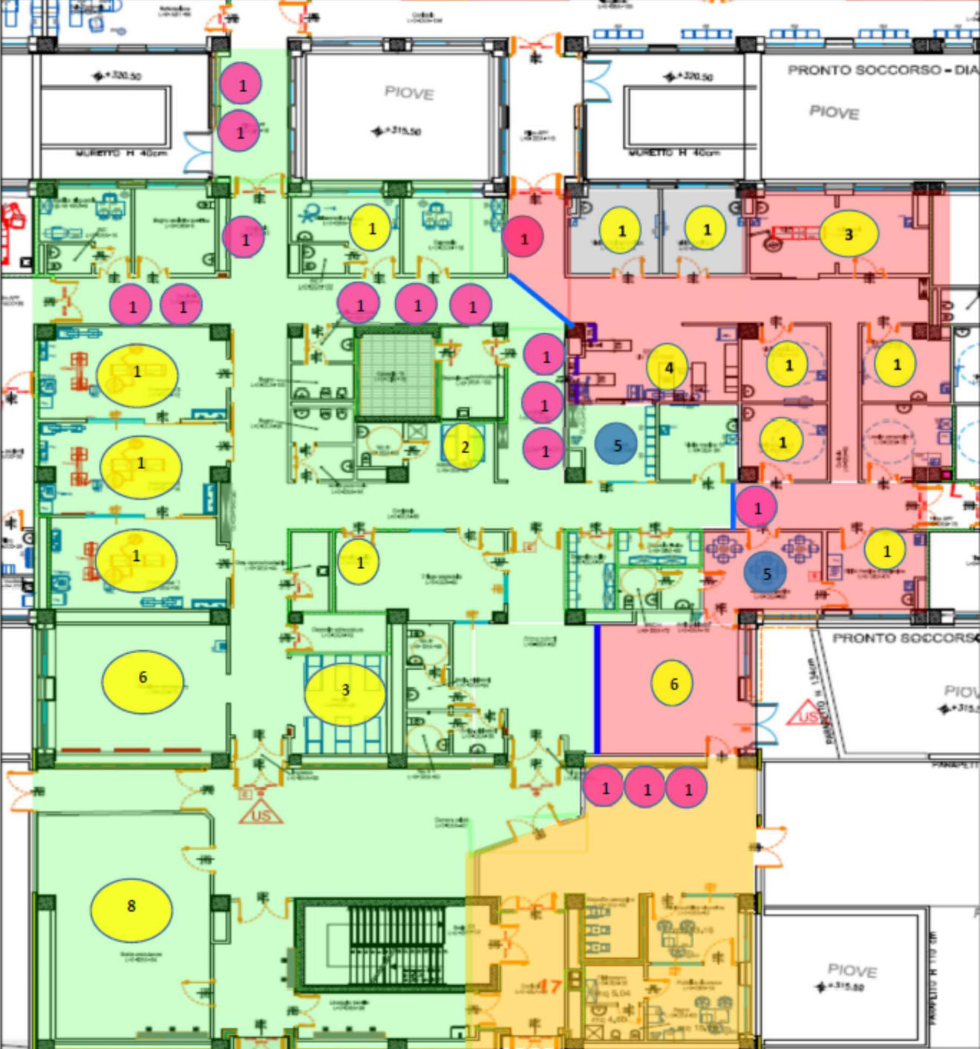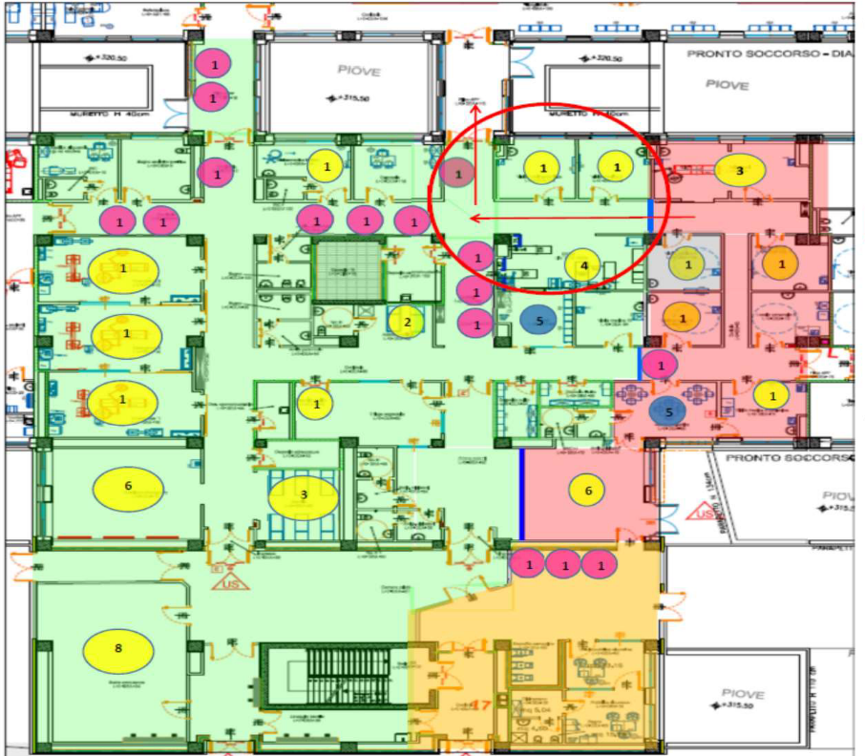
Figure 4A. This figure depicts how the ED was divided into two separate areas. Red areas represent the COVID ED whereas areas colored in green represent the Non-COVID ED. The yellow color indicates the entrance to the COVID ED. Access to Non-COVID ED is marked with a star. As shown by the different arrangement in the pictures, the physical division was flexible, according to patients' in-flow. Red and green areas grow and shrink according to needs.

REFERENCE
1. Italian Ministry of Health. Dashboard Covid-19 Situazione in Italia. salute.gov https://www.salute.gov.it/portale/nuovocoronavirus/dettaglioContenutiNuovoCoronavirus.jsp?lingua=italiano&id=5351&area=nuovoCoronavirus&menu=vu (2021).

