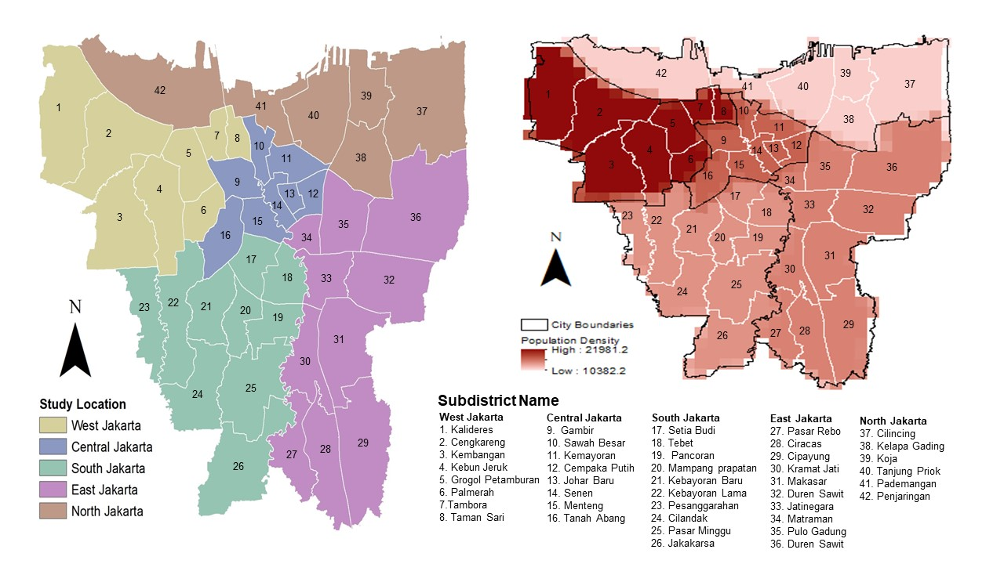
Supplementary Figure 1. Jakarta study location (A) and population density (B). The color in figure A indicates the city names, and B shows the population density with a gradient from dark red to bright red (high to low). The numbers in figure 1 represent the names of the districts.
B
A

