**Impact of COVID-19 on incidence, treatment and survival of patients with hepatocellular carcinoma in the Netherlands**

Alicia Furumayaa,b, Otto M. van Deldenb,c, Roeland F. de Wilded, Judith de Vos-Geelene*, Lydia G. van der Geestf* on behalf of the Dutch Hepatocellular & Cholangiocarcinoma Group (DHCG) and the COVID & Cancer-NL consortium.

a Department of Surgery, Amsterdam UMC location University of Amsterdam, Amsterdam, The Netherlands; b Cancer Center Amsterdam, Amsterdam, The Netherlands; c Department of Interventional Radiology, Amsterdam UMC location University of Amsterdam, Amsterdam, The Netherlands; d Department of Surgery, Erasmus MC, University Medical Center Rotterdam, Rotterdam, The Netherlands; e Department of Internal Medicine, Division of Medical Oncology, GROW, Maastricht University Medical Centre, Maastricht, the Netherlands; f The Netherlands Comprehensive Cancer Organisation, Utrecht, the Netherlands

**Table of contents**

Figure S1. Treatment methods in COVID-high versus COVID-low months

Figure S2. Survival of HCC patients

Table S1. Comparison of monthly incidence rates between 2017-2019 and 2020

**Figure S1. Treatment methods in COVID-high versus COVID-low months**

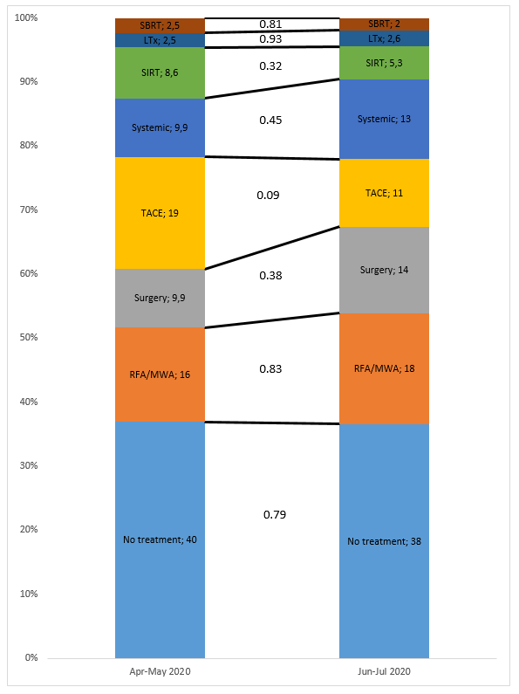Numbers in bar indicate percentages of patients treated by the treatment methods, totals add up to >100% as treatment methods were not mutually excluded. To aid visual representation, bars were normalized to 100%. The number between bars represent p-values of Chi-squared tests.

**Figure S2.** Survival of HCC patients.

A 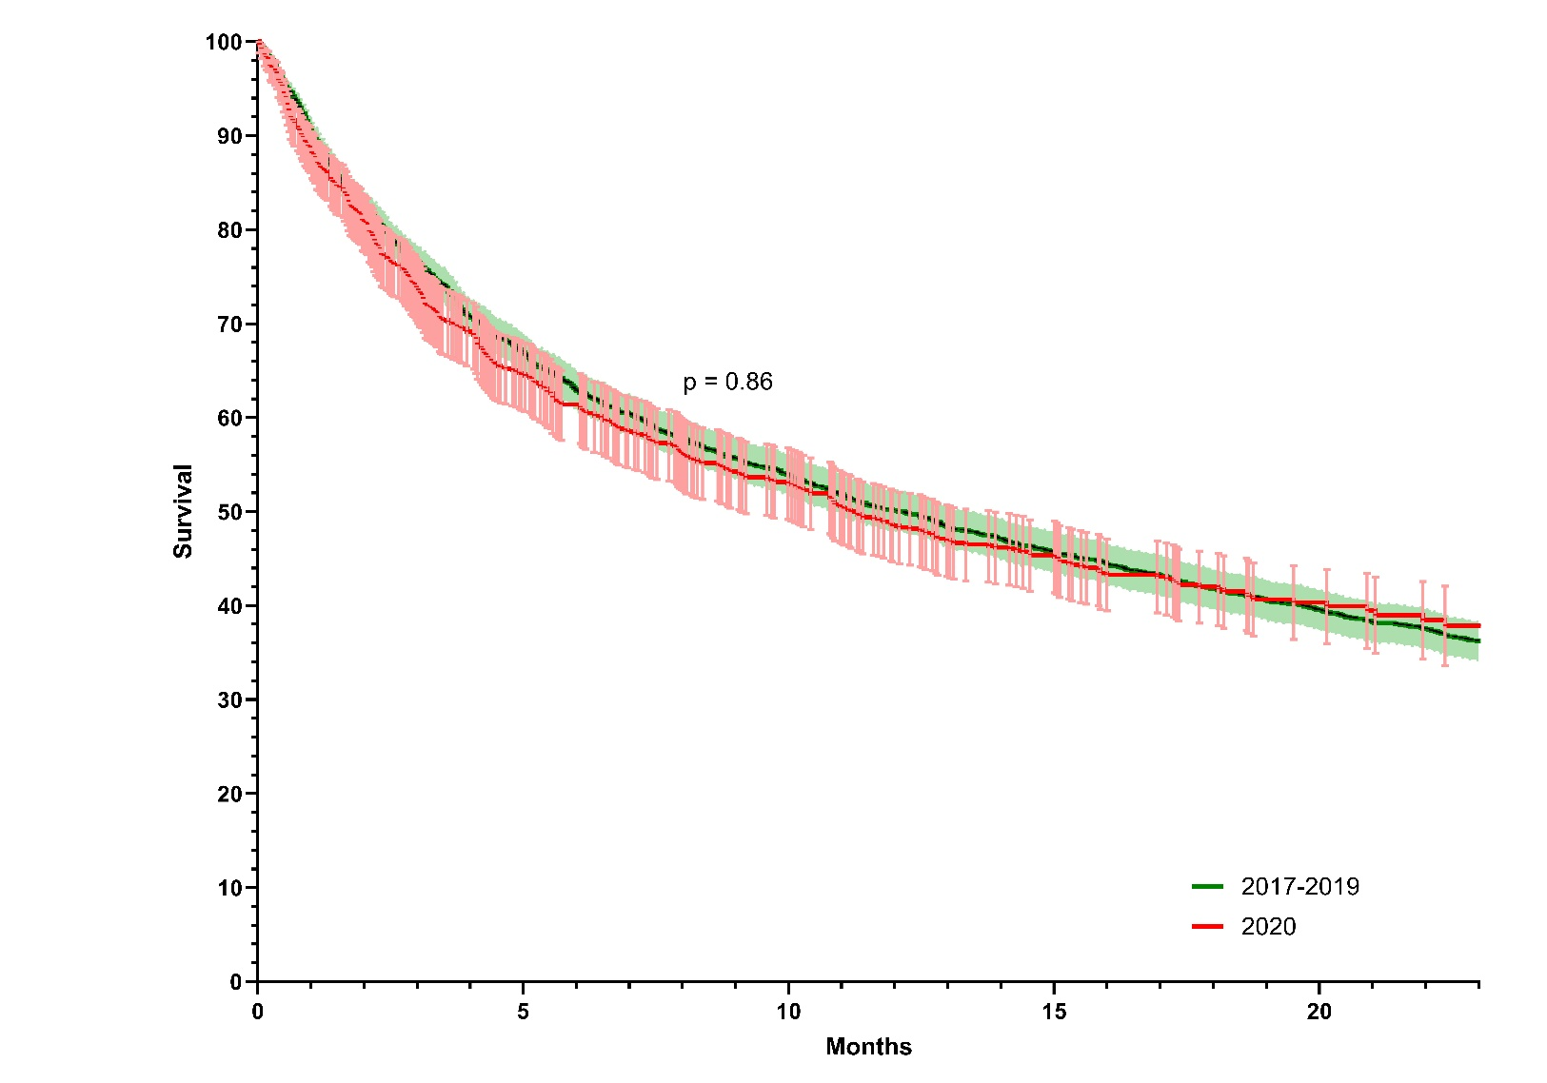

|  |  |  |  |  |  |  |
| --- | --- | --- | --- | --- | --- | --- |
| Number at risk (%) | | | | | | |
|  | 0 | 5 | 10 | 15 | 20 | 23 |
| 2017-2019 | 2132 (100) | 1428 (67) | 1148 (54) | 972 (46) | 840 (39) | 770 (36) |
| 2020 | 658 (100) | 426 (65) | 350 (53) | 269 (41) | 106 (16) | 50 (7.6) |

B 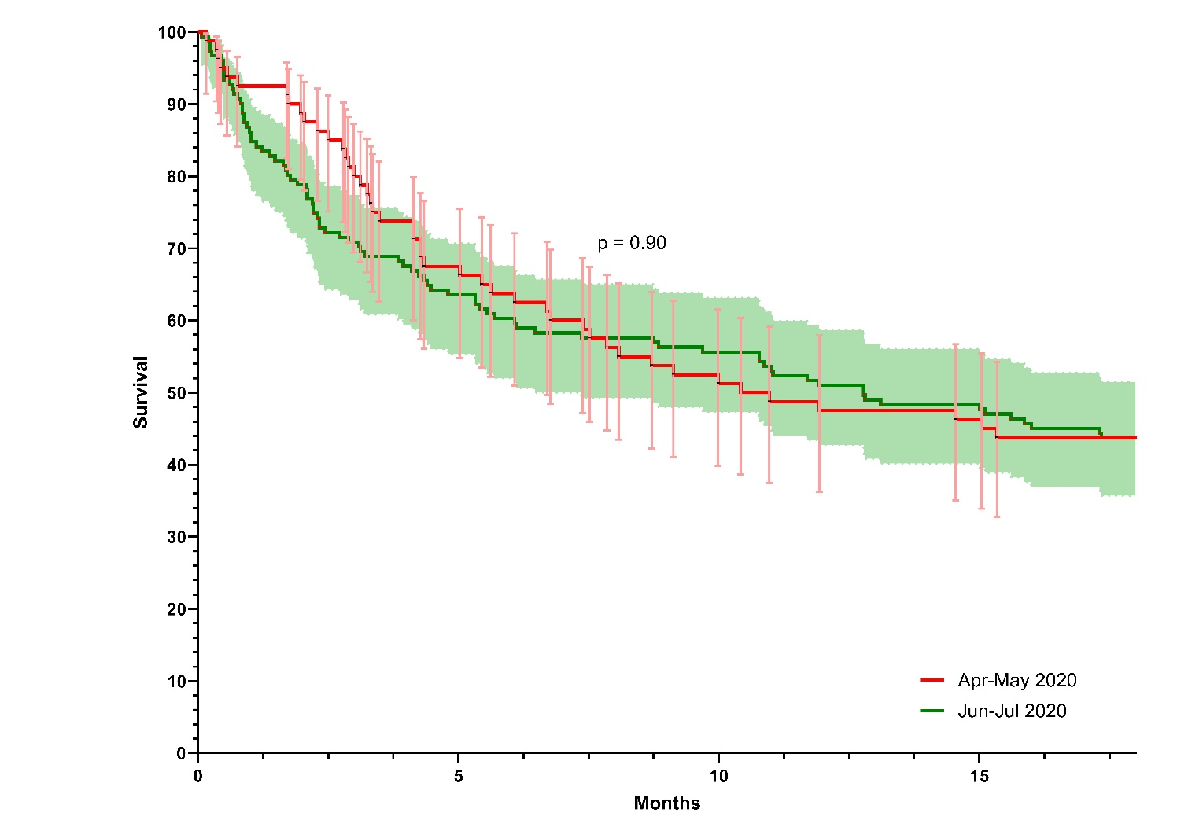

|  |  |  |  |  |  |
| --- | --- | --- | --- | --- | --- |
| Number at risk (%) | | | | | |
|  | 0 | 5 | 10 | 15 | 18 |
| Apr-May | 80 (100) | 55 (69) | 42 (53) | 38 (48) | 36 (45) |
| Jun-Jul | 151 (100) | 97 (64) | 85 (56) | 74 (49) | 67 (44) |

(A) In 2017-2019 and 2020. (B) In COVID-high (Apr-May 2020) and COVID-low months (Jun-Jul 2020). Survival curves with 95% confidence interval (CI). Figures are truncated at the maximum follow-up time for the latest comparison period (i.e. 23 months for 2017-2019 versus 2020, and 18 months for COVID-high versus COVID-low). Number at risk (percentages of total) are shown below the curves.

**Table S1. Comparison of monthly incidence rates between 2017-2019 and 2020**

|  |  |  |  |  |
| --- | --- | --- | --- | --- |
|  | **Incidence\*** | | **Incidence rate ratio**  **(95% CI)** | **p-value** |
| **Month** | **2017-2019** | **2020** |
| **Overall** | | | | |
| **January** | 4.4 (3.7-4.8) | 4.3 | 0.97 (0.72-1.30) | 0.84 |
| **February** | 4.5 (4.3-4.6) | 3.7 | 0.83 (0.61-1.12) | 0.23 |
| **March** | 4.4 (3.8-5.0) | 4.0 | 0.90 (0.67-1.21) | 0.49 |
| **April** | 3.8 (3.5-4.0) | 3.1 | 0.81 (0.58-1.14) | 0.22 |
| **May** | 4.6 (3.1-6.0) | 2.6 | 0.56 (0.39-0.80) | **0.001** |
| **June** | 4.1 (3.7-4.6) | 5.4 | 1.32 (1.00-1.72) | **0.05** |
| **July** | 5.1 (4.7-5.3) | 5.9 | 1.16 (0.90-1.49) | 0.26 |
| **August** | 3.8 (3.2-4.5) | 4.5 | 1.19 (0.89-1.59) | 0.25 |
| **September** | 4.3 (3.9-4.7) | 4.0 | 0.92 (0.68-1.24) | 0.59 |
| **October** | 4.3 (3.7-5.1) | 3.8 | 0.87 (0.64-1.18) | 0.38 |
| **November** | 4.7 (4.3-5.0) | 4.1 | 0.88 (0.65-1.17) | 0.37 |
| **December** | 4.2 (3.7-4.8) | 3.3 | 0.80 (0.58-1.11) | 0.18 |
| **Cirrhosis** | | | | |
| **January** | 2.7 (1.8-3.6) | 2.8 | 1.04 (0.72-1.50) | 0.82 |
| **February** | 3.0 (2.7-3.5) | 2.4 | 0.80 (0.55-1.17) | 0.25 |
| **March** | 2.5 (1.8-3.0) | 2.5 | 0.98 (0.67-1.44) | 0.92 |
| **April** | 2.3 (2.0-2.7) | 1.5 | 0.66 (0.41-1.05) | 0.08 |
| **May** | 2.9 (2.3-3.9) | 1.8 | 0.84 (0.42-0.97) | **0.04** |
| **June** | 2.5 (2.3-2.7) | 3.3 | 1.31 (0.93-1.86) | 0.12 |
| **July** | 3.1 (2.9-3.2) | 3.5 | 1.14 (0.82-1.58) | 0.45 |
| **August** | 2.4 (2.0-3.0) | 2.7 | 1.11 (0.76-1.61) | 0.59 |
| **September** | 2.6 (2.1-3.3) | 2.3 | 0.90 (0.61-1.33) | 0.59 |
| **October** | 2.6 (2.1-3.2) | 2.3 | 0.88 (0.59-1.31) | 0.53 |
| **November** | 2.8 (2.5-3.1) | 2.9 | 1.04 (0.73-1.48) | 0.83 |
| **December** | 2.7 (2.4-3.1) | 2.2 | 0.82 (0.55-1.22) | 0.33 |
| **No cirrhosis** | | | | |
| **January** | 1.7 (1.1-2.2) | 1.5 | 0.86 (0.53-1.40) | 0.53 |
| **February** | 1.5 (0.9-1.8) | 1.3 | 0.88 (0.52-1.49) | 0.88 |
| **March** | 1.9 (1.4-2.2) | 1.5 | 0.79 (0.49-1.28) | 0.79 |
| **April** | 1.5 (1.4-1.7) | 1.6 | 1.04 (0.64-1.70) | 0.86 |
| **May** | 1.7 (0.9-2.1) | 0.7 | 0.42 (0.22-0.82) | **0.008** |
| **June** | 1.6 (1.3-1.9) | 2.1 | 1.32 (0.86-2.03) | 0.21 |
| **July** | 2.0 (1.4-2.5) | 2.4 | 1.19 (0.80-1.77) | 0.39 |
| **August** | 1.3 (0.9-1.6) | 1.8 | 1.34 (0.83-2.15) | 0.23 |
| **September** | 1.7 (1.4-2.2) | 1.6 | 0.95 (0.60-1.53) | 0.84 |
| **October** | 1.7 (1.5-1.9) | 1.5 | 0.86 (0.53-1.40) | 0.54 |
| **November** | 1.9 (1.7-2.2) | 1.2 | 0.63 (0.37-1.07) | 0.09 |
| **December** | 1.5 (1.2-1.6) | 1.1 | 0.77 (0.44-1.34) | 0.36 |
| * Incidence are reported per 1.000.000 persons. For 2017-2019, mean (min, max) are given. | | | | |