What Remains Now That the Fear Has Passed? Developmental Trajectory Analysis of COVID-19 Pandemic for Co-occurrences of Twitter, Google Trends, and Public Health Data

Benjamin Havis Rathke¹, Han Yu*¹, Hong Huang²
¹Department of Applied Statistics and Research Methods, University of Northern Colorado, Greeley, CO 80639, USA, rath1045@bears.unco.edu
^{*1}Department of Applied Statistics and Research Methods, University of Northern Colorado, Greeley, CO 80639, USA, han.yu@unco.edu
²School of Information, University of South Florida, Tampa, FL, 33620, USA, honghuang@usf.edu
*Corresponding author

Appendices
Trust Sentiment Random Forest
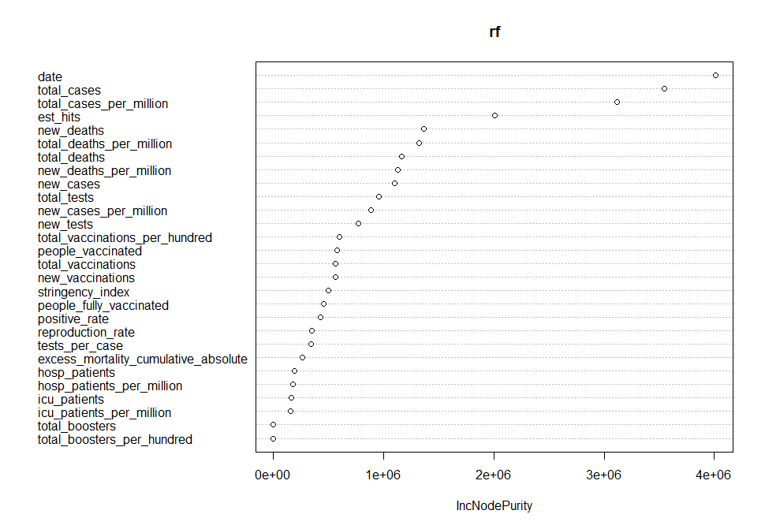
Appendix 1: Variable importance plot for trust sentiment random forest using node purity.
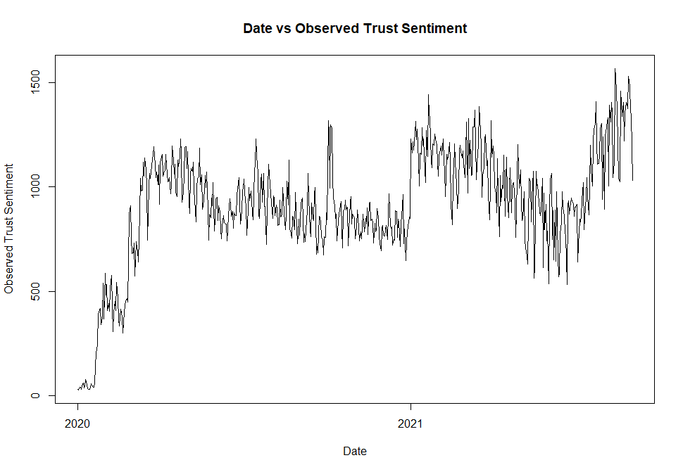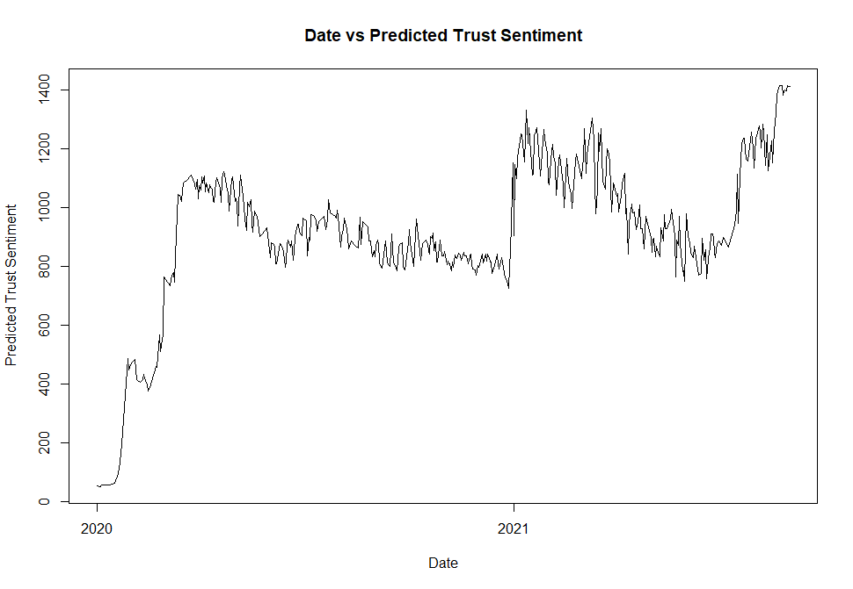
Appendix 2: Observed (left) and predicted (right) trust sentiment vs time.

Surprise Sentiment Random Forest
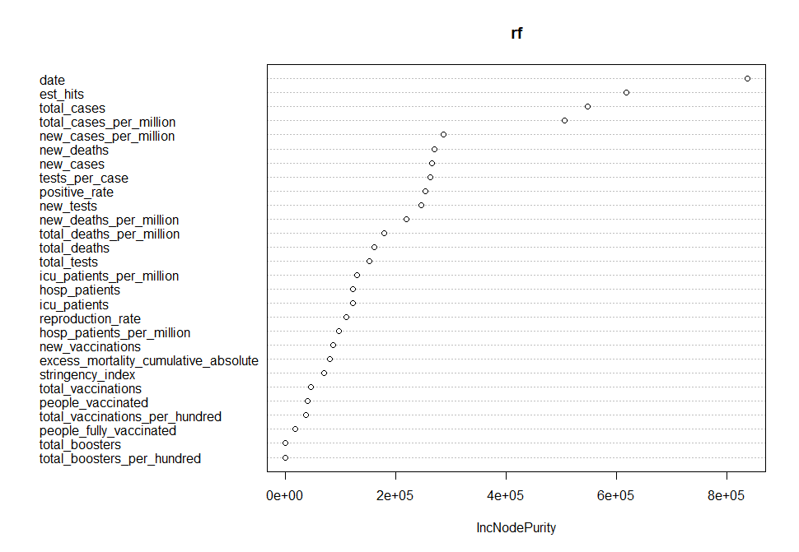
Appendix 3: Variable importance plot for surprise sentiment random forest using node purity.
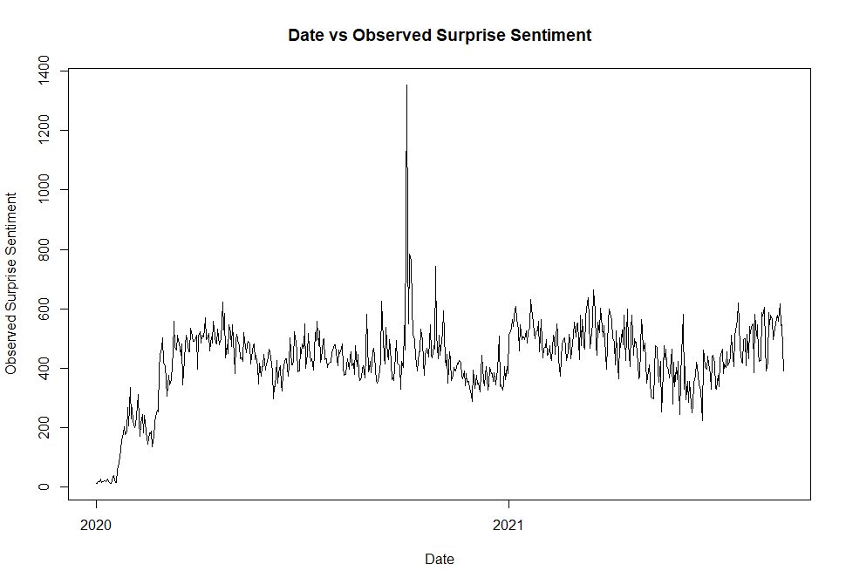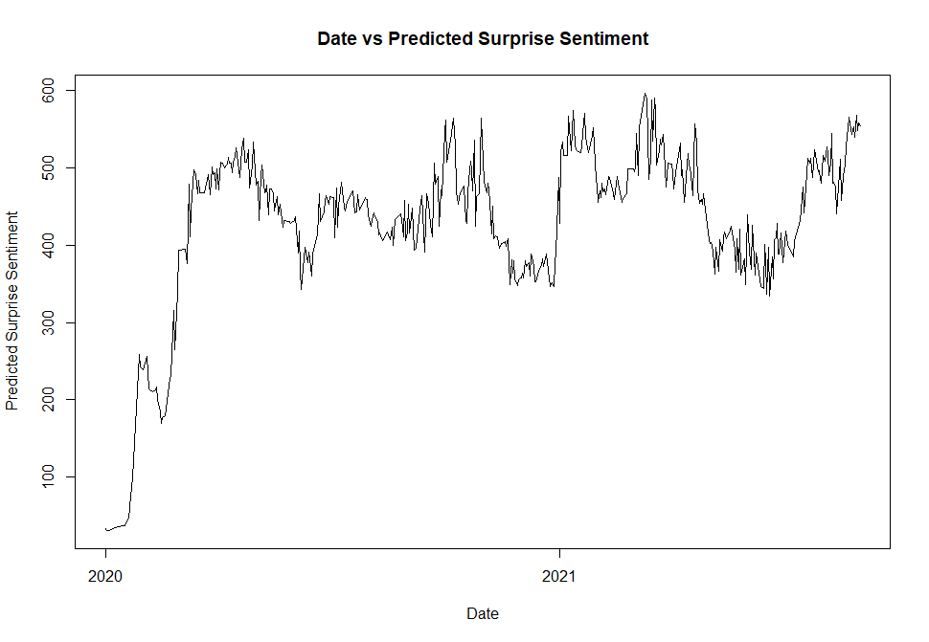
Appendix 4: Observed (left) and predicted (right) surprise sentiment vs time.

Sadness Sentiment Random Forest

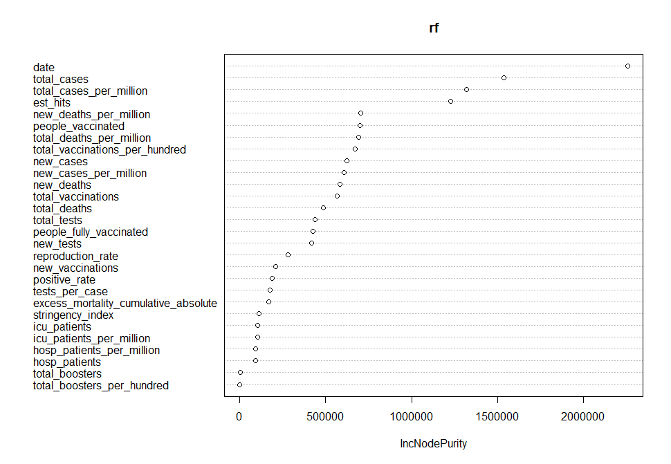
Appendix 5: Variable importance plot for sadness sentiment random forest using node purity.

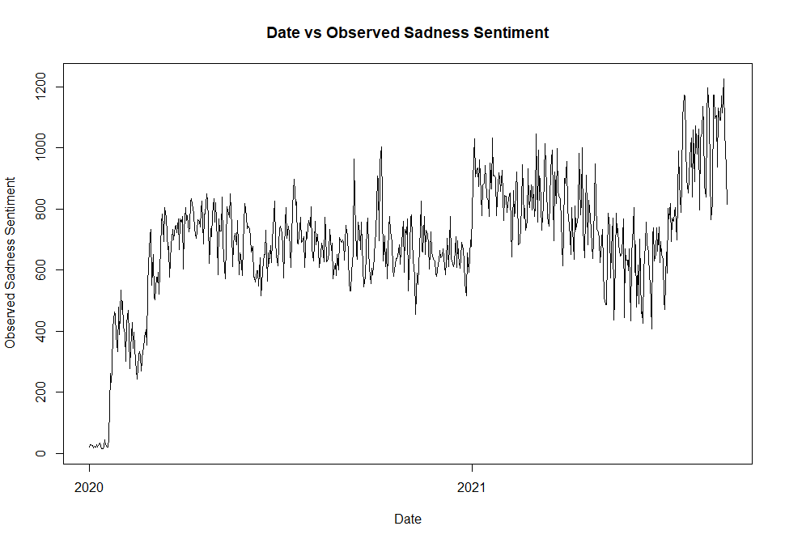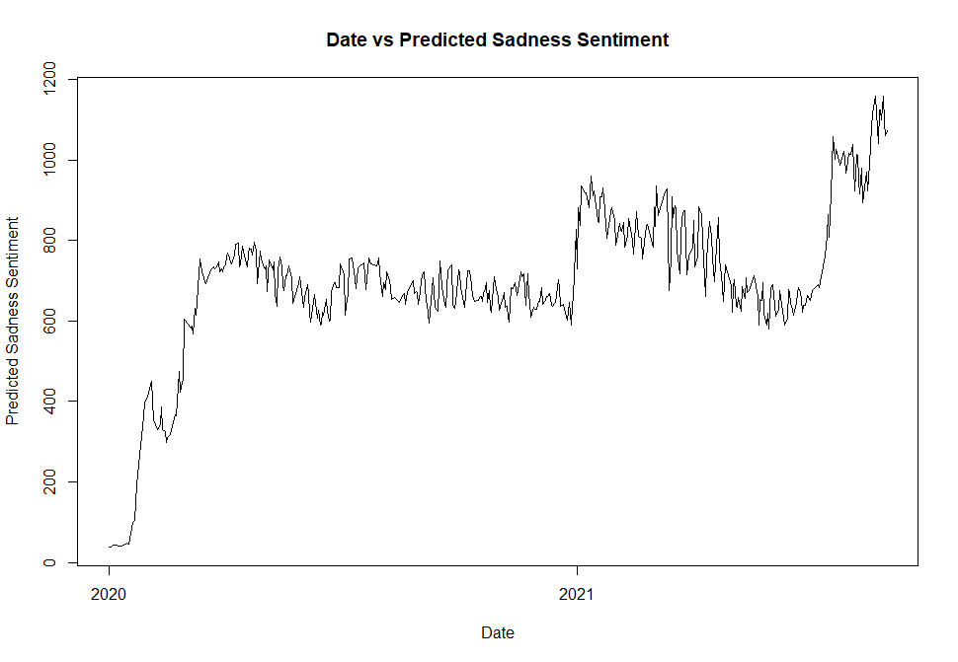
Appendix 6: Observed (left) and predicted (right) sadness sentiment vs time.

Joy Sentiment Random Forest
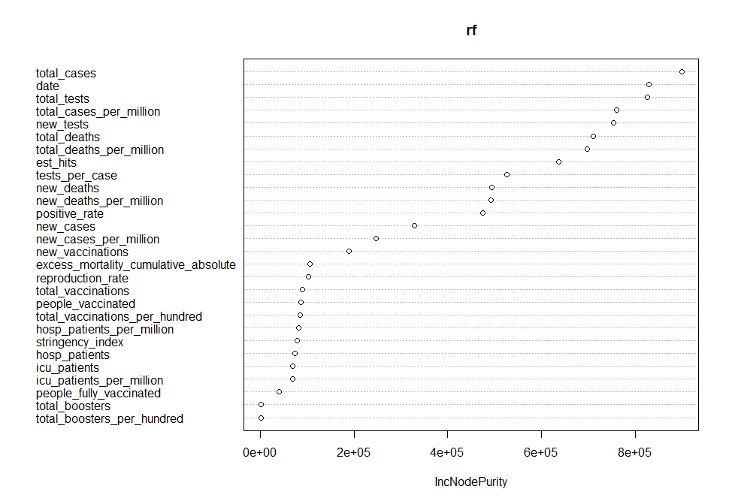Appendix 7: Variable importance plot for joy sentiment random forest using node purity.
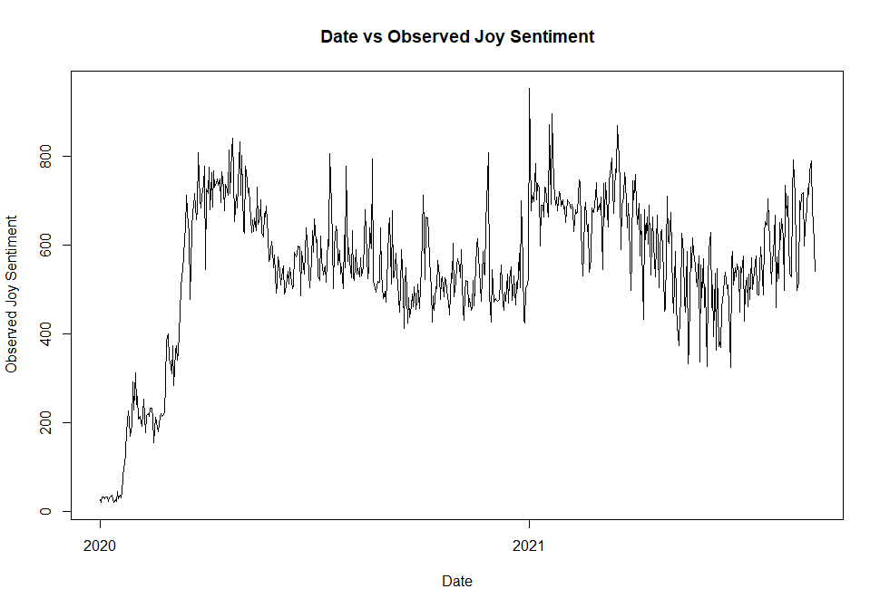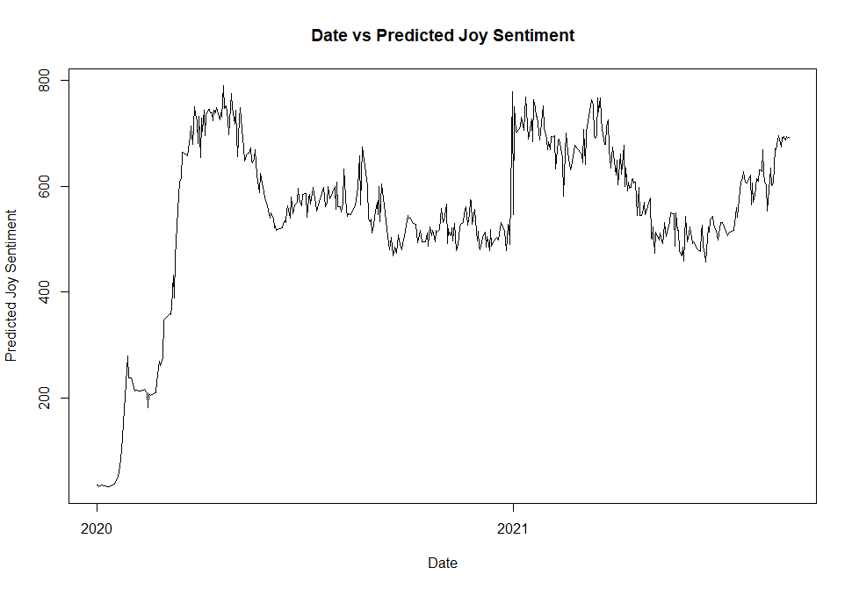
Appendix 8: Observed (left) and predicted (right) joy sentiment vs time.

Fear Sentiment Random Forest
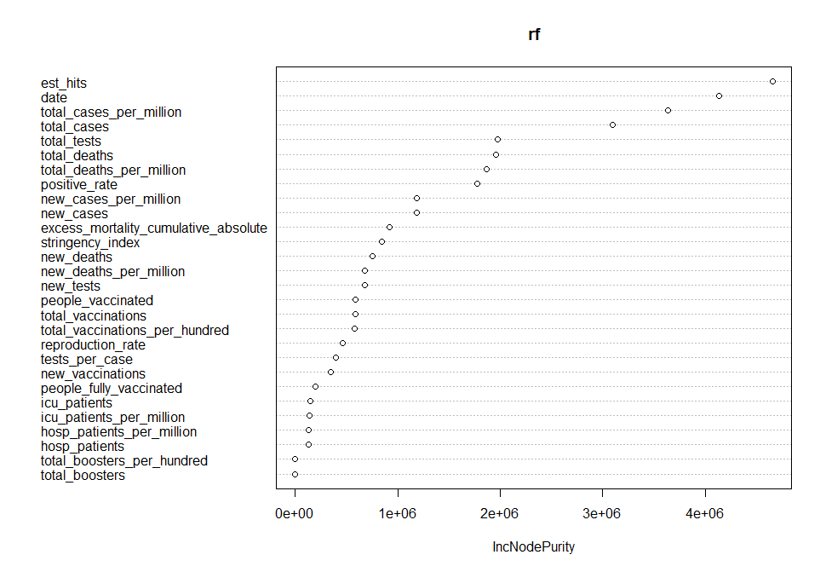
Appendix 9: Variable importance plot for fear sentiment random forest using node purity.
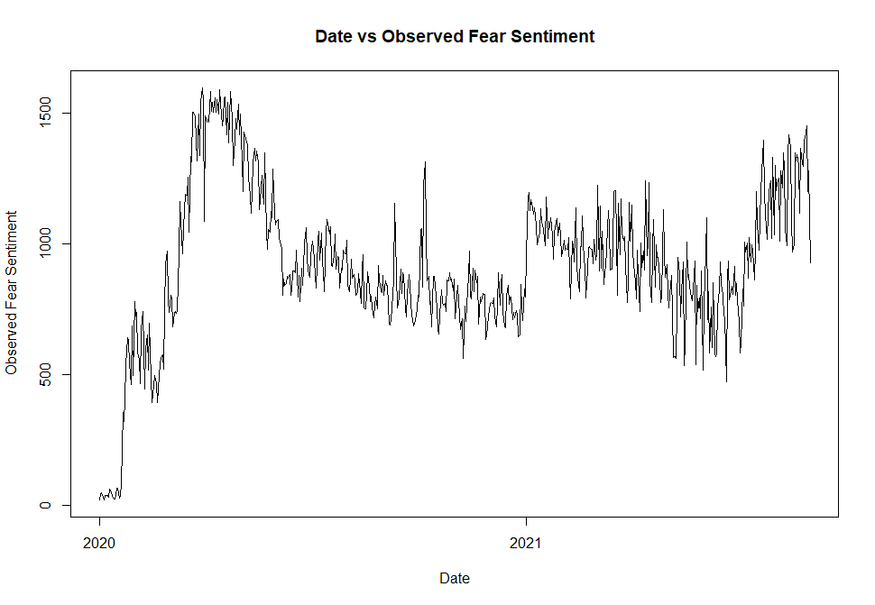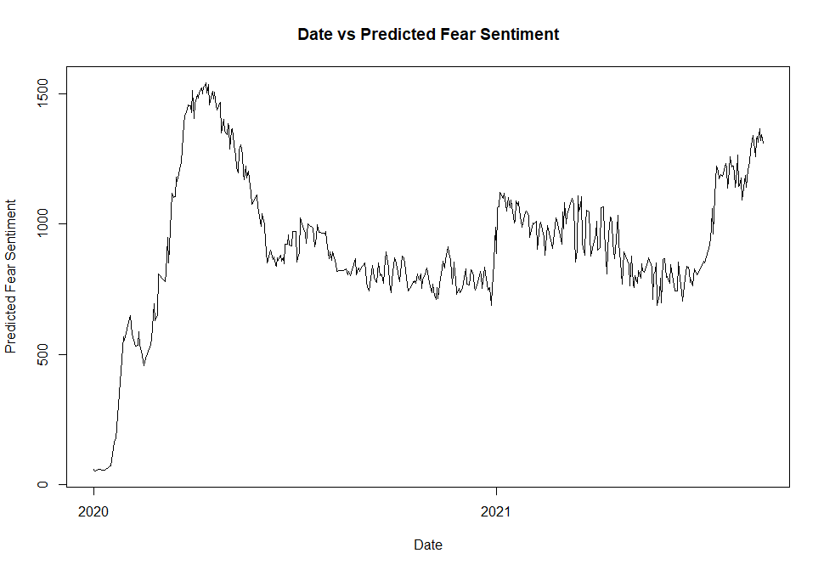
Appendix 10: Observed (left) and predicted (right) fear sentiment vs time.

Disgust Sentiment Random Forest

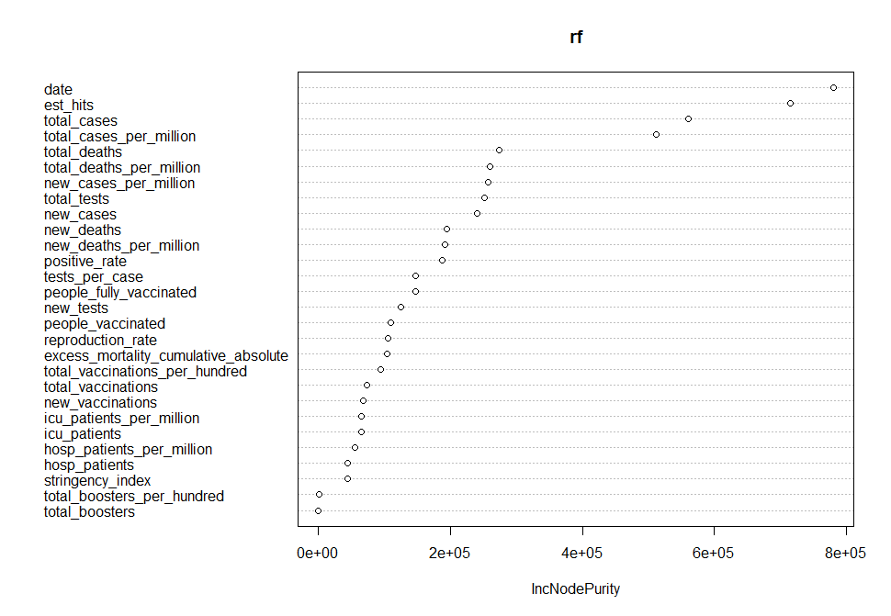
Appendix 11: Variable importance plot for disgust sentiment random forest using node purity.
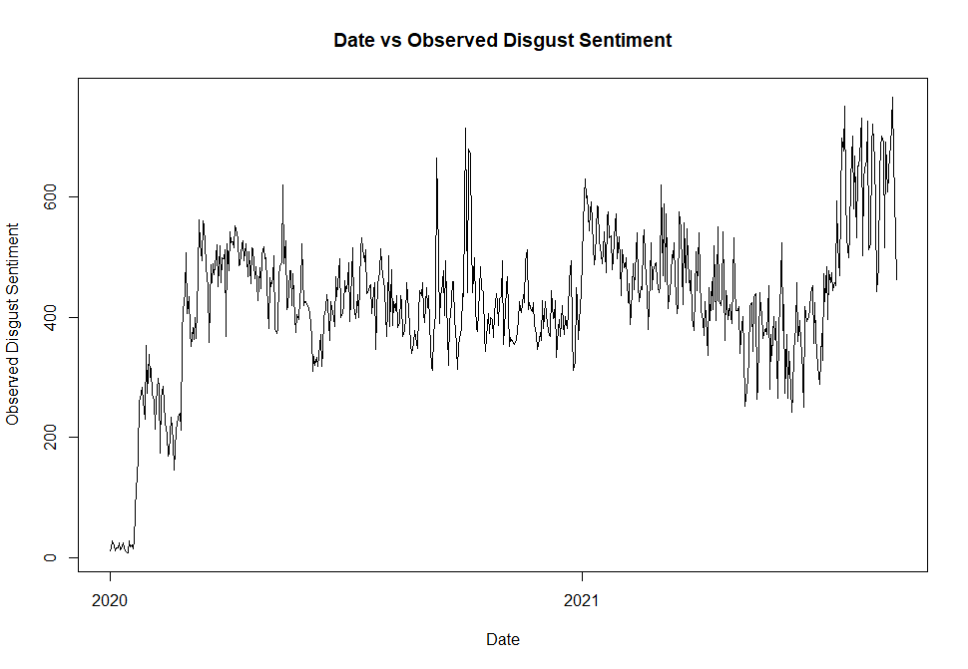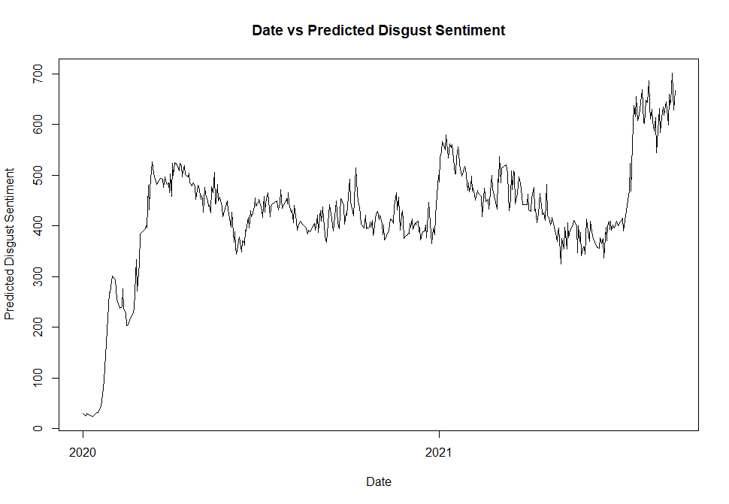
Appendix 12: Observed (left) and predicted (right) disgust sentiment vs time.

Anticipation Sentiment Random Forest
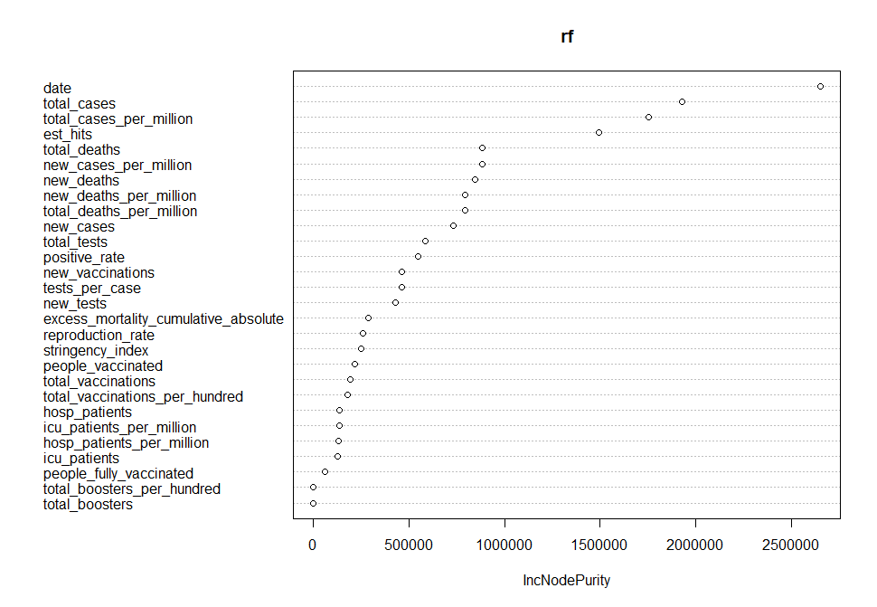Appendix 13: Variable importance plot for anticipation sentiment random forest using node purity.

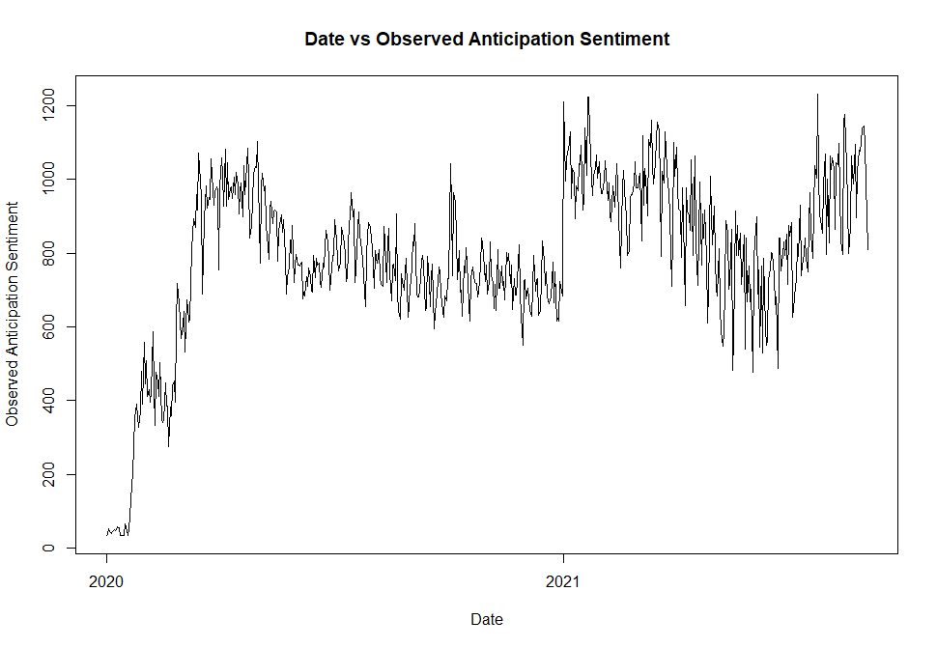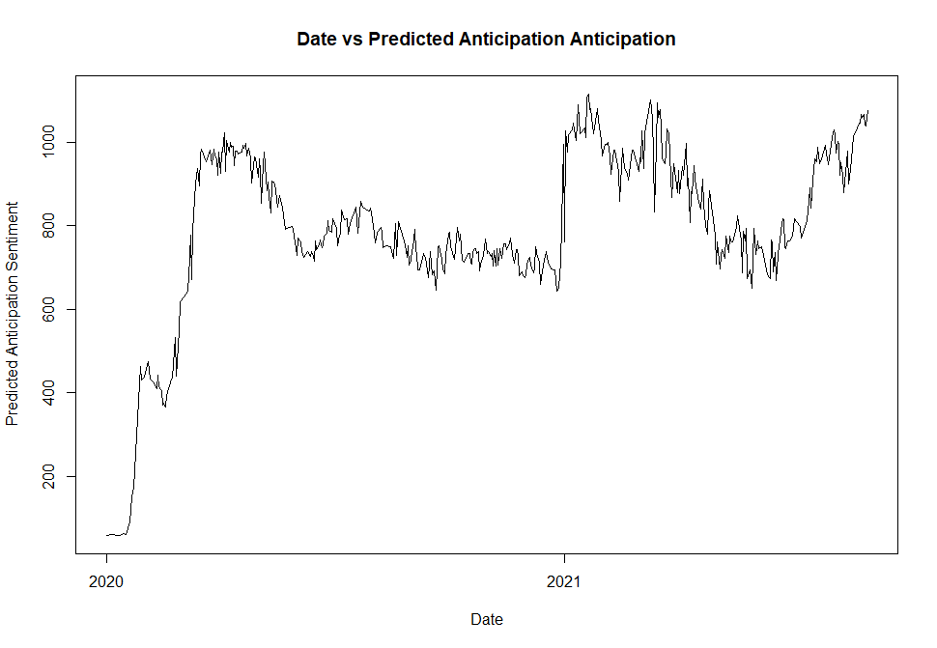
Appendix 14: Observed (left) and predicted (right) anticipation sentiment vs time.

Anger Sentiment Random Forest
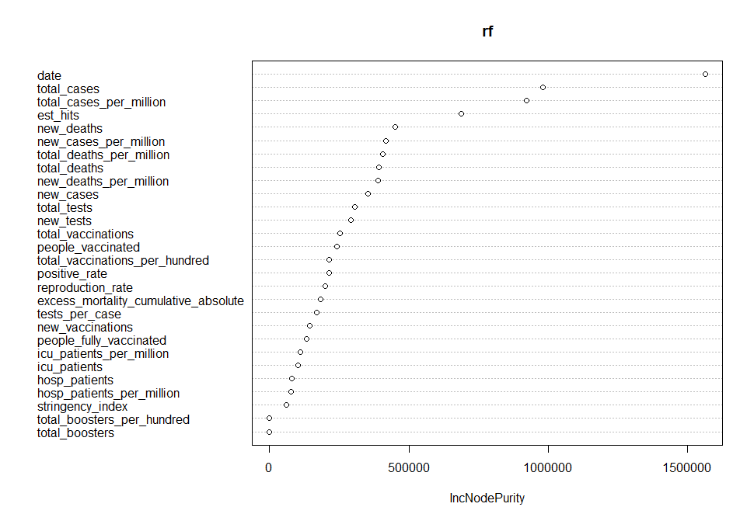
Appendix 15: Variable importance plot for anger sentiment random forest using node purity.
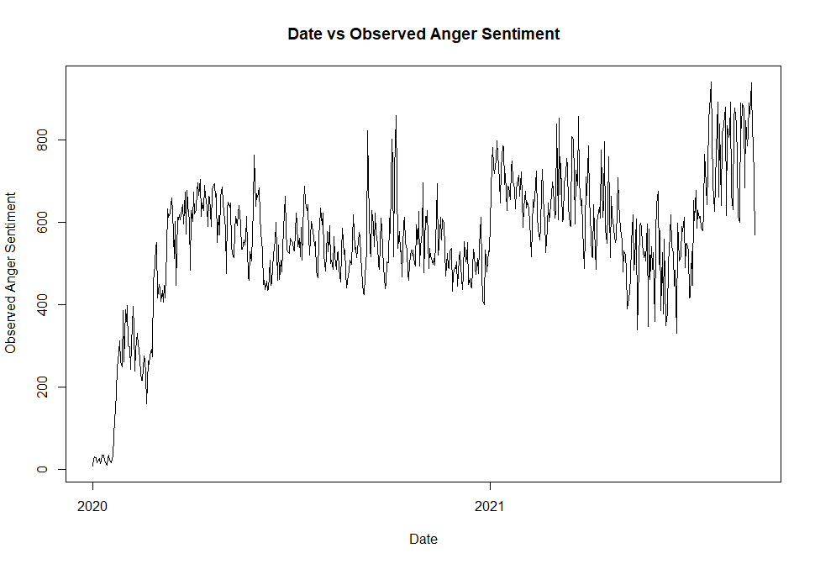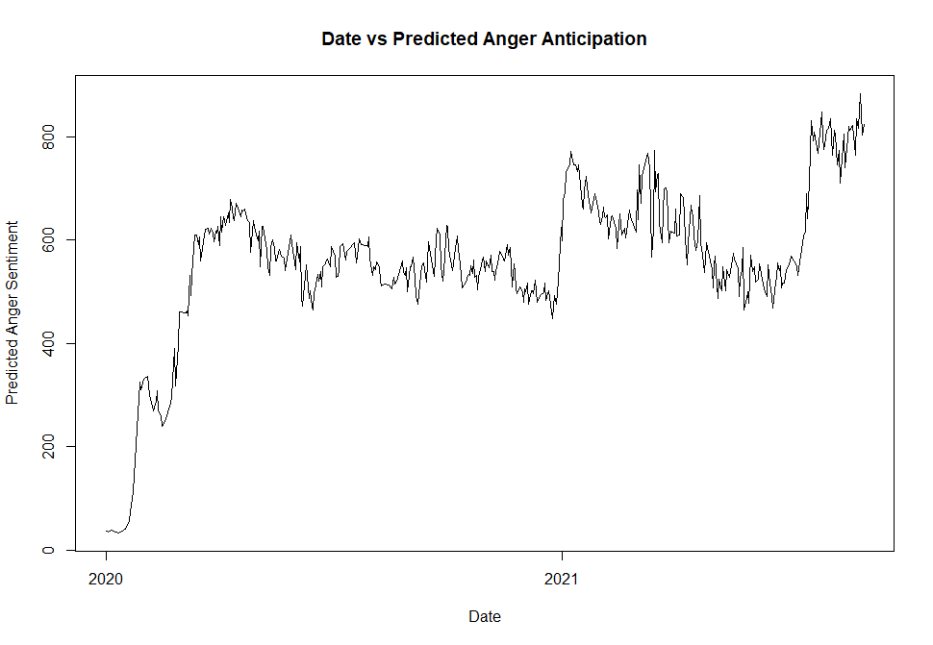
Appendix 16: Observed (left) and predicted (right) anger sentiment vs time.

