Appendices

Trust Sentiment Random Forest
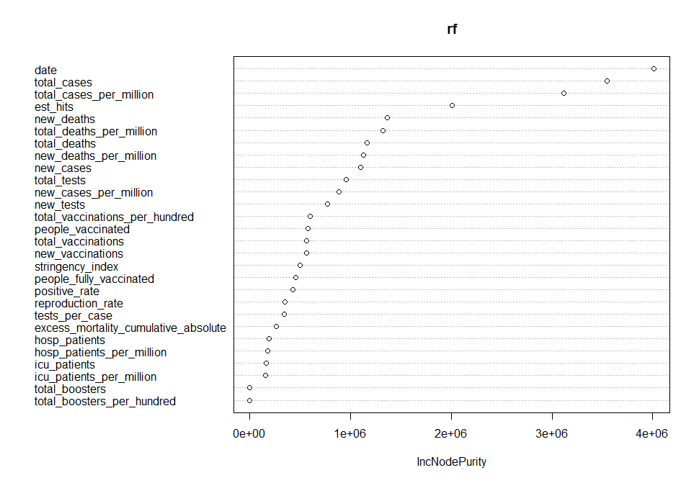
Appendix 1: Variable important plot for trust sentiment random forest using node purity
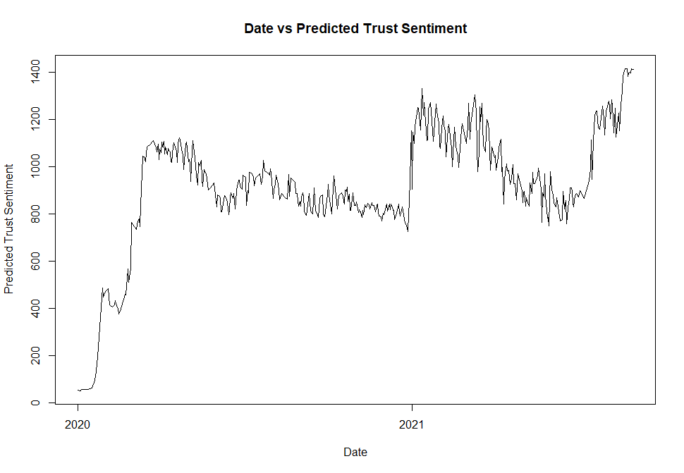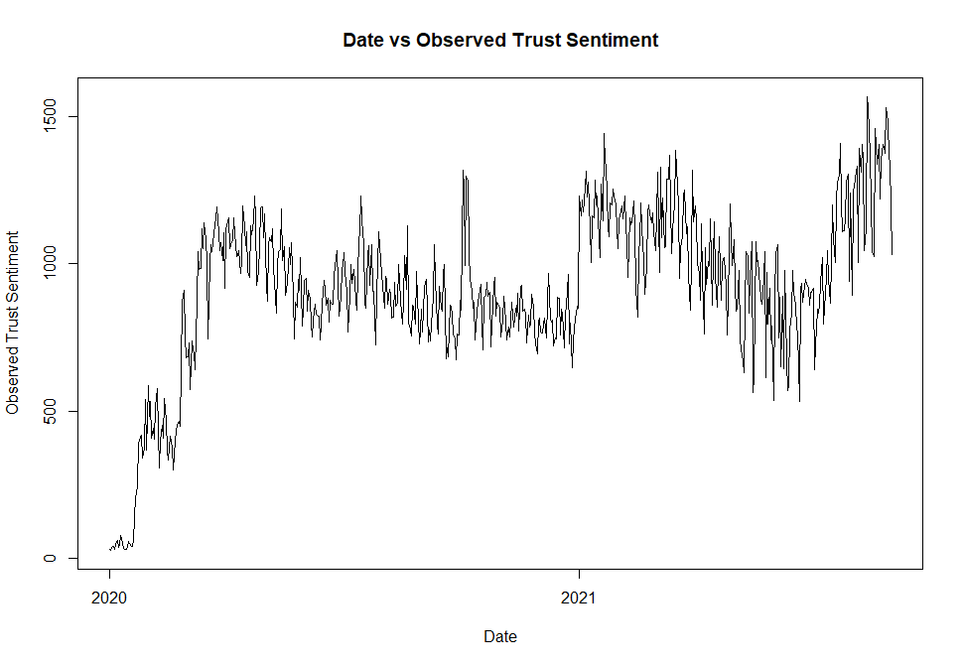
Appendix 2: Observed (left) and predicted (right) trust sentiment vs time

Surprise Sentiment Random Forest
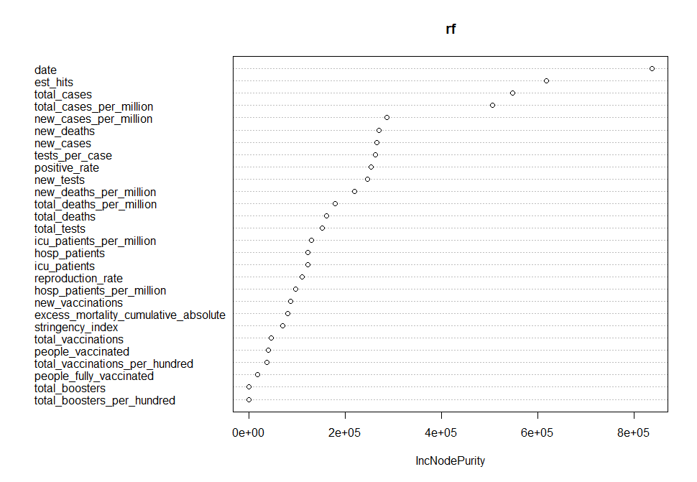
Appendix 3: Variable important plot for surprise sentiment random forest using node purity
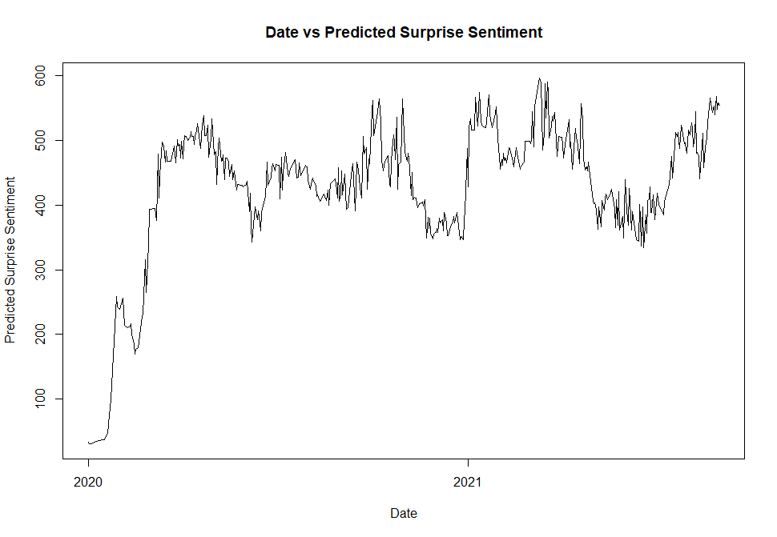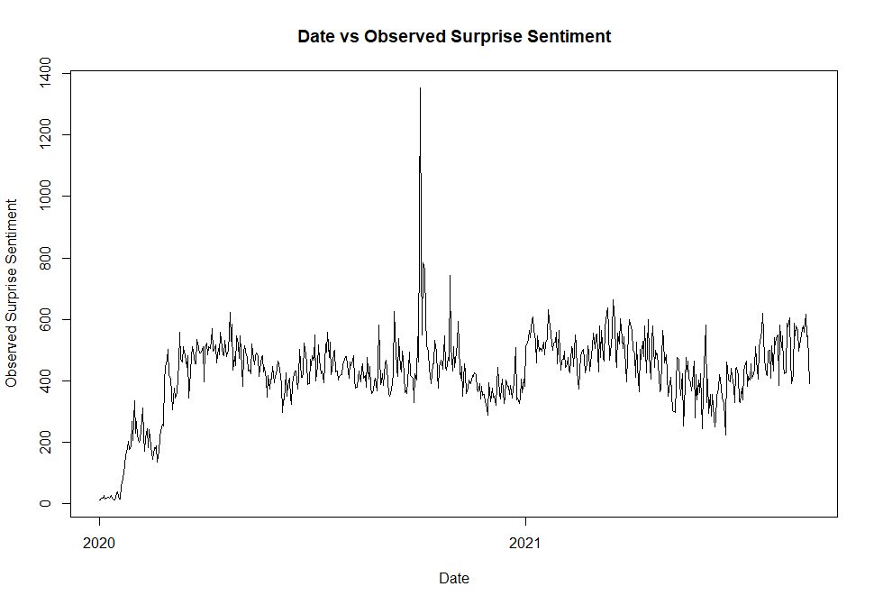
Appendix 4: Observed (left) and predicted (right) surprise sentiment vs time
Sadness Sentiment Random Forest

Sadness Sentiment Random Forest
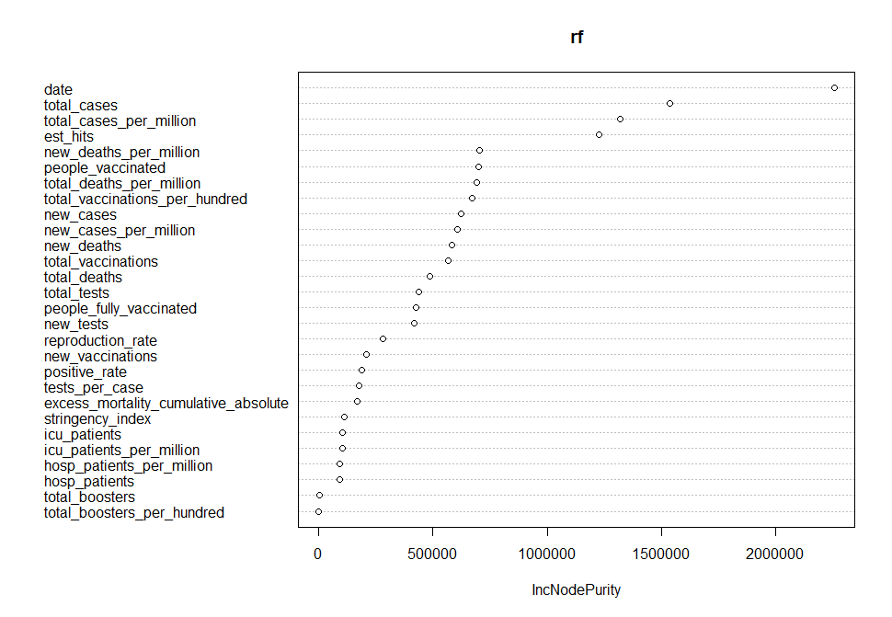
Appendix 5: Variable important plot for sadness sentiment random forest using node purity

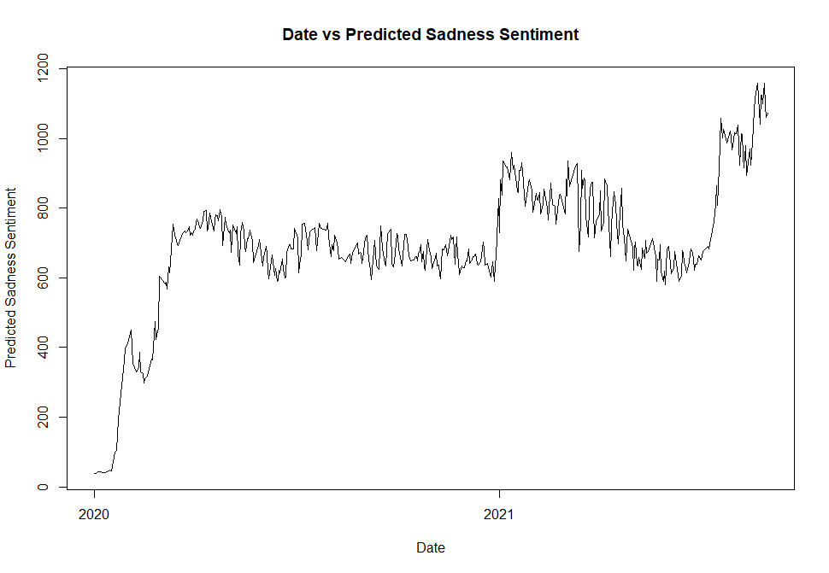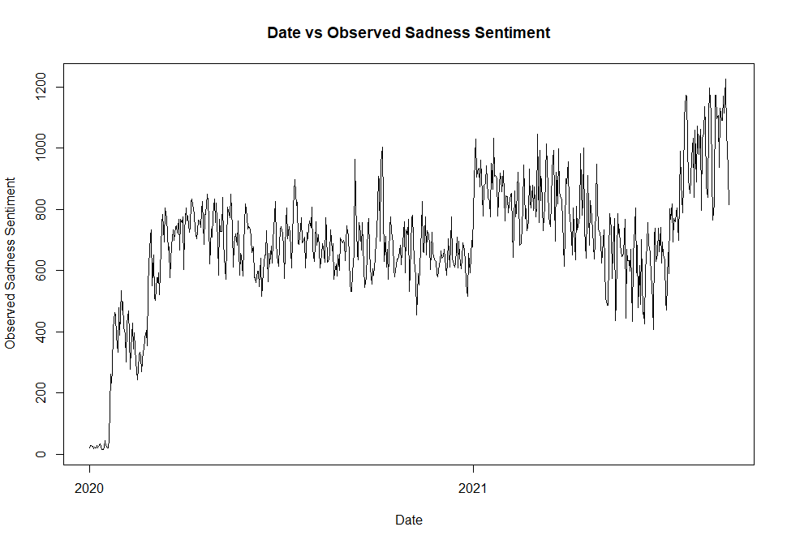
Appendix 6: Observed (left) and predicted (right) sadness sentiment vs time

Joy Sentiment Random Forest
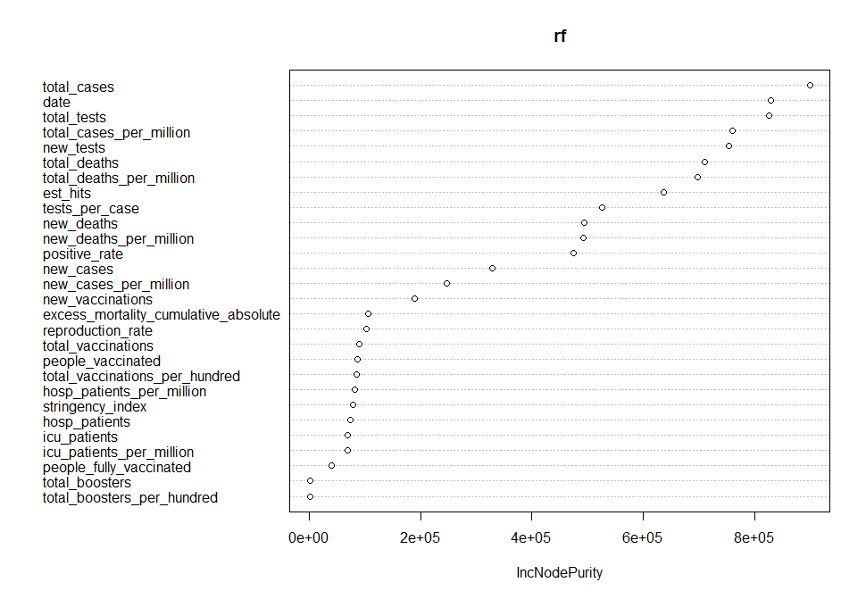Appendix 7: Variable important plot for joy sentiment random forest using node purity
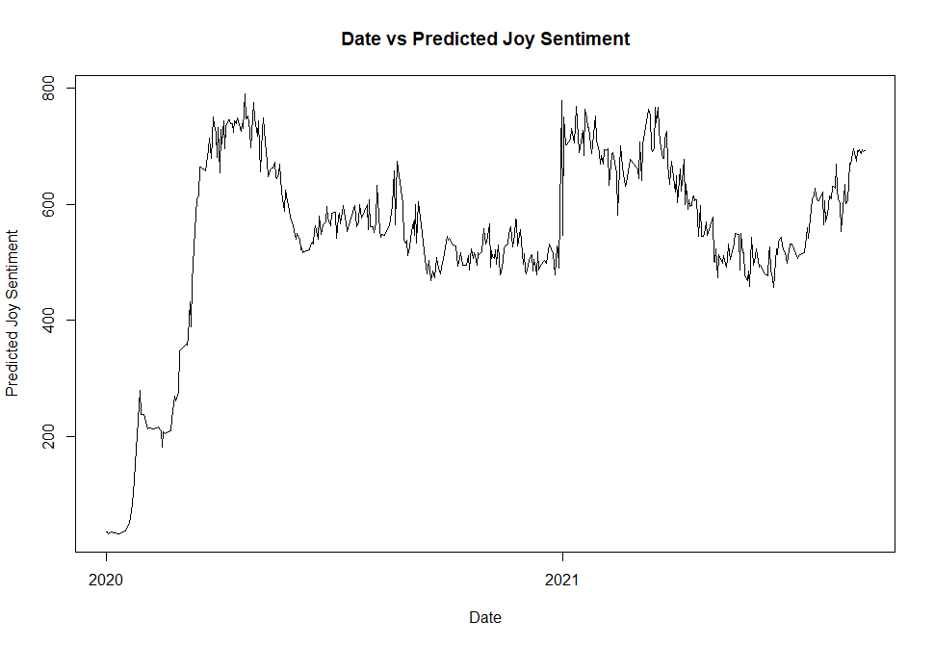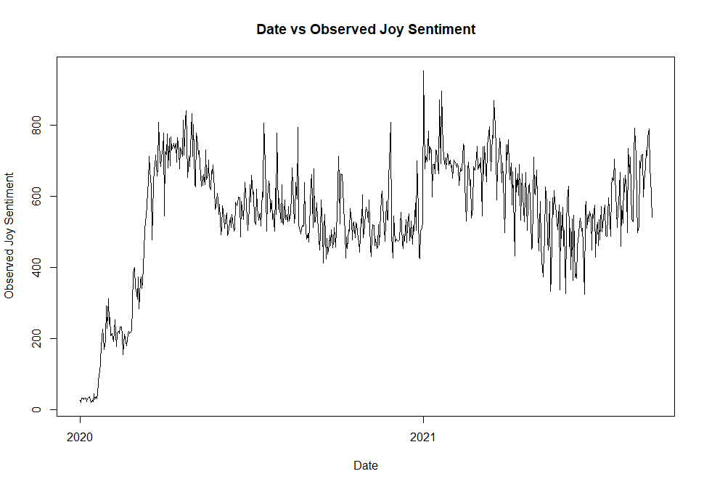
Appendix 8: Observed (left) and predicted (right) joy sentiment vs time

Fear Sentiment Random Forest
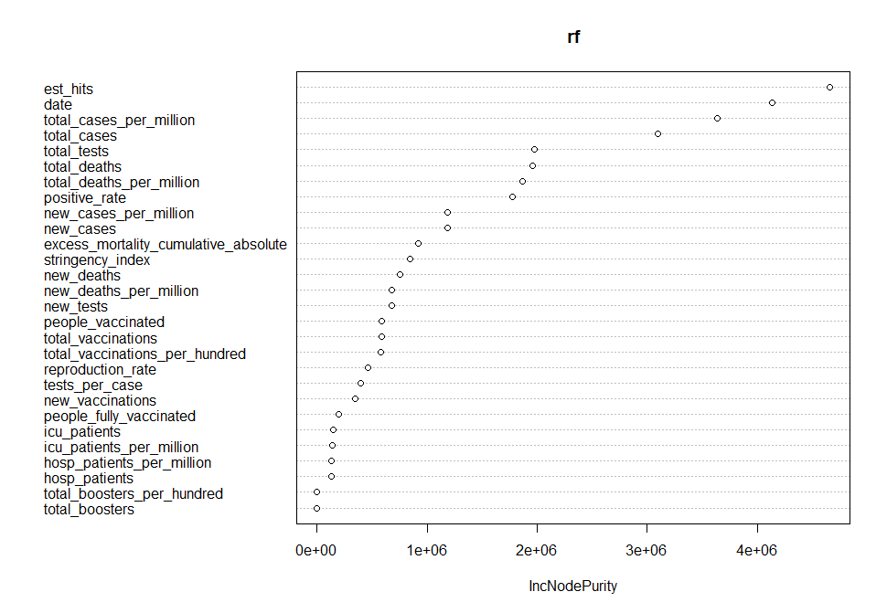
Appendix 9: Variable important plot for fear sentiment random forest using node purity
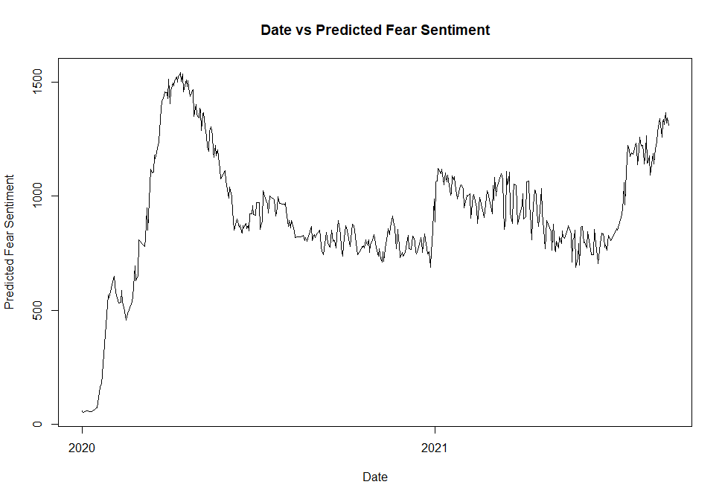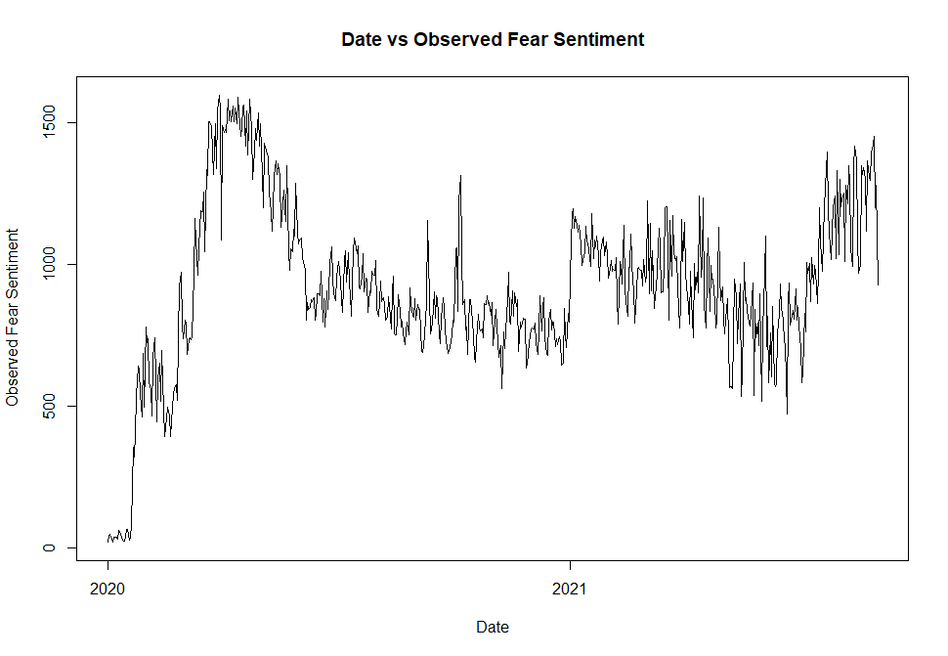
Appendix 10: Observed (left) and predicted (right) fear sentiment vs time

Disgust Sentiment Random Forest

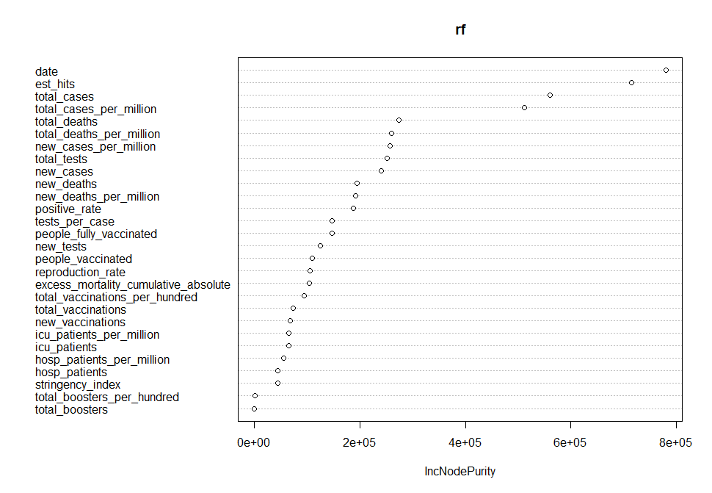
Appendix 11: Variable important plot for disgust sentiment random forest using node purity
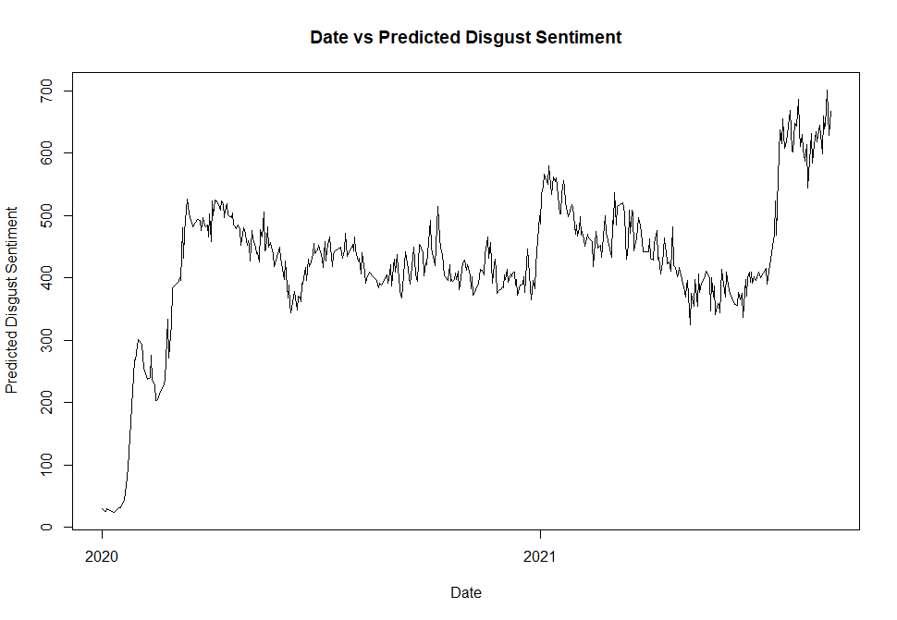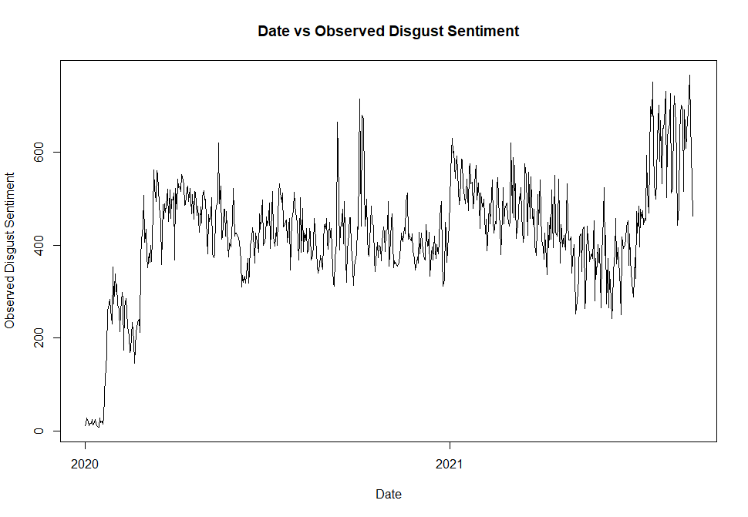
Appendix 12: Observed (left) and predicted (right) disgust sentiment vs time

Anticipation Sentiment Random Forest
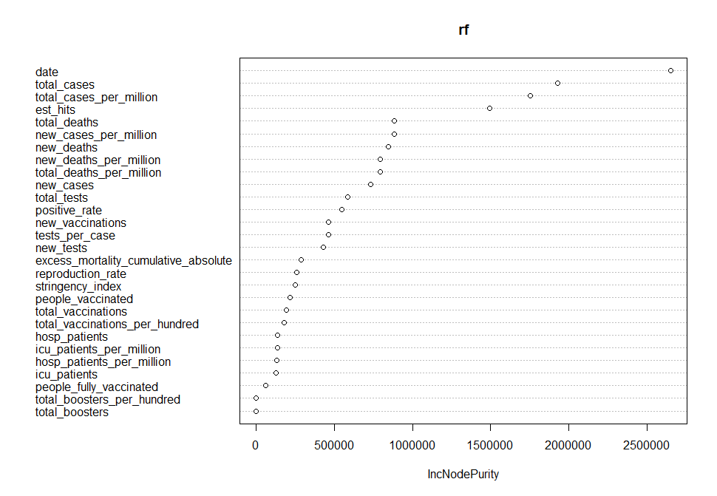Appendix 13: Variable important plot for anticipation sentiment random forest using node purity

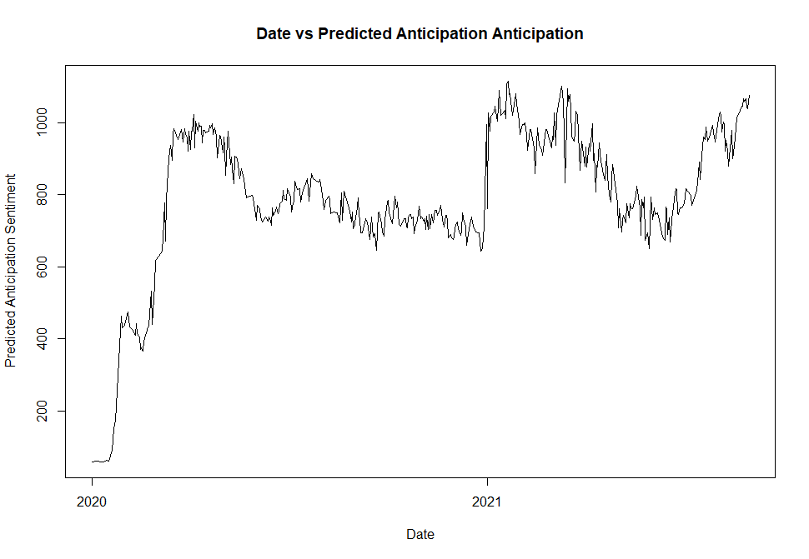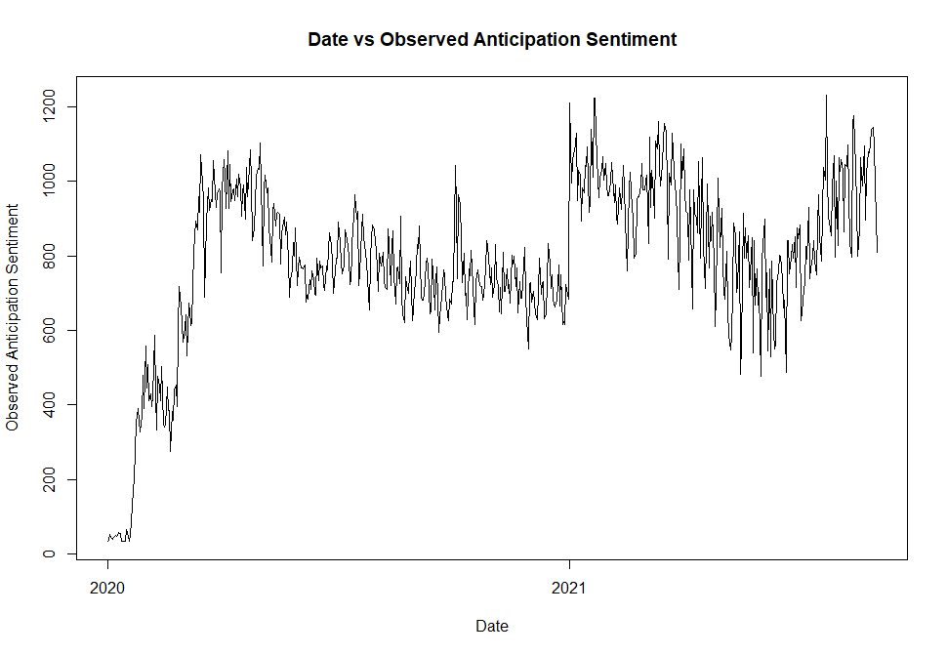
Appendix 14: Observed (left) and predicted (right) anticipation sentiment vs time

Anger Sentiment Random Forest
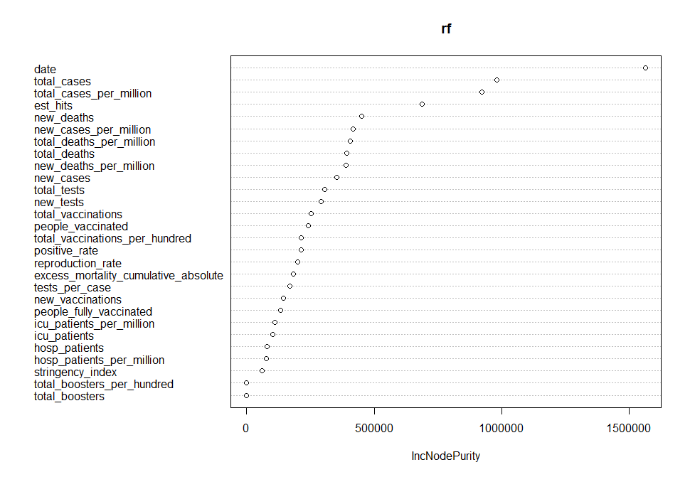
Appendix 15: Variable important plot for anger sentiment random forest using node purity
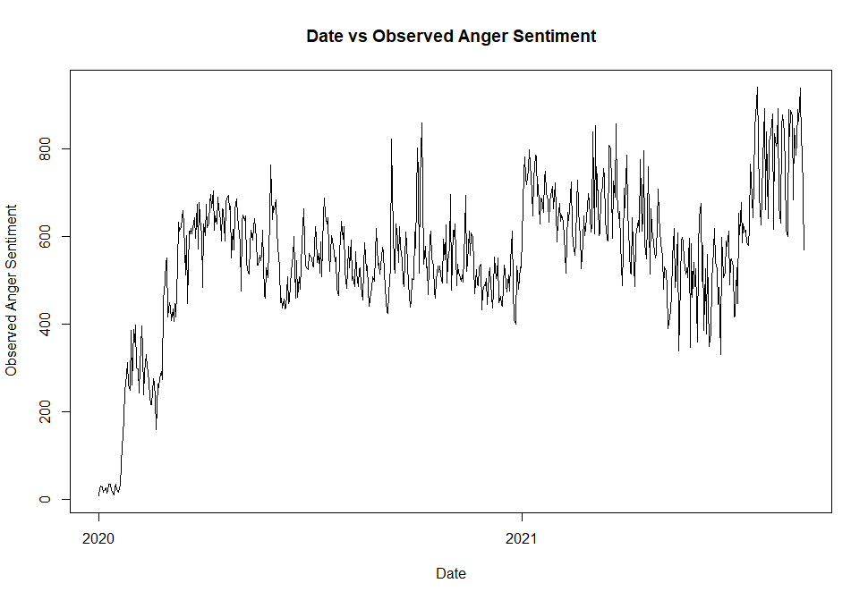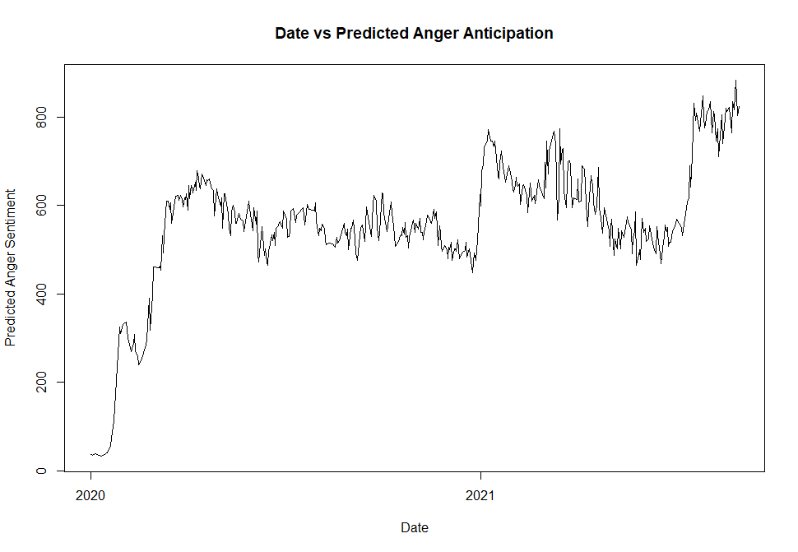
Appendix 16: Observed (left) and predicted (right) anger sentiment vs time

