Climate, Weather, and Collective Reputation:

Implications for California’s Wine Prices and Quality*

# Sarah C. Whitnall and Julian M. Alston

# Online Appendices

## Results using growing season average temperature

We estimated the following model of K&L prices, which replicates Equation (2) but replaces degree-day variables with a conventional measure of temperature: a quadratic function of growing season average temperature (April to October).

$$\ln\left({Price}_{wrvt}\right)=α_{wr}+{}_{1}{tavg}_{rv}+β_{2}{tavg}_{rv}^{2}+ρ_{1}ppt_{rv}+ρ_{2}ppt_{rv}^{2}+ \\ δ_{1} win{e age}_{wrvt}+δ_{2}{wine age}_{wrvt}^{2}+θ_{1}v+θ_{2}v^{2}+ψ_{t}+ϵ_{wrvt}$$

(3)

We do not detect a statistically significant relationship between growing season average temperature and K&L wine prices. Even if the relationship were significant, the direction of the results for the model pooling all varieties is unintuitive—hotter vintages are associated with higher prices (see Figure 9).

Figure 9 Estimated effect of growing season average temperature (April–October) on natural logarithm of wine prices from K&L

Figure 10 Estimated effect of growing season average temperature (April–October) on natural logarithm of wine prices from K&L, Cabernet Sauvignon

Figure 11 Estimated effect of growing season average temperature (April–October) on natural logarithm of wine prices from K&L, Chardonnay

Table 11 Estimated effect of growing season average temperature (April–October) on natural logarithm of wine prices from K&L

|  |  |  |  |
| --- | --- | --- | --- |
|  | (1) | (2) | (3) |
|  | All varieties | Cabernet Sauvignon | Chardonnay |
| Growing season avg temp, Apr-Oct | -0.3430 | 0.0784 | 0.3016 |
|  | (0.3276 | (0.5950) | (0.5205) |
|  |  |  |  |
| Growing season avg temp, Apr-Oct squared | 0.0092 | -0.0029 | -0.0087 |
|  | (0.0092) | (0.0165) | (0.0195) |
|  |  |  |  |
| Precipitation | -1.0406*** | -1.6947*** | -0.2640 |
|  | (0.3518) | (0.1766) | (0.5150) |
|  |  |  |  |
| Precipitation squared | 1.5506** | 3.0423*** | -0.6241 |
|  | (0.6917) | (0.4035) | (0.8723) |
|  |  |  |  |
| Wine age | -0.0458*** | -0.0221** | -0.1724*** |
|  | (0.0102) | (0.0079) | (0.04212) |
|  |  |  |  |
| Wine age squared | 0.0008*** | 0.0005*** | 0.0020*** |
|  | (0.0002) | (0.0001) | (0.0005) |
|  |  |  |  |
| Vintage year | 0.0000 | 0.0000 | 0.0000 |
|  | (0.0000) | (0.0000) | (0.0000) |
|  |  |  |  |
| Vintage year squared | -0.0003** | -0.0001 | -0.0019*** |
|  | (0.0001) | (0.0001) | (0.0005) |
|  |  |  |  |
| Constant | 8.9087*** | 5.1343 | 5.1522 |
|  | (2.8191) | (5.3809) | (4.8473) |
| R2 | 0.808 | 0.817 | 0.604 |
| Winery fixed effects | ✓ | ✓ | ✓ |
| Auction year fixed effects | ✓ | ✓ | ✓ |
| Observations | 47662 | 30649 | 6123 |

Notes: Each column shows the results from a separate regression model for the varietal wine identified in the column header, using winery-vintage observations from all premium growing regions in California from 1981 to 2020. Includes winery-by-region fixed effects, linear and quadratic vintage year, auction year fixed effect, quadratic function of wine age, and quadratic function of growing-season precipitation. The reported estimates are the effect of a one unit increase in the explanatory variable (identified in the row label) on the natural logarithm of wine prices. Standard errors for the reported estimates in parentheses are heteroskedastic robust and clustered by region and vintage-coastal group. Significance: * p<0.05, ** p<0.01, *** p<0.001.

## Wine Spectator website



Figure 12 Example of a wine’s rating on the Wine Spectator website

## Scores and Prices by Vintage and Grape Variety

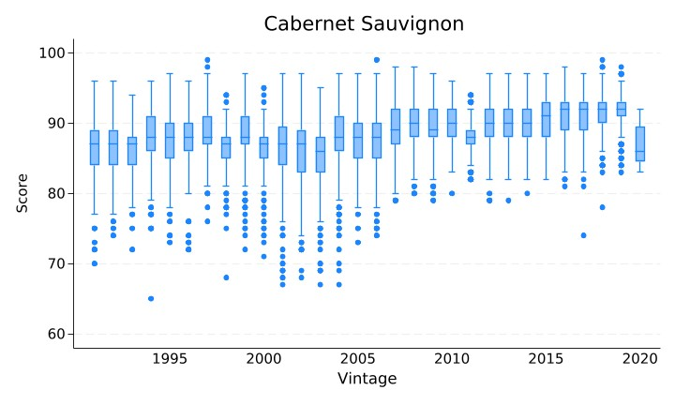

(a) Score

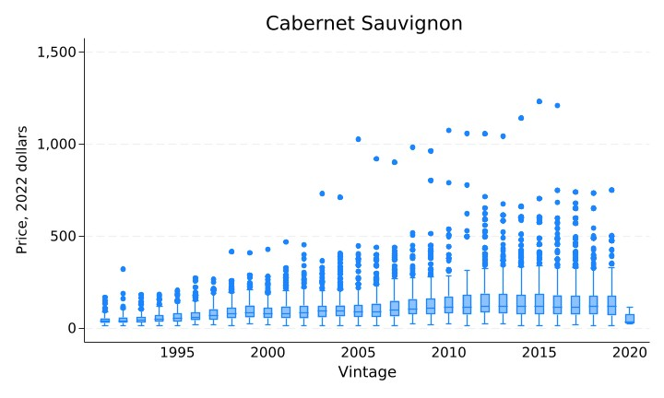

(b) Price (2022 dollars/bottle)

Figure 13 Wine scores and prices by vintage, Cabernet Sauvignon

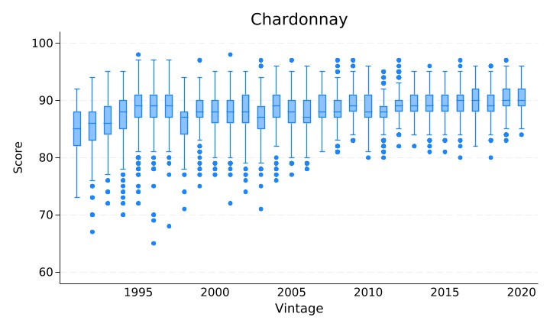

(a) Score

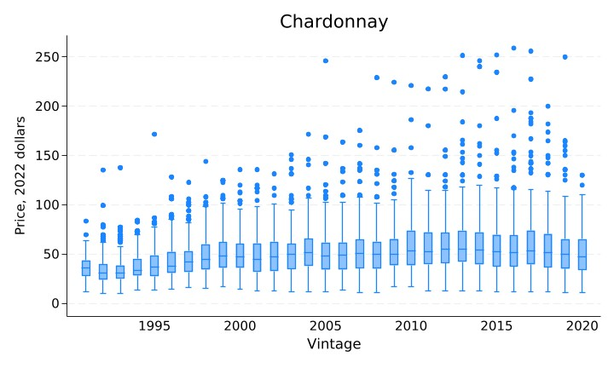

(b) Price (2022 dollars/bottle)

Figure 14 Wine scores and prices by vintage, Chardonnay

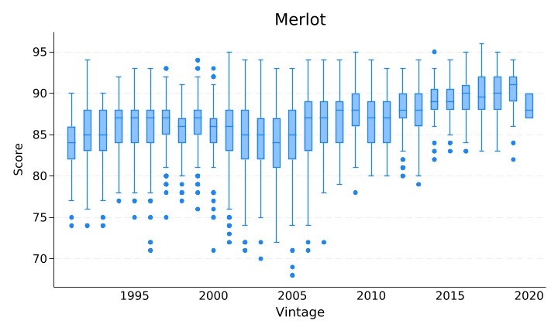

(a) Score

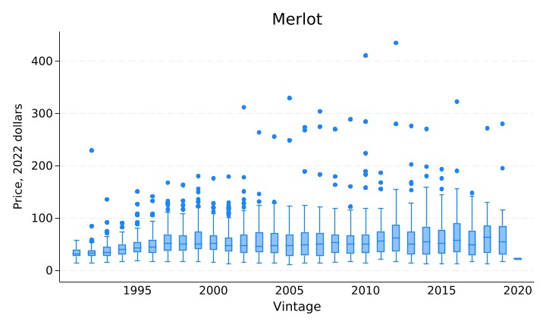

(b) Price (2022 dollars/bottle)

Figure 15 Wine scores and prices by vintage, Merlot

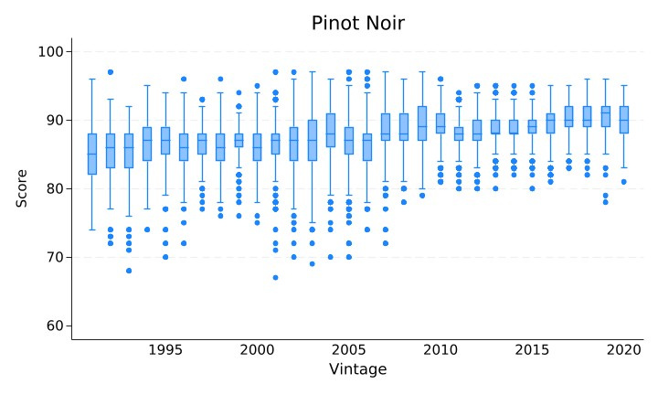

(a) Score

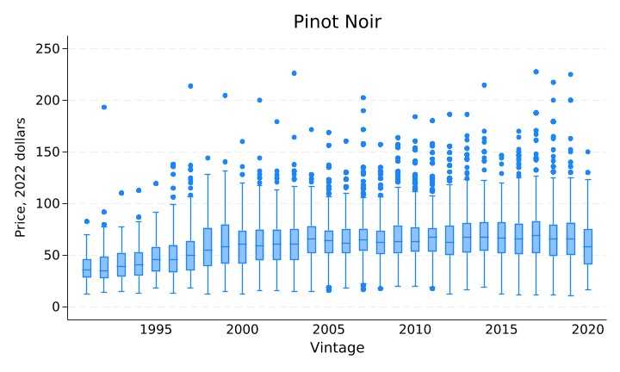

(b) Price (2022 dollars/bottle)

Figure 16 Wine scores and prices by vintage, Pinot Noir

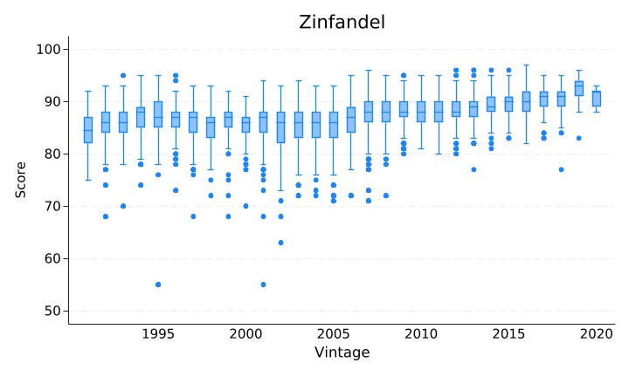

(a) Score

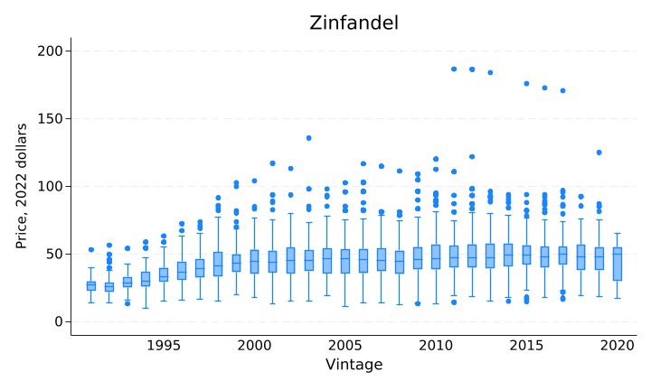

(b) Price (2022 dollars/bottle)

Figure 17 Wine scores and prices by vintage, Zinfandel

## Summary Statistics by Region and Grape Variety

Table 3a. Summary Statistics: All Varieties

|  |  |  |  |  |  |  |  |  |  |
| --- | --- | --- | --- | --- | --- | --- | --- | --- | --- |
| Region | Average Temp.  Apr–Oct | WS  No. of Obs. | WS  Average  Price | WS  Average Score | WS  Cases Made | WS Average “Age” | K&L  No. of Obs. | K&L  Average  Price | K&L Average “Age” |
|  | *oC* | *Count* | *$/bottle* | *points* | *Average* | *Years* | *Count* | *$/bottle* | *Years* |
| **North Coast AVAs** | 17.9 | 36,718 | 76.9 | 88.4 | 3,977 | 3.0 | 44,039 | 250.3 | 11.8 |
| ***Napa Valley AVAs*** | 18.4 | 19,238 | 93.6 | 88.5 | 4,433 | 3.3 | 28,363 | 328.3 | 13.7 |
| Oakville | 18.5 | 921 | 155.8 | 90.3 | 1,969 | 3.6 | 1,659 | 184.8 | 10.4 |
| Rutherford | 18.6 | 817 | 130.9 | 89.4 | 2,481 | 3.5 | 561 | 204.2 | 12.8 |
| Howell Mountain | 18.2 | 688 | 105.9 | 89.1 | 1,069 | 3.5 | 2,051 | 199.6 | 15.6 |
| Stags Leap District | 18.3 | 480 | 123.1 | 89.3 | 2,314 | 4.0 | 2,042 | 289.5 | 12.4 |
| St Helena | 19.2 | 378 | 146.4 | 90.5 | 822 | 3.4 | 175 | 127.6 | 8.4 |
| Mt Veeder | 18.4 | 323 | 99.8 | 89.3 | 1,261 | 3.4 | 45 | 111.6 | 11.0 |
| Other NV AVAs | 18.8 | 1,141 | 70.7 | 88.2 | 3,752 | 2.7 | 497 | 113.3 | 7.2 |
| Napa Valley | 18.4 | 11,464 | 90.4 | 88.2 | 5,517 | 3.4 | 20,589 | 375.0 | 14.4 |
| ***Sonoma Coast AVAs*** | 17.3 | 15,558 | 59.5 | 88.4 | 3,006 | 2.7 | 15,422 | 109.9 | 8.4 |
| Russian River Valley | 17.0 | 6,259 | 59.7 | 88.6 | 2,323 | 2.5 | 4,207 | 90.2 | 7.7 |
| Sonoma Valley | 17.3 | 1,473 | 55.9 | 87.6 | 2,269 | 3.0 | 724 | 87.5 | 12.2 |
| Dry Creek Valley | 18.2 | 1,688 | 42.6 | 86.9 | 2,350 | 2.8 | 450 | 63.2 | 10.6 |
| Alexander Valley | 18.2 | 1,568 | 50.3 | 87.1 | 7,506 | 3.1 | 707 | 77.0 | 16.4 |
| Other SC AVAs | 18.2 | 1,175 | 74.2 | 89.2 | 3,882 | 2.8 | 1,659 | 133.2 | 7.9 |
| Sonoma Coast | 17.0 | 3,395 | 68.3 | 89.4 | 2,531 | 2.5 | 7,675 | 123.6 | 7.6 |
| ***Other NC AVAs*** | 17.7 | 1,922 | 49.6 | 87.1 | 7,269 | 2.6 | 254 | 65.5 | 8.1 |
| Anderson Valley | 17.5 | 1,020 | 62.0 | 88.3 | 1,125 | 2.5 | 144 | 72.4 | 7.9 |
|  |  |  |  |  |  |  |  |  |  |
| **Central Coast AVAs** | 17.5 | 7,852 | 52.2 | 87.3 | 6,414 | 2.5 | 3,803 | 171.2 | 12.7 |
| Sta. Rita Hills | 17.3 | 1,462 | 63.1 | 88.9 | 1,041 | 2.4 | 66 | 78.1 | 6.2 |
| Sta. Lucia Highlands | 16.8 | 1,319 | 63.5 | 88.8 | 1,732 | 2.3 | 491 | 91.4 | 6.8 |
| Paso Robles | 19.0 | 1,020 | 39.4 | 85.8 | 10,341 | 2.7 | 136 | 48.3 | 9.3 |
| Other CC AVAs | 17.5 | 4,051 | 47.8 | 86.7 | 8,889 | 2.5 | 3,110 | 191.1 | 13.9 |
|  |  |  |  |  |  |  |  |  |  |
| **All Coastal Regions** | 17.9 | 44,570 | 72.5 | 88.2 | 4,406 | 2.9 | 47,842 | 244.0 | 11.9 |

Notes: Summary statistics for premium growing regions in California using PRISM data for average temperature, and winery-vintage observations for Wine Spectator data for vintages between 1991 and 2020 and for K&L data for vintages between 1981 and 2020. Averages are simple averages across the relevant sample—so effectively weighted by shares of observations in sub-regions.

Table 3b. Summary Statistics: Cabernet Sauvignon

|  |  |  |  |  |  |  |  |  |  |
| --- | --- | --- | --- | --- | --- | --- | --- | --- | --- |
| Region | Average Temp.  Apr–Oct | WS  No. of Obs. | WS  Average  Price | WS  Average Score | WS  Cases Made | WS Average “Age” | K&L  No. of Obs. | K&L  Average  Price | K&L Average “Age” |
|  | °*C* | *Count* | *$/bottle* | *points* | *Average* | *Years* | *Count* | *$/bottle* | *Years* |
| **North Coast AVAs** | 18.4 | 12,087 | 118.0 | 89.0 | 4,618 | 3.8 | 28,311 | 329.6 | 14.1 |
| ***Napa Valley AVAs*** | 18.5 | 10,459 | 126.7 | 89.4 | 3,879 | 3.8 | 26,362 | 346.1 | 14.0 |
| Oakville | 18.5 | 828 | 166.4 | 90.6 | 1,987 | 3.6 | 1,655 | 185.1 | 10.4 |
| Rutherford | 18.6 | 666 | 144.8 | 89.6 | 2,713 | 3.7 | 550 | 204.6 | 13.0 |
| Howell Mountain | 18.2 | 431 | 133.6 | 89.8 | 1,029 | 3.8 | 1,895 | 210.8 | 15.6 |
| Stags Leap District | 18.3 | 396 | 134.2 | 89.7 | 2,491 | 4.2 | 2,042 | 289.5 | 12.4 |
| St Helena | 19.2 | 309 | 165.1 | 91.0 | 881 | 3.5 | 175 | 127.6 | 8.4 |
| Mt Veeder | 18.4 | 206 | 123.4 | 89.7 | 1,486 | 3.7 | 45 | 111.6 | 11.0 |
| Other NV AVAs | 18.8 | 910 | 128.0 | 89.7 | 1,217 | 3.6 | 470 | 132.9 | 9.4 |
| Napa Valley | 18.4 | 6,713 | 117.3 | 89.0 | 5,065 | 3.9 | 19,530 | 390.4 | 14.5 |
| ***Sonoma Coast AVAs*** | 17.8 | 1,478 | 65.3 | 86.9 | 7,830 | 3.6 | 1,949 | 106.6 | 14.9 |
| Russian River Valley | 17.0 | 48 | 46.9 | 86.3 | 1,645 | 3.4 | 23 | 53.8 | 12.9 |
| Sonoma Valley | 17.3 | 257 | 69.7 | 87.0 | 3,267 | 3.7 | 128 | 77.0 | 26.5 |
| Dry Creek Valley | 18.2 | 192 | 56.7 | 86.2 | 2,822 | 3.5 | 175 | 84.9 | 11.3 |
| Alexander Valley | 18.2 | 751 | 60.3 | 86.6 | 10,419 | 3.6 | 651 | 80.1 | 17.3 |
| Other SC AVAs | 18.2 | 230 | 87.5 | 88.6 | 9,945 | 3.6 | 80 | 80.3 | 20.8 |
| Sonoma Coast | 17.0 | 0 | . | . | . | . | 892 | 138.1 | 11.8 |
| ***Other NC AVAs*** | 18.1 | 150 | 31.5 | 85.1 | 24,518 | 3.0 | 0 |  |  |
| Anderson Valley | 17.5 | 7 | 45.4 | 88.1 | 501 | 3.1 | 0 |  |  |
|  |  |  |  |  |  |  |  |  |  |
| **Central Coast AVAs** | 17.7 | 724 | 55.0 | 85.6 | 16,366 | 3.3 | 2,525 | 218.2 | 14.5 |
| Sta. Rita Hills | 17.3 | 0 |  |  |  |  | 0 |  |  |
| Sta. Lucia Highlands | 16.8 | 10 | 33.6 | 84.0 | 4,278 | 3.0 | 0 |  |  |
| Paso Robles | 19.0 | 297 | 41.5 | 85.4 | 28,125 | 3.1 | 0 |  |  |
| Other CC AVAs | 17.6 | 417 | 65.2 | 85.8 | 8,280 | 3.4 | 2,525 | 218.2 | 14.5 |
|  |  |  |  |  |  |  |  |  |  |
| **All Coastal Regions** | 18.3 | 12,811 | 114.4 | 88.8 | 5,282 | 3.7 | 30,836 | 320.5 | 14.1 |

Notes: Summary statistics for premium growing regions in California using PRISM data for average temperature, and winery-vintage observations for Wine Spectator data for vintages between 1991 and 2020 and for K&L data for vintages between 1981 and 2020. Averages are simple averages across the relevant sample—so effectively weighted by shares of Cabernet Sauvignon observations in sub-regions.

Table 3c. Summary Statistics: Chardonnay

|  |  |  |  |  |  |  |  |  |  |
| --- | --- | --- | --- | --- | --- | --- | --- | --- | --- |
| Region | Average Temp.  Apr–Oct | WS  No. of  Obs. | WS  Average  Price | WS  Average  Score | WS  Cases  Made | WS  Average  “Age” | K&L  No. of Obs. | K&L  Average  Price. | K&L  Average  “Age” |
|  | *oC* | *Count* | *$/bottle* | *points* | *Average* | *Years* | *Count* | *$/bottle* | *Years* |
| **North Coast AVAs** | 17.5 | 8,033 | 54.1 | 88.6 | 5,955 | 2.3 | 5,993 | 123.1 | 6.3 |
| ***Napa Valley AVAs*** | 17.8 | 3,532 | 50.8 | 88.2 | 6,798 | 2.3 | 1,011 | 111.8 | 5.5 |
| Rutherford | 18.6 | 63 | 72.8 | 89.3 | 1,104 | 2.1 | 7 | 271.7 | 2.4 |
| Howell Mountain | 18.2 | 32 | 52.3 | 86.7 | 1,110 | 2.0 | 0 | . | . |
| Stags Leap District | 18.3 | 21 | 55.1 | 87.5 | 1,327 | 2.2 | 0 | . | . |
| Mt Veeder | 18.4 | 37 | 59.6 | 89.4 | 1,071 | 2.6 | 0 | . | . |
| Other NV AVAs | 18.5 | 1,592 | 51.4 | 88.6 | 5,897 | 2.3 | 669 | 108.6 | 5.1 |
| Napa Valley | 18.4 | 1,787 | 49.2 | 87.8 | 8,087 | 2.2 | 335 | 115.0 | 6.2 |
| ***Sonoma Coast AVAs*** | 17.3 | 4,217 | 58.1 | 89.1 | 4,124 | 2.4 | 4,978 | 125.5 | 6.4 |
| Russian River Valley | 17.0 | 2,095 | 54.5 | 88.9 | 3,510 | 2.4 | 1,023 | 106.4 | 6.3 |
| Sonoma Valley | 17.3 | 333 | 57.7 | 88.6 | 3,052 | 2.5 | 381 | 108.4 | 8.4 |
| Dry Creek Valley | 18.2 | 81 | 30.3 | 86.0 | 4,079 | 2.3 | 0 | . | . |
| Alexander Valley | 18.2 | 265 | 42.2 | 88.4 | 8,310 | 2.4 | 0 | . | . |
| Knights Valley | 18.7 | 87 | 110.1 | 91.1 | 1,289 | 2.3 | 1,207 | 138.9 | 7.3 |
| Other SC AVAs | 18.4 | 307 | 67.7 | 90.0 | 5,331 | 2.5 | 146 | 80.2 | 8.5 |
| Sonoma Coast | 17.0 | 1,049 | 64.4 | 89.8 | 4,520 | 2.5 | 2,221 | 132.9 | 5.6 |
| ***Other NC AVAs*** | 18.0 | 284 | 35.3 | 86.7 | 22,652 | 2.2 | 4 | 66.2 | 4.2 |
| Anderson Valley | 17.5 | 102 | 41.5 | 87.4 | 1,318 | 2.4 | 3 | 73.2 | 4.3 |
|  |  |  |  |  |  |  |  |  |  |
| **Central Coast AVAs** | 17.4 | 2,280 | 42.1 | 87.6 | 10,189 | 2.3 | 146 | 56.1 | 7.8 |
| Santa Cruz Mnts | 17.5 | 196 | 48.7 | 88.4 | 1,426 | 2.5 | 124 | 60.1 | 7.6 |
| Sta. Rita Hills | 17.3 | 330 | 51.7 | 88.8 | 1,340 | 2.4 | 2 | 67.5 | 6.0 |
| Sta. Lucia Highlands | 16.8 | 264 | 49.6 | 88.8 | 3,595 | 2.2 | 10 | 24.4 | 8.5 |
| Paso Robles | 19.0 | 51 | 25.8 | 82.6 | 4,327 | 1.9 | 0 | . | . |
| Other CC AVAs | 17.5 | 1,439 | 38.2 | 87.2 | 14,829 | 2.3 | 10 | 35.0 | 10.4 |
|  |  |  |  |  |  |  |  |  |  |
| **All Coastal Regions** | 17.5 | 10,313 | 51.4 | 88.4 | 6,891 | 2.3 | 6,139 | 121.5 | 6.3 |

Notes: Summary statistics for premium growing regions in California using PRISM data for average temperature, and winery-vintage observations for Wine Spectator data for vintages between 1991 and 2020 and for K&L data for vintages between 1981 and 2020. Averages are simple averages across the relevant sample—so effectively weighted by shares of Chardonnay observations in sub-regions.

## Sample Selection Bias

To estimate whether our sample potentially suffers from selection bias, we estimate the following model using OLS:

$$pr\left(observe wine\right)=α_{wr}+\sum_{d=1}^{D}{β_{d}{DD}_{drv}+ρ_{1}{ppt}_{rv}+ρ_{2}{ppt}_{rv}^{2}+θ_{1}v{+θ}_{2}v^{2}+ψ_{t}+ϵ_{wrvt}},$$

where Pr(observe wine) is the probability of observing a wine from a given winery, and all other variables are the same as those in our main model (Equation 2).

Table 9 shows the results from estimating the above model using two datasets: the first is our main dataset of auction prices for ultra-premium California Cabernet Sauvignon wines from K&L, and the second dataset is a collection of recommended retail prices at release for premium California Cabernet Sauvignon wines from the Wine Spectator magazine.

The probability of observing a wine from a given winery in our K&L dataset does depend on temperature exposure during the vintage but the magnitudes of the effects are small. Hot temperatures in Aug-Oct, and cold temperatures in Feb-Oct cause a statistically significant decrease in the likelihood that a wine will be observed. A one-standard-deviation increase in DD 30ºC to 35ºC Aug-Oct decreases the likelihood that a wine will be observed by 0.11 percent. A one-standard-deviation increase in DD >35ºC Aug-Oct decreases the likelihood a wine will be observed by 0.14 percent. A one-standard-deviation increase in DD <-2ºC Feb-Oct decreases the likelihood that a wine will be observed by 1.68 percent. While these measured effects are statistically significant, the economic implications are small.

We find very similar results when we use the same approach with recommended retail prices from Wine Spectator magazine. A one-standard-deviation increase in DD 30ºC to 35ºC Aug-Oct decreases the likelihood that a wine will be observed by 0.23 percent. A one-standard-deviation increase in DD >35ºC Aug-Oct decreases the likelihood that a wine will be observed by 0.18 percent. A one-standard-deviation increase in DD <-2ºC Feb-Oct decreases the likelihood that a wine will be observed by 1.08 percent.

Table 9 Estimated effect of degree day variables on the probability of observing a Cabernet Sauvignon wine from a given winery, California, K&L and Wine Spectator datasets

|  |  |  |
| --- | --- | --- |
|  | (1) | (2) |
|  | K&L | Wine Spectator |
| DD <-2°C Feb-Oct | -0.0714*** | -0.0298** |
|  | (0.0196) | (0.0123) |
|  | {-1.679} | {-1.076} |
|  |  |  |
| DD -2°C to 10°C Feb-Oct | -0.0003** | -0.0008*** |
|  | (0.0001) | (0.0001) |
|  | {-0.008} | {-0.028} |
|  |  |  |
| DD 30°C to 35°C Apr-Jul | -0.0003 | -0.0007 |
|  | (0.0009) | (0.0006) |
|  | {-0.006} | {-0.026} |
|  |  |  |
| DD 30°C to 35°C Aug-Oct | -0.0045*** | -0.0062*** |
|  | (0.0009) | (0.0008) |
|  | {-0.108} | {-0.228} |
|  |  |  |
| DD >35°C Apr-Jul | -0.0016 | -0.0007 |
|  | (0.0015) | (0.0011) |
|  | {-0.040} | {-0.024} |
|  |  |  |
| DD >35°C Aug-Oct | -0.0057*** | -0.0049*** |
|  | (0.0017) | (0.0006) |
|  | {-0.139} | {-0.181} |
| R2 | 0.712 | 0.377 |
| Observations | 43360 | 59218 |

Notes: Each column shows the results from a separate regression model for the dataset as identified in the column header, using winery-vintage observations for Cabernet Sauvignon in California. Includes winery-by-region fixed effects, linear and quadratic vintage year, year fixed effect (auction year for K&L, issue year for WS), quadratic function of wine age, and quadratic function of growing-season precipitation. The reported estimates are the effect of a one unit increase in the explanatory variable (identified in the row label) on the probability of observing a wine from a winery. Standard errors for the reported estimates in parentheses are heteroskedastic robust and clustered by region. Marginal effects in curly brackets show the change in probability caused by a one within-winery standard deviation increase in the explanatory variable. Significance: * p<0.05, ** p<0.01, *** p<0.001.

## Results by Region and Grape Variety

Table 4a. Estimated effect of degree days indices on natural logarithm of wine prices from K&L by region, Cabernet Sauvignon

|  |  |  |  |  |
| --- | --- | --- | --- | --- |
|  | (1) | (2) | (3) | (4) |
|  | All regions | Napa AVAs | Sonoma AVAs | Central Coast AVAs |
| DD <-2°C Feb-Oct | -0.0928* | -0.1007*** | -0.0656 | -0.1090 |
|  | (0.0495) | (0.0230) | (0.0386) | (0.0765) |
|  | {-1.054} | {-1.098} | {-1.263} | {-0.738} |
|  |  |  |  |  |
| DD -2°C to 10°C Feb-Oct | -0.0006*** | -0.0006*** | 0.0001 | -0.0009** |
|  | (0.0001) | (0.0001) | (0.0003) | (0.0003) |
|  | {-2.039} | {-2.003} | {0.243} | {-3.371} |
|  |  |  |  |  |
| DD 30°C to 35°C Apr-Jul | -0.0007 | -0.0013* | -0.0003 | 0.0154*** |
|  | (0.0007) | (0.0006) | (0.0021) | (0.0039) |
|  | {-0.390} | {-0.779} | {-0.157} | {7.127} |
|  |  |  |  |  |
| DD 30°C to 35°C Aug-Oct | -0.0062*** | -0.0059*** | -0.0141*** | -0.0090*** |
|  | (0.0011) | (0.0012) | (0.0029) | (0.0022) |
|  | {-2.820} | {-2.681} | {-6.053} | {-4.258} |
|  |  |  |  |  |
| DD >35°C Apr-Jul | -0.0089*** | -0.0084*** | -0.0110** | -0.0318*** |
|  | (0.0020) | (0.0015) | (0.0044) | (0.0061) |
|  | {-2.353} | {-2.261} | {-2.258} | {-7.643} |
|  |  |  |  |  |
| DD >35°C Aug-Oct | -0.0056** | -0.0050** | 0.0097* | -0.0019 |
|  | (0.0024) | (0.0022) | (0.0051) | (0.0044) |
|  | {-1.271} | {-1.150} | {2.015} | {-0.427} |
|  |  |  |  |  |
| Precipitation | -2.0267*** | -2.1282*** | 0.2547 | -3.6476*** |
|  | (0.2542) | (0.2242) | (0.6080) | (0.5736) |
|  | {-5.488} | {-5.480} | {1.882} | {-6.935} |
|  |  |  |  |  |
| Precipitation squared | 4.4220*** | 4.7157*** | -1.5620 | 9.2921*** |
|  | (0.7962) | (0.6779) | (1.6795) | (1.7264) |
|  | {165.678} | {216.517} | {-1.961} | {23696.590} |
|  |  |  |  |  |
| Wine age | -0.0246*** | -0.0299*** | -0.0360** | 0.0502*** |
|  | (0.0070) | (0.0054) | (0.0159) | (0.0132) |
|  | {-16.966} | {-20.199} | {-19.524} | {45.056} |
|  |  |  |  |  |
| Wine age squared | 0.0005*** | 0.0006*** | 0.0001 | -0.0003 |
|  | (0.0001) | (0.0002) | (0.0004) | (0.0004) |
|  | {14.129} | {15.913} | {2.913} | {-8.541} |
|  |  |  |  |  |
| Vintage year | 0.0021 | 0.0006 | -0.0523*** | 0.0563*** |
|  | (0.0065) | (0.0068) | (0.0109) | (0.0120) |
|  | {1.492} | {0.413} | {-28.121} | {50.729} |
|  |  |  |  |  |
| Vintage year squared | -0.0002 | -0.0001 | 0.0005 | -0.0006** |
|  | (0.0001) | (0.0001) | (0.0003) | (0.0003) |
|  | {-5.126} | {-4.398} | {11.807} | {-24.146} |
|  |  |  |  |  |
| Constant | 5.9426*** | 6.0834*** | 6.1519*** | 4.1058*** |
|  | (0.1655) | (0.0498) | (0.1353) | (0.0697) |
|  | {.} | {.} | {.} | {.} |
| R2 | 0.820 | 0.832 | 0.563 | 0.246 |
| Winery fixed effects | ✓ | ✓ | ✓ | ✓ |
| Auction year fixed effects | ✓ | ✓ | ✓ | ✓ |
| Observations | 30649 | 26178 | 1925 | 2525 |

Notes: Each column shows the results from a separate regression model for all regions or sub-regions as identified in the column header, using winery-vintage observations for Cabernet Sauvignon from 1981 to 2020. Includes winery-by-region fixed effects, linear and quadratic vintage year, auction year fixed effect, quadratic function of wine age, and quadratic function of growing-season precipitation. The reported estimates are the effect of a one unit increase in the explanatory variable (identified in the row label) on the natural logarithm of wine prices. Standard errors for the reported estimates in parentheses are heteroskedastic robust and clustered by region and vintage-coastal group. Marginal effects in curly brackets show the percentage change in price caused by a one within-winery standard deviation increase in the explanatory variable. Significance: * p<0.05, ** p<0.01, *** p<0.001.

Table 4b. Estimated effect of degree-days indices on natural logarithm of wine prices from K&L by region, Chardonnay

|  |  |  |  |  |
| --- | --- | --- | --- | --- |
|  | (1) | (2) | (3) | (4) |
|  | All regions | Napa AVAs | Sonoma AVAs | Central Coast AVAs |
| DD <-2°C Feb-Oct | 0.0340 | -0.4217*** | 0.1292 | -7.6656 |
|  | (0.1045) | (0.1222) | (0.0980) | (4.5928) |
|  | {0.216} | {-1.969} | {0.931} | {-0.789} |
|  |  |  |  |  |
| DD -2°C to 10°C Feb-Oct | -0.0014** | -0.0005 | -0.0017*** | -0.0013 |
|  | (0.0005) | (0.0003) | (0.0003) | (0.0014) |
|  | {-4.703} | {-1.544} | {-5.552} | {-4.755} |
|  |  |  |  |  |
| DD 30°C to 35°C Apr-Jul | -0.0023 | -0.0059** | -0.0027 | -0.0410* |
|  | (0.0017) | (0.0027) | (0.0018) | (0.0210) |
|  | {-1.013} | {-2.245} | {-1.242} | {-14.608} |
|  |  |  |  |  |
| DD 30°C to 35°C Aug-Oct | -0.0023 | -0.0004 | -0.0039* | -0.0156 |
|  | (0.0021) | (0.0035) | (0.0018) | (0.0178) |
|  | {-1.152} | {-0.208} | {-1.982} | {-6.768} |
|  |  |  |  |  |
| DD >35°C Apr-Jul | 0.0019 | 0.0206*** | -0.0011 | 0.0790*** |
|  | (0.0054) | (0.0064) | (0.0050) | (0.0238) |
|  | {0.337} | {2.965} | {-0.207} | {15.149} |
|  |  |  |  |  |
| DD >35°C Aug-Oct | -0.0072** | -0.0075* | -0.0069 | -0.0018 |
|  | (0.0028) | (0.0038) | (0.0042) | (0.0212) |
|  | {-2.140} | {-2.062} | {-2.130} | {-0.517} |
|  |  |  |  |  |
| Precipitation | -0.4560 | 0.4732 | -0.7931** | -2.8298 |
|  | (0.3442) | (0.5143) | (0.2799) | (2.6221) |
|  | {-2.537} | {2.676} | {-4.083} | {-5.694} |
|  |  |  |  |  |
| Precipitation squared | -0.3837 | -1.7056 | 0.2452 | 8.9392 |
|  | (0.7723) | (2.0949) | (0.7607) | (8.4257) |
|  | {-0.858} | {-0.894} | {0.822} | {13092.339} |
|  |  |  |  |  |
| Wine age | -0.0574*** | -0.0489*** | -0.0571*** | 0.0862** |
|  | (0.0123) | (0.0145) | (0.0152) | (0.0266) |
|  | {-18.846} | {-13.392} | {-19.747} | {35.140} |
|  |  |  |  |  |
| Wine age squared | 0.0018*** | 0.0013 | 0.0017** | -0.0040** |
|  | (0.0004) | (0.0009) | (0.0008) | (0.0015) |
|  | {13.867} | {8.431} | {13.613} | {-53.629} |
|  |  |  |  |  |
| Vintage year | 0.1021*** | 0.0518 | 0.1064** | -0.2530** |
|  | (0.0324) | (0.0560) | (0.0456) | (0.0945) |
|  | {36.342} | {14.922} | {39.901} | {-87.285} |
|  |  |  |  |  |
| Vintage year squared | -0.0018*** | -0.0010 | -0.0019** | 0.0041** |
|  | (0.0005) | (0.0009) | (0.0007) | (0.0015) |
|  | {-34.890} | {-16.034} | {-38.332} | {83.027} |
|  |  |  |  |  |
| Constant | 4.0075*** | 4.4087*** | 4.1384*** | 8.3192*** |
|  | (0.5129) | (0.9208) | (0.6769) | (1.8251) |
|  | {.} | {.} | {.} | {.} |
| R2 | 0.614 | 0.793 | 0.415 | 0.529 |
| Winery fixed effects | ✓ | ✓ | ✓ | ✓ |
| Auction year fixed effects | ✓ | ✓ | ✓ | ✓ |
| Observations | 6123 | 1005 | 3952 | 145 |

Notes: Each column shows the results from a separate regression model for all regions or sub-regions as identified in the column header, using winery-vintage observations for Chardonnay from 1981 to 2020. Includes winery-by-region fixed effects, linear and quadratic vintage year, auction year fixed effect, quadratic function of wine age, and quadratic function of growing-season precipitation. The reported estimates are the effect of a one unit increase in the explanatory variable (identified in the row label) on the natural logarithm of wine prices. Standard errors for the reported estimates in parentheses are heteroskedastic robust and clustered by region. Marginal effects in curly brackets show the percentage change in price caused by a one within-winery standard deviation increase in the explanatory variable. Significance: * p<0.05, ** p<0.01, *** p<0.001.

## Testing for differences in coefficients estimates across wine varieties

Table 12 shows the estimated effect of degree days indices on the natural logarithm of wine prices from K&L (same as Table 4). It also shows results from testing for differences in the coefficients when the model is estimated for each wine variety individually compared with those from the full sample, including all five wines.

Coefficients on the key degree day variables estimated using Cabernet Sauvignon and Chardonnay wine prices were not significantly different from those from the model using the full sample across all five varieties. The estimates for Cabernet Sauvignon were similar in terms of magnitude and significance to those for the full sample, in part because Cabernet Sauvignon wines comprise more than 60 percent of the total K&L sample. For Chardonnay, the coefficient estimates were all of the same sign as those from the full sample model, but some estimates differed in terms of magnitude or statistically significance.

For Pinot Noir, some coefficient estimates differed in terms of magnitude and direction—for example, DD 30ºC to 35ºC Apr-Jul and DD 30ºC to 35ºC Aug-Oct and DD >35ºC Aug to Oct—but these estimates were statistically insignificant and not significantly different from those for the full sample model.

Some coefficient estimates for Merlot and Zinfandel were statistically significantly different from those estimated on the full sample. The results suggest Zinfandel was significantly more sensitive to exposure to cool temperatures. For Merlot, the estimated effects of DD 30ºC to 35ºC Apr-Jul and DD 30ºC to 35ºC Aug-Oct were positive and significantly different from the estimated effects for the full sample. The estimates of other coefficients for Merlot and Zinfandel were broadly similar to those from the full sample although generally less statistically significant, perhaps reflecting the smaller sample size for models using only those wine varieties.

Testing at all DD coefficients jointly, we found that the degree day coefficients for Pinot Noir, Merlot, and Zinfandel were significantly different from the coefficients estimated using all varieties at the 1% level.

Table 12 Testing if coefficient estimates from variety-specific models were significantly different from all varieties model

|  |  |  |  |  |  |  |
| --- | --- | --- | --- | --- | --- | --- |
|  | (1) | (2) | (3) | (4) | (5) | (6) |
|  | All varieties | Cabernet Sauvignon | Chardonnay | Pinot Noir | Merlot | Zinfandel |
| DD <-2°C Feb-Oct | -0.0329 | -0.0928* | 0.0340 | 0.0097 | 0.0007 | -0.2034*** |
|  |  | [0.055] | [0.077] | [-0.039] | [-0.039] | [0.169] |
|  |  | {0.128} | {0.646} | {0.287} | {0.536} | {0.001} |
|  |  |  |  |  |  |  |
| DD -2°C to 10°C Feb-Oct | -0.0007*** | -0.0006*** | -0.0014** | -0.0008** | -0.0019** | -0.0000 |
|  |  | [-0.000] | [0.000] | [-0.000] | [0.001] | [-0.001] |
|  |  | {0.661} | {0.284} | {0.702} | {0.000} | {0.040} |
|  |  |  |  |  |  |  |
| DD 30°C to 35°C Apr-Jul | -0.0005 | -0.0007 | -0.0023 | -0.0027 | 0.0122** | -0.0035 |
|  |  | [0.001] | [-0.001] | [-0.002] | [-0.012] | [0.002] |
|  |  | {0.322} | {0.725} | {0.553} | {0.000} | {0.429} |
|  |  |  |  |  |  |  |
| DD 30°C to 35°C Aug-Oct | -0.0035** | -0.0062*** | -0.0023 | 0.0029 | 0.0079 | -0.0022 |
|  |  | [0.003] | [0.000] | [-0.005] | [-0.012] | [-0.002] |
|  |  | {0.066} | {0.863} | {0.090} | {0.002} | {0.315} |
|  |  |  |  |  |  |  |
| DD >35°C Apr-Jul | -0.0062*** | -0.0089*** | 0.0019 | -0.0051 | -0.0090 | 0.0047 |
|  |  | [0.002] | [-0.003] | [0.004] | [0.002] | [-0.010] |
|  |  | {0.268} | {0.565} | {0.462} | {0.624} | {0.000} |
|  |  |  |  |  |  |  |
| DD >35°C Aug-Oct | -0.0063*** | -0.0056** | -0.0072** | 0.0022 | -0.0249 | -0.0005 |
|  |  | [-0.000] | [0.001] | [-0.012] | [0.019] | [-0.005] |
|  |  | {0.997} | {0.560} | {0.018} | {0.047} | {0.205} |
|  |  |  |  |  |  |  |
| Precipitation | -1.4026*** | -2.0267*** | -0.4560 | 0.6694* | -0.3080 | -0.7786 |
|  |  | [0.730] | [-0.730] | [-1.817] | [-0.990] | [-1.208] |
|  |  | {0.010} | {0.188} | {0.000} | {0.360} | {0.077} |
|  |  |  |  |  |  |  |
| Precipitation squared | 2.8158** | 4.4220*** | -0.3837 | -1.2830* | 1.0560 | 1.0211 |
|  |  | [-1.858] | [2.443] | [3.507] | [1.509] | [3.399] |
|  |  | {0.006} | {0.048} | {0.000} | {0.653} | {0.063} |
|  |  |  |  |  |  |  |
| Wine age | -0.0379*** | -0.0246*** | -0.0574*** | -0.0526*** | -0.0623** | -0.0376*** |
|  |  | [-0.016] | [0.019] | [0.014] | [0.021] | [0.002] |
|  |  | {0.015} | {0.118} | {0.113} | {0.415} | {0.853} |
|  |  |  |  |  |  |  |
| Wine age squared | 0.0008*** | 0.0005*** | 0.0018*** | 0.0005** | 0.0008*** | 0.0012*** |
|  |  | [0.000] | [-0.001] | [0.000] | [0.000] | [-0.000] |
|  |  | {0.012} | {0.008} | {0.216} | {0.823} | {0.164} |
|  |  |  |  |  |  |  |
| Vintage year | 0.0100 | 0.0021 | 0.1021** | -0.0464*** | 0.0073 | 0.0257 |
|  |  | [0.008] | [-0.093] | [0.059] | [0.003] | [0.000] |
|  |  | {0.055} | {0.001} | {0.000} | {0.874} | {0.999} |
|  |  |  |  |  |  |  |
| Vintage year squared | -0.0004** | -0.0002 | -0.0018*** | -0.0000 | -0.0006*** | -0.0008 |
|  |  | [-0.000] | [0.001] | [-0.001] | [0.000] | [0.000] |
|  |  | {0.039} | {0.001} | {0.027} | {0.221} | {0.846} |
|  |  |  |  |  |  |  |
| Constant | 5.9163*** | 5.9426*** | 4.0075*** | 6.4650*** | 5.1910*** | 4.1793*** |
|  |  | [0.066] | [1.980] | [-1.374] | [0.411] | [0.834] |
|  |  | {0.508} | {0.000} | {0.000} | {0.587} | {0.070} |
| Joint test DD vars |  | {0.023} | {0.059} | {0.000} | {0.000} | {0.000} |
| R2 | 0.810 | 0.820 | 0.614 | 0.569 | 0.603 | 0.400 |
| Observations | 47662 | 30649 | 6123 | 8688 | 805 | 1350 |

Notes: Each column shows the results from a separate regression model for the varietal wine identified in the column header, using winery-vintage observations from all premium growing regions in California from 1981 to 2020. Includes winery-by-region fixed effects, linear and quadratic vintage year, auction year fixed effect, quadratic function of wine age, and quadratic function of growing-season precipitation. The reported estimates are the effect of a one unit increase in the explanatory variable (identified in the row label) on the natural logarithm of wine prices. The value in square brackets is the difference between the coefficient estimate for all varieties in column 1 and the coefficient estimate for the varietal wine identified in the column header. The value in curly brackets is the p-value testing whether the difference between the coefficient estimates in square brackets is significantly different from zero, taking into account uncertainty in the estimated effects. The row labelled “Joint test DD vars” is the p-value from the joint test of the restriction that all degree day coefficients are equal to the corresponding coefficients in the model of all varieties, taking into account uncertainty in the estimated effects. Significance: * p<0.05, ** p<0.01, *** p<0.001.