Supplementary materials

1. The role of participants’ gender on the similarity ratings

To address the potential effects of gender imbalance in the bilingual participant groups in both Experiment 1 and 2 (see table 1), we have conducted a separate analysis examining gender as a potential predictor on similarity ratings. Except for “female” and “male”, our participants also had choices “prefer not to say” and “other”, however, none of our participants chose either of these options.

Table 1.
Number of participants in Experiments 1 and 2, based on their gender

 | Experiment 1 |  | Experiment 2
 | Ukrainian-Russian bilinguals | English monolinguals | Ukrainian-Russian bilinguals | English monolinguals
Male | 3 | 15 | 20 | 16
Female | 48 | 9 | 44 | 18
Total number of participants | 51 | 24 | 64 | 34

In Experiment 1, we designed two cumulative link mixed models for each part of the analysis. In the first part where we compare the similarity ratings between Ukrainian-Russian bilinguals and English monolinguals, the maximum convergence model included a three-way interaction between group (Ukrainian-Russian vs English), participant’s gender (male vs female) and grammatical gender of an item in both L1s (feminine vs masculine vs neuter) and whether there were any effects on Likert scores. By-item and by-participant random intercepts were also added to the model. The results of the clmm model are presented in table 2.

Table 2.
Results of the Cumulative Link Mixed Model (CLMM) for Similarity Ratings from Experiment 1, Comparing Ukrainian-Russian Bilinguals and English Monolinguals, including Participant’s Gender as a predictor

 | Estimate | Std. Error | z-value | Pr(>|z|)
Group (Ukrainian) | -1.349 | 0.392 | -3.445 | 0.001***
Participant’s gender (male) | -0.659 | 0.560 | -1.178 | 0.239
Grammatical gender of an item in both languages (masculine) | -0.141 | 0.236 | -0.598 | 0.550
Grammatical gender of an item in both languages (neuter) | -0.087 | 0.236 | -0.369 | 0.712
Group (Ukrainian) * Participant’s gender (male) | 1.605 | 0.704 | 2.279 | 0.023*
Group (Ukrainian) * Grammatical gender of an item in both languages (masculine) | 0.187 | 0.167 | 1.120 | 0.263
Group (Ukrainian) * Grammatical gender of an item in both languages (neuter) | 0.205 | 0.168 | 1.226 | 0.220
Participant’s gender (male)*Grammatical gender of an item in both languages (masculine) | 0.486 | 0.236 | 2.064 | 0.039*
Participant’s gender (male)*Grammatical gender of an item in both languages (neuter) | 0.303 | 0.237 | 1.282 | 0.200
Group (Ukrainian) * Participant’s gender (male)*Grammatical gender of an item in both languages (masculine) | -0.450 | 0.299 | -1.505 | 0.132
Group (Ukrainian) * Participant’s gender (male)*Grammatical gender of an item in both languages (neuter) | -0.175 | 0.302 | -0.579 | 0.562

Significance codes: 0 ‘***’ 0.001 ‘**’ 0.01 ‘*’ 0.05 ‘.’ 0.1 ‘ ’ 1

If there were an effect of participant gender specifically within the bilingual group, we would expect a significant three-way interaction between group (Ukrainian-Russian vs. English), participant’s gender (male vs. female), and grammatical gender of the item in both L1s (masculine vs. feminine). This interaction would indicate that male Ukrainian-Russian bilingual participants rated items with masculine grammatical gender significantly higher than those with feminine grammatical gender. However, this three-way interaction was not significant (SE = 0.302, z = -0.579, p = 0.562), suggesting that participant gender did not have a unique effect within the bilingual group based on grammatical gender.
However, the only significant fixed effect was group (Ukrainian-Russian bilinguals), which was unrelated to the prediction about participant gender effects. In addition, two interactions reached significance. Firstly, group and participant’s gender significant interaction (SE = 0.704, z = 2.279, p = 0.023) indicated that, on average, male Ukrainian-Russian bilingual participants rated all items higher than female bilingual participants. Secondly, significant interaction between participant’s gender and grammatical gender in both L1s (SE = 0.236, z = 2.064, p = 0.039) suggested that male participants from both groups (Ukrainian-Russian bilinguals and English monolinguals) rated items with masculine grammatical gender significantly higher than those with feminine grammatical gender. However, while male participants tended to rate masculine-gendered items higher overall, this pattern was consistent across both groups (including English monolinguals that were not aware of grammatical gender systems in Ukrainian and Russian), with no evidence of a unique gender effect specific to the bilingual group.
In the second part of the analysis, we examined a model with a four-way interaction involving condition (congruent in Ukrainian vs. congruent in Russian), grammatical gender in Ukrainian (masculine vs. feminine), participant’s gender (male vs. female), and group proficiency (ranging from -100 for full proficiency in Russian to +100 for full proficiency in Ukrainian). A significant four-way interaction would indicate that male Ukrainian-Russian bilingual participants with higher proficiency in Ukrainian rated stimuli with masculine grammatical gender in Ukrainian higher than those with feminine grammatical gender. And vice versa for female participants. However, no significant interactions confirming this prediction was found (table 3).

Table 3.
Results of the Cumulative Link Mixed Model (CLMM) for Similarity Ratings from Experiment 1, Comparing Ukrainian-Russian bilingual group based on Language Proficiency, including Participant’s Gender as a predictor

 | Estimate | Std. Error | z-value | Pr(>|z|)
Condition (congruent in Russian) | -0.369 | 0.438 | -0.842 | 0.4
Participant’s gender (male) | 0.731 | 0.549 | 1.331 | 0.183
Grammatical gender of an item in Ukrainian (masculine) | -0.280 | 0.462 | -0.607 | 0.544
Language Proficiency | 0.007 | 0.011 | 0.59 | 0.555
Condition (congruent in Russian) * Participant’s gender (male) | 0.036 | 0.319 | 0.113 | 0.91
Condition (congruent in Russian) * Grammatical gender of an item in Ukrainian (masculine) | 0.316 | 0.653 | 0.484 | 0.628
Participant’s gender (male) * Grammatical gender of an item in Ukrainian (masculine) | 0.169 | 0.332 | 0.507 | 0.612
Condition (congruent in Russian) * Language Proficiency | -0.004 | 0.007 | -0.568 | 0.57
Participant’s gender (male) * Language Proficiency | 0.006 | 0.038 | 0.165 | 0.869
Grammatical gender of an item in Ukrainian (masculine) * Language Proficiency | -0.003 | 0.008 | -0.427 | 0.669
Condition (congruent in Russian) * Participant’s gender (male) * Language Proficiency | -0.071 | 0.468 | -0.152 | 0.879
Condition (congruent in Russian) * Participant’s gender (male) * Language Proficiency | -0.022 | 0.022 | -1.008 | 0.313
Condition (congruent in Russian) * Grammatical gender of an item in Ukrainian (masculine) * Language Proficiency | 0.004 | 0.011 | 0.356 | 0.722
Participant’s gender (male) * Grammatical gender of an item in Ukrainian (masculine) * Language Proficiency | -0.019 | 0.023 | -0.823 | 0.411
Condition (congruent in Russian) * Participant’s gender (male) * Grammatical gender of an item in Ukrainian (masculine) * Language Proficiency | 0.024 | 0.032 | 0.726 | 0.468

Significance codes: 0 ‘***’ 0.001 ‘**’ 0.01 ‘*’ 0.05 ‘.’ 0.1 ‘ ’ 1
As can be seen in table 3, no significant effects were found for either interaction/ main effect, suggesting that participant’s gender did not significantly impact their responses when rating nouns that have mismatching grammatical gender in Ukrainian and Russian.
To check if participants’ gender affected their ratings in Experiment 2, we build clmm models analogously to Experiment 1. In the first part of the analysis where we analysed ratings for nouns with matching grammatical gender across Ukrainian and Russian (table 4), the maximum convergence model included a four-way interaction between Condition (congruent in both L1s vs incongruent in both L1s), Grammatical gender of an item in both languages (masculine vs feminine), Participant’s gender (male vs female), Group (Ukrainian-Russian bilinguals vs English monolinguals). It also included random intercepts for participants and items.

Table 4.
Results of the Cumulative Link Mixed Model (CLMM) for Similarity Ratings from Experiment 2, Comparing Ukrainian-Russian Bilinguals and English Monolinguals, including Participant’s Gender as a predictor

 | Estimate | Std. Error | z value | Pr(>|z|)
Condition (incongruent in both L1s) | -0.051 | 0.048 | -1.057 | 0.291
Grammatical gender of an item in both languages (masculine) | -0.098 | 0.059 | -1.669 | 0.095
Participant’s gender (male) | 0.736 | 0.236 | 3.121 | 0.002**
Group (Ukrainian-Russian bilinguals) | 1.760 | 0.193 | 9.142 | < 0.001***
Condition (incongruent in both L1s) * Grammatical gender of an item in both languages (masculine) | 0.080 | 0.068 | 1.181 | 0.237
Condition (incongruent in both L1s) * Participant’s gender (male) | 0.020 | 0.070 | 0.287 | 0.774
Grammatical gender of an item in both languages (masculine)* Participant’s gender (male) | 0.022 | 0.070 | 0.309 | 0.757
Condition (incongruent in both L1s) * Group (Ukrainian-Russian bilinguals) | -1.897 | 0.063 | -29.997 | < 0.001***
Grammatical gender of an item in both languages (masculine)* Group (Ukrainian-Russian bilinguals) | 0.122 | 0.063 | 1.949 | 0.051
Participant’s gender (male)* Group (Ukrainian-Russian bilinguals) | -0.789 | 0.304 | -2.597 | 0.009**
Condition (incongruent in both L1s) * Grammatical gender of an item in both languages (masculine) * Participant’s gender (male) | -0.044 | 0.099 | -0.442 | 0.658
Condition (incongruent in both L1s) * Grammatical gender of an item in both languages (masculine) * Group (Ukrainian-Russian bilinguals) | -0.029 | 0.089 | -0.333 | 0.739
Condition (incongruent in both L1s) * Participant’s gender (male) * Group (Ukrainian-Russian bilinguals) | -0.114 | 0.102 | -1.113 | 0.266
Grammatical gender of an item in both languages (masculine) * Participant’s gender (male)* Group (Ukrainian-Russian bilinguals) | -0.021 | 0.102 | -0.202 | 0.840
Condition (incongruent in both L1s) * Participant’s gender (male) * Group (Ukrainian-Russian bilinguals) * Grammatical gender of an item in both languages (masculine) | 0.099 | 0.145 | 0.683 | 0.495

Significance codes: 0 ‘***’ 0.001 ‘**’ 0.01 ‘*’ 0.05 ‘.’ 0.1 ‘ ’ 1

We did not find any significant interactions either for participant’s gender – grammatical gender in 2 L1s (SE = 0.070, z = 0.309, p = 0.757), or for the four-way condition-participant’s gender – group – grammatical gender interaction (SE = 0.145, z = 0.683, p = 0.495), indicating that participants’ gender did not have a significant effect on ratings of items with masculine grammatical gender.
In the part 2, the maximum convergence model condition (congruent in Ukrainian vs. congruent in Russian), grammatical gender in Ukrainian (masculine vs. feminine), participant’s gender (male vs. female), and language proficiency (ranging from -100 for full proficiency in Russian to +100 for full proficiency in Ukrainian). Similarly, to the second clmm model in Experiment 1, no significant effects were found for either interaction/ main effect (table 5), suggesting that participant’s gender did not significantly impact their responses when rating nouns that have mismatching grammatical gender in Ukrainian and Russian.
Overall, results from both experiments indicate that participants’ gender did not significantly impact ratings or impact the main findings. The gender imbalance in the bilingual groups did not seem to introduce systematic bias into the results, and rating patterns were consistent across male and female participants.

Table 5.
Results of the Cumulative Link Mixed Model (CLMM) for Similarity Ratings from Experiment 2, Comparing Ukrainian-Russian bilingual group based on Language Proficiency, including Participant’s Gender as a predictor

 | Estimate | Std. Error | z-value | Pr(>|z|)
Condition (congruent in Ukrainian) | -0.369 | 0.438 | -0.842 | 0.4
Grammatical gender of an item in Ukrainian (masculine)
Participant’s gender (male) | 0.731 | 0.549 | 1.331 | 0.183
Language Proficiency | 0.007 | 0.011 | 0.59 | 0.555
Condition (congruent in Ukrainian) * Grammatical gender of an item in Ukrainian (masculine) | 0.036 | 0.319 | 0.113 | 0.91
Condition (congruent in Russian) * Participant’s gender (male) | 0.316 | 0.653 | 0.484 | 0.628
Participant’s gender (male) * Grammatical gender of an item in Ukrainian (masculine) | 0.169 | 0.332 | 0.507 | 0.612
Condition (congruent in Ukrainian) * Language Proficiency | -0.004 | 0.007 | -0.568 | 0.57
Grammatical gender of an item in Ukrainian (masculine) * Language Proficiency
Participant’s gender (male) * Language Proficiency | 0.006 | 0.038 | 0.165 | 0.869
Condition (congruent in Ukrainian) * Participant’s gender (male) * Grammatical gender of an item in Ukrainian (masculine) | -0.071 | 0.468 | -0.152 | 0.879
Condition (congruent in Ukrainian) * Grammatical gender of an item in Ukrainian (masculine)* Language Proficiency | -0.022 | 0.022 | -1.008 | 0.313
Condition (congruent in Ukrainian) * Participant’s gender (male) * Language Proficiency | 0.004 | 0.011 | 0.356 | 0.722
Participant’s gender (male) * Grammatical gender of an item in Ukrainian (masculine) * Language Proficiency | -0.019 | 0.023 | -0.823 | 0.411
Condition (congruent in Ukrainian) * Participant’s gender (male) * Grammatical gender of an item in Ukrainian (masculine) * Language Proficiency | 0.024 | 0.032 | 0.726 | 0.468

Significance codes: 0 ‘***’ 0.001 ‘**’ 0.01 ‘*’ 0.05 ‘.’ 0.1 ‘ ’ 1

2. Reanalysis of Experiment 2 results using stimuli from Experiment 1 (excluding neuter-gender stimuli)

In this subsection, we examine whether significant results would still emerge for the second experiment when using only a subset of stimuli from Experiment 1. Experiment 1 included 50 conceptually neutral items, 10 of which had neuter grammatical gender in both Ukrainian and Russian. After excluding the neuter stimuli, the subset consisted of 40 items, each paired once with a male and once with a female character (object-character pairs the same as in the Experiment 1). This yielded a total of 80 pairs chosen from 640 pairs.
The current analysis was divided into two parts, following the structure of the analyses in both Experiments 1 and 2: (1) the analysis of stimuli with matching grammatical gender in both L1s and (2) the analysis of stimuli with mismatching grammatical gender in the two L1s.
For the first part, we focused on the similarity ratings of Ukrainian-Russian bilinguals and English monolinguals, considering stimuli with matching grammatical gender in both Ukrainian and Russian. A cumulative link mixed model (CLMM) was employed, identical to the model used in prior analyses, to test whether the interaction between Group (Ukrainian-Russian bilinguals vs. English monolinguals) and Condition (congruent in both Ukrainian and Russian vs. incongruent in both Ukrainian and Russian) had a significant effect on similarity ratings (Likert scores). The maximum convergence model also included random intercepts for participants and items.
The results (table 5) revealed a robust statistically significant effect of the interaction (SE = 0.105, z = -16.620, p <0.001 for Ukrainian-Russian group and incongruent condition), consistent with the findings from the full analysis in Experiment 2. These results indicate that, even when using only the stimuli from Experiment 1 without adding additional pairs to mitigate potential semantic associations, Ukrainian-Russian bilinguals rated incongruent pairs in both of their L1s as significantly less similar compared to congruent pairs.

Table 5.
Results of the Cumulative Link Mixed Model (CLMM) for Similarity Ratings from Experiment 2, Comparing Ukrainian-Russian Bilinguals and English Monolinguals, using pairs of stimuli from Experiment 1 (without neuter gender)

 | Estimate | Std. Error | z-value | Pr(>|z|)
Group (Ukrainian-Russian bilinguals) | 1.291 | 0.165 | 7.806 | <0.001***
Condition (incongruent in 2L1s) | 0.075 | 0.074 | 1.008 | 0.313
Group (Ukrainian-Russian bilinguals) * Condition (incongruent in 2L1s) | -1.750 | 0.105 | -16.620 | <0.001***

Significance codes: 0 ‘***’ 0.001 ‘**’ 0.01 ‘*’ 0.05 ‘.’ 0.1 ‘ ’ 1

Similarly, in the second part of the analysis, we focused on the similarity ratings of pairs containing items with mismatching grammatical gender in the two L1s, as rated by Ukrainian-Russian bilinguals. To do so, we developed a clmm model to examine the interaction between language proficiency (ranging from -100 for exclusive proficiency in Russian to +100 for exclusive proficiency in Ukrainian) and condition (congruent in Ukrainian vs. congruent in Russian). By-item and by-participants random intercepts were also included in the model.
The results (Table 6) revealed a statistically significant interaction between proficiency and condition (SE = 0.004, z =2.684, p = 0.007 for pairs congruent in Ukrainian), also consistent with the findings from the full analysis in Experiment 2. This suggests that participants with higher proficiency in Ukrainian rated pairs congruent in Ukrainian (but incongruent in Russian) as more similar, whereas participants with higher proficiency in Russian showed the opposite pattern, rating pairs congruent in Russian as more similar.

Table 6.
Results of the Cumulative Link Mixed Model (CLMM) for Similarity Ratings from Experiment 2, Comparing Ukrainian-Russian Bilinguals based on the Language Proficiency, using pairs of stimuli from Experiment 1

 | Estimate | Std. Error | z-value | Pr(>|z|)
Language Proficiency | -0.004 | 0.003 | -1.260 | 0.208
Condition (congruent in Ukrainian) | 0.101 | 0.087 | 1.155 | 0.248
Language Proficiency * Condition (congruent in Ukrainian) | 0.010 | 0.004 | 2.684 | 0.007**

Significance codes: 0 ‘***’ 0.001 ‘**’ 0.01 ‘*’ 0.05 ‘.’ 0.1 ‘ ’ 1

Overall, this analysis confirms that even when using pairs from Experiment 1 without expanding the stimuli to include pairings with all eight characters (as opposed to just two), significant effects of language on bilinguals’ categorisation are still observed for the subset of data from the second experiment.

3. Distribution of Likert scores in Experiments 1 and 2

To explore the potential effects of the modifications in instructions between experiment 1 and 2, we analysed the differences in distributions of Likert scores. While the main body of instructions remained unchanged, in Experiment 2 participants received the instruction verbally in addition to seeing it on the screen, with the experimenter emphasising the need to use the whole range of scores from 1 to 9.

3.1. Comparing Ukrainian-Russian bilinguals and English monolinguals (using stimuli with matching grammatical gender in both L1s)

First, we examined the histograms of Likert scores for the two groups of participants using pairs that contain stimuli that had matching grammatical gender. In Experiment 1, the histograms for the two groups (English and Ukrainian-Russian) show distinct patterns (fig. 1). For instance, the English monolingual group displays a fairly uniform distribution across the Likert scale with no clear peaks. The responses are spread quite evenly, although there is a slight increase in frequency around the middle scores (4-6). On the other hand, the Ukrainian-Russian bilingual group shows a different pattern, with a noticeable concentration of responses at the lower end of the Likert scale (1-3), that was also reflected in figure 1 in the manuscript. The distribution is positively skewed (table 7), indicating that participants from this group tended to select lower scores more frequently. In Experiment 2, the histograms illustrate a shift in the response patterns for both groups. The English group exhibits a more left-skewed distribution compared to Experiment 1, with a higher frequency of responses at the lower end (1-4). This change is supported by an increase in skewness (from 0.056 in Experiment 1 to 0.391 in Experiment 2) and a slight increase in variance (5.737) and standard deviation (2.395), as shown in table 7.
Conversely, the Ukrainian-Russian group shows a more balanced distribution with a peak around the middle of the Likert scale (scores 4-6). The responses appear less skewed than in Experiment 1 (from 0.847 in Experiment 1 to 0.177 in Experiment 2), indicating a broader spread of scores and a more symmetric pattern, potentially due to the emphasis in the modified instructions. Additionally, the group's variance (4.941) and standard deviation (2.223) were lower than in Experiment 1, suggesting a more consistent use of the scale. The interquartile range (IQR) also narrowed from 4 to 3, reflecting a more concentrated central tendency.

Figure 1.
Distribution of Likert scores in Experiments 1 and 2, by participant group and using stimuli with matching grammatical gender in 2L1s
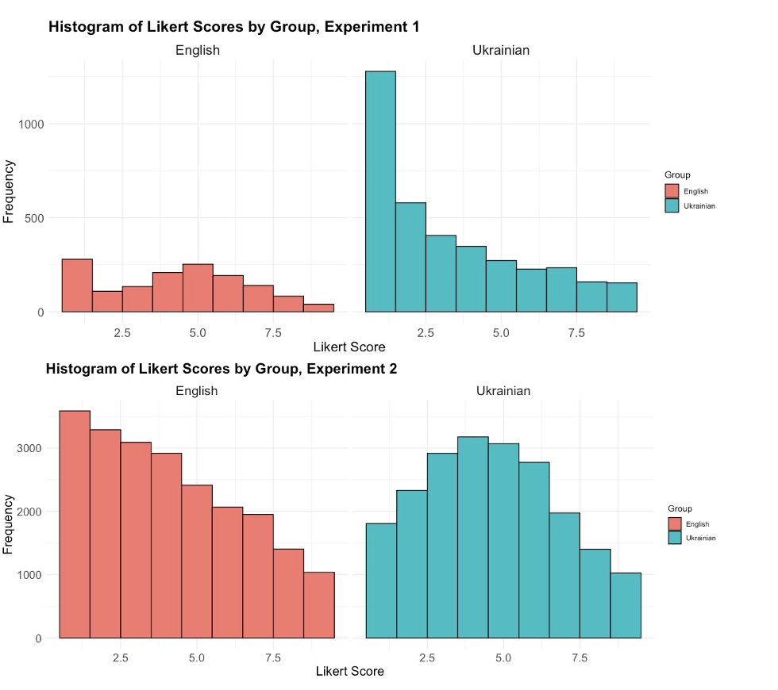

Table 7.
Descriptive statistics for Likert scores across Experiments 1 and 2 by participant group

Variable | Scores for Experiment 1 |  | Scores for Experiment 2
 | English | Ukrainian-Russian | English | Ukrainian-Russian
Range | 1-9 | 1-9 | 1-9 | 1-9
Interquartile Range (IQR) | 4 | 4 | 4 | 3
Variance | 5.269 | 6.044 | 5.737 | 4.941
Standard Deviation | 2.295 | 2.459 | 2.395 | 2.223
Skewness | 0.056 | 0.847 | 0.391 | 0.177
Kurtosis | 2.023 | 2.516 | 2.060 | 2.157

3.2. Results of Ukrainian-Russian bilinguals (using stimuli with mismatching grammatical gender in both L1s)

The distribution of Likert scores for Ukrainian-Russian bilinguals responding to stimuli with mismatching grammatical gender also displayed notable shifts between Experiment 1 and Experiment 2 (figure 2).
In Experiment 1, the histogram shows a pronounced skew toward the lower end of the Likert scale, with the majority of responses concentrated between scores 1 and 3. The descriptive statistics (table 8) further support this observation, with a positive skewness of 0.846, reflecting the asymmetry of the distribution. The variance (6.347) and standard deviation (2.519) highlight substantial variability in the scores, though the distribution is less spread out than in Experiment 2. The kurtosis value of 2.468 suggests a heavier tail compared to a normal distribution, indicating some extremity in responses.
Conversely, in Experiment 2, the histogram illustrates a more balanced distribution, with a peak around the middle of the scale (scores 4–6). This indicates a broader use of the Likert scale, likely influenced by the emphasis in the modified instructions to use the full range of scores. The descriptive statistics (table 8) show a reduction in skewness to 0.072, reflecting a more symmetric response pattern compared to Experiment 1. With the decrease of variance and standard deviation (to 5.338 and to 2.311 respectively), less variability was observed in participant responses. The kurtosis also decreased to 2.018, indicating a less peaked and more evenly distributed set of responses.
Overall, these results suggest that the modification in instructions had a significant effect on response behaviour, encouraging participants to utilise the entire Likert scale more evenly.

Figure 2.
Distribution of Likert scores of Ukrainian-Russian bilinguals in Experiments 1 and 2, using stimuli with mismatching grammatical gender in 2L1s

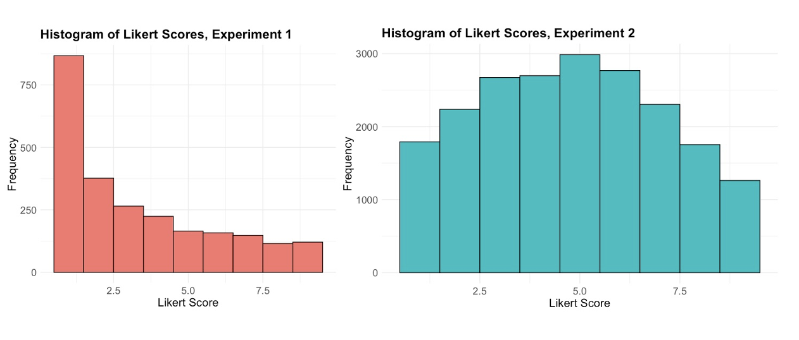

Table 7.
Descriptive statistics for Likert scores across Experiments 1 and 2 for Ukrainian-Russian bilingual group

Variable | Experiment 1 | Experiment 2
Range | 1-9 | 1-9
Interquartile Range (IQR) | 4 | 4
Variance | 6.347 | 5.338
Standard Deviation | 2.519 | 2.311
Skewness | 0.846 | 0.072
Kurtosis | 2.468 | 2.018

