Appendix
Appendix I. Set of sentences used in the experiment. Each sentence was extracted from French movies and spoken by the same actor with neutral or angry emotional prosody.
Emotion | Original verbal content | Film
anger | Tu comprends pas que c'est un cadeau que je te fais  [Don't you understand that this is a gift I'm giving you] | L'Humanité  (Bruno Dumont, 1999)
neutral | Dis ce soir on va à la brasserie  [Hey tonight we’re going to the brewery] | L'Humanité  (Bruno Dumont, 1999)
anger | Pas un voleur  [Not a thief] | La Drôlesse ‘The Hussy’ (Jacques Doillon, 1979 )
neutral | C'est mon beau père  [He’s my father-in-law] | La Drôlesse ‘The Hussy’ (Jacques Doillon, 1979)
anger | Tu tires dans le tunnel  [You’re shooting in the tunnel] | Bande de Fille ‘Girlhood’ (Céline Sciamma, 2014)
neutral | On a qu'à faire un truc qui change  [Let's do something different] | Bande de Fille ‘Girlhood’ (Céline Sciamma, 2014)
anger | J’te parle  [I'm talking to you] | Bande de Fille ‘Girlhood’ (Céline Sciamma, 2014)
neutral | Je veux pas faire de CAP  [I don't want to do a CAP] | Bande de Fille ‘Girlhood’ (Céline Sciamma, 2014)
anger | J'y toucherai quand j'aurai envie d'y toucher  [I'll touch it when I want to touch it] | Buffet Froid  (Bertrand Blier, 1979)
neutral | Boirait pas encore un petit verre  [Wouldn't drink a little more] | Buffet Froid  (Bertrand Blier, 1979)
anger | Rends-le moi  [Give it back to me] | Rosetta  (Frères Dardennes, 1999)
neutral | J'ai travaillé  [I worked] | Rosetta  (Frères Dardennes, 1999)
anger | Arrête  [Stop it] | Une étrange affaire ‘Strange Affair’  (Pierre Granier-Deferre, 1981)
neutral | Tu veux pas je descende Filo  [You don't want me to come down Filo] | Une étrange affaire ‘Strange Affair’  (Pierre Granier-Deferre, 1981)
anger | Je suis pas malade moi  [I'm not crazy] | Buffet Froid  (Bertrand Blier, 1979)
neutral | C'est fermé à clef  [It's locked] | Buffet Froid  (Bertrand Blier, 1979)
anger | Des idées de quoi  [Ideas of what] | Buffet Froid  (Bertrand Blier, 1979)
neutral | Pas vraiment  [Not really] | Buffet Froid  (Bertrand Blier, 1979)

Appendix II. Output of the linear mixed models estimated for ratings of valence (a) and intensity (b), with PROSODY (neutral vs. angry), FACE (presence vs. absence) and MORPHING (morphing+ vs. morphing-) as fixed effects. PARTICIPANT SEX (female vs. male) and ACTOR SEX (female vs. male) were also included as control variables. Reference level (intercept): Face: absence; Prosody: angry; Morphing: morphing-; Participant Sex male; Actor Sex: male. (n= 3600 for valence and n= 3600). The ouput is reported only one model (i.e., the one with no reveling of the intercept). Models on the same data sets with relevel of the intercept are not reported for the sake of brevity. Significance codes: p < 0.001 (***), p < 0.01 (**), p < 0.05 (*). Cut-off point for significance: p = 0.016. [p = 0.05 divided by the number of models (3) run].

- Valence
Effect | β | SE | df | t | pvalue
(Intercept) | 48.48 | 3.54 | 14.30 | 13.70 | <0.001 | ***
Morphing_morphing+ | 22.36 | 2.96 | 32.40 | 7.55 | <0.001 | ***
Face_presence | 6.24 | 2.24 | 2736.54 | 2.79 | 0.005 | **
ParticipantSex_female | 2.78 | 2.88 | 591.82 | 0.97 | 0.33
ActorSex_female | -4.96 | 4.95 | 10.83 | -1.00 | 0.34
Prosody_neutral | -20.98 | 2.54 | 1351.82 | -8.26 | <0.001 | ***
Morphing_morphing+ x Face_presence | -2.33 | 3.15 | 2876.77 | -0.74 | 0.46
Morphing_morphing+ x ParticipantSex_female | -3.38 | 3.30 | 2293.37 | -1.03 | 0.31
Face_presence x ParticipantSex_female | -3.92 | 3.18 | 2723.10 | -1.23 | 0.22
Morphing_morphing+ x ActorSex_female | 5.87 | 4.33 | 29.18 | 1.36 | 0.18
Face_presence x ActorSex_female | 1.17 | 3.33 | 2808.36 | 0.35 | 0.73
ParticipantSex_female x ActorSex_female | -3.18 | 3.34 | 2804.04 | -0.95 | 0.34
Morphing_morphing+ x Prosody_neutral | -22.99 | 3.15 | 2878.37 | -7.29 | <0.001 | ***
Face_presence x Prosody_neutral | -8.07 | 3.16 | 2869.55 | -2.56 | 0.01 | *
ParticipantSex_female x Prosody_neutral | -4.40 | 3.61 | 1355.00 | -1.22 | 0.22
ActorSex_female x Prosody_neutral | -5.14 | 3.32 | 2812.68 | -1.55 | 0.12
Morphing_morphing+ x Face_presence x ParticipantSex_female | 3.40 | 4.48 | 2877.83 | 0.76 | 0.45
Morphing_morphing+ x Face_presence x ActorSex_female | 0.87 | 4.70 | 2817.91 | 0.18 | 0.85
Morphing_morphing+ x ParticipantSex_female x ActorSex_female | 5.84 | 4.73 | 2813.53 | 1.24 | 0.22
Face_presence x ParticipantSex_female x ActorSex_female | 3.21 | 4.73 | 2800.67 | 0.68 | 0.50
Morphing_morphing+ x Face_presence x Prosody_neutral | 2.15 | 4.46 | 2961.19 | 0.48 | 0.63
Morphing_morphing+ x ParticipantSex_female x Prosody_neutral | 4.00 | 4.48 | 2879.68 | 0.89 | 0.37
Face_presence x ParticipantSex_female x Prosody_neutral | 5.20 | 4.48 | 2870.54 | 1.16 | 0.25
Morphing_morphing+ x ActorSex_female x Prosody_neutral | -3.65 | 4.70 | 2818.86 | -0.78 | 0.44
Face_presence x ActorSex_female x Prosody_neutral | 3.13 | 4.70 | 2814.67 | 0.67 | 0.51
ParticipantSex_female x ActorSex_female x Prosody_neutral | 1.71 | 4.72 | 2812.48 | 0.36 | 0.72
Morphing_morphing+ x Face_presence x ParticipantSex_female x ActorSex_female | -3.95 | 6.68 | 2817.94 | -0.59 | 0.56
Morphing_morphing+ x Face_presence x ParticipantSex_female x Prosody_neutral | -4.93 | 6.34 | 2962.83 | -0.78 | 0.44
Morphing_morphing+ x Face_presence x ActorSex_female x Prosody_neutral | -1.17 | 6.65 | 2858.81 | -0.18 | 0.86
Morphing_morphing+ x ParticipantSex_female x ActorSex_female x Prosody_neutral | -3.79 | 6.68 | 2819.05 | -0.57 | 0.57
Face_presence x ParticipantSex_female x ActorSex_female x Prosody_neutral | -3.33 | 6.69 | 2814.65 | -0.50 | 0.62
Morphing_morphing+ x Face_presence x ParticipantSex_female x ActorSex_female x Prosody_neutral | 2.25 | 9.46 | 2858.75 | 0.24 | 0.81

- Intensity
Effect | β | SE | df | t | p
(Intercept) | 52.26 | 3.64 | 13.74 | 14.34 | < 0.001 | ***
Morphing_morphing+ | 18.29 | 2.45 | 53.55 | 7.47 | < 0.001 | ***
Face_presence | -1.52 | 2.10 | 2599.38 | -0.72 | 0.47
ParticipantSex_female | -1.17 | 2.88 | 494.38 | -0.41 | 0.68
ActorSex_female | -1.93 | 5.04 | 9.99 | -0.38 | 0.71
Prosody_neutral | -19.60 | 2.53 | 979.02 | -7.74 | < 0.001 | ***
Morphing_morphing+ x Face_presence | 4.98 | 2.93 | 2870.07 | 1.70 | 0.09 | .
Morphing_morphing+ x ParticipantSex_female | 0.01 | 3.01 | 2557.46 | 0.00 | 1.00
Face_presence x ParticipantSex_female | 5.67 | 2.99 | 2591.34 | 1.90 | 0.06 | .
Morphing_morphing+ x ActorSex_female | 1.07 | 3.61 | 50.08 | 0.30 | 0.77
Face_presence x ActorSex_female | 0.26 | 3.09 | 2807.52 | 0.09 | 0.93
ParticipantSex_female x ActorSex_female | -0.48 | 3.11 | 2791.12 | -0.15 | 0.88
Morphing_morphing+ x Prosody_neutral | -23.28 | 2.93 | 2869.72 | -7.94 | < 0.001 | ***
Face_presence x Prosody_neutral | -1.08 | 2.94 | 2859.08 | -0.37 | 0.71
ParticipantSex_female x Prosody_neutral | -3.67 | 3.60 | 981.26 | -1.02 | 0.31
ActorSex_female x Prosody_neutral | -4.13 | 3.09 | 2799.33 | -1.34 | 0.18
Morphing_morphing+ x Face_presence x ParticipantSex_female | -6.05 | 4.17 | 2869.17 | -1.45 | 0.15
Morphing_morphing+ x Face_presence x ActorSex_female | 0.04 | 4.38 | 2810.71 | 0.01 | 0.99
Morphing_morphing+ x ParticipantSex_female x ActorSex_female | 5.43 | 4.40 | 2796.32 | 1.23 | 0.22
Face_presence x ParticipantSex_female x ActorSex_female | -4.91 | 4.40 | 2798.99 | -1.12 | 0.26
Morphing_morphing+ x Face_presence x Prosody_neutral | -3.18 | 4.15 | 2957.15 | -0.77 | 0.44
Morphing_morphing+ x ParticipantSex_female x Prosody_neutral | -1.31 | 4.17 | 2869.06 | -0.32 | 0.75
Face_presence x ParticipantSex_female x Prosody_neutral | -0.68 | 4.17 | 2858.11 | -0.16 | 0.87
Morphing_morphing+ x ActorSex_female x Prosody_neutral | 3.06 | 4.38 | 2810.80 | 0.70 | 0.48
Face_presence x ActorSex_female x Prosody_neutral | 2.14 | 4.38 | 2805.77 | 0.49 | 0.63
ParticipantSex_female x ActorSex_female x Prosody_neutral | -0.24 | 4.40 | 2798.53 | -0.06 | 0.96
Morphing_morphing+ x Face_presence x ParticipantSex_female x ActorSex_female | 3.98 | 6.22 | 2809.86 | 0.64 | 0.52
Morphing_morphing+ x Face_presence x ParticipantSex_female x Prosody_neutral | 0.91 | 5.90 | 2955.24 | 0.15 | 0.88
Morphing_morphing+ x Face_presence x ActorSex_female x Prosody_neutral | -0.85 | 6.19 | 2853.28 | -0.14 | 0.89
Morphing_morphing+ x ParticipantSex_female x ActorSex_female x Prosody_neutral | -6.02 | 6.22 | 2810.09 | -0.97 | 0.33
Face_presence x ParticipantSex_female x ActorSex_female x Prosody_neutral | 0.82 | 6.22 | 2804.91 | 0.13 | 0.89
Morphing_morphing+ x Face_presence x ParticipantSex_female x ActorSex_female x Prosody_neutral | 2.07 | 8.80 | 2851.53 | 0.24 | 0.81

Appendix IV. Dendrogram (bottom) and gap statistic plot (bottom) based on valence judgments of neutral prosody.

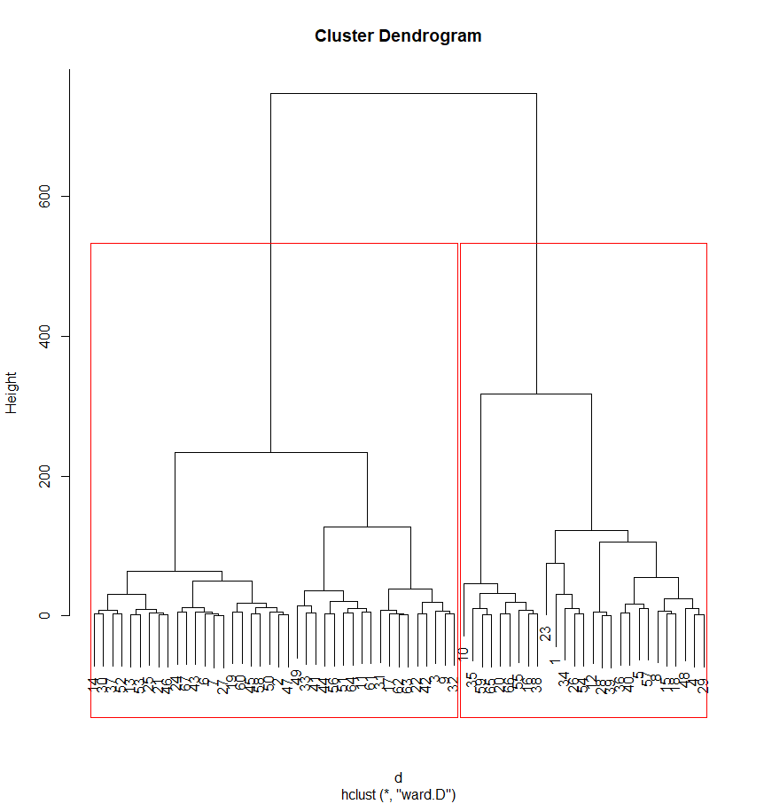
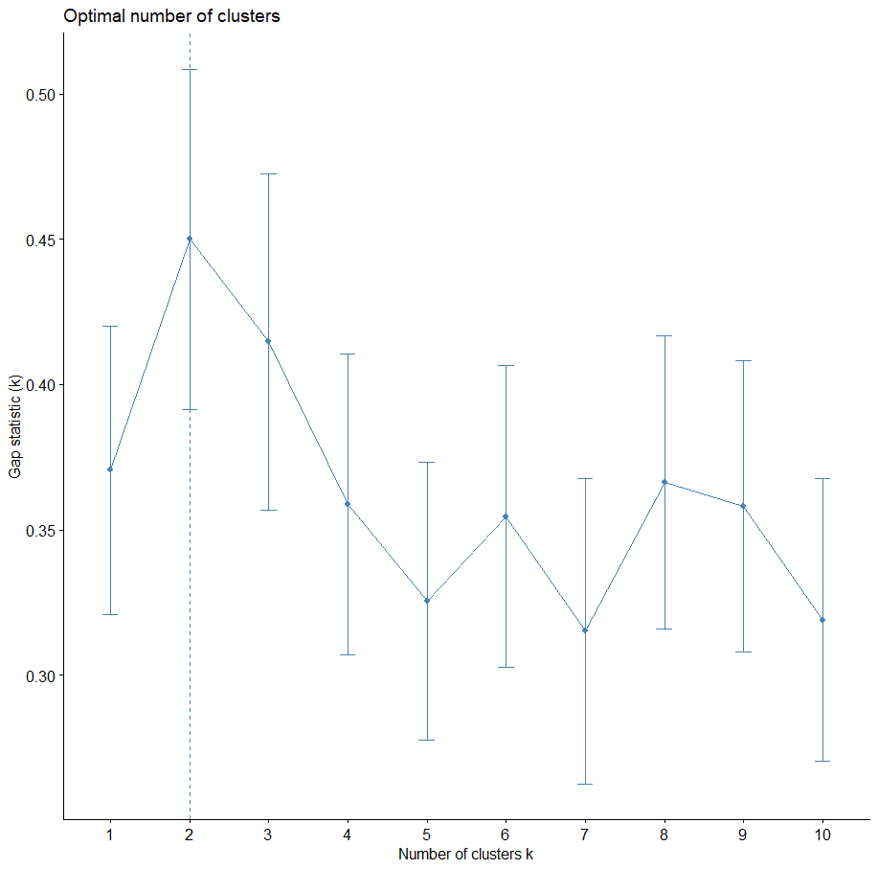
Appendix IV. Output of the linear mixed models estimated for ratings of valence (a) and intensity (b), with PROSODY (neutral vs. angry), FACE (neutral vs. angry) and CLUSTER (cluster1 vs. cluster2) as fixed effects. Reference level (intercept): Prosody: angry; Face: angry; Cluster: cluster1. (n= 1206 for valence and n= 1206 for intensity). The ouput is reported only one model (i.e., the one with no reveling of the intercept). Models on the same data sets with relevel of the intercept are not reported for the sake of brevity. Significance codes: p < 0.001 (***), p < 0.01 (**), p < 0.05 (*). Cut-off point for significance: p = 0.016. [p = 0.05 divided by the number of models (3) run].
- Valence
Effect | β | SE | df | t | p
(Intercept) | 64.97 | 3.53 | 26.42 | 18.36 | <2e-16 | ***
Face_neutral | -20.67 | 2.99 | 112.46 | -6.91 | 3.01e-10 | ***
Prosody_neutral | -35.51 | 2.93 | 1124.98 | -12.1 | <2e-16 | ***
Cluster_cluster2 | -17.04 | 3.53 | 219.97 | -4.81 | 2.71e-06 | ***
Face_neutral:Prosody_neutral | 46.16 | 4.16 | 1125.88 | 11.09 | <2e-16 | ***
Face_neutral:Cluster_cluster2 | 13.07 | 3.99 | 1121.21 | 3.27 | 0.001 | **
Prosody_neutral:Cluster_cluster2 | 0.82 | 3.99 | 1122.29 | 0.20 | 0.83
Face_neutral:Prosody_neutral:Cluster_cluster2 | -35.44 | 5.66 | 1125.23 | -6.25 | 5.64e-10 | ***

- Intensity
Effect | β | SE | df | t | p
(Intercept) | 62.44 | 3.19 | 39.48 | 19.53 | <2e-16 | ***
Face_neutral | -10.59 | 2.83 | 45.03 | -3.73 | 0.0005 | ***
Prosody_neutral | -34.79 | 2.47 | 1123.01 | -14.06 | <2e-16 | ***
Cluster_cluster2 | -11.29 | 3.49 | 147.33 | -3.22 | 0.0015 | **
Face_neutral:Prosody_neutral | 20.73 | 3.51 | 1122.44 | 5.90 | 4.59e-09 | ***
Face_neutral:Cluster_cluster2 | 7.80 | 3.372 | 1119.35 | 2.31 | 0.02 | *
Prosody_neutral:Cluster_cluster2 | 3.13 | 3.372 | 1120.4 | 0.92 | 0.35
Face_neutral:Prosody_neutral:Cluster_cluster2 | -17.11 | 4.782 | 1121.8 | -3.57 | 0.0003 | ***

