Supplementary materials

S1: Details of statistical models
Table 1.
Summary of optimal Generalized Linear Mixed Model for structural priming in monolingual Dutch children on a strict coding scheme.
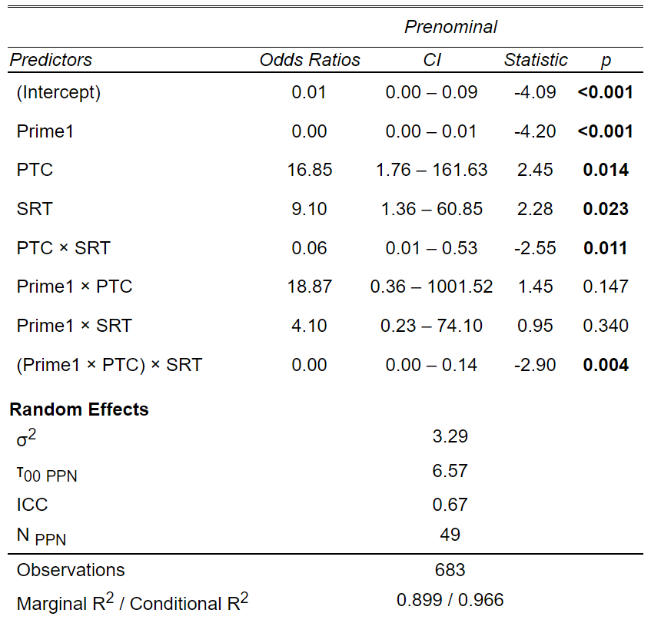
Prenominal ~ Prime + (1|Participant) + PTC*SRT*Prime, family = binomial (link=logit), glmerControl(optimizer = "bobyqa", optCtrl = list(maxfun = 1000000)))

Table 2.
Summary of optimal Generalized Linear Mixed Model for structural priming in monolingual Dutch children on a lenient coding scheme.
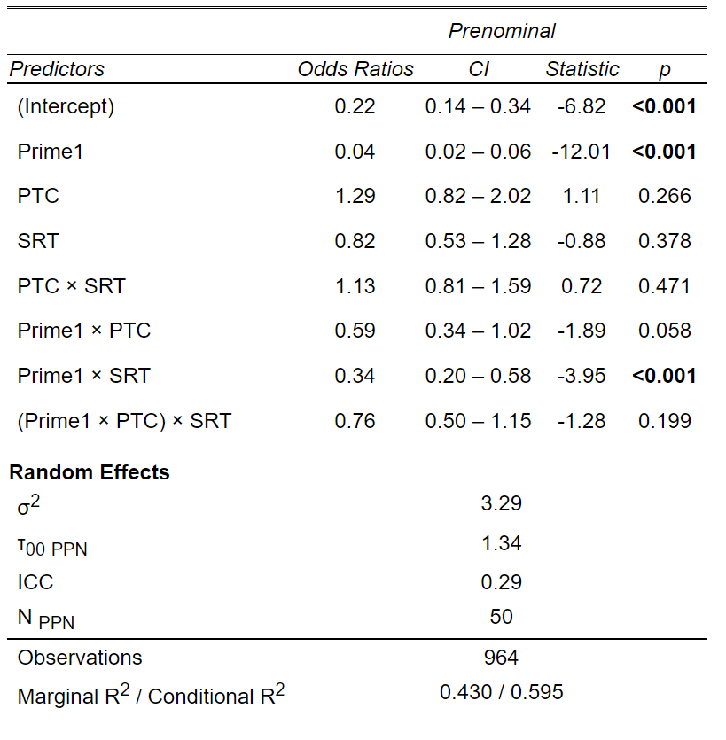
Prenominal ~ Prime + (1|Participant) + PTC*SRT*Prime, family = binomial(link=logit), glmerControl(optimizer = "bobyqa", optCtrl = list(maxfun = 1000000)))

Table 3.
Summary of optimal Generalized Linear Mixed Model for structural priming in bilingual children on a strict coding scheme.
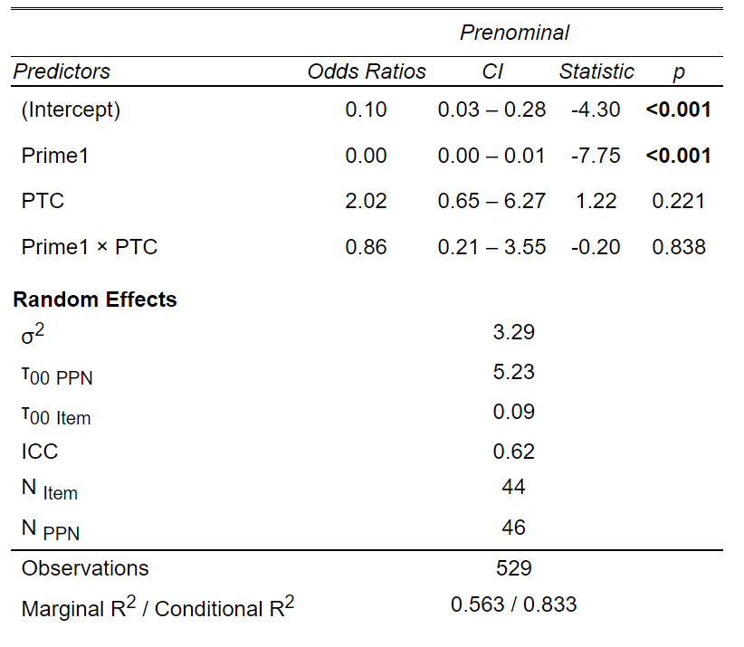
Prenominal ~ Prime + (1|Item) + (1|Participant) + Prime=PTC, data = experiment2, family = binomial(link=logit), glmerControl(optimizer = "bobyqa", optCtrl = list(maxfun = 1000000)))

Table 4.
Summary of optimal Generalized Linear Mixed Model for structural priming in bilingual children on a lenient coding scheme.
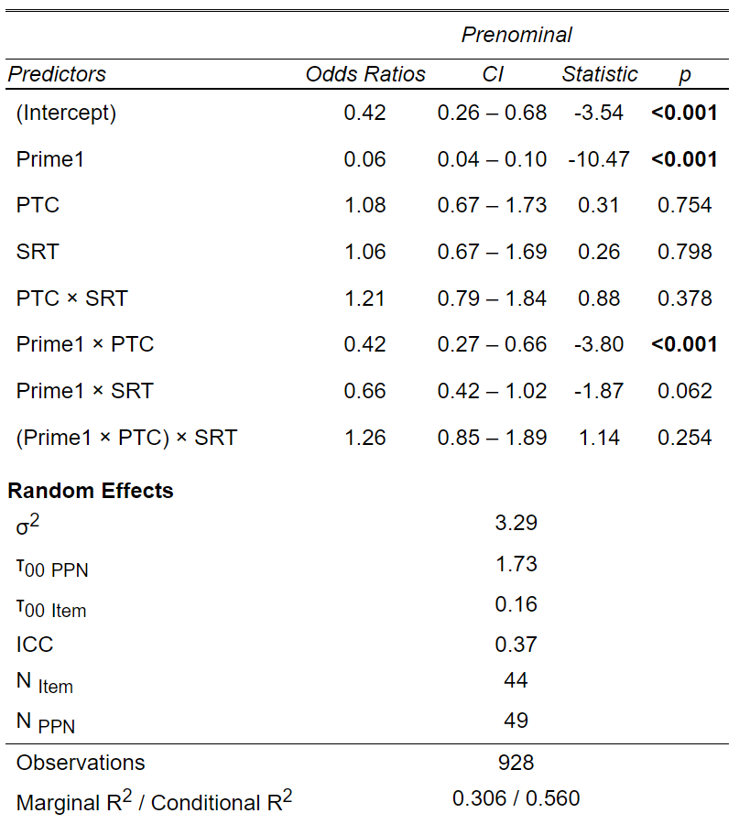
Prenominal ~ Prime + (1|Item) + (1|Participant) + PTC*SRT*Prime, family = binomial(link=logit), glmerControl(optimizer = "bobyqa", optCtrl = list(maxfun = 1000000)))

Table 5.
Summary of optimal Generalized Linear Mixed Model for structural priming in bilingual and monolingual children on a strict coding scheme.
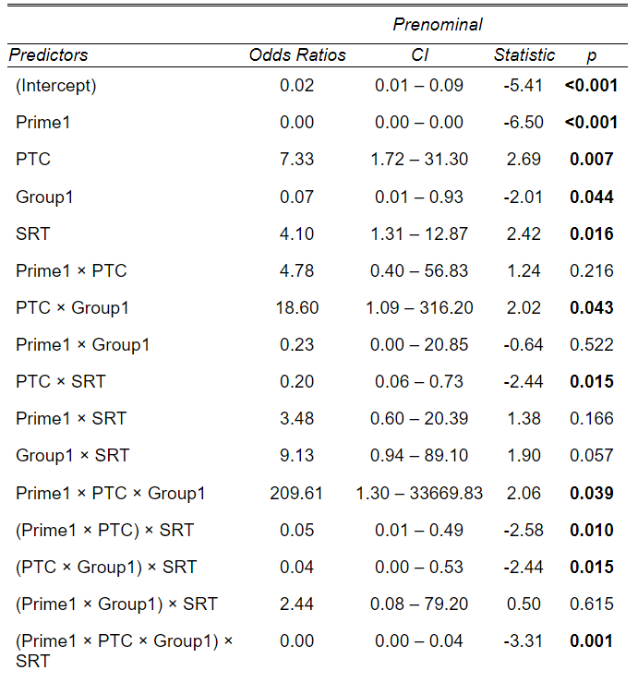
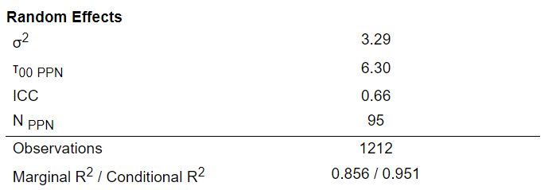
Prenominal ~ Prime + (1|Participant) + PTC*Prime*Group*SRT, family = binomial(link=logit), glmerControl(optimizer = "bobyqa", optCtrl = list(maxfun = 1000000)))

Figure 1.
Three-way interaction between Prime, PTC and Group on a strict coding scheme in monolingual and bilingual children.

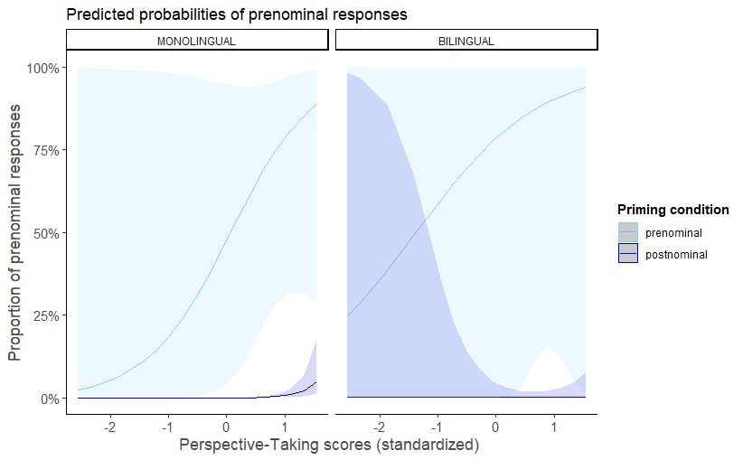

Table 6.
Summary of optimal Generalized Linear Mixed Model for structural priming in bilingual and monolingual children on a lenient coding scheme.
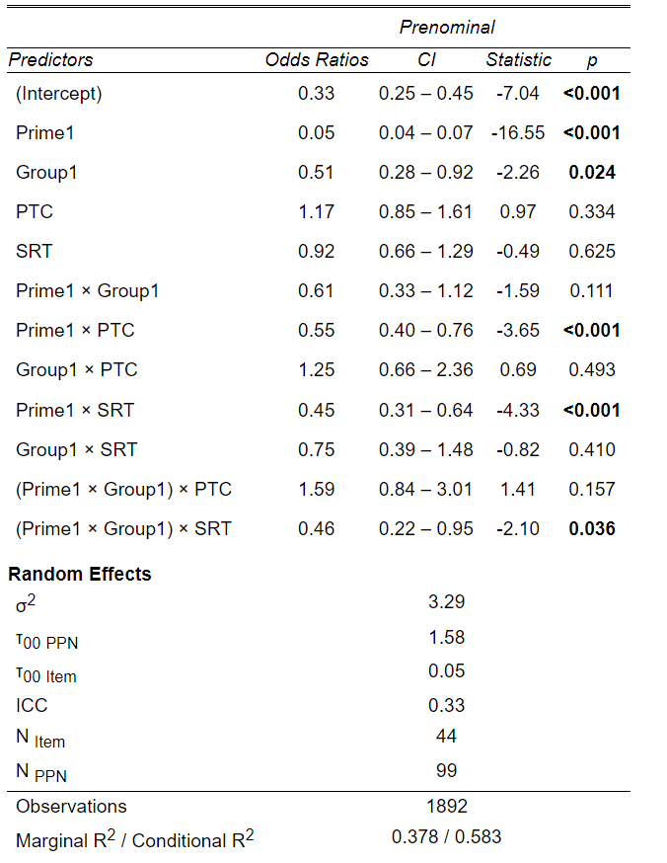
Prenominal ~ Prime*Group + (1|Item) + (1|Participant) + PTC*Prime*Group + SRT*Prime*Group, family = binomial(link=logit), glmerControl(optimizer = "bobyqa", optCtrl = list(maxfun = 1000000)))

Figure 2.
Two-way interaction between Prime and PTC on a lenient coding scheme in monolingual and bilingual children combined.

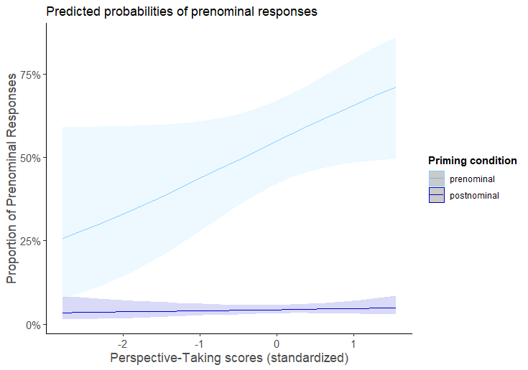

Figure 3.
Two-way interaction between Prime and SRT on a lenient coding scheme in monolingual and bilingual children combined.

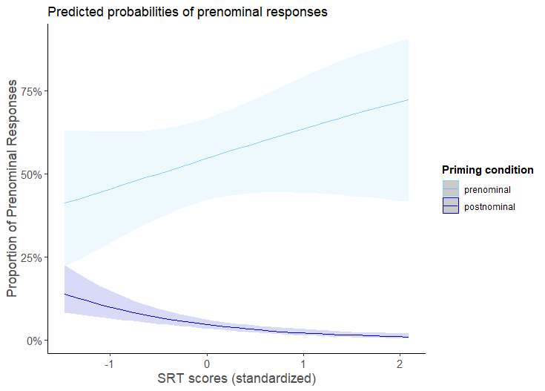

Figure 4.
Three-way interaction between Prime, SRT and Group on a lenient coding scheme in monolingual and bilingual children.

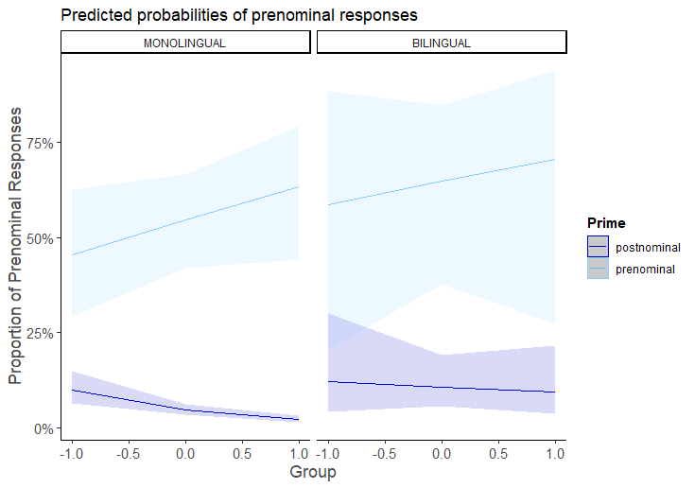

S2: Theory of Mind tasks
We administered a supplementary measure of cognitive perspective-taking in the form of Theory of Mind tasks to verify the validity of the Perspective-taking Test for Children, given that the PTC is not a widely used task. We used three Theory of Mind tasks that have previously been used together to measure Theory of Mind abilities (Bensalah et al., 2016): one change-of-location task (Wimmer & Perner, 1983) and two unexpected-content tasks (Bartsch & Wellman, 1989; Perner, Leekam, & Wimmer, 1987). We followed the procedure as described by Bensalah et al. (2016).

In Wimmer & Perner’s (1983) change-of-location task, the experimenter shows the children two boxes: one with a green lid and one with a pink lid. Two characters are then introduced: a bear and a monkey. The bear stores his toy in the box with the green lid because he wants to play outside, so is explained to the child. While the bear is outside, the monkey comes in and replaces the toy from the box with the green lid to the box with the pink lid. Then, the bear comes back and wants to play with his toy again. The experimenter asks the child the following two questions: (1) “Where will the bear look for his toy?”, and (2) “Why will bear look for his toy in [answer to (1)]?”. The two test questions are followed by control questions: (1) “Where did bear put his toy before he went outside?” and (2) “Where is the toy really?”.

In the Band-Aid task (Bartsch & Wellman, 1989), the experimenter shows the children two boxes: one with a picture of Band-Aids on it and one with a plain lid. The child is asked to point to the box with the Band-Aids in it and is then invited to open both boxes. The plain box contains Band-Aids and the labelled box is empty. The boxes are then closed and the same characters, the bear and the monkey, are reintroduced. The experimenter asks the child four questions: (1) “Where will the monkey look for the Band-Aids?”, followed by a control question “Will he find the Band-Aids there?”, (2) “Why should the bear look in this box [box with plain lid]?”, (3) “Does the bear know where the Band-Aids are?”, and (4) “What does the bear think?”. The last question was followed by another control question “Where are the Band-Aids?”.

In the Candies task (Perner et al., 1987), the experimenter shows the child the contents of two boxes. One box, with a picture of sweets on it, contains pencils. The other box, with no picture on it, contains sweets. The experimenter asks the child to predict what they thought was in the boxes before they had seen the content by asking three questions: (1) “What did you think was in the boxes before you saw inside them?”, (2) “What does your sibling / parent think the boxes contain?”, and (3) “Why would they think that the boxes contain [answer to (2)]?”. The final question was a control question: “What is in the boxes?”.

We used the same scoring as Bensalah et al. (2016): provided that the children answered correctly on the control questions, children received a score of 1 for each correct answer on the three tasks described above. The maximum score for the Theory of Mind tasks was therefore 9 points.

Table 7.
Scores of monolingual and bilingual children on Theory of Mind task.
 | Monolinguals | Bilinguals | p
Theory of Mind task (max. = 9) | 5.64 (2.50) | 4.57 (2.81) | t(97) = 2.0, p = .05

Figure 5.
Violin plot of the distribution of ToM scores per group (monolingual vs. bilingual).

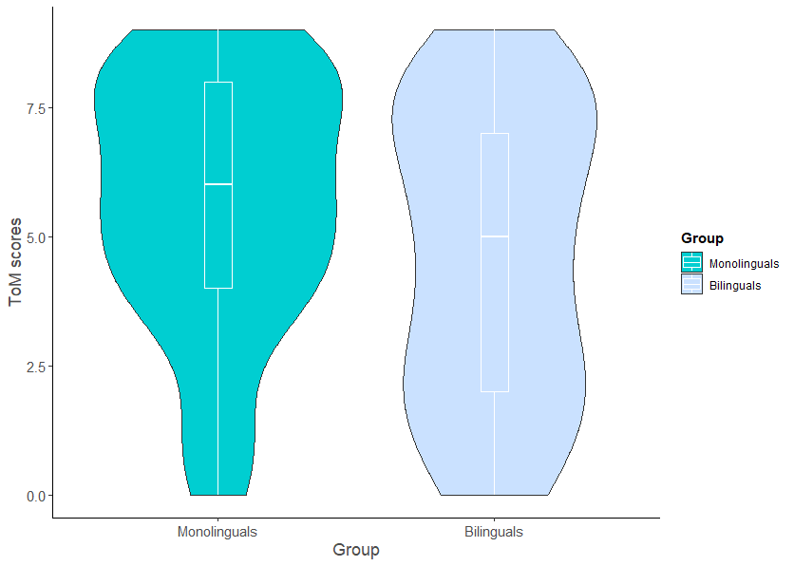

Scores on the Perspective-taking Test for Children and Theory of Mind scores were highly correlated (r(96) = .60, p < .001). We interpreted this as support for the validity of the Perspective-taking Test for Children.

S3: Cross-linguistic influence in bilingual children
As an additional analysis, we explored the possibility that the bilingual children’s other language may have influenced their performance on the priming task, that is whether there was any evidence for cross-linguistic influence (CLI) (Van Dijk et al., 2022, Hervé et al., 2016, Unsworth, under review)(cite the meta-analysis study and Herve et al, 2016, Unsworth under review). To this end, we classified children’s home language based on the characteristics of the possessive structure. For languages that have both the prenominal and the postnominal possessive structure, we classified the language based on its preferred structure (e.g., English was classified as ‘Prenominal’ given its preference for the prenominal structure for animate entities; Rosenbach; 2008 and French was classified as “Postnominal”, given this is the only option for expressing possession in French). We applied Helmert contrasts to the categorical fixed effect Home Language (prenominal was coded as -0.5, and postnominal as 0.5). Two languages (Tigrinya and Malay, n = 3) were excluded from this analysis, because we were unable to find reliable documentation on the possessive structure in these languages.

We re-ran the same model as in section 3 including this variable. The best-fitting model on a strict coding scheme revealed a main effect of Prime (ß = -7.48, SE = 1.09, |z| = -6.84, p < .001). The two-way interaction between Prime and Home Language approached significance (ß = 3.05, SE = 1.66, |z| = 1.84, p = .07). On a lenient coding scheme, the two-way interaction between Prime and Home Language was significant (ß = 1.37, SE = 0.46, |z| = 2.96, p = .003).

Figure 6.
Two-way interaction between Prime and Home Language on a lenient coding scheme in bilingual children.
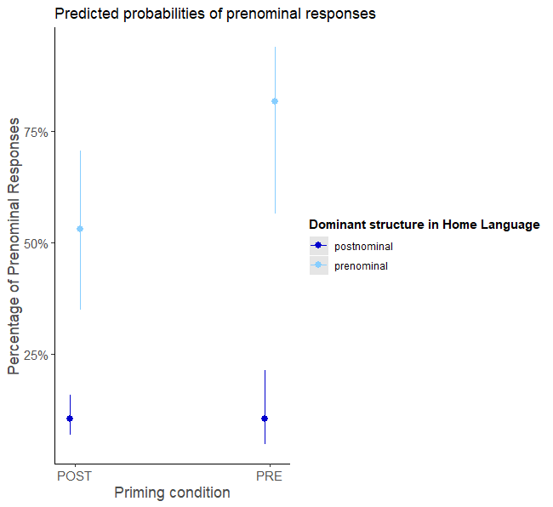

As illustrated in Figure 6, children whose other language prefers or only has the prenominal structure were more likely to produce the prenominal possessive after hearing the prenominal possessive in Dutch than children whose other language prefers or only has the postnominal structure.

Table 8.
Summary of optimal Generalized Linear Mixed Model for cross-linguistic influence on structural priming in bilingual children on a strict coding scheme.
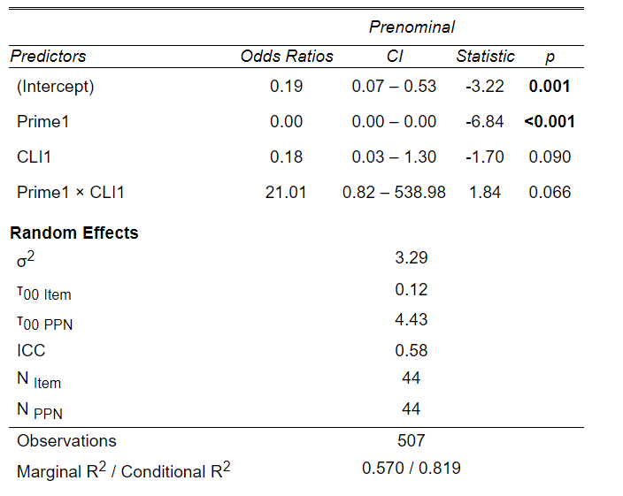
Prenominal ~ Prime + (1|Item) + (1|Participant) + Prime*CLI, data = experiment2, family = binomial(link=logit), glmerControl(optimizer = "bobyqa", optCtrl = list(maxfun = 1000000)))

Table 9.
Summary of optimal Generalized Linear Mixed Model for cross-linguistic influence on structural priming in bilingual children on a lenient coding scheme.
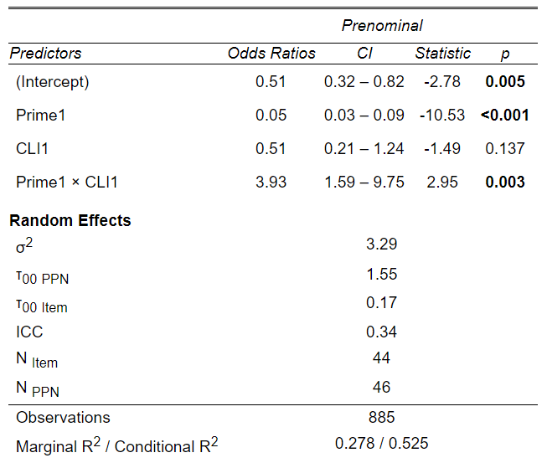
Prenominal ~ Prime + (1|Item) + (1|Participant) + Prime*CLI, , family = binomial(link=logit), glmerControl(optimizer = "bobyqa", optCtrl = list(maxfun = 1000000)))

S4: Statistical models with CLT instead of SRT as language proficiency measure
Table 10.
Summary of optimal Generalized Linear Mixed Model for structural priming in monolingual Dutch children on a strict coding scheme
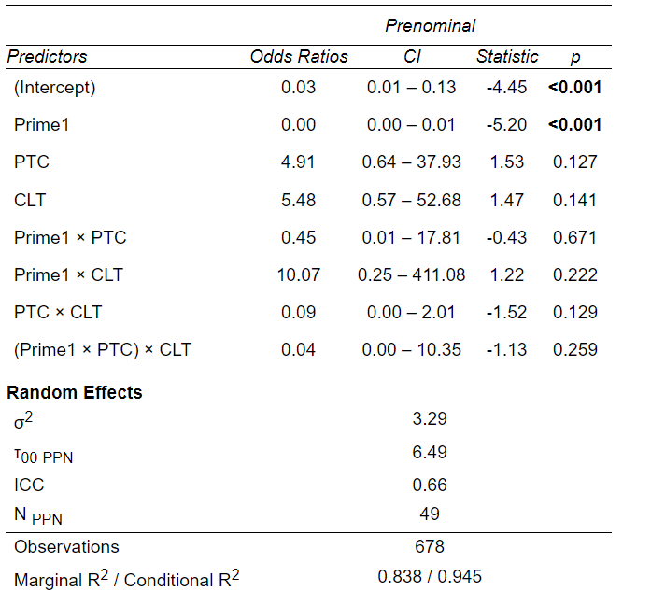.

Table 11.
Summary of optimal Generalized Linear Mixed Model for structural priming in monolingual Dutch children on a lenient coding scheme
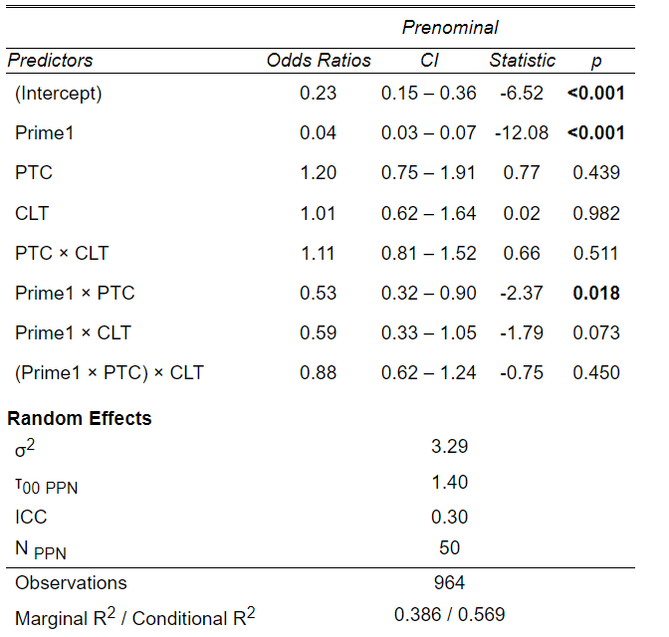

Table 12.
Summary of optimal Generalized Linear Mixed Model for structural priming in bilingual children on a lenient coding scheme
