Supplementary materials for “Learning speaker-specific linguistic ‘style’ is mediated by deviance from common language-use”

S1. An analysis of the number of correct responses by condition
In this section, we report an additional analysis comparing the number of correct responses, instead of the binary classification to learners and non-learners as was done in Experiment 1. To be able to compare the results of the two experiments, this analysis was conducted for the data in Experiment 2 as well. In the analysis, we counted the number of correct responses in the test phase for each participant and compared it between conditions using unpaired two-sample t-tests. We note that this analysis may be susceptible to guessing strategy, and therefore may be less accurate.
Experiment 1
Pairwise comparisons revealed that the number of correct responses was larger in the HL condition than in the HH condition (t(29.22) = 2.15, p = 0.04; Figure 1), and marginally larger in the LL condition compared to the HH condition (t(34.38) = 1.87, p = 0.07). The number of correct responses in the HL and LL conditions did not differ significantly (t(35.39) = 0.57, p = 0.575).

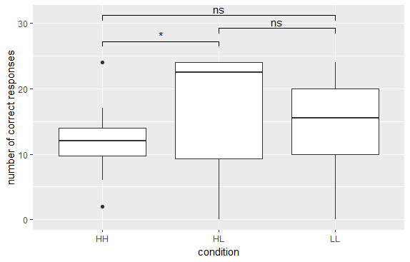
Figure 1. Number of correct responses by condition in Ex.1. * p < 0.05

Experiment 2
Pairwise comparisons revealed that the number of correct responses was larger in the HL condition than in the HH condition (t(100.25) = 4.667, p < 0.001; Figure 2), and in the LL condition compared to the HH condition (t(105.02) = 7.262, p < 0.001). The number of correct responses in the HL and LL conditions did not differ significantly (t(125.25), p = 0.066).
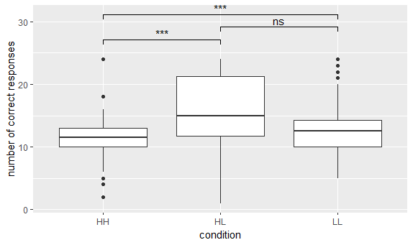
Figure 2. Number of correct responses by condition in Ex.2. *** p < 0.001

Overall, the pattern of results reported here is similar to the results attained with the analyses reported in the main manuscript (for both experiments), but with smaller effect sizes.

