Appendices
Appendix 1. No of Publications over the year
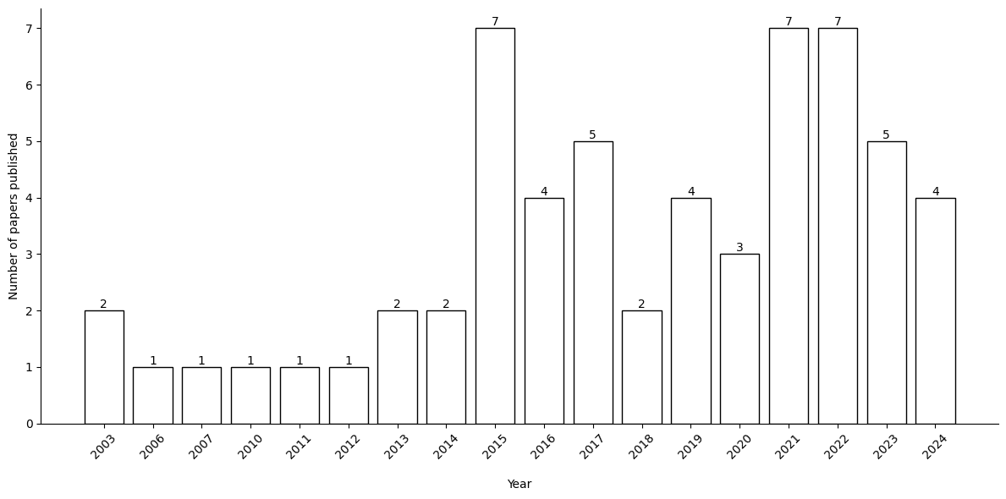

Appendix 2. Theoretical Rationale and Methodology of Studies (N=59)
Category | Count (Frequency)
Theoretical Framework
Social exchange theory | 27 (45.8%)
Psychological contract theory | 16 (27.1%)
Conservation of Resource Theory | 10 (16.9%)
Affective event theory | 6 (10.2%)
Job demand resource theory | 4 (6.8%)
Organization support theory | 4 (6.8%)
Social information processing | 4 (6.8%)
Other | 15 (25.4%)
Not provided | 11 (18.6%)
Details of the Methods Used
Methodology
Quantitative | 57 (96.6%)
Qualitative | 1 (1.7%)
Mixed Method | 1 (1.7 %)
Design
Cross-sectional | 49 (83.0%)
Longitudinal | 9 (15.3%)
Experimental | 1 (1.7%)
Research strategies
Interviews (face-to-face and telephone interviews) | 6 (10.2%)
Questionnaires | 54 (91.5)
Experiment | 1 (1.7%)
Industry
Health care and social assistance | 10 (16.9%)
Education and training | 5 (8.5%)
Manufacturing | 3 (5.1%)
Military and police | 3 (5.1%)
Information media and telecommunications | 3 (5.1%)
Accommodation and food services | 3 (5.1%)
Financial, bank, and insurance services  Multiple industries  Other | 3 (5.1%)  17 (28.8%)  3 (5.9%)

