**Umbilical Venous Flow Volume and Fetal Combined Cardiac Output in Twin Pregnancies**

Sommart Bumrungphuet1, Katsusuke Ozawa2, Wirada Hansahiranwadee1, Jin Muromoto2, Seiji Wada2, and Haruhiko Sago2

*1Maternal-Fetal Medicine Division, Obstetrics & Gynaecology Department, Faculty of Medicine, Ramathibodi Hospital, Mahidol University, Bangkok, Thailand*

*2Center for Maternal-Fetal, Neonatal and Reproductive Medicine, National Center for Child Health and Development, Tokyo, Japan*

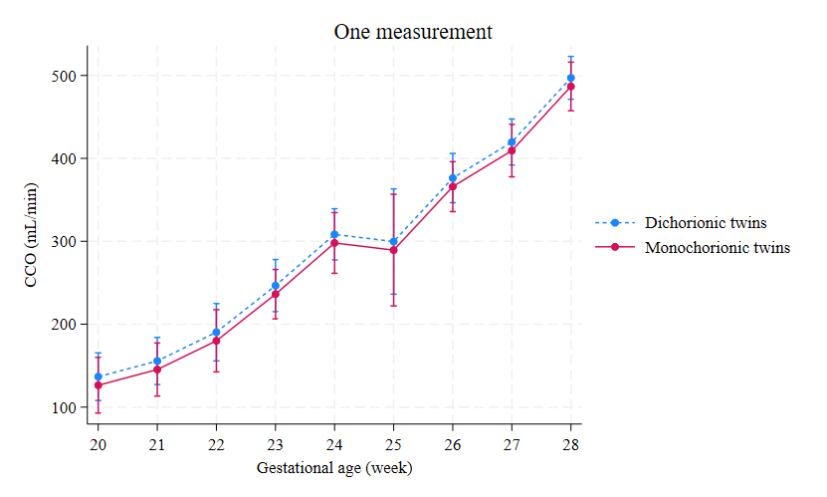

**Supplementary Figure 1**

The adjusted predictions of CCO, along with 95% confidence intervals according to gestational age, analyzed in dichorionic and monochorionic twin fetuses in groups with one measurement.

CCO, combined cardiac output.

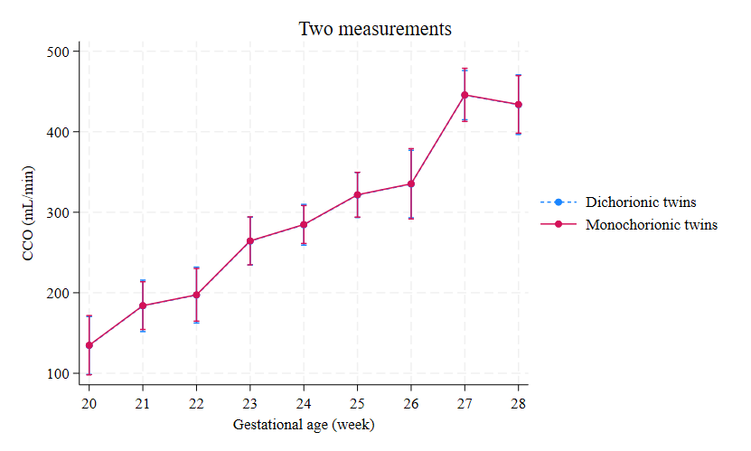

**Supplementary Figure 2**

The adjusted predictions of CCO, along with 95% confidence intervals according to gestational age, analyzed in dichorionic and monochorionic twin fetuses in groups with two measurements.

CCO, combined cardiac output.

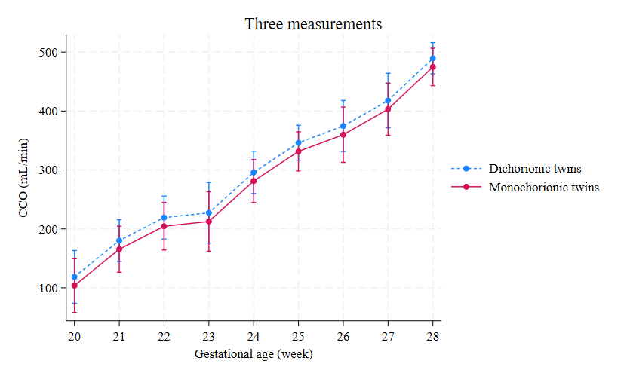

**Supplementary Figure 3**

The adjusted predictions of CCO, along with 95% confidence intervals according to gestational age, analyzed in dichorionic and monochorionic twin fetuses in groups with three measurements.

CCO, combined cardiac output.

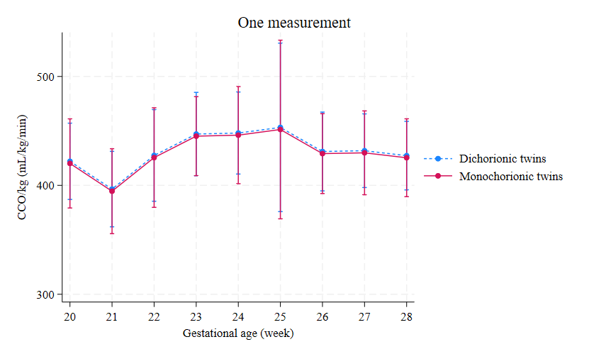

**Supplementary Figure 4**

The adjusted predictions of CCO/kg, along with 95% confidence intervals according to gestational age, analyzed in dichorionic and monochorionic twin fetuses in groups with one measurement.

CCO, combined cardiac output.

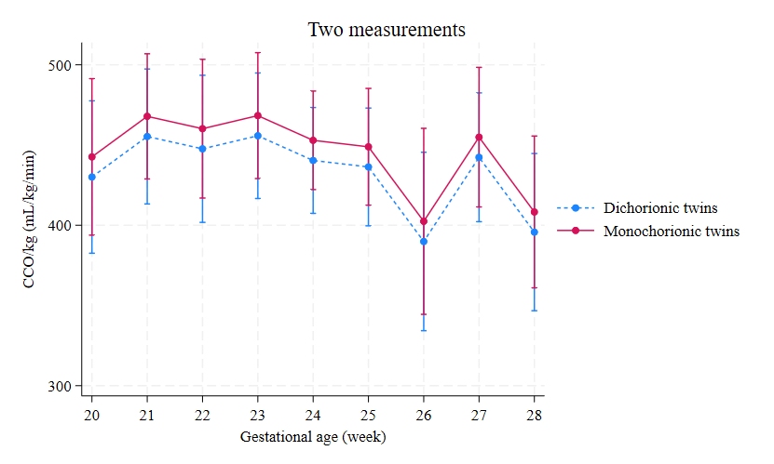

**Supplementary Figure 5**

The adjusted predictions of CCO/kg, along with 95% confidence intervals according to gestational age, analyzed in dichorionic and monochorionic twin fetuses in groups with two measurements.

CCO, combined cardiac output.

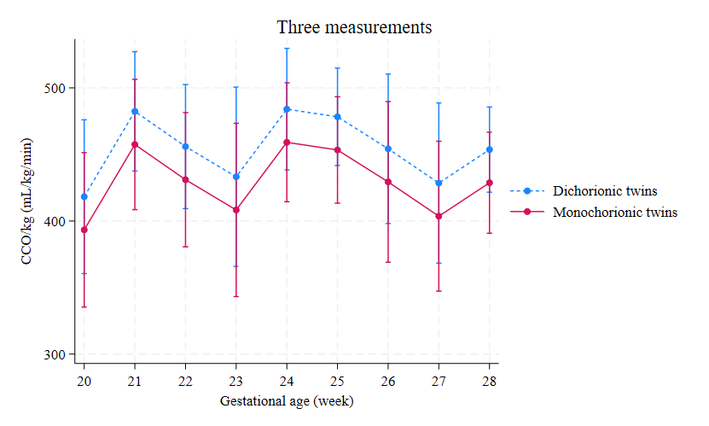

**Supplementary Figure 6**

The adjusted predictions of CCO/kg, along with 95% confidence intervals according to gestational age, analyzed in dichorionic and monochorionic twin fetuses in groups with three measurements.

CCO, combined cardiac output.

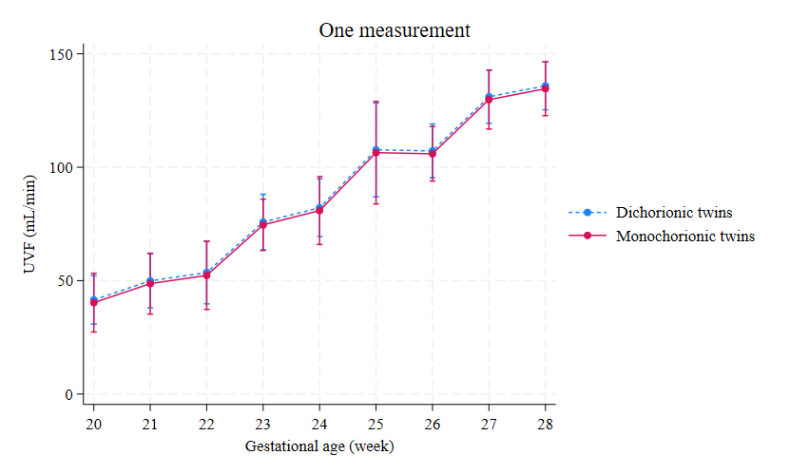

**Supplementary Figure 7**

The adjusted predictions of UVFV, along with 95% confidence intervals according to gestational age, analyzed in dichorionic and monochorionic twin fetuses in groups with one measurement.

UVFV, umbilical venous flow volume.

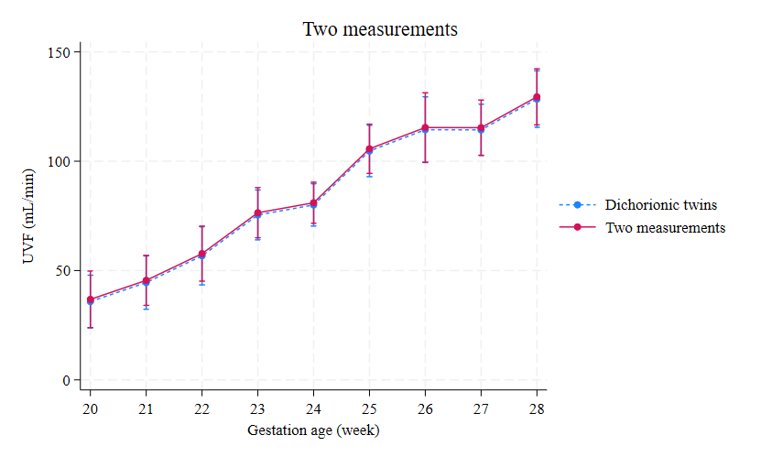

**Supplementary Figure 8**

The adjusted predictions of UVFV, along with 95% confidence intervals according to gestational age, analyzed in dichorionic and monochorionic twin fetuses in groups with two measurements.

UVFV, umbilical venous flow volume.

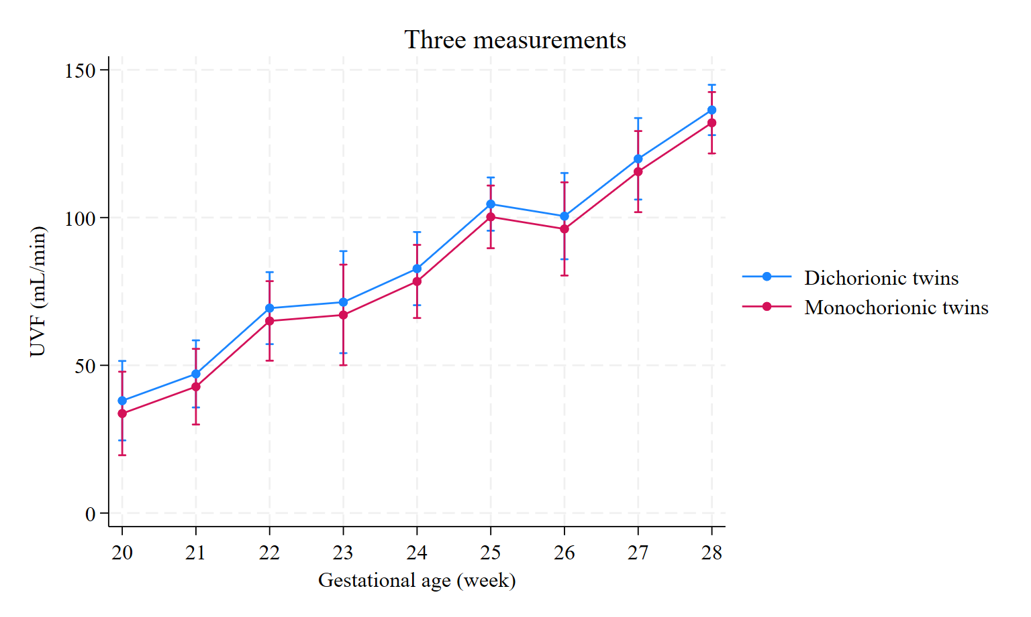

**Supplementary Figure 9**

The adjusted predictions of UVFV, along with 95% confidence intervals according to gestational age, analyzed in dichorionic and monochorionic twin fetuses in groups with three measurements.

UVFV, umbilical venous flow volume.

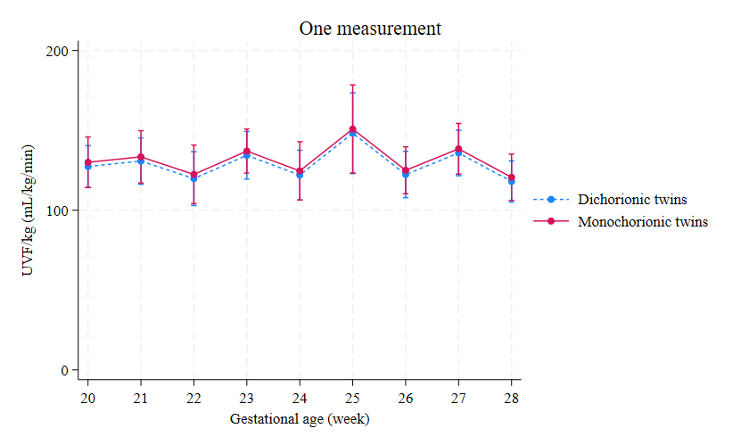

**Supplementary Figure 10**

The adjusted predictions of UVFV/kg, along with 95% confidence intervals according to gestational age, analyzed in dichorionic and monochorionic twin fetuses in groups with one measurement.

UVFV, umbilical venous flow volume.

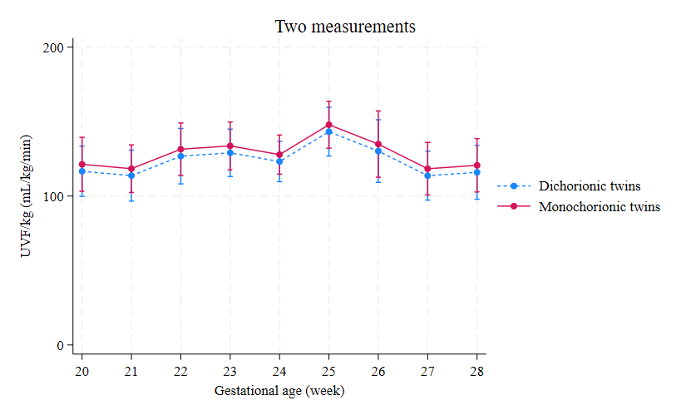

**Supplementary Figure 11**

The adjusted predictions of UVFV/kg, along with 95% confidence intervals according to gestational age, analyzed in dichorionic and monochorionic twin fetuses in groups with two measurements.

UVFV, umbilical venous flow volume.

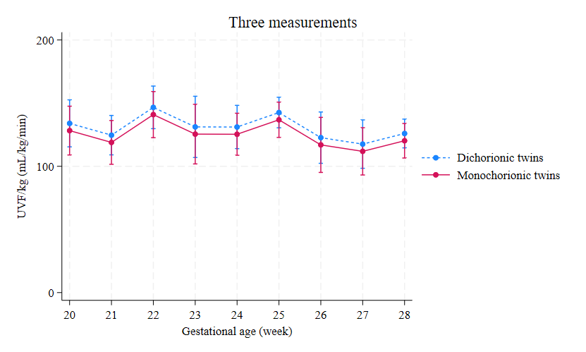

**Supplementary Figure 12**

The adjusted predictions of UVFV/kg, along with 95% confidence intervals according to gestational age, analyzed in dichorionic and monochorionic twin fetuses in groups with three measurements.

UVFV, umbilical venous flow volume.

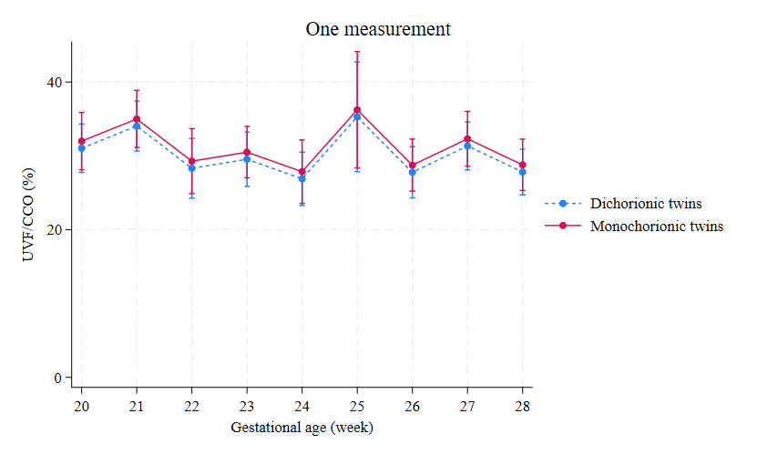

**Supplementary Figure 13**

The proportion of UVFV to CCO as percentage, along with 95% confidence intervals according to gestational age, analyzed in dichorionic and monochorionic twin fetuses in groups with one measurement.

CCO, combined cardiac output; UVFV, umbilical venous flow volume.

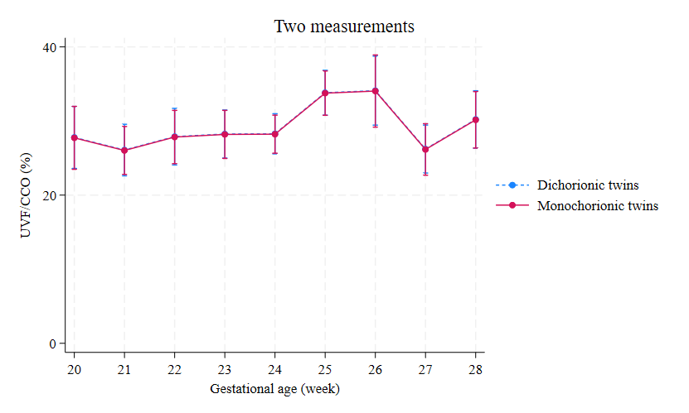

**Supplementary Figure 14**

The proportion of UVFV to CCO as percentage, along with 95% confidence intervals according to gestational age, analyzed in dichorionic and monochorionic twin fetuses in groups with two measurements.

CCO, combined cardiac output; UVFV, umbilical venous flow volume.

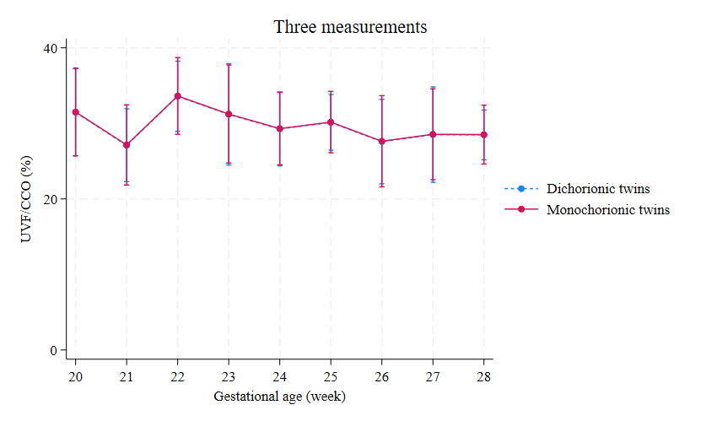

**Supplementary Figure 15**

The proportion of UVFV to CCO as percentage, along with 95% confidence intervals according to gestational age, analyzed in dichorionic and monochorionic twin fetuses in groups with three measurements.

CCO, combined cardiac output; UVFV, umbilical venous flow volume.