Supplementary materials
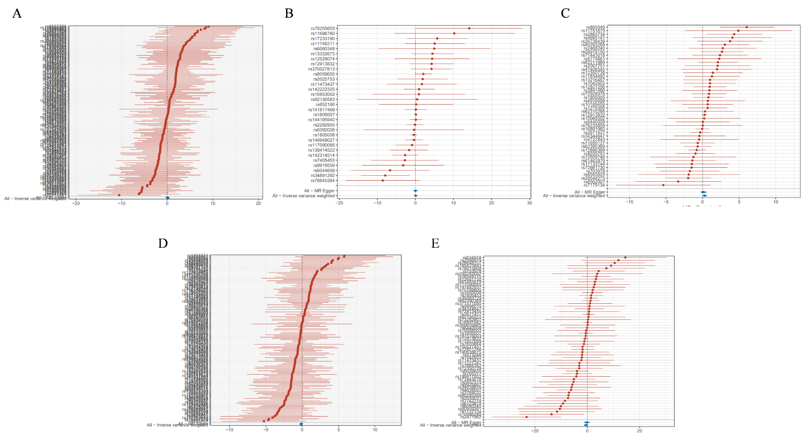
Figure S1. Forest plots of MR analysis. (A) Blond hair group on endometriosis. (B) Red hair group on endometriosis. (C) Light brown hair group on endometriosis. (D) Dark brown hair on endometriosis. (E) Black hair on endometriosis.

Traits | Search Entries  in the IEU OpenGWAS project | Data sources (ID) | Sample size | Ncases | Ncontrols | Ancestry
Exposure
blonde hair | Hair color  (natural, before greying): blond | 1747_1 | 360,270 | 41,178 | 319,092 | European
red hair | Hair color  (natural, before greying): Red | 1747_2 | 360,270 | 16,615 | 343,655 | European
light brown hair | Hair color  (natural, before greying): light brown | 1747_3 | 360,270 | 147,560 | 212,710 | European
dark brown hair | Hair color  (natural, before greying): dark brown | 1747_4 | 360,270 | 134,627 | 225,643 | European
Black | Hair color  (natural, before greying): black | 1747_5 | 360,270 | 15,809 | 344,461 | European
Outcome
Skin pigmentation | Skin pigmentation | ebi-a-GCST90029033 | 548,203 | - | - | European
Table S3. GWAS Data for natural hair color and Skin pigmentation in Europe ieu open gwas project.

Exposure | Test of heterogeneity |  |  |  | Test of pleiotropy
 | MR Inverse-Variance  Weighted (MR IVW) |  | MR Egger  regression (MR Egger) |  | MR Egger regression  (MR Egger)
 | Cochrane Q | P | Cochrane Q | P | Egger  intercept | P
blonde hair | 27,600.97 | 0 | 25,767.21 | 0 | -0.0047 | 0.0019
red hair | 25,947.38 | 0 | 25,946.57 | 0 | 0.0002 | 0.9669
Light  brown hair | 71.7383 | 0 | 71.7287 | 0 | 0.0001 | 0.9582
Dark  brown hair | 16,060.72 | 0 | 14,094.05 | 0 | 0.0047 | 0.00004
black hair | 19,036.83 | 0 | 16,856.69 | 0 | 0.0088 | 0.0162
Table S4. Sensitivity analysis of natural hair

Exposure |  | Outcome | Method | Nsnp | Pval | OR(95%CI)
Blonde | Skin pigmentation |  | Inverse variance weighted | 142 | 3E-39 | 2.6788(2.3117~3.1041）
 |  |  | MR Egger | 142 | 7E-24 | 3.2790(2.7110~3.9659）
 |  |  | Weighted median | 142 | 2E-188 | 1.7335(1.6708~1.7985）
 |  |  | Simple mode | 142 | 1E-21 | 1.5494(1.4366~1.6710）
 |  |  | Penalised weighted median | 142 | 3E-104 | 1.6023(1.5355~1.6721）
 |  |  | Simple mode | 142 | 1E-22 | 1.5494(1.4406~1.6664）
Red | Skin pigmentation |  | Inverse variance weighted | 57 | 0.0002549 | 2.8565(1.6276~5.0132）
 |  |  | MR Egger | 57 | 0.0036757 | 2.8346(1.4462~5.5561）
 |  |  | Weighted median | 57 | 1.59E-66 | 1.9587(1.8145~2.1143）
 |  |  | Simple mode | 57 | 0.1130209 | 1.3446(0.9377~1.9282）
 |  |  | Penalised weighted median | 57 | 1.13E-65 | 1.9582(1.8132~2.1149）
 |  |  | Simple mode | 57 | 0.1105807 | 1.3446(0.9400~1.9234）
Light brown | Skin pigmentation |  | Inverse variance weighted | 122 | 0.0078 | 0.9010(0.8344~0.9729）
 |  |  | MR Egger | 122 | 0.5148 | 0.8931(0.6393~1.2477）
 |  |  | Weighted median | 122 | 0.0045 | 0.9031(0.8417~0.9689）
 |  |  | Simple mode | 122 | 0.2898 | 0.9263(0.8065~1.0638）
 |  |  | Penalised weighted median | 122 | 0.0807 | 0.9106(0.8238~1.0066）
Dark brown | Skin pigmentation |  | Inverse variance weighted | 130 | 1.33E-87 | 0.5256(0.4932~0.5601）
 |  |  | MR Egger | 130 | 1.03E-40 | 0.4809(0.4472~0.5171）
 |  |  | Weighted median | 130 | 0 | 0.5205(0.5117~0.5294）
 |  |  | Simple mode | 130 | 2.68E-23 | 0.7524(0.7188~0.7875）
 |  |  | Penalised weighted median | 130 | 0 | 0.5179(0.5118~0.5240）
 |  |  | Simple mode | 130 | 2.06E-24 | 0.7524(0.7200~0.7862）
Black | Skin pigmentation |  | Inverse variance weighted | 50 | 7.87E-26 | 0.0751(0.0464~0.1217）
 |  |  | MR Egger | 50 | 2.87E-13 | 0.0451(0.0245~0.0830）
 |  |  | Weighted median | 50 | 4.29E-57 | 0.2325(0.1943~0.2782）
 |  |  | Simple mode | 50 | 1.41E-15 | 0.3613(0.3039~0.4295）
 |  |  | Penalised weighted median | 50 | 1.98E-56 | 0.2494(0.2100~0.2961）
 |  |  | Simple mode | 50 | 3.49E-15 | 0.3613(0.3026~0.4314）
Table S5. Causal estimates linking genetic hair color predictions to skin pigmentation risk.

Method | beta | lci95 | uci95 | or | or_lci95 | or_uci95 | pval
BWMR | -0.1692 | -0.3244 | -0.0141 | 0.8443 | 0.7230 | 0.9860 | 0.0325
Table S6. The results of Bayesian Mendelian randomization analysis between hair color and endometriosis.

