**Directional Selection and Evolution of Polygenic Traits in Eastern Eurasia: Insights from Ancient DNA**

Davide Piffer

Supplementary figures

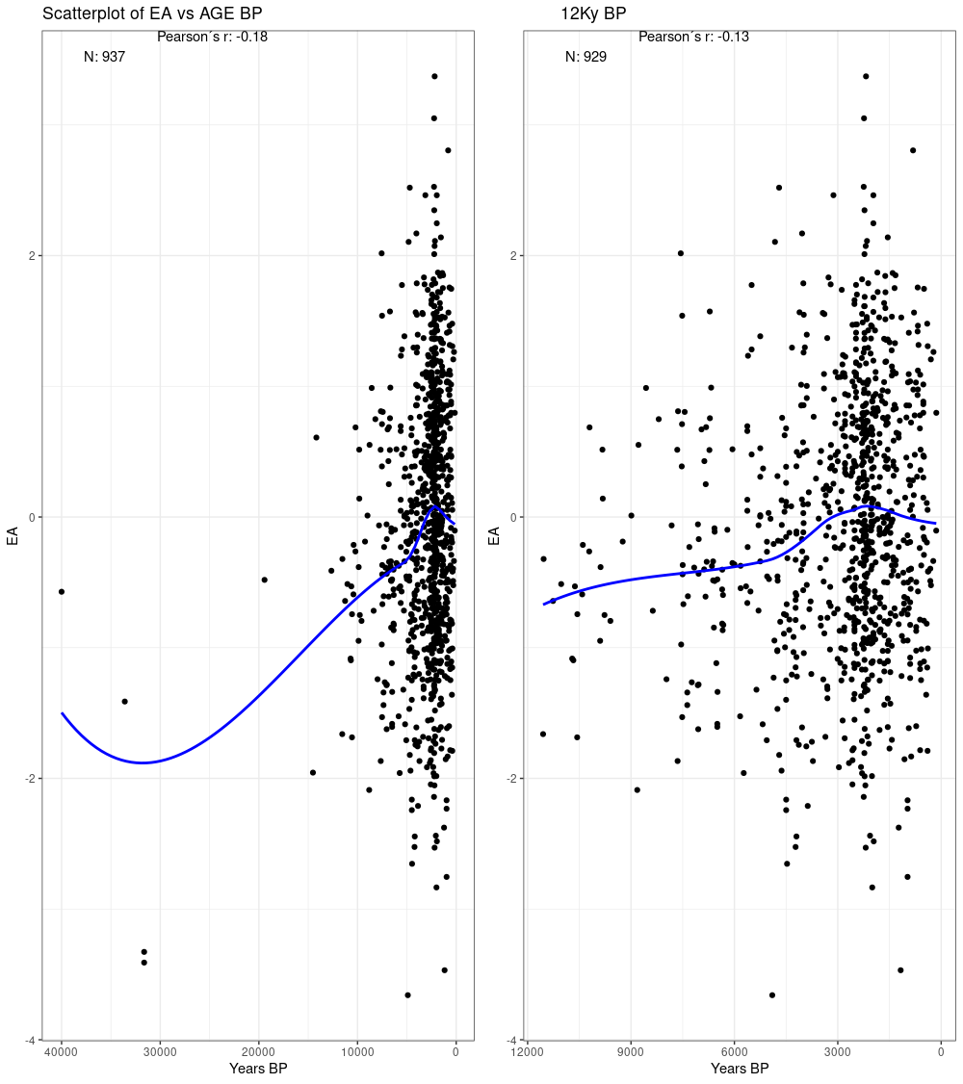

Supplementary Figure 1.

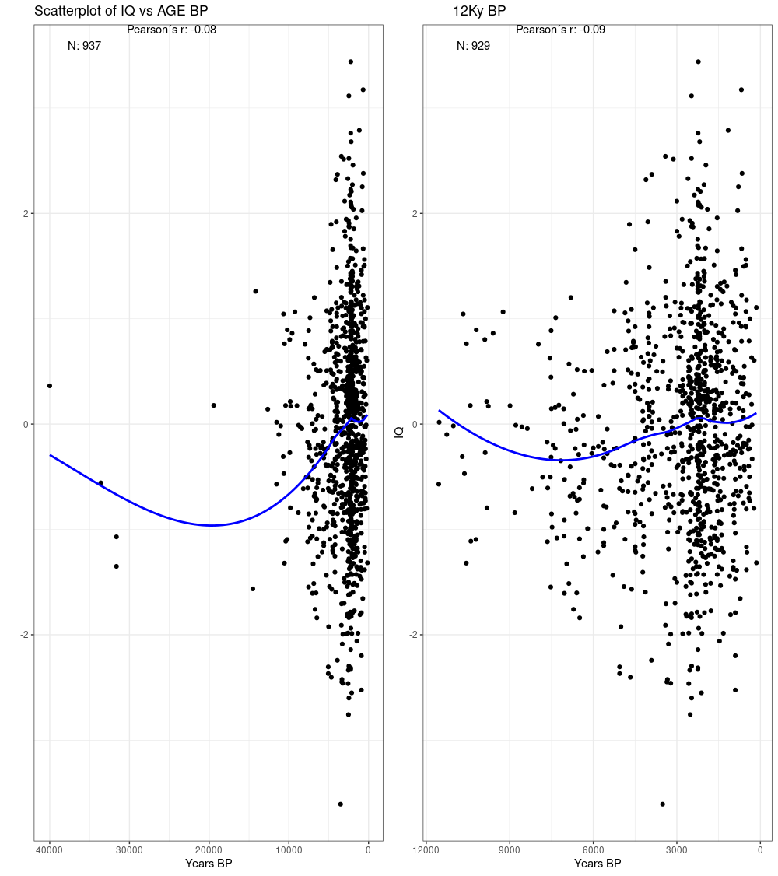

Supplementary Figure 2.

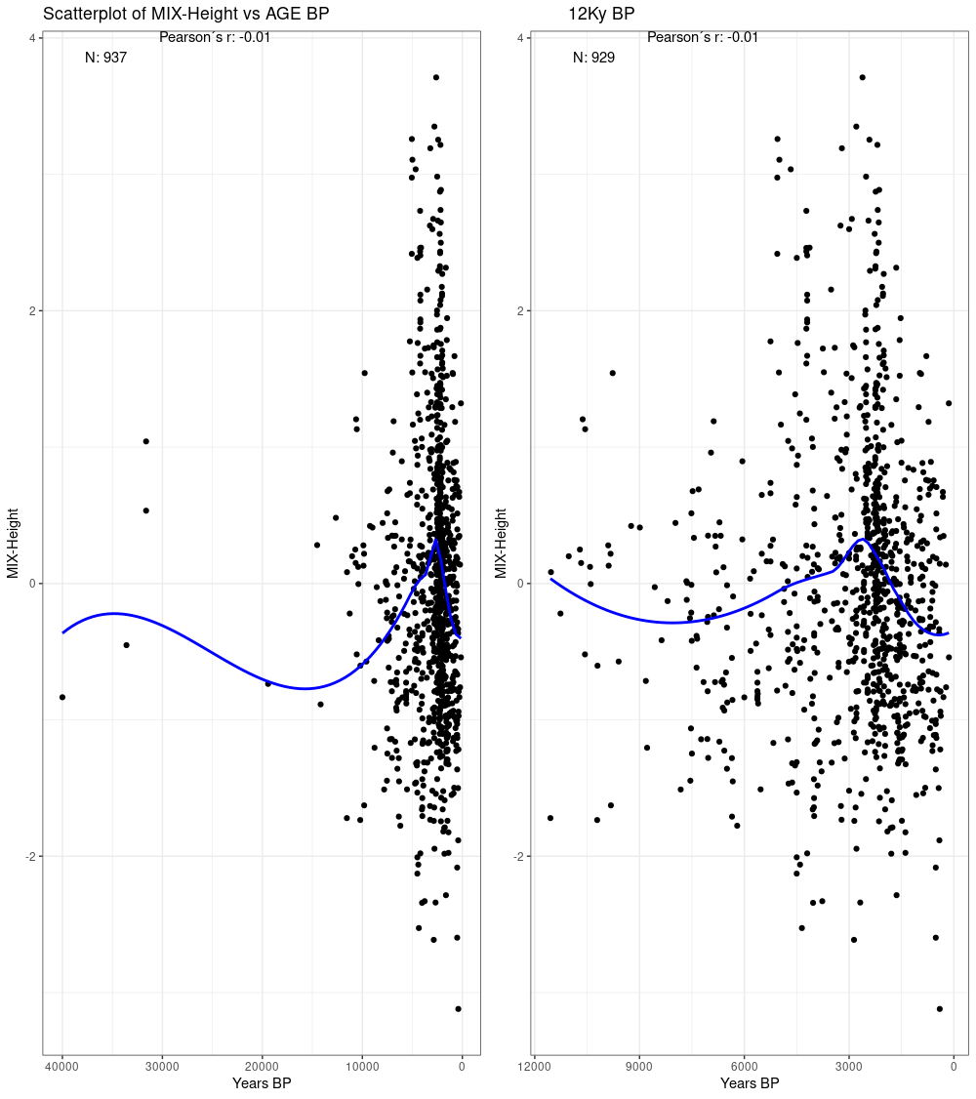

Supplementary Figure 3.

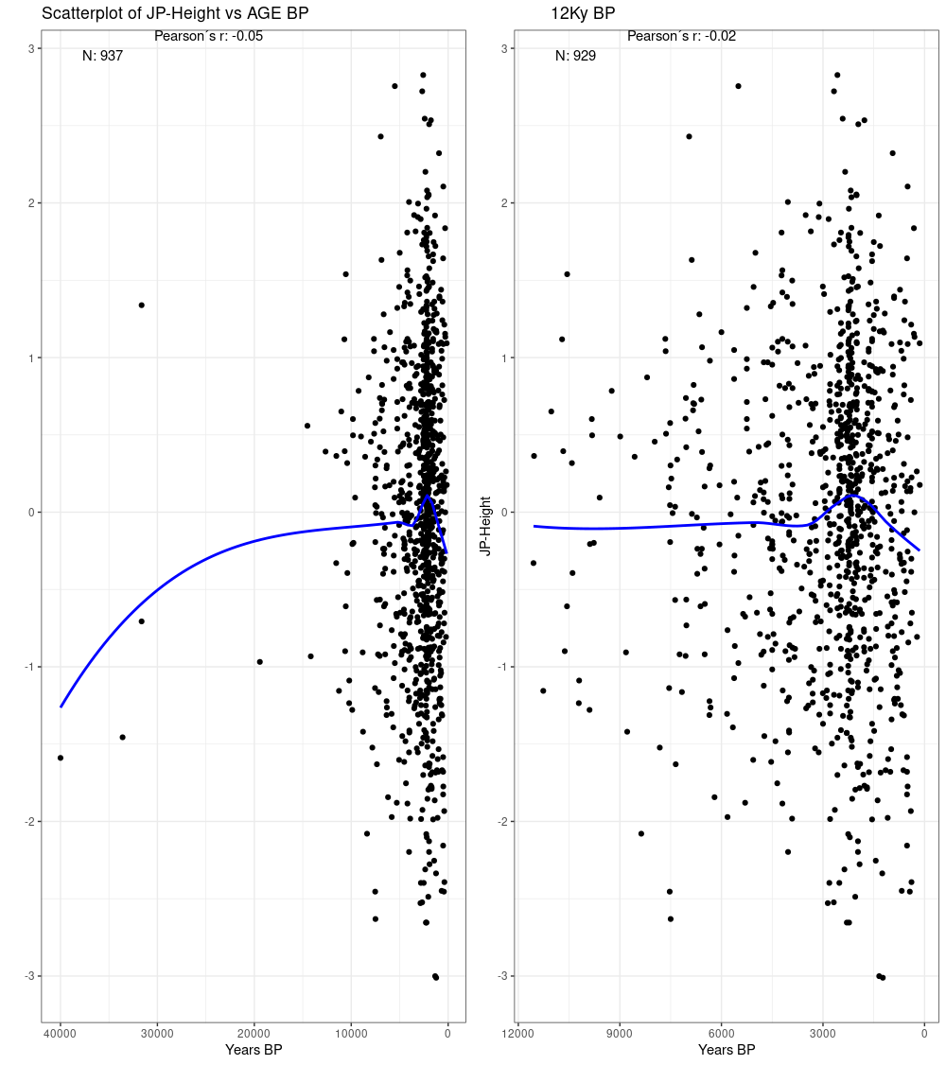

Supplementary Figure 4.

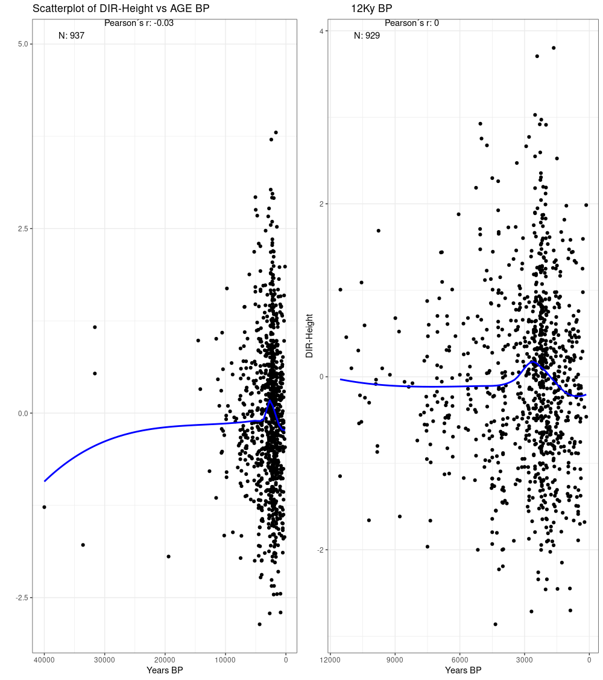

Supplementary Figure 5.

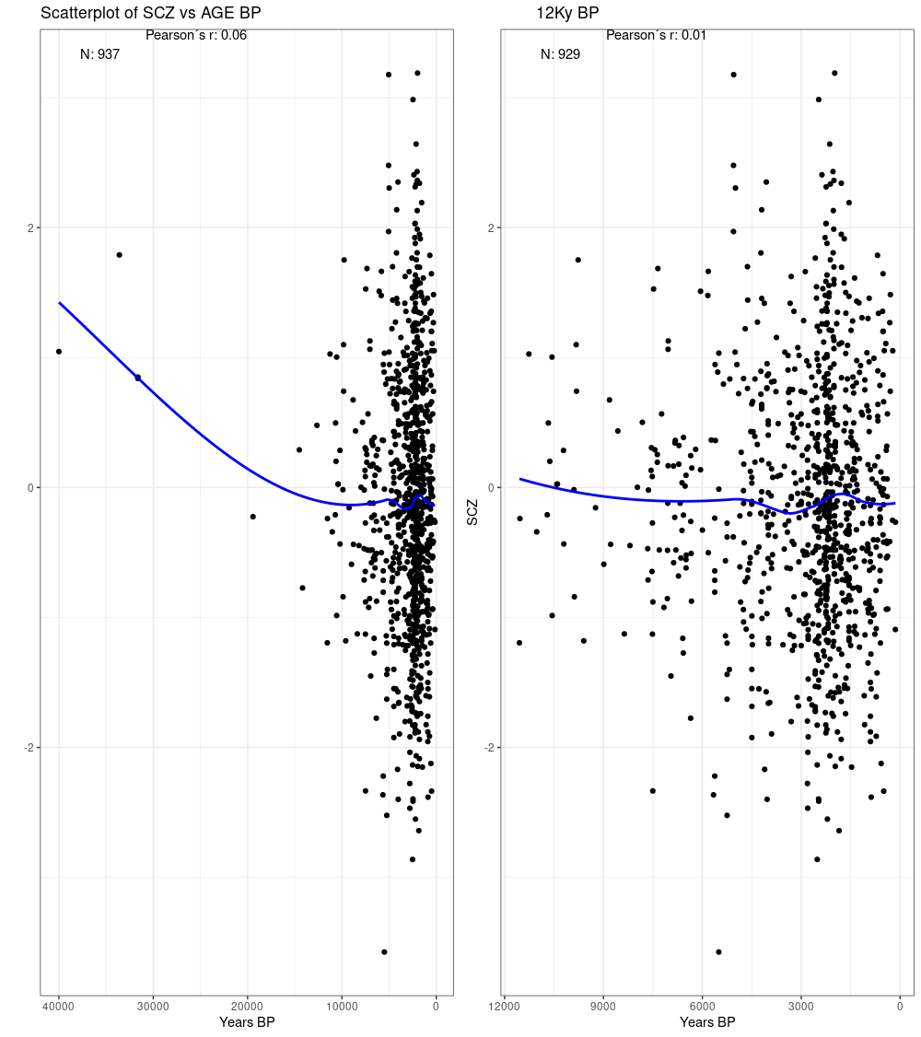

Supplementary Figure 6.

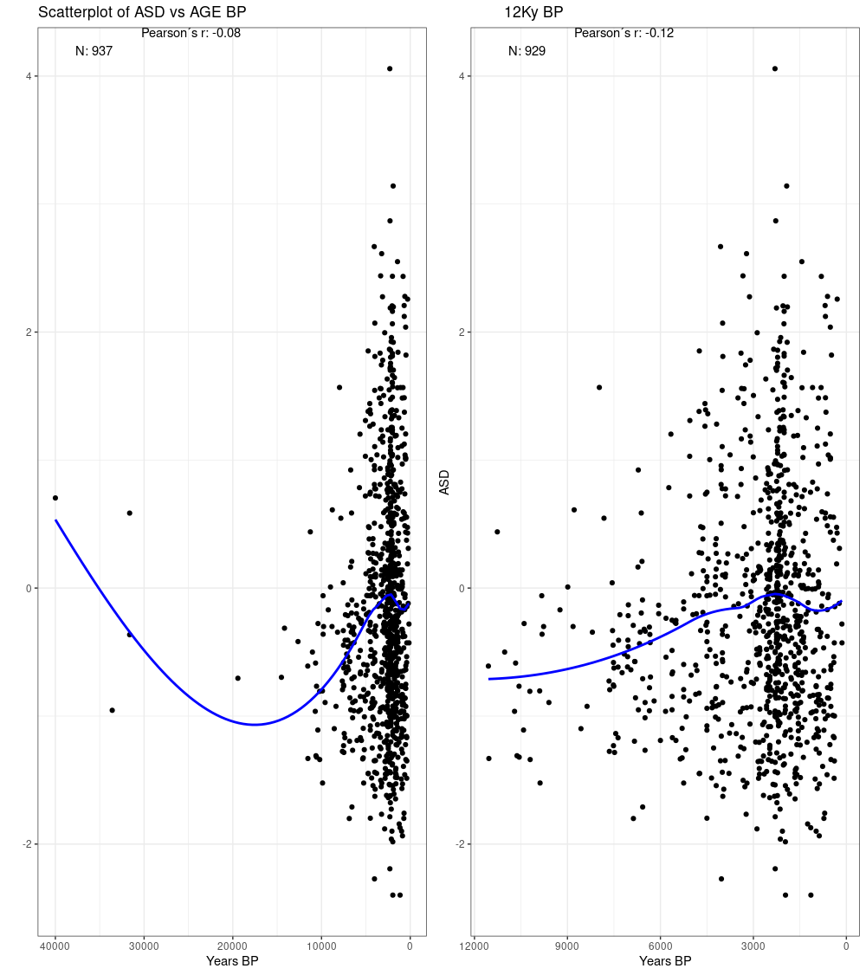

Supplementary Figure 7.

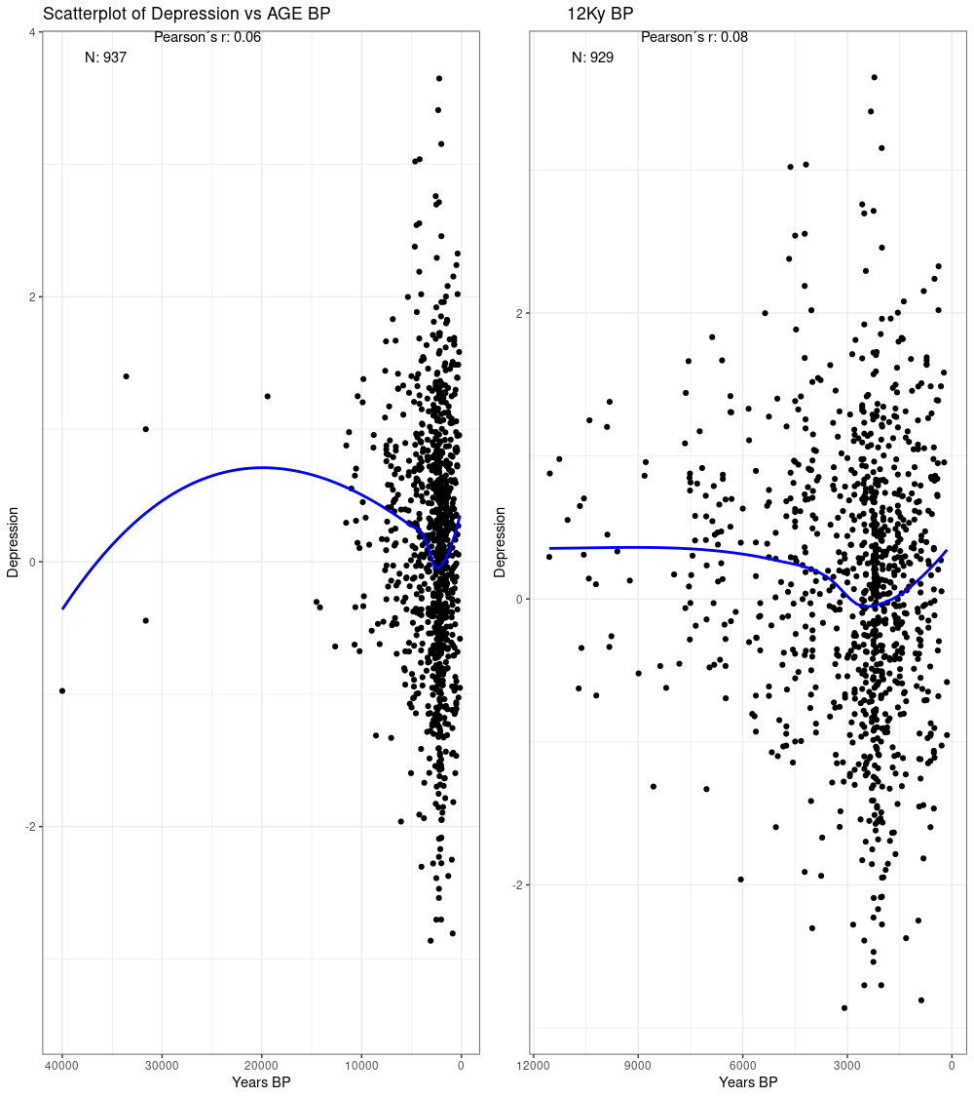

Supplementary Figure 8.

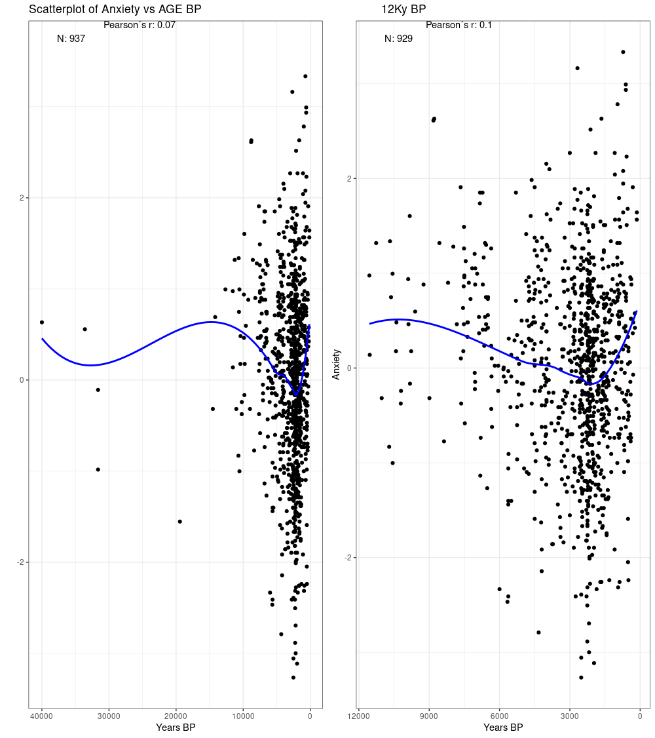

Supplementary Figure 9.

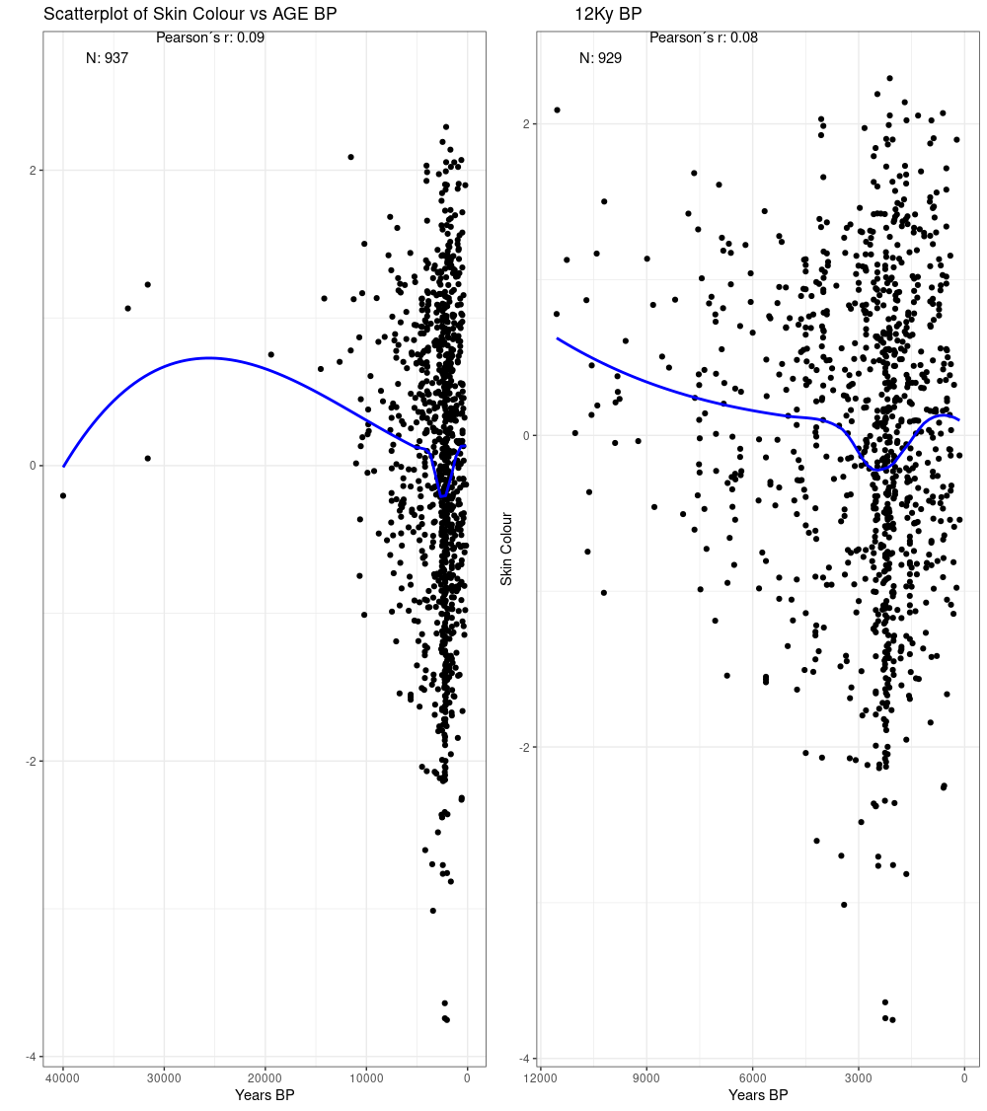

Supplementary Figure 10.

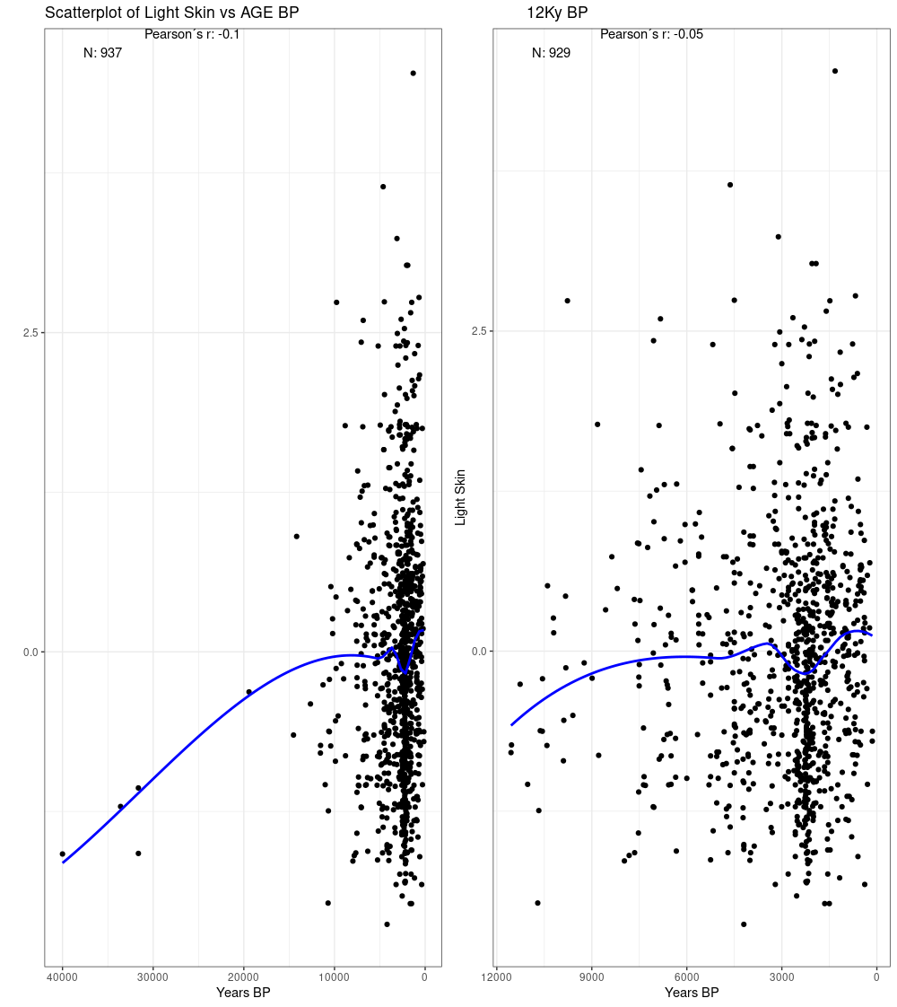

Supplementary Figure 11.

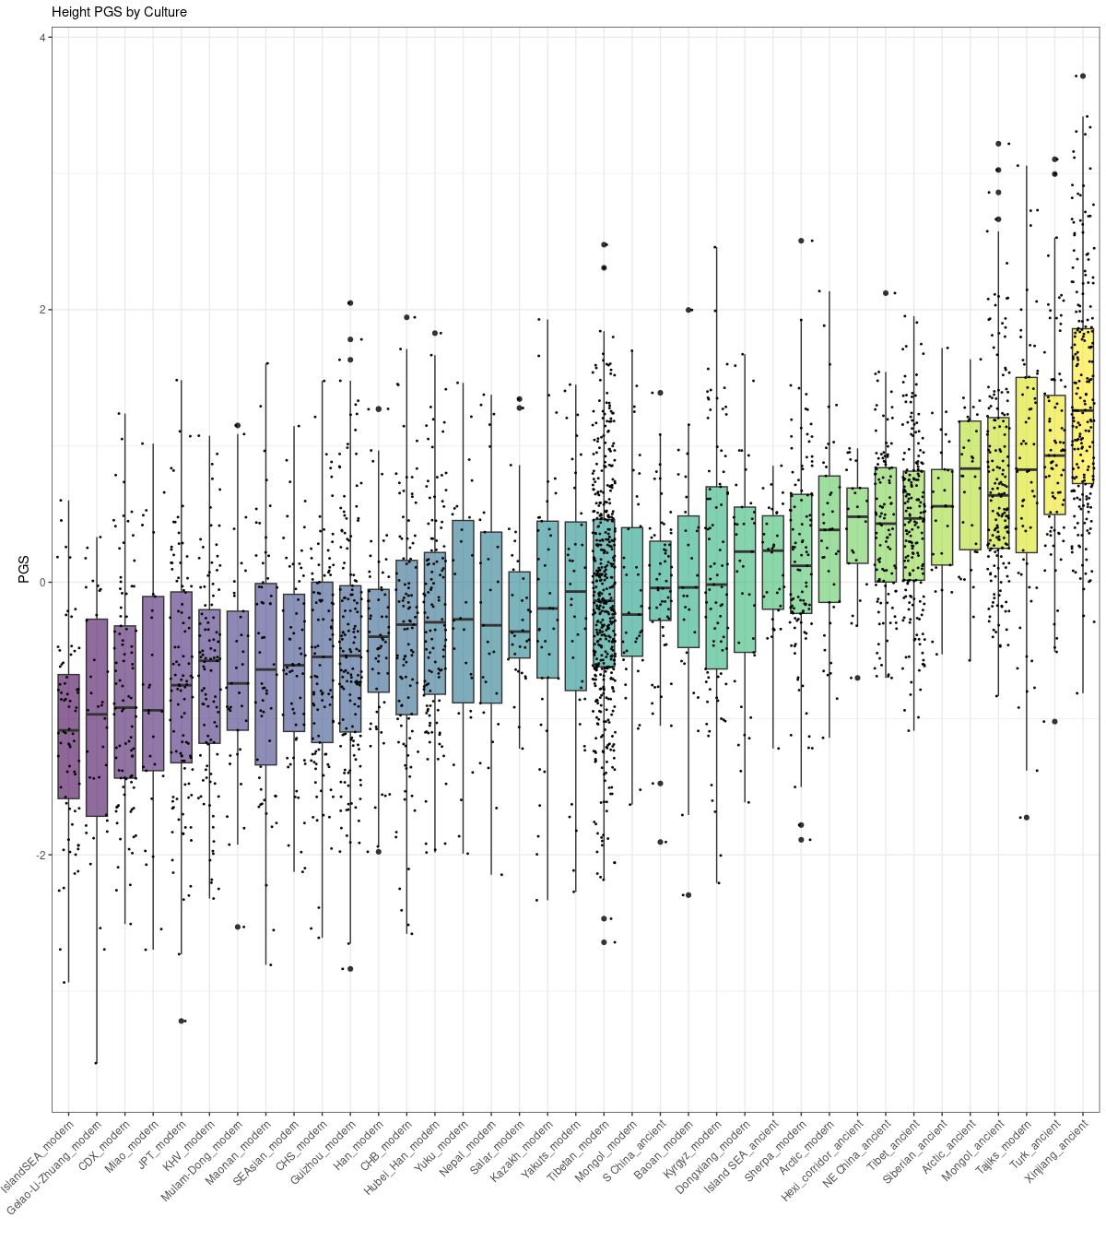

Supplementary Figure 12.