**Twin Data Support a Sensitive Period for Singing Ability**

**Supplemental Material**

Daniel Yeom 1, Nick Haslam 1, Yi Ting Tan 2, Gary E. McPherson 2, Sarah J. Wilson 1 3

1 Melbourne School of Psychological Sciences, University of Melbourne, Parkville, VIC 3010, Australia

2 Melbourne Conservatorium of Music, University of Melbourne, Southbank, VIC 3006, Australia

3 Department of Medicine, University of Melbourne, Austin Health, Heidelberg, VIC 3084, Australia

**Supplemental Methods**

The three singing tasks employed in the study were a Familiar Tune Task, an Unfamiliar Tune Task and a Single Note task. From these three singing tasks, three measures of pitch deviation (PD) and two measures of interval deviation (ID) were calculated, leading to five individual measures of accuracy in total. PD describes the average absolute difference (error) between each target note and each participant’s sung note. ID describes the average absolute difference between each target *interval* (i.e. the distance between two successive notes) and each participant’s sung interval. All measures were calculated in cents.

Each participant’s PD was calculated on each task using the following formula:

$$PD= \frac{Σ_{i-1}^{n}| 1200 × \log_{2}\frac{f_{i}}{r_{i}}|}{n}$$

Where $f_{i}$ is the fundamental frequency (Hz) of the *i*th pitch produced by the participant, $r_{i}$ is the fundamental frequency of the target pitch and *n* is the number of trials. For the Familiar and Unfamiliar Tune tasks, a PD for each trial was first calculated by calculating each note’s PD and then averaging over all notes in the trial. For the Single Note and Unfamiliar Tune tasks where participants were asked to recall fixed pitches/melodies as accurately as possible, we also applied octave adjustments to correct any notes that were sung in an incorrect octave using the below formula:

$${PD}_{oct}= |1200 – 1200 × \log_{2}\frac{f_{i}}{r_{i}}|$$

Where $f_{i}$ and $r_{i}$ are as above. Note that if a participant does not make octave errors, the formula gives the same measure of PD as the original formula.

For the Familiar and Unfamiliar Tune tasks we calculated ID using the following formula:

$$ID =\frac{\sum_{i=2}^{n}{\left|\left(1200×\log_{2}{\frac{f_{i}}{f_{i-1}}}\right)-\left(1200×\log_{2}{\frac{r_{i}}{r_{i-1}}}\right)\right|}}{n}$$

Where $f_{i}$ is the fundamental frequency (Hz) of the *i*th pitch produced by the participant, $f_{i-1}$ is the fundamental frequency of the note preceding the *i*th pitch, $r_{i}$ is the fundamental frequency of the target pitch, $r_{i-1}$ is the fundamental frequency of the note preceding the target pitch and *n* is the number of notes in each trial.

In the Familiar Tune task participants were able to start on any note of their choosing. To estimate

$$r_{i} =2^{\frac{int}{1200}}×r_{i-1}$$

where $r_{i}$ represents the fundamental reference frequency of the *i*th note in the tune, $r_{i-1}$ is the fundamental reference frequency of the preceding note and *int* refers to the expected interval in cents between the two notes. *Int* can be calculated by multiplying the difference in semitones between two notes by 100; for example, an interval between notes G and A is two semitones, which equals 200 cents. Octave adjustments for this task were not required as all expected pitch values were derived from the participant’s starting note.

**Supplemental Results**

For Figures S1 and S2 below, the twin data was split by randomised twin order. To eliminate birth order effects, the twins’ birth order was randomly reallocated within each pair (i.e., one twin of a pair would be randomly allocated a 1, while the other would get a 2). Both samples therefore contain a random mix of first-born and second-born twins. We refer to these as Sample 1 (*n* = 587) and Sample 2 (*n* = 576). For Figure S3, we used years of training from the original music training variable that was used to create the vocal training variable in the main model, which covers training on any instrument. This general music training variable replaced the vocal training variable in the analysis.

**Figure S1**

Structural equation model for Sample 1 (*n* = 587). Standardised path coefficients are shown. SPI = Singing Phenotypic Index.

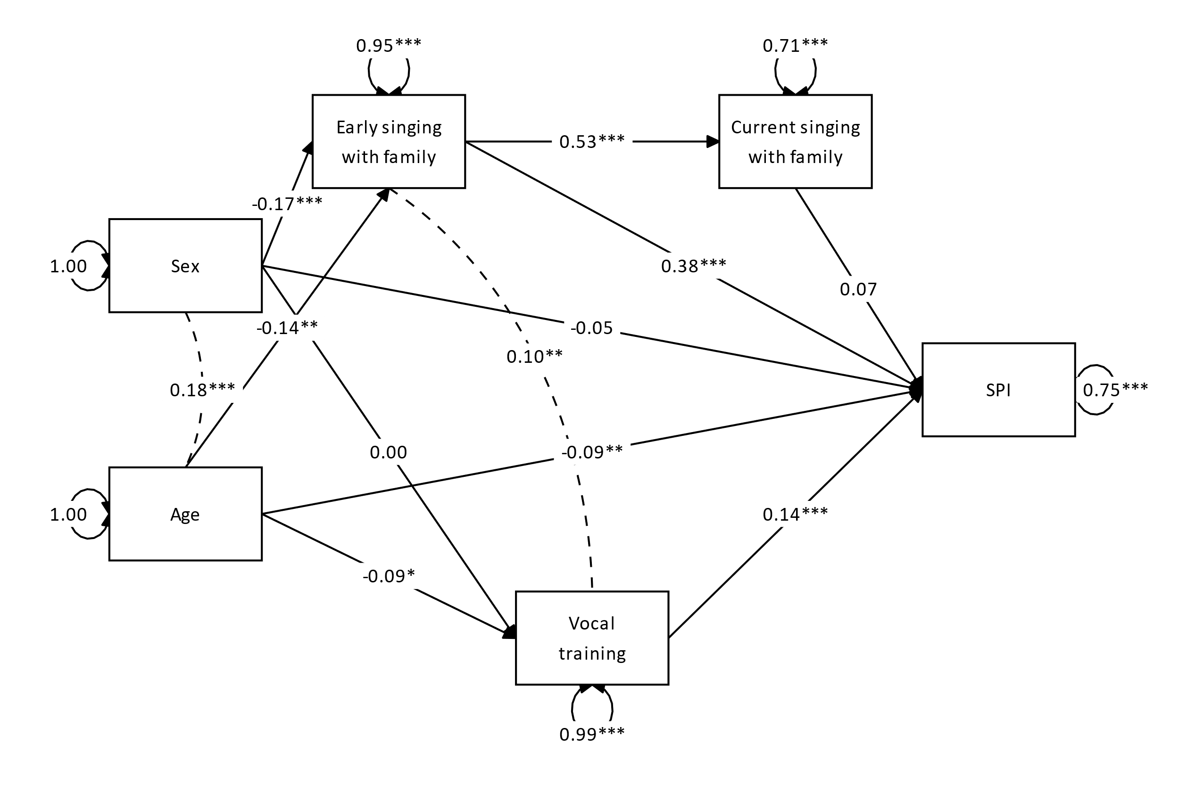

**Figure S2**

Structural equation model for Sample 2 (*n* = 576). Standardised path coefficients are shown. SPI = Singing Phenotypic Index.

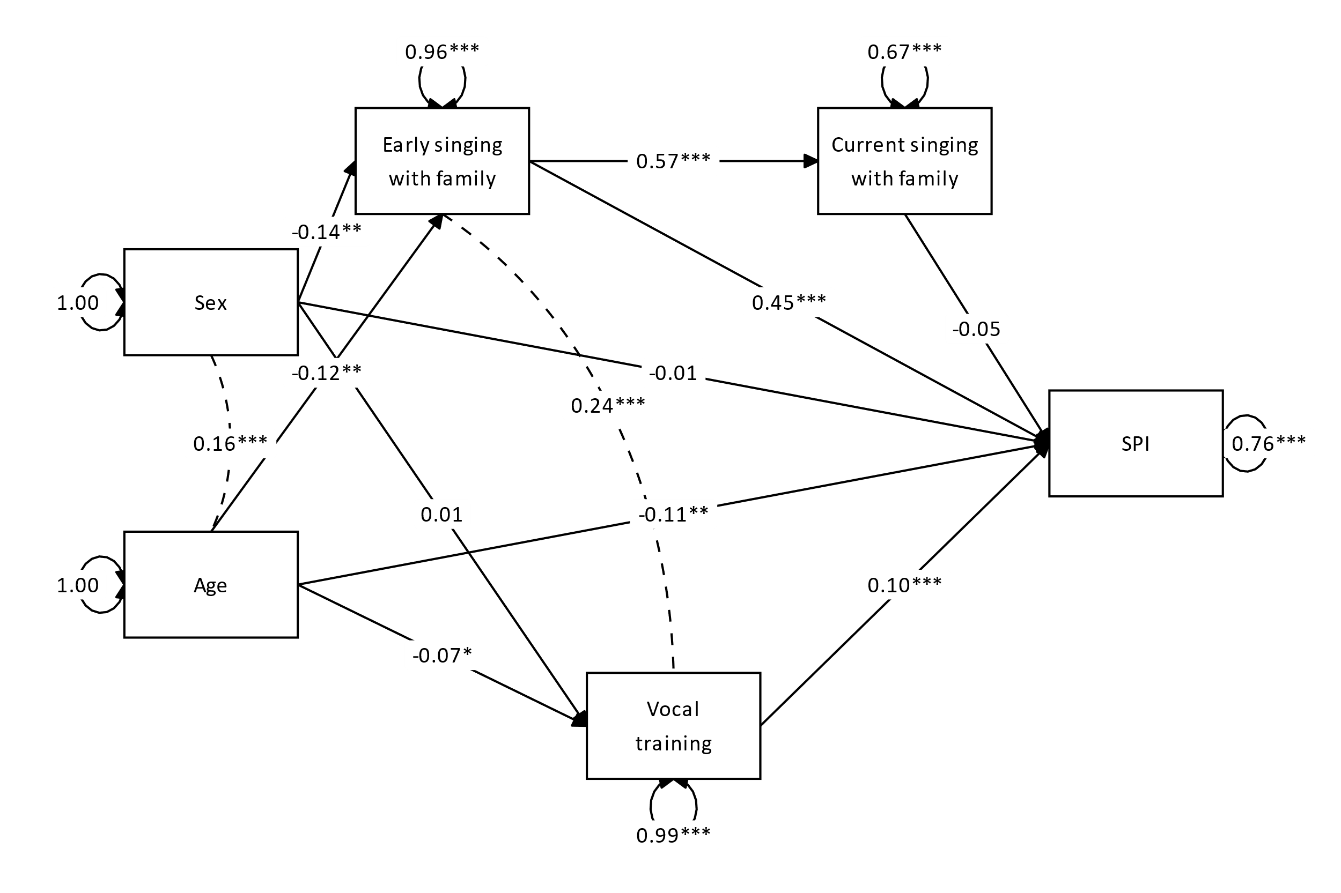

**Figure S3**

Structural equation model for the full sample (*n* = 1163), with years of music training on any instrument in place of vocal training. Standardised path coefficients are shown. SPI = Singing Phenotypic Index.

