Supplemental material: Model-based network meta-analysis: Joint estimation of dose-response and time-course relationships.
Authors: Anders Strathe¹, Martin Bøg¹ and Anders Gorst-Rasmussen¹
TABLE S1. Overview of design features for the simulation study
Study | Arm | Agent | Dose | N
1 | 1 | soc | 0 | 50
1 | 2 | A | 0.1 | 50
1 | 3 | A | 0.3 | 50
1 | 4 | A | 1 | 50
1 | 5 | A | 3 | 50
2 | 1 | soc | 0 | 250
2 | 2 | A | 0.25 | 500
2 | 3 | A | 1 | 500
3 | 1 | soc | 0 | 250
3 | 2 | A | 0.25 | 500
3 | 3 | A | 1 | 500
4 | 1 | soc | 0 | 500
4 | 2 | A | 1 | 500
4 | 3 | B | 3 | 500
5 | 1 | soc | 0 | 50
5 | 2 | B | 0.125 | 50
5 | 3 | B | 0.5 | 50
5 | 4 | B | 2 | 50
5 | 5 | B | 4 | 50
6 | 1 | soc | 0 | 250
6 | 2 | B | 0.5 | 500
6 | 3 | B | 3 | 500
7 | 1 | soc | 0 | 250
7 | 2 | B | 0.5 | 500
7 | 3 | B | 3 | 500
8 | 1 | soc | 0 | 50
8 | 2 | C | 0.125 | 50
8 | 3 | C | 0.5 | 50
8 | 4 | C | 2 | 50
8 | 5 | C | 4 | 50
9 | 1 | soc | 0 | 250
9 | 2 | C | 0.5 | 500
9 | 3 | C | 2 | 500
10 | 1 | soc | 0 | 250
10 | 2 | C | 0.5 | 500
10 | 3 | C | 2 | 500
soc: Standard-of-Care. N: Number of subjects per arm.

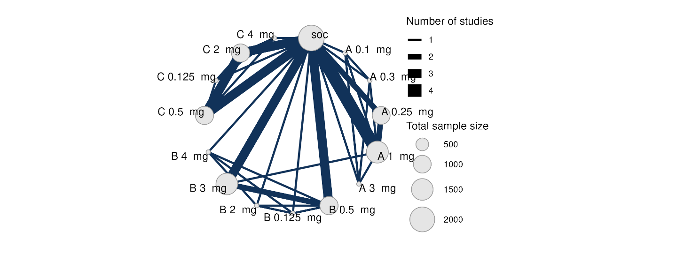
FIGURE S1. Network of treatment comparisons from 10 simulated RCTs, using 3 hypothetical agents A, B and C. Each treatment is represented by a node. Where direct RCT evidence exists for a particular comparison, the nodes are connected by a line, the thickness of which is proportional to the number of comparisons.
TABLE S2. Numerical values used in the simulations.
Parameter | Value
Reference treatment: $μ_{i}^{}$(EmaxT, %) | -2.5
Reference treatment: $μ_{i}^{}$ (kT, 1/week) | -2.0
Agent A: EmaxD^{(A)} (%) | -10
Agent A: log ED50^{(A)} (mg) | -2
Agent A: b^{(a)} | -0.2
Agent B: EmaxD^{(B)} (%) | -15
Agent B: log ED50^{(B)} (mg) | -1.5
Agent B: b^{(B)} | -0.4
Agent C: EmaxD^{(C)} (%) | -20
Agent C: log ED50^{(C)} (mg) | -0.75
Agent C: b^{(C)} | -0.8
Between-study variance in EmaxT | 0.50²
Between-study variance in kT | 0.20²
Correlation between EmaxT and kT | 0.25

A  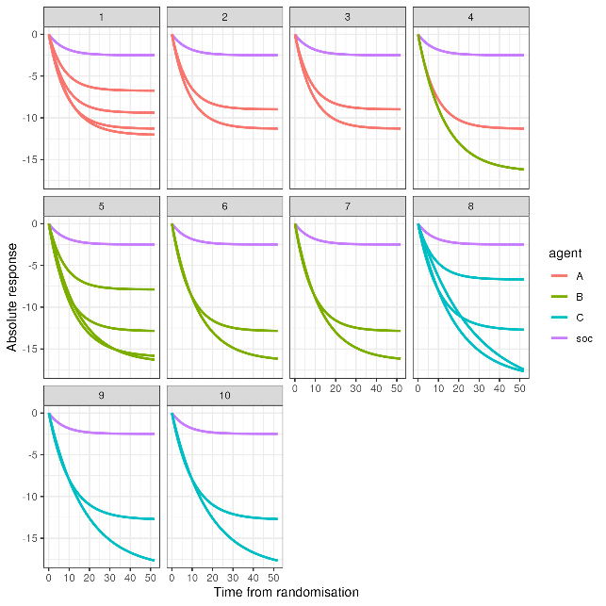 | B  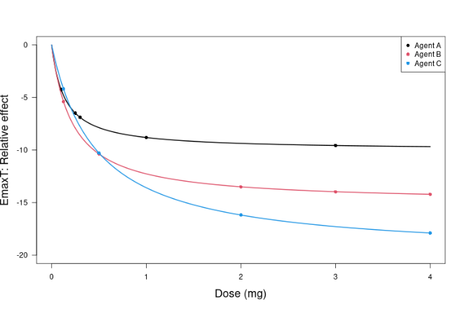
FIGURE S2. The true mean time-course (A) and dose-response profiles (B).
soc: Standard-Of-Care

TABLE S3. Individual patient level covariance matrix.
Week | 2 | 4 | 8 | 12 | 16 | 20 | 28 | 36 | 44 | 52
2 | 1.819 | 1.804 | 2.158 | 2.574 | 2.703 | 2.922 | 2.998 | 2.993 | 3.091 | 2.899
4 | 1.804 | 3.057 | 3.646 | 4.359 | 4.805 | 5.202 | 5.729 | 5.907 | 6.105 | 6.208
8 | 2.158 | 3.646 | 6.400 | 7.619 | 8.468 | 9.467 | 10.51 | 11.127 | 11.57 | 11.799
12 | 2.574 | 4.359 | 7.619 | 10.784 | 11.99 | 13.439 | 15.125 | 16.192 | 16.868 | 17.27
16 | 2.703 | 4.805 | 8.468 | 11.99 | 15.059 | 16.87 | 19.534 | 21.293 | 22.592 | 23.251
20 | 2.922 | 5.202 | 9.467 | 13.439 | 16.87 | 20.432 | 23.65 | 26.051 | 27.752 | 28.626
28 | 2.998 | 5.729 | 10.51 | 15.125 | 19.534 | 23.65 | 30.761 | 34.027 | 36.763 | 38.541
36 | 2.993 | 5.907 | 11.127 | 16.192 | 21.293 | 26.051 | 34.027 | 40.744 | 44.426 | 46.821
44 | 3.091 | 6.105 | 11.57 | 16.868 | 22.592 | 27.752 | 36.763 | 44.426 | 51.291 | 54.496
52 | 2.899 | 6.208 | 11.799 | 17.27 | 23.251 | 28.626 | 38.541 | 46.821 | 54.496 | 61.034

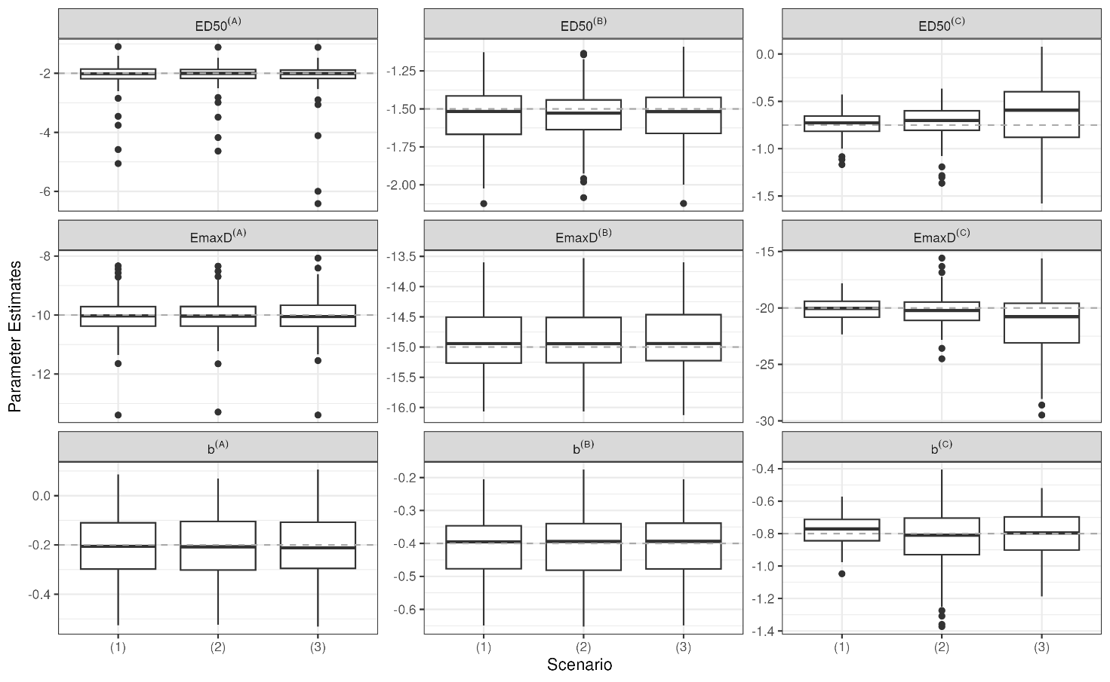
FIGURE S3. Estimation of drug effect parameters under different scenarios: (1) All arms are observed for 52 weeks, (2) Truncate phase 2 for agent C to 28 weeks and (3) Truncate phase 2 to 28 weeks and exclude phase 3 for agent C. Individual patient data (arm-level) was simulated from an unstructured covariance matrix, generating correlated observations across time-points. The mean time-course was simulated from an exponential function ( $E_{max}T\left(1-exp⁡(-exp⁡(kT)×time)\right)$), where the long-term treatment effect (EmaxT) is dose-dependent and described by an Emax model, having 2 parameters; maximum response relative to placebo (EmaxD^{(q)}) and the dose at which of half the maximum response can be achieved (ED50^{(c)}) for the 3 agents (q = [A, B, C]). Decay parameter (kT) was dose-dependent and described by a log-linear model, having 1 slope parameter (b^{(c)}). Estimation model assumes univariate normal likelihood. The grey dotted lines present the true values used in the simulations.
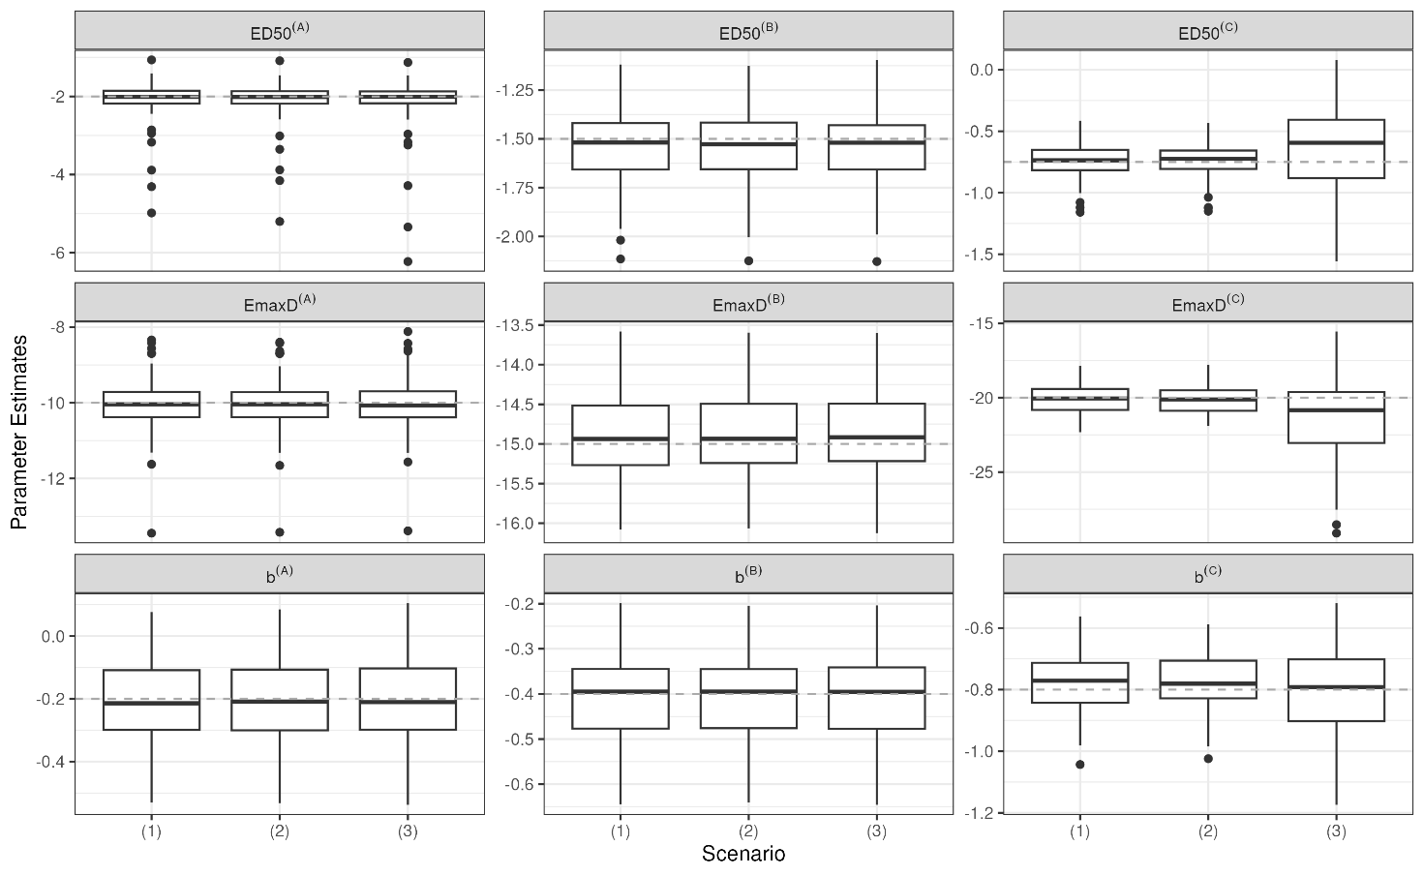
FIGURE S4. Estimation of drug effect parameters under different scenarios: (1) All arms are observed for 52 weeks, (2) Truncate phase 2 for agent C to 28 weeks and (3) Truncate phase 2 to 28 weeks and exclude phase 3 for agent C. Individual patient data (arm-level) was simulated from an unstructured covariance matrix, generating correlated observations across time-points. The mean time-course was simulated from an exponential function ( $E_{max}T\left(1-exp⁡(-exp⁡(kT)×time)\right)$), where the long-term treatment effect (EmaxT) is dose-dependent and described by an Emax model, having 2 parameters; maximum response relative to placebo (EmaxD^{(q)}) and the dose at which of half the maximum response can be achieved (ED50^{(c)}) for the 3 agents (q = [A, B, C]). Decay parameter (kT) was dose-dependent and described by a log-linear model, having 1 slope parameter (b^{(c)}). Estimation model multivariate normal likelihood, with within-arm correlation structure approximated by an AR-1 process. The grey dotted lines present the true values used in the simulations.
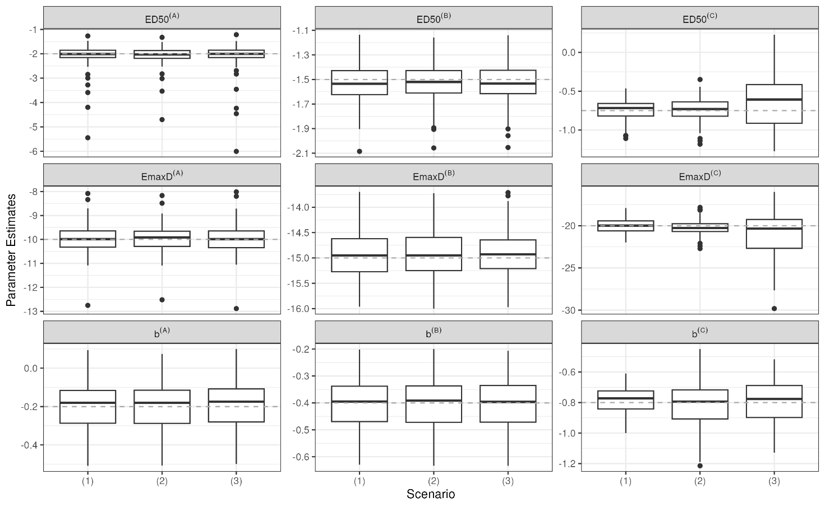
FIGURE S5. Estimation of drug effect parameters under different scenarios: (1) All arms are observed for 52 weeks, (2) Truncate phase 2 for agent C to 28 weeks and (3) Truncate phase 2 to 28 weeks and exclude phase 3 for agent C. Individual patient data (arm-level) was simulated from an unstructured covariance matrix, generating correlated observations across time-points. The mean time-course was simulated from an exponential function ( $E_{max}T\left(1-exp⁡(-exp⁡(kT)×time)\right)$), where the long-term treatment effect (EmaxT) is dose-dependent and described by an Emax model, having 2 parameters; maximum response relative to placebo (EmaxD^{(q)}) and the dose at which of half the maximum response can be achieved (ED50^{(c)}) for the 3 agents (q = [A, B, C]). Decay parameter (kT) was dose-dependent and described by a log-linear model, having 1 slope parameter (b^{(c)}). Estimation model multivariate normal likelihood, with observed within-arm correlation matrix used in estimation. The grey dotted lines present the true values used in the simulations.

TABLE S4. Overview of the illustrative dataset
Agent | Author | Year | Study name | N | End of treatment | Treatments
Liraglutide | Astrup | 2009 | Phase 2 (1807)ª | 469 | 20 | placebo, lira 1.2 mg, lira 1.8 mg, lira 2.4 mg, lira 3.0 mg
Liraglutide | Pi-Sunyer | 2015 | SCALE Obesity and Prediabetes | 3731 | 56 | placebo, lira 3.0 mg
Semaglutide | O'Neil | 2018 | Phase 2 (4153)^{b} | 957 | 52 | placebo, sema 0.05 mg, sema 0.10 mg, sema 0.20 mg, sema 0.30 mg, sema 0.40 mg, sema 0.30 mg F, sema 0.40 mg F, lira 3.0 mg
Semaglutide | Wilding | 2021 | STEP 1 | 1961 | 68 | placebo, sema 2.4 mg
Semaglutide | Garvey | 2022 | STEP 5 | 304 | 104 | placebo, sema 2.4 mg
Semaglutide | Kadowaki | 2022 | STEP 6^{c} | 302 | 68 | placebo, sema 1.7 mg, sema 2.4 mg
Semaglutide | Rubino | 2022 | STEP 8 | 338 | 68 | placebo, sema 2.4 mg, lira 3.0 mg
ªOrlistat treatment was excluded due to the inclusion criteria of comparing the effect of an GLP-1 to another GLP-1 or placebo (dietary restriction and adjunct to lifestyle intervention) for weight reduction in patients with obesity without diabetes.
^{b}Semaglutide dose levels were standardized to weekly equivalents by multiplying daily doses with 7 to match the once-weekly doses used in phase 3. The treatment labelled “F” represents doses, where semaglutide was dose-escalated in every second to target doses 0.30 mg and 0.40 mg, respectively.
^{c}STEP 6 trial population included both normo-glycaemic, prediabetic and T2D subjects. To align with the study selection the T2D subgroup was excluded from the analysis and hence N=302.

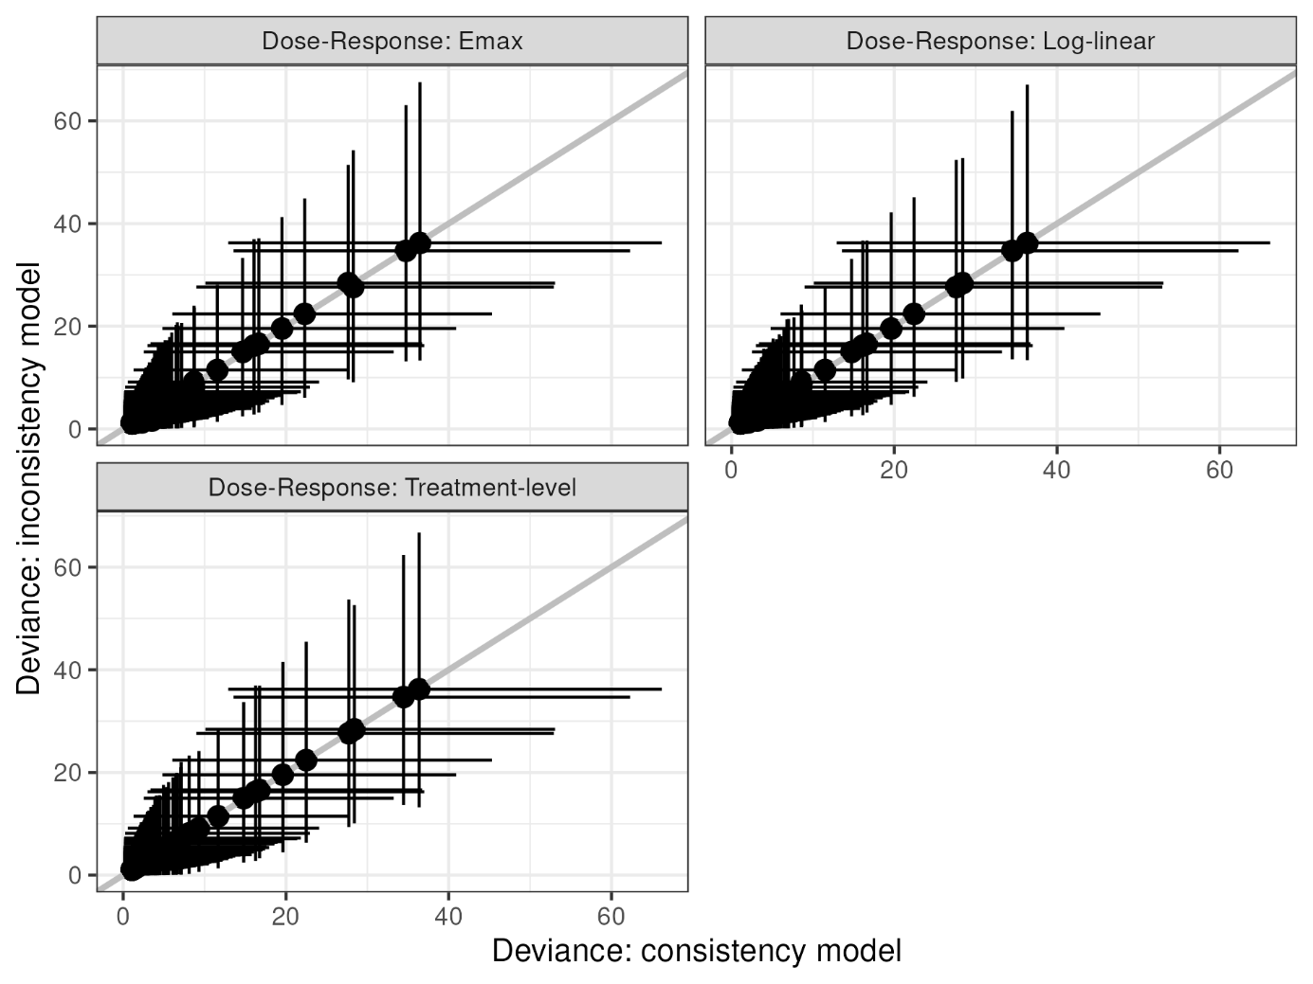
FIGURE S6. Deviance-deviance plots showing the contribution to the posterior residual deviance for each data point from different drug effect models compared to the UME model. The black diagonal line represents the line of equality

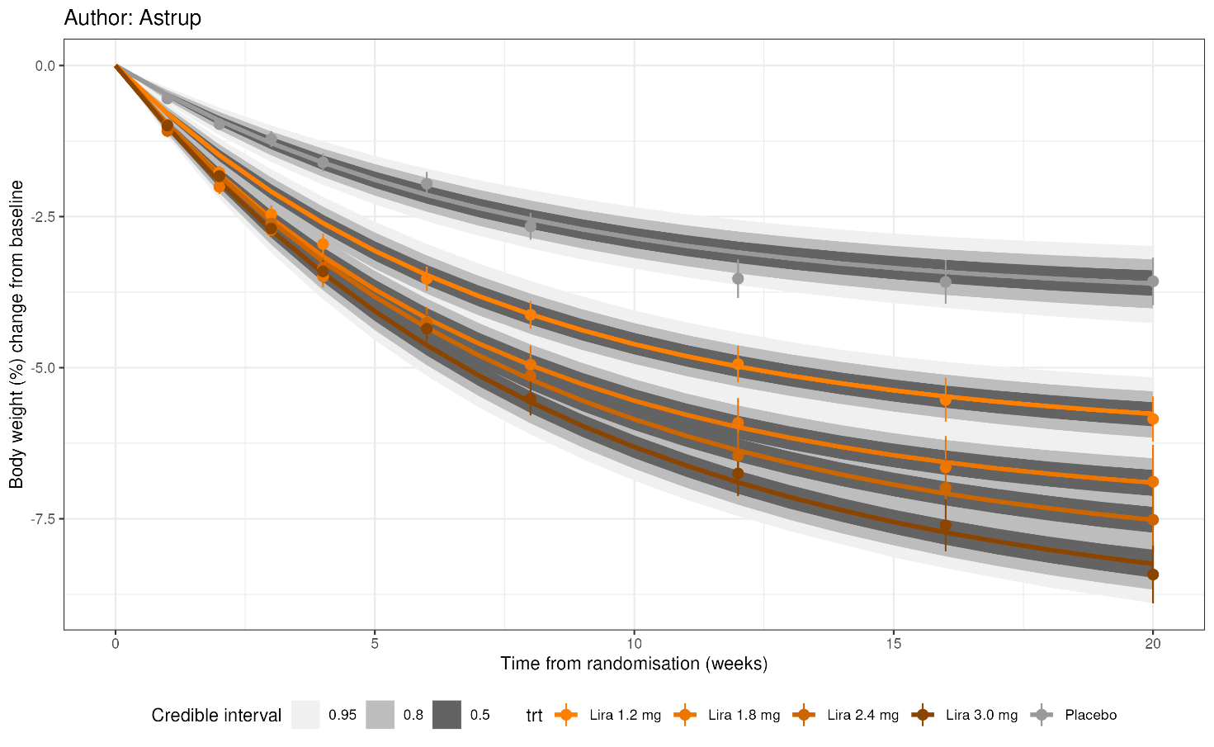
FIGURE S7. Body weight changes over time for the Astrup study in the obesity dataset. Data is presented as the observed mean percentage change from baseline in body weight (+/- 1 standard error of the mean) over time among participants in the full analysis population during the on-treatment observation period. Lines are model posterior means and credible intervals.

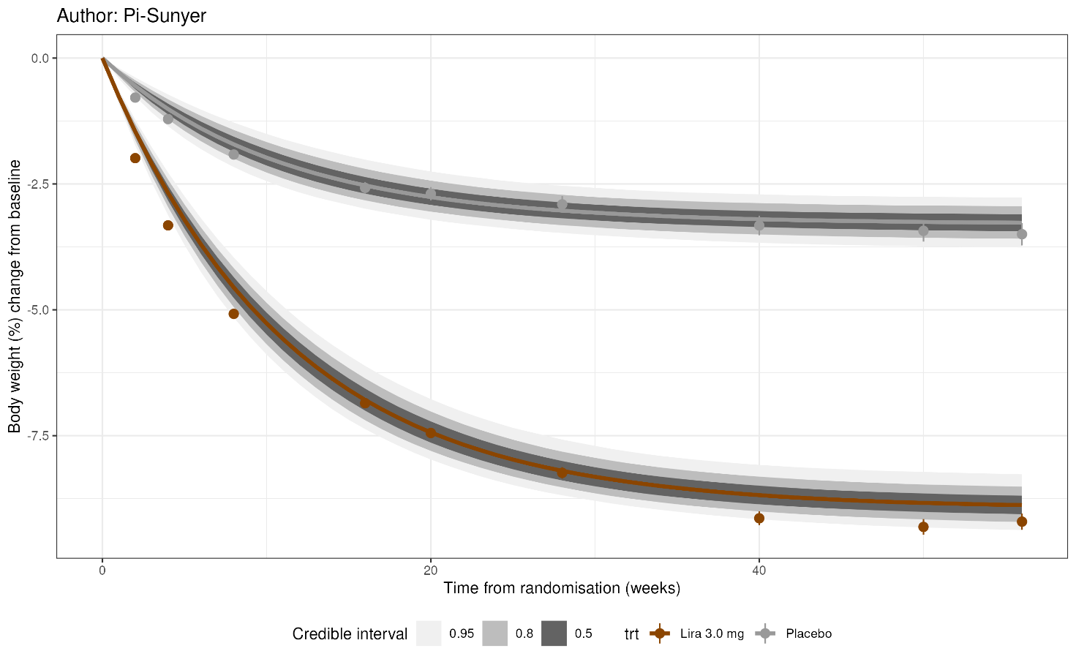
FIGURE S8. Body weight changes over time for the Pi-Sunyer study in the obesity dataset. Data is presented as the observed mean percentage change from baseline in body weight (+/- 1 standard error of the mean) over time among participants in the full analysis population during the on-treatment observation period. Lines are model posterior means and credible intervals.

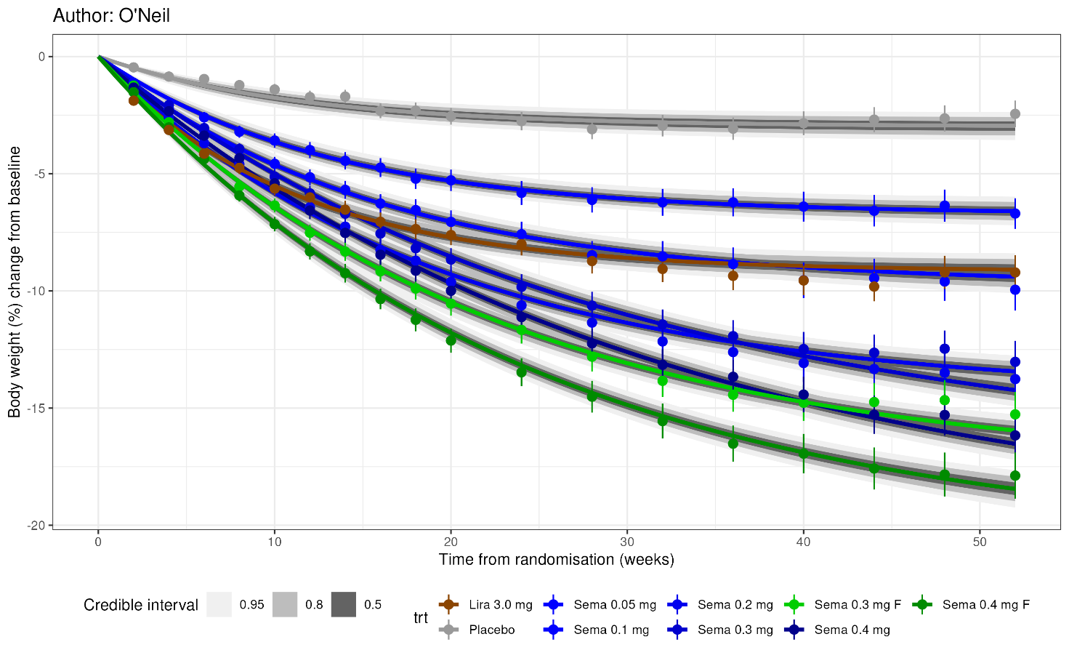
FIGURE S9. Body weight changes over time for the O'Neil study in the obesity dataset. Data is presented as the observed mean percentage change from baseline in body weight (+/- 1 standard error of the mean) over time among participants in the full analysis population during the on-treatment observation period. Lines are model posterior means and credible intervals.
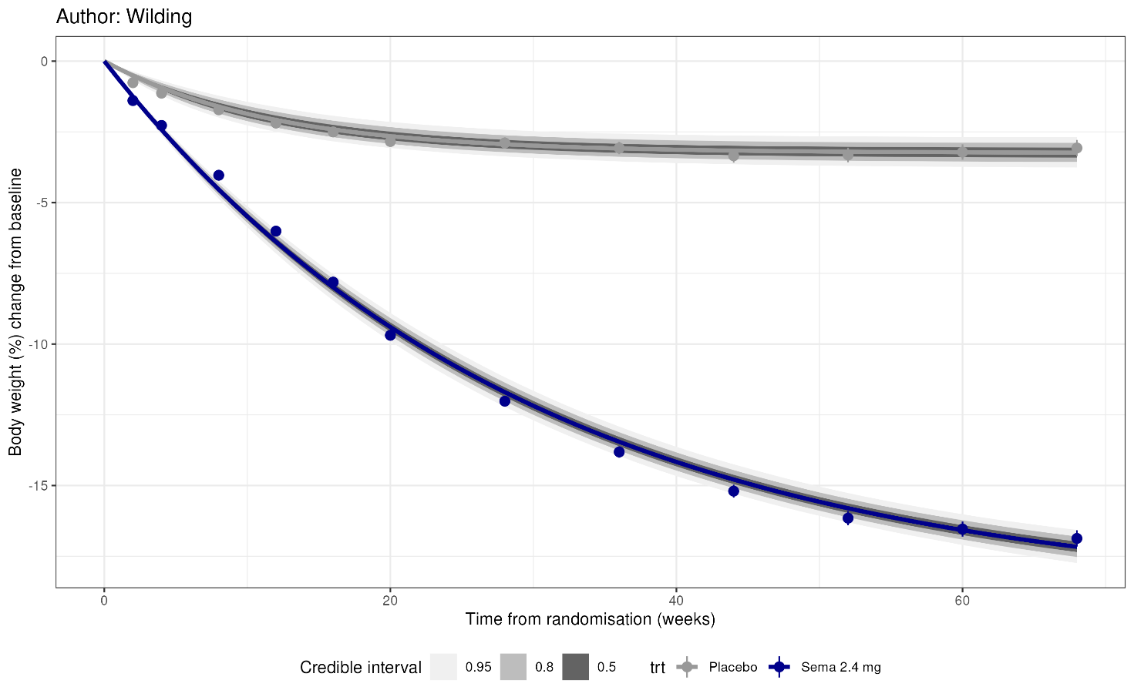
FIGURE S10. Body weight changes over time for the Wilding study in the obesity dataset. Data is presented as the observed mean percentage change from baseline in body weight (+/- 1 standard error of the mean) over time among participants in the full analysis population during the on-treatment observation period. Lines are model posterior means and credible intervals.

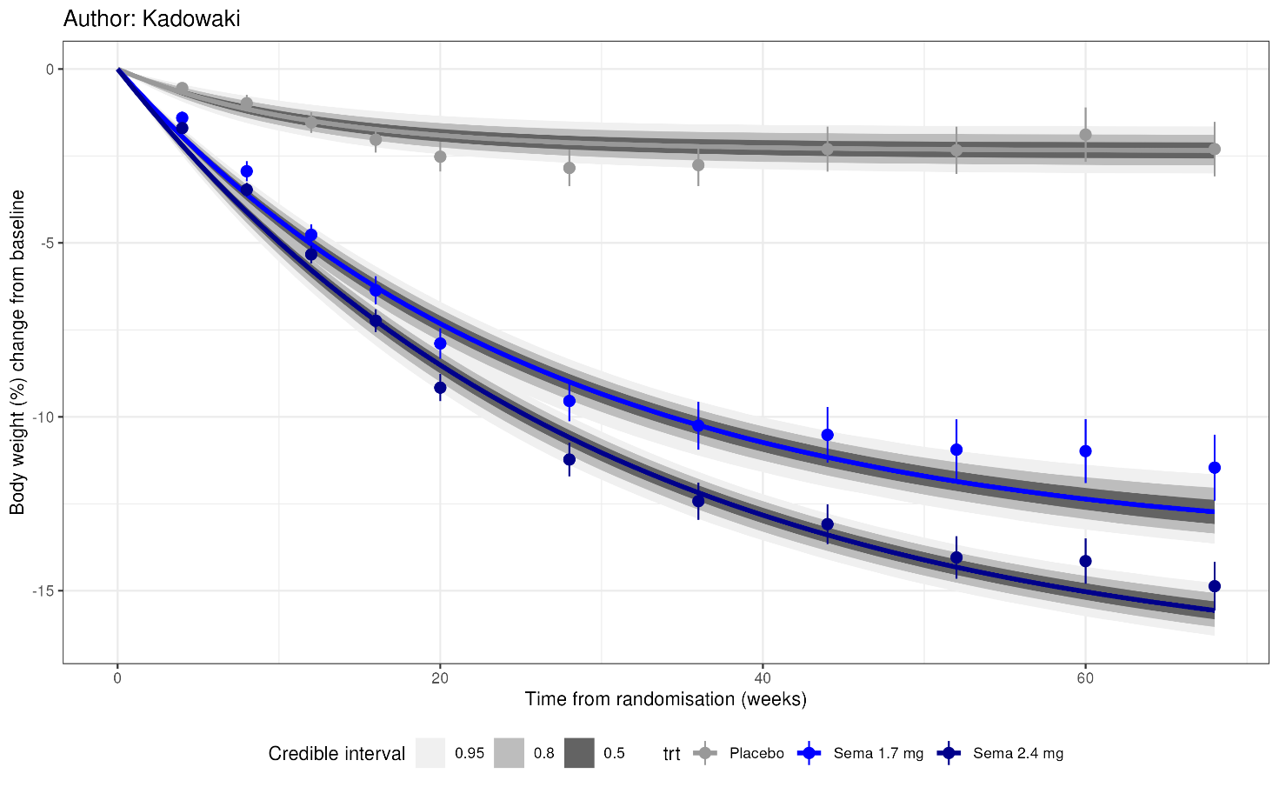
FIGURE S11. Body weight changes over time for the Kadowaki study in the obesity dataset. Data is presented as the observed mean percentage change from baseline in body weight (+/- 1 standard error of the mean) over time among participants in the full analysis population during the on-treatment observation period. Lines are model posterior means and credible intervals.
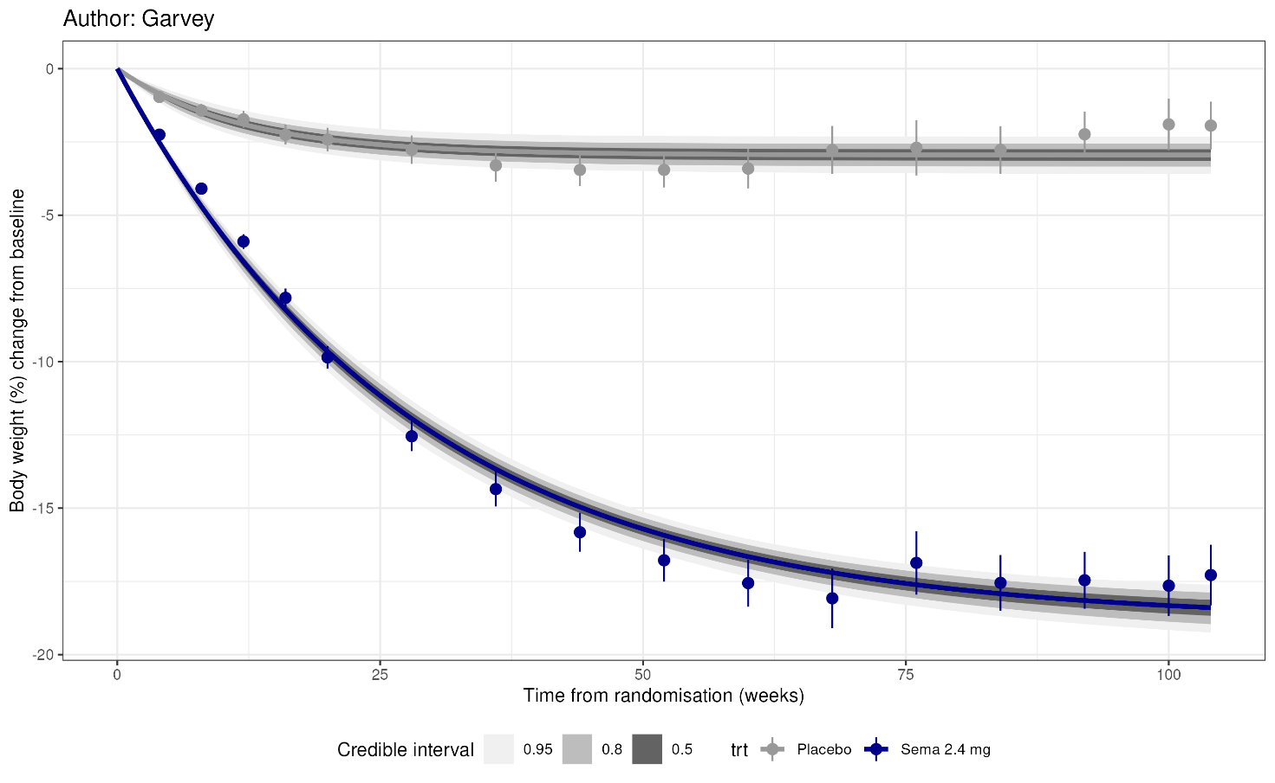
FIGURE S11. Body weight changes over time for the Garvey study in the obesity dataset. Data is presented as the observed mean percentage change from baseline in body weight (+/- 1 standard error of the mean) over time among participants in the full analysis population during the on-treatment observation period. Lines are model posterior means and credible intervals.
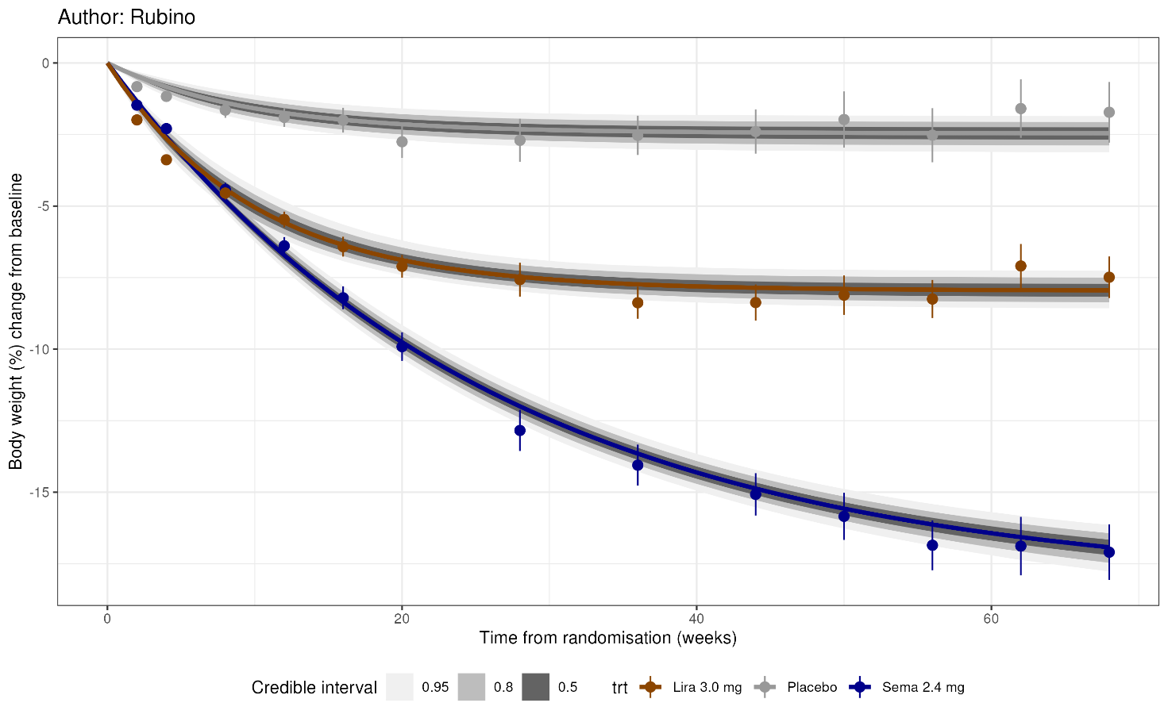
FIGURE S12. Body weight changes over time for the Rubino study in the obesity dataset. Data is presented as the observed mean percentage change from baseline in body weight (+/- 1 standard error of the mean) over time among participants in the full analysis population during the on-treatment observation period. Lines are model posterior means and credible intervals.

