Online Appendix 1. Operationalising collective skill formation systems
Operationalising collective skill formation systems entails making choices about variables. One approach would lie in the use of a categorical variable distinguishing collective skill formation systems from non-collective ones. There are, however, two drawbacks related to this approach. First, there is not a unanimously agreed ‘list’ of collective skill formation systems. Most studies would point to five countries that unequivocally feature this kind of system: Austria, Denmark, Germany, Netherlands, and Switzerland (Bonoli and Emmennegger, 2022; Busemeyer and Trampusch 2011). However, while these countries may be ideal-typical, there are others who would plausibly qualify. The Norwegian training system, for instance, has been recently compared to the Danish system precisely by virtue of their similar institutional set-up (Arnholz and Østhus, 2024). Moreover, some Central and Eastern European countries, often excluded from these categorisations, have developed elements in their training system that makes them in some respects similar to those of German-speaking countries (Hancké 2012). Secondly, and perhaps more fundamentally, national training systems can hardly be considered as organised in their entirety according to one over-arching principle. Rather, different forms of training typically exist within each country, with different skill ‘eco-system’ often emerging at regional or sectoral level (Finegold 1999, Crouch et al. 2009). Countries that are quintessentially collectivist feature for instance ‘statist’ elements that co-exist alongside collectivist ones (see e.g. Graf et al. 2012), while countries labelled as ‘liberal skill formation systems’ have had moments in which they conducted reforms approximating their skill formation systems to collective ones (Vossiek 2018). In short, making discrete choices about which countries should belong to the universe of collective systems would require a considerable degree of subjectivity and it would inevitably lack the nuance that is itself characteristic of all national skill formation systems. Thus, we take a different approach. We follow Emmenegger and Haslberger (2023) and measure collective skill formation systems through a continuous variables that captures the share of students engaged in any given year in upper-secondary vocational training programmes that combine school- and work- based learning as a share of all upper-secondary students (which we refer to as “Dual VET share”). The dual nature of training – taking place both in schools and at the workplace – is the most important feature of collective skill formation systems (Streeck 2012). Using this variable allows us therefore to capture a key feature of collective skill formation systems, while also retaining some of the nuance discussed above. For example, by relying on this variable we are able to assign a ‘higher’ value to Switzerland compared to Austria. The dual VET share indicator reveals, in line with assessments in the literature, that in the case of Switzerland the primacy of collective skill formation systems at national level is greater than in Austria where non-negligible forms of highly successful school-based training exist too (see e.g. Graf et al. 2012). At the same time, when placing the five countries that are most often identified as collective skill formation systems in the literature along the proposed dual VET share measure, they all locate toward the top, boosting our confidence in the accuracy of dual VET share as a proxy (Figure A1.1). In sum, using the dual VET share variable allows us to rely on a data-driven measure of skill formation systems that accounts for some of the nuance of national training systems while not forcing us to make categorical choices.

Figure A1.1. Collective skill formation systems and dual VET share
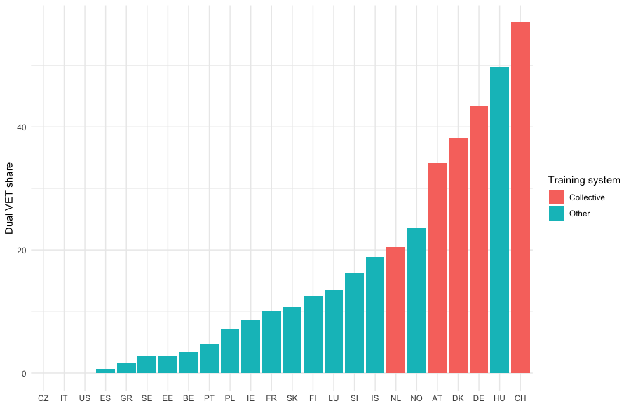

References

Arnholtz, Jens, & Østhus, Ståle. (2024). Is labour migration disrupting dual vocational education and training systems? Empirical evidence from the Danish and Norwegian construction sectors. European Journal of Industrial Relations [online first].
Bonoli, Giuliano, and Patrick Emmenegger. 2020. Collective Skill Formation in the Knowledge Economy. Oxford: Oxford University Press.
Busemeyer, Marius, and Trampusch, Christine. (2012). The political economy of collective skill formation. Oxford: Oxford University Press.
Crouch, C., Schröder, M., & Voelzkow, H. (2009). Regional and sectoral varieties of capitalism. Economy and society, 38(4), 654-678.
Emmenegger, Patrick, and Matthias Haslberger. 2023. “Yesterday’s Model for Tomorrow’s Economy?” University of St. Gallen.
Finegold, D. (1999) ‘Creating self-sustaining, high-skill ecosystems’, Oxford Review of Economic Policy, 15:1, 60-81.
Graf, Lukas, Lorenz Lassnigg, and Justin J.W. Powell. 2012. “Austrian Corporatism and Institutional Change in the Relationship Between Apprenticeship Training and School-Based VET.” In The Political Economy of Collective Skill Formation, edited by Marius R. Busemeyer and Christine Trampusch, 58–82. Oxford: Oxford University Press.
Hancké, Bob. 2012. Endogenous Coordination. Multinational Companies and the Production of Collective Goods in Central and Eastern Europe. Stato e mercato, 32(2), 203-228.
Vossiek, Janis. 2018. Collective skill formation in liberal market economies?: the politics of training reforms in Australia, Ireland and the United Kingdom. Bern: Peter Lang Publishing.

