**ONLINE APPENDIX**

**“Generation Z: Pessimistic and Populist? A Conjoint Experiment on the Determinants of Populist Voting in Spain”, Zagórski et al. (2024), EPSR**

***Figure A1:*** *Marginal means (MMs) of party attributes, by generation.*

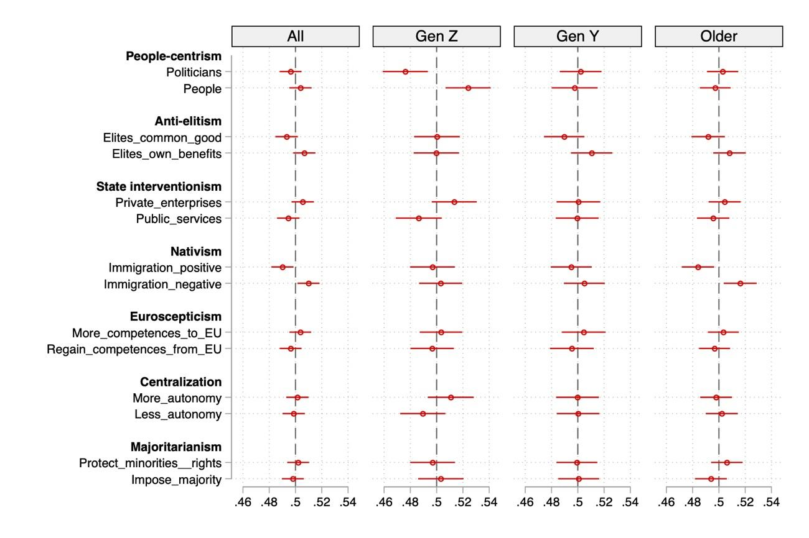

***Figure A2:*** *Marginal means (MMs) of party attributes for Generation Z, by ideology.*

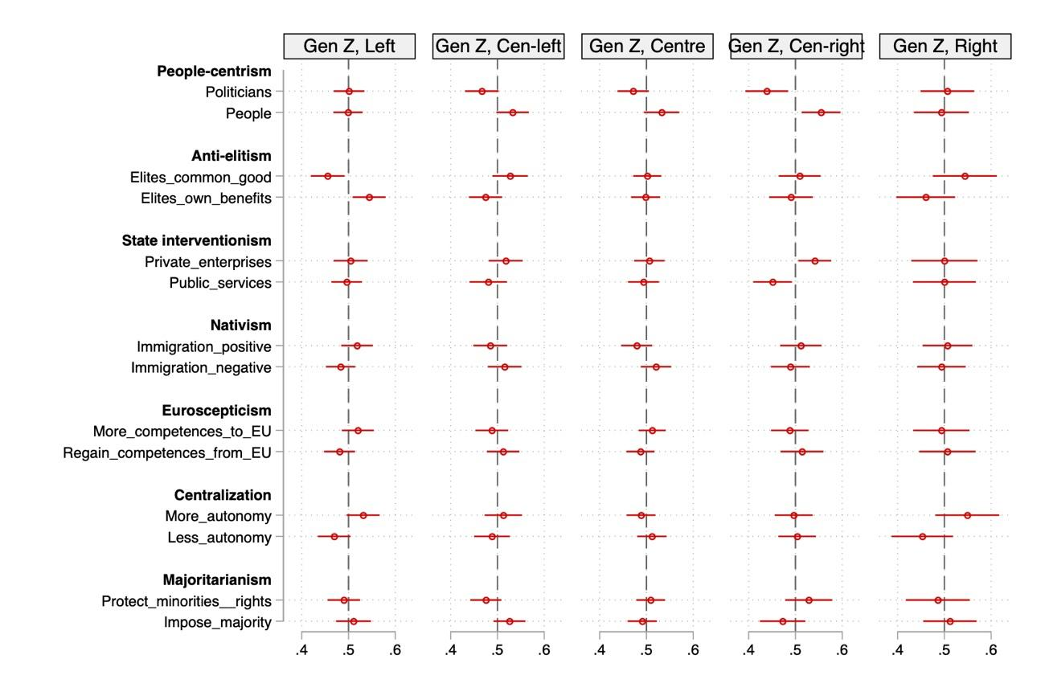

***Figure A3:*** *Marginal means (MMs) of party attributes for Generation Z, by economic expectations.*

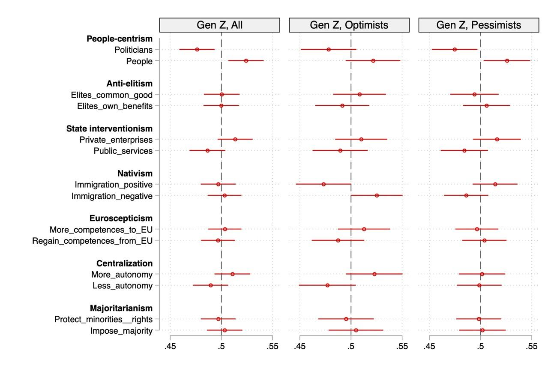

***Figure A4:*** *Marginal means (MMs) of party attributes for Generation Z with pessimistic economic expectations, by ideology.*

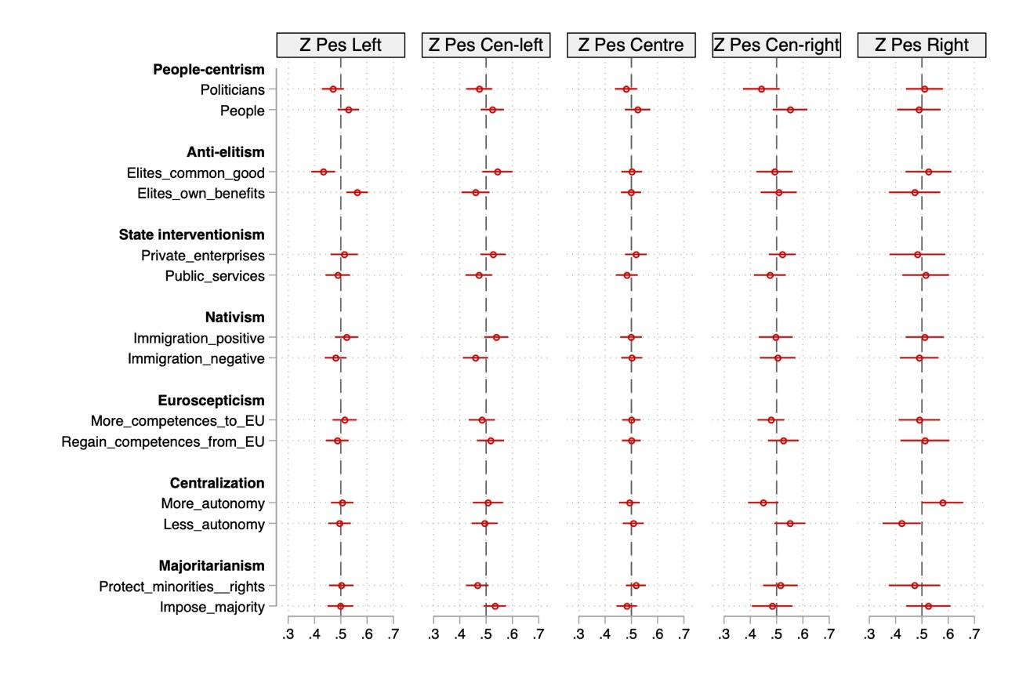

***Figure A5:*** *Average marginal component effects (AMCEs) of party attributes, by ideology.*

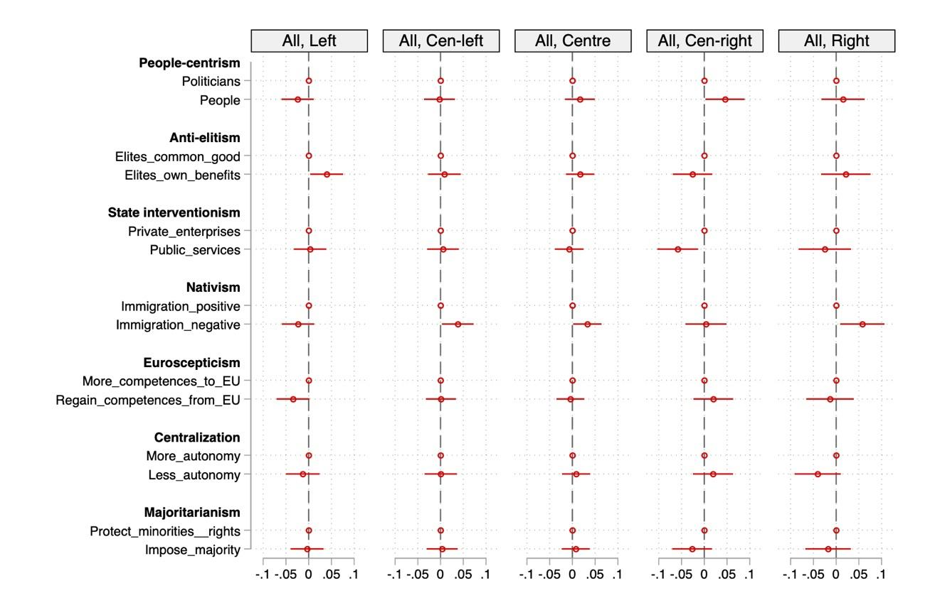

***Figure A6:*** *Marginal means (MMs) of party attributes, by ideology.*

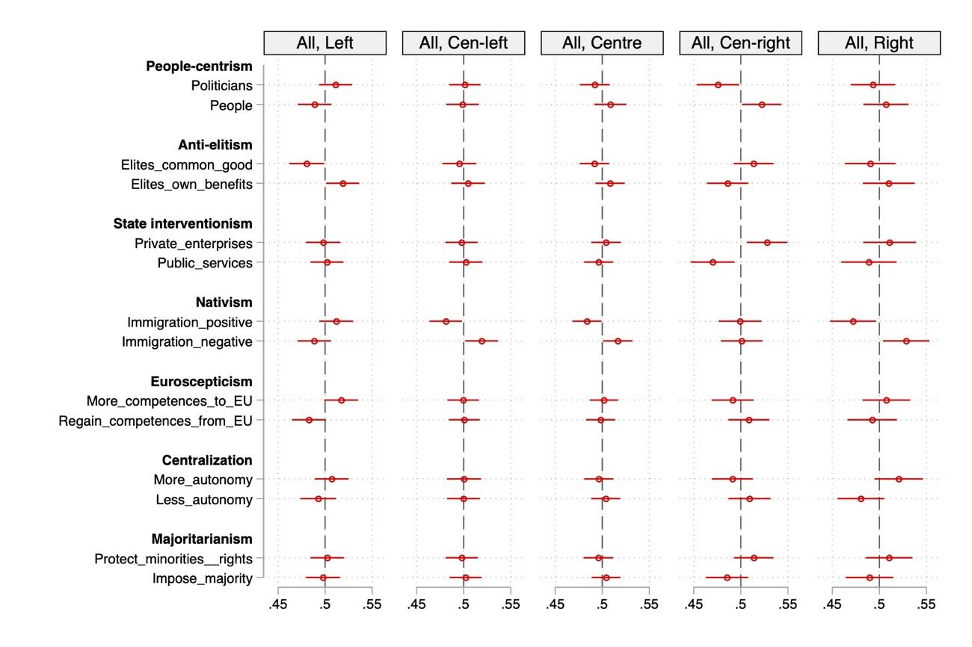

***Figure A7:*** *Average marginal component effects (AMCEs) of party attributes for Generation Y, by ideology.*

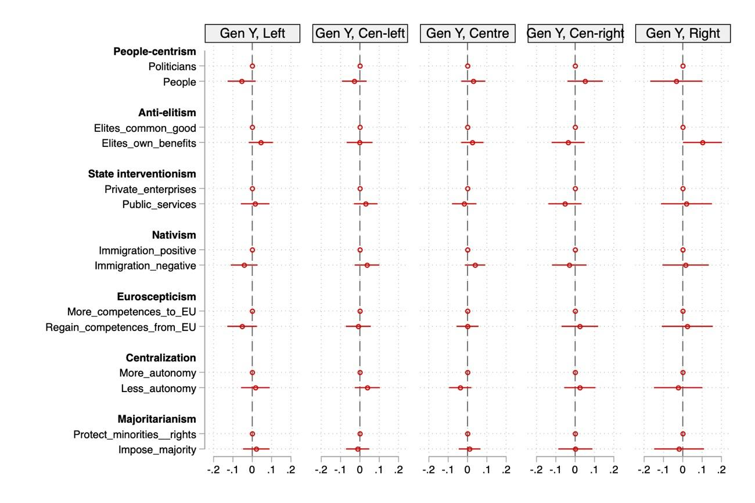

***Figure A8:*** *Marginal means (MMs) of party attributes for Generation Y, by ideology.*

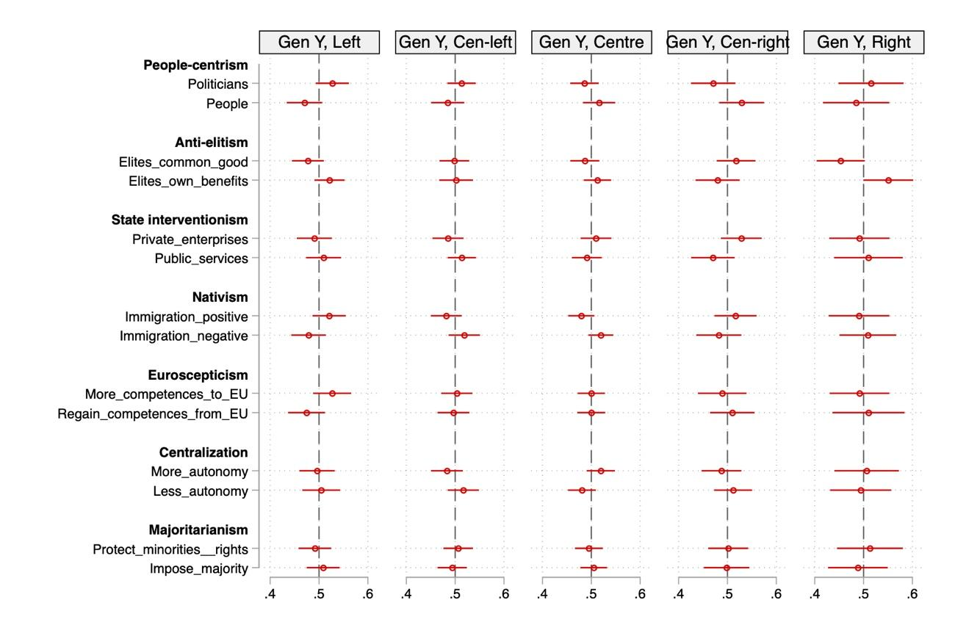

***Figure A9:*** *Average marginal component effects (AMCEs) of party attributes for older generations (41+), by ideology.* 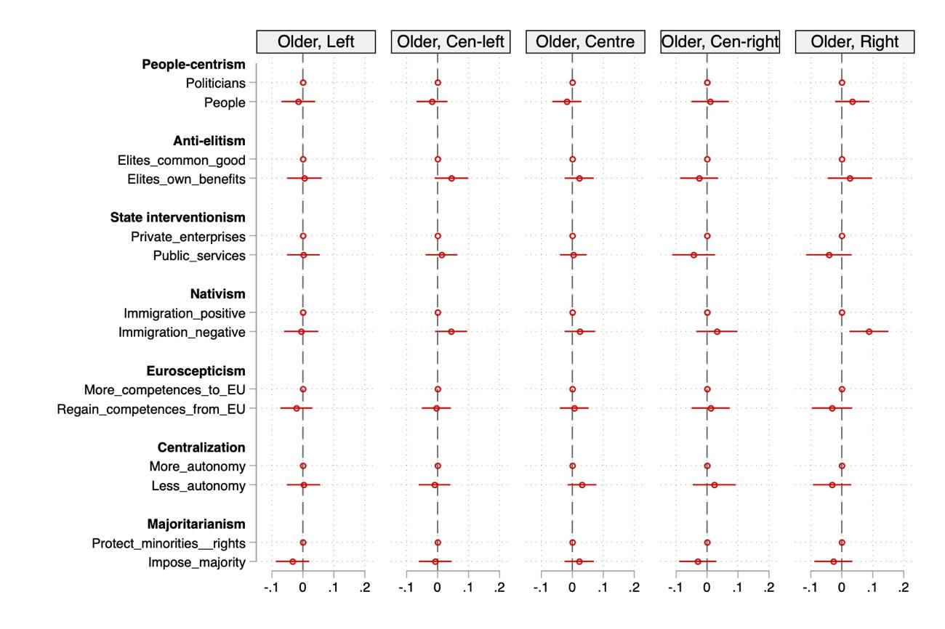

***Figure A10:*** *Marginal means (MMs) of party attributes for older generations (+41), by ideology.*

