**Does it Matter that an Ally is Democratic During Crises?**

***Public Diplomacy and Attitudes Toward International Allies in Times of Crisis***

**APPENDIX**

Table A 1: Variables Balance among Treatment Groups

Table A 2: Regression table of MS. Figure 4

Table A3: Full Treatment Assignment and Experimental Groups

Figure A1: As MS. Figure 4 but also with controls

Table A3: Linear Probability Models replicating results MS. Figure 4

Figure A2: Political Parties Preferences

Figure A3: Not Don’t Know at Random & Heckman Probit Model

Figure A4: Controlling for Reading Times

Figure A5: Treatments and chance DV : is important to be an USA ally?

Figure A6: Treatments and chance DV : is important to be China’s ally?

Figures A7a&b: Recoding DV: Logit models

Figure A8: Not Don’t Know at Random (NDKR)

Figure A9 : Socio Economic Controls

Table A 1: Variables Balance among Treatment Groups

|  |  |  |  |  |  |  |  |  |  |
| --- | --- | --- | --- | --- | --- | --- | --- | --- | --- |
|  | Mean | Mean | Mean | Mean | Mean | Diff. | Diff. | Diff. | Diff. |
|  | Control Group | USA Pos Tr | USA Neg Tr | CHN Pos Tr | CHN Neg Tr | USA Pos Tr | USA Neg Tr | CHN Post Tr | CHN Neg Tr |
| Age | 48.377 | 50.293 | 48.073 | 48.773 | 48.140 | 1.952** | -0.822 | 0.052 | -0.739 |
|  | (15.377) | (15.292) | (15.987) | (15.140) | (15.353) | (0.995) | (0.996) | (0.997) | (0.996) |
| Male | 0.437 | 0.510 | 0.430 | 0.513 | 0.423 | 0.059* | -0.041 | 0.063** | -0.049 |
|  | (0.497) | (0.501) | (0.496) | (0.501) | (0.495) | (0.032) | (0.032) | (0.032) | (0.032) |
| University Degree | 0.217 | 0.227 | 0.260 | 0.273 | 0.297 | -0.035 | 0.007 | 0.023 | 0.052* |
|  | (0.413) | (0.419) | (0.439) | (0.446) | (0.458) | (0.028) | (0.028) | (0.028) | (0.028) |
| Economic Well Off | 0.033 | 0.030 | 0.047 | 0.047 | 0.043 | -0.013 | 0.008 | 0.008 | 0.004 |
|  | (0.180) | (0.171) | (0.211) | (0.211) | (0.204) | (0.013) | (0.013) | (0.013) | (0.013) |
| Democracy Always | 0.583 | 0.563 | 0.593 | 0.643 | 0.517 | -0.021 | 0.017 | 0.079** | -0.079** |
|  | (0.494) | (0.497) | (0.492) | (0.480) | (0.501) | (0.032) | (0.032) | (0.032) | (0.032) |
| Good IntPol Know. | 0.573 | 0.583 | 0.597 | 0.620 | 0.477 | 0.017 | 0.033 | 0.062* | -0.117*** |
|  | (0.495) | (0.494) | (0.491) | (0.486) | (0.500) | (0.032) | (0.032) | (0.032) | (0.032) |
| Daily Info Cons. | 0.860 | 0.843 | 0.830 | 0.843 | 0.850 | -0.002 | -0.019 | -0.002 | 0.006 |
|  | (0.348) | (0.364) | (0.376) | (0.364) | (0.358) | (0.023) | (0.023) | (0.023) | (0.023) |
| High Pol. Interest | 0.447 | 0.437 | 0.470 | 0.523 | 0.453 | -0.037 | 0.005 | 0.072** | -0.016 |
|  | (0.498) | (0.497) | (0.500) | (0.500) | (0.499) | (0.032) | (0.032) | (0.032) | (0.032) |
| Trust Gov | 4.200 | 4.316 | 4.229 | 4.397 | 4.312 | 0.030 | -0.078 | 0.133 | 0.026 |
|  | (2.049) | (2.002) | (2.024) | (1.974) | (2.006) | (0.136) | (0.135) | (0.133) | (0.134) |
| N | 300 | 300 | 300 | 300 | 300 | 1,500 | 1,500 | 1,500 | 1,500 |
|  |  |  |  |  |  |  |  |  |  |

|  |  |  |
| --- | --- | --- |
| Table A2 |  |  |
|  | M1 | M2 |
|  |  |  |
|  |  |  |
|  | Democratic Ally Dummy | Democratic Ally Dummy |
|  |  |  |
| USA Positive Tr. | 0.422** | 0.550** |
|  | (0.215) | (0.235) |
| USA Negative Tr. | -0.172 | -0.072 |
|  | (0.207) | (0.227) |
| CHN Negative Tr. | 0.099 | 0.113 |
|  | (0.209) | (0.224) |
| CHN Positive Tr. | -0.379* | -0.404* |
|  | (0.204) | (0.212) |
| Democracy always | 1.733*** | 1.672*** |
|  | (0.135) | (0.151) |
| Good Knowledge Int Pol | 0.307** | 0.288* |
|  | (0.135) | (0.152) |
| Daily info | 0.595*** | 0.595*** |
|  | (0.193) | (0.221) |
| Dummy Political Interest | 0.532*** | 0.489*** |
|  | (0.134) | (0.15)) |
| Trust Gov. scale | 0.123*** | 0.129*** |
|  | (0.033) | (0.036) |
| Deaths due to COVID | -0.136 | -0.182 |
|  | (0.294) | (0.313) |
| Family&friends w/COVID | 0.365* | 0.308 |
|  | (0.203) | (0.222) |
| COVID worsened finance | 0.113 | 0.070 |
|  | (0.133) | (0.148) |
| Constant | -1.874*** | -1.806*** |
|  | (0.291) | (0.320) |
|  |  |  |
| Observations | 1,312 | 1,071 |
| chi2 | 286.5 | 218 |
| LL | -843 | -677.5 |
|  |  |  |
| Coefficients and standard errors |  |  |
| *** p<0.01, ** p<0.05, * p<0.1 |  |  |

Figure A1



|  |  |  |
| --- | --- | --- |
| Table A3: Linear Probability |  |  |
| LPM | M3 | M4 |
|  |  |  |
|  | Democratic Ally Dummy | Democratic Ally Dummy |
|  |  |  |
| USA Positive Tr. | 0.071* | 0.092** |
|  | (0.037) | (0.040) |
| USA Negative Tr. | -0.031 | -0.013 |
|  | (0.037) | (0.041) |
| CHN Negative Tr. | 0.017 | 0.02 |
|  | (0.037) | (0.040) |
| CHN Positive Tr. | -0.069* | -0.073* |
|  | (0.037) | (0.038) |
| Democracy always | 0.365*** | 0.350*** |
|  | (0.025) | (0.028) |
| Good Knowledge Int Pol | 0.054** | 0.051* |
|  | (0.025) | (0.028) |
| Daily info | 0.115*** | 0.115*** |
|  | (0.036) | (0.042) |
| Dummy Political Interest | 0.096*** | 0.087*** |
|  | (0.024) | (0.027) |
| Trust Gov. scale | 0.022*** | 0.023*** |
|  | (0.006) | (0.007) |
| Deaths due to COVID | -0.023 | -0.03 |
|  | (0.053) | (0.056) |
| Family&friends w/COVID | 0.065* | 0.056 |
|  | (0.035) | (0.000) |
| COVID worsened finance | 0.019 | 0.012 |
|  | (0.024) | (0.026) |
| Constant | 0.139*** | 0.155*** |
|  | (0.052) | (0.058) |
|  |  |  |
| Observations | 1,312 | 1,071 |
| F | 28.62 | 21.56 |
| R2 | 0.209 | 0.197 |
| RMSE | 0.424 | 0.423 |
|  |  |  |
| Coefficients and standard errors in parentheses | |  |
| *** p<0.01, ** p<0.05, * p<0.1 |  |  |

Figure A2 Parties



Figures A3: Heckman probit





Rho: -0.468**

Figure A4: Controlling for vignette’s reading time



Table 3A. Full Treatment Assignment and Experimental Groups.

|  |  |  |  |  |  |
| --- | --- | --- | --- | --- | --- |
| **Group 1** | | | | | |
| **Control** | | | | | |
| The Covid-19 virus dramatically hit Italy in the spring of 2020, pushing the country’s health system to its own limits. Given the dimension of the emergency, existing medical supplies and personnel were not sufficient to properly face the situation. | | | | | |
| **Group 2** | **Group 3** | **Group 4** | **Group 5** | **Group 6** | **Group 7** |
| **China Positive** | **China Negative** | **USA Positive** | **USA Negative** | **EU Positive** | **EU Negative** |
| [Text Group 1, +]  During the peak of the emergency in Italy, it has been argued that China made a relevant contribution to assist the national health system, sending ventilators, masks and/or medical personnel. This contribution helped reduce considerably the number of positive cases and save some lives. | [Text Group 1, +]  During the peak of the emergency in Italy, it has been argued that China’s contribution to assist the national health system, sending ventilators, masks and/or medical personnel, was insufficient. A more substantial contribution could have helped reduce considerably the number of positive cases and save some lives. | [Text Group 1, +]  During the peak of the emergency in Italy, it has been argued that the USA made a relevant contribution to assist the national health system, sending ventilators, masks and/or medical personnel. This contribution helped reduce considerably the number of positive cases and save some lives. | [Text Group 1, +]  During the peak of the emergency in Italy, it has been argued that USA’s contribution to assist the national health system, sending ventilators, masks and/or medical personnel, was insufficient. A more substantial contribution could have helped reduce considerably the number of positive cases and save some lives. | [Text Group 1, +]  During the peak of the emergency in Italy, it has been argued that the European Union, coordinating the assistance from its members states with ventilators, masks and/or medical personnel, made a relevant contribution to assist the national health system. This contribution helped reduce considerably the number of positive cases and save some lives. | [Text Group 1, +]  During the peak of the emergency in Italy, it has been argued that the European Union, coordinating the assistance from its members states with ventilators, masks and/or medical personnel, made an insufficient contribution to assist the national health system. A more substantial contribution could have helped reduce considerably the number of positive cases and save some lives. |

*Original Italian*

Il virus COVID ha colpito in maniera drammatica l’Italia nella primavera del 2020, portando il sistema sanitario nazionale verso i propri limiti. Materiale medico e personale sanitario non erano sufficienti data la dimensione dell’emergenza.

**[positive]** Durante il picco dell’emergenza in Italia, è stato evidenziato che **[la Cina/ gli Stati Uniti/stati membri della Unione Europea]**ha/hanno svolto un contribuito rilevante nell’aiutare il sistema sanitario nazionale inviando ventilatori, mascherine e/o personale medico. Questo ha aiutato a ridurre notevolmente il numero dei contagi e a salvare delle vite.

**[negative]** Durante il picco dell’emergenza in Italia, è stato evidenziato che il contributo della/degli **[Cina/Stati Uniti/stati membri della Unione Europea]**nell’aiutare il sistema sanitario nazionale inviando ventilatori, mascherine e/o personale medico è stato insufficiente. Un aiuto più consistente avrebbe aiutato a ridurre notevolmente il numero dei contagi e a salvare delle vite.

Figure A5: changing DV – USA ally



Figure A6: changing DV – China ally



Figure A7a: Recoding the DV as dichotomous - logit models

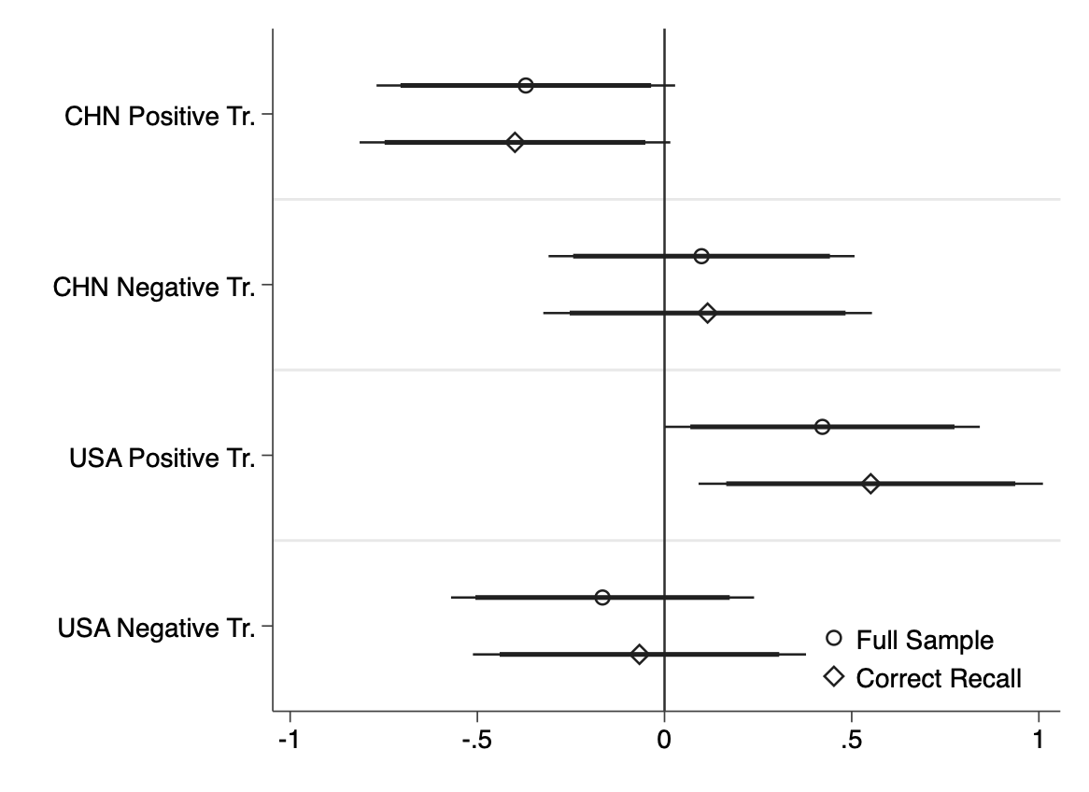

Figure A7b: Recoding DV order logit models

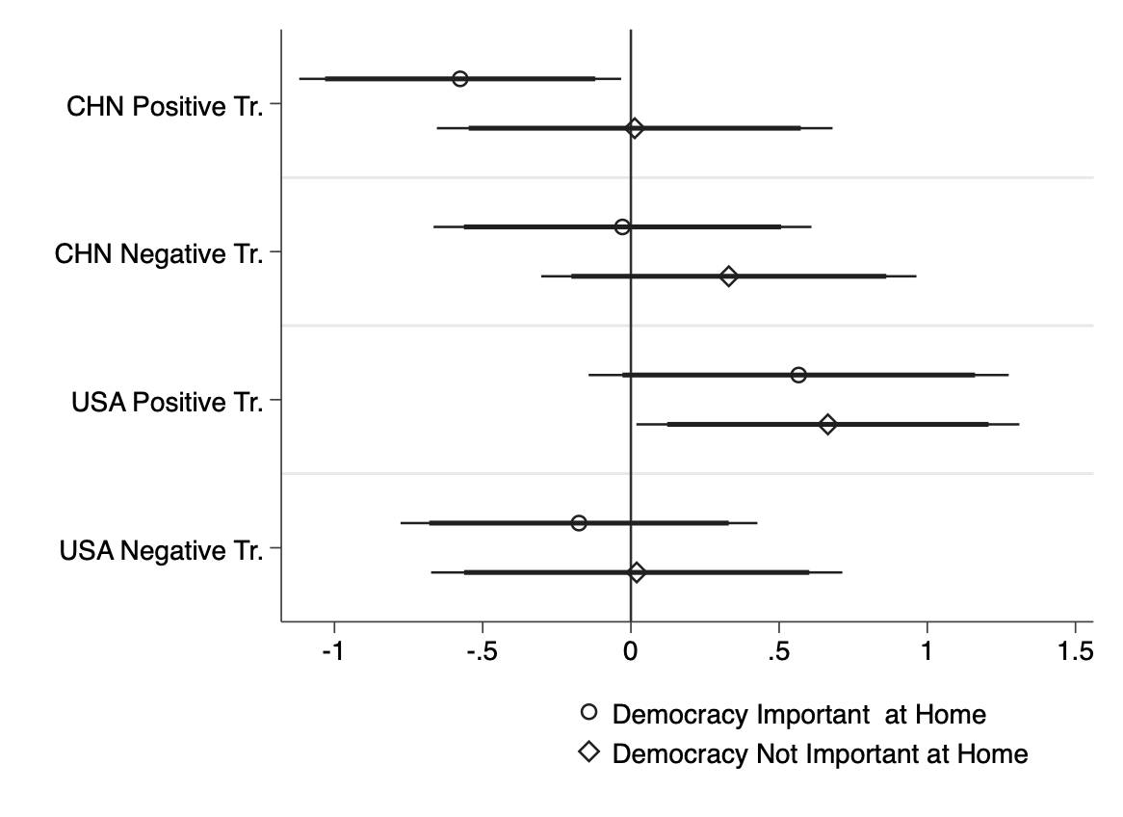

Figure A8: Not Don’t Know at Random (NDKR): what indicators lead to higher probability to “DK” as answer?



Figure A9: Socio Economic Controls

