**Appendix**

Sampling quota

*Switzerland*

Age: 18-24 (10.37%), 25-34 (18.66%), 35-44 (19.04%), 45-54 (20.53%), 55+ (31.40%)  
Gender: Male (49.96%), Female (50.04%)  
Education: ISCED 0-2 (13.24%), ISCED 3-4 (47.83%), ISCED 5-8 (38.93%)

*United States*Age: 18-24 (13%), 25-34 (19%), 35-44 (18%), 45-54 (19%), 55+ (31%)  
Gender: Male (49%), Female (51%)  
Education: Less than HS (10%), HS (29%), Some College/Associate Degree (26%),  
Bachelors (21%), Advanced Degree (13%)

**Survey questionnaire (English version, United States)**

### **Introduction**

### Dear participant,

Welcome and thank you for participating in this survey!

This survey is part of a research project coordinated by [ANONYMOUS]. The interdisciplinary project seeks to get a better understanding of attitudes and judgements of the US population regarding important social and political issues. The duration of the survey is around 15 minutes. All answers will be treated anonymously and used only for the purpose of scientific analysis.

**Pre-treatment questionnaire**

You are …

* A woman
* A man
* Other

In which year were you born ? __________

What is the highest level of education you have attained or the highest degree you have obtained?

* None
* Highschool
* Associate’s degree
* Bachelor’s degree
* Master’s degree
* Professional degree
* Doctoral degree

We now ask you a few questions on your political views.

In politics people sometimes talk of liberal and conservative. Where would you place yourself on a scale from 0 to 10 where 0 means liberal and 10 means conservative?

* Scale from 1 (liberal) to 10 (conservative)

Would you say it is generally bad or good for the US economy that people come to live here from other countries?

* Scale from 1 (bad for the economy) to 10 (good for the economy)

Would you say that the US cultural life is generally undermined or enriched by people coming to live here from other countries?

* Scale from 1 (cultural life undermined) to 10 (cultural life enriched)

**Experiment**

Each country decides about the admission of immigrants: Who should be allowed into the country and which permit should the person obtain? In the following, we ask you to evaluate fictitious profiles describing different scenarios of immigrant admission to the United States.

#### *Vignette factors & levels*

|  |  |  |
| --- | --- | --- |
| X1 | Gender | Female; male |
| X2 | Age | Young (24, 29); old (43, 48) |
| X3 | Family status | single; married with two children |
| X4 | Nationality | Germany; Canada / Kosovo; Mexico |
| X5 | Education | vocational training/high-school (low) / university degree/college (high) |
| X6 | Settlement rights (permit duration) | temporary vs. permanent |
| X7 | Social rights | access to welfare benefits (yes/no) |

#### *Vignette text*

The applicant is a **man [X1]** of **20 years [X2]** and **single [X3].** The **Canadian [X4]** citizen is a **highly-skilled worker and has a university degree [X5]**. The permit that the applicant would receive allows for **temporary residence of restricted duration [X6]** and **no access to public social benefits [X7].**

The applicant is a **woman [X1]** of **50 years [X2]** and **married with two children [X3].** The **Mexican [X4]** citizen is a **low-skilled worker with some vocational training [X5].** The permit that the applicant would receive allows for **permanent settlement of unlimited duration [X6]** and **access to public social benefits [X7].**

#### *Outcome (Judgement)*

Imagine that you have to decide whether the applicant should receive the proposed immigration permit, to what extent would you be against or in favor of its approval?

Scale from 1 (strongly against) to 10 (strongly in favor)

**Post-treatment questionnaire**

Are you a US citizen?

* Yes
* No

Figure A1: Histograms of immigrant admission preferences

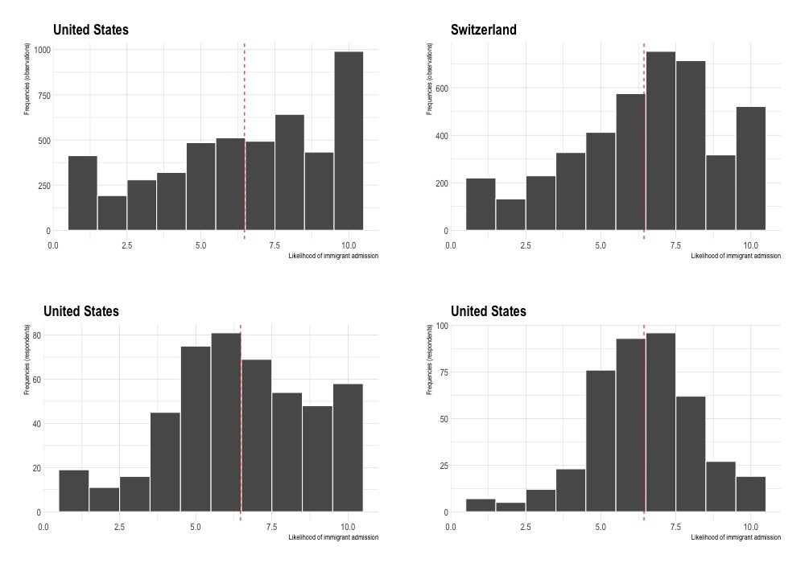

*Note: The histograms display the distribution of the outcome variable of the vignette experiment, the willingness to admit a particular immigrant. The first row is based on the total number of observations (US: 4760, CH: 4200) and the second row is based on the number of respondents (10 vignettes per respondent). Separate samples for the United States and Switzerland. The dashed red line marks the mean value.*

Table A1: Regression estimates by country sample

*****Note: Linear regression models with clustered standard errors by respondents. Levels of statistical significance indicated as follows: ∗p<0.05; ∗∗p<0.01; ∗∗∗p<0.001.*

Figure A2: Coefficient plot of moderation effects

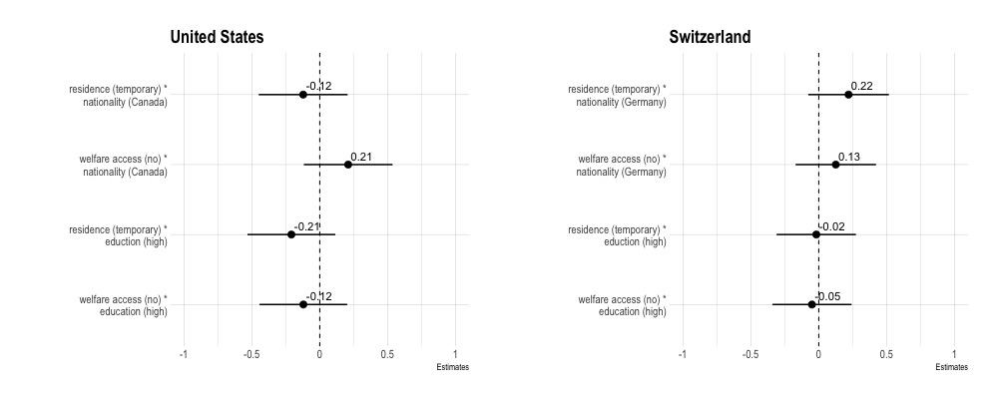

*Note: The coefficient plots display the interaction coefficient between immigrant rights restriction (temporary residence, no welfare access) and immigrant characteristics (nationality, education). The plot shows the point estimate with a 95%-confidence interval. The estimates are based on the same model as Figure 2 of the manuscript.*

Figure A3: Heterogenous treatment effects of immigrant rights on admission preferences

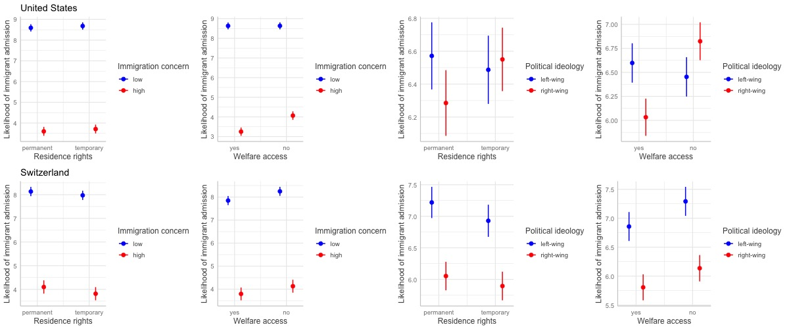

*Note: The coefficient plots are based on linear regression models that include all vignette factors, interaction terms between immigrant rights and respondents‘ political views (immigration concerns, political ideology), separate estimates for the two country samples. Predicted probabilities with 95% confidence intervals shown.*

Figure A4: Heterogeneity of rights-conditionality by individual pre-dispositions

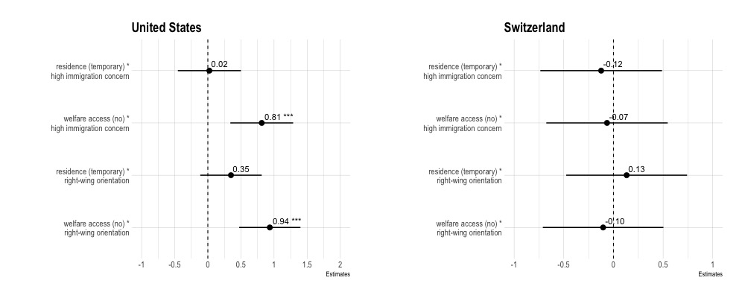

*Note: The coefficient plots display the interaction coefficient between immigrant rights restriction (temporary residence, no welfare access) and respondents‘ political predispositions (immigration concern, right-wing ideology). The plot shows the point estimate with a 95%-confidence interval and the statistical significance (∗p<0.05; ∗∗p<0.01; ∗∗∗p<0.001).*

Table A2: Regression estimates based on the full sample

**

*Note: Linear regression models with clustered standard errors by respondents based on the full sample (United States and Switzerland). Level of statistical significance indicated as follows: ∗p<0.05; ∗∗p<0.01; ∗∗∗p<0.001.*