**Appendix:**

**1. Background of the survey**

The field work for the full sample began during the month of October, 2020 and concluded in the first week of February 2021. The interviews were conducted in the local majority language in each country/region. The results were returned to the Quality of Government Institute in February, 2021. The E.U. regional survey was undertaken by Efficience 3 (E3), a French market-research, Survey Company specializing in public opinion throughout Europe for researchers, politicians and advertising firms. E3 has also conducted the 2010, 2013 and 2017 rounds of the EQI and were thus familiar with the question format and goals of the survey. E3 conducted the interviews themselves in several countries and used sub-contracting partners in others.

The survey employs a 50/50 hybrid administration of randomly selected respondents via Computer Assisted Telephone interviews (CATI) and self-selected online respondents, the latter of which were employed in this study. The online administration is used exclusively in this study.

To increase the online sample, E3 worked with local partners to create a multi-channel communication of online and off-line networks to recruit potential respondents. These channels include using banners on various portals and websites, email recruitment via panel owner's databases, newsletters, brand communications, loyalty website and social media platforms. The firm also actively recruited via telephone and face-to-face interactions. All survey email invitations included a general description of the survey, confidentiality and anonymity statements, for panel members, the opportunity to unsubscribe or opt-out of future research; and an appropriate privacy policy or statement. As randomization via this administration was not possible as with CATI, the quota system was employed, based on age, gender and education characteristics of each region.

In addition, to compensate for some key demographic over/under-representation upon receiving the final sample, E3 provides weights based on age, gender and education for each region, comparing the sample drawn to actual demographic statistics from the latest figures provided by Eurostat. A breakdown of the online sample used in this study listed in Table A1 below by country. For more information on the survey, please see Charron et al (2022)[1]

**Table A1: Sample by country**

|  |  |  |
| --- | --- | --- |
| **Country** | **Abbreviation** | **Online** |
| Germany | DE | 9647 |
| Romania | RO | 2084 |
| Italy | IT | 6454 |
| Austria | AT | 2258 |
| Poland | PL | 5279 |
| Spain | ES | 5204 |
| Sweden | SE | 2039 |
| Finland | FI | 1248 |
| Denmark | DK | 1277 |
| Ireland | IE | 754 |
| Belgium | BE | 2857 |
| Netherlands | NL | 3081 |
| Hungary | HU | 2041 |
| Slovakia | SK | 1041 |
| Croatia | HR | 520 |
| Bulgaria | BG | 1541 |
| France | FR | 6646 |
| Czech Rep. | CZ | 2474 |
| Portugal | PT | 1788 |
| Greece | EL | 3421 |
| Luxembourg | LU | 260 |
| Estonia | EE | 533 |
| Latvia | LV | 519 |
| Lithuania | LT | 1020 |
| Slovenia | SI | 508 |
| Malta | MT | 0 |
| Cyprus | CY | 0 |
| *Total* | *EU-27* | *64494* |

**2. The conjoint experiment**

**Question:** Finally, let’s say that two politicians in a city or town similar to yours are (*\*being considered*/*\*\*running*) for city mayor (*\*see alt name list*), and there have been several recent corruption scandals. The election is close and these are the only candidates with a chance to take office. Based on what you see below, which of these candidates do you believe would be best to reduce municipal level corruption? (A or B or neither)

|  |  |  |
| --- | --- | --- |
| **Description** | **Candidate A** | **Candidate B** |
|  | Gender, Age | Gender, Age |
|  | Party label | Party label |
| **Political background** | Background | Background |
| **Main election issue** | Issue | Issue |
| **Personality type** | Type | Type |

*Randomize the order of ’political background’, ’main election issue’ and personality type’ in the table above. Randomize the following characteristics according to the categories above:

**Randomized characteristics:**

**Gender:**

|  |  |
| --- | --- |
| 1 | Male |
| 2 | Female |

**Age:** 51, 52, or 53

**Party affiliation:** Select from country-specific party list of 2-5 largest parties, including respondent’s choice a party on Q21.

**Background:**

|  |  |
| --- | --- |
| 1 | Well-connected politician |
| 2 | Political outsider |

**Main election issue:**

|  |  |
| --- | --- |
| 1 | Health care |
| 2 | Education |
| 3 | Infrastructure |
| 4 | Economic development |

**Personality type:**

|  |  |
| --- | --- |
| 1 | Cautious and careful, |
| 2 | Willing to take risks |

**Table A2: Mlogit estimates (Figure 1 in main text)**

|  |  |  |  |
| --- | --- | --- | --- |
|  | | (1) | (2) |
|  | | Vote A | Abstain |
| Candidate A traits | |  |  |
| C1 female | | 0.147*** | 0.032 |
|  | | (0.023) | (0.023) |
| C1 age | | -0.006 | -0.006 |
|  | | (0.014) | (0.014) |
| C1_party_match | | 1.687*** | -0.379*** |
|  | | (0.039) | (0.056) |
| C1 insider | | 0.004 | 0.034 |
|  | | (0.023) | (0.023) |
| C1 health care | | 0.138*** | 0.025 |
|  | | (0.034) | (0.039) |
| C1_education | | 0.074** | 0.012 |
|  | | (0.033) | (0.039) |
| C1 econ. dev. | | 0.130*** | 0.074* |
|  | | (0.034) | (0.038) |
| C1 risk taker | | -0.164*** | -0.028 |
|  | | (0.024) | (0.023) |
| Candidate B traits | |  |  |
| C2 female | | -0.187*** | -0.145*** |
|  | | (0.023) | (0.023) |
| C2 age | | -0.012 | -0.019 |
|  | | (0.014) | (0.014) |
| C2_party_match | | -1.707*** | -1.984*** |
|  | | (0.039) | (0.046) |
| C2 insider | | -0.083*** | -0.039 |
|  | | (0.024) | (0.024) |
| C2 health care | | -0.103*** | -0.055 |
|  | | (0.033) | (0.039) |
| C2 education | | -0.070** | -0.013 |
|  | | (0.033) | (0.039) |
| C2 econ. dev. | | -0.140*** | -0.083** |
|  | | (0.033) | (0.039) |
| C2 risk taker | | 0.207*** | 0.103*** |
|  | | (0.024) | (0.024) |
| round | | -0.069*** | -0.200*** |
|  | | (0.023) | (0.018) |
| constant | | 0.171 | 0.568*** |
|  | | (0.106) | (0.107) |
|  | |  |  |
| Obs. | | 96,160 |  |
| Pseudo R-squared | | 0.0708 |  |
| Pr (Chi2) | | 0.0000 |  |
|  |  | | |
| Note: logged odds from multinomial logit reported with standard errors are in parenthesis, clustered by respondent. Reference category of the outcome variable is ‘vote candidate B’ | | | |
|  | *** p<0.01, ** p<0.05, * p<0.1 | | |

**Table A3: Heterogeneous treatment effects by respondent gender**

|  |  |
| --- | --- |
|  | (1) |
|  | vote_treat1 |
|  |  |
| C1 female | 0.012** |
|  | (0.006) |
| Respondent female | -0.037*** |
|  | (0.011) |
| C1female*fem. resp. | 0.029*** |
|  | (0.008) |
| C1_age | -0.000 |
|  | (0.002) |
| C1_party_match | 0.411*** |
|  | (0.006) |
| C1_insider | -0.005 |
|  | (0.006) |
| C1_insider * fem. resp. | 0.005 |
|  | (0.008) |
| C1_risk taker | -0.024*** |
|  | (0.006) |
| C1_risk taker * fem. resp. | -0.013 |
|  | (0.008) |
| C1 health care | 0.022** |
|  | (0.009) |
| C1_health care * fem. resp. | 0.006 |
|  | (0.012) |
| C1 education | -0.004 |
|  | (0.009) |
| C1 education * fem. resp. | 0.032*** |
|  | (0.012) |
| C1 econ. dev. | 0.012 |
|  | (0.009) |
| C1 econ. dev. * fem. resp. | 0.012 |
|  | (0.012) |
| round | 0.006* |
|  | (0.004) |
| constant | 0.330*** |
|  | (0.018) |
| Obs. | 96160 |
| R-squared | 0.097 |
|  | |
| Note: marginal effects from linear probability model reported with standard errors are in parenthesis, clustered by respondent. ‘candidate B’ traits also included along with respondent controls for age, education and population are included (not shown ). | |
| *** p<0.01, ** p<0.05, * p<0.1 | |

**Table A4: Effects of female candidacy by country**

|  |  |  |  |
| --- | --- | --- | --- |
|  | **Vote against corruption** | | |
| **Country** | **AMCE** | **s.e.** | **Obs.** |
| Germany | 0.017** | 0.008 | 14,690 |
| Romania | -0.001 | 0.014 | 3,244 |
| Italy | 0.034*** | 0.011 | 9,914 |
| Austria | 0.021 | 0.020 | 3,400 |
| Poland | 0.021** | 0.010 | 8,054 |
| Spain | 0.037*** | 0.015 | 7,740 |
| Sweden | 0.055*** | 0.019 | 3,118 |
| Finland | 0.071*** | 0.023 | 1,644 |
| Denmark | 0.090*** | 0.023 | 1,886 |
| Ireland | 0.006 | 0.029 | 1,136 |
| Belgium | 0.039*** | 0.014 | 4,338 |
| Netherlands | 0.047*** | 0.017 | 4,608 |
| Hungary | 0.013 | 0.017 | 3,122 |
| Slovakia | 0.022 | 0.024 | 1,536 |
| Croatia | 0.056* | 0.032 | 810 |
| Bulgaria | 0.043** | 0.020 | 2,346 |
| France | 0.026** | 0.012 | 8,670 |
| Czech Republic | 0.037** | 0.015 | 3,664 |
| Portugal | 0.066*** | 0.023 | 2,700 |
| Greece | 0.076*** | 0.018 | 5,252 |
| Luxembourg | 0.026 | 0.041 | 406 |
| Slovenia | 0.024 | 0.032 | 766 |
| Lithuania | 0.016 | 0.024 | 1,538 |
| Estonia | -0.003 | 0.032 | 796 |
| Latvia | -0.002 | 0.031 | 782 |
|  |  |  |  |

Note: marginal effects estimates if ‘female candidate a’ calculated from LMP models one country at a time. Both candidate treatment variables included along with a dummy for round 2. Survey design weights are used and standard errors are clustered by respondent.

We find from Table A2 that in 22 of the 25 countries, there is a positive coefficient for female candidates (only in Romania, Latvia and Estonia, which equate to 5.1% of the total EU population, is the sign negative, yet insignificant). In 14 and 15 of these, the AMCE is significant at the 95% and 90% level of confidence respectively, which in turn correspond to 86% and 87% of the total EU population respectively, including the five largest members (Germany, France, Italy, Spain, and Poland). The effect is large in all Nordic countries, such as Demark (DK), Finland (FI) and Sweden (SE), yet also in Southern European states, such as Portugal (PT), Greece (EL), Spain (ES) and Italy (IT), and even significant in Central-Eastern countries such as Czechia (CZ) and Bulgaria (BG). Thus, while not uniform in degree, the results do suggest an overall pattern within EU countries not entirely driven by geography.

**Table A4: Test of the Effects of Candidate Characteristics in Neutral vs. ‘Corruption’ Election**

|  |  |
| --- | --- |
|  | (1) |
|  | Vote ‘candidate A’ |
| Corruption group | -0.007 |
|  | (0.009) |
| Female candidate | 0.023*** |
|  | (0.006) |
| **Female*corruption** | **0.017\*\*** |
|  | **(0.007)** |
| Partisan match | 0.445*** |
|  | (0.009) |
| **Partisan match*corruption** | **-0.032\*\*\*** |
|  | **(0.010)** |
| Outsider | -0.011* |
|  | (0.006) |
| **Outsider*corruption** | **0.019\*\*\*** |
|  | **(0.007)** |
| Risk taker | -0.022*** |
|  | (0.006) |
| **Risk taker * corruption** | **-0.009** |
|  | **(0.007)** |
| Issue: Health care | 0.024*** |
|  | (0.008) |
| **Health care* corruption** | **0.001** |
|  | **(0.010)** |
| Issue: education | 0.020** |
|  | (0.008) |
| **Education * corruption** | **-0.006** |
|  | **(0.010)** |
| Issue: Econ. dev. | 0.017** |
|  | (0.008) |
| **Econ. dev.*corruption** | **0.006** |
|  | **(0.010)** |
| Age | -0.001 |
|  | (0.002) |
| Constant | 0.287*** |
|  | (0.012) |
| Obs. | 115,554 |
| R-squared | 0.103 |
|  | |
| Note: Dependent variable is ‘vote candidate A’, and coefficients are the Average Conditional Interaction Effects of Candidate A’s characteristics with clustered standard errors are in parenthesis. Estimates from linear probability model adjusted for design and post stratification weights. Model includes all Candidate 2 characteristics and a dummy for the survey round (not shown). Sample does not include smaller EU countries due to lack of statistical power due to few observations in the non-corruption group. Reference to ‘corruption group’ is the group of respondents who answered the neutral conjoint experiment without any reference to voting in response to corruption. Reference to ‘issue’ is ‘infrastructure’. Interactions imply the effects of the treatments in the ‘corruption group’ compared with the neutral (control) group. | |
| *** p<0.01, ** p<0.05, * p<0.1 | |

To determine whether the effects of the treatments have systematically different effects depending on whether or not corruption is specified, we test interactions with all candidate characteristics via a dummy variable indicting if the respondent saw the reference to corruption in the question description or not. [2]The interaction coefficients thus provide a test of whether the effects of the candidate characteristics on candidate choice vary systematically depending on whether ‘combatting corruption’ is specified. In general, we find that respondents still prefer female candidates even when the question refers to a more neutral election, which is certainly in line with the literature on voter preferences for female candidates (Schwarz and Coppock 2021). However, the significant interaction term (p=0.03) indicates that the ‘female effect’ is roughly 2.3 times larger (0.034 versus 0.015) when corruption is specified, compared with voting in general, which supports the notion of a female ‘cleaner’ stereotype in response to corruption.

In addition, we also find that the large, positive effects of partisanship diminishes somewhat when corruption is specified (from 0.44 to 0.41, p=0.02). We also observe that while people in the neutral question group significantly prefer insiders to outsiders, there is no effect of insider/outsider status in the corruption group, as indicated in our main findings in Figure 1. The effects of risk-taking and issue choice of candidates on respondents’ candidate choice to fight corruption do not systematically vary between the corruption-specified and neutral elections, however. The results of the interactions are shown in Table A3 in the appendix.

In looking at H1b (abstention), we find that in the absence of information about corruption, when two females are presented, we see the lowest probability of abstention (29.5%), significantly lower than when one or two males are presented. The difference in predicted turnout between the unspecified and specified corruption scenarios are significantly different for the two female category, and just under conventional statistical significance (p=0.07) for the two-male category (see Figure A1 in the appendix). In this case, our results are also in line with the literature that posits that corruption dampens turnout in general (Bauhr and Charron, 2018; Birch, 2010; Dahlberg and Solevid, 2016; Sundström & Stockemer 2015), where we see that just specifying corruption leads to 1% higher predicted probability of abstention.[3]

**Figure A1: Choice of ‘Abstention’ by Gender of Mayoral Candidate Options**

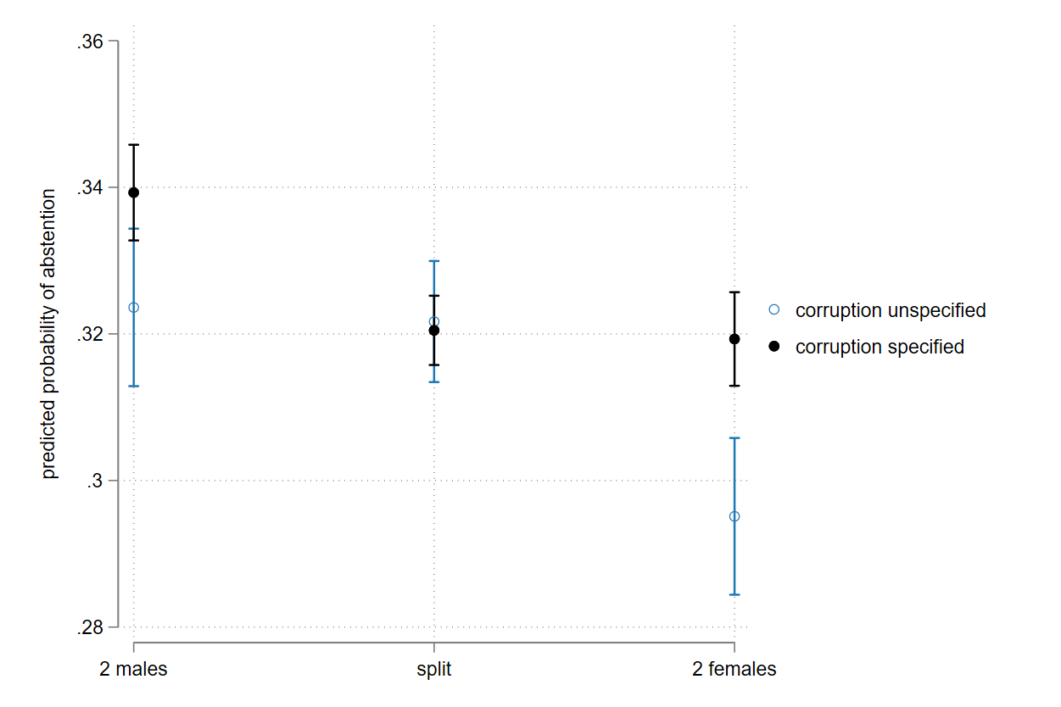

Note: dots show the predicted probabilities of ‘Abstention’ from Logit estimation with 95% confidence intervals. All candidate A and B characteristics are also included in the model (not shown). ‘64,089’ individuals and ‘128,178’ total profiles analyzed. Reference to ‘corruption unspecified’ is the group of respondents who answered the neutral conjoint experiment without any reference to voting in response to corruption, where the model includes a dummy variable interaction with the corruption frame and the candidates’ gender. Estimates adjusted for design and post stratification weights and standard errors are clustered by respondent.

**4. Exploring sources of geographic heterogeneity of the results**

Figure A2 replicates the findings from the test of H3b in the main text, yet here we substitute the percentage of females in sub-national parliament with the national level. In this case we find a very similar result in terms for the substance. At low levels of political gender equality, there is in fact no distinction between the male and female candidate when it comes to fighting corruption. However, the relationship is significant at roughly the 30th percentile of the distribution of women MP’s in national parliament, whereby female candidates are preferred. At the highest levels of political gender equality in national parliaments females are preferred on average by roughly 5% points compared with male candidates.

**Figure A2: Interaction between candidate gender and national female representation**

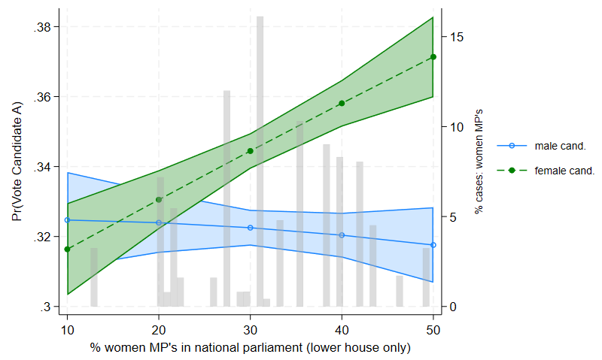

Note: lines represent predicted probability of supporting ‘candidate A’ from an interaction model with candidate gender and percentage of females in national lower chamber (from Eurostat, 2021), with 95% confidence intervals. Model is specified in the same way as Figure 1 in the main text, with all other candidate traits included. Histogram represents the distribution of female representation within the sample.

Because of this heterogeneity found, we re-estimate the main model (H1) for each individual country and recorded the AMCE of a female candidate by member state.

**5. Co partisanship and preferences for women candidates to fight corruption**

We also investigate if co-partisanship matters for the extent to which citizens believe women candidates will be best to fight corruption. We find that positive effects of female candidacy are nearly twice as large when the respondent and candidate are not co-partisans, yet even among co-partisans we see a roughly 2% positive effect of female candidacy.

**Figure A3. Conditional marginal effect of female candidacy on support for ‘candidate A’ by co-partisanship**

1. <https://investigacionesregionales.org/wp-content/uploads/sites/3/2022/09/1.-Charron.pdf>
2. We limited the scope to countries with a total sample size of 2000 or greater, which would yield at least 500 respondents in the alternative question group. In this case, respondents from 17 countries are given this question (see Appendix, Figure A1). The two groups are mutually exclusive, meaning that if a respondent saw the ‘combatting corrupting’ frame in the first round, they would not see the neutral frame in the second round, and vice versa.
3. In addition, we test the effect of voters perceptions on corruption and find that the ‘female effect’ is significant among all respondents irrespective of *a priori* corruption perceptions, although the effect is stronger among participants that believe that corruption leads to unfair privileges and wealth ( see appendix 5)