**Supplemental material**

For “Populist Attitudes and Foreign Policy Postures:

A Comparative Analysis of Four European Countries”

# Content

Question wording 2

Exploratory factor analysis: foreign policy postures 4

Exploratory factor analysis: populist attitudes 7

Regression tables of interactions models (populism*ideology) 8

Correlations across different populism scales in Italy 12

Comparison across different populism scales ( Italy only) 13

Robustness check: alternative populism scale 15

Robustness check: populism*nativism interaction 20

## Question wording

We report the wording from the English core questionnaire, except for the questions on education level (where response options are difficult to translate).

Foreign policy postures

Please say whether you agree or disagree with each of the following statements:

* [Country] should work more through international organisations, like the UN (cooperative internationalism)
* In deciding on its foreign policies, [country] should take into account the view of its major allies (cooperative internationalism)
* The best way for [country] to be a world leader in foreign affairs is to build international consensus (cooperative internationalism)
* [Country] should be more committed to diplomacy and not so fast to use the military in international crises (cooperative internationalism)
* [Country's] interests are best protected by avoiding involvement with other nations (isolationism)
* [Country] shouldn't risk its citizens' happiness and wellbeing by getting involved with other nations (isolationism)
* [Country] needs to simply mind its own business when it comes to international affairs (isolationism)
* [Country] needs a strong military to be effective in international relations (militant internationalism)
* [Country] should take all steps including the use of force to prevent aggression by any expansionist power (militant internationalism)
* [Country] doesn't need to withdraw from international affairs, it just needs to stop letting international organisations tell us what we can and can't do (militant internationalism)
* [Country] should always do what is in its own interest, even if our allies object (militant internationalism)
* [Country] should be more willing to share its wealth with other nations, even if it doesn't coincide with our political interests (global justice)
* [Country] should spend significantly more on foreign aid (global justice)
* [Country] already does enough to help the world's poor (global justice)

Response options: (1) 1 Strongly agree; (2) 2 Agree; (3) 3 Neither agree or disagree; (4) 4 Disagree; (5) 5 Strongly disagree; (-98); Don’t know

Populism scale

Here is a series of statements where people tend to have different opinions. Please give us your opinion by indicating how much you agree or disagree:

* My political opponents don't just have bad policy ideas, they have evil intentions (Manichaeism)
* Politics is a struggle between good and evil (Manichaeism)
* Politics is simple - it's us versus them (Manichaeism)
* Experts really don't know that much (anti-expert elite)
* I am more confident in my opinion than in other people's facts / I am more confident in my opinion than other people's opinion (in Italy) (anti-expert elite)

(1) 1 Strongly agree; (2) 2 Agree; (3) 3 Neither agree or disagree; (4) 4 Disagree; (5) 5 Strongly disagree; (-98) Don’t know

Ideology

[France:] Politically, do you stand…? (1) Far left; (2) To the left; (3) In the centre; (4) To the right; (5) Far right; (6) Neither left nor right; (98) DK

[Germany:] When it comes to politics you often hear the terms “left” and “right”. We would like to know whether you place yourself more on the left or more on the right. (1) Left - (10) Right; (98) DK

[Italy:] In politics people sometimes talk of “left” and “right”. Where would you place yourself on a scale in which 1 means “left” and 7 means “right”? (1) Left - (7) Right; (96) I am not able to place on this scale; (98) DK

[United Kingdom:] Some people talk about ‘left’, ‘right’ and ‘centre’ to describe parties and politicians. With this in mind, where would you place yourself on this scale? (1) Very left-wing; (2) Fairly left-wing; (3) Slightly left-of-centre; (4) Centre; (5) Slightly right-of-centre; (6) fairly right-wing; (7) very right-wing; (98) DK

Gender

Are you…? (1) Male; (2) Female

Age

Variable calculated from birth year

Education

[France:] Quel est le plus haut diplôme que vous avez attaint? (1) Aucun diplôme; (2) Certificat d`étude; (3) Brevet des collèges; (4) Diplôme de l'enseignement technique court (CAP, BEP ou équivalent) ; (5) Baccalauréat, brevet professionnel ou equivalent; (6) Diplôme du premier cycle universitaire ou technique (Bac +2, BTS, DEUG, License); (7) Diplôme du second/troisième cycle universitaire (Master, Grandes écoles, Doctorat); (-92) Autre; (-96) Je ne sais pas / Je préfère ne pas répondre

(-99) NA

[Germany:] Welchen höchsten Bildungsabschluss haben Sie? (1) Noch in schulischer Ausbildung; (2) Haupts-(volks-)schulabschluss; (3) Realschul- oder gleichwertiger Abschluss (POS, Mittlere Reife); (4) Abitur, Fachhochschulreife; (5) Ohne Schulabschluss; (-99) Keine Angabe

[Italy:]Titolo di Studio: (1) 1 – Laurea; (2) 2 – Università senza laurea; (3) 3 – Media superiore con diploma; (4) 4 – Media superiore non conclusa; (5) 5 – Media inferiore con licenza; (6) 6 – Media inferiore non conclusa; (7) 7 – Elementare con licenza; (8) 8 – Elementare non conclusa; (9) 9 – Nessuna scuola

[United Kingdom:] What is the highest educational or work-related qualification you have? (1) No formal qualifications; (2) Youth training certificate/skillseekers; (3) Recognised trade apprenticeship completed; (4) Clerical and commercial; (5) City & Guilds certificate; (6) City & Guild certificate advanced

(7) ONC; (8) CSE grades 2-5; (9) CSE grade 1, GCE O level, GCSE, School Certificate; (10) Scottish Ordinary/Lower Certificate; (11) GCE A level or Higher Certificate; (12) Scottish Higher Certificate; (13) Nursing qualification (e.g., SEN, SRN, SCM, RGN); (14) Teaching qualification; (15) University diploma; (16) University or CNAA first degree (e.g., BA, B. Sc, B. Ed); (17) University or CNAA higher degree (e.g., M. Sc, Ph. D); (-92) Other technical, professional or higher qualification; (-96) Prefer not to say; (-98) Don’t know

## Exploratory factor analysis: foreign policy postures

To build our four measures of foreign policy postures we run a series of exploratory factor analyses on both pooled data as well as on country-specific data. From the final measures we have excluded two items given the analysis on pooled data - as in Gravelle et al. (2017) mi_stopIOs and mi_ownint misbehave (see Table A1) - while we have excluded one item - ci_allies since this has a different wording in the German survey.

Pooled data

Table A1: Exploratory factor analysis: full list of items (rotated matrix, promax rotation).

|  |  |  |  |  |
| --- | --- | --- | --- | --- |
| Variable | Factor1 | Factor2 | Factor3 | Factor4 |
| mi_strongmil | 0,5844 |  |  |  |
| mi_preventagg | 0,5813 |  |  |  |
| mi_stopIOs |  | 0,3219 |  |  |
| mi_ownint |  | 0,4220 |  |  |
| ci_UN |  |  |  | 0,5611 |
| ci_allies |  |  |  | 0,5247 |
| ci_consensus |  |  |  | 0,5739 |
| ci_diplomacy |  |  |  | 0,5430 |
| iso_avoid |  | 0,7168 |  |  |
| iso_riskhappiness |  | 0,5794 |  |  |
| iso_mindown |  | 0,7443 |  |  |
| gj_share |  |  | 0,6229 |  |
| gj_aid |  |  | 0,7072 |  |
| gj_enough |  |  | 0,5433 |  |

Blanks are factor loadings <0.3

Table A2: Exploratory factor analysis: reduced list of items (rotated matrix, promax rotation).

|  |  |  |  |  |
| --- | --- | --- | --- | --- |
| Variable | Factor1 | Factor2 | Factor3 | Factor4 |
| mi_strongmil | 0,5888 |  |  |  |
| mi_preventagg | 0,5947 |  |  |  |
| ci_UN |  | 0,5505 |  |  |
| ci_allies |  | 0,5048 |  |  |
| ci_consensus |  | 0,5853 |  |  |
| ci_diplomacy |  | 0,5491 |  |  |
| iso_avoid |  |  | 0,7053 |  |
| iso_riskhappiness |  |  | 0,5629 |  |
| iso_mindown |  |  | 0,7234 |  |
| gj_share |  |  |  | 0,6333 |
| gj_aid |  |  |  | 0,7208 |
| gj_enough |  |  |  | 0,5366 |

Blanks are factor loadings <0.3

Single country analysis

France

Table A3: Exploratory factor analysis: reduced list of items (rotated matrix, promax rotation).

|  |  |  |  |  |
| --- | --- | --- | --- | --- |
| Variable | Factor1 | Factor2 | Factor3 | Factor4 |
| mi_strongmil | 0,5360 |  |  |  |
| mi_preventagg | 0,5527 |  |  |  |
| ci_UN |  | 0,5604 |  |  |
| ci_allies |  | 0,5331 |  |  |
| ci_consensus |  | 0,4654 |  |  |
| ci_diplomacy |  |  |  |  |
| iso_avoid |  |  | 0,6899 |  |
| iso_riskhappiness |  |  | 0,6506 |  |
| iso_mindown |  |  | 0,7139 |  |
| gj_share |  |  |  | 0,3821 |
| gj_aid |  |  |  | 0,4398 |
| gj_enough |  |  | -0,3404 | 0,3307 |

Blanks are factor loadings <0.3

Germany

Table A4: Exploratory factor analysis: reduced list of items (rotated matrix, promax rotation).

|  |  |  |  |  |
| --- | --- | --- | --- | --- |
| Variable | Factor1 | Factor2 | Factor3 | Factor4 |
| mi_strongmil | 0,5448 |  |  |  |
| mi_preventagg | 0,5186 |  |  |  |
| ci_UN |  | 0,5358 |  |  |
| ci_allies |  | 0,5968 |  |  |
| ci_consensus |  | 0,5912 |  |  |
| ci_diplomacy | -0,3345 | 0,4788 |  |  |
| iso_avoid |  |  | 0,6357 |  |
| iso_riskhappiness |  |  | 0,4648 |  |
| iso_mindown |  |  | 0,6582 |  |
| gj_share |  |  |  | 0,6527 |
| gj_aid |  |  |  | 0,7294 |
| gj_enough |  |  |  | 0,5556 |

Blanks are factor loadings <0.3

Italy

Table A5: Exploratory factor analysis: reduced list of items (rotated matrix, promax rotation).

|  |  |  |  |  |
| --- | --- | --- | --- | --- |
| Variable | Factor1 | Factor2 | Factor3 | Factor4 |
| mi_strongmil | 0,5291 |  |  |  |
| mi_preventagg | 0,4880 |  |  |  |
| ci_UN |  | 0,5286 |  |  |
| ci_allies |  | 0,5207 |  |  |
| ci_consensus |  | 0,6296 |  |  |
| ci_diplomacy |  | 0,6487 |  |  |
| iso_avoid |  |  | 0,7261 |  |
| iso_riskhappiness |  |  | 0,5884 |  |
| iso_mindown |  |  | 0,7001 |  |
| gj_share |  |  |  | 0,6232 |
| gj_aid |  |  |  | 0,7010 |
| gj_enough |  |  |  | 0,3874 |

Blanks are factor loadings <0.3

United Kingdom

Table A6: Exploratory factor analysis: reduced list of items (rotated matrix, promax rotation).

|  |  |  |  |  |
| --- | --- | --- | --- | --- |
| Variable | Factor1 | Factor2 | Factor3 | Factor4 |
| mi_strongmil | 0,5719 |  |  |  |
| mi_preventagg | 0,5875 |  |  |  |
| ci_UN |  | 0,5755 |  |  |
| ci_allies |  | 0,4066 |  |  |
| ci_consensus |  | 0,6023 |  |  |
| ci_diplomacy |  | 0,5829 |  |  |
| iso_avoid |  |  | 0,7310 |  |
| iso_riskhappiness |  |  | 0,6441 |  |
| iso_mindown |  |  | 0,6878 |  |
| gj_share |  |  |  | 0,8181 |
| gj_aid |  |  |  | 0,8735 |
| gj_enough |  |  |  | 0,6406 |

Blanks are factor loadings <0.3

## Exploratory factor analysis: populist attitudes

Pooled data

Table A6: Exploratory factor analysis (rotated matrix, promax rotation).

|  |  |  |
| --- | --- | --- |
| Variable | Factor1 | Factor2 |
| Man1 | 0.47 |  |
| Man2 | 0.53 |  |
| Man3 | 0.42 |  |
| Expert1 |  | 0.40 |
| Expert2 |  | 0.40 |

Blanks are factor loadings <0.3

## Regression tables of interactions models (populism*ideology)

Table A8: OLS model of militant internationalism posture on populism and other predictors

|  |  |  |  |  |
| --- | --- | --- | --- | --- |
|  | France | Germany | UK | Italy |
| Constant | 0.51*** | 0.45*** | 0.54*** | 0.43*** |
|  | (0.05) | (0.04) | (0.04) | (0.06) |
| Populism | 0.16 | 0.39*** | 0.11 | 0.35*** |
|  | (0.10) | (0.06) | (0.07) | (0.09) |
| Left | -0.09 | -0.15* | -0.40*** | -0.16* |
|  | (0.08) | (0.07) | (0.07) | (0.07) |
| Centre-Left | -0.06 | -0.02 | -0.13** | -0.17** |
|  | (0.05) | (0.04) | (0.04) | (0.05) |
| Centre-Right | 0.04 | 0.12** | 0.001 | -0.04 |
|  | (0.05) | (0.05) | (0.05) | (0.05) |
| Right | -0.04 | 0.06 | -0.01 | 0.08 |
|  | (0.07) | (0.09) | (0.10) | (0.06) |
| Not Self-Categorized | 0.03 |  |  | -0.04 |
|  | (0.05) |  |  | (0.06) |
| Populism * Left | -0.06 | 0.14 | 0.52*** | 0.05 |
|  | (0.17) | (0.16) | (0.15) | (0.14) |
| Populism * Centre-Left | 0.04 | -0.08 | 0.10 | 0.19 |
|  | (0.12) | (0.10) | (0.09) | (0.12) |
| Populism * Centre-Right | -0.01 | -0.12 | 0.07 | 0.16 |
|  | (0.12) | (0.10) | (0.10) | (0.11) |
| Populism * Right | 0.23 | -0.05 | 0.21 | 0.10 |
|  | (0.14) | (0.17) | (0.19) | (0.13) |
| Populism * Not Self-Categorized | -0.08 |  |  | 0.04 |
|  | (0.12) |  |  | (0.12) |
| Age | 0.001*** | -0.001*** | 0.001*** | -0.001 |
|  | (0.001) | (0.001) | (0.001) | (0.001) |
| Female | -0.01 | -0.03** | -0.02* | -0.01 |
|  | (0.01) | (0.01) | (0.01) | (0.01) |
| Education (medium) (ref: low) | 0.01 | -0.01 | -0.01 | -0.001 |
|  | (0.02) | (0.02) | (0.02) | (0.03) |
| Education (high) (ref: low) | 0.001 | -0.06*** | -0.04* | -0.04 |
|  | (0.03) | (0.02) | (0.02) | (0.03) |
| *N* | 1515 | 1492 | 1287 | 1619 |
| adj. *R*2 | 0.095 | 0.128 | 0.189 | 0.195 |
| F-Test | 1.53 | 0.85 | 3.07* | 0.77 |

Note: Reference category for left-right self-categorization is 'centre'. Standard error in parenthesis. F-test for the null hypothesis that the interactions are zero. * *p* < 0.05, ** *p* < 0.01, *** *p* < 0.001

Table A9: OLS model of cooperative internationalism posture on populism and other predictors

|  |  |  |  |  |
| --- | --- | --- | --- | --- |
|  | France | Germany | UK | Italy |
| Constant | 0.49*** | 0.51*** | 0.70*** | 0.39*** |
|  | (0.04) | (0.03) | (0.03) | (0.05) |
| Populism | 0.19* | -0.04 | -0.21*** | 0.16* |
|  | (0.08) | (0.05) | (0.06) | (0.07) |
| Left | 0.12 | 0.08 | 0.06 | 0.20*** |
|  | (0.07) | (0.05) | (0.06) | (0.05) |
| Centre-Left | 0.09* | 0.14*** | 0.08* | 0.15*** |
|  | (0.04) | (0.03) | (0.03) | (0.04) |
| Centre-Right | 0.02 | -0.04 | -0.08* | 0.05 |
|  | (0.05) | (0.04) | (0.04) | (0.04) |
| Right | -0.05 | -0.34*** | -0.19* | 0.05 |
|  | (0.06) | (0.07) | (0.08) | (0.05) |
| Not Self-Categorized | -0.01 |  |  | 0.04 |
|  | (0.05) |  |  | (0.05) |
| Populism * Left | -0.19 | -0.03 | 0.15 | -0.24* |
|  | (0.14) | (0.12) | (0.12) | (0.12) |
| Populism * Centre-Left | -0.17 | -0.20** | -0.01 | -0.22* |
|  | (0.10) | (0.08) | (0.07) | (0.10) |
| Populism * Centre-Right | -0.16 | -0.001 | 0.12 | -0.16 |
|  | (0.11) | (0.08) | (0.08) | (0.09) |
| Populism * Right | -0.08 | 0.46*** | 0.21 | -0.22* |
|  | (0.12) | (0.13) | (0.16) | (0.10) |
| Populism * Not Self-Categorized | -0.09 |  |  | -0.09 |
|  | (0.10) |  |  | (0.10) |
| Age | 0.001*** | 0.001*** | 0.001 | 0.001*** |
|  | (0.001) | (0.001) | (0.001) | (0.001) |
| Female | -0.01 | -0.03*** | -0.01 | -0.001 |
|  | (0.01) | (0.01) | (0.01) | (0.01) |
| Education (medium) (ref: low) | 0.02 | 0.03** | 0.02 | 0.02 |
|  | (0.02) | (0.01) | (0.01) | (0.02) |
| Education (high) (ref: low) | 0.05* | 0.06*** | 0.05*** | 0.07** |
|  | (0.02) | (0.01) | (0.01) | (0.03) |
| *N* | 1517 | 1496 | 1299 | 1620 |
| adj. *R*2 | 0.055 | 0.127 | 0.173 | 0.094 |
| F-Test | 0.84 | 6.66*** | 1.53 | 1.59 |

Note: Reference category for left-right self-categorization is 'centre'. Standard error in parenthesis. F-test for the null hypothesis that the interactions are zero. * *p* < 0.05, ** *p* < 0.01, *** *p* < 0.001

Table A10: OLS model of Regressions of isolationism posture on populism and other predictors

|  |  |  |  |  |
| --- | --- | --- | --- | --- |
|  | France | Germany | UK | Italy |
| Constant | 0.33*** | 0.38*** | 0.37*** | 0.45*** |
|  | (0.05) | (0.03) | (0.04) | (0.05) |
| Populism | 0.61*** | 0.54*** | 0.54*** | 0.52*** |
|  | (0.10) | (0.06) | (0.07) | (0.08) |
| Left | 0.04 | -0.11 | 0.05 | -0.001 |
|  | (0.08) | (0.06) | (0.07) | (0.06) |
| Centre-Left | 0.02 | -0.10* | -0.05 | -0.05 |
|  | (0.05) | (0.04) | (0.04) | (0.05) |
| Centre-Right | 0.13* | 0.06 | 0.03 | 0.11* |
|  | (0.05) | (0.04) | (0.05) | (0.05) |
| Right | 0.21** | 0.04 | 0.03 | 0.15** |
|  | (0.07) | (0.08) | (0.10) | (0.05) |
| Not Self-Categorized | 0.23*** |  |  | 0.13* |
|  | (0.05) |  |  | (0.05) |
| Populism * Left | -0.17 | 0.14 | -0.18 | -0.12 |
|  | (0.17) | (0.14) | (0.15) | (0.13) |
| Populism * Centre-Left | 0.01 | 0.05 | -0.001 | -0.06 |
|  | (0.12) | (0.09) | (0.09) | (0.11) |
| Populism * Centre-Right | -0.08 | -0.05 | -0.07 | -0.16 |
|  | (0.13) | (0.09) | (0.10) | (0.10) |
| Populism * Right | -0.07 | 0.09 | 0.06 | -0.13 |
|  | (0.14) | (0.15) | (0.19) | (0.11) |
| Populism * Not Self-Categorized | -0.31* |  |  | -0.21 |
|  | (0.12) |  |  | (0.11) |
| Age | -0.001 | -0.001 | -0.001*** | -0.001 |
|  | (0.001) | (0.001) | (0.001) | (0.001) |
| Female | 0.001 | 0.01 | 0.01 | -0.01 |
|  | (0.01) | (0.01) | (0.01) | (0.01) |
| Education (medium) (ref: low) | -0.04 | -0.01 | -0.03 | -0.06* |
|  | (0.03) | (0.01) | (0.02) | (0.03) |
| Education (high) (ref: low) | -0.07** | -0.05*** | -0.10*** | -0.10*** |
|  | (0.03) | (0.01) | (0.02) | (0.03) |
| *N* | 1519 | 1506 | 1298 | 1621 |
| adj. *R*2 | 0.223 | 0.229 | 0.239 | 0.194 |
| F-Test | 2.37* | 0.60 | 0.55 | 0.98 |

Note: Reference category for left-right self-categorization is 'centre'. Standard error in parenthesis. F-test for the null hypothesis that the interactions are zero. * *p* < 0.05, ** *p* < 0.01, *** *p* < 0.001

Table A11: OLS model of global justice posture on populism and other predictors

|  |  |  |  |  |
| --- | --- | --- | --- | --- |
|  | France | Germany | UK | Italy |
| Constant | 0.60*** | 0.49*** | 0.38*** | 0.53*** |
|  | (0.05) | (0.04) | (0.05) | (0.05) |
| Populism | -0.11 | -0.12 | -0.11 | -0.18* |
|  | (0.09) | (0.06) | (0.08) | (0.08) |
| Left | 0.05 | 0.24*** | 0.33*** | 0.15** |
|  | (0.07) | (0.07) | (0.08) | (0.06) |
| Centre-Left | 0.08 | 0.17*** | 0.21*** | 0.02 |
|  | (0.05) | (0.04) | (0.04) | (0.05) |
| Centre-Right | -0.10 | -0.06 | -0.06 | -0.14** |
|  | (0.05) | (0.05) | (0.05) | (0.04) |
| Right | -0.13* | -0.12 | -0.15 | -0.11* |
|  | (0.06) | (0.09) | (0.11) | (0.05) |
| Not Self-Categorized | -0.09 |  |  | -0.07 |
|  | (0.05) |  |  | (0.05) |
| Populism * Left | 0.29 | -0.18 | -0.18 | -0.08 |
|  | (0.16) | (0.15) | (0.17) | (0.13) |
| Populism * Centre-Left | -0.01 | -0.11 | -0.23* | 0.09 |
|  | (0.11) | (0.10) | (0.10) | (0.11) |
| Populism * Centre-Right | -0.02 | -0.04 | -0.08 | 0.10 |
|  | (0.12) | (0.10) | (0.11) | (0.10) |
| Populism * Right | -0.03 | 0.06 | -0.07 | -0.02 |
|  | (0.13) | (0.17) | (0.21) | (0.11) |
| Populism * Not Self-Categorized | 0.10 |  |  | 0.06 |
|  | (0.11) |  |  | (0.11) |
| Age | -0.001** | -0.001*** | -0.001*** | -0.001 |
|  | (0.001) | (0.001) | (0.001) | (0.001) |
| Female | 0.03* | -0.02 | 0.03* | -0.01 |
|  | (0.01) | (0.01) | (0.01) | (0.01) |
| Education (medium) (ref: low) | -0.04 | 0.03* | 0.04* | -0.01 |
|  | (0.02) | (0.01) | (0.02) | (0.03) |
| Education (high) (ref: low) | -0.02 | 0.08*** | 0.13*** | 0.01 |
|  | (0.02) | (0.02) | (0.02) | (0.03) |
| *N* | 1515 | 1505 | 1293 | 1617 |
| adj. *R*2 | 0.195 | 0.172 | 0.325 | 0.149 |
| F-Test | 1.38 | 0.69 | 1.59 | 0.73 |

Note: Reference category for left-right self-categorization is 'centre'. Standard error in parenthesis. F-test for the null hypothesis that the interactions are zero. * *p* < 0.05, ** *p* < 0.01, *** *p* < 0.001

## Correlations across different populism scales in Italy

Figure A1: Correlation analysis

## Comparison across different populism scales (Italy only)

Table A12: Regressions of foreign policy postures on populism (Akkerman et al. 2014) and other predictors in Italy

|  |  |  |  |  |
| --- | --- | --- | --- | --- |
|  | Militant Internationalism | Cooperative Internationalism | Isolationism | Global Justice |
| Constant | 0.48*** | 0.49*** | 0.54*** | 0.54*** |
|  | (0.05) | (0.04) | (0.04) | (0.04) |
| Populism (Akkerman) | 0.16*** | -0.05* | 0.21*** | -0.15*** |
|  | (0.03) | (0.02) | (0.02) | (0.02) |
| Left | -0.14*** | 0.08*** | -0.06** | 0.11*** |
|  | (0.02) | (0.02) | (0.02) | (0.02) |
| Centre-Left | -0.08*** | 0.05*** | -0.08*** | 0.05*** |
|  | (0.02) | (0.01) | (0.01) | (0.01) |
| Centre-Right | 0.04** | -0.03 | 0.05** | -0.10*** |
|  | (0.02) | (0.01) | (0.02) | (0.01) |
| Right | 0.15*** | -0.05*** | 0.11*** | -0.12*** |
|  | (0.02) | (0.02) | (0.02) | (0.02) |
| Not self-categorized | -0.01 | -0.001 | 0.03 | -0.04** |
|  | (0.02) | (0.01) | (0.02) | (0.02) |
| Age | -0.001 | 0.001*** | -0.001 | -0.001 |
|  | (0.001) | (0.001) | (0.001) | (0.001) |
| Gender (1=female) | -0.02* | -0.00 | -0.02 | -0.01 |
|  | (0.01) | (0.01) | (0.01) | (0.01) |
| Education (2) | -0.01 | 0.02 | -0.06* | -0.01 |
|  | (0.03) | (0.02) | (0.03) | (0.02) |
| Education (3) | -0.05 | 0.07** | -0.11*** | 0.02 |
|  | (0.03) | (0.02) | (0.03) | (0.03) |
| *N* | 1659 | 1663 | 1663 | 1660 |
| adj. *R*2 | 0.138 | 0.095 | 0.146 | 0.152 |

Note: Reference category for left-right self-categorization is 'centre'. Standard error in parenthesis. * *p* < 0.05, ** *p* < 0.01, *** *p* < 0.001. The Akkerman et al. (2014) scale includes the following six items, for which responses may range from 1 (Strongly disagree) to 5 (Strongly agree): “The politicians in the [country] parliament need to follow the will of the people”; “The people, and not politicians, should make our most important policy decisions”; “The political differences between the elite and the people are larger than the differences among the people”; “I would rather be represented by a citizen than by a specialized politician”; “Elected officials talk too much and take too little action”; and “What people call ‘com- promise’ in politics is really just selling out on one’s principles.” We compute final populism scores by using the “Goertz approach”.

Table A13: Regressions of foreign policy postures on populism (Castanho Silva et al. 2018) and other predictors in Italy

|  |  |  |  |  |
| --- | --- | --- | --- | --- |
|  | Militant Internationalism | Cooperative Internationalism | Isolationism | Global Justice |
| Constant | 0.49*** | 0.39*** | 0.52*** | 0.57*** |
|  | (0.05) | (0.04) | (0.04) | (0.04) |
| Populism (Castanho Silva) | 0.23*** | 0.12*** | 0.26*** | -0.23*** |
|  | (0.04) | (0.03) | (0.03) | (0.03) |
| Left | -0.14*** | 0.09*** | -0.06** | 0.12*** |
|  | (0.02) | (0.02) | (0.02) | (0.02) |
| Centre-Left | -0.09*** | 0.05*** | -0.08*** | 0.05*** |
|  | (0.02) | (0.01) | (0.01) | (0.01) |
| Centre-Right | 0.03 | -0.02 | 0.04* | -0.09*** |
|  | (0.02) | (0.01) | (0.01) | (0.01) |
| Right | 0.14*** | -0.04** | 0.10*** | -0.12*** |
|  | (0.02) | (0.02) | (0.02) | (0.02) |
| Not self-categorized | -0.02 | -0.001 | 0.02 | -0.04* |
|  | (0.02) | (0.01) | (0.02) | (0.01) |
| Age | -0.001 | 0.001*** | -0.001 | -0.001 |
|  | (0.001) | (0.001) | (0.001) | (0.001) |
| Gender (1=female) | -0.02* | -0.01 | -0.01 | -0.01 |
|  | (0.01) | (0.01) | (0.01) | (0.01) |
| Education (2) | -0.02 | 0.03 | -0.05 | -0.01 |
|  | (0.03) | (0.02) | (0.03) | (0.03) |
| Education (3) | -0.07* | 0.07** | -0.11*** | 0.02 |
|  | (0.03) | (0.03) | (0.03) | (0.03) |
| *N* | 1648 | 1651 | 1653 | 1648 |
| adj. *R*2 | 0.132 | 0.097 | 0.131 | 0.154 |

Note: Reference category for left-right self-categorization is 'centre'. Standard error in parenthesis. * *p* < 0.05, ** *p* < 0.01, *** *p* < 0.001. The Castanho Silva et al. (2018) scale has nine items, three in each subdimension, in which responses can range from 1 (Strongly agree) to 5 (Strongly disagree). People centrism is measured by three items: “Politicians should always listen closely to the problems of the people”; “Politicians don’t have to spend time among ordinary people to do a good job”; and “The will of the people should be the highest principle in this country’s politics.” Antielitism is measured by the items: “The government is pretty much run by a few big interests looking out for themselves”; “Government officials use their power to try to improve people’s lives”; and “Quite a few of the people running the government are crooked.” Finally, a Manichean outlook is expected to emerge from the items “You can tell if a person is good or bad if you know their politics”; “The people I disagree with politically are not evil”; and “The people I disagree with politically are just misinformed.” We compute final populism scores by using the “Goertz approach”.

## Robustness check: alternative populism scale

We explored whether results are robust to using an operationalization of populism that accounts for a proxy measure of people-centrism. The item used to approximate people-centrism reads as follows:

“And on a scale from 1 to 7, where 1 means 'no influence' and 7 means 'a great deal of influence', how much influence on decisions about security and defence policy **should** the public have?”

Response options: (1) 1 – No influence, … (7) 7 – A great deal of influence, (-98) Don’t know

Scale construction was identical to the procedure used in the article, except that we additionally used the people-centrism proxy as a third subdimension. The three subdimensions were combined using the ‘Goertz approach’ (Wuttke et al. 2020). The variable was rescaled to a range of 0 to 1.

The distributions of this new populism measure and the one used in the main article are very similar (see Figure A2) and the correlation between these variables is high (r=0.70, p<.001).

Below, we show results from regression analyses of the main effects of populism on foreign policy postures. Other than using the alternative populism measure, the regression models were identical to those reported in the article. The results are substantially the same. Direction and statistical significance of the associations remain the same, while effect sizes are somewhat but not significantly lower.

Figure A2: Correlation analysis of populism measures



Table A14: Regressions of militant internationalism posture on populism and other predictors

|  |  |  |  |  |
| --- | --- | --- | --- | --- |
|  | France | Germany | UK | Italy |
| Constant | 0.58*** | 0.55*** | 0.56*** | 0.45*** |
|  | (0.04) | (0.03) | (0.03) | (0.05) |
| Alter. populism scale | 0.07* | 0.17*** | 0.10** | 0.33*** |
|  | (0.03) | (0.04) | (0.04) | (0.04) |
| Left | -0.11*** | -0.10*** | -0.18*** | -0.14*** |
|  | (0.03) | (0.03) | (0.03) | (0.02) |
| Center-Left | -0.05** | -0.06*** | -0.09*** | -0.09*** |
|  | (0.02) | (0.02) | (0.01) | (0.02) |
| Center-Right | 0.04* | 0.07*** | 0.03* | 0.03 |
|  | (0.02) | (0.02) | (0.02) | (0.02) |
| Right | 0.09*** | 0.05 | 0.10** | 0.12*** |
|  | (0.02) | (0.03) | (0.03) | (0.02) |
| Not self-categorized | 0.01 |  |  | -0.02 |
|  | (0.02) |  |  | (0.02) |
| Age | 0.001*** | -0.001*** | 0.001*** | -0.001 |
|  | (0.001) | (0.001) | (0.001) | (0.001) |
| Gender (1=female) | -0.01 | -0.03** | -0.03* | -0.02 |
|  | (0.01) | (0.01) | (0.01) | (0.01) |
| Education (2) | -0.02 | -0.02 | -0.03 | 0.01 |
|  | (0.03) | (0.02) | (0.02) | (0.03) |
| Education (3) | -0.04 | -0.08*** | -0.06** | -0.03 |
|  | (0.03) | (0.02) | (0.02) | (0.03) |
| *N* | 1408 | 1414 | 1212 | 1583 |
| adj. *R*2 | 0.084 | 0.095 | 0.169 | 0.159 |

Note: Reference category for left-right self-categorization is 'centre'. Standard error in parenthesis. * *p* < 0.05, ** *p* < 0.01, *** *p* < 0.001

Table A15: Regressions of cooperative internationalism posture on populism and other predictors

|  |  |  |  |  |
| --- | --- | --- | --- | --- |
|  | France | Germany | UK | Italy |
| Constant | 0.57*** | 0.52*** | 0.63*** | 0.44*** |
|  | (0.03) | (0.02) | (0.03) | (0.04) |
| Populism (Goertz) | 0.04 | -0.04 | -0.06 | 0.06* |
|  | (0.03) | (0.03) | (0.03) | (0.03) |
| Left | 0.04 | 0.08*** | 0.13*** | 0.09*** |
|  | (0.02) | (0.02) | (0.03) | (0.02) |
| Center-Left | 0.02 | 0.06*** | 0.09*** | 0.06*** |
|  | (0.02) | (0.01) | (0.01) | (0.01) |
| Center-Right | -0.05** | -0.04*** | -0.03* | -0.02 |
|  | (0.02) | (0.01) | (0.01) | (0.01) |
| Right | -0.07*** | -0.12*** | -0.10*** | -0.06*** |
|  | (0.02) | (0.02) | (0.03) | (0.02) |
| Not self-categorized | -0.04* |  |  | 0.001 |
|  | (0.02) |  |  | (0.01) |
| Age | 0.001*** | 0.001*** | 0.001 | 0.001*** |
|  | (0.001) | (0.001) | (0.001) | (0.001) |
| Gender (1=female) | -0.01 | -0.03** | -0.01 | -0.001 |
|  | (0.01) | (0.01) | (0.01) | (0.01) |
| Education (2) | -0.001 | 0.03* | 0.02 | 0.02 |
|  | (0.02) | (0.01) | (0.01) | (0.02) |
| Education (3) | 0.03 | 0.06*** | 0.07*** | 0.07** |
|  | (0.02) | (0.01) | (0.01) | (0.03) |
| *N* | 1413 | 1415 | 1222 | 1581 |
| adj. *R*2 | 0.050 | 0.119 | 0.157 | 0.096 |

Note: Reference category for left-right self-categorization is 'centre'. Standard error in parenthesis. * *p* < 0.05, ** *p* < 0.01, *** *p* < 0.001

Table A16: Regressions of isolationism posture on populism and other predictors

|  |  |  |  |  |
| --- | --- | --- | --- | --- |
|  | France | Germany | UK | Italy |
| Constant | 0.45*** | 0.45*** | 0.41*** | 0.54*** |
|  | (0.04) | (0.03) | (0.03) | (0.04) |
| Alter. populism scale | 0.39*** | 0.40*** | 0.42*** | 0.32*** |
|  | (0.03) | (0.03) | (0.04) | (0.03) |
| Left | -0.04 | -0.06* | -0.02 | -0.06** |
|  | (0.03) | (0.02) | (0.03) | (0.02) |
| Center-Left | 0.02 | -0.09*** | -0.07*** | -0.08*** |
|  | (0.02) | (0.01) | (0.01) | (0.01) |
| Center-Right | 0.09*** | 0.04** | 0.01 | 0.04** |
|  | (0.02) | (0.01) | (0.02) | (0.02) |
| Right | 0.21*** | 0.09*** | 0.07* | 0.09*** |
|  | (0.02) | (0.03) | (0.03) | (0.02) |
| Not self-categorized | 0.10*** |  |  | 0.03* |
|  | (0.02) |  |  | (0.02) |
| Age | -0.001 | -0.001 | -0.001*** | -0.001 |
|  | (0.001) | (0.001) | (0.001) | (0.001) |
| Gender (1=female) | -0.01 | -0.001 | 0.01 | -0.01 |
|  | (0.01) | (0.01) | (0.01) | (0.01) |
| Education (2) | -0.07* | -0.02 | -0.05** | -0.06 |
|  | (0.03) | (0.01) | (0.02) | (0.03) |
| Education (3) | -0.11*** | -0.08*** | -0.12*** | -0.09** |
|  | (0.03) | (0.02) | (0.02) | (0.03) |
| *N* | 1411 | 1423 | 1220 | 1582 |
| adj. *R*2 | 0.196 | 0.181 | 0.199 | 0.158 |

Note: Reference category for left-right self-categorization is 'centre'. Standard error in parenthesis. * *p* < 0.05, ** *p* < 0.01, *** *p* < 0.001

Table A17: Regressions of global justice posture on populism and other predictors.

|  |  |  |  |  |
| --- | --- | --- | --- | --- |
|  | France | Germany | UK | Italy |
| Constant | 0.57*** | 0.49*** | 0.39*** | 0.53*** |
|  | (0.04) | (0.03) | (0.04) | (0.04) |
| Alter. populism scale | -0.03 | -0.13*** | -0.11** | -0.16*** |
|  | (0.03) | (0.04) | (0.04) | (0.03) |
| Left | 0.18*** | 0.18*** | 0.25*** | 0.13*** |
|  | (0.03) | (0.03) | (0.04) | (0.02) |
| Center-Left | 0.07*** | 0.13*** | 0.12*** | 0.06*** |
|  | (0.02) | (0.01) | (0.02) | (0.01) |
| Center-Right | -0.11*** | -0.08*** | -0.10*** | -0.10*** |
|  | (0.02) | (0.02) | (0.02) | (0.01) |
| Right | -0.15*** | -0.10** | -0.19*** | -0.12*** |
|  | (0.02) | (0.03) | (0.04) | (0.02) |
| Not self-categorized | -0.05** |  |  | -0.05** |
|  | (0.02) |  |  | (0.02) |
| Age | -0.001* | -0.001** | -0.001*** | -0.001 |
|  | (0.001) | (0.001) | (0.001) | (0.001) |
| Gender (1=female) | 0.03** | -0.01 | 0.03* | -0.01 |
|  | (0.01) | (0.01) | (0.01) | (0.01) |
| Education (2) | -0.04 | 0.04* | 0.05** | -0.001 |
|  | (0.03) | (0.02) | (0.02) | (0.03) |
| Education (3) | -0.02 | 0.09*** | 0.15*** | -0.001 |
|  | (0.03) | (0.02) | (0.02) | (0.03) |
| *N* | 1409 | 1423 | 1217 | 1581 |
| adj. *R*2 | 0.197 | 0.178 | 0.309 | 0.161 |

Note: Reference category for left-right self-categorization is 'centre'. Standard error in parenthesis. * *p* < 0.05, ** *p* < 0.01, *** *p* < 0.001

## Robustness check: populism*nativism interaction

We tested for interactions between populism and nativism as an alternative, “thick” ideology. We used the following items to measure nativism. In order to take country-specific characteristics into account, the wording of the item for recording ethnocultural ideas of national identity was varied. Three nativism indicators were thus available for each country:

Please say whether you agree or disagree with each of the following statements:

* Even in its milder forms, Islam is a serious danger to Western civilization.
* All further immigration to [country] should be halted.
* [Only in UK:] Non-white British citizens who were born in this country are just as 'British' as white citizens born in this country.
* [Only in Germany:] Deutsche Staatsbürger mit Migrationshintergrund, die in Deutschland geboren sind, sind genauso „deutsch“ wie Deutsche ohne Migrationshintergrund.
* [Only in France:] Les citoyens français nés en France de parents étrangers sont aussi « français » que les citoyens sans ascendance étrangère.
* [Only in Italy:] I cittadini italiano di colore sono tanto « italiani » quanto quelli bianchi. [Only in IT]

(1) 1 – Strongly agree, … (5) 5 – Strongly disagree, (-98) Don’t know

A summative index was calculated and rescaled to a range of 0 to 1.

Below, we show results from regression analyses of the populism*nativism interaction effects on foreign policy postures. Other than using the replacing left-right self-placement with nativism, the regression models were identical to those reported in the article. The results are substantively the same, in the sense that there is no systematic pattern of interactions. By and large, the main effects of populism on foreign policy seem to be independent of nativism.

Table A18: Regressions of militant internationalism posture on populism*nativism interaction and other predictors

|  |  |  |  |  |
| --- | --- | --- | --- | --- |
|  | France | Germany | UK | Italy |
| Constant | 0.47*** | 0.41*** | 0.43*** | 0.29*** |
|  | (0.04) | (0.04) | (0.03) | (0.05) |
| Populism (Goertz) | 0.01 | 0.22** | 0.07 | 0.14 |
|  | (0.07) | (0.08) | (0.06) | (0.08) |
| Nativism | 0.14** | 0.22*** | 0.26*** | 0.36*** |
|  | (0.05) | (0.06) | (0.06) | (0.06) |
| Populism * Nativism | 0.19 | 0.06 | 0.001 | 0.26* |
|  | (0.12) | (0.13) | (0.12) | (0.13) |
| Age | 0.001*** | -0.001*** | 0.001*** | -0.001* |
|  | (0.001) | (0.001) | (0.001) | (0.001) |
| Gender (1=female) | -0.01 | -0.03* | -0.01 | -0.02 |
|  | (0.01) | (0.01) | (0.01) | (0.01) |
| Education (2) | 0.01 | -0.01 | -0.01 | 0.01 |
|  | (0.02) | (0.02) | (0.01) | (0.03) |
| Education (3) | 0.01 | -0.05** | -0.03 | -0.01 |
|  | (0.02) | (0.02) | (0.02) | (0.03) |
| *N* | 1601 | 1477 | 1392 | 1755 |
| adj. *R*2 | 0.132 | 0.145 | 0.177 | 0.283 |

Note: Standard error in parenthesis. * *p* < 0.05, ** *p* < 0.01, *** *p* < 0.001

Table A19: Regressions of cooperative internationalism posture on populism*nativism interaction and other predictors

|  |  |  |  |  |
| --- | --- | --- | --- | --- |
|  | France | Germany | UK | Italy |
| Constant | 0.59*** | 0.71*** | 0.82*** | 0.53*** |
|  | (0.04) | (0.03) | (0.03) | (0.04) |
| Populism (Goertz) | 0.10 | -0.26*** | -0.21*** | 0.08 |
|  | (0.06) | (0.06) | (0.05) | (0.07) |
| Nativism | -0.22*** | -0.47*** | -0.45*** | -0.22*** |
|  | (0.05) | (0.04) | (0.05) | (0.05) |
| Populism * Nativism | 0.09 | 0.54*** | 0.42*** | 0.001 |
|  | (0.10) | (0.10) | (0.09) | (0.11) |
| Age | 0.001*** | 0.001*** | 0.001* | 0.001*** |
|  | (0.001) | (0.001) | (0.001) | (0.001) |
| Gender (1=female) | -0.01 | -0.03*** | -0.03*** | -0.001 |
|  | (0.01) | (0.01) | (0.01) | (0.01) |
| Education (2) | 0.01 | 0.03** | 0.001 | 0.01 |
|  | (0.02) | (0.01) | (0.01) | (0.02) |
| Education (3) | 0.04 | 0.04*** | 0.03* | 0.04* |
|  | (0.02) | (0.01) | (0.01) | (0.02) |
| *N* | 1605 | 1479 | 1405 | 1759 |
| adj. *R*2 | 0.087 | 0.188 | 0.218 | 0.105 |

Note: Standard error in parenthesis. * *p* < 0.05, ** *p* < 0.01, *** *p* < 0.001

Table A20: Regressions of isolationism posture on populism*nativism interaction and other predictors

|  |  |  |  |  |
| --- | --- | --- | --- | --- |
|  | France | Germany | UK | Italy |
| Constant | 0.37*** | 0.26*** | 0.27*** | 0.35*** |
|  | (0.04) | (0.03) | (0.03) | (0.04) |
| Populism (Goertz) | 0.31*** | 0.37*** | 0.41*** | 0.22** |
|  | (0.07) | (0.07) | (0.05) | (0.07) |
| Nativism | 0.31*** | 0.37*** | 0.39*** | 0.40*** |
|  | (0.05) | (0.05) | (0.05) | (0.05) |
| Populism * Nativism | 0.16 | 0.03 | -0.16 | 0.08 |
|  | (0.11) | (0.10) | (0.11) | (0.12) |
| Age | -0.001*** | -0.001** | -0.001*** | -0.001** |
|  | (0.001) | (0.001) | (0.001) | (0.001) |
| Gender (1=female) | 0.001 | 0.01 | 0.02* | -0.001 |
|  | (0.01) | (0.01) | (0.01) | (0.01) |
| Education (2) | -0.05* | -0.01 | -0.001 | -0.03 |
|  | (0.02) | (0.01) | (0.01) | (0.02) |
| Education (3) | -0.07** | -0.03* | -0.05*** | -0.05* |
|  | (0.02) | (0.01) | (0.01) | (0.02) |
| *N* | 1608 | 1489 | 1411 | 1760 |
| adj. *R*2 | 0.333 | 0.359 | 0.365 | 0.296 |

Note: Standard error in parenthesis. * *p* < 0.05, ** *p* < 0.01, *** *p* < 0.001

Table A21: Regressions of global justice posture on populism*nativism interaction and other predictors

|  |  |  |  |  |
| --- | --- | --- | --- | --- |
|  | France | Germany | UK | Italy |
| Constant | 0.67*** | 0.67*** | 0.62*** | 0.59*** |
|  | (0.04) | (0.04) | (0.03) | (0.04) |
| Populism (Goertz) | 0.16* | 0.04 | -0.13* | 0.16* |
|  | (0.06) | (0.07) | (0.06) | (0.07) |
| Nativism | -0.40*** | -0.51*** | -0.71*** | -0.33*** |
|  | (0.05) | (0.05) | (0.06) | (0.05) |
| Populism * Nativism | -0.12 | 0.02 | 0.44*** | -0.28* |
|  | (0.10) | (0.12) | (0.12) | (0.12) |
| Age | 0.001 | -0.001 | -0.001*** | 0.001 |
|  | (0.001) | (0.001) | (0.001) | (0.001) |
| Gender (1=female) | 0.02** | -0.02 | 0.02 | -0.01 |
|  | (0.01) | (0.01) | (0.01) | (0.01) |
| Education (2) | -0.04 | 0.03* | 0.01 | -0.02 |
|  | (0.02) | (0.01) | (0.02) | (0.02) |
| Education (3) | -0.04 | 0.06*** | 0.07*** | -0.02 |
|  | (0.02) | (0.01) | (0.02) | (0.02) |
| *N* | 1606 | 1489 | 1403 | 1756 |
| adj. *R*2 | 0.330 | 0.315 | 0.374 | 0.237 |

Note: Standard error in parenthesis. * *p* < 0.05, ** *p* < 0.01, *** *p* < 0.001

Figure A3: Predicted militant internationalism scores, nativism-populism interaction

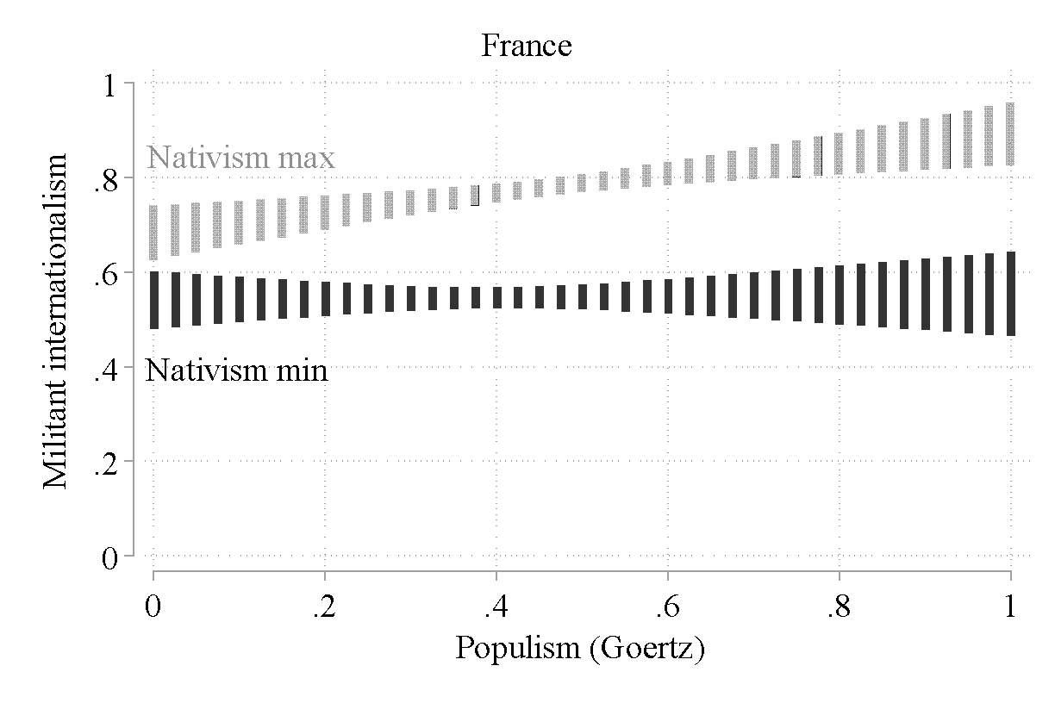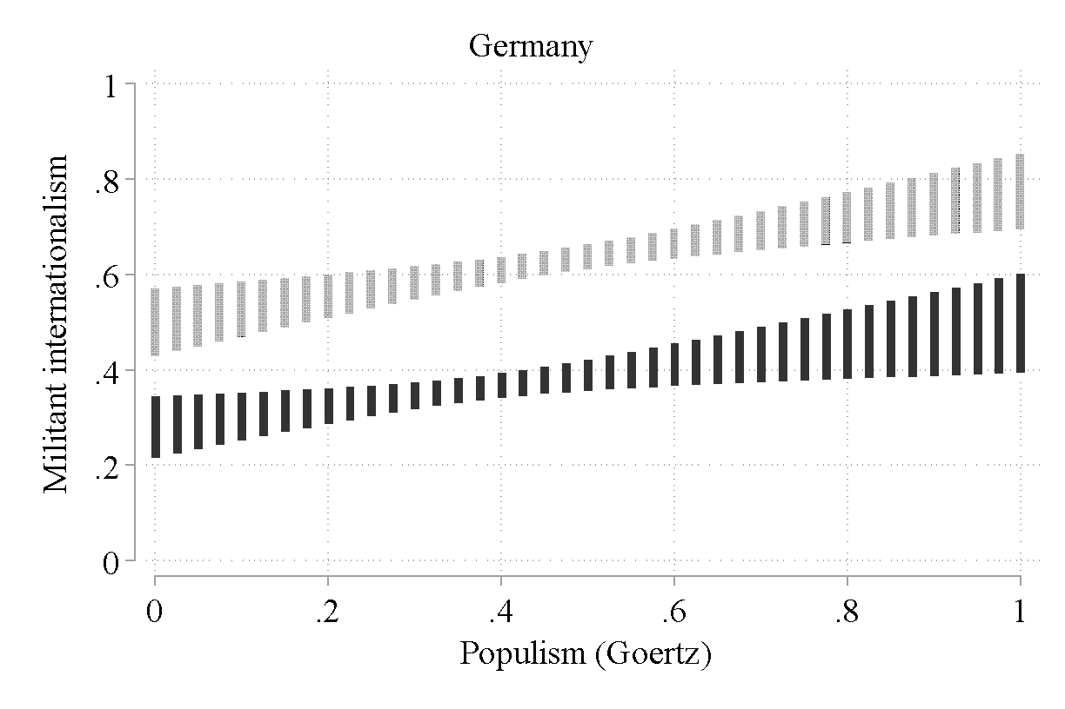 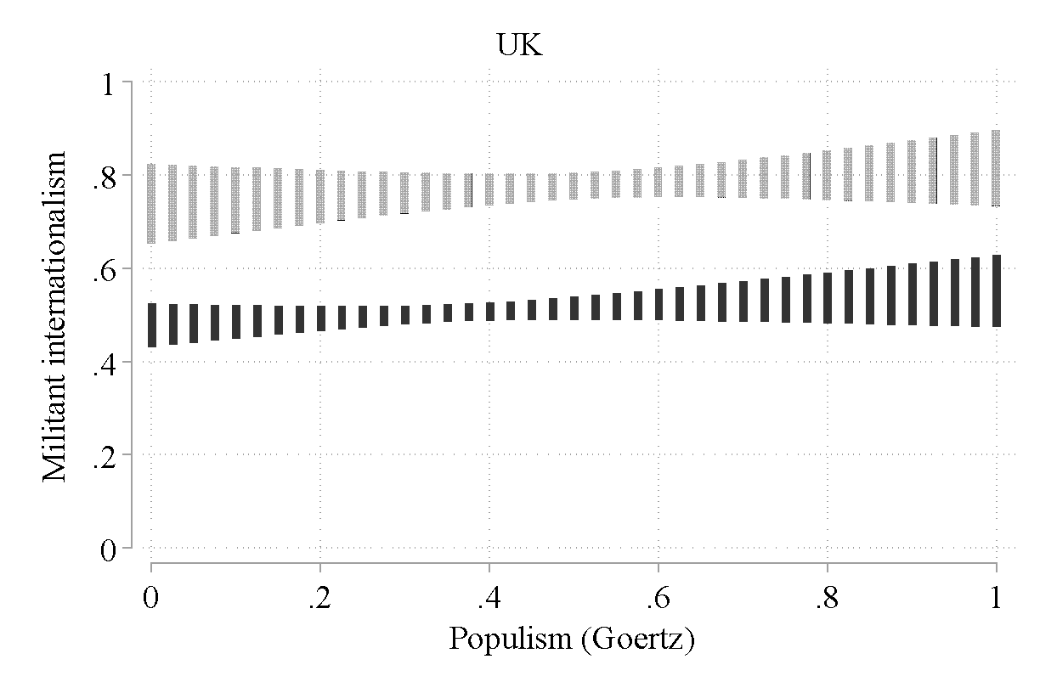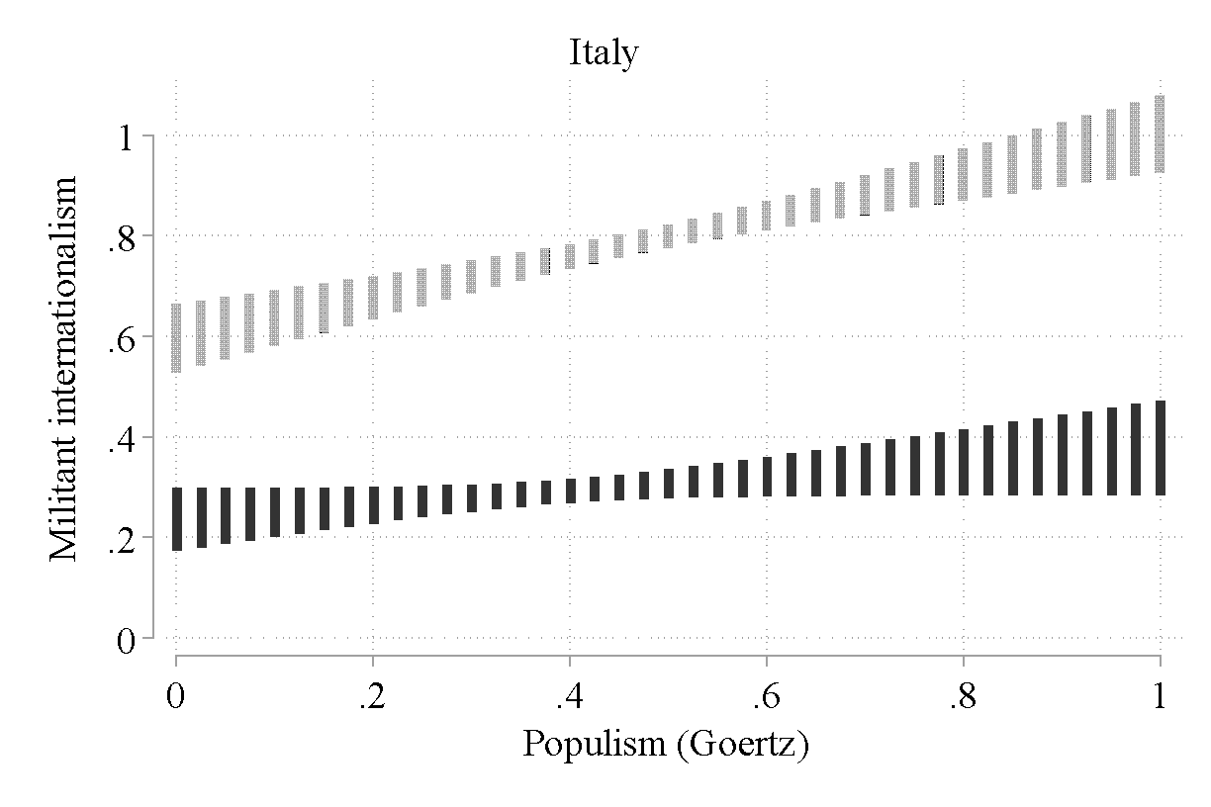

Note: Postestimations made for categories “Left” and “Right” of the left-right self-categorization variable. Bars around estimation points show 95% confidence intervals.

Figure A4: Predicted cooperative internationalism scores, nativism-populism interaction

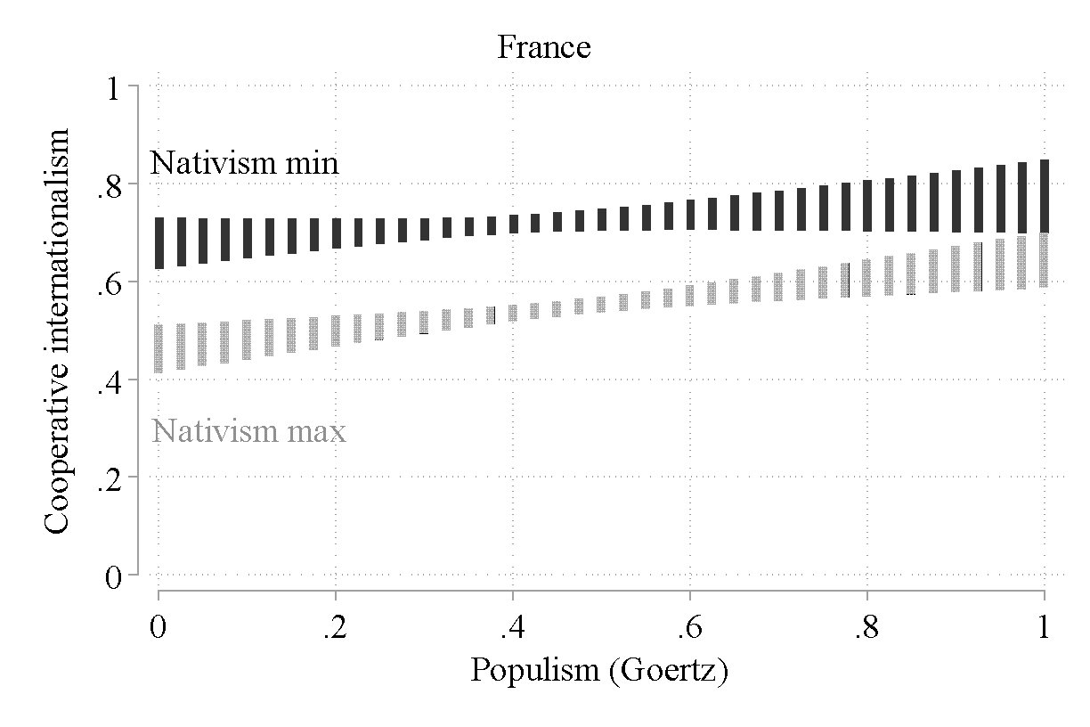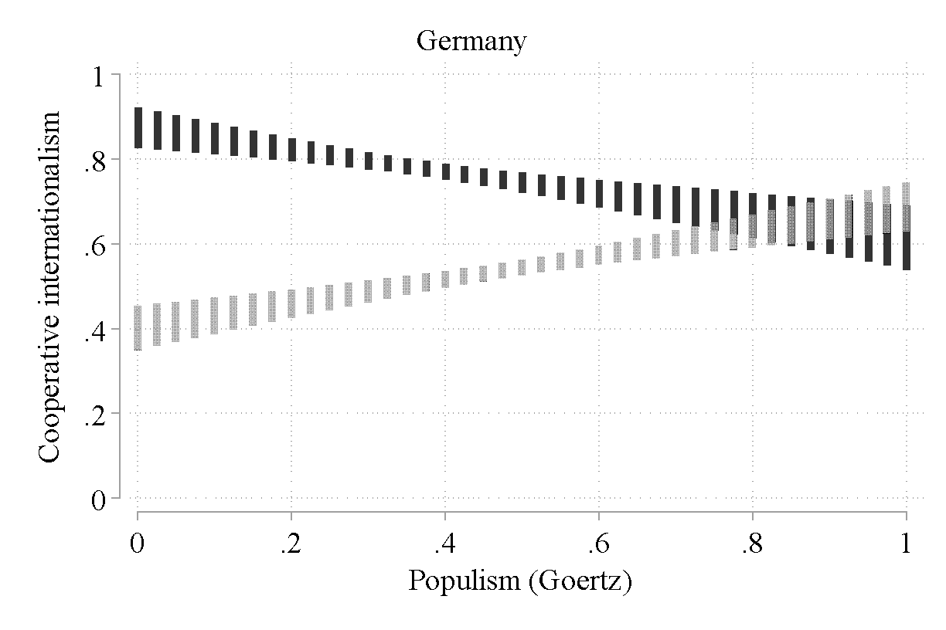 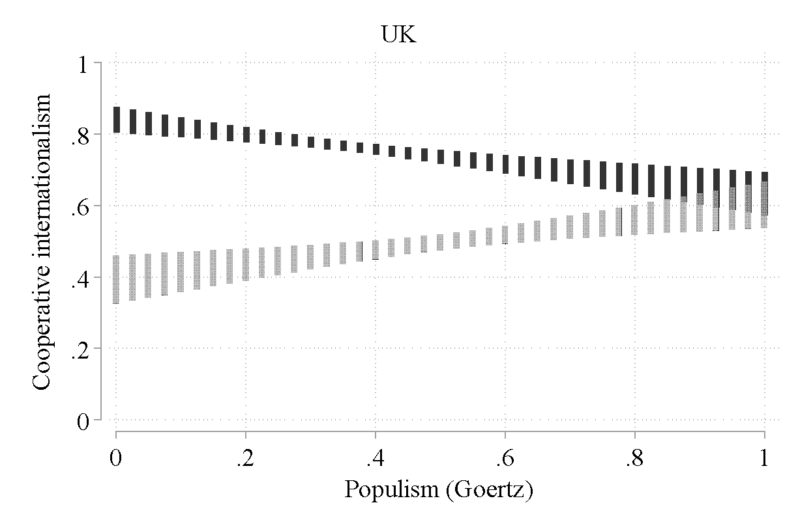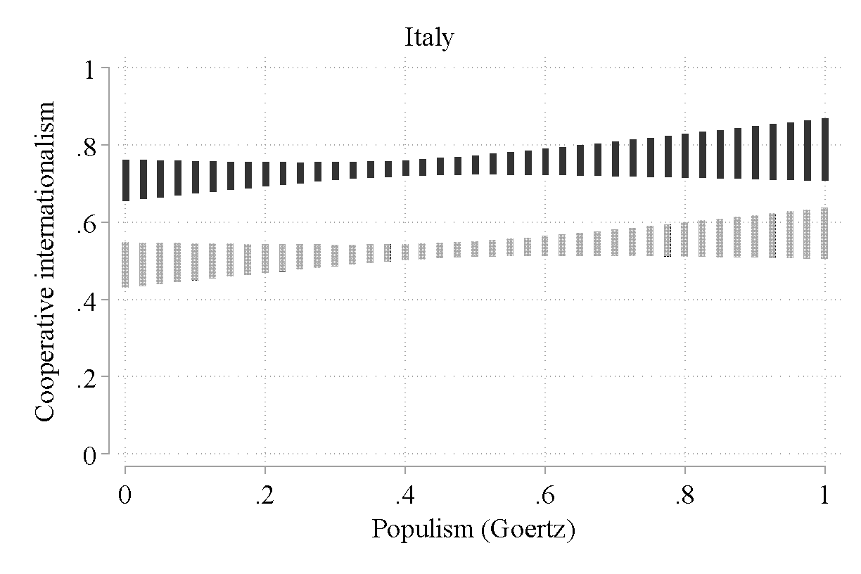

Note: Postestimations made for categories “Left” and “Right” of the left-right self-categorization variable. Bars around estimation points show 95% confidence intervals.

Figure A5: Predicted isolationism scores, nativism-populism interaction

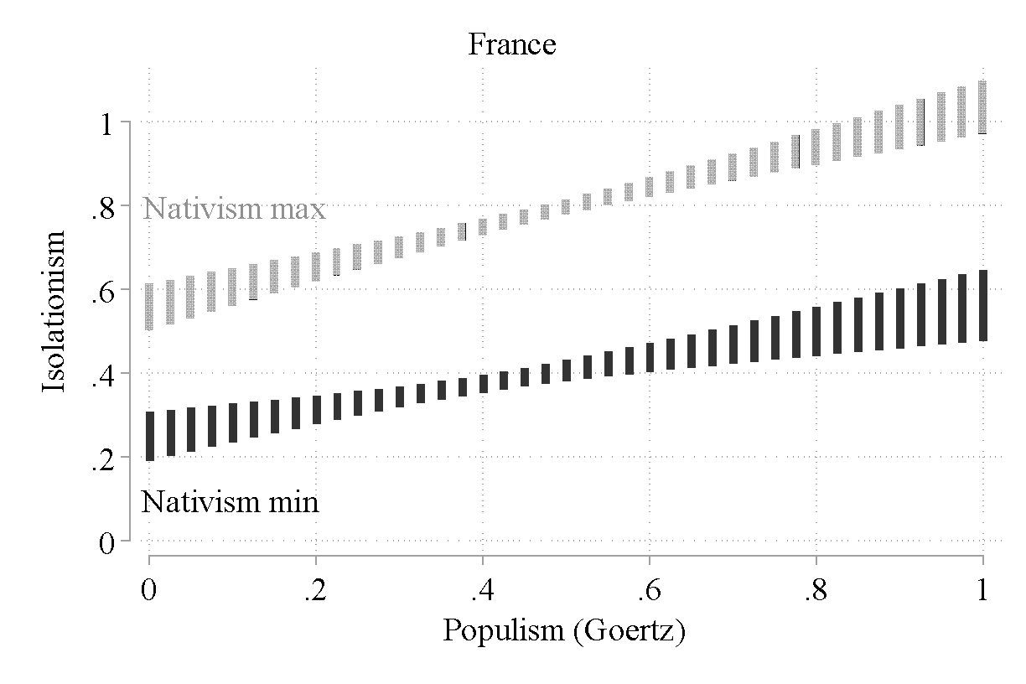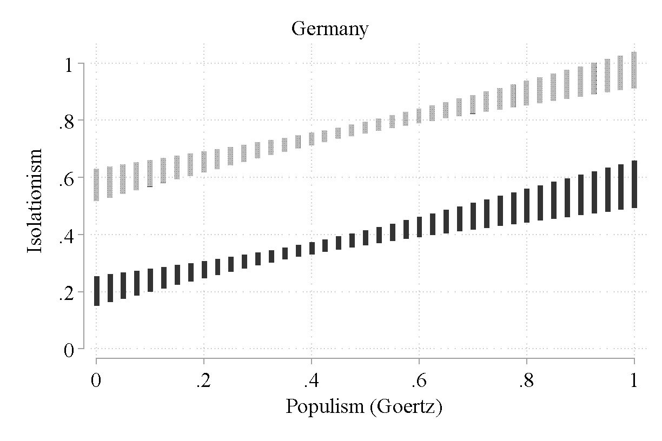 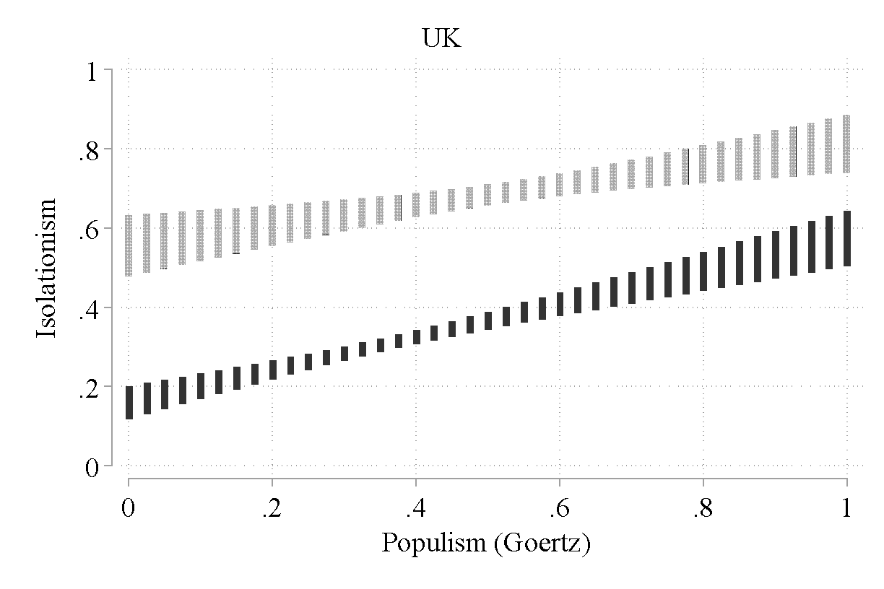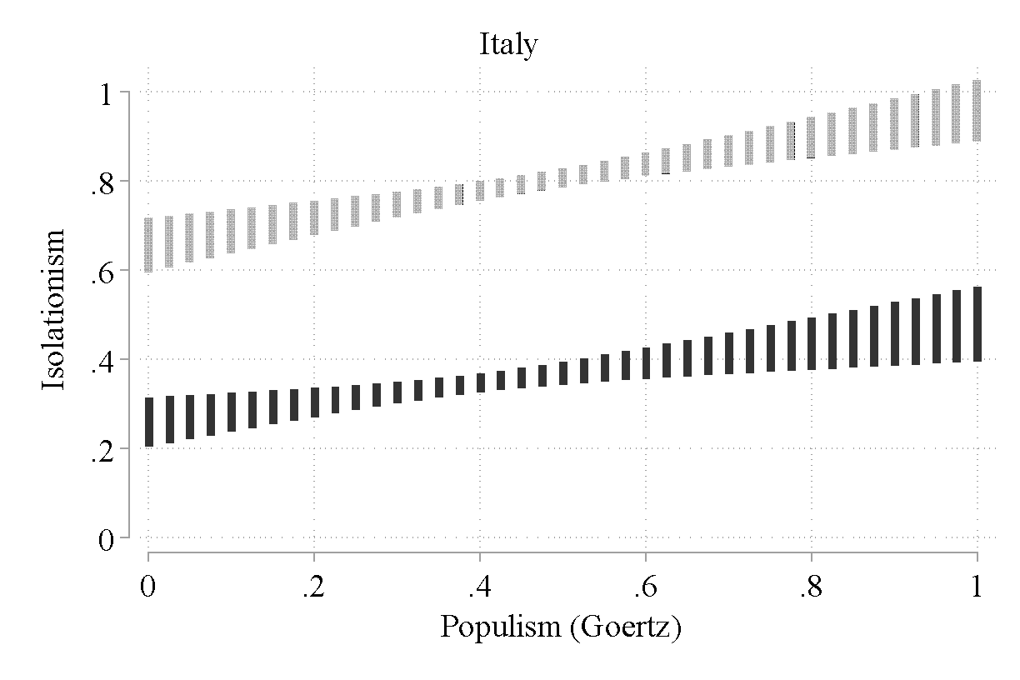

Note: Postestimations made for categories “Left” and “Right” of the left-right self-categorization variable. Bars around estimation points show 95% confidence intervals.

Figure A6: Predicted global justice scores, nativism-populism interaction

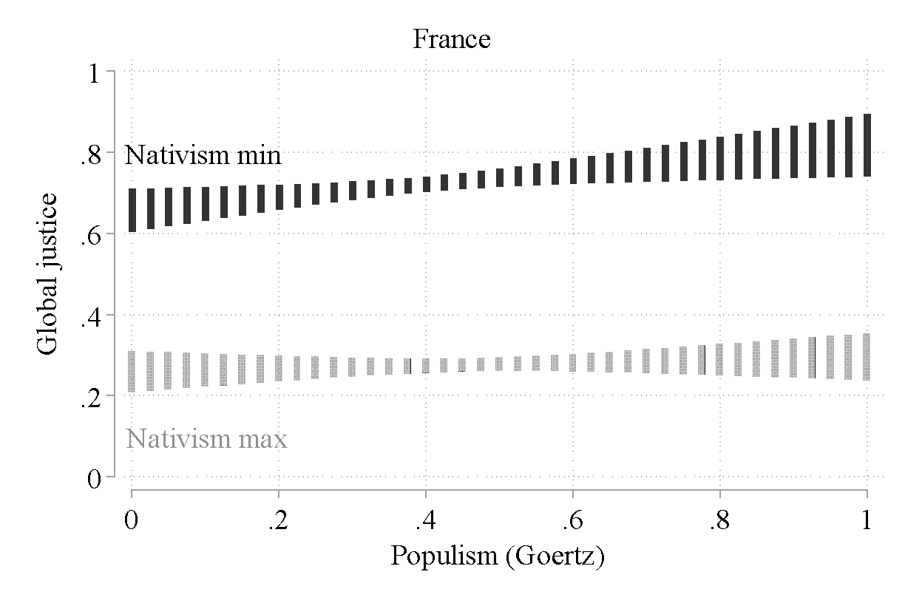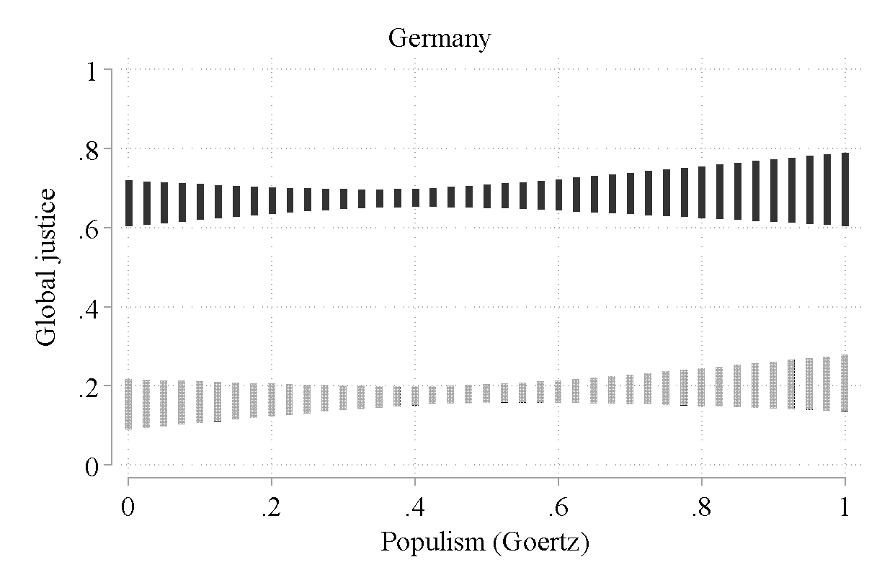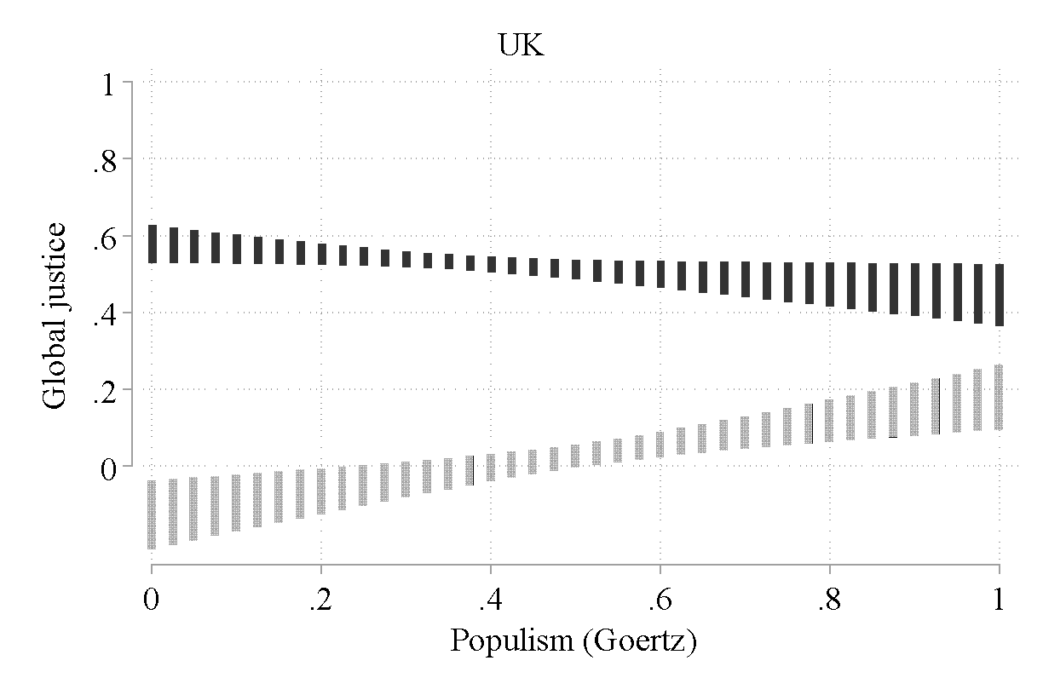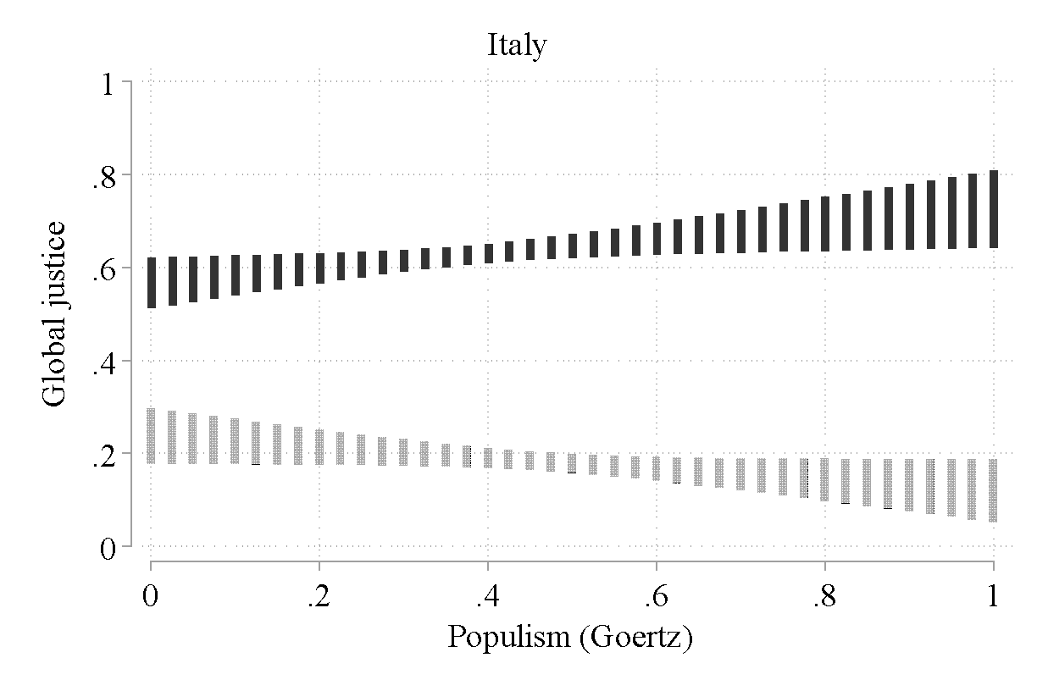

Note: Postestimations made for categories “Left” and “Right” of the left-right self-categorization variable. Bars around estimation points show 95% confidence intervals.