Appendix

Table A.1. Available observations by country and year
Descriptive models:
Country | 2002 | 2004 | 2006 | 2008 | 2010 | 2012 | 2014 | 2016 | 2018 | 2020 | Total
AT | 2,106 | 2,064 | 2,187 | . | . | . | 1,728 | 1,957 | 2,400 | 1,831 | 14,273
BE | 1,619 | 1,659 | 1,692 | 1,660 | 1,624 | 1,777 | 1,681 | 1,695 | 1,679 | . | 15,086
CH | 1,925 | 2,012 | 1,727 | 1,727 | 1,414 | 1,412 | 1,444 | 1,424 | 1,431 | 1,447 | 15,963
CZ | 1,200 | 2,707 | . | 1,903 | 2,271 | 1,816 | 1,995 | 2,166 | 2,352 | 2,389 | 18,799
DE | 2,763 | 2,634 | 2,724 | 2,632 | 2,859 | 2,791 | 2,907 | 2,700 | 2,238 | 7,779 | 32,027
DK | 1,408 | 1,383 | 1,424 | 1,530 | 1,485 | 1,549 | 1,413 | . | 1,491 | . | 11,683
ES | 1,525 | 1,530 | 1,745 | 2,364 | 1,795 | 1,784 | 1,818 | 1,854 | 1,535 | 2,170 | 18,120
FI | 1,825 | 1,854 | 1,771 | 2,044 | 1,748 | 2,066 | 1,963 | 1,836 | 1,648 | 1,515 | 18,270
FR | 1,455 | 1,754 | 1,918 | 1,981 | 1,670 | 1,903 | 1,834 | 1,982 | 1,920 | 1,865 | 18,282
GB | 1,909 | 1,754 | 2,195 | 2,183 | 2,175 | 2,071 | 2,130 | 1,831 | 2,091 | . | 18,339
HU | 1,479 | 1,332 | 1,376 | 1,405 | 1,446 | 1,862 | 1,558 | 1,504 | 1,557 | 1,743 | 15,262
IE | 1,825 | 2,097 | 1,522 | 1,662 | 2,367 | 2,466 | 2,217 | 2,563 | 2,076 | . | 18,795
NL | 2,246 | 1,780 | 1,799 | 1,705 | 1,760 | 1,775 | 1,826 | 1,607 | 1,549 | 1,414 | 17,461
NO | 1,987 | 1,678 | 1,652 | 1,461 | 1,452 | 1,536 | 1,346 | 1,464 | 1,309 | 1,341 | 15,226
PL | 1,843 | 1,522 | 1,526 | 1,453 | 1,574 | 1,728 | 1,468 | 1,532 | 1,375 | 1,850 | 15,871
PT | 1,312 | 1,899 | 1,983 | 2,137 | 1,991 | 2,049 | 1,177 | 1,202 | 988 | 1,700 | 16,438
SE | 1,839 | 1,795 | 1,796 | 1,702 | 1,399 | 1,748 | 1,701 | 1,475 | 1,488 | 2,154 | 17,097
SI | 1,376 | 1,261 | 1,304 | 1,182 | 1,279 | 1,167 | 1,123 | 1,212 | 1,221 | 1,171 | 12,296
SK | . | 1,303 | 1,602 | 1,708 | 1,762 | 1,783 | . | . | 1,050 | 1,330 | 10,538
Tot | 31,642 | 34,018 | 31,943 | 32,439 | 32,071 | 33,283 | 31,329 | 30,004 | 31,398 | 31,699 | 319,826
Most complete models*:
Country | 2002 | 2004 | 2006 | 2008 | 2010 | 2012 | 2014 | 2016 | 2018 | 2020 | Total
AT | 1,225 | 1,051 | 1,265 | 0 | 0 | 0 | 1,232 | 1,415 | 1,904 | 1,271 | 9,363
BE | 1,198 | 1,218 | 1,392 | 1,378 | 1,296 | 1,532 | 1,466 | 1,478 | 1,471 | 0 | 12,429
CH | 1,469 | 1,557 | 1,380 | 1,285 | 1,141 | 1,147 | 1,176 | 1,146 | 1,132 | 1,165 | 12,598
CZ | 832 | 1,562 | 0 | 1,290 | 1,499 | 1,151 | 1,269 | 1,599 | 1,489 | 1,594 | 12,285
DE | 2,102 | 1,978 | 1,982 | 2,088 | 2,182 | 2,336 | 2,534 | 2,351 | 1,950 | 5,544 | 25,047
DK | 1,220 | 1,204 | 1,264 | 1,304 | 1,289 | 1,339 | 1,262 | 0 | 1,278 | 0 | 10,160
ES | 802 | 799 | 1,001 | 1,391 | 1,268 | 1,314 | 1,292 | 1,307 | 1,039 | 1,329 | 11,542
FI | 1,674 | 1,713 | 1,630 | 1,892 | 1,616 | 1,941 | 1,849 | 1,696 | 1,550 | 1,426 | 16,987
FR | 0 | 1,393 | 1,607 | 1,686 | 1,442 | 1,643 | 1,614 | 1,714 | 1,622 | 1,573 | 14,294
GB | 1,649 | 1,228 | 1,716 | 1,854 | 1,688 | 1,539 | 1,715 | 1,475 | 1,704 | 0 | 14,568
HU | 0 | 1,032 | 0 | 979 | 1,064 | 1,205 | 1,059 | 875 | 864 | 1,181 | 8,259
IE | 0 | 1,516 | 1,078 | 1,403 | 1,452 | 1,723 | 1,643 | 1,817 | 1,436 | 0 | 12,068
NL | 1,891 | 1,498 | 1,545 | 1,474 | 1,391 | 1,470 | 1,629 | 1,400 | 1,298 | 1,256 | 14,852
NO | 1,770 | 1,618 | 1,578 | 1,400 | 1,379 | 1,455 | 1,272 | 1,377 | 1,191 | 1,267 | 14,307
PL | 1,428 | 1,165 | 1,153 | 1,124 | 1,150 | 1,291 | 1,045 | 1,120 | 825 | 1,295 | 11,596
PT | 851 | 935 | 965 | 825 | 0 | 888 | 901 | 1,022 | 766 | 1,047 | 8,200
SE | 1,731 | 1,680 | 1,636 | 1,610 | 1,300 | 1,566 | 1,549 | 1,362 | 1,368 | 1,970 | 15,772
SI | 1,027 | 776 | 921 | 809 | 879 | 819 | 824 | 978 | 996 | 983 | 9,012
SK | 0 | 714 | 867 | 0 | 1,037 | 1,120 | 0 | 0 | 789 | 855 | 5,382
Tot | 20,869 | 24,637 | 22,980 | 23,792 | 23,073 | 25,479 | 25,331 | 24,132 | 24,672 | 23,756 | 238,721

*some country are missing in some years compared to the previous table, because no income variable is available

Figure A1. Average SWD (pooled over the period 2002-2020) and trends in some country
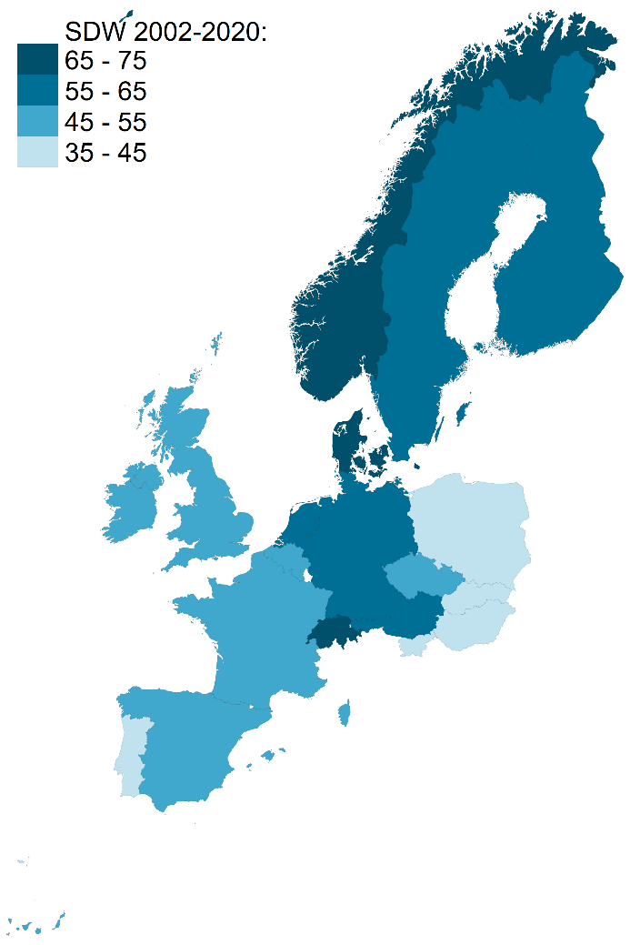
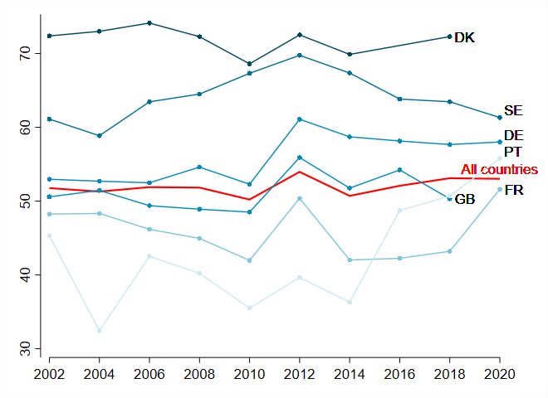

Table A2. Distribution of the four kinds of places by country
 |  | Big cities | Outskirts of big cities | Small cities | Rural areas | Total
AT | Freq. | 3,144 | 1,384 | 3,705 | 6,040 | 14,273
 | % | 22.0 | 9.7 | 26.0 | 42.3 | 100
BE | Freq. | 2,003 | 1,583 | 3,613 | 7,887 | 15,086
 | % | 13.3 | 10.5 | 23.9 | 52.3 | 100
CH | Freq. | 1,322 | 1,665 | 3,854 | 9,122 | 15,963
 | % | 8.2 | 10.4 | 24.1 | 57.1 | 100
CZ | Freq. | 5,231 | 849 | 7,294 | 5,425 | 18,799
 | % | 27.8 | 4.5 | 38.8 | 28.9 | 100
DE | Freq. | 5,659 | 4,297 | 11,742 | 10,329 | 32,027
 | % | 17.7 | 13.4 | 36.7 | 32.3 | 100
DK | Freq. | 2,028 | 2,499 | 3,937 | 3,219 | 11,683
 | % | 17.4 | 21.4 | 33.7 | 27.6 | 100
ES | Freq. | 3,774 | 1,211 | 5,383 | 7,752 | 18,120
 | % | 20.8 | 6.7 | 29.7 | 42.8 | 100
FI | Freq. | 3,595 | 2,240 | 5,461 | 6,974 | 18,270
 | % | 19.7 | 12.3 | 29.9 | 38.2 | 100
FR | Freq. | 3,478 | 2,267 | 5,983 | 6,554 | 18,282
 | % | 19.0 | 12.4 | 32.7 | 35.9 | 100
GB | Freq. | 1,511 | 4,057 | 8,348 | 4,423 | 18,339
 | % | 8.2 | 22.1 | 45.5 | 24.1 | 100
HU | Freq. | 3,958 | 608 | 5,348 | 5,348 | 15,262
 | % | 25.9 | 4.0 | 35.0 | 35.0 | 100
IE | Freq. | 1,365 | 4,361 | 5,013 | 8,056 | 18,795
 | % | 7.3 | 23.2 | 26.7 | 42.9 | 100
NL | Freq. | 3,546 | 1,812 | 4,480 | 7,623 | 17,461
 | % | 20.3 | 10.4 | 25.7 | 43.7 | 100
NO | Freq. | 2,363 | 2,761 | 4,141 | 5,961 | 15,226
 | % | 15.5 | 18.1 | 27.2 | 39.2 | 100
PL | Freq. | 3,919 | 683 | 5,159 | 6,110 | 15,871
 | % | 24.7 | 4.3 | 32.5 | 38.5 | 100
PT | Freq. | 3,900 | 2,550 | 5,088 | 4,900 | 16,438
 | % | 23.7 | 15.5 | 31.0 | 29.8 | 100
SE | Freq. | 2,494 | 3,820 | 5,887 | 4,896 | 17,097
 | % | 14.6 | 22.3 | 34.4 | 28.6 | 100
SI | Freq. | 1,354 | 1,651 | 2,633 | 6,658 | 12,296
 | % | 11.0 | 13.4 | 21.4 | 54.2 | 100
SK | Freq. | 1,747 | 571 | 3,243 | 4,977 | 10,538
 | % | 16.6 | 5.4 | 30.8 | 47.2 | 100
Total | Freq. | 56,391 | 40,869 | 100,312 | 122,254 | 319,826
 | % | 17.6 | 12.8 | 31.3 | 38.2 | 100

Table A3. Rural population (% total population)
 | Eurostat statistic* | ESS datataset
AT | 41 | 42
BE | 18 | 51
CH | 25 | 58
CZ | 47 | 30
DE | 23 | 32
DK | 45 | 27
ES | 27 | 43
FI | 30 | 38
FR | 35 | 35
GB | 14 | 23
HU | 40 | 32
IE | 43 | 42
NL | 15 | 45
NO | 40 | 40
PL | 42 | 41
PT | 27 | 36
SE | 29 | 28
SI | 45 | 54
SK | 41 | 49
Average across all countries in the sample | 33 | 39

* Population distribution by degree of urbanization in 2014 (only Norway: 2015), from the EU-SILC survey. This measure is based on the classification of local administrative units (LAU) following the criteria of geographical contiguity and population density. For more information: https://ec.europa.eu/eurostat/web/degree-of-urbanisation/methodology

Table A4. Regression results on SWD (0-100).
 | Descriptive models |  | Models including individual controls
Age |  |  | 0.06*** | 0.06*** | 0.06***
Male (ref: female) |  |  | 1.80*** | 1.79*** | 1.26***
No country citizenship |  |  | 10.69*** | 10.69*** | 10.56***
Ethnic minority |  |  | 2.26*** | 2.23*** | 2.20***
Unemployed |  |  | -3.71*** | -3.71*** | -3.75***
Class (ref: upper-middle class)
Lower-grade service class |  |  | 16 classes : | 16 classes : | -0.73***
Small business owners |  |  | omitted | omitted | -1.50***
Skilled workers |  |  |  |  | -1.97***
Unskilled workers |  |  |  |  | -2.69***
Education level (ref: less than secondary)
Secondary and post secodary |  |  | 0.65 | 0.67* | 0.82**
Tertiary |  |  | 3.11*** | 3.12*** | 3.28***
Income national deciles (ref: 1st deciles)
2nd decile |  |  | 0.82 | 0.84* | 0.82
3rd decile |  |  | 1.87*** | 1.87*** | 1.87***
4th decile |  |  | 2.51*** | 2.51*** | 2.56***
5th decile |  |  | 3.34*** | 3.35*** | 3.42***
6th decile |  |  | 4.00*** | 4.01*** | 4.12***
7th decile |  |  | 4.46*** | 4.47*** | 4.63***
8th decile |  |  | 5.36*** | 5.38*** | 5.55***
9th decile |  |  | 6.46*** | 6.47*** | 6.68***
10th decile |  |  | 7.14*** | 7.14*** | 7.35***
Country dummies (ref: AT)
BE | -3.90*** | -3.84*** | -4.83*** | -4.78*** | -4.82***
CH | 13.76*** | 13.81*** | 12.07*** | 12.11*** | 12.08***
CZ | -7.60*** | -7.55*** | -6.68*** | -6.63*** | -6.85***
DE | -2.07*** | -2.03*** | -2.20*** | -2.14*** | -2.22***
DK | 13.94*** | 14.00*** | 14.45*** | 14.49*** | 14.39***
ES | -7.76*** | -7.71*** | -8.01*** | -7.95*** | -8.02***
FI | 6.74*** | 6.77*** | 7.07*** | 7.09*** | 6.91***
FR | -12.08*** | -12.04*** | -12.53*** | -12.49*** | -12.54***
UK | -15.48*** | -15.41*** | -14.12*** | -14.00*** | -14.29***
HU | -5.16*** | -5.09*** | -5.44*** | -5.32*** | -5.29***
IE | 3.08*** | 3.13*** | 2.42*** | 2.47*** | 2.54***
NL | 10.75*** | 10.80*** | 10.61*** | 10.66*** | 10.59***
NO | -13.11*** | -13.05*** | -12.21*** | -12.16*** | -12.39***
PL | -15.17*** | -15.13*** | -11.83*** | -11.81*** | -11.98***
PT | 6.03*** | 6.06*** | 5.51*** | 5.55*** | 5.46***
SE | -17.81*** | -17.73*** | -17.46*** | -17.41*** | -17.57***
SI | -13.43*** | -13.39*** | -13.38*** | -13.35*** | -13.60***
SK | -6.70*** | -6.62*** | -7.24*** | -7.16*** | -7.09***
Place (ref: big cities and their outskirts)
Outskirts of big cities | -0.52 | -0.06 | -0.22 | 2.15** | 2.10**
Small cities | -1.64*** | -0.57 | -0.83** | 1.62** | 1.54**
Rural areas | -2.53*** | -1.35 | -1.31* | 1.90** | 1.72**
Year (ref: 2002)
2004 | -0.35 | 0.64 | 0.14 | 2.27* | 2.26*
2006 | 0.26 | 1.01 | 1.23 | 3.57*** | 3.58***
2008 | 0.38 | 1.67 | 0.55 | 3.90** | 3.98**
2010 | -1.21 | 0.08 | -0.11 | 2.19 | 2.25
2012 | 2.50 | 3.14 | 3.56 | 6.03* | 6.09*
2014 | -0.96 | -0.02 | -0.12 | 2.76 | 2.83
2016 | 0.64 | 1.32 | 1.00 | 3.28 | 3.29
2018 | 1.45 | 2.73 | 1.22 | 4.63** | 4.69**
2020 | 1.66 | 2.08 | 1.96 | 3.23 | 3.30
Place-specific trends :
Outskirts#2004 |  | -2.30* |  | -3.60** | -3.53**
Outskirts#2006 |  | -1.24 |  | -3.28*** | -3.22***
Outskirts#2008 |  | -1.34 |  | -4.09* | -4.09*
Outskirts#2010 |  | -2.11 |  | -2.86* | -2.88*
Outskirts#2012 |  | 1.21 |  | -1.28 | -1.27
Outskirts#2014 |  | 0.88 |  | -1.58 | -1.57
Outskirts#2016 |  | 0.63 |  | -2.14 | -2.10
Outskirts#2018 |  | -1.75 |  | -4.15*** | -4.13***
Outskirts#2020 |  | 2.16 |  | 0.60 | 0.60
Small cities#2004 |  | -0.83 |  | -2.03 | -2.00
Small cities #2006 |  | -1.24 |  | -2.53*** | -2.52***
Small cities #2008 |  | -1.47** |  | -3.27*** | -3.32***
Small cities #2010 |  | -1.69* |  | -2.52*** | -2.55***
Small cities #2012 |  | -0.49 |  | -2.27* | -2.29*
Small cities #2014 |  | -1.08 |  | -3.03*** | -3.07***
Small cities #2016 |  | -1.38 |  | -2.82* | -2.81*
Small cities #2018 |  | -1.60* |  | -3.90*** | -3.94***
Small cities #2020 |  | -0.85 |  | -1.10 | -1.12
Rural#2004 |  | -1.20 |  | -2.56*** | -2.52***
Rural #2006 |  | -0.41 |  | -2.74*** | -2.70***
Rural #2008 |  | -1.71 |  | -4.63*** | -4.66***
Rural #2010 |  | -1.32 |  | -2.91*** | -2.89***
Rural #2012 |  | -1.81 |  | -4.22*** | -4.22***
Rural #2014 |  | -1.88* |  | -4.48** | -4.50**
Rural #2016 |  | -0.83 |  | -2.81** | -2.73**
Rural #2018 |  | -1.43 |  | -4.16** | -4.16**
Rural #2020 |  | -1.01 |  | -2.43 | -2.42
Constant | 59.02*** | 58.13*** | 48.92*** | 46.50*** | 47.92***
Observations | 319,826 | 319,826 | 238,721 | 238,721 | 238,721
Adjusted R-squared | 0.08 | 0.08 | 0.12 | 0.12 | 0.12

Standard errors clustered at the country level (*p=0.05, **p=0.01, ***p=0.001).

Figure A2. Trends of SWD (0-100) in the different kinds of places in Europe, 2002-2020 (95% confidence intervals)
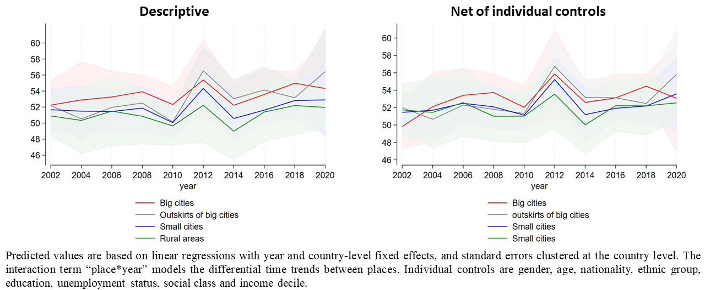

Figure A3. Differences of SWD (0-100) between several social groups in Europe, 2002-2020: results from multilevel models.
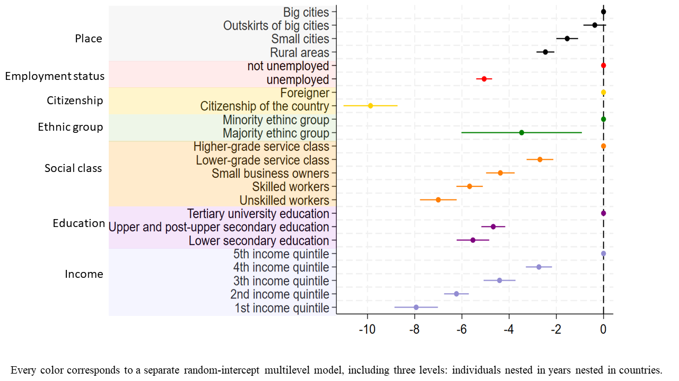
Figure A4. Differences in SWD between people living in the four kinds of places within each income quintile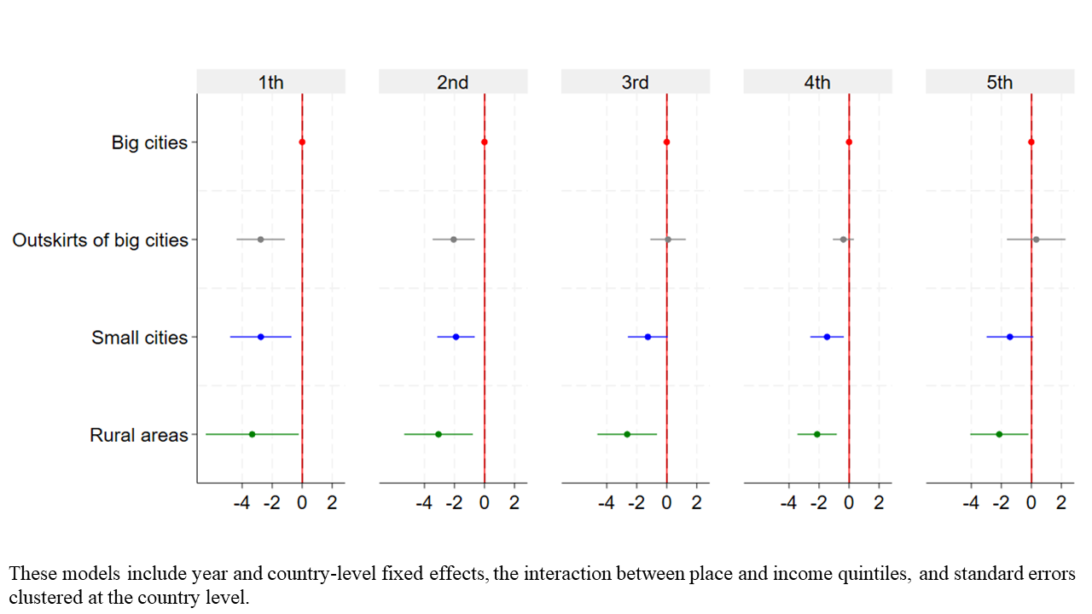

Figure A5. Differences in SWD between the big cities and the other kinds of places in each of the studied countries (2002-2020), descriptive
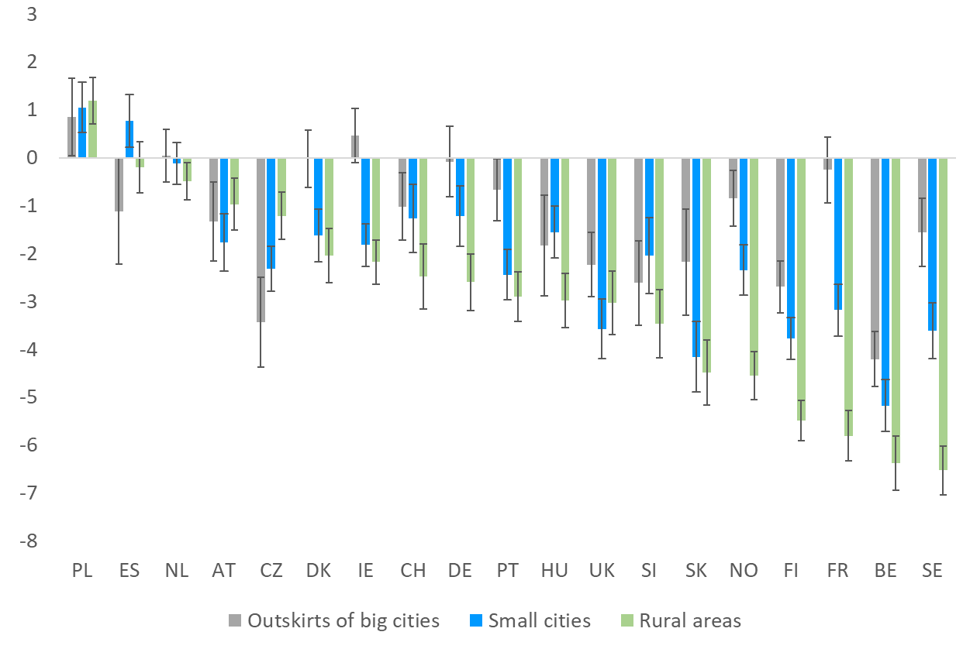

Figure A6. Differences of SWD between the four kinds of places in each country under study (2002-2020), net of individual controls

Figure A7. Average trust in country’s parliament in the different kinds of places in the countries with the largest urban-rural differences, 2002-2020 (95% confidence intervals)

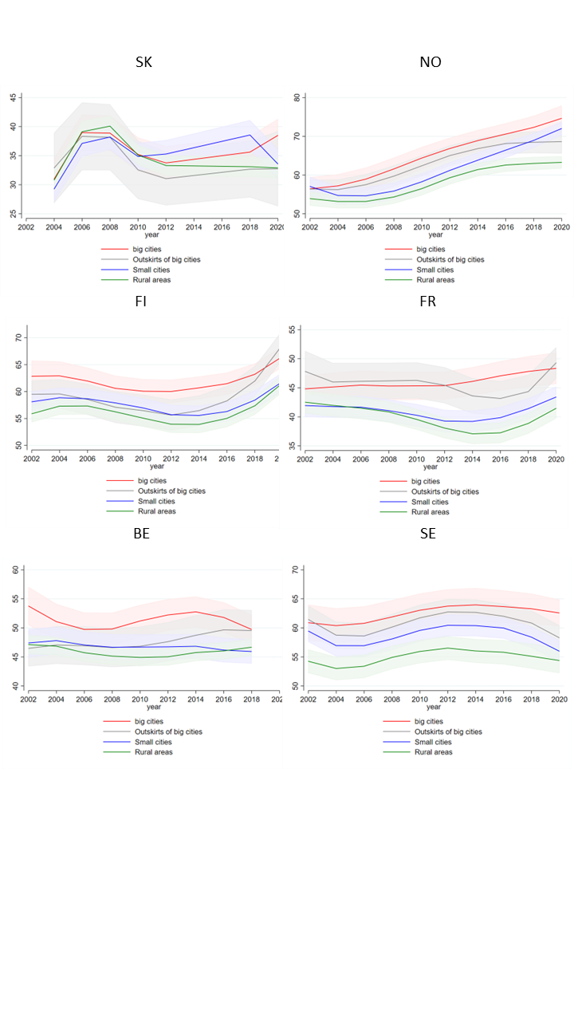

Figure A8. Average trust in politicians in the different kinds of places in the countries with the largest urban-rural differences, 2002-2020 (95% confidence intervals)

