Online Appendix

Table A1. Correlates between the variables measuring political engagement
 | Close to a political party (Cramer’s V) |  | Political interest  (Spearman’s coeff.)
Variables | 2018 | 2021 | 2018 | 2021
Political system allows people to have a say in what government does | 0,149*** | 0,185*** | 0,292*** | 0,364***
Political system allows people to have influence on politics | 0,170*** | 0,195*** | 0,329*** | 0,393***
Able to take active role in political group | 0,199*** | 0,207*** | 0,460*** | 0,467***
Confident in own ability to participate in politics | 0,204*** | 0,201*** | 0,471*** | 0,447***
Political interest | 0,331*** | 0,376*** | - | -
Source: ESS, Round 9 and 10.
Note: ***p value ≤ 0.001.

Table A2. Descriptive analysis of variables
 | 2018 |  |  |  |  | 2021
Variables | N | min. | max. | mean | sd | N | min. | max. | mean | sd
Income decile | 13633 | 1 | 10 | 5,61 | 2,82 | 14273 | 1 | 10 | 5,64 | 2,92
Education (7=higher tertiary education/MA level | 42097 | 1 | 7 | 3,75 | 1,88 | 19450 | 1 | 7 | 3,72 | 1,83
Age (1) | 42286 | 15 | 90 | 48,42 | 19,02 | 19418 | 15 | 90 | 48,87 | 19,19
Gender (male=1) | 42440 | 0 | 1 | 0,49 | 0,50 | 19574 | 0 | 1 | 0,48 | 0,50
How interested in politics (4=very interested) | 42366 | 1 | 4 | 2,39 | 0,94 | 19545 | 1 | 4 | 2,22 | 0,92
Political system allows people to have a say in what government does (5=a great deal) | 41286 | 1 | 5 | 2,25 | 0,94 | 19154 | 1 | 5 | 2,13 | 0,96
Able to take active role in political group (5=completely able) | 41714 | 1 | 5 | 2,09 | 1,04 | 19210 | 1 | 5 | 1,99 | 1,02
Political system allows people to have influence on politics (5=a great deal) | 41498 | 1 | 5 | 2,17 | 0,92 | 19190 | 1 | 5 | 2,04 | 0,93
Confident in own ability to participate in politics (5=completely confident) | 41560 | 1 | 5 | 2,23 | 1,05 | 19152 | 1 | 5 | 2,07 | 0,98
Close to a party (1=close) | 41341 | 0 | 1 | 0,49 | 0,50 | 19002 | 0 | 1 | 0,39 | 0,49
Had Covid-19 (1=yes) | - | - | - | - | - | 12959 | 0 | 1 | 0,20 | 0,40
Things happened since start of COVID-19: was made redundant/lost job | - | - | - | - | - | 19574 | 0 | 1 | 0,02 | 0,12
Things happened since start of COVID-19: income from job was reduced | - | - | - | - | - | 19574 | 0 | 1 | 0,06 | 0,24
Things happened since start of COVID-19: was furloughed | - | - | - | - | - | 19574 | 0 | 1 | 0,05 | 0,22
Things happened since start of COVID-19: was forced to take unpaid leave/holiday | - | - | - | - | - | 19574 | 0 | 1 | 0,02 | 0,13
Note: (1) By including under-18s, informed consent is ensured. In accordance with the standards of professional ethics that regulate survey administration by ESS, informed consent is provided for in the collection and analysis of data, implying that the questioning of minors will depend on the consent of their parents (at: https://www. isi-web.org/background-documentation-and-bibliography-isi-declaration-professional-ethics).
Source: ESS, Round 9 and 10.

Figure A1. Mean positioning of countries in the sample regarding income and education

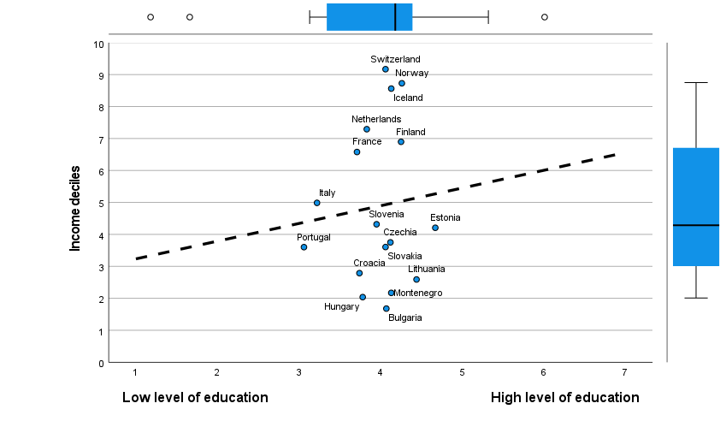

Source: ESS, Round 9 and 10.
Note: The dashed line illustrates the linear fit between the two variables.

Figure A2. Distribution of the dependent variables by income deciles and education levels

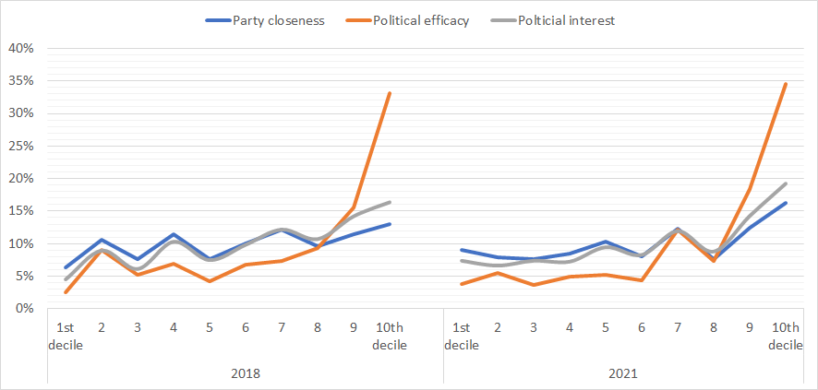

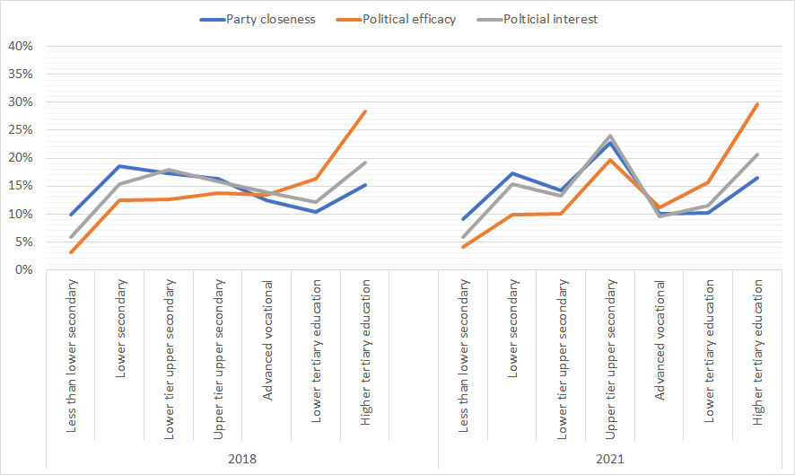
Source: ESS, Round 9 and 10.

Figure A3. Distribution of the dependent variables by income terciles

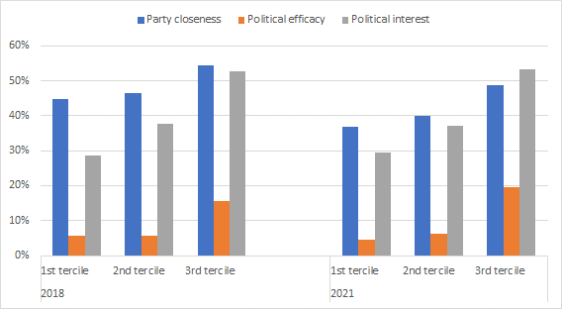
Source: ESS, Round 9 and 10.

Table A3. Mean differences in political engagement by income terciles
 |  | Party closeness |  |  | Political efficacy |  |  | Political interest
Income |  | Mean (standard error) | Difference (a) – (b)  (b) – (c) (standard error) | Difference  (a) – (c) (standard error) | Mean (standard error) | Difference (a) – (b)  (b) – (c) (standard error) | Difference  (a) – (c) (standard error) | Mean (standard error) | Difference (a) – (b)  (b) – (c) (standard error) | Difference  (a) – (c) (standard error)
2018
 | 1st tercile (a) | 0,449 (0,008) |  |  | 0,055 (0,004) |  |  | 0,287 (0,007)
 |  |  | -0,015 ns (0,011) |  |  | -0,001 ns (0,005) |  |  | -0,090*** (0,010)
 | 2nd tercile  (b) | 0,464 (0,008) |  | -0,095***  (0,011) | 0,056 (0,004) |  | -0,100***  (0,007) | 0,377 (0,007) |  | -0,240***  (0,010)
 |  |  | -0,080*** (0,010) |  |  | -0,099*** (0,007) |  |  | -0,150*** (0,010)
 | 3rd tercile  (c) | 0,544 (0,007) |  |  | 0,155 (0,005) |  |  | 0,527 (0,007)
2021
 | 1st tercile | 0,369 (0,007) |  |  | 0,046 (0,003) |  |  | 0,294 (0,007)
 |  |  | -0,031** (0,010) |  |  | -0,017*** (0,005) |  |  | -0,076*** (0,010)
 | 2nd tercile | 0,400 (0,007) |  | -0,119***  (0,010) | 0,063 (0,004) |  | -0,149***  (0,007) | 0,370 (0,007) |  | -0,240***  (0,010)
 |  |  | -0,088*** (0,010) |  |  | -0,132*** (0,007) |  |  | -0,164*** (0,010)
 | 3rd tercile | 0,488 (0,007) |  |  | 0,195 (0,006) |  |  | 0,534 (0,007)
Source: ESS, Round 9 and 10.
Note: Results are based on t-tests. The means are calculated with the dependent variables dichotomized, which allows their comparison. **p ≤ 0.01; ***p value ≤ 0.001. “ns” is for not significant.

Figure A4. Predicted probabilities of feeling close to a party by income quintiles

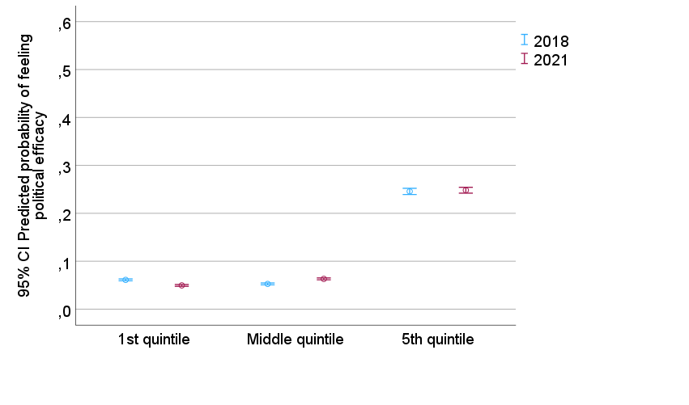
Note: The estimates are from Model 2 in Table 2.

Table A4. Regression models to explain political engagement by socioeconomic groups and the pandemic year, 2018 and 2021
 | Party closeness |  |  |  | Political efficacy |  |  |  | political interest
 | Model 1 |  | Model 2 |  | Model 1 |  | Model 2 |  | Model 1 |  | Model 2
 | Exp(b) | b (sd) | Exp(b) | b (sd) | Exp(b) | b (sd) | Exp(b) | b (sd) | Exp(b) | b (sd) | Exp(b) | b (sd)
Dummy income (third tercile=1) | 1,56 | 0,45***  (0,09) | 1,51 | 0,41***  (0,09) | 2,02 | 0,70***  (0,08) | 1,77 | 0,57***  (0,17) | 2,05 | 0,72*** (0,07) | 2,18 | 0,78***  (0,05)
Dummy education (highest level=1) | 1,59 | 0,47***  (0,05) | 1,20 | 0,18#  (0,11) | 3,45 | 1,24*** (0,13) | 2,80 | 1,03***  (0,10) | 3,53 | 1,26*** (0,14) | 3,11 | 1,13***  (0,18)
Dummy year (2020=1) | 0,69 | -0,36***  (0,11) | 0,50 | -0,69***  (0,12) | 1,03 | 0,03 (0,05) | 0,60 | -0,50***  (0,15) | 0,93 | -0,08 (0,06) | 0,87 | -0,14  (0,13)
Dummy income * Dummy year |  |  | 1,08 | 0,07  (0,08) |  |  | 1,31 | 0,27 (0,24) |  |  | 0,89 | -0,12  (0,13)
Dummy education * Dummy year |  |  | 1,72 | 0,54***  (0,17) |  |  | 1,51 | 0,41# (0,22) |  |  | 1,28 | 0,25*  (0,11)
Age | 1,02 | 0,02***  (0,00) | 1,02 | 0,02***  (0,00) | 0,99 | -0,01 (0,01) | 0,99 | -0,01 (0,01) | 1,02 | 0,02***  (0,00) | 1,02 | 0,02***  (0,00)
Gender (male=1) | 1,23 | 0,21***  (0,06) | 1,24 | 0,21***  (0,06) | 1,86 | 0,62***  (0,05) | 1,87 | 0,62*** (0,05) | 1,86 | 0,62***  (0,07) | 1,87 | 0,62***  (0,07)
Intercept | 0,28 | -1,28***  (0,17) | 0,33 | -1,12***  (0,15) | 0,05 | -3,08***  (0,44) | 0,06 | -2,82***  (0,44) | 0,09 | -2,40***  (0,19) | 0,09 | -2,37***  (0,18)
Akaike corrected | 41058,38 |  | 41084,21 |  | 47871,62 |  | 47830,38 |  | 44241,53 |  | 44255,34
Bayesian | 41035,54 |  | 41091,36 |  | 47878,69 |  | 47837,44 |  | 44248,72 |  | 44262,52
N | 9513 |  |  |  | 8677 |  |  |  | 9740
Number of countries | 17 |  |  |  | 17 |  |  |  | 17
Country fixed effect | Yes |  |  |  | Yes |  |  |  | Yes
Source: ESS, Round 9 and 10.
Notes: Generalized linear logistic regression models with dependent variables: 1 = close to a political party; 0 = close to no political party; 1 = feel political efficacy; 0 = does not feel political efficacy; and 1 = is interested in politics, 0 = is not interested in politics. Probability distribution: binomial. Link function: logit. Subject effect: country. # p ≤ 0.1; * p ≤ 0.05; **p ≤ 0.01; ***p ≤ 0.001.

Figure A5. Predicted probabilities of political engagement by education groups and year

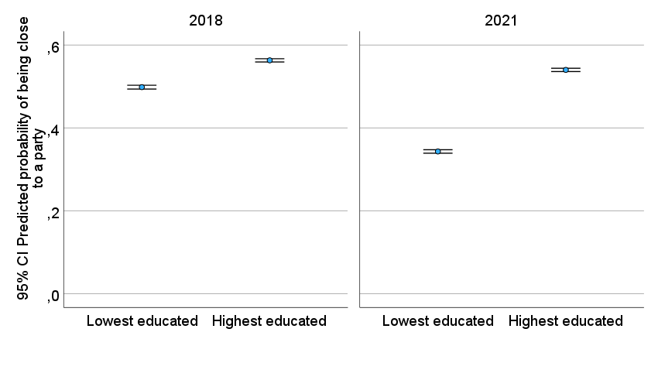

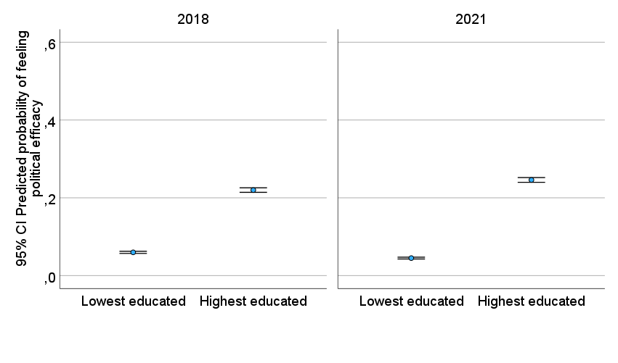

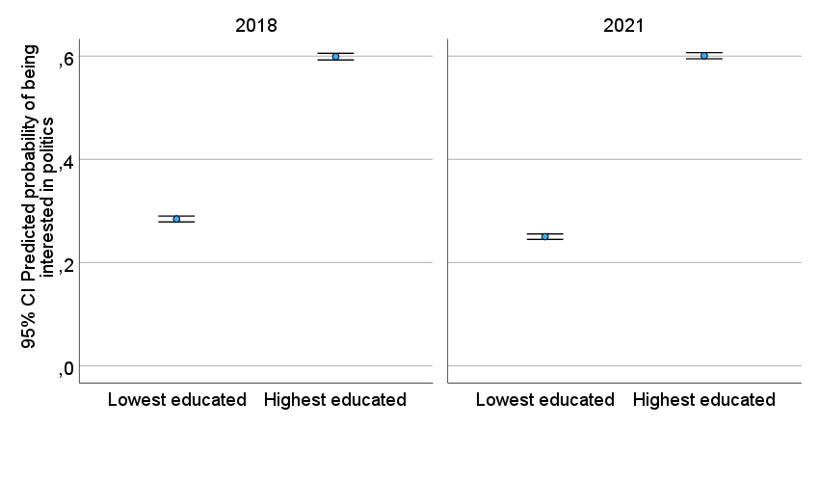

Note: The estimates are from Model 2 in Table A4.

Table A5. Regression models to explain political engagement by socioeconomic groups and by the pandemic health and economic impact (all countries in the sample), 2021
 | Party closeness |  |  |  | Political efficacy |  |  |  | political interest
 | Model 1 |  | Model 2 |  | Model 1 |  | Model 2 |  | Model 1 |  | Model 2
 | Exp(b) | b (sd) | Exp(b) | b (sd) | Exp(b) | b (sd) | Exp(b) | b (sd) | Exp(b) | b (sd) | Exp(b) | b (sd)
Income 1st quintile (=1) | 0,71 | -0,35*** (0,11) | 0,74 | -0,30* (0,12) | 0,92 | -0,09 (0,27) | 0,92 | -0,08 (0,24) | 0,64 | -0,44*** (0,05) | 0,69 | -0,38*** (0,08)
Income 5th quintile (=1) | 1,24 | 0,22* (0,10) | 1,29 | 0,26*** (0,07) | 1,78 | 0,58*** (0,13) | 1,76 | 0,57*** (0,16) | 1,43 | 0,36*** (0,06) | 1,60 | 0,47*** (0,12)
Low education level (=1) | 0,74 | -0,30*** (0,08) | 0,73 | -0,32* (0,11) | 0,53 | -0,63*** (0,12) | 0,49 | -0,70*** (0,15) | 0,41 | -0,89*** (0,10) | 0,40 | -0,92*** (0,11)
High education level (=1) | 1,43 | 0,35*** (0,10) | 1,39 | 0,33*** (0,10) | 3,05 | 1,11*** (0,10) | 2,76 | 1,02*** (0,16) | 2,27 | 0,82*** (0,07) | 2,41 | 0,88*** (0,07)
Had economic loss due to COVID-19 (=1) | 1,08 | 0,08 (0,12) | 1,33 | 0,29*** (0,08) | 0,73 | -0,31 (0,27) | 0,56 | -0,58 (0,47) | 1,02 | 0,02 (0,13) | 1,22 | 0,20# (0,10)
Had COVID-19 (=1) | 0,97 | -0,03 (0,04) | 0,86 | -0,15 (0,12) | 0,95 | -0,05 (0,17) | 0,86 | -0,15 (0,37) | 0,87 | -0,14** (0,05) | 0,89 | -0,12 (0,11)
Income 1st quintile * Had economic loss |  |  | 0,77 | -0,27 (0,20) |  |  | 1,10 | 0,10 (0,36) |  |  | 0,65 | -0,42# (0,24)
Income 1st quintile * Had COVID-19 |  |  | 0,97 | -0,04 (0,09) |  |  | 0,83 | -0,19 (0,60) |  |  | 1,04 | 0,04 (0,25)
Lower education * Had economic loss |  |  | 0,80 | -0,23 (0,17) |  |  | 1,07 | 0,07 (0,61) |  |  | 0,93 | -0,08 (0,11)
Lower education * Had COVID-19 |  |  | 1,25 | 0,22* (0,11) |  |  | 1,24 | 0,22 (0,50) |  |  | 1,23 | 0,21 (0,14)
Income 5th quintile * Had economic loss |  |  | 0,76 | -0,27 (0,23) |  |  | 1,00 | 0,00 (0,31) |  |  | 0,67 | -0,40# (0,24)
Income 5th quintile * Had COVID-19 |  |  | 0,99 | -0,01 (0,25) |  |  | 1,09 | 0,08 (0,27) |  |  | 0,84 | -0,18 (0,27)
Higher education * Had economic loss |  |  | 0,80 | -0,23 (0,16) |  |  | 1,77 | 0,57** (0,22) |  |  | 0,88 | -0,13 (0,15)
Higher education * Had COVID-19 |  |  | 1,28 | 0,24** (0,09) |  |  | 1,08 | 0,08 (0,39) |  |  | 0,88 | -0,14 (0,14)
Age | 1,02 | 0,02*** (0,00) | 1,02 | 0,02*** (0,00) | 0,99 | -0,02*** (0,00) | 0,99 | -0,01*** (0,00) | 1,02 | 0,02*** (0,00) | 1,02 | 0,02*** (0,00)
Gender (male=1) | 1,27 | 0,24*** (0,04) | 1,27 | 0,24*** (0,04) | 1,73 | 0,55*** (0,07) | 1,73 | 0,55*** (0,08) | 2,05 | 0,72*** (0,10) | 2,04 | 0,71*** (0,10)
Intercept | 0,36 | -1,03*** (0,20) | 0,35 | -1,05*** (0,19) | 0,16 | -1,85*** (0,41) | 0,17 | -1,79*** (0,36) | 0,28 | -1,28*** (0,25) | 0,26 | -1,33*** (0,25)
Akaike corrected | 27576,19 |  | 27596,27 |  | 34046,99 |  | 34074,12 |  | 29764,27 |  | 29810,26
Bayesian | 27582,93 |  | 27603,01 |  | 34053,68 |  | 34080,80 |  | 29771,04 |  | 29817,01
N | 6311 |  |  |  | 5904 |  |  |  | 6496
Number of countries | 17 |  |  |  | 17 |  |  |  | 17
Country fixed effect | Yes |  |  |  | Yes |  |  |  | Yes
Source: ESS, Round 10.
Notes: Generalized linear logistic regression models with dependent variables: 1 = close to a political party; 0 = close to no political party; 1 = feel political efficacy; 0 = does not feel political efficacy; and 1 = is interested in politics, 0 = is not interested in politics. Probability distribution: binomial. Link function: logit. Subject effect: country. # p ≤ 0.1; * p ≤ 0.05; **p ≤ 0.01; ***p ≤ 0.001

Figure A6. Predicted probabilities of political engagement by socioeconomic groups and pandemic effect

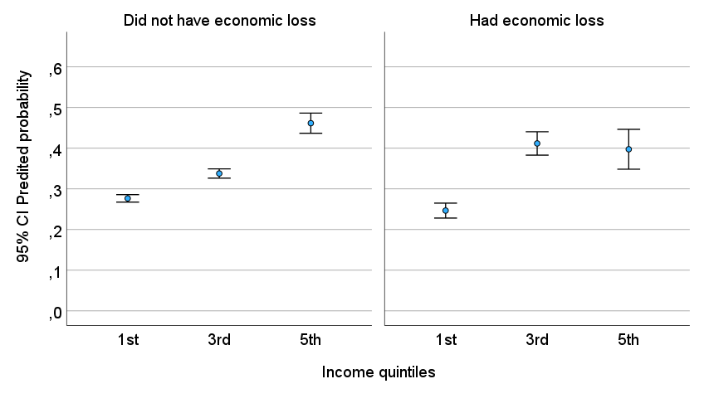

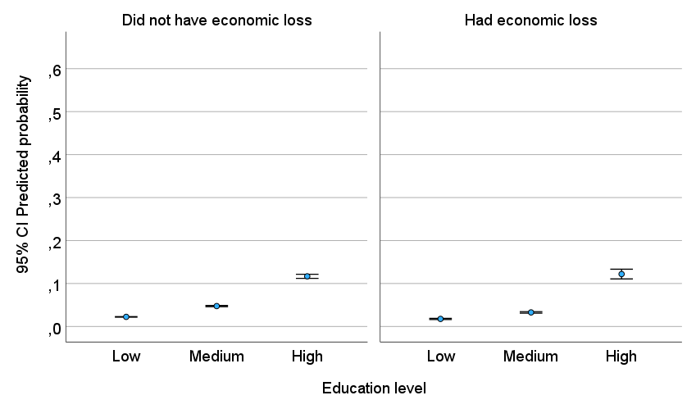

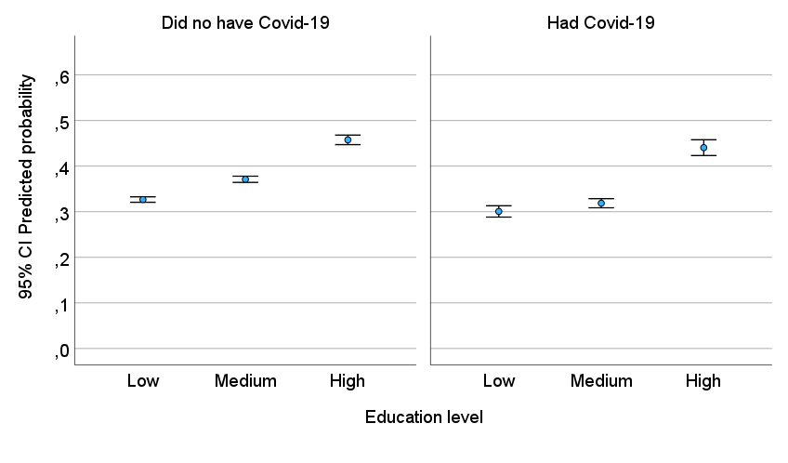

Note: The estimates are from Model 2 in Table A5.

Table A6. Regression models to explain political engagement by socioeconomic groups and by the pandemic health and economic impact (most unequal countries), 2021
 | Party closeness |  |  |  | Political efficacy |  | Political interest
 | Model 1 |  | Model 2 |  | Model 1 |  | Model 1 |  | Model 2
 | Exp(b) | b (sd) | Exp(b) | b (sd) | Exp(b) | b (sd) | Exp(b) | b (sd) | Exp(b) | b (sd)
Dummy income (third tercile=1) | 1,29 | 0,25* (0,12) | 1,35 | 0,30# (0,16) | 1,67 | 0,51 (0,36) | 1,24 | 0,21*** (0,05) | 1,14 | 0,13* (0,05)
Dummy education (highest level=1) | 2,31 | 0,84*** (0,07) | 1,95 | 0,67*** (0,03) | 12,76 | 2,55*** (0,46) | 6,62 | 1,89*** (0,06) | 6,49 | 1,87*** (0,13)
Had economic loss due to Covid-19 (=1) | 0,72 | -0,33* (0,16) | 0,81 | -0,21 (0,23) | 0,69 | -0,37 (0,38) | 0,71 | -0,34*** (0,10) | 0,81 | -0,21 (0,16)
Had Covid-19 (=1) | 1,27 | 0,24*** (0,04) | 1,00 | 0,00 (0,04) | 1,78 | 0,57# (0,31) | 1,36 | 0,31*** (0,07) | 1,10 | 0,10 (0,06)
Dummy income * Had economic loss |  |  | 0,91 | -0,10 (0,14) |  |  |  |  | 0,81 | -0,21*** (0,05)
Dummy income * Had Covid-19 |  |  | 0,82 | -0,20 (0,16) |  |  |  |  | 1,51 | 0,41*** (0,11)
Dummy education * Had economic loss |  |  | 0,81 | -0,21 (0,21) |  |  |  |  | 0,86 | -0,15 (0,09)
Dummy education * Had Covid-19 |  |  | 2,23 | 0,80*** (0,17) |  |  |  |  | 1,17 | 0,16 (0,30)
Age | 1,02 | 0,02*** (0,00) | 1,02 | 0,02*** (0,00) | 1,01 | 0,01 (0,01) | 1,01 | 0,01*** (0,00) | 1,01 | 0,01*** (0,00)
Gender (male=1) | 1,75 | 0,56*** (0,07) | 1,74 | 0,55*** (0,08) | 1,81 | 0,59*** (0,12) | 1,78 | 0,58*** (0,16) | 1,80 | 0,59*** (0,17)
Intercept | 0,13 | -2,02*** (0,48) | 0,14 | -1,97*** (0,48) | 0,01 | -4,98*** (0,64) | 0,07 | -2,69*** (0,38) | 0,07 | -2,65*** (0,33)
Akaike corrected | 6024,66 |  | 6029,94 |  | 9174,96 |  | 6632,40 |  | 6631,46
Bayesian | 6029,85 |  | 6035,13 |  | 9180,14 |  | 6637,63 |  | 6636,68
N | 1339 |  |  |  | 1316 |  | 1392
Number of countries | 6 |  |  |  | 6 |  | 6
Country fixed effect | Yes |  |  |  | Yes |  | Yes
Source: ESS, Round 10.
Notes: Generalized linear logistic regression models with dependent variables: 1 = close to a political party; 0 = close to no political party; 1 = feel political efficacy; 0 = does not feel political efficacy; and 1 = is interested in politics, 0 = is not interested in politics. Probability distribution: binomial. Link function: logit. Subject effect: country. * p ≤ 0.05; **p ≤ 0.01; ***p ≤ 0.00

Figure A7. Predicted probabilities of being close to a party by socioeconomic groups and pandemic effect

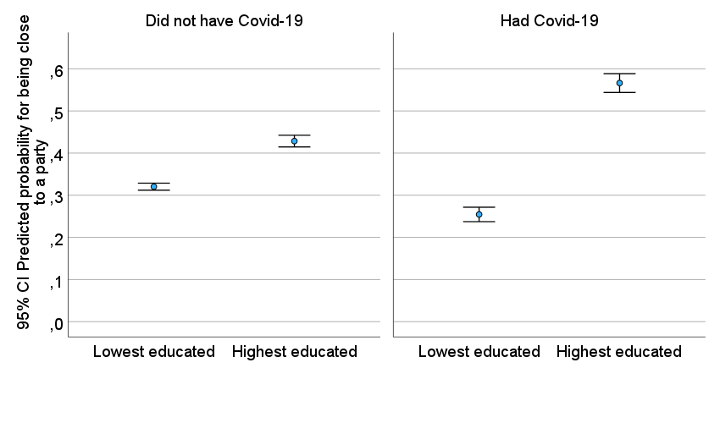
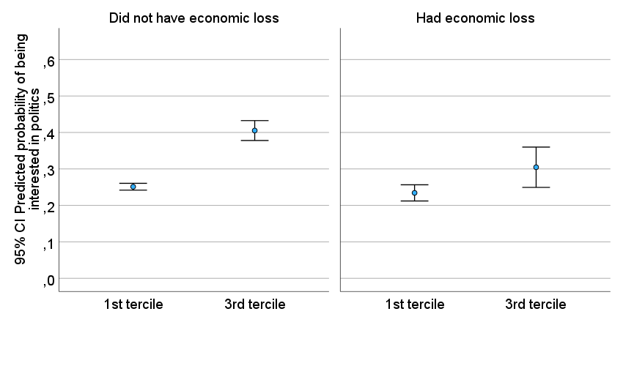

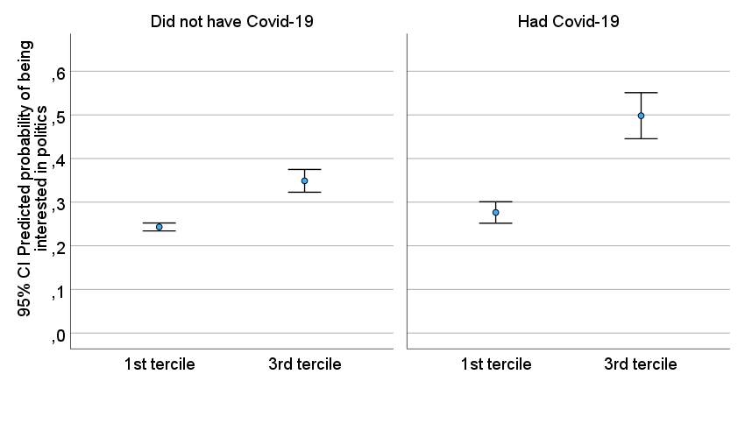

Note: The estimates are from Model 2 in Table A6.

Table A7. Regression models to explain political efficacy (continuous scale) by socioeconomic groups and the pandemic year (2018 and 2021)
 | Model 1 |  | Model 2
 | b | sd | b | sd
Intercept | 8,56*** | 0,06 | 8,524*** | 0,07
Income 1st quintile (=1) | -0,30*** | 0,08 | -0,30*** | 0,05
Income 5th quintile (=1) | 0,81*** | 0,15 | 1,05*** | 0,00
Low education level (=1) | -0,72*** | 0,10 | -0,72*** | 0,01
High education level (=1) | 1,59*** | 0,08 | 1,52*** | 0,00
Dummy year (2021=1) | 0,40 | 0,35 | 0,47 | 0,38
Dummy year * Income 1st quintile |  |  | 0,03 | 0,19
Dummy year * Income 5th quintile |  |  | -0,50*** | 0,05
Dummy year * Low education |  |  | 0,02 | 0,19
Dummy year * High education |  |  | 0,13 | 0,13
Age | -0,02*** | 0,00 | -0,02*** | 0,00
Gender (male=1) | 0,68*** | 0,04 | 0,69*** | 0,03
Akaike corrected | 105291,69 |  | 105273,65
Bayesian | 105307,70 |  | 105289,66
N | 22159
Number of countries | 17 |  | 17
Country fixed effect | Yes |  | Yes
Source: ESS, Round 9 and 10.
Notes: Generalized linear regression models with political efficacy measured as: 4 = lowest level of political efficacy20 = highest level of political efficacy. Probability distribution: normal. Link function: identity. Subject effect: country. # p ≤ 0.1; * p ≤ 0.05; **p ≤ 0.01; ***p ≤ 0.001.

Table A8. Regression models to explain political interest (ordinal scale) by socioeconomic groups and the pandemic year (2018 and 2021)
 | Model 1 |  |  |  |  |  | Model 2
 | Very interested |  | Quite interested |  | Hardly interested |  | Very interested |  | Quite interested |  | Hardly interested
 | Exp(b) | b (sd) | Exp(b) | b (sd) | Exp(b) | b (sd) | Exp(b) | b (sd) | Exp(b) | b (sd) | Exp(b) | b (sd)
Intercept | 0,14 | -1,99***  (0,61) | 0,84 | -0,18  (0,31) | 2,01 | 0,70***  (0,08) | 0,15 | -1,90***  (0,56) | 0,78 | -0,25  (0,35) | 1,92 | 0,65***  (0,11)
Income 1st quintile (=1) | 0,54 | -0,61***  (0,08) | 0,63 | -0,47***  (0,11) | 0,66 | -0,41***  (0,03) | 0,53 | -0,64***  (0,03) | 0,71 | -0,34***  (0,02) | 0,69 | -0,37***  (0,01)
Income 5th quintile (=1) | 1,12 | 0,11  (0,40) | 0,94 | -0,06  (0,35) | 0,99 | -0,01  (0,20) | 0,65 | -0,42***  (0,02) | 0,60 | -0,52***  (0,01) | 0,80 | -0,22***  (0,01)
Low education level (=1) | 0,58 | -0,54#  (0,33) | 0,68 | -0,39  (0,32) | 0,72 | -0,33**  (0,12) | 0,88 | -0,12#  (0,07) | 1,07 | 0,06  (0,05) | 0,89 | -0,12***  (0,01)
High education level (=1) | 2,80 | 1,03***  (0,37) | 1,90 | 0,64***  (0,22) | 1,25 | 0,23#  (0,14) | 1,51 | 0,41***  (0,03) | 1,44 | 0,37***  (0,02) | 1,09 | 0,09***  (0,01)
Dummy year (2021=1) | 1,43 | 0,36  (0,31) | 1,42 | 0,35  (0,25) | 1,21 | 0,19  (0,17) | 1,14 | 0,13  (0,29) | 1,50 | 0,41#  (0,23) | 1,23 | 0,20  (0,14)
Dummy year * Income 1st quintile |  |  |  |  |  |  | 1,04 | 0,04  (0,14) | 0,73 | -0,31**  (0,13) | 0,92 | -0,08#  (0,05)
Dummy year * Income 5th quintile |  |  |  |  |  |  | 3,56 | 1,27***  (0,14) | 3,31 | 1,20***  (0,04) | 1,94 | 0,66***  (0,08)
Dummy year * Low education |  |  |  |  |  |  | 0,40 | -0,93***  (0,27) | 0,38 | -0,98***  (0,14) | 0,66 | -0,41***  (0,04)
Dummy year * High education |  |  |  |  |  |  | 3,57 | 1,27***  (0,09) | 2,11 | 0,75***  (0,09) | 1,61 | 0,47***  (0,10)
Age | 1,02 | 0,02*  (0,01) | 1,01 | 0,01  (0,01) | 1,00 | 0,00  (0,00) | 1,02 | 0,02*  (0,01) | 1,01 | 0,01  (0,01) | 1,00 | 0,00  (0,00)
Gender (male=1) | 1,66 | 0,51  (0,34) | 1,35 | 0,30  (0,22) | 1,00 | 0,00  (0,14) | 1,67 | 0,51  (0,35) | 1,35 | 0,30  (0,23) | 1,00 | 0,00  (0,14)
Akaike corrected | 256179,76 |  |  |  |  |  | 258179,39
Bayesian | 256203,89 |  |  |  |  |  | 258203,51
N | 22966 |  |  |  |  |  | 22966
Number of countries | 17 |  |  |  |  |  | 17
Country fixed effect | Yes |  |  |  |  |  | Yes
Source: ESS, Round 9 and 10.
Notes: Generalized linear multilevel logistic regression models with political interest measured as: 1 = not at all interested; 2 = hardly interested; 3 = quite interested; 4 = very interested. Probability distribution: multinomial. Link function: generalized logit. Subject effect: country. # p ≤ 0.1; * p ≤ 0.05; **p ≤ 0.01; ***p ≤ 0.001.

Table A9. Regression models to explain political efficacy (continuous scale) by socioeconomic groups and the pandemic health and economic impact (most unequal countries), 2021
 | Model 1 |  | Model 2
 | b | sd | b | sd
Income 1st quintile (=1) | -0,52*** | 0,04 | -0,63*** | 0,05
Income 5th quintile (=1) | 0,62*** | 0,05 | 0,59*** | 0,02
Low education level (=1) | -1,07*** | 0,02 | -1,14*** | 0,02
High education level (=1) | 1,41*** | 0,20 | 1,28*** | 0,22
Had economic loss due to COVID-19 (=1) | -0,37*** | 0,08 | -0,46*** | 0,08
Had COVID-19 (=1) | -0,27*** | 0,04 | -0,50*** | 0,14
Income 1st quintile * Had economic loss |  |  | 0,36# | 0,20
Income 1st quintile * Had COVID-19 |  |  | 0,29*** | 0,09
Lower education * Had economic loss |  |  | -0,08 | 0,12
Lower education * Had COVID-19 |  |  | 0,29 | 0,22
Income 5th quintile * Had economic loss |  |  | -0,33*** | 0,04
Income 5th quintile * Had COVID-19 |  |  | 0,31*** | 0,08
Higher education * Had economic loss |  |  | 0,44# | 0,23
Higher education * Had COVID-19 |  |  | 0,22** | 0,08
Age | -0,01*** | 0,00 | -0,01*** | 0,00
Gender (male=1) | 0,83*** | 0,02 | 0,83*** | 0,02
Intercept | 8,03*** | 0,39 | 8,09*** | 0,39
Akaike corrected | 16658,79 |  | 16655,30
Bayesian | 16671,18 |  | 16667,68
N | 3628
Number of countries | 6 |  | 6
Country fixed effect | Yes |  | Yes
Source: ESS, Round 10.
Notes: Generalized linear regression models with political efficacy measured as: 4 = lowest level of political efficacy20 = highest level of political efficacy. Probability distribution: normal. Link function: identity. Subject effect: country. # p ≤ 0.1; * p ≤ 0.05; **p ≤ 0.01; ***p ≤ 0.001.

Table A10. Regression models to explain political interest (ordinal scale) by socioeconomic groups and the pandemic health and economic impact (most unequal countries), 2021
 | Model 1 |  |  |  |  |  | Model 2
 | Very interested |  | Quite interested |  | Hardly interested |  | Very interested |  | Quite interested |  | Hardly interested
 | Exp(b) | b (sd) | Exp(b) | b (sd) | Exp(b) | b (sd) | Exp(b) | b (sd) | Exp(b) | b (sd) | Exp(b) | b (sd)
Intercept | 0,06 | -2,76***  (0,63) | 0,50 | -0,68***  (0,15) | 1,13 | 0,13  (0,08) | 0,07 | -2,60***  (0,60) | 0,52 | -0,66***  (0,14) | 1,20 | 0,18#  (0,10)
Income 1st quintile (=1) | 0,67 | -0,40  (0,30) | 0,50 | -0,70***  (0,08) | 0,69 | -0,37***  (0,03) | 0,42 | -0,87***  (0,15) | 0,56 | -0,59***  (0,11) | 0,68 | -0,38***  (0,04)
Income 5th quintile (=1) | 1,52 | 0,42***  (0,05) | 1,90 | 0,64***  (0,03) | 1,38 | 0,32***  (0,02) | 1,82 | 0,60***  (0,02) | 1,57 | 0,45***  (0,03) | 1,55 | 0,44***  (0,02)
Low education level (=1) | 0,13 | -2,01***  (0,08) | 0,27 | -1,32***  (0,09) | 0,56 | -0,58***  (0,05) | 0,15 | -1,92***  (0,07) | 0,22 | -1,50***  (0,10) | 0,48 | -0,73***  (0,06)
High education level (=1) | 7,39 | 2,00***  (0,12) | 3,20 | 1,16***  (0,10) | 2,24 | 0,81***  (0,14) | 7,45 | 2,01***  (0,09) | 4,34 | 1,47***  (0,12) | 2,73 | 1,00***  (0,04)
Had economic loss due to COVID-19 (=1) | 1,15 | 0,14  (0,16) | 1,33 | 0,29*  (0,12) | 1,28 | 0,25***  (0,04) | 0,57 | -0,56***  (0,01) | 1,30 | 0,27***  (0,03) | 0,90 | -0,11  (0,13)
Had COVID-19 (=1) | 0,65 | -0,43***  (0,11) | 0,91 | -0,10***  (0,01) | 0,90 | -0,10**  (0,03) | 0,53 | -0,63***  (0,13) | 0,71 | -0,34***  (0,08) | 0,88 | -0,13  (0,12)
Income 1st quintile * Had economic loss |  |  |  |  |  |  | 3,58 | 1,27#  (0,68) | 0,34 | -1,07***  (0,27) | 1,22 | 0,20  (0,14)
Income 1st quintile * Had COVID-19 |  |  |  |  |  |  | 3,79 | 1,33**  (0,42) | 1,25 | 0,22  (0,16) | 0,87 | -0,14*  (0,06)
Lower education * Had economic loss |  |  |  |  |  |  | 0,72 | -0,33  (0,91) | 1,40 | 0,34***  (0,06) | 1,89 | 0,64***  (0,15)
Lower education * Had COVID-19 |  |  |  |  |  |  | 0,19 | -1,66#  (0,95) | 1,79 | 0,58***  (0,07) | 1,20 | 0,19  (0,12)
Income 5th quintile * Had economic loss |  |  |  |  |  |  | 1,52 | 0,42***  (0,03) | 3,84 | 1,35***  (0,02) | 3,15 | 1,15***  (0,07)
Income 5th quintile * Had COVID-19 |  |  |  |  |  |  | 0,51 | -0,66***  (0,10) | 1,14 | 0,13***  (0,01) | 0,49 | -0,71***  (0,03)
Higher education * Had economic loss |  |  |  |  |  |  | 1,42 | 0,35***  (0,04) | 0,43 | -0,85***  (0,20) | 0,70 | -0,36  (0,26)
Higher education * Had COVID-19 |  |  |  |  |  |  | 0,95 | -0,05  (0,20) | 0,67 | -0,40*  (0,20) | 0,70 | -0,36  (0,38)
Age | 1,02 | 0,02***  (0,01) | 1,01 | 0,01***  (0,00) | 1,00 | 0,00  (0,00) | 1,02 | 0,02***  (0,01) | 1,01 | 0,01***  (0,00) | 1,00 | 0,00  (0,00)
Gender (male=1) | 3,67 | 1,30***  (0,03) | 3,23 | 1,17***  (0,13) | 1,78 | 0,58***  (0,06) | 3,73 | 1,32***  (0,02) | 3,26 | 1,18***  (0,12) | 1,78 | 0,58***  (0,06)
Akaike corrected | 45450,96 |  |  |  |  |  | 46200,54
Bayesian | 45496,62 |  |  |  |  |  | 46219,19
N | 3758 |  |  |  |  |  | 3758
Number of countries | 6 |  |  |  |  |  | 6
Country fixed effect | Yes |  |  |  |  |  | Yes
Source: ESS, Round 9 and 10.
Notes: Generalized linear multilevel logistic regression models with political interest measured as: 1 = not at all interested; 2 = hardly interested; 3 = quite interested; 4 = very interested. Probability distribution: multinomial. Link function: generalized logit. Subject effect: country. # p ≤ 0.1; * p ≤ 0.05; **p ≤ 0.01; ***p ≤ 0.001.

