The record of coal exploration in the Ordovician-Silurian in the Southern Uplands of Scotland and Ireland

Parnell, J., Armstrong, J.G.T., Lings, A.

Supplementary Information
Transcripts
Localities for evidence for coal
Supplementary References

Transcript of Fig. 3.
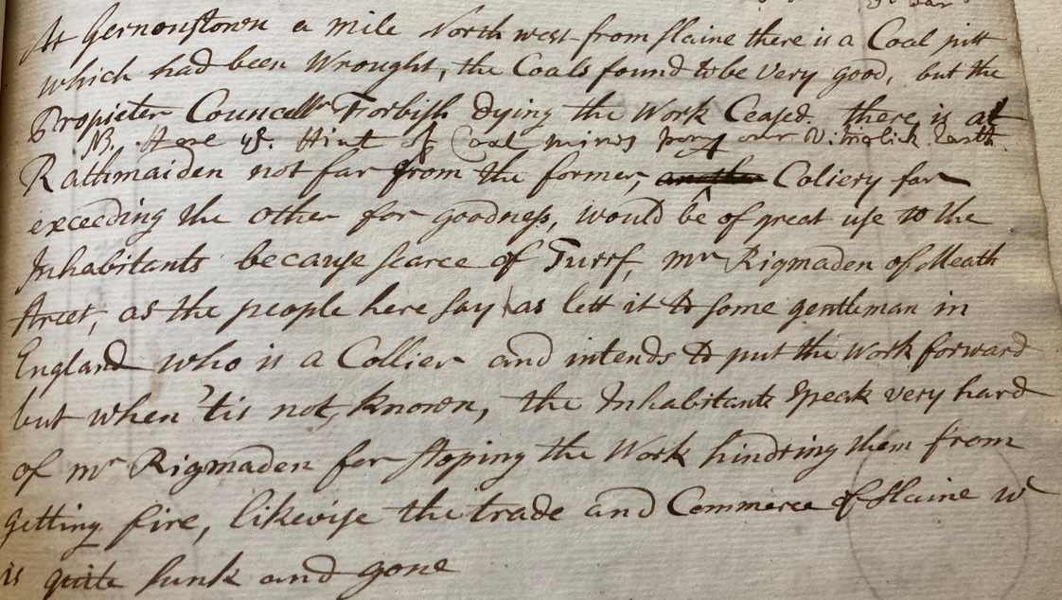
At Gernonstown a mile north west from Slaine there is a coal pit which had been wrought, the coals found to be very good, but the proprietor Councillor Frorbish dying the work ceased. There is at Rathmaiden not far from the former, a colliery far exceeding the other for goodness, would be of great use to the inhabitants because scarce of turf, Mr. Rigmaden of Meath Street, as the people here say has let it to some gentleman in England who is a collier and intends to put the work forward but when tis not known, the inhabitants speak very hard of Mr. Rigmaden for stopping the work hindering them from getting fire, likewise the trade and commerce of Slaine which is quite sunk and gone.

Transcript of Fig. 5.
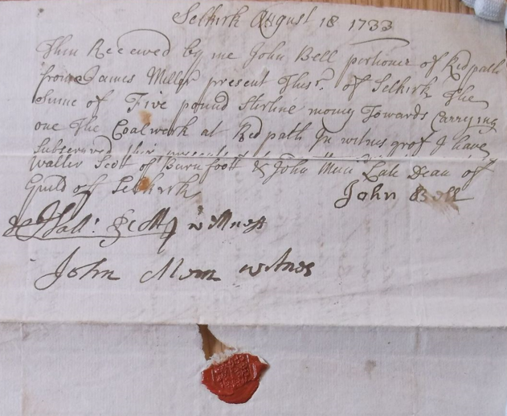
Selkirk August 18 1733
This received by me John Bell portioner of Redpath from James Miller present this P. of Selkirk the sum of five pound sterling money towards carrying on the coalwork at Redpath. In witness of I have subserved the present date and written before these witnesses Walter Scott of Burnfoot and John Moon late Dean of Guild Selkirk.
John Bell
Walter Scott witness
John Moon witness

Table S1. Localities for evidence for coal in Ordovician-Silurian, Southern Uplands-Down-Longford Terrane
Locality | Map code | Grid Reference | Description | Reference
Ireland
Glasleck, Shercock, Co. Cavan | GL | H 7204 | ‘Strong vein of blind coal’  Very sulphurous.  Worked as fuel in bad winters. | Coote 1802,  Walford 1818,  Long 1833,  Kinahan 1889
Ballyjamesduff, Co. Cavan | BJ | N 5290 | Alderman Bevan sank shaft. ‘Vein (blind coal) of very good quality’ | Coote 1802, Long 1833
Castlerahan, Co. Cavan | CR | N 5387 | Shaft near lake sunk some few years pre-1837 | Lewis 1837
Kilnaleck, Co. Cavan | KL | N 430905 | Several shafts,  Some fuel produced | Whitty 1854, 1855  Symonds 1858
Ballylane Lough, Co. Armagh | BL | H 9634 | Trials for coal | Egan 1877
Enagh Lough, Co. Armagh | EL | J 0332 | Trials for coal | Egan 1877
Lissummon, Co. Armagh | LS | J 0433 | 2 small shafts sunk. Tradition of burnable coal. | Egan 1877
Drumlack, Co. Armagh | DL | H 9541 | Thin seam of excellent coal | Lewis 1837
Coulter’s Bridge, Co. Armagh | CO | H 9519 | Pit opened | Egan 1877
Drumcrow, Co. Armagh | DW | H 9832 | Slight search | Egan 1877
Lislea Cottage, Co. Armagh | LL | H 8034 | Pit yielded coal adequate for blacksmith | Egan 1877
Scarva, Co. Down | SV | J 0743 | Inhabitants report coal; 1799 trial intended.  Coal Mine on estate 1842 | Stewart 1799,  Dublin Evening Packet 1842
Coalpit Bay, Co. Down | CB | J 594788 | Eponymous | Hull et al. 1871
Donaghadee, Co. Down. | DD | J 5879 | ‘Colliery near Donaghadee’ assumed by Woods to be mistaken | Woods 1985 reporting on Pococke 1760
Kirkistown, Co. Down | KK | J 6457 | Coal found, new trial intended | Stewart 1799
Killough, Co. Down | KH | J 5336 | Shaft sunk in search of coal | Smith & Harris 1744
Gilford, Co. Down | GF | J 0648 | Several attempts to find productive coal | Lewis 1837
Hillsborough, Co. Down | HB | J 2458 | Marquis of Downshire opening coal mine | Tralee Chronicle 1850
The Temple, Co. Down | TP | J 3561 | Application to develop coal discovery | Northern Whig 1901
Lawrencetown, Co. Down | LT | J 0849 | Coal shafts (on 1837-42 6-inch map) | Egan 1872
Donaghcloney Bridge, Co. Down | DC | J 1353 | Shaft sunk for coal by Lord Downshire, 109ft depth | Egan 1872
Slane Coalpits, Co. Meath | SC | N 974762 | Mining directed by Lord Cunningham pre-1802.  Coal works ~30 years pre-1837. | Pococke 1752, Thompson 1802  Lewis 1837
Rathmaiden, Co. Meath | RM | N 9677 | Colliery seeking investment | House of Commons 1763
Lurgankeel, Co. Louth | LK | J 0212 | Shaft sunk for coal | Newry Telegraph 1872, Iron and Coal Trades Review 1918
Scotland
Borrow Head, Wigtownshire | BH | NX 4534 | Trials | New Statistical Account of Scotland 1845
Coalpit Burn, Rivox Fell, Dumfriesshire | RF | NT 0005 | Two shafts sunk ‘of considerable depth’ | Harkness 1851,  Ordnance Survey 2009
Breckonside, Dumfriesshire | BK | NT 1102 | Shaft in search of coal | Taylor 1791
Glenkiln, Dumfriesshire | GK | NY 007895 | Deep shaft in search of coal | Lapworth 1878
Kirkmichael (Auchenbraith?), Dumfriesshire | KM | NY 0187  (NX 9991) | Trials | Jameson 1805
Larghill, Dumfriesshire | LH | NX 817745 | Horizontal shaft | Harkness 1851
Coal Hole, Dumfriesshire | CH | NX 729990 | Eponymous | Harkness 1851, Ordnance Survey 2009
Lindean, Selkirkshire | LD | NT 4931 | Bored for coal | Lapworth 1872
Cauldshiels, Selkirkshire-Roxburghshire | CS | NT 515323 | Bored for coal.  Possibly same or contiguous to Bowdenmoor | Lapworth 1870, 1872
Maxton, Roxburghshire | MX | NT 6030 | Coal sought through thin ORS cover | Milne 1843, Jedburgh Gazette 1912
Milsington, Roxburghshire | MS | NT 4012 | Report of mine in early Travelogue. No corroboration. | Lowther et al. 1894
Redpath, Berwickshire | RP | NT 5836 | Receipt for coal exploration | Bell 1733
Cadon Bank,  Peeblesshire | CD | NT 3435 | Mining operation by Earl of Traquair, bed ~8 cm thick | Jameson 1840, Nicol 1850
Windylawsburnfoot, Peeblesshire | WB | NT 2444 | Digging of pit, supported by council in 1759 | Chambers 1864, Buchan 1925
Kilbucho, Peeblesshire | KB | NT 0835 | Exploration for coal | Statistical Account of Scotland 1792

Supplementary References
Bell, J. 1733. Receipt John Bell to James Miller (coalwork at Redpath). WM/7/313, Scottish Borders Archive and Local History Service. https://www.calmview.eu/HUBCAT/CalmView/Record.aspx?src=CalmView.Catalog&id=WM%2f7%2f313&pos=1
Buchan, J.W. 1925. A History of Peeblesshire, vol. II. Jackson, Wylie & Co., Glasgow.
Chambers, W. 1864. A History of Peeblesshire. W. & R. Chambers, Edinburgh.
Coote, C. 1802. Statistical Survey of the County of Cavan, with Observations on the Means of Improvement. The Dublin Society, Dublin.
Dublin Evening Packet 1842. County of Armagh (property sale). Dublin Evening Packet and Correspondent, 26 February 1842, Dublin.
Egan, F.W. 1872. Explanatory Memoir to accompany Sheet 48 of the maps of the Geological Survey of Ireland, illustrating parts of the Counties of Down and Armagh. Dublin, Her Majesty’s Stationery Office.
Egan, F.W. 1877. Explanatory Memoir to accompany Sheet 59 of the maps of the Geological Survey of Ireland, illustrating the Districts of Newtown Hamilton, Keady, and Castleblaney. Dublin, Her Majesty’s Stationery Office.
Geikie, A., Horne, J., Skae, H.M. & Etheridge, R. 1877. Explanation of sheet 9: Kirkcudbright (north-east part) and Dumfriesshire (south-west part). Memoir of the Geological Survey of Great Britain (Scotland). Her Majesty’s Stationery Office, Edinburgh.
Harkness, R. 1851. On the Silurian rocks of Dumfriesshire and Kirkcudbrightshire. Quarterly Journal of the Geological Society of London, 7, 46-58.
Horne, J., Peach, B. N. & Teall, J. J. H. 1896. Explanation of sheet 5: Kirkcudbrightshire. Memoir of the Geological Survey of Great Britain (Scotland). Her Majesty’s Stationery Office, Edinburgh.
House of Commons 1763. Journal of the House of Commons of the Kingdom of Ireland, 7, From the Thirteenth to the Twentythird year of King George the Second, viz. 1739-1749, Dublin. Transcripts 2 November and 12 November 1747.
Hull, E. & Cruise, R.J. 1871. Explanatory Memoir to accompany sheets 91 and 92 of the maps of the Geological Survey of Ireland, illustrating parts of the counties of Meath, Louth, and Dublin. Her Majesty’s Stationery Office, Dublin.
Hull, E., Warren, J.L. & Leonard, W.B. 1871. The country around Bangor, Newtownards, Comber and Saintfield in the County of Down. Memoir of the Geological Survey of Ireland. Her Majesty’s Stationery Office, London.
Iron and Coal Trades Review 1918. Ireland. The Iron and Coal Trades Review, 97, July 5, 1918, p. 22. London.
Jameson, R. 1805. A Mineralogical Description of the County of Dumfries. Bell & Bradfute, W. Blackwood, Edinburgh.
Jameson, R. 1840. Fossil organic remains in transition-rocks in the great Southern High Land of Scotland. Edinburgh New Philosophical Journal, 28, 198-199.
Jedburgh Gazette 1912. Boring for coal near Maxton. Jedburgh Gazette, April 12, 1912. Jedburgh.
Kinahan, G.H. 1889. Economic Geology of Ireland. Journal of the Royal Geological Society of Ireland, 18, 1-514.
Lapworth, C. 1870. On the Lower Silurian rocks of Galashiels, part 1. Geological Magazine, 7, 204-209.
Lapworth, C. 1872. On the Lower Silurian rocks in the neighbourhood of Galashiels. Transactions of the Edinburgh Geological Society, 2, 46-58.
Lapworth, C. 1878. The Moffat Series. Quarterly Journal of the Geological Society of London, 34, 240-346.
Lewis, S. 1837. A Topographical Dictionary of Ireland Comprising the Several Counties; Cities; Boroughs; Corporate, Market and Post Towns; Parishes; and Villages, with Historical and Statistical Descriptions Embellished with Engravings of the Arms of the Cities, Bishopricks, Corporate Towns, and Boroughs ; and of the Seals of the Several Municipal Corporations, With an appendix describing the electoral boundaries of the several bouroughs as defined by the act of the 2d. and 3d. of William IV. S. Lewis, London.
Long, G. (ed) 1833. The Penny Cyclopaedia of the Society for the Diffusion of Useful Knowledge. Volume 6. Charles Knight, London.
Lowther, C., Fallow, R. & Mauson, P. 1894. Our Journal into Scotland: Anno Domini 1629, 5th of November, from Lowther. Edinburgh, David Douglas.
Milne, D. 1843. Geological account of Roxburghshire. Transactions of the Royal Society of Edinburgh, 15, 433-502.
Morris, J.H., Somerville, I.D. & MacDermot, C.V. 2003. A Geological Description of Roscommon, Longford, Westmeath, and adjoining parts of Cavan, Leitrim and Galway, to accompany the Bedrock Geology 1:100,000 Scale Map Series, Sheet 12, Longford-Roscommon. Geological Survey of Ireland, Dublin.
Newry Telegraph 1872. Prospecting for coal in County Louth. Newry Telegraph, 8 October 1872, Newry.
New Statistical Account of Scotland 1845. Volume IV. Dumfries-Kirkcudbright-Wigton. William Blackwood and Sons, Edinburgh.
Nicol, J. 1850. Observations on the Silurian strata of the south-east of Scotland. Quarterly Journal of the Geological Society of London, 6, 53-65.
Northern Whig 1901. Ireland’s mineral resources. Northern Whig, 15 February 1901, Belfast.
Ordnance Survey 2009. Ordnance Survey Name Books: Kirkcudbrightshire OS Name Books, 1848-1851. https://scotlandsplaces.gov.uk/digital-volumes/ordnance-survey-name-books/kirkcudbrightshire-os-name-books-1848-1851.
Pococke, R. 1752. Pococke's Tour in Ireland in 1752. Stokes, G.T. (ed). Hodges, Figgis, and Co.; Simpkin, Marshall, Hamilton, Kent, and Co., Dublin and London (1891).
Smith, C. & Harris, W. 1744. The Antient and Present State of the County of Down. Edward Exshaw, Dublin.
Statistical Account of Scotland 1792. Statistical Account of Scotland, Drawn Up from the Communications of the Ministers of the Different Parishes, Volume 4. William Creech, Edinburgh.
Stewart, D. 1799. The report of Donald Stewart, Itinerant Mineralogist to the Dublin Society. Transactions of the Dublin Society, 1, 142pp. (Printed 1800)
Symonds, W.S. 1858. Notes of a geologist in Ireland during August and September 1857. The Geologist, 5, 312-313.
Taylor, J. 1791. Letter from James Taylor to the Earl of Hopetoun and Samuel Laing. DGNHAS Miscellany GGD805.
Thompson, R. 1802. Statistical Survey of the County of Meath, With Observations on the Means of Improvement. The Dublin Society, Dublin.
Tralee Chronicle 1850. Coal mines – County Down. Tralee Chronicle and Killarney Echo, 11 May 1850, Tralee.
Walford, T. 1818. The Scientific Tourist Through Ireland, in which the Traveller is Directed to the Principal Objects of Antiquity, Art, Science & the Picturesque, by an Irish Gentleman. London, John Booth.
Whitty, J.I. 1854. Notice of the anthracite found in the Silurian rocks, in the County of Cavan. Journal of the Geological Society of Dublin, 6, 187-195.
Whitty, J.I. 1855. On the Silurian anthracite of Cavan. Report of the Twenty-Fourth Meeting of the British Association for the Advancement of Science, held at Liverpool in September 1854, 95-96. London, John Murray.
Woods, C.J. 1985. Pococke’s Journey Through County Down in 1760. Ulster Journal of Archaeology, 48, 113-115.

