**Supplemental Information—Table of Contents**

**1. Appendix A:** Survey Instrument

**2. Appendix B:** Summary Statistics

**3. Appendix C:** Preregistration

**4. Appendix D:** Interaction Effects for US Army Chaplains

**5. Appendix E:** Robustness Checks for US Army Chaplains

**6. Appendix F:** Logit Regression Models

**Appendix A: Survey Instrument**

**1. Informed consent script:**

**What the study is about:**

The purpose of this research is to better understand perceptions toward conflict.

**What the survey will ask you to do:**

We will first ask you a series of background questions. These will include questions about your age, gender, race, income, and education. At no point will you be asked any question which could personally identify you. Thus, we assure you that your responses will be anonymous and confidential. After these, we will ask you for brief responses to questions related to conflict. We estimate that this survey will take you about 7-10 minutes to complete.

**Risks and discomforts:**

We do not anticipate any risks from participating in this research.

**Benefits:**

There are no direct benefits to participating in the survey. Participants may gain some indirect benefits from greater engagement with important political and societal issues. Information from this study may benefit other people now or in the future by helping us better understand what and how people think about important policy and defense issues.

**Privacy, confidentiality, and data security:**

All survey data is collected through an anonymous link from the survey research firm Qualtrics. No identifying information, including IP address or physical location, will be collected.We anticipate that your participation in this survey presents no greater risk than everyday use of the Internet.

**Sharing de-identified data collected in this research:**

De-identified data from this study may be shared with the research community at large to advance science and health. To protect your privacy, we do not collect any personal information that could identify you. This is done to ensure that, by current scientific standards and known methods, no one will be able to identify you from the information we share.

**Taking part is voluntary:**

Your participation in this research is voluntary. You have the right to withdraw at any point during the study, for any reason and the data you have submitted to that point will be destroyed and not stored for use.

**If you have questions:**

The main researchers conducting this study are Dr. Paul Lushenko at the US Army War College and Dr. Keith Carter at the US Naval War College. You are encouraged to ask the researcher questions at any time about the nature of the study and the methods that are being used. You may contact them at paul.lushenko.mil@armywarcollege.edu.

**Please indicate below that you agree to participate in this survey (consent):**

* I agree to participate
* I do not agree to participate

**2. Demographic variables:**

1. What is your sex?

* Male
* Female
* Other

1. How old are you?

* Under 18
* 19-25
* 26-35
* 36-45
* 46-55
* 56-65
* Over 65

1. What racial or ethnic group best describes you?

* American Indian and Alaskan Native
* Asian
* Black
* Hispanic
* Native Hawaiian and Other Pacific Islander
* White, Non-Hispanic
* Other

1. What is the highest level of education that you have completed?

* Some high school
* High school (diploma or GED)
* Some college, but no degree
* 2-year college degree
* 4-year college degree
* Advanced or professional degree (MA, MBA, MD, JD, PhD, etc.)

**3. Experiment:**

*Programming Note: General prompt provided to all respondents.*

Since the terrorist attacks of September 11, 2001, the US has used unmanned aerial systems, or drones, to conduct military operations abroad.

In the following section, you’ll be presented with **hypothetical** scenarios about drones and asked about your thoughts.

a. Do you agree to read the details very carefully and then give your most thoughtful answers?

* Yes
* No

*Programming Note: Treatment scenarios are randomized.*

**Scenario #1 Treatment (Near Certainty, Undeclared Theater)**: “Since the terrorist attacks of 9/11, the US military has adopted a **near-certainty targeting standard** while using drones to strike terrorists in **undeclared theaters of operations**. This means that commanders’ approval of drone strikes is based on the likelihood of no civilian casualties and the operations take place in conflict zones that are neither sanctioned by the United Nations nor have US boots on the ground.”

**Scenario #2 Treatment (Reasonable Certainty, Undeclared Theater)**: “Since the terrorist attacks of 9/11, the US military has adopted a **reasonable-certainty targeting standard** while using drones to strike terrorists in **undeclared theaters of operations**. This means that commanders’ approval of drone strikes is based on the likelihood of some civilian casualties and the operations take place in conflict zones that are neither sanctioned by the United Nations nor have US boots on the ground.”

**Scenario #3 Treatment (Near Certainty, Declared Theater)**: “Since the terrorist attacks of 9/11, the US military has adopted a **near-certainty targeting standard** while using drones to strike terrorists in **declared theaters of operations**. This means that commanders’ approval of drone strikes is based on the likelihood of no civilian casualties and the operations take place in conflict zones that are sanctioned by the United Nations and have US boots on the ground.”

**Scenario #4 Treatment (Reasonable Certainty, Declared Theater)**: “Since the terrorist attacks of 9/11, the US military has adopted a **reasonable-certainty targeting standard** while using drones to strike terrorists in **declared theaters of operations**. This means that commanders’ approval of drone strikes is based on the likelihood of some civilian casualties and the operations take place in conflict zones that are sanctioned by the United Nations and have US boots on the ground.”

**Control Scenario (No Variation in Certainty and Theater)**: “Since the terrorist attacks of 9/11, the US military has used drones to strike terrorists abroad.”

**4. Adjudicating legitimacy and support:**

*Programming Note: As per our 2x2 factorial and between-subject survey experiment design, respondents will view one of five scenarios, ordered randomly, and then answer several questions*.

1. How ***legitimate*** (or rightful) do you believe drone strikes are under these circumstances?

* Very Legitimate
* Slightly Legitimate
* Neither Legitimate Nor Illegitimate
* Slightly Illegitimate
* Very Illegitimate

1. How ***legal*** do you believe drone strikes are under these circumstances?

* Very Legal
* Slightly Legal
* Neither Legal Nor Illegal
* Slightly Illegal
* Very Illegal

1. Do you ***support*** the use of drone strikes are under these circumstances?

* Strongly Support
* Support
* Neither Support Nor Oppose
* Oppose
* Strongly Oppose

**5. Civilian Casualty Threshold for Reasonable Certainty:**

*Programming Note: Respondents receiving the reasonable-certainty targeting standard treatment will get the following question.*

1. Under the **reasonable-certainty targeting standard**, what number of civilian casualties would you be willing to accept?

* More than 100
* 50-100
* 10-50
* 5-10
* 1-2

**6. Open-ended question:**

1. What factors did you consider while evaluating the ***legitimacy*** of drone strikes used under these circumstances?

b. Under what conditions do you think civilian casualties are acceptable during war?

**7. Factor questions:**

I will now ask you some questions to get your views on foreign affairs.

*Programming Note: The following questions are randomized.*

**(This question is designed to assess respondents’ preference for the use of force abroad.)**

a. To what extent do you agree with the following statement? “The use of military force has a role to play in upholding global order.”

* Strongly Agree
* Agree
* Neither Agree Nor Disagree
* Disagree
* Strongly Disagree

**(This question is designed to assess respondents’ morality.)**

b. To what extent do you agree that the United States has a moral obligation to use drone strikes abroad?

* Strongly Agree
* Agree
* Neither Agree Nor Disagree
* Disagree
* Strongly Disagree

c. Please rank order the conditions under which you are willing to accept some civilian casualties during war.

* When protecting US military forces
* When protecting allied or partnered military forces
* In response to an enemy attack on US territory that kills US citizens
* When killing a high-value target, such as an enemy commander
* When an enemy uses civilians as “human shields”
* When protecting a US military base during combat operations

**(This question is designed to assess respondents’ understanding of the ethics of drones.)**

1. To what extent do you agree that drones make war post-heroic or riskless, meaning soldiers are no longer exposed to risk of battlefield harms?

* Strongly Agree
* Agree
* Neither Agree Nor Disagree
* Disagree
* Strongly Disagree

**(This question is designed to assess respondents’ understanding of international law.)**

e. To what extent do you agree that it is important for the United States to uphold international law when using drones abroad?

* Strongly Agree
* Agree
* Neither Agree Nor Disagree
* Disagree
* Strongly Disagree

**(This question is designed to assess respondents’ understanding of domestic law.)**

f. To what extent do you agree that it is important for the United States Congress to authorize the use of drones abroad?

* Strongly Agree
* Agree
* Neither Agree Nor Disagree
* Disagree
* Strongly Disagree

**(This question is designed to assess respondents’ concern of a moral hazard.)**

g. To what extent do you agree the use of drones abroad will be abused by leaders?

* Strongly Agree
* Agree
* Neither Agree Nor Disagree
* Disagree
* Strongly Disagree

**8. Follow-up demographic questions:**

Before completing this survey, we would like to ask you a few more questions about yourself.

a. What is your annual income?

* Less than $10,000
* $10,000 to $24,999
* $25,000 to $49,999
* $50,000 to $74,999
* $75,000 to $99,999
* $100,000 or more

1. Generally speaking, do you usually think of yourself as a…?

* Democratic
* Independent
* Republican
* Other
* I am not sure

1. Generally speaking, do you think of yourself as…?

* Extremely Liberal
* Liberal
* Slightly Liberal
* Moderate, middle of the road
* Slightly Conservative
* Conservative
* Extremely Conservative
* I am not sure

d. What state do you live in?

* Alabama (1) … (50)

1. How would you describe your religious affiliation today?

* Protestant Christian
* Catholic
* Other Christian
* Jewish
* Muslim
* Buddhist
* Hindu
* Atheist
* No formal religious affiliation
* Other

1. How important is religion in your life?

* Very Important
* Somewhat Important
* Neutral
* Somewhat Unimportant
* Very Unimportant

1. Have you ever served or are you currently serving in the US military (including **any component** (Active Duty, National Guard, or Reserves), **military academies**, and **Reserve Officers’ Training Corps**)?

* Yes
* No

*Programming Note: Respondents answering Yes to question 7g will receive the following six questions.*

h. How many years have you served in the US military?

* 0 to 3
* 4 to 8
* 9 to 13
* 14 or more

i. What branch of the US military did you serve in?

* Army
* Navy
* Marine Corps
* Air Force
* Space Force
* Coast Guard

j. Did you serve in Special Operations Forces?

* Yes
* No

1. Are you a Cadet, Enlisted, or Commissioned?

* Cadet
* Enlisted
* Commissioned

1. How many times have you been deployed overseas?

* 0
* 1
* 2
* 3
* 4 or more

1. Have you ever been in combat?

* Yes
* No

**Appendix B: Summary Statistics**

We administered a preregistered survey experiment among US Army chaplains in February 2024. Here are the summary statistics of this rare sample, consisting of 283 respondents:

|  |  | N | % |
| --- | --- | --- | --- |
| Sex | Female | 5 | 1.77 |
|  | Male | 276 | 97.53 |
|  | Other | 2 | 0.71 |
| Age | 26-35 | 26 | 9.19 |
|  | 36-45 | 115 | 40.64 |
|  | 46-55 | 104 | 36.75 |
|  | 56-65 | 38 | 13.43 |
| Race | American Indian, Alaskan Native | 7 | 2.47 |
|  | Asian | 10 | 3.53 |
|  | Black | 11 | 3.89 |
|  | Hispanic | 8 | 2.83 |
|  | Native Hawaiian, Other Pacific Islander | 1 | 0.35 |
|  | Other | 16 | 5.65 |
|  | White, Non-Hispanic | 230 | 81.27 |
| Education | 4-Year Degree | 1 | 0.35 |
|  | Advanced Degree | 282 | 99.65 |
| Income | $50,000-$74,999 | 18 | 6.36 |
|  | $75,000-$99,999 | 75 | 26.50 |
|  | > $100,000 | 190 | 67.14 |
| Religion | Buddhist | 1 | 0.35 |
|  | Catholic | 10 | 3.53 |
|  | Jewish | 2 | 0.71 |
|  | Muslim | 1 | 0.35 |
|  | Not Affiliated | 1 | 0.35 |
|  | Other | 6 | 2.12 |
|  | Other Christian | 37 | 13.07 |
|  | Protestant Christian | 225 | 79.51 |

**Appendix C: Preregistration**

**1) Have any data been collected for this study already?** No.  
  
**2) What's the main question being asked or hypothesis being tested in this study?**  
How do shifts in military targeting standards affect perceptions of the legal and legitimate use of drone strikes among US Army Officers, especially US Army Chaplains who are entrusted to shape the moral use of force? To study this question, we administer an original survey experiment among a representative sample of US Army Chaplains. We vary the targeting standard, including the near-certainty or reasonable-certainty of civilian casualties, as well as the—declared or undeclared—theater of operations, to evaluate whether, and under what conditions, US Army Chaplains perceive drone strikes as legal and legitimate. We hypothesize that, regardless of the theater of operations, US Army Chaplains’ perceptions of legitimate drone strikes is shaped by the more stringent near-certainty targeting standard. Similarly, we hypothesize that, regardless of the targeting standard, US Army Chaplains’ perceptions of legal drone strikes is shaped by operations in a declared theater of operations.

**3) Describe the key dependent variable(s) specifying how they will be measured.**  
The key dependent variables of our study are US Army Chaplains’ perceptions of legal and legitimate drone strikes, which we study using a 2x2 factorial and between-subject survey experiment, among a representative sample of US Army Chaplains. Second, after reading a hypothetical but realistic scenario, which is driven by our factorial design, respondents will answer the following two questions. First, “How legitimate (or rightful) do you believe drone strikes are under these circumstances?” Second, “How legal do you believe drone strikes are under these circumstances?” For both questions, we use a 5-point Likert scale to measure respondents’ perceptions of legal and legitimate drone strikes, ranging from “Very Legitimate/Very Legal” (5) to “Very Illegitimate/Very Illegal” (1).

**4) How many and which conditions will participants be assigned to?**

Respondents will be presented with one of five randomly assigned scenarios, including four experimental groups and one control group, which describe a hypothetical but realistic US drone strike conducted under a certain targeting standard—near-certainty or reasonable-certainty—and in a certain theater of operations—declared or undeclared.

**5) Specify exactly which analyses you will conduct to examine the main question/hypothesis.**  
We will use a battery of statistical methods, including difference-of-means (t-tests), regressions (multivariate), and causal mediation analysis, to analyze the data.

**6) Describe exactly how outliers will be defined and handled, and your precise exclusionary rule(s).**   
We will exclude respondents who fail to complete the survey. We will also exclude respondents who fail successive manipulation checks. We will also account for respondents’ overall attentiveness in terms of the time it took them to complete the survey.

**7) How many observations will be collected or what will determine sample size?  
No need to justify decision, but be precise about exactly how the number will be determined.**

To enhance the precision of our point estimates while decreasing the variance, while also ensuring strong statistical power to aid causal identification, we will field our survey experiment among at least 250 US Army Chaplains. Thus, we will randomly assign at least 50 respondents to each experimental group as well as the control group.

**8) Anything else you would like to pre-register?  
(e.g., secondary analyses, variables collected for exploratory purposes, unusual analyses planned?)**  
We will also measure several demographic and dispositional variables.

**Appendix D: Interaction Effects for US Army Chaplains—Moral and Legal Legitimacy**

We extend our main findings by determining how religious denomination interacts with US Army chaplains’ perceptions of the moral and legal legitimacy of US drone strikes, finding that Catholic versus Christian chaplains can be more permissive of strikes in terms of both moral (Table D.1) and legal (Table D.2) legitimacy outcomes.

**Table D.1: OLS Regression Results—Chaplains’ Perceptions of Moral Legitimacy**

|  |  |
| --- | --- |
| Stringent OTH Strikes × Catholic | 1.017 |
|  | (0.833) |
| Lenient OTH Strikes × Catholic | 1.155 |
|  | (0.936) |
| Lenient Battlefield Strikes × Catholic | 2.354* |
|  | (1.194) |
| Stringent OTH Strikes × Christian | -0.960+ |
|  | (0.562) |
| Lenient OTH Strikes × Christian | -1.059* |
|  | (0.537) |
| Stringent Battlefield Strikes × Christian | 0.718 |
|  | (0.591) |
| Lenient Battlefield Strikes × Christian | -0.789 |
|  | (0.593) |
| Lenient Battlefield Strikes × Jewish | 0.354 |
|  | (1.499) |
| Stringent OTH Strikes × Other | 0.350 |
|  | (1.073) |
| Lenient OTH Strikes × Other | -0.845 |
|  | (1.303) |
| Lenient Battlefield Strikes × Other | 0.854 |
|  | (1.304) |
| Constant | 4.528*** |
|  | (0.175) |
| Number of Observations | 283 |
| + p < 0.1, * p < 0.05, ** p < 0.01, *** p < 0.001 | |

**Table D.2: OLS Regression Results—Chaplains’ Perceptions of Legal Legitimacy**

|  |  |
| --- | --- |
| Stringent OTH Strikes × Catholic | -0.106 |
|  | (0.807) |
| Lenient OTH Strikes × Catholic | 0.677 |
|  | (0.906) |
| Lenient Battlefield Strikes × Catholic | 1.658 |
|  | (1.155) |
| Stringent OTH Strikes × Christian | -1.153* |
|  | (0.544) |
| Lenient OTH Strikes × Christian | -0.680 |
|  | (0.520) |
| Stringent Battlefield Strikes × Christian | 0.427 |
|  | (0.572) |
| Lenient Battlefield Strikes × Christian | -0.656 |
|  | (0.574) |
| Lenient Battlefield Strikes × Jewish | 0.158 |
|  | (1.451) |
| Stringent OTH Strikes × Other | 1.228 |
|  | (1.038) |
| Lenient OTH Strikes × Other | -0.823 |
|  | (1.261) |
| Lenient Battlefield Strikes × Other | 1.658 |
|  | (1.262) |
| Constant | 4.528*** |
|  | (0.169) |
| Number of Observations | 283 |
| + p < 0.1, * p < 0.05, ** p < 0.01, *** p < 0.001 | |

**Appendix E: Robustness Checks**

We run multiple robustness checks, which we discussed in our main text and present below in comparison to our main OLS specifications reflected in Models 1 (main model), Model 2 (attentiveness), and Model 3 (attention check) of Tables E.1 (moral legitimacy) and E.2 (legal legitimacy).

In Model 2 of Tables E.1 and E.2, we assess the implications for respondent attentiveness, sub-setting our data based on fast (less than one minute) and slow (more than 10 minutes) survey completion times. In Model 3 of Tables E.1 and E.2, we assess the implications of our attention check, wherein we ask respondents if they agree to read the details very carefully and then give their most thoughtful answers. In terms of Table E.1, our results when controlling for respondent attentiveness (Model 2) as well as the attention check (Model 3) are relatively consistent with our initial findings (Model 1) with one exception. Chaplains do not prefer *stringent battlefield strikes* at statistically significant levels, in terms of moral legitimacy, but they do not discount their legal legitimacy as well. On the other hand, we find that our results for Table E.2 can be stronger, suggesting our initial findings were conservative for chaplains’ perceptions of legally legitimate drone strikes.

**Table E.1: OLS Regression Results—Chaplains’ Perceptions of Moral Legitimacy**

|  | (1) | (2) | (3) |
| --- | --- | --- | --- |
| Stringent Over-the-Horizon Strikes | -0.315 | -0.287 | -0.315 |
|  | (0.206) | (0.301) | (0.205) |
| Lenient Over-the-Horizon Strikes | -0.667** | -0.981** | -0.637** |
|  | (0.205) | (0.327) | (0.205) |
| Stringent Battlefield Strikes | 0.339+ | 0.201 | 0.333 |
|  | (0.204) | (0.313) | (0.204) |
| Lenient Battlefield Strikes | -0.242 | -0.002 | -0.242 |
|  | (0.206) | (0.322) | (0.206) |
| Constant | 4.333*** | 4.370*** | 4.333*** |
|  | (0.145) | (0.207) | (0.145) |
| Observations | 283 | 109 | 281 |

+ p < 0.1, * p < 0.05, ** p < 0.01, *** p < 0.001.

**Table E.2: OLS Regression Results—Chaplains’ Perceptions of Legal Legitimacy**

|  | (1) | (2) | (3) |
| --- | --- | --- | --- |
| Stringent Over-the-Horizon Strikes | -0.762*** | -1.060*** | -0.762*** |
|  | (0.198) | (0.290) | (0.198) |
| Lenient Over-the-Horizon Strikes | -0.667*** | -0.963** | -0.637** |
|  | (0.197) | (0.314) | (0.198) |
| Stringent Battlefield Strikes | 0.339+ | 0.053 | 0.333+ |
|  | (0.196) | (0.300) | (0.197) |
| Lenient Battlefield Strikes | -0.078 | 0.060 | -0.078 |
|  | (0.199) | (0.309) | (0.199) |
| Constant | 4.351*** | 4.519*** | 4.351*** |
|  | (0.139) | (0.199) | (0.139) |
| Observations | 283 | 109 | 281 |

+ p < 0.1, * p < 0.05, ** p < 0.01, *** p < 0.001.

As discussed in our main text as well, we further run ordered probit regressions, using the five-point measures of moral and legal legitimacy as dependent variables, where higher values indicate greater levels of perceived legitimacy. We model these outcomes across all treatment groups, using the control group as a reference category, and include the same demographic variables and covariates used in our OLS regressions. We observe that our results for chaplains’ perceptions of moral legitimacy are largely comparable with our main OLS specifications (Table E.3). Specifically, we observe negative and positive coefficients on *lenient over-the-horizon strikes* and *stringent battlefield strikes*, respectively, which are both statistically significant outcomes. These results suggest that, when compared to the control group, we observe reductions and increases in perceptions of moral legitimacy in ways that we anticipated given our OLS main results. Wald tests also indicate the effect of these treatments are statistically distinguishable. Similarly, while we retain most of the effects across our demographic and control variables, we also observe useful differences. First, we observe that chaplains who identify with the Republican Party perceive US drone strikes as more morally legitimate, which reflects the Republican Party’s historical preference for the use of force abroad. Second, we also observe that operational experience may matter in shaping chaplains’ perceptions of morally legitimate strikes to varying degrees. Combat deployments and service with special operations forces dampen chaplains’ perceptions of morally legitimate strikes in ways that are comparable to the effects of operational experiences for their perceptions of legally legitimate strikes that we observed with our main OLS specifications.

**Table E.3: Ordered Probit Regression Results—Chaplains’ Perceptions of Moral Legitimacy**

|  |  |
| --- | --- |
| Stringent Over-the-Horizon Strikes | -0.357 |
|  | (0.286) |
| Lenient Over-the-Horizon Strikes | -0.825** |
|  | (0.304) |
| Stringent Battlefield Strikes | 1.003** |
|  | (0.306) |
| Lenient Battlefield Strikes | -0.022 |
|  | (0.288) |
| Sex | 0.315 |
|  | (0.505) |
| Age | 0.182 |
|  | (0.129) |
| Race | 0.103 |
|  | (0.074) |
| Education | 3.613 |
|  | (235.034) |
| Income | -0.096 |
|  | (0.178) |
| Political Party | 0.255* |
|  | (0.130) |
| Ideology | 0.088 |
|  | (0.082) |
| Use of Force | 0.220+ |
|  | (0.129) |
| Morality | 0.550*** |
|  | (0.105) |
| Post Heroic | -0.042 |
|  | (0.078) |
| International Law | -0.189 |
|  | (0.116) |
| US Congress | -0.026 |
|  | (0.097) |
| Abuse | -0.402*** |
|  | (0.103) |
| Years of Experience | -0.001 |
|  | (0.162) |
| Special Operations | -0.438+ |
|  | (0.243) |
| # of Deployments | -0.207* |
|  | (0.100) |
| Combat Experience | -0.493+ |
|  | (0.292) |
| Observations | 283 |

+ p < 0.1, * p < 0.05, ** p < 0.01, *** p < 0.001.

At the same time, we also observe that our results for chaplains’ perceptions of legal legitimacy are largely comparable with our main OLS specifications (Table E.4). Specifically, we observe negative coefficients on *lenient* and *stringent over-the-horizon strikes*, and a positive coefficient on *stringent battlefield strikes*, which are all statistically significant outcomes. These results suggest that, when compared to the control group, we observe reductions and increases in perceptions of legal legitimacy in ways that we anticipated given our main OLS results. Wald tests also indicate the effect of these treatments are statistically distinguishable. Similarly, while we retain most of the effects across our demographic and control variables, we also observe useful differences. First, we observe that chaplains who hold more conservative political views perceive US drone strikes as more legally legitimate, which reflects a favorable interpretation of the putative legality of US drone strikes abroad. Second, this finding is reinforced by chaplains’ understanding of domestic law. Chaplains who are more agreeable to congressional authorization of US drone strikes perceive these operations as less legally legitimate.

**Table E.4: Ordered Probit Regression Results—Chaplains’ Perceptions of Legal Legitimacy**

|  |  |
| --- | --- |
| Stringent Over-the-Horizon Strikes | -0.673* |
|  | (0.273) |
| Lenient Over-the-Horizon Strikes | -0.611* |
|  | (0.275) |
| Stringent Battlefield Strikes | 0.761** |
|  | (0.284) |
| Lenient Battlefield Strikes | 0.100 |
|  | (0.274) |
| Sex | -4.819 |
|  | (156.856) |
| Age | -0.069 |
|  | (0.119) |
| Race | 0.035 |
|  | (0.071) |
| Education | -5.964 |
|  | (605.102) |
| Income | -0.156 |
|  | (0.167) |
| Political Party | 0.078 |
|  | (0.117) |
| Ideology | 0.155* |
|  | (0.076) |
| Use of Force | 0.206+ |
|  | (0.123) |
| Morality | 0.338*** |
|  | (0.093) |
| Post Heroic | -0.009 |
|  | (0.071) |
| International Law | 0.066 |
|  | (0.103) |
| US Congress | -0.172+ |
|  | (0.090) |
| Abuse | -0.245** |
|  | (0.095) |
| Years of Experience | -0.050 |
|  | (0.154) |
| Special Operations | -0.070 |
|  | (0.225) |
| # of Deployments | -0.133 |
|  | (0.093) |
| Combat Experience | -0.634* |
|  | (0.268) |
| Observations | 283 |

+ p < 0.1, * p < 0.05, ** p < 0.01, *** p < 0.001.

We also find that the results of these robustness checks are consistent when calculating average marginal effects, presented in Figures E.1 (Moral Legitimacy) and E.2 (Legal Legitimacy). Here, we measure the average predicated change in chaplains’ perceptions of legitimacy outcomes across the experimental groups.

**Figure E.1: Average Marginal Effects—Chaplains’ Perceptions of Moral Legitimacy**

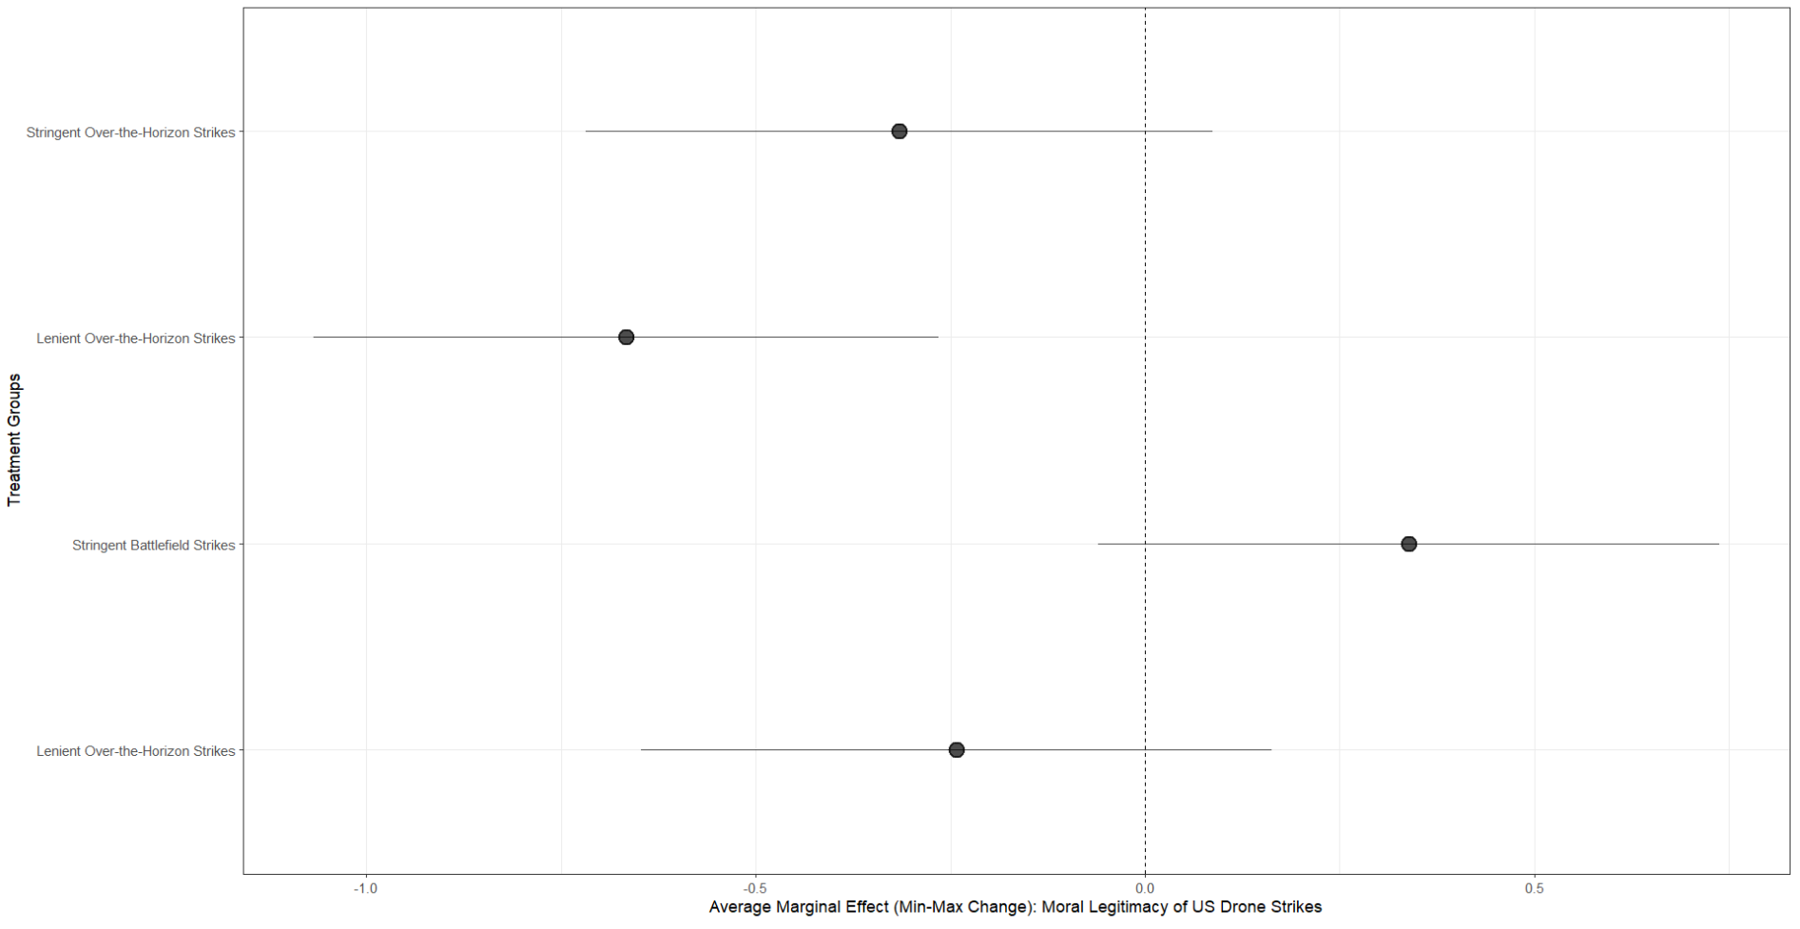

**Figure E.2: Average Marginal Effects—Chaplains’ Perceptions of Legal Legitimacy**

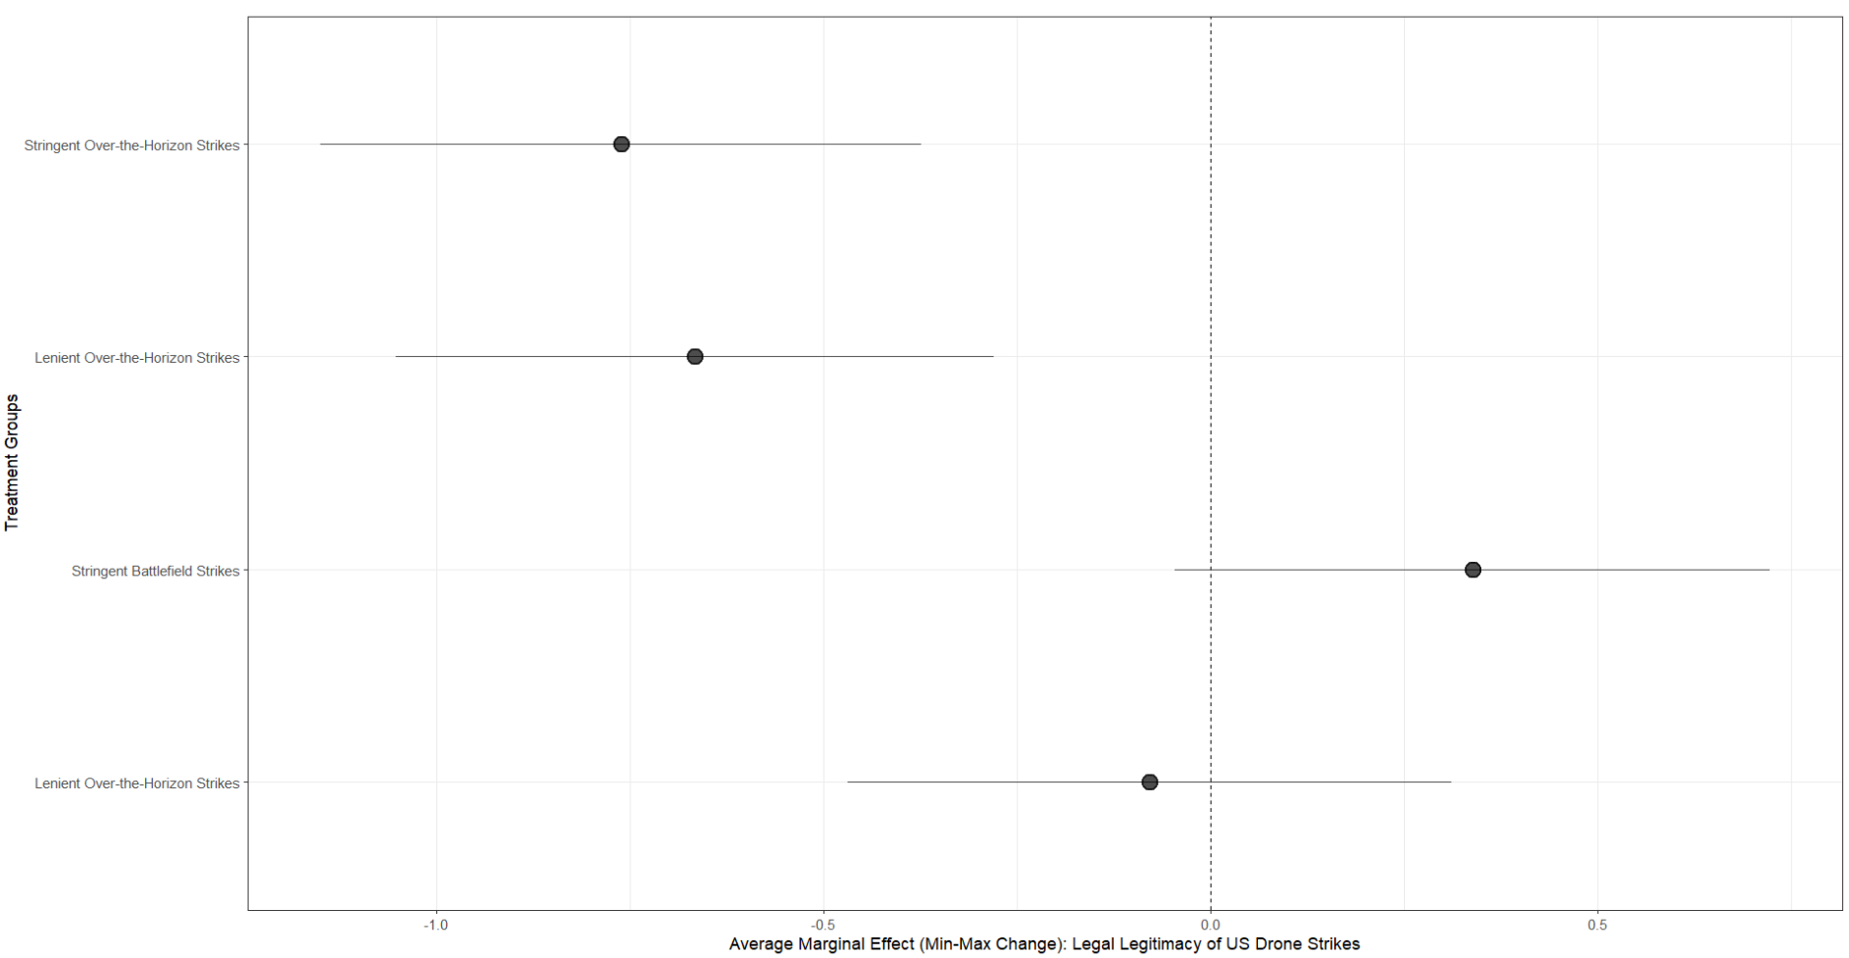

As a final measure, we also draw on Stoetzer et al. (2024) by conceptualizing our main results as “latent treatment effects,” which helps us account for criticisms of poor construct validity and measurement error of our main outcome variable of interest, legitimacy. As such, we use the hIRT package in R to model our results. This package uses hierarchical item response theory models where both the mean and variance of latent preferences may depend on measured covariates. In doing so, we find that our results are consistent with our main findings, though the standard errors can be larger, which is consistent with analysis provided by Stoetzer et al. (2024). Of note, the larger standard error for education is based on a virtual totality of respondents selecting “Advanced Degree,” whereas only one respondent selected “4-Year Degree.”

**Figure E.4: Chaplains’ Perceived Legitimacy using the hIRT Package in R**

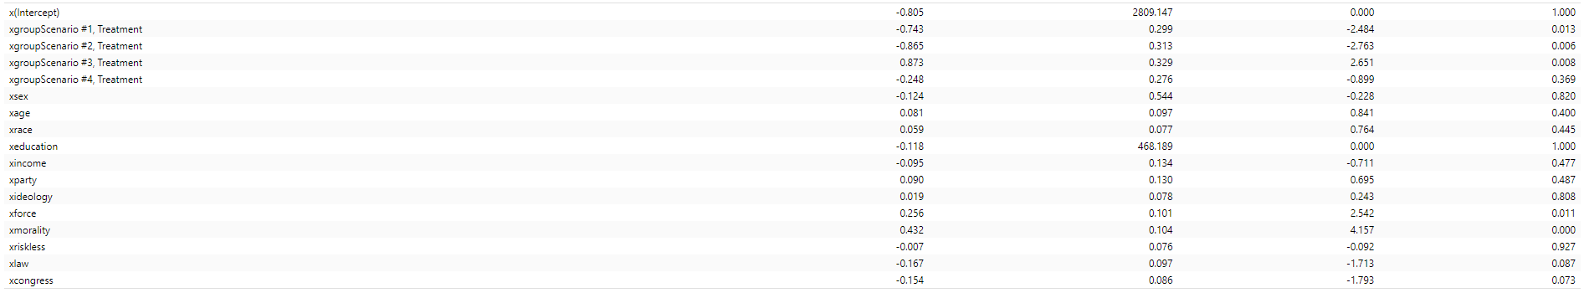

**Appendix F: Logit Regression Models**

For these logit regression models, which we discussed in our main text, the vertical bars present 95% confidence intervals about each point estimate for chaplains’ perceptions of legitimacy. These figures show the change in predicted probability for perceptions of moral (Figure F.1) and legal (Figure F.2) legitimacy for US drone strikes produced by changing the indicator variable—chaplain’s perceptions of legitimacy and attitudes of support—from 0 to 1.

**Figure F.1: Logit Regression Model— Chaplains’ Perceptions of Moral Legitimacy**

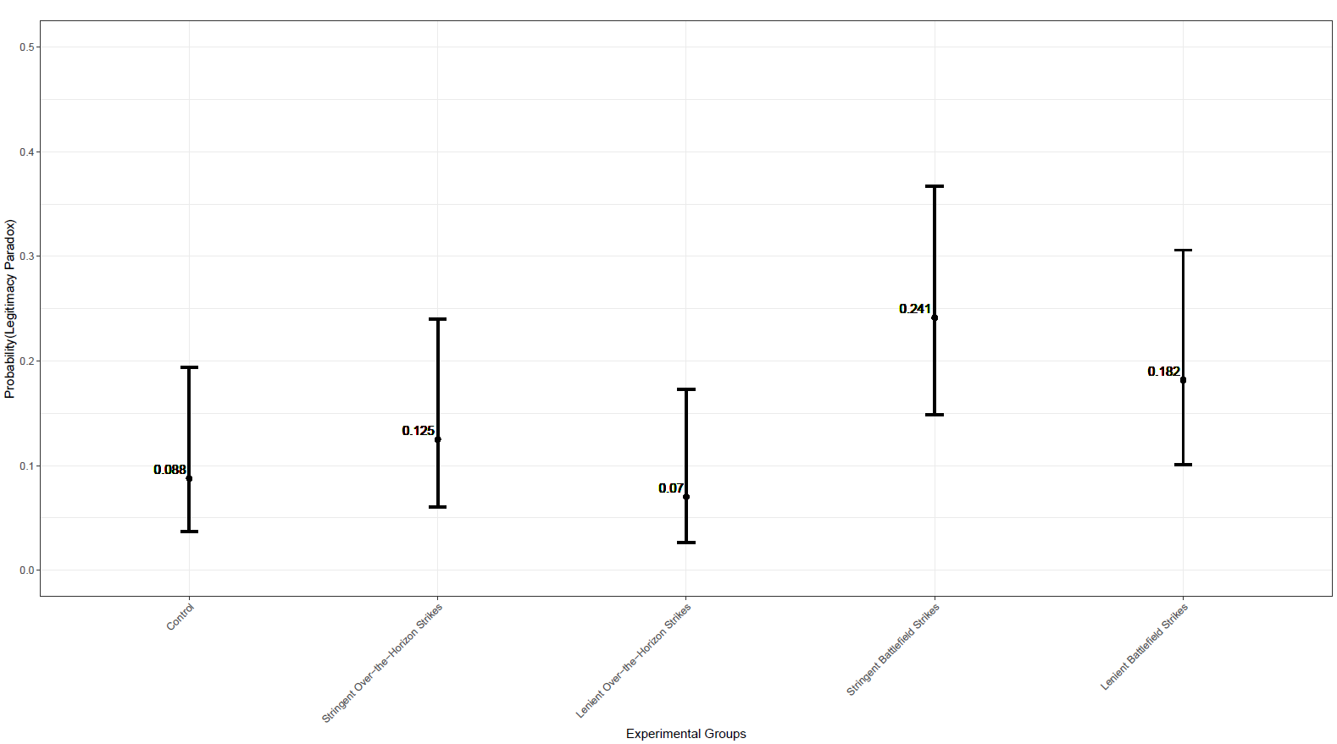

**Figure F.2: Logit Regression Model— Chaplains’ Perceptions of Legal Legitimacy**

