**Online Appendix**

**Table A. Control and Treatment Prompts**

|  |  |
| --- | --- |
| Control | Treatment |
| 2006 regulation requires each local administration in Indonesia to have a “Religious Harmony Forum” to approve the construction of houses of worship. This law means that the majority religion in a local area can block construction of religion houses of local minority religions. Some people have criticized the “religious harmony” law passed in 2006 that gives the local majority religion the right to block the construction of minority religion houses of worship. These people say that this law threatens freedom of religion in Indonesia. | 2006 regulation requires each local administration in Indonesia to have a “Religious Harmony Forum” to approve the construction of houses of worship. This law means that the majority religion in a local area can block construction of religion houses of local minority religions. Some people have criticized the “religious harmony” law passed in 2006 that gives the local majority religion the right to block the construction of minority religion houses of worship. These people say that this law threatens freedom of religion in Indonesia.  For example, in 2018, a Christian group in Papua-a predominantly Christian area-used the law to demand a mosque dismantle their minaret because it stood higher than any church in the area. In addition, the Christian group demanded government action against the “noisy loudspeakers” during the call to prayer as well as restrictions on Muslim missionaries in the area. Because Christians are the majority group in the area, they have the legal right to block construction or renovation of non-Christian houses of worship. |

**Figure A. Facebook advertisement**



To illustrate the underlying estimations that resulted in the means shown in Figure 1 in the article, Figure B below shows the density plots of participants’ estimates of the Christian population, both at the national level and provincial level. The dotted lines mark the mean estimate for each group.

**Figure B. Density Plots of Christian Population Estimates**

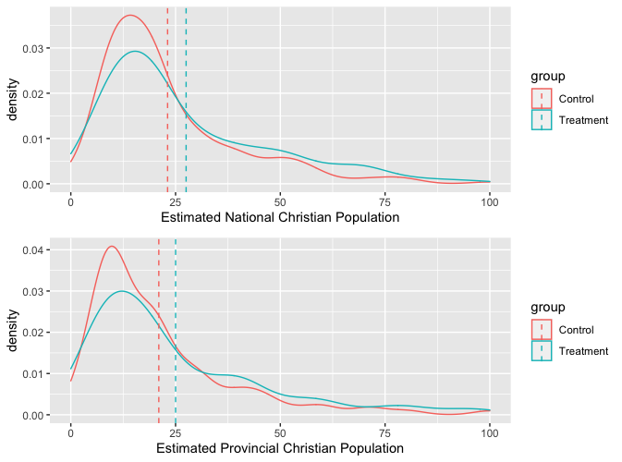

**Table B. Primary results with age, urban, and province control variables**

|  |  |  |
| --- | --- | --- |
|  | | |
|  |  | |
|  | National | Province |
|  | (A1) | (A2) |
|  | | |
| Treatment | 4.028** | 3.364* |
|  | (1.830) | (1.943) |
|  |  |  |
| Urban | -5.855*** | -5.792*** |
|  | (1.876) | (1.995) |
|  |  |  |
| Male | 1.002 | 2.197 |
|  | (1.907) | (2.017) |
|  |  |  |
| Age | -0.175** | -0.048 |
|  | (0.079) | (0.083) |
|  |  |  |
| Constant | 32.704*** | 24.926*** |
|  | (2.975) | (3.144) |
|  |  |  |
|  | | |
| Observations | 402 | 401 |
| Log Likelihood | -1,737.584 | -1,756.623 |
| Akaike Inf. Crit. | 3,485.169 | 3,523.246 |
|  | | |
| Note: | *p<0.1**p<0.05***p<0.01 | |

**Table C. Primary results with province fixed effects**

|  |  |  |
| --- | --- | --- |
|  | | |
|  |  | |
|  | National | Province |
|  | (A3) | (A4) |
|  | | |
| Treatment | 6.668*** | 5.069** |
|  | (1.970) | (2.059) |
|  |  |  |
|  |  |  |
| Constant | 8.166 | -1.534 |
|  | (12.891) | (13.459) |
|  |  |  |
|  | | |
| Observations | 369 | 372 |
| Log Likelihood | -1,579.659 | -1,608.655 |
| Akaike Inf. Crit. | 3,217.317 | 3,275.310 |
|  | | |
| Note: | *p<0.1**p<0.05***p<0.01 | |