**ONLINE APPENDIX MATERIAL**

**Table A1:** Descriptive Statistics

|  |  |  |  |  |
| --- | --- | --- | --- | --- |
|  | Min | Max | Mean | SD |
| Democrats Orientation to Religion | 1 | 3 | 1.85 | .73 |
| Unfriendly |  |  |  |  |
| Neutral |  |  |  |  |
| Friendly |  |  |  |  |
| Republicans Orientation to Religion | 1 | 3 | 2.57 | .66 |
| Unfriendly |  |  |  |  |
| Neutral |  |  |  |  |
| Friendly |  |  |  |  |
| Supreme Court Orientation to Religion | 1 | 3 | 2.28 | .65 |
| Unfriendly |  |  |  |  |
| Neutral |  |  |  |  |
| Friendly |  |  |  |  |
| Christian Nationalism | 0 | 1 | .47 | .5 |
| Republican | 0 | 1 | .31 | .46 |
| Democrat | 0 | 1 | .33 | .47 |
| Independent | 0 | 1 | .26 | .44 |
| Other Party | 0 | 1 | .1 | .3 |
| Conservative Ideology | 1 | 5 | 3.07 | 1.09 |
| Age | 1 | 4 | 2.78 | .96 |
| Man | 0 | 1 | .45 | .5 |
| Woman | 0 | 1 | .54 | .5 |
| White | 0 | 1 | .69 | .46 |
| Black | 0 | 1 | .11 | .31 |
| Hispanic | 0 | 1 | .14 | .34 |
| Other Race | 0 | 1 | .07 | .25 |
| Education | 1 | 6 | 4.15 | 1.51 |
| Income | 1 | 9 | 5.57 | 3.06 |
| Southern | 0 | 1 | .41 | .49 |
| White Evangelical Protestant | 0 | 1 | .25 | .44 |
| White Non-Evangelical Protestant | 0 | 1 | .16 | .37 |
| Black Protestant | 0 | 1 |  |  |
| Catholic | 0 | 1 | .19 | .39 |
| Other Christian | 0 | 1 | .02 | .15 |
| Non-Christian | 0 | 1 | .07 | .25 |
| Atheist | 0 | 1 | .06 | .24 |
| Agnostic | 0 | 1 | .06 | .24 |
| Nothing in Particular | 0 | 1 | .17 | .37 |
| Religious Service Attendance | 1 | 6 | 2.84 | 1.66 |

**Source:** Pew American Trends Panel, Wave 114.

**Table A2:** Multinomial logistic regression models predicting Americans’ perceptions that the Democratic Party is unfriendly or friendly (vs. neutral) toward religion.

|  |  |  |  |  |  |  |
| --- | --- | --- | --- | --- | --- | --- |
|  | Model 1 | | Model 2 | | Model 3 | |
|  | Reference: Neutral | | Reference: Neutral | | Reference: Neutral | |
| Predictors | Unfriendly | Friendly | Unfriendly | Friendly | Unfriendly | Friendly |
| Christian Nationalism | 0.94*** | 0.46** | 1.17*** | 0.55 | 0.79 | -0.32 |
| Democrat | -1.44*** | 0.50* | -0.94** | 0.39 | -1.43*** | 0.51* |
| Independent | -0.23 | 0.43* | -0.02 | 0.59 | -0.22 | 0.46* |
| Other Party | -0.22 | 0.44 | -0.10 | 0.79* | -0.22 | 0.45 |
| Ideological Identity | 0.98*** | -0.10 | 1.01*** | -0.10 | 0.97*** | -0.19 |
| Age | -0.09 | 0.06 | -0.09 | 0.05 | -0.09 | 0.07 |
| Woman | -0.53*** | -0.31* | -0.53*** | -0.31* | -0.53*** | -0.31* |
| Black | -0.57 | -0.16 | -0.58 | -0.17 | -0.57 | -0.14 |
| Hispanic | -0.08 | 0.32 | -0.06 | 0.29 | -0.07 | 0.34 |
| Other Race | -0.17 | 0.04 | -0.16 | 0.07 | -0.17 | 0.06 |
| Education | 0.10 | -0.03 | 0.09 | -0.02 | 0.09 | -0.04 |
| Household Income | 0.01 | -0.02 | 0.01 | -0.02 | 0.01 | -0.02 |
| Southern | -0.27* | -0.07 | -0.29* | -0.05 | -0.27* | -0.07 |
| White Non-Evangelical | -0.37 | 0.14 | -0.37 | 0.15 | -0.36 | 0.15 |
| Black Protestant | -0.60 | 0.73 | -0.56 | 0.64 | -0.58 | 0.76 |
| Catholic | -0.49** | -0.05 | -0.50** | -0.09 | -0.49** | -0.04 |
| Other Christian | -0.03 | 0.09 | -0.04 | 0.02 | -0.03 | 0.09 |
| Non-Christian Religion | -0.55 | -0.16 | -0.56 | -0.22 | -0.55 | -0.17 |
| Atheist | -0.60 | 0.07 | -0.64 | 0.01 | -0.61 | 0.03 |
| Agnostic | 0.01 | 0.22 | -0.01 | 0.16 | 0.01 | 0.20 |
| Nothing in Particular | -0.62* | -0.03 | -0.63* | -0.08 | -0.62* | -0.03 |
| Worship Attendance | 0.10* | 0.01 | 0.10* | 0.00 | 0.10* | 0.01 |
| CN × Democrat |  |  | -0.87 | 0.39 |  |  |
| CN × Independent |  |  | -0.36 | -0.39 |  |  |
| CN × Other Party |  |  | -0.29 | -1.15* |  |  |
| CN × Conservative ID |  |  |  |  | 0.05 | 0.27 |
| Intercept | -3.35*** | -1.00* | -3.56*** | -1.00 | -3.35*** | -0.77 |
| Pseudo R2 | .22 |  | .23 |  | .22 |  |

**Source:** Pew American Trends Panel, Wave 114 (N = 4,685).

**Note:** Unstandardized betas; p values are calculated with robust standard errors. Excluded categories are Republican, White, and White Evangelical Protestant.

* p < .05; ** p < .01; *** p < .001 (two-tailed tests).

**Table A3:** Multinomial logistic regression models predicting Americans’ perceptions that the Republican Party is unfriendly or friendly (vs. neutral) toward religion.

|  |  |  |  |  |  |  |
| --- | --- | --- | --- | --- | --- | --- |
|  | Model 1 | | Model 2 | | Model 3 | |
|  | Reference: Neutral | | Reference: Neutral | | Reference: Neutral | |
| Predictors | Unfriendly | Friendly | Unfriendly | Friendly | Unfriendly | Friendly |
| Christian Nationalism | 0.23 | -0.23 | 0.05 | 0.94*** | -1.66** | -3.67*** |
| Democrat | 2.57*** | 0.40* | 2.67*** | 1.70*** | 2.49*** | 0.34 |
| Independent | 0.96** | -0.01 | 0.99 | 0.98*** | 0.95** | 0.06 |
| Other Party | 1.39*** | -0.33 | 1.27* | 0.72* | 1.33*** | -0.36 |
| Ideological Identity | -0.18 | -0.21** | -0.16 | -0.17* | -0.52*** | -0.77*** |
| Age | 0.08 | 0.01 | 0.08 | 0.01 | 0.08 | 0.02 |
| Woman | -0.37* | -0.41*** | -0.36 | -0.40*** | -0.33 | -0.36** |
| Black | 0.56 | -0.57 | 0.54 | -0.55 | 0.59 | -0.52 |
| Hispanic | -0.05 | -0.32 | -0.03 | -0.25 | -0.03 | -0.26 |
| Other Race | 0.36 | -0.39 | 0.36 | -0.37 | 0.42 | -0.30 |
| Education | -0.00 | 0.11** | -0.01 | 0.09* | -0.02 | 0.08* |
| Household Income | -0.00 | 0.08*** | 0.00 | 0.09*** | -0.00 | 0.09*** |
| Southern | -0.08 | -0.03 | -0.11 | -0.10 | -0.09 | -0.03 |
| White Non-Evangelical | 0.34 | 0.13 | 0.36 | 0.18 | 0.37 | 0.21 |
| Black Protestant | -0.10 | -0.40 | 0.03 | -0.16 | 0.02 | -0.15 |
| Catholic | 0.00 | -0.37* | 0.02 | -0.34 | 0.03 | -0.29 |
| Other Christian | -0.35 | 0.05 | -0.37 | 0.03 | -0.37 | 0.06 |
| Non-Christian Religion | -0.13 | -0.11 | -0.13 | -0.10 | -0.14 | -0.10 |
| Atheist | 0.45 | 1.12** | 0.45 | 1.08** | 0.43 | 1.04** |
| Agnostic | -0.05 | 1.39*** | 0.00 | 1.45*** | -0.06 | 1.39*** |
| Nothing in Particular | -0.57 | -0.15 | -0.54 | -0.11 | -0.57 | -0.13 |
| Worship Attendance | 0.03 | 0.07 | 0.02 | 0.06 | 0.02 | 0.05 |
| CN × Democrat |  |  | -0.35 | -2.23*** |  |  |
| CN × Independent |  |  | -0.18 | -1.39*** |  |  |
| CN × Other Party |  |  | 0.10 | -1.56*** |  |  |
| CN × Conservative ID |  |  |  |  | 0.56** | 1.06*** |
| Intercept | -2.08*** | 0.97* | -1.97** | -0.02 | -0.94 | 2.57*** |
| Pseudo R2 | .13 |  | .14 |  | .15 |  |

**Source:** Pew American Trends Panel, Wave 114 (N = 4,682).

**Note:** Unstandardized betas; p values are calculated with robust standard errors. Excluded categories are Republican, White, and White Evangelical Protestant.

* p < .05; ** p < .01; *** p < .001 (two-tailed tests).

**Table A4:** Multinomial logistic regression models predicting Americans’ perceptions that the Supreme Court is unfriendly or friendly (vs. neutral) toward religion.

|  |  |  |  |  |  |  |
| --- | --- | --- | --- | --- | --- | --- |
|  | Model 1 | | Model 2 | | Model 3 | |
|  | Reference: Neutral | | Reference: Neutral | | Reference: Neutral | |
| Predictors | Unfriendly | Friendly | Unfriendly | Friendly | Unfriendly | Friendly |
| Christian Nationalism | -0.02 | -0.55*** | -0.18 | 0.31 | -0.44 | -3.42*** |
| Democrat | 0.37 | 0.79*** | 0.24 | 1.49*** | 0.35 | 0.81*** |
| Independent | -0.02 | 0.53** | -0.12 | 1.21*** | -0.01 | 0.63*** |
| Other Party | 0.12 | 0.17 | -0.07 | 0.74* | 0.10 | 0.19 |
| Ideological Identity | -0.10 | -0.64*** | -0.10 | -0.62*** | -0.17 | -1.03*** |
| Age | 0.07 | -0.00 | 0.07 | -0.00 | 0.08 | 0.02 |
| Woman | -0.08 | -0.18 | -0.09 | -0.18 | -0.08 | -0.15 |
| Black | 1.47*** | -0.12 | 1.46*** | -0.13 | 1.48*** | -0.08 |
| Hispanic | 0.12 | -0.01 | 0.11 | 0.02 | 0.13 | 0.05 |
| Other Race | -0.28 | -0.33 | -0.28 | -0.32 | -0.27 | -0.28 |
| Education | -0.03 | 0.08* | -0.02 | 0.07 | -0.03 | 0.06 |
| Household Income | -0.03 | 0.05* | -0.04 | 0.06* | -0.04 | 0.06* |
| Southern | -0.19 | -0.13 | -0.18 | -0.16 | -0.19 | -0.14 |
| White Non-Evangelical | -0.36 | 0.04 | -0.37 | 0.06 | -0.35 | 0.12 |
| Black Protestant | -1.00* | -0.16 | -1.01* | -0.01 | -0.97* | 0.07 |
| Catholic | 0.03 | -0.27 | 0.02 | -0.25 | 0.03 | -0.18 |
| Other Christian | -0.12 | 0.07 | -0.11 | 0.09 | -0.12 | 0.07 |
| Non-Christian Religion | 0.02 | 0.18 | 0.02 | 0.21 | 0.04 | 0.23 |
| Atheist | -0.98 | 0.58 | -0.98 | 0.58 | -0.97 | 0.56 |
| Agnostic | -1.07* | 0.22 | -1.07* | 0.26 | -1.08* | 0.25 |
| Nothing in Particular | -0.63* | 0.00 | -0.63* | 0.03 | -0.63* | 0.05 |
| Worship Attendance | -0.06 | 0.02 | -0.06 | 0.01 | -0.07 | 0.01 |
| CN × Democrat |  |  | 0.17 | -1.25*** |  |  |
| CN × Independent |  |  | 0.14 | -1.12** |  |  |
| CN × Other Party |  |  | 0.30 | -0.76 |  |  |
| CN × Conservative ID |  |  |  |  | 0.12 | 0.92*** |
| Intercept | -0.85 | 0.89* | -0.73 | 0.26 | -0.60 | 1.84*** |
| Pseudo R2 | .14 |  | .14 |  | .15 |  |

**Source:** Pew American Trends Panel, Wave 114 (N = 4,679).

**Note:** Unstandardized betas; p values are calculated with robust standard errors. Excluded categories are Republican, White, and White Evangelical Protestant.

* p < .05; ** p < .01; *** p < .001 (two-tailed tests).

**Table A5:** Multinomial logistic regression models predicting Americans’ perceptions that the Biden Administration is unfriendly or friendly (vs. neutral) toward religion.

|  |  |  |  |  |  |  |
| --- | --- | --- | --- | --- | --- | --- |
|  | Model 1 | | Model 2 | | Model 3 | |
|  | Reference: Neutral | | Reference: Neutral | | Reference: Neutral | |
| Predictors | Unfriendly | Friendly | Unfriendly | Friendly | Unfriendly | Friendly |
| Christian Nationalism | 0.72*** | 0.27 | 0.88*** | 0.41 | 1.07 | 0.17 |
| Democrat | -1.78*** | 0.56** | -1.27** | 0.55 | -1.77*** | 0.56** |
| Independent | -0.62*** | 0.45* | -0.57* | 0.59* | -0.62*** | 0.45* |
| Other Party | -0.18 | 0.23 | -0.01 | 0.59 | -0.17 | 0.24 |
| Ideological Identity | 0.89*** | -0.18* | 0.91*** | -0.18* | 0.95*** | -0.20* |
| Age | 0.21** | 0.22*** | 0.21** | 0.22*** | 0.21** | 0.22*** |
| Woman | -0.36** | -0.03 | -0.36** | -0.03 | -0.37** | -0.03 |
| Black | 0.06 | -0.04 | 0.07 | -0.05 | 0.06 | -0.04 |
| Hispanic | 0.30 | 0.17 | 0.33 | 0.15 | 0.30 | 0.18 |
| Other Race | -0.43 | -0.12 | -0.43 | -0.10 | -0.44 | -0.12 |
| Education | 0.07 | -0.01 | 0.06 | -0.01 | 0.07 | -0.01 |
| Household Income | 0.01 | -0.01 | 0.01 | -0.00 | 0.01 | -0.01 |
| Southern | -0.13 | -0.08 | -0.15 | -0.07 | -0.13 | -0.08 |
| White Non-Evangelical | -0.10 | 0.37 | -0.10 | 0.39 | -0.10 | 0.37 |
| Black Protestant | -1.36* | 0.26 | -1.32* | 0.20 | -1.37* | 0.26 |
| Catholic | -0.37 | 0.08 | -0.38* | 0.07 | -0.37 | 0.08 |
| Other Christian | -0.53 | -0.33 | -0.56 | -0.37 | -0.53 | -0.33 |
| Non-Christian Religion | -0.61* | -0.11 | -0.62* | -0.14 | -0.61* | -0.11 |
| Atheist | -1.16** | 0.43 | -1.16** | 0.39 | -1.17** | 0.42 |
| Agnostic | -0.49 | 0.02 | -0.48 | -0.01 | -0.48 | 0.02 |
| Nothing in Particular | -0.55* | -0.05 | -0.55* | -0.08 | -0.55* | -0.05 |
| Worship Attendance | 0.10 | -0.02 | 0.10 | -0.02 | 0.10 | -0.02 |
| CN × Democrat |  |  | -0.92 | 0.19 |  |  |
| CN × Independent |  |  | -0.06 | -0.28 |  |  |
| CN × Other Party |  |  | -0.39 | -1.12* |  |  |
| CN × Conservative ID |  |  |  |  | -0.10 | 0.04 |
| Intercept | -3.85*** | -1.10* | -4.00*** | -1.18* | -4.08*** | -1.07* |
| Pseudo R2 | .22 |  | .22 |  | .22 |  |

**Source:** Pew American Trends Panel, Wave 114 (N = 4,689).

**Note:** Unstandardized betas; p values are calculated with robust standard errors. Excluded categories are Republican, White, and White Evangelical Protestant.

* p < .05; ** p < .01; *** p < .001 (two-tailed tests).

Figure A1: Predicted marginal probability of perceiving the Democratic Party as neutral toward religion by Christian nationalism, partisan identity, and ideological identity.

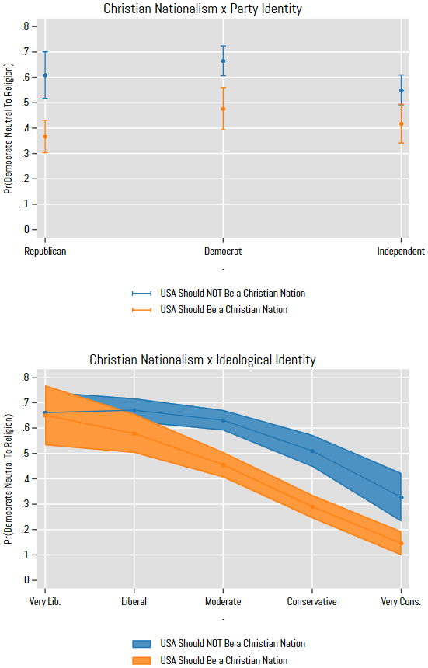

Source: Pew American Trends Panel, Wave 114

Note: Controls held at their means. Error bars are 95% confidence intervals.

Figure A2: Predicted marginal probability of perceiving the Democratic Party as unfriendly toward religion by Christian nationalism, partisan identity, and ideological identity.

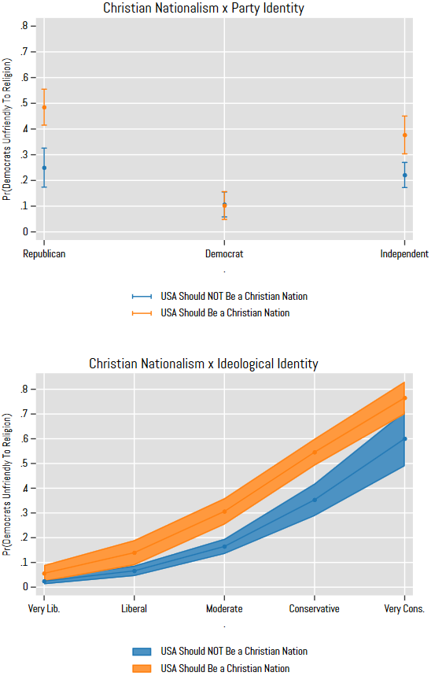

Source: Pew American Trends Panel, Wave 114

Note: Controls held at their means. Error bars are 95% confidence intervals.

Figure A3: Predicted marginal probability of perceiving the Republican Party as neutral toward religion by Christian nationalism, partisan identity, and ideological identity.

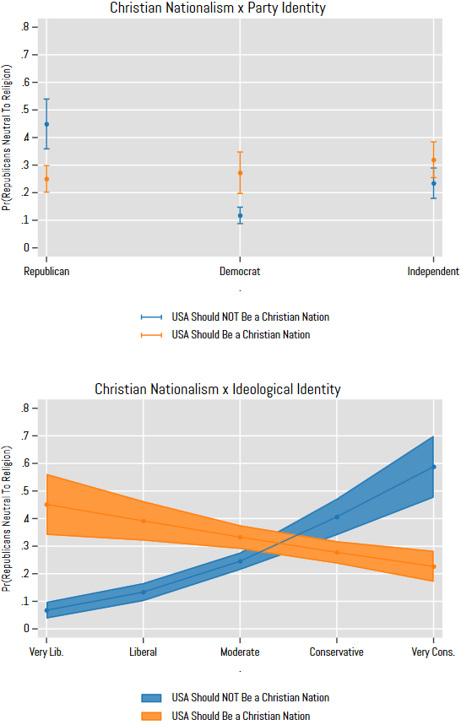

Source: Pew American Trends Panel, Wave 114

Note: Controls held at their means. Error bars are 95% confidence intervals.

Figure A4: Predicted marginal probability of perceiving the Republican Party as unfriendly toward religion by Christian nationalism, partisan identity, and ideological identity.

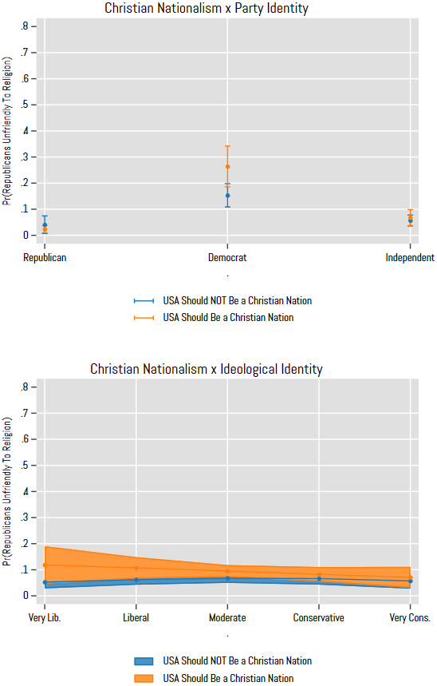

Source: Pew American Trends Panel, Wave 114

Note: Controls held at their means. Error bars are 95% confidence intervals.