**INTRODUCTION**

Much like American politicians, larger political entities (e.g., parties, administrations, branches of government, institutions) often carry reputations about their general posture or orientation toward religion. For example, the idea of “the God gap” between Republicans and Democrats is a reflection of genuine differences in religious composition between parties, but it also reflects differences in *perceptions* about which party is more “pro-religion” or “pro-Christianity” (Castle et al. 2017; Claassen 2015). Polling data since 2003 have shown Americans generally perceive the Republican Party as more “friendly” toward religion compared to the Democratic Party. Yet entities within parties can carry their own reputations. In 2009, Americans rated the Obama Administration much higher in terms of friendliness toward religion compared to the party he represented (Pew Research Center 2009). As scholarship on political campaigns and rhetoric recognize, these religious reputations are often strategically cultivated, since it generally benefits politicians, parties, and administrations to be viewed as pro-religion (Bramlett and Burge 2021; Campbell et al. 2021; Coe and Chapp 2017; Perry 2023).

Other entities, however, are less helped by such a reputations, particularly if they are expected to be religiously impartial. The Supreme Court, for example, is ideally supposed to be non-partisan and unbiased, rendering decisions on whether laws or policies are “Constitutional,” not on whether they advance a preferred religious doctrine or constituency. Consistent with this idea, 83% of Americans believe Supreme Court justices should not bring their own religious views into how they decide major cases. Yet the composition of the Supreme Court changed considerably during the Trump Presidency, and subsequently rendered decisions in favor of conservative Christians, involving freedom to refuse serving gay couples, public prayer at high school football games, and most famously, overturning Roe v. Wade (Totenberg 2022). Unsurprisingly, in 2022, 44% of Americans believed the justices have relied “too much” on their own religious beliefs in recent decisions and the percentage of Americans who believe the Supreme Court is “friendly” toward religion nearly doubled since 2019 from 18% to 35%, while views of their religious neutrality declined 18% (Pew Research Center 2022).

This research note examines how “identity congruence,” or the correspondence between Americans’ partisan and ideological identities with the perceived identity of politicians or political groups, shapes how Americans perceive the religious orientations of specific political entities. Drawing on group identity theories of religion and politics, Perry and Davis (2024) find that identity congruence powerfully influences the perceived religiosity of individual politicians. Specifically, they find the leading predictor of how Americans rated the religiosity of prominent politicians like Donald Trump, Joe Biden, or Kamala Harris was Americans’ own partisan or ideological identity rather than their own religious characteristics or even knowledge of a given politician’s religious identity.[1] The authors also find religious perceptions were shaped by Christian nationalism (Broeren and Djupe 2023; Djupe et al. 2023; Vegter et al. 2023), which can not only be an aspect of identity congruence on its own (Perry 2023), but other studies show also works in combination with partisan and ideological identities, suggesting the influence of each on Americans’ perceptions would be contingent (Djupe et al. 2023; Perry and Davis 2024).

In the current study, I expect patterns observed by Perry and Davis (2024) to extend to entities like political parties and institutions. Pew Research Center (2009, 2022) has long observed that Americans’ perceptions of these entities’ religious orientations differ strongly across partisan and religious identities in expected directions. Yet the reputations of individual politicians as well as parties and institutions are most often benefited (or at least not penalized) by being viewed as more religious or pro-religion by in-group members (Campbell et al. 2021; Castle et al. 2017; Coe and Chapp 2017). In contrast, I expect that partisan and ideological interests would lead Americans to perceive the religious orientation of the Supreme Court differently. Though in-group bias might incline Democrats and Republicans, liberals and conservatives to view their corresponding parties as “friendly toward religion” with positive valence, those same in-group considerations might incline Democrats and liberals, for example, to view the Supreme Court as “friendly toward religion” with negative valence (given its legitimacy depends on fairness rather than partisan or religious fidelity), while inclining Republicans and conservatives to view the Supreme Court as “neutral” toward religion.

The potential influence of Christian nationalism, however, is an additional puzzle that warrants more examination, specifically its role as a factor in identity congruence. On the one hand, research suggests Christian nationalism sacralizes in-groups vis-à-vis out-groups (e.g., Perry et al. 2024a, 2024b), and thus, it might be expected that greater Christian nationalism would amplify positive in-group evaluations, inclining Americans—Democrat or Republican, liberal or conservative—to view their own political in-groups as friendly to religion, given that pro-religion friendliness is still seen as a positive characteristic across parties (Campbell et al. 2021; Perry and Davis 2024). Yet, Djupe et al. (2023) argue Christian nationalism is essentially “a Republican project” resulting in cross-pressures for Democrats that might temper their own in-group preferences. In other words, perhaps Christian nationalism among Democrats will mitigate their tendency to evaluate the religious orientations of the Republican Party or current Supreme Court with negative valence, like we might expect for Democrats in general.

Integrating and testing these ideas, I draw on data from a large nationally representative survey of American adults to predict Americans’ perceptions of friendliness, neutrality, or unfriendliness toward religion focusing on the Democratic Party, the Republican Party, and the Supreme Court. My analyses largely support expectations that both Christian nationalism and congruence on political identities, separately and in combination, predict how Americans perceive the posture of all three political entities toward religion. Yet I also find the entity itself matters. My findings thus extend our understanding of how Americans’ group orientations shape their evaluations of key political entities in complex ways.

**METHODS**

**Data**

Data for this study are from Wave 114 of the Pew Research Center American Trends Panel survey (hereafter ATP 114), which are publicly available at [www.pewresearch.org](http://www.pewresearch.org). The ATP 114 was fielded from September 13-18, 2022 by Ipsos, a global marketing and polling firm. ATP waves are nationally representative, random-sample surveys of U.S. adults who participate via self-administered online surveys in English or Spanish. For the ATP 114, 11,687 panelists were sampled and a total of 10,588 responded for a response rate of 91%. The ATP surveys are all weighted in a multiple step process that accounts for multiple stages of sampling and nonresponse. The weights were used for the multivariate analyses in order to bring the sample into conformity with demographic and non-demographic benchmarks. Only half (N = 5,300) of ATP114 respondents were randomly selected to answer certain questions about religion and politics used in this study. After eliminating cases with missing data, the final N for full models is between 4,679 and 4,685.

**Dependent Variables**

Outcomes for this study are three questions in which Pew asked respondents: “For each of the of the following groups, please indicate whether it is generally: FRIENDLY toward religion, NEUTRAL toward religion, or UNFRIENDLY toward religion.” 1) The Democratic Party, 2) The Republican Party, and 3) The Supreme Court.”[2] Because neutrality toward religion rather than friendliness, for at least one entity (The Supreme Court), might be viewed as the ideal evaluation, I treat these responses as categorical rather than ordinal. Thus, I use multinomial logistic regression for all three groups with “neutral toward religion” as the reference category.

**Key Independent Variables**

My key predictor variables are indicators of partisan and ideological identity as well as an indicator of Christian nationalism. Party identity is measured with four nominal categories: Republican (reference), Democrat, Independent, and Other Party. Conservative ideological identity is entered as an ordinal variable from 1=Very liberal to 5=Very conservative.[3]

Christian nationalism has been measured in a variety of ways, ranging from single-item indicators (Perry et al. 2024a; Perry and Whitehead 2019) to multi-item scales (Djupe et al. 2023; Gorski and Perry 2022; McDaniel et al. 2022; Whitehead and Perry 2020). I use a straightforward binary measure from the ATP114 that simply asks Americans: “Do you think the United States should be a Christian nation?” Respondents could answer yes or no. Though this measure does not allow for shades of agreement, if “Christian nationalism” represents the belief that the United States should be a Christian nation, this indicator is clear and direct.[4] Thus, rather than attempt to combine this indicator with other measures to capture a broader construct, I simply focus on those who affirm or reject the notion that the US should be a Christian nation.

**Control Variables**

Though I anticipate the primary confounds will be among key predictor variables, I also control for a variety of demographic and religious characteristics theorized to influence Americans’ religious evaluations. These include age (in 4 categories), gender (male = 0, female = 1),[5] racial identity, (White = reference, Black, Hispanic, and Other Race), education (1 = less than high school to 6 = post-graduate degree), household income (1 = less than $30,000 to 9 = $100,000 or more), and Southern residence.

Religious characteristics included measures for religious identity and practice. For religious identity, I organize respondents into White Evangelical Protestant (reference), White Non-Evangelical Protestant, Black Protestant, Catholic, Other Christian, Non-Christian Religion, Atheist, Agnostic, and Nothing in Particular. For religious practice, the ATP114 includes a question about religious service attendance, which is measured from 1 = never to 6 = more than once a week. Online Appendix Table A1 presents descriptive statistics for all variables in multivariate models.

**Plan of Analysis**

Online Appendix Tables A2-A4 present multinomial logistic regression models predicting Americans’ perceptions of friendliness or unfriendliness vs. neutrality (reference) toward religion among the Democratic Party (Table A2), the Republican Party (Table A3), and the Supreme Court (Table A4). In each table, I first present a baseline model with full controls (Model 1), followed by interaction terms between Christian nationalism and party identity (Model 2) and ideological identity (Model 3). I use robust standard errors due to the weighting required for Pew data. For simplicity, I present my results below by plotting and interpreting average marginal effects.

**RESULTS**

Figure 1 presents forest plots for all three political entities with my key predictor variables. Effects with error bars (95% confidence intervals) that do not cross the vertical line (the line of null effect) are statistically significant. Focusing on the Democratic Party in the first panel, Americans who affirm the US should be a Christian nation are more likely to view the Democratic Party as unfriendly toward religion and less likely to view it as neutral, consistent with findings from Perry and Davis (2024) regarding Democratic politicians and with Djupe et al.’s (2023) argument that Christian nationalism represents a “Republican project.” The effects of party identity and ideological identity are as expected. Compared to Republicans, Democrats are more likely to view the Democratic party as neutral or friendly toward religion and less likely to view it as unfriendly. Regarding ideological identity, the more Americans identify with conservatism as opposed to liberalism, they are more likely to view the Democratic Party as unfriendly toward religion and less likely to view it as neutral or friendly.

[FIGURE 1 ABOUT HERE]

The effect of Christian nationalism is somewhat different for Americans’ perceptions about the Republican Party in the second panel. Among Americans who affirm the US should be a Christian nation, they are less likely to view the Republican Party as friendly toward religion, but no different in viewing it as neutral or unfriendly. The effect of conservative ideological identity gives a clue why. As Americans identify more with conservatism, they are more likely to view the Republican Party as neutral toward religion, less likely to view it as friendly, and no more likely to view it as unfriendly. This suggests that among Americans who identify with the Republican Party ideologically, they see the Republican Party as simply fair, rather than partial toward religion. The effects of party identity are more straightforwardly group-oriented. Compared to Republicans, Democrats are more likely to view the Republican Party as unfriendly toward religion and less likely to view it as neutral.

Lastly, focusing on the Supreme Court in the last panel, those Americans who affirm that the US should be a Christian nation are more likely to view the Supreme Court as neutral toward religion and less likely to view it as friendly. This pattern is nearly identical for conservative ideological identity. Taken together, these findings suggest religious impartiality and fairness is the more complimentary view for the conservative-dominated Supreme Court. Indeed, the partisan pattern is instructive here. Compared to Republicans, Democrats and Independents are less likely to view the Supreme Court as neutral toward religion and more likely to view it as friendly, suggesting the negative evaluation of the current Court’s orientation to religion would be one of pro-religion bias, not unfriendliness.

Given that Christian nationalism’s associations with various social attitudes is often highly contingent on key political and social identities (Djupe et al. 2023; Gorski and Perry 2022; Perry and Davis 2024), how do these factors combine to shape Americans’ religious evaluations of political entities? Figure 2 presents predicted marginal probabilities of believing the Democratic Party, Republican Party, and Supreme Court are “friendly” toward religion by party identity and Christian nationalism.

Regarding the Democratic Party, Democrats who affirm Christian nationalism are slightly more likely than those who do not to perceive the Democratic Party as friendly toward religion. This pattern does not hold for other parties, suggesting Christian nationalism in combination with being a political in-group member combines to increase perceptions of the Democratic party’s friendliness toward religion. This theory is supported in that I observe the identical pattern among Republicans regarding the Republican Party in the middle panel.

[FIGURE 2 ABOUT HERE]

Yet I observe the opposite pattern for Democrats and Independents regarding the Republican Party. Though Republicans who affirm the US should be a Christian nation are significantly more likely than those who do not to perceive the Republican Party as friendly toward religion, for Democrats and Independents, those who affirm Christian nationalism are less likely than those who do not do not to perceive the Republican Party as friendly toward religion. Again, these patterns suggest Christian nationalism combines with partisan in-group identity to shape Americans’ perceptions of the orientations of political parties toward religion.

Regarding the Supreme Court, however, I observe a different pattern. Among Republicans, whether they affirm Christian nationalism or not, they are relatively unlikely to view the Supreme Court as friendly toward religion. However, among Democrats and Independents, those who reject Christian nationalism are more likely to view the Supreme Court as friendly toward religion, while those who affirm Christian nationalism are less likely to view the Supreme Court as friendly. Thus, in this case, it seems that while Christian nationalism trends to incline party members to view the partisan in-group as friendly toward religion (and the partisan out-group as unfriendly), evaluations of the Supreme Court’s “friendliness” toward religion follow a different logic.

Plotting the interactions between ideological identity and Christian nationalist belief in Figure 3 reveal additional interesting patterns. Regarding the Democratic Party, Americans who affirm or reject Christian nationalism do not differ from one another in terms of viewing the Democratic Party as friendly to religion across ideological identity. However, regarding the Republican Party, the two groups of Americans most likely to view Republicans as friendly to religion are 1) those who identify as “very liberal” or “liberal” and reject Christian nationalism and 2) those who identify as “conservative” or “very conservative” and affirm Christian nationalism. These patterns likely reflect two valences given to “friendliness” toward religion. For the anti-Christian nationalist liberals, pro-religion friendliness is likely a negatively-valenced characteristic they eagerly assign Republicans. Alternatively, Christian nationalist conservatives likely view friendliness to religion as something positive they associate with Republicans.

Regarding the Supreme Court, there is again a different pattern from the two parties. Among Christian nationalists, ideological identity makes virtually no difference. Whether Christian nationalists are “very liberal” or “very conservative,” they are unlikely to say the Supreme Court is friendly toward religion. However, among those who reject Christian nationalism, those most likely to say the Supreme Court is friendly to religion are those who are “very liberal” or “liberal,” suggesting that pro-religion friendliness is meant negatively among anti-Christian nationalist liberals.

[FIGURE 3 ABOUT HERE]

Another way to show how evaluations of the Supreme Court differ from the two parties is to show how party identity, ideological identity, and Christian nationalism correspond to shape evaluations of the Supreme Court being “neutral” toward religion in Figure 4 (based on the same models in Appendix Table A4). Because the Supreme Court’s general legitimacy is far more tied to being non-partisan and unbiased toward religion (Pew Research Center 2022), I would expect Christian nationalists, largely in support of the current Supreme Court and its decisions, would be more likely to emphasize its neutrality toward religion rather than its friendliness. In contrast, I would expect anti-Christian nationalists who fear the Supreme Court as packed with religious conservatives would be less likely to perceive the Supreme Court as neutral.

Indeed, this is exactly what I find in Figure 4. Democrats and Independents who reject Christian nationalism (thus combining party identity with anti-Christian nationalism) are the least likely to see the Supreme Court as neutral toward religion. However, among Americans across party identities who affirm Christian nationalism, their likelihood of seeing the Supreme Court as neutral toward religion stays relatively high. Turning to ideological identity, those Americans who are “very liberal” or “liberal” and reject Christian nationalism are the least likely to view the Supreme Court as neutral toward religion (because they are the most likely to view the Supreme Court as friendly toward religion in Figure 3), while Americans who affirm Christian nationalism are consistently likely to view the Supreme Court as neutral toward religion regardless of their ideological identity.[6]

[FIGURE 4 ABOUT HERE]

**DISCUSSION AND CONCLUSIONS**

The current study examined how Americans perceive the orientations of various political entities toward religion. Confirming previous research looking at individual politicians (Perry and Davis 2024), I find congruence on partisan and ideological identity predicts that Democrats and those who identify with liberalism view Democrats as friendly toward religion. However, among Republicans, Christian nationalism and being more conservative inclined Americans to view Republicans as neutral toward religion. This suggested, what would later be demonstrated with reference to the Supreme Court, that in-group preferences may lead to religious neutrality being the more positively-valenced evaluation rather than being “friendly” to religion.

Though this latter finding was unexpected for Republicans, I anticipated that pattern regarding the Supreme Court and my analyses affirmed my expectations. Christian nationalism and conservative ideological identity inclined Americans to view the Supreme Court as neutral and away from viewing it as friendly toward religion. In contrast, Democrats and Independents, particularly if they rejected Christian nationalism, were more likely than Republicans to view the Supreme Court as friendly toward religion and less likely to view it as neutral. This affirmed that perceptions of “friendly” and “neutral” can be positively or negatively-valenced depending on the entity in question and whether its legitimacy as an institution depends on its neutrality.

Also as anticipated, I found perceptions of entities’ orientations toward religion were contingent on the entity and combinations of Christian nationalism and political identity. And the patterns affirmed both the idea of Christian nationalism as fundamentally about sacralizing in-groups vis-à-vis out-groups (Perry et al. 2024a, 2024b), as well as a source of cross pressure for Democrats (Djupe et al. 2023). On the former point, Democrats who affirmed Christian nationalism were more likely to view the Democratic Party as friendly to religion, but not Republicans. In that circumstance, being “friendly” toward religion is positively-valenced toward the in-group. Yet regarding the Supreme Court, Democrats and liberals who affirm Christian nationalism were less likely to view the Supreme Court as friendly toward religion, despite the fact that among Democrats and liberals, the Supreme Court’s pro-religion friendliness was likely being understood in a negative, biased way (see Figure 1). Thus, perhaps Christian nationalism was tempering the extent to which Democrats and liberals evaluated the current conservative Supreme Court negatively. In contrast, Democrats and liberals who rejected Christian nationalism were more likely to say the Supreme Court was friendly to religion. Future studies should further tease out how Christian nationalism interacts with political identities to shape Americans’ religious evaluations of political entities and individuals.

Recognizing some data limitations, the data are obviously cross-sectional and experimental designs (e.g., Campbell et al. 2021; Castle et al. 2017) might be useful in discerning whether religious rhetoric in combination with information about the specific entity (partisan or non-partisan institution) might work in combination with identity-related factors to shape Americans’ perceptions. It would also be important to test these patterns at different time points, for example, under different Presidential administrations or if the overall composition of the Supreme Court changes.

Limitations notwithstanding, these findings extend our understanding of how Americans’ group-based and ideological characteristics potentially shape their religious evaluations in the political arena. While recent research (Perry and Davis 2024) led me to expect positively-valenced religious evaluations on the basis of identity congruence, examining political entities whose institutional legitimacy depends on it being religiously unbiased (Pew Research Center 2022) reveals perceptions of pro-religion friendliness can be negative, but equally shaped by in-group/out-group dynamics.

**REFERENCES**

Bramlett, Brittany H., and Ryan P. Burge. 2021. God Talk in a Digital Age: How Members of

Congress Use Religious Language on Twitter. Politics and Religion 14:316-338.

Broeren, Zachary D., and Paul A. Djupe 2023. “The Ingroup Love and Outgroup Hate of

Christian Nationalism: Experimental Evidence About the Implementation of The Rule of Law.” *Politics & Religion.* <https://doi.org/10.1017/S1755048323000305>

Campbell, David E., Geoffrey C. Layman, and John C. Green. 2021. *Secular Surge: A New Fault*

*Line in American Politics*. Cambridge, UK: Cambridge University Press.

Castle, Jeremiah J., Geoffrey C. Layman, David E. Campbell, and John C. Green. 2017. "Survey

experiments on candidate religiosity, political attitudes, and vote choice." *Journal for the Scientific Study of Religion* 56(1): 143-161.

Claassen, Ryan L. 2015. *Godless Democrats and Pious Republicans?: Party Activists, Party*

*Capture, and the 'God Gap'.* Cambridge, UK: Cambridge University Press.

Coe, Kevin, and Christopher B. Chapp. 2017. “Religious Rhetoric Meets the Target Audience:

Narrowcasting Faith in Presidential Elections.” *Communication Monographs* 84:110-127.

Djupe, Paul A., Andrew R. Lewis, and Anand E. Sokhey. 2023. *The Full Armor of God: The*

*Mobilization of Christian Nationalism in American Politics.* Cambridge, UK: Cambridge University Press.

Gorski, Philip S., and Samuel L. Perry. 2022. *The Flag and The Cross: White Christian*

*Nationalism and the Threat to American Democracy.* New York: Oxford University

Press.

Jefferson, Hakeem. 2020. "The curious case of Black conservatives: construct validity and the 7-

point liberal-conservative scale." *SSRN* <https://dx.doi.org/10.2139/ssrn.3602209>

Kinder, Donald R., and Nathan P. Kalmoe. 2017. *Neither Liberal Nor Conservative: Ideological*

*Innocence in the American Public.* Chicago: University of Chicago Press.

McDaniel, Eric L., Irfan Nooruddin, and Allyson F. Shortle. 2022. The everyday crusade:

Christian nationalism in American politics. Cambridge, UK: Cambridge University Press.

Perry, Samuel L. 2023. "Mating call, dog whistle, trigger: Asymmetric alignments, race, and the

use of reactionary religious rhetoric in American politics." *Sociological Theory* 41(1):

56-82.

Perry, Samuel L., and Joshua T. Davis. 2024. "What Makes Politicians “Religious”? How

Identity Congruence Shapes Religious Evaluations." *Journal for the Scientific Study of Religion* 63(1): 137-159.

Perry, Samuel L., Cyrus Schleifer, Andrew L. Whitehead, and Kenneth E. Frantz. 2024a. “Our

kind of American: Christian nationalism, race, and contingent views of cultural membership.” The Sociological Quarterly 65(1): 126-156.

Perry, Samuel L., Allyson F. Shortle, Eric L. McDaniel, and Joshua B. Grubbs. 2024b. “White

or Woke Christian Nationalists? How Race Moderates the Link Between Christian Nationalism and Progressive Identities.” *Public Opinion Quarterly*.

Perry, Samuel L., and Andrew L. Whitehead. 2019. "Christian America in black and white:

Racial identity, religious-national group boundaries, and explanations for racial inequality." *Sociology of Religion* 80(3): 277-298.

Pew Research Center. 2009. “GOP Seen as Friendlier To Religion Than Democrats.” <https://www.pewresearch.org/religion/2009/12/01/gop-seen-as-friendlier-to-religion-than-democrats/>. Accessed on December 6, 2023.

Pew Research Center. 2022. “45% of Americans Say U.S. Should Be a ‘Christian Nation’.” <https://www.pewresearch.org/religion/2022/10/27/45-of-americans-say-u-s-should-be-a-christian-nation/>. Accessed on December 6, 2023.

Totenberg, Nina. 2022. “The Supreme Court is the Most Conservative in 90 Years. NPR. <https://www.npr.org/2022/07/05/1109444617/the-supreme-court-conservative>. Accessed on April 16, 2024.

Vegter, Abigail, Andrew R. Lewis, and Cammie Jo Bolin. 2023. “Which Civil Religion? Partisanship, Christian Nationalism, and the Dimensions of Civil Religion in the United States.” *Politics & Religion* 16(2):286-300.

Whitehead, Andrew L., and Samuel L. Perry. 2020. *Taking America Back for God: Christian Nationalism in the United States.* New York: Oxford University Press.

Figure 1: Average marginal effects of predictors on Americans’ perceptions that the Democratic Party, Republican Party, and Supreme Court are friendly, neutral, or unfriendly toward religion.

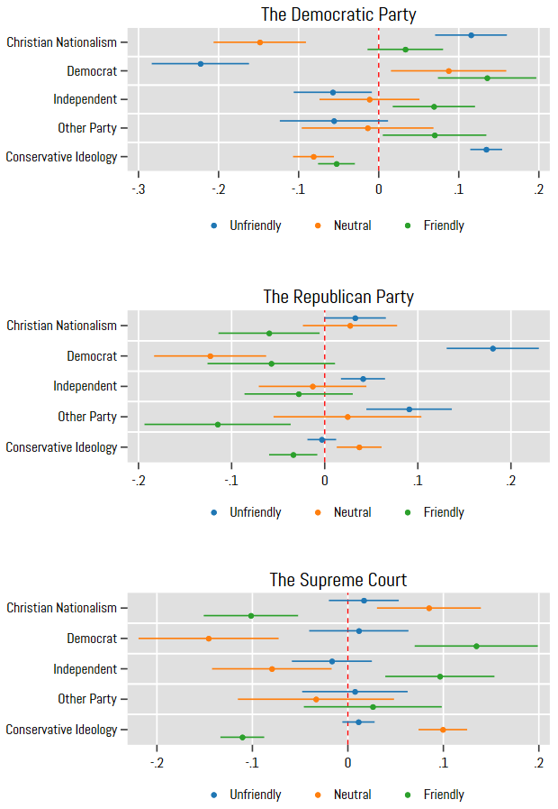

Source: American Trends Panel Survey, Wave 114.

Note: Controls held at their means. Error bars are 95% confidence intervals.

Figure 2: Predicted marginal probabilities of perceiving the Democratic Party, Republican Party, and Supreme Court as friendly toward religion by Christian nationalism and partisan identity.

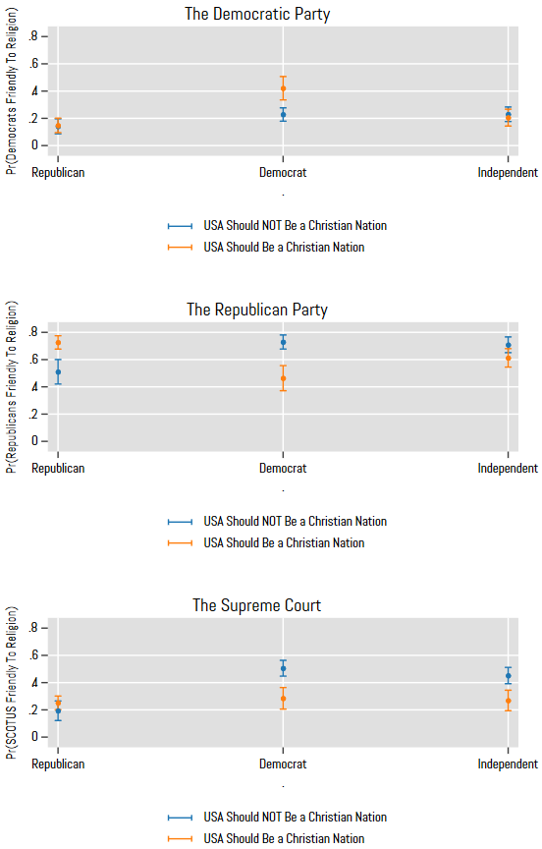

Source: Pew American Trends Panel, Wave 114.

Note: Controls held at their means. Error bars are 95% confidence intervals.

Figure 3: Predicted marginal probabilities of perceiving the Democratic Party, Republican Party, and Supreme Court as friendly toward religion by Christian nationalism and ideological identity.

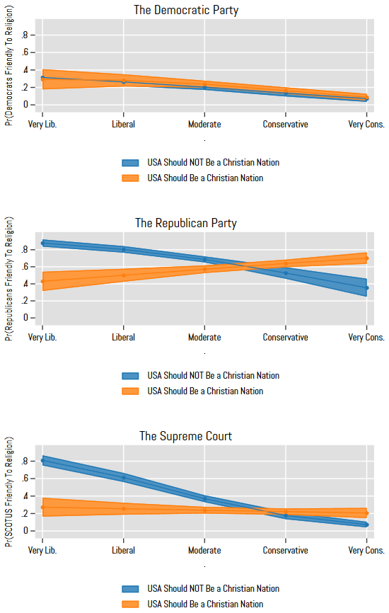

Source: Pew American Trends Panel, Wave 114

Note: Controls held at their means. Error bars are 95% confidence intervals.

Figure 4: Predicted marginal probability of perceiving the Supreme Court as neutral toward religion by Christian nationalism, partisan identity, and ideological identity.

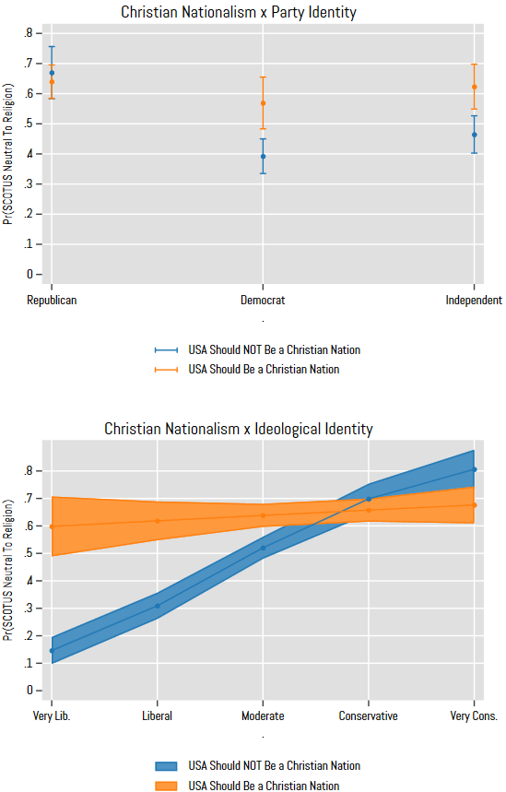

Source: Pew American Trends Panel, Wave 114

Note: Controls held at their means. Error bars are 95% confidence intervals.

**ONLINE APPENDIX MATERIAL**

**Table A1:** Descriptive Statistics

|  |  |  |  |  |
| --- | --- | --- | --- | --- |
|  | Min | Max | Mean | SD |
| Democrats Orientation to Religion | 1 | 3 | 1.85 | .73 |
| Unfriendly |  |  |  |  |
| Neutral |  |  |  |  |
| Friendly |  |  |  |  |
| Republicans Orientation to Religion | 1 | 3 | 2.57 | .66 |
| Unfriendly |  |  |  |  |
| Neutral |  |  |  |  |
| Friendly |  |  |  |  |
| Supreme Court Orientation to Religion | 1 | 3 | 2.28 | .65 |
| Unfriendly |  |  |  |  |
| Neutral |  |  |  |  |
| Friendly |  |  |  |  |
| Christian Nationalism | 0 | 1 | .47 | .5 |
| Republican | 0 | 1 | .31 | .46 |
| Democrat | 0 | 1 | .33 | .47 |
| Independent | 0 | 1 | .26 | .44 |
| Other Party | 0 | 1 | .1 | .3 |
| Conservative Ideology | 1 | 5 | 3.07 | 1.09 |
| Age | 1 | 4 | 2.78 | .96 |
| Man | 0 | 1 | .45 | .5 |
| Woman | 0 | 1 | .54 | .5 |
| White | 0 | 1 | .69 | .46 |
| Black | 0 | 1 | .11 | .31 |
| Hispanic | 0 | 1 | .14 | .34 |
| Other Race | 0 | 1 | .07 | .25 |
| Education | 1 | 6 | 4.15 | 1.51 |
| Income | 1 | 9 | 5.57 | 3.06 |
| Southern | 0 | 1 | .41 | .49 |
| White Evangelical Protestant | 0 | 1 | .25 | .44 |
| White Non-Evangelical Protestant | 0 | 1 | .16 | .37 |
| Black Protestant | 0 | 1 |  |  |
| Catholic | 0 | 1 | .19 | .39 |
| Other Christian | 0 | 1 | .02 | .15 |
| Non-Christian | 0 | 1 | .07 | .25 |
| Atheist | 0 | 1 | .06 | .24 |
| Agnostic | 0 | 1 | .06 | .24 |
| Nothing in Particular | 0 | 1 | .17 | .37 |
| Religious Service Attendance | 1 | 6 | 2.84 | 1.66 |

**Source:** Pew American Trends Panel, Wave 114.

**Table A2:** Multinomial logistic regression models predicting Americans’ perceptions that the Democratic Party is unfriendly or friendly (vs. neutral) toward religion.

|  |  |  |  |  |  |  |
| --- | --- | --- | --- | --- | --- | --- |
|  | Model 1 | | Model 2 | | Model 3 | |
|  | Reference: Neutral | | Reference: Neutral | | Reference: Neutral | |
| Predictors | Unfriendly | Friendly | Unfriendly | Friendly | Unfriendly | Friendly |
| Christian Nationalism | 0.94*** | 0.46** | 1.17*** | 0.55 | 0.79 | -0.32 |
| Democrat | -1.44*** | 0.50* | -0.94** | 0.39 | -1.43*** | 0.51* |
| Independent | -0.23 | 0.43* | -0.02 | 0.59 | -0.22 | 0.46* |
| Other Party | -0.22 | 0.44 | -0.10 | 0.79* | -0.22 | 0.45 |
| Ideological Identity | 0.98*** | -0.10 | 1.01*** | -0.10 | 0.97*** | -0.19 |
| Age | -0.09 | 0.06 | -0.09 | 0.05 | -0.09 | 0.07 |
| Woman | -0.53*** | -0.31* | -0.53*** | -0.31* | -0.53*** | -0.31* |
| Black | -0.57 | -0.16 | -0.58 | -0.17 | -0.57 | -0.14 |
| Hispanic | -0.08 | 0.32 | -0.06 | 0.29 | -0.07 | 0.34 |
| Other Race | -0.17 | 0.04 | -0.16 | 0.07 | -0.17 | 0.06 |
| Education | 0.10 | -0.03 | 0.09 | -0.02 | 0.09 | -0.04 |
| Household Income | 0.01 | -0.02 | 0.01 | -0.02 | 0.01 | -0.02 |
| Southern | -0.27* | -0.07 | -0.29* | -0.05 | -0.27* | -0.07 |
| White Non-Evangelical | -0.37 | 0.14 | -0.37 | 0.15 | -0.36 | 0.15 |
| Black Protestant | -0.60 | 0.73 | -0.56 | 0.64 | -0.58 | 0.76 |
| Catholic | -0.49** | -0.05 | -0.50** | -0.09 | -0.49** | -0.04 |
| Other Christian | -0.03 | 0.09 | -0.04 | 0.02 | -0.03 | 0.09 |
| Non-Christian Religion | -0.55 | -0.16 | -0.56 | -0.22 | -0.55 | -0.17 |
| Atheist | -0.60 | 0.07 | -0.64 | 0.01 | -0.61 | 0.03 |
| Agnostic | 0.01 | 0.22 | -0.01 | 0.16 | 0.01 | 0.20 |
| Nothing in Particular | -0.62* | -0.03 | -0.63* | -0.08 | -0.62* | -0.03 |
| Worship Attendance | 0.10* | 0.01 | 0.10* | 0.00 | 0.10* | 0.01 |
| CN × Democrat |  |  | -0.87 | 0.39 |  |  |
| CN × Independent |  |  | -0.36 | -0.39 |  |  |
| CN × Other Party |  |  | -0.29 | -1.15* |  |  |
| CN × Conservative ID |  |  |  |  | 0.05 | 0.27 |
| Intercept | -3.35*** | -1.00* | -3.56*** | -1.00 | -3.35*** | -0.77 |
| Pseudo R2 | .22 |  | .23 |  | .22 |  |

**Source:** Pew American Trends Panel, Wave 114 (N = 4,685).

**Note:** Unstandardized betas; p values are calculated with robust standard errors. Excluded categories are Republican, White, and White Evangelical Protestant.

* p < .05; ** p < .01; *** p < .001 (two-tailed tests).

**Table A3:** Multinomial logistic regression models predicting Americans’ perceptions that the Republican Party is unfriendly or friendly (vs. neutral) toward religion.

|  |  |  |  |  |  |  |
| --- | --- | --- | --- | --- | --- | --- |
|  | Model 1 | | Model 2 | | Model 3 | |
|  | Reference: Neutral | | Reference: Neutral | | Reference: Neutral | |
| Predictors | Unfriendly | Friendly | Unfriendly | Friendly | Unfriendly | Friendly |
| Christian Nationalism | 0.23 | -0.23 | 0.05 | 0.94*** | -1.66** | -3.67*** |
| Democrat | 2.57*** | 0.40* | 2.67*** | 1.70*** | 2.49*** | 0.34 |
| Independent | 0.96** | -0.01 | 0.99 | 0.98*** | 0.95** | 0.06 |
| Other Party | 1.39*** | -0.33 | 1.27* | 0.72* | 1.33*** | -0.36 |
| Ideological Identity | -0.18 | -0.21** | -0.16 | -0.17* | -0.52*** | -0.77*** |
| Age | 0.08 | 0.01 | 0.08 | 0.01 | 0.08 | 0.02 |
| Woman | -0.37* | -0.41*** | -0.36 | -0.40*** | -0.33 | -0.36** |
| Black | 0.56 | -0.57 | 0.54 | -0.55 | 0.59 | -0.52 |
| Hispanic | -0.05 | -0.32 | -0.03 | -0.25 | -0.03 | -0.26 |
| Other Race | 0.36 | -0.39 | 0.36 | -0.37 | 0.42 | -0.30 |
| Education | -0.00 | 0.11** | -0.01 | 0.09* | -0.02 | 0.08* |
| Household Income | -0.00 | 0.08*** | 0.00 | 0.09*** | -0.00 | 0.09*** |
| Southern | -0.08 | -0.03 | -0.11 | -0.10 | -0.09 | -0.03 |
| White Non-Evangelical | 0.34 | 0.13 | 0.36 | 0.18 | 0.37 | 0.21 |
| Black Protestant | -0.10 | -0.40 | 0.03 | -0.16 | 0.02 | -0.15 |
| Catholic | 0.00 | -0.37* | 0.02 | -0.34 | 0.03 | -0.29 |
| Other Christian | -0.35 | 0.05 | -0.37 | 0.03 | -0.37 | 0.06 |
| Non-Christian Religion | -0.13 | -0.11 | -0.13 | -0.10 | -0.14 | -0.10 |
| Atheist | 0.45 | 1.12** | 0.45 | 1.08** | 0.43 | 1.04** |
| Agnostic | -0.05 | 1.39*** | 0.00 | 1.45*** | -0.06 | 1.39*** |
| Nothing in Particular | -0.57 | -0.15 | -0.54 | -0.11 | -0.57 | -0.13 |
| Worship Attendance | 0.03 | 0.07 | 0.02 | 0.06 | 0.02 | 0.05 |
| CN × Democrat |  |  | -0.35 | -2.23*** |  |  |
| CN × Independent |  |  | -0.18 | -1.39*** |  |  |
| CN × Other Party |  |  | 0.10 | -1.56*** |  |  |
| CN × Conservative ID |  |  |  |  | 0.56** | 1.06*** |
| Intercept | -2.08*** | 0.97* | -1.97** | -0.02 | -0.94 | 2.57*** |
| Pseudo R2 | .13 |  | .14 |  | .15 |  |

**Source:** Pew American Trends Panel, Wave 114 (N = 4,682).

**Note:** Unstandardized betas; p values are calculated with robust standard errors. Excluded categories are Republican, White, and White Evangelical Protestant.

* p < .05; ** p < .01; *** p < .001 (two-tailed tests).

**Table A4:** Multinomial logistic regression models predicting Americans’ perceptions that the Supreme Court is unfriendly or friendly (vs. neutral) toward religion.

|  |  |  |  |  |  |  |
| --- | --- | --- | --- | --- | --- | --- |
|  | Model 1 | | Model 2 | | Model 3 | |
|  | Reference: Neutral | | Reference: Neutral | | Reference: Neutral | |
| Predictors | Unfriendly | Friendly | Unfriendly | Friendly | Unfriendly | Friendly |
| Christian Nationalism | -0.02 | -0.55*** | -0.18 | 0.31 | -0.44 | -3.42*** |
| Democrat | 0.37 | 0.79*** | 0.24 | 1.49*** | 0.35 | 0.81*** |
| Independent | -0.02 | 0.53** | -0.12 | 1.21*** | -0.01 | 0.63*** |
| Other Party | 0.12 | 0.17 | -0.07 | 0.74* | 0.10 | 0.19 |
| Ideological Identity | -0.10 | -0.64*** | -0.10 | -0.62*** | -0.17 | -1.03*** |
| Age | 0.07 | -0.00 | 0.07 | -0.00 | 0.08 | 0.02 |
| Woman | -0.08 | -0.18 | -0.09 | -0.18 | -0.08 | -0.15 |
| Black | 1.47*** | -0.12 | 1.46*** | -0.13 | 1.48*** | -0.08 |
| Hispanic | 0.12 | -0.01 | 0.11 | 0.02 | 0.13 | 0.05 |
| Other Race | -0.28 | -0.33 | -0.28 | -0.32 | -0.27 | -0.28 |
| Education | -0.03 | 0.08* | -0.02 | 0.07 | -0.03 | 0.06 |
| Household Income | -0.03 | 0.05* | -0.04 | 0.06* | -0.04 | 0.06* |
| Southern | -0.19 | -0.13 | -0.18 | -0.16 | -0.19 | -0.14 |
| White Non-Evangelical | -0.36 | 0.04 | -0.37 | 0.06 | -0.35 | 0.12 |
| Black Protestant | -1.00* | -0.16 | -1.01* | -0.01 | -0.97* | 0.07 |
| Catholic | 0.03 | -0.27 | 0.02 | -0.25 | 0.03 | -0.18 |
| Other Christian | -0.12 | 0.07 | -0.11 | 0.09 | -0.12 | 0.07 |
| Non-Christian Religion | 0.02 | 0.18 | 0.02 | 0.21 | 0.04 | 0.23 |
| Atheist | -0.98 | 0.58 | -0.98 | 0.58 | -0.97 | 0.56 |
| Agnostic | -1.07* | 0.22 | -1.07* | 0.26 | -1.08* | 0.25 |
| Nothing in Particular | -0.63* | 0.00 | -0.63* | 0.03 | -0.63* | 0.05 |
| Worship Attendance | -0.06 | 0.02 | -0.06 | 0.01 | -0.07 | 0.01 |
| CN × Democrat |  |  | 0.17 | -1.25*** |  |  |
| CN × Independent |  |  | 0.14 | -1.12** |  |  |
| CN × Other Party |  |  | 0.30 | -0.76 |  |  |
| CN × Conservative ID |  |  |  |  | 0.12 | 0.92*** |
| Intercept | -0.85 | 0.89* | -0.73 | 0.26 | -0.60 | 1.84*** |
| Pseudo R2 | .14 |  | .14 |  | .15 |  |

**Source:** Pew American Trends Panel, Wave 114 (N = 4,679).

**Note:** Unstandardized betas; p values are calculated with robust standard errors. Excluded categories are Republican, White, and White Evangelical Protestant.

* p < .05; ** p < .01; *** p < .001 (two-tailed tests).

**Table A5:** Multinomial logistic regression models predicting Americans’ perceptions that the Biden Administration is unfriendly or friendly (vs. neutral) toward religion.

|  |  |  |  |  |  |  |
| --- | --- | --- | --- | --- | --- | --- |
|  | Model 1 | | Model 2 | | Model 3 | |
|  | Reference: Neutral | | Reference: Neutral | | Reference: Neutral | |
| Predictors | Unfriendly | Friendly | Unfriendly | Friendly | Unfriendly | Friendly |
| Christian Nationalism | 0.72*** | 0.27 | 0.88*** | 0.41 | 1.07 | 0.17 |
| Democrat | -1.78*** | 0.56** | -1.27** | 0.55 | -1.77*** | 0.56** |
| Independent | -0.62*** | 0.45* | -0.57* | 0.59* | -0.62*** | 0.45* |
| Other Party | -0.18 | 0.23 | -0.01 | 0.59 | -0.17 | 0.24 |
| Ideological Identity | 0.89*** | -0.18* | 0.91*** | -0.18* | 0.95*** | -0.20* |
| Age | 0.21** | 0.22*** | 0.21** | 0.22*** | 0.21** | 0.22*** |
| Woman | -0.36** | -0.03 | -0.36** | -0.03 | -0.37** | -0.03 |
| Black | 0.06 | -0.04 | 0.07 | -0.05 | 0.06 | -0.04 |
| Hispanic | 0.30 | 0.17 | 0.33 | 0.15 | 0.30 | 0.18 |
| Other Race | -0.43 | -0.12 | -0.43 | -0.10 | -0.44 | -0.12 |
| Education | 0.07 | -0.01 | 0.06 | -0.01 | 0.07 | -0.01 |
| Household Income | 0.01 | -0.01 | 0.01 | -0.00 | 0.01 | -0.01 |
| Southern | -0.13 | -0.08 | -0.15 | -0.07 | -0.13 | -0.08 |
| White Non-Evangelical | -0.10 | 0.37 | -0.10 | 0.39 | -0.10 | 0.37 |
| Black Protestant | -1.36* | 0.26 | -1.32* | 0.20 | -1.37* | 0.26 |
| Catholic | -0.37 | 0.08 | -0.38* | 0.07 | -0.37 | 0.08 |
| Other Christian | -0.53 | -0.33 | -0.56 | -0.37 | -0.53 | -0.33 |
| Non-Christian Religion | -0.61* | -0.11 | -0.62* | -0.14 | -0.61* | -0.11 |
| Atheist | -1.16** | 0.43 | -1.16** | 0.39 | -1.17** | 0.42 |
| Agnostic | -0.49 | 0.02 | -0.48 | -0.01 | -0.48 | 0.02 |
| Nothing in Particular | -0.55* | -0.05 | -0.55* | -0.08 | -0.55* | -0.05 |
| Worship Attendance | 0.10 | -0.02 | 0.10 | -0.02 | 0.10 | -0.02 |
| CN × Democrat |  |  | -0.92 | 0.19 |  |  |
| CN × Independent |  |  | -0.06 | -0.28 |  |  |
| CN × Other Party |  |  | -0.39 | -1.12* |  |  |
| CN × Conservative ID |  |  |  |  | -0.10 | 0.04 |
| Intercept | -3.85*** | -1.10* | -4.00*** | -1.18* | -4.08*** | -1.07* |
| Pseudo R2 | .22 |  | .22 |  | .22 |  |

**Source:** Pew American Trends Panel, Wave 114 (N = 4,689).

**Note:** Unstandardized betas; p values are calculated with robust standard errors. Excluded categories are Republican, White, and White Evangelical Protestant.

* p < .05; ** p < .01; *** p < .001 (two-tailed tests).

Figure A1: Predicted marginal probability of perceiving the Democratic Party as neutral toward religion by Christian nationalism, partisan identity, and ideological identity.

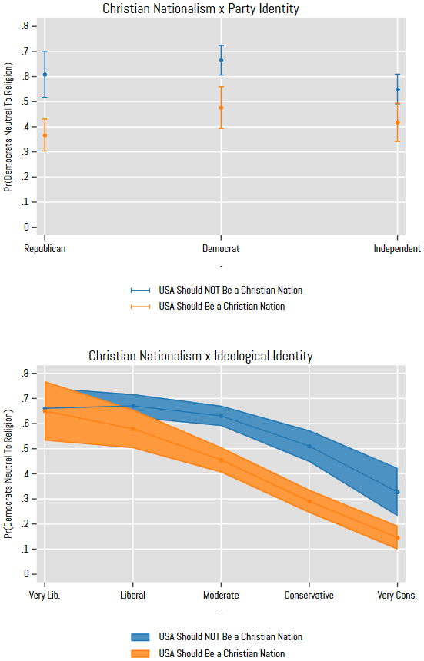

Source: Pew American Trends Panel, Wave 114

Note: Controls held at their means. Error bars are 95% confidence intervals.

Figure A2: Predicted marginal probability of perceiving the Democratic Party as unfriendly toward religion by Christian nationalism, partisan identity, and ideological identity.

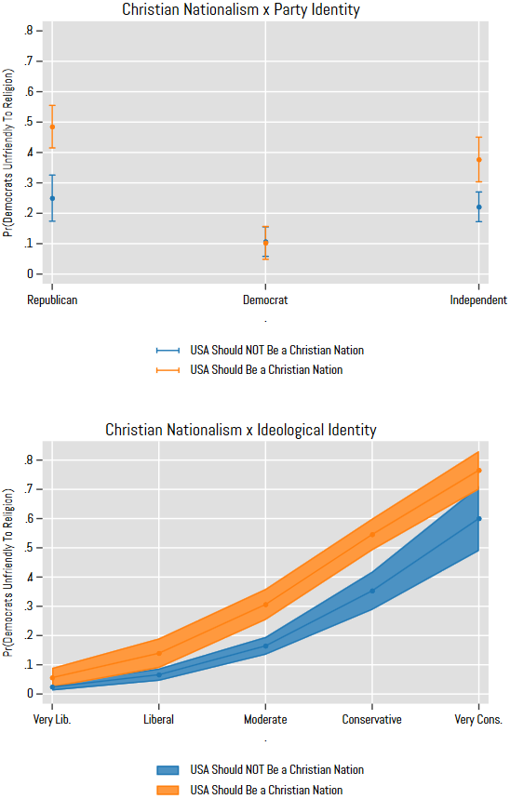

Source: Pew American Trends Panel, Wave 114

Note: Controls held at their means. Error bars are 95% confidence intervals.

Figure A3: Predicted marginal probability of perceiving the Republican Party as neutral toward religion by Christian nationalism, partisan identity, and ideological identity.

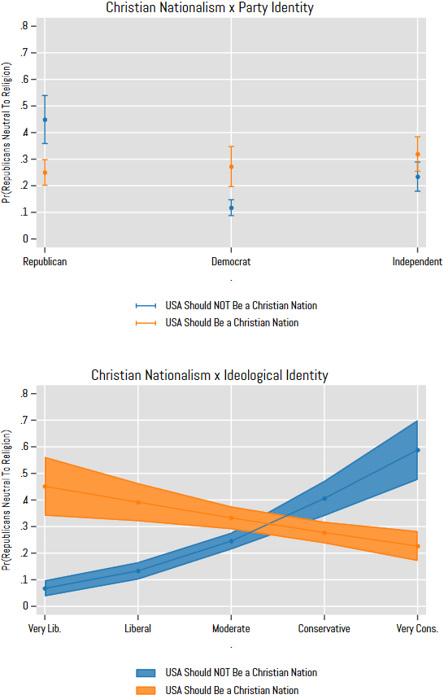

Source: Pew American Trends Panel, Wave 114

Note: Controls held at their means. Error bars are 95% confidence intervals.

Figure A4: Predicted marginal probability of perceiving the Republican Party as unfriendly toward religion by Christian nationalism, partisan identity, and ideological identity.

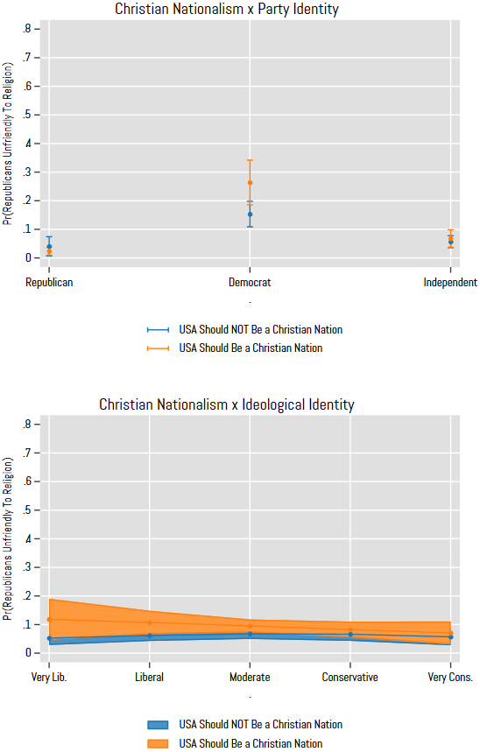

Source: Pew American Trends Panel, Wave 114

Note: Controls held at their means. Error bars are 95% confidence intervals.

1. Regarding racial identity, Perry and Davis (2023) found Black Americans in particular tended to rate Democratic candidates’ religiosity higher compared to White Americans, and when comparing the religiosity of Biden vs. Harris, were more likely to rate Harris’s religiosity higher. Thus, racial identity congruence reflects congruence on partisan and/or racial identities.
2. The survey also asked about “the Biden Administration,” but since Perry and Davis (2024) have already explored the link between identity congruence and feelings about Biden’s religiosity, the novel contribution would be limited. Analyses of this outcome, however, were nearly identical as those for The Democratic Party (see Online Appendix Table A5).
3. This is often referred to as an “ideology” measure, though I argue it more accurately reflects an ideological identity. Research on such ideological spectrum measures suggest Americans are often unclear on what policy opinions correspond to being “Very Liberal,” “Moderate,” “Conservative,” etc. (Jefferson 2020; Kinder and Kalmoe 2017). Rather, it is more accurate to understand this as an indicator of self-identification (“I consider myself very liberal.”). I include it as an ordinal measure to reflect the degree of commitment one has to identities across the spectrum, much like one would include a 5- or 7-value partisan identity measure.
4. In observing how these answers correspond with other questions, roughly 80% of Americans who affirmed the US should be a Christian nation thought the Bible should have “Some/A Great Deal” of influence on laws in the United States and 89% believe America’s founders intended the United States to be a Christian nation.
5. The ATP also gave options for a non-binary category, but the numbers were so small as to be unreliable in models. Thus, these cases were omitted.
6. I replicate these same figures regarding Democrats and Republicans as the entities in consideration and the differences are clear from the Supreme Court (see Appendix Figures A1 and A3). As Americans become more conservative, for example, they are less likely to see Democrats as neutral toward religion regardless of their views on Christian nationalism, because they are more likely to view Democrats as unfriendly to religion (see Figure A2). Conversely, regarding Republicans, ideological identity and Christian nationalism reflect the opposite pattern that I find in Figure 3. Those *least* likely to view Republicans as neutral toward religion are anti-Christian nationalist liberals and pro-Christian nationalist conservatives (both of whom largely view Republicans as friendly to religion).