**ONLINE APPENDIX MATERIAL**

**Table A1:** Ordinary least squares regression models predicting support for leaders violating democratic norms during national emergencies with four Christian nationalism measures.

|  |  |  |  |  |  |  |  |  |
| --- | --- | --- | --- | --- | --- | --- | --- | --- |
|  | God’s Plan | | Christian Nation | | Founding Docs | | True American | |
| Predictors | b | RSE | b | RSE | b | RSE | b | RSE |
| God’s Plan | 0.04*** | 0.01 |  |  |  |  |  |  |
| Christian Nation |  |  | 0.04*** | 0.01 |  |  |  |  |
| Founding Docs |  |  |  |  | 0.03*** | 0.01 |  |  |
| True American |  |  |  |  |  |  | 0.04*** | 0.01 |
| Conservative Ideology | 0.01 | 0.03 | 0.01 | 0.03 | 0.01 | 0.03 | 0.01 | 0.03 |
| Republican Partisanship | -0.10*** | 0.02 | -0.09*** | 0.02 | -0.09*** | 0.02 | -0.09*** | 0.02 |
| Some of the time | 0.10*** | 0.01 | 0.10*** | 0.01 | 0.10*** | 0.01 | 0.10*** | 0.01 |
| Only now and then | 0.15*** | 0.02 | 0.14*** | 0.02 | 0.15*** | 0.02 | 0.14*** | 0.02 |
| Hardly at all | 0.15*** | 0.02 | 0.16*** | 0.02 | 0.16*** | 0.02 | 0.16*** | 0.02 |
| Don’t know | 0.12*** | 0.03 | 0.11*** | 0.03 | 0.13*** | 0.03 | 0.11*** | 0.03 |
| Age | -0.10*** | 0.03 | -0.10*** | 0.03 | -0.11*** | 0.03 | -0.11*** | 0.03 |
| Woman | 0.05*** | 0.01 | 0.05*** | 0.01 | 0.05*** | 0.01 | 0.05*** | 0.01 |
| Non-binary | -0.04 | 0.04 | -0.05 | 0.04 | -0.04 | 0.04 | -0.05 | 0.04 |
| Black | 0.05** | 0.02 | 0.05*** | 0.02 | 0.06*** | 0.02 | 0.05** | 0.02 |
| Hispanic | -0.01 | 0.02 | -0.01 | 0.02 | -0.00 | 0.02 | -0.00 | 0.02 |
| Other Race | -0.00 | 0.02 | -0.00 | 0.02 | -0.01 | 0.02 | -0.00 | 0.02 |
| Education | -0.08*** | 0.02 | -0.07*** | 0.02 | -0.08*** | 0.02 | -0.07*** | 0.02 |
| $30-60K | 0.00 | 0.01 | 0.00 | 0.01 | 0.00 | 0.01 | 0.00 | 0.01 |
| $60-100K | -0.04* | 0.02 | -0.04** | 0.02 | -0.04** | 0.02 | -0.04** | 0.02 |
| $100-200K | -0.06*** | 0.02 | -0.07*** | 0.02 | -0.07*** | 0.02 | -0.07*** | 0.02 |
| $200K or more | -0.10*** | 0.03 | -0.10*** | 0.03 | -0.10*** | 0.03 | -0.10*** | 0.03 |
| Didn’t report | -0.03 | 0.02 | -0.03 | 0.02 | -0.03 | 0.02 | -0.03 | 0.02 |
| Southern | 0.01 | 0.01 | 0.01 | 0.01 | 0.01 | 0.01 | 0.01 | 0.01 |
| Non-Evangelical Prot. | 0.01 | 0.02 | 0.02 | 0.02 | 0.01 | 0.02 | 0.02 | 0.02 |
| Catholic | 0.05** | 0.02 | 0.06*** | 0.02 | 0.05** | 0.02 | 0.06*** | 0.02 |
| Other Christian | -0.03 | 0.04 | -0.01 | 0.04 | -0.02 | 0.04 | -0.01 | 0.04 |
| Other Religion | -0.01 | 0.02 | -0.00 | 0.02 | -0.01 | 0.02 | 0.00 | 0.02 |
| Atheist | -0.03 | 0.03 | -0.04 | 0.03 | -0.04 | 0.03 | -0.03 | 0.03 |
| Agnostic | -0.00 | 0.03 | -0.00 | 0.03 | -0.01 | 0.03 | 0.00 | 0.03 |
| Nothing in Particular | 0.02 | 0.02 | 0.03 | 0.02 | 0.02 | 0.02 | 0.04 | 0.02 |
| Religiosity | -0.01 | 0.02 | 0.01 | 0.02 | 0.02 | 0.02 | -0.01 | 0.02 |
| Constant | 0.25*** | 0.03 | 0.27*** | 0.03 | 0.28*** | 0.03 | 0.27*** | 0.03 |
| R-squared | 0.22 |  | 0.22 |  | 0.21 |  | 0.22 |  |

**Source:** National Addiction and Social Attitudes Survey, Wave 1 (N = 2,802).

**Note:** Excluded categories are Most of the time, Man, White, Less than $30K per year, and Evangelical Protestant; RSE = robust standard errors.

* p < .05, ** p < .01, *** p < .001 (two-tailed tests).

**Table A2:** Ordinary least squares regression models predicting support for leaders violating democratic norms during national emergencies across party identities.

|  |  |  |  |  |  |  |
| --- | --- | --- | --- | --- | --- | --- |
|  | Democrat | | Republican | | Independent | |
| Predictors | b | RSE | b | RSE | b | RSE |
| Christian Nationalism | 0.40*** | 0.05 | 0.17*** | 0.05 | 0.12* | 0.05 |
| Conservative Ideology | 0.11** | 0.04 | -0.21*** | 0.06 | -0.03 | 0.04 |
| Some of the time | 0.04* | 0.02 | 0.11*** | 0.03 | 0.10*** | 0.02 |
| Only now and then | 0.05* | 0.02 | 0.19*** | 0.03 | 0.17*** | 0.03 |
| Hardly at all | 0.05 | 0.04 | 0.23*** | 0.04 | 0.16*** | 0.03 |
| Don’t know | -0.03 | 0.04 | 0.28*** | 0.06 | 0.13*** | 0.04 |
| Age | -0.22*** | 0.04 | -0.02 | 0.06 | -0.08 | 0.05 |
| Woman | 0.04* | 0.02 | 0.04* | 0.02 | 0.06** | 0.02 |
| Non-binary | 0.04 | 0.07 | -0.32*** | 0.04 | -0.09 | 0.06 |
| Black | 0.02 | 0.02 | 0.08 | 0.06 | 0.01 | 0.03 |
| Hispanic | -0.01 | 0.02 | -0.01 | 0.03 | 0.00 | 0.03 |
| Other Race | 0.01 | 0.03 | -0.05 | 0.04 | 0.00 | 0.03 |
| Education | -0.07* | 0.03 | -0.03 | 0.04 | -0.08* | 0.03 |
| $30-60K | 0.02 | 0.02 | -0.05 | 0.03 | -0.03 | 0.03 |
| $60-100K | -0.00 | 0.02 | -0.07* | 0.03 | -0.08** | 0.03 |
| $100-200K | -0.01 | 0.03 | -0.13*** | 0.04 | -0.09** | 0.03 |
| $200K or more | -0.08 | 0.05 | -0.12* | 0.05 | -0.21*** | 0.04 |
| Didn’t report | -0.00 | 0.03 | -0.09* | 0.04 | -0.01 | 0.03 |
| Southern | 0.00 | 0.02 | 0.03 | 0.02 | -0.01 | 0.02 |
| Non-Evangelical Prot. | 0.00 | 0.03 | 0.03 | 0.04 | 0.05 | 0.04 |
| Catholic | 0.03 | 0.03 | 0.04 | 0.03 | 0.09** | 0.03 |
| Other Christian | 0.05 | 0.10 | 0.04 | 0.05 | -0.07 | 0.06 |
| Other Religion | -0.02 | 0.04 | 0.05 | 0.04 | 0.04 | 0.04 |
| Atheist | -0.04 | 0.04 | 0.15 | 0.10 | 0.03 | 0.05 |
| Agnostic | 0.02 | 0.04 | -0.07 | 0.07 | 0.05 | 0.05 |
| Nothing in Particular | 0.04 | 0.03 | 0.04 | 0.04 | 0.04 | 0.04 |
| Religiosity | -0.02 | 0.03 | -0.08 | 0.05 | 0.00 | 0.04 |
| Constant | 0.28*** | 0.04 | 0.39*** | 0.08 | 0.25*** | 0.06 |
| R-squared | 0.35 |  | 0.23 |  | 0.23 |  |
| N | 1,082 |  | 633 |  | 838 |  |

**Source:** National Addiction and Social Attitudes Survey, Wave 1.

**Note:** Excluded categories are Most of the time, Man, White, Less than $30K per year, and Evangelical Protestant; RSE = robust standard errors.

* p < .05, ** p < .01, *** p < .001 (two-tailed tests).

**Table A3:** Ordinary least squares regression models predicting support for leaders violating democratic norms during national emergencies across racial identity.

|  |  |  |  |  |  |  |
| --- | --- | --- | --- | --- | --- | --- |
|  | White | | Black | | Hispanic | |
| Predictors | b | RSE | b | RSE | b | RSE |
| Christian Nationalism | 0.22*** | 0.03 | 0.31*** | 0.07 | 0.31*** | 0.06 |
| Conservative Ideology | -0.03 | 0.04 | -0.01 | 0.07 | -0.01 | 0.07 |
| Republican Partisanship | -0.08** | 0.03 | -0.08 | 0.05 | -0.13* | 0.06 |
| Some of the time | 0.08*** | 0.02 | 0.14*** | 0.03 | 0.14*** | 0.03 |
| Only now and then | 0.15*** | 0.03 | 0.07 | 0.04 | 0.19*** | 0.04 |
| Hardly at all | 0.19*** | 0.03 | 0.08 | 0.04 | 0.14** | 0.05 |
| Don’t know | 0.14*** | 0.03 | 0.07 | 0.05 | 0.07 | 0.06 |
| Age | -0.11** | 0.03 | -0.10 | 0.06 | -0.08 | 0.07 |
| Woman | 0.05*** | 0.01 | 0.04 | 0.03 | 0.06* | 0.03 |
| Non-binary | -0.05 | 0.04 | 0.07 | 0.05 | -0.04 | 0.06 |
| Education | -0.09*** | 0.02 | -0.10 | 0.05 | -0.00 | 0.05 |
| $30-60K | -0.01 | 0.02 | 0.04 | 0.03 | 0.05 | 0.04 |
| $60-100K | -0.02 | 0.02 | -0.04 | 0.04 | -0.10** | 0.04 |
| $100-200K | -0.05* | 0.02 | -0.00 | 0.06 | -0.11* | 0.05 |
| $200K or more | -0.08** | 0.03 | -0.16 | 0.14 | -0.25** | 0.09 |
| Didn’t report | -0.04 | 0.02 | -0.01 | 0.04 | -0.00 | 0.04 |
| Southern | 0.01 | 0.01 | -0.01 | 0.03 | 0.05 | 0.03 |
| Non-Evangelical Prot. | 0.03 | 0.02 | -0.00 | 0.05 | -0.00 | 0.07 |
| Catholic | 0.05* | 0.02 | 0.07 | 0.04 | 0.05 | 0.05 |
| Other Christian | -0.01 | 0.04 | -0.02 | 0.06 | 0.00 | 0.07 |
| Other Religion | 0.01 | 0.03 | -0.01 | 0.04 | -0.10 | 0.06 |
| Atheist | -0.03 | 0.03 | -0.18 | 0.10 | 0.02 | 0.07 |
| Agnostic | -0.01 | 0.04 | -0.05 | 0.06 | 0.04 | 0.08 |
| Nothing in Particular | 0.03 | 0.02 | 0.06 | 0.04 | 0.05 | 0.05 |
| Religiosity | -0.05 | 0.03 | 0.02 | 0.06 | 0.04 | 0.05 |
| Constant | 0.31*** | 0.04 | 0.28*** | 0.08 | 0.17* | 0.08 |
| R-squared | 0.19 |  | 0.28 |  | 0.36 |  |
| N | 1,848 |  | 351 |  | 367 |  |

**Source:** National Addiction and Social Attitudes Survey, Wave 1.

**Note:** Excluded categories are Most of the time, Man, White, Less than $30K per year, and Evangelical Protestant; RSE = robust standard errors.

* p < .05, ** p < .01, *** p < .001 (two-tailed tests).

**Figure A1:** Predicted marginal effects of gender identity on support for leaders violating democratic norms across values of Christian nationalism.

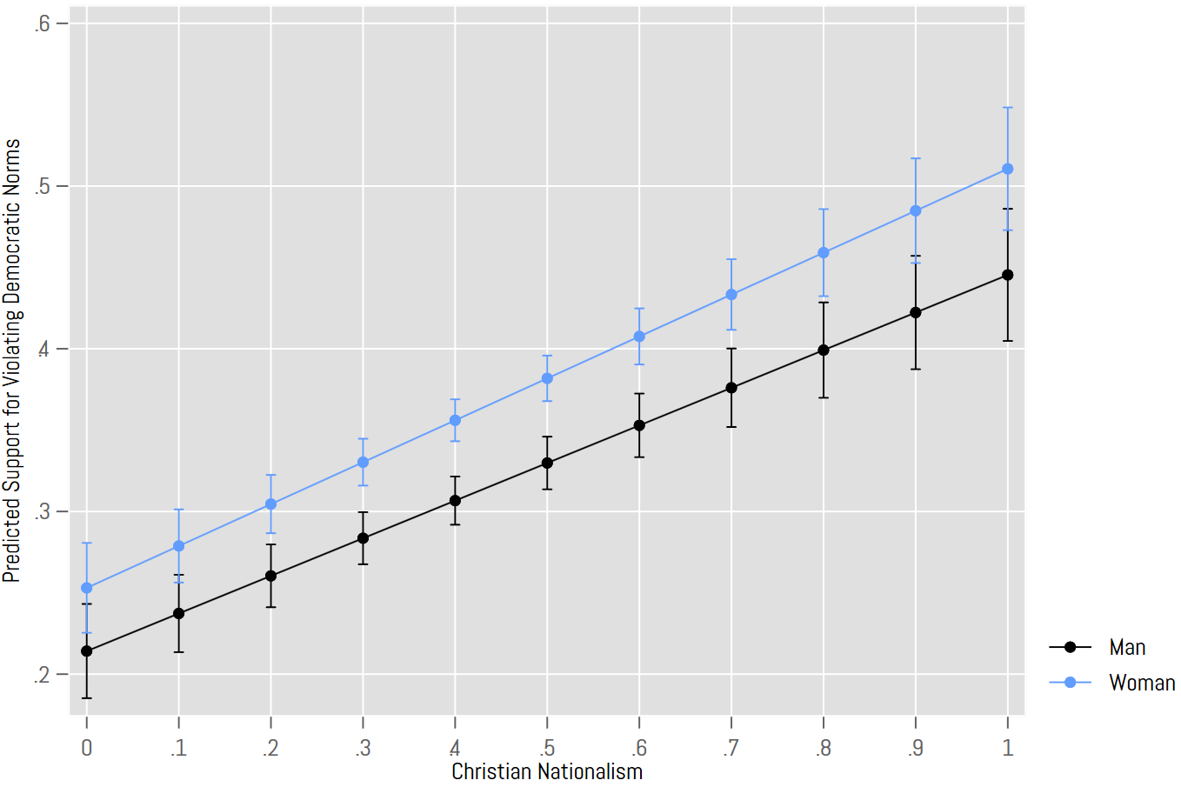

**Source:** National Addiction and Social Attitudes Survey, Wave 1 (N=2,802).

**Note:** Results from Model 3, Table 3. All variables range from 0 to 1. Controls held at their means. Error bars are 95% confidence intervals.