Appendix
The Ingroup Love and Outgroup Hate of Christian Nationalism: Experimental Evidence about the Rule of Law

Variable Coding
Christian nationalism – Is an index of 6 statements each using 5 point likert scales with the third reverse coded so that disagreement is high: The federal government should declare the United States a Christian nation; The federal government should advocate Christian values; The federal government should enforce strict separation of church and state; The success of the United States is part of God's plan; and The federal government should allow prayer in public schools; and The federal government should allow the display of religious symbols in public spaces. Recoded to run from 0-1.
Belief in Christian persecution – Is an index of four statements using a 5 point likert scale with agreement the high value: Christians will lose their religious freedom if Democrats control the federal government; A Democratic President is likely to ban the Bible; A Democratic President will force you to pay for abortions; and A Democratic President will take your guns. Recoded to run from 0-1.
Worship attendance – “Aside from weddings and funerals, how often do you typically attend religious services?” 5=More than once a week or Once a week; 4=A few times a month; 3=A few times a year; 2=Seldom; 1=Never.
Education – “What is the highest level of education that you have completed?” 1= Less than High School, 2=High School or GED, 3=Some college or trade school, 4=4-year college graduate, 5=Graduate education (toward a master's or doctoral degree)
White – “What is your race/ethnicity?” (choose as many as apply) White=1; Hispanic, Black, Asian, Other =0.
Age – “In what year were you born?” Age = 2021 - year born.
Women – women=1, men=0.
Partisanship – “Generally, which of these party labels bests describes you?” 1=Strong Democrat, 2=Democrat, 3=4=Strong Democrat/Republican, 4=Independent, 5=independent, but lean Republican, 6=Republican, 7=Strong Republican
Religious tradition – Coded using the denominational RELTRAD scheme from Steensland et al. (2000) with the adjustments from Burge and Djupe (2021).
Table A1 – Demographic Distribution Across Treatment Cells and Randomization Tests
Demographics | Baptist | Football | Muslim | Vegan | ANOVA p
% Women | 53.2 | 56.5 | 55.1 | 55.0 | 0.925
% College | 41.4 | 36.6 | 38.1 | 41.6 | 0.525
% White | 77.1 | 77.8 | 77.0 | 77.3 | 0.999
% South | 36.0 | 39.4 | 40.3 | 38.7 | 0.775
% 18-24 | 7.8 | 7.3 | 8.7 | 6.7 | 0.824
Source: September 2021 Survey.

Table A2 – Principal factors analysis of the Christian nationalism index, with and without rotation
 | Factor Loadings, Principal Factor | Factor Loadings,  Promax Rotation |  | Uniqueness
 |  | Factor 1 | Factor 2
Christian nation | .80 | .79 |  | .31
Christian values | .82 | .73 |  | .30
Separation of church and state |  |  |  | .97
Success of US is God’s plan | .75 | .59 |  | .43
Prayer in Public schools | .81 |  | .71 | .28
Display of symbols in public spaces | .77 |  | .75 | .33
Eigenvalue/variance | 3.11 | 2.81 | 2.62
Source: September 2021 Survey. N=2,020
Notes: Loadings less than 0.5 have been omitted for clarity.

Table A3 – Principal factors analysis of the Christian Persecution index, with and without rotation
 | Factor Loadings, Principal Factor | Factor Loadings,  Promax Rotation |  | Uniqueness
 |  | Factor 1 | Factor 2
Lose religious freedom | .90 | .64 | .29 | .18
Ban the bible | .88 | .64 | .26 | .22
Force you to pay for abortions | .82 | .47 | .38 | .32
Take your guns | .85 | .49 | .39 | .28
Eigenvalue/variance | 2.98 | 2.88 | 2.68
Source: September 2021 Survey. N=2,020

Table A4 – Full OLS Model Estimates Underlying Figures 3 and 4 (p values in parentheses)
 | Interaction with  Christian nationalism | Interaction with belief in  Christian persecution
(Intercept) | 0.62 | 0.56
 | (0.00) | (0.00)
Reference: Military treatment | — | —
Baptist treatment | -0.51 | -0.42
 | (0.00) | (0.00)
Football treatment | -0.60 | -0.50
 | (0.00) | (0.00)
Muslim treatment | -0.28 | -0.19
 | (0.00) | (0.00)
Vegan treatment | -0.42 | -0.36
 | (0.00) | (0.00)
Christian nationalism | -0.08 | 0.17
 | (0.44) | (0.00)
Christian persecution | -0.15 | -0.27
 | (0.00) | (0.00)
White | -0.01 | -0.01
 | (0.84) | (0.76)
Reference: Democrat | — | —
Independent | 0.06 | 0.06
 | (0.03) | (0.03)
Republican | 0.04 | 0.04
 | (0.19) | (0.18)
Women | 0.09 | 0.09
 | (0.00) | (0.00)
Education | -0.02 | -0.02
 | (0.05) | (0.05)
Age | 0.00 | 0.00
 | (0.59) | (0.59)
Midwest | -0.05 | -0.05
 | (0.12) | (0.12)
South | -0.05 | -0.05
 | (0.10) | (0.10)
West | -0.07 | -0.07
 | (0.02) | (0.03)
Reference: Evangelical | — | —
Mainline | 0.03 | 0.03
 | (0.44) | (0.43)
Black Protestant | -0.01 | -0.00
 | (0.95) | (0.99)
Catholic | -0.00 | -0.01
 | (0.89) | (0.86)
Other Christian | -0.01 | -0.02
 | (0.85) | (0.84)
Jewish | 0.00 | 0.01
 | (0.95) | (0.91)
Muslim | -0.11 | -0.11
 | (0.19) | (0.18)
Other Faith | 0.02 | 0.01
 | (0.64) | (0.74)
No Religion | 0.07 | 0.07
 | (0.04) | (0.04)
Non-Denominational | 0.12 | 0.12
 | (0.00) | (0.00)
Unclassified | 0.03 | 0.03
 | (0.55) | (0.58)
Baptist treatment * Christian nationalism | 0.45
 | (0.00)
Football treatment * Christian nationalism | 0.39
 | (0.00)
Muslim treatment * Christian nationalism | 0.18
 | (0.15)
Vegan treatment * Christian nationalism | 0.17
 | (0.17)
Baptist * Christian persecution |  | 0.29
 |  | (0.00)
Football * Christian persecution |  | 0.22
 |  | (0.02)
Muslim * Christian persecution |  | 0.01
 |  | (0.89)
Vegan * Christian persecution |  | 0.08
 |  | (0.37)
N | 2003 | 2003
R² | 0.13 | 0.13
Source: September 2021 Survey.
Figure A1 – Marginal Effect of Christian Nationalism by Treatment, Split by 6, 4, and 2 question Christian Nationalism Scale Versions
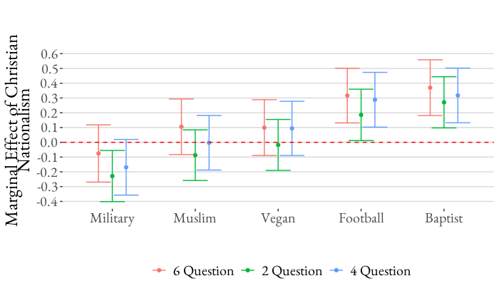
Source: September 2021 Survey.
Note: 95% CIs displayed.

Figure A2 – Stability of Treatment Effects with Different Model Specifications
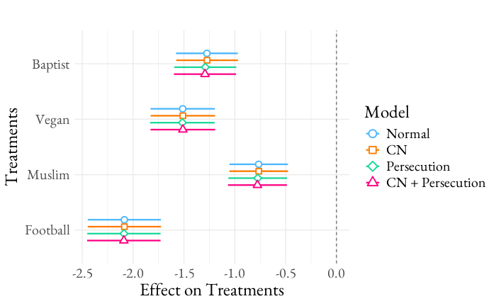
Source: September 2021 Survey.
Note: 95 percent CIs shown.

Are the Effects Conditional on Partisanship?
There’s an intriguing possibility that partisanship plays a special role in producing these effects, in part because of the explicit partisan nature of the religious persecution claims. In 2020, the persecution claims we tested were the only claims of Christian persecution that were being made in this time frame (or something like them). That fact does raise the possibility that persecution has been received differently and then adopted and used differently because it has been attached to the Democratic Party. We thank R2 for encouraging this discussion and analysis.

In October 2020, at the height of the election campaign (we brought in some other data gathered in the same way for context), partisanship did interact with Christian nationalism to shape who reported hearing elites making these arguments. In Figure A3, CN has a positive effect among all three partisan affiliations, but was much stronger among Republicans. That pattern remained stable into 2021 (with the data used in this paper), which isn’t surprising given the Insurrection and the aftermath. One thing to note is that the floor was raised in 2021 – non-CN Republicans doubled in their probability of hearing at least one persecution claim. Also, Independents finally tuned in and that is reflected in a relationship with CN in 2021.

Figure A3 – The Interaction of Partisanship and Christian Nationalism in Hearing a Christian Persecution Claim
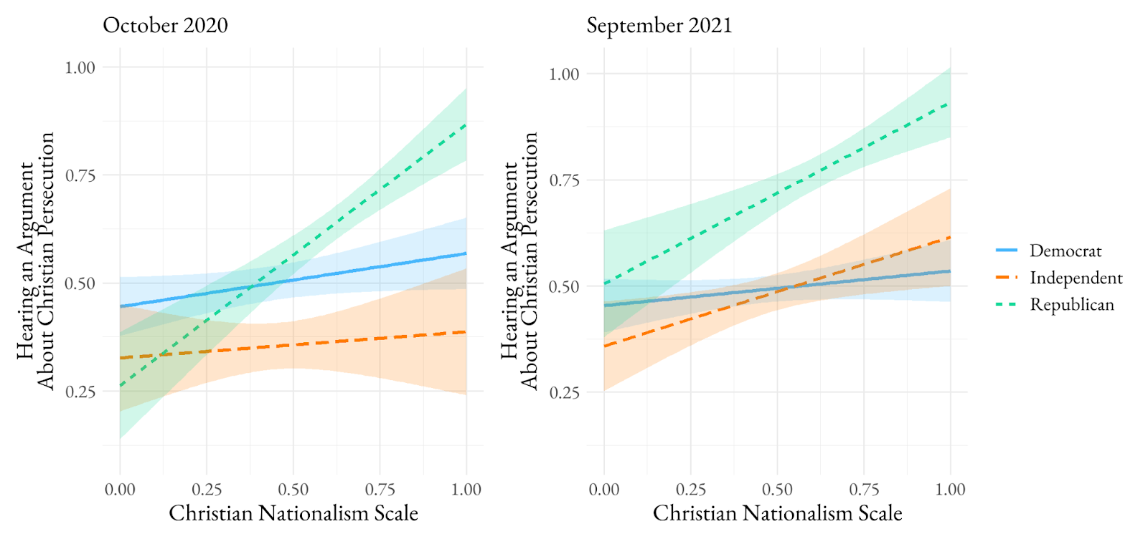
If the exposure is not equal by partisanship, then does adoption of persecution beliefs by Christian nationalists likewise differ by partisanship? We used those same four statements, but asked whether the respondents agree with them. The conditional influence by partisanship of Christian nationalism on that persecution scale is shown in Figure A4. Democrats and Independents start at a lower threshold in their adoption of Christian persecution beliefs, but rise more quickly with growing Christian nationalism to almost catch Christian nationalist Republicans. Yes, in the end, Christian nationalist Democrats believe somewhat fewer persecution beliefs, which is surely a function of exposure to this argumentation seen in Figure A3, but substantively their scores are quite close. The relationships are also stable across the 2020-2021 period.

Figure A4 – How Christian Nationalism is Connected to Christian Persecution Beliefs for Partisans
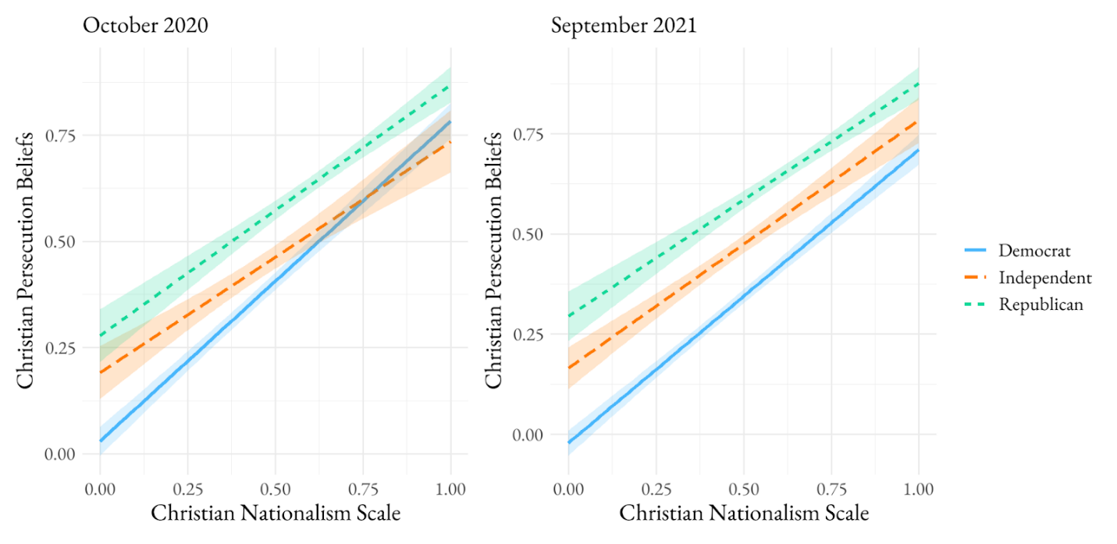

In Figure A5, we assess whether the treatment effect pattern is contingent on partisanship. There are two ways to view these results. One is to assess the effects compared to zero, and only the Muslim and Vegan host significant declines in the probability of a warning among Democrats and Independents when Christian persecution jumps from 0 to 1. Of course, weaker effects overall are expected given that we are cutting the sample size by roughly 3x in each cell. The other is to assess the general pattern relative to what we see at the sample-level (Figure 4), which most closely reflects the pattern seen here among Independents. In almost all cases, the Muslim and Vegan show a lower likelihood of receiving a warning than the football fan or Baptist, though it’s clearly not always significant as Figure 4 and independents in Figure A5 show. Therefore, we tentatively believe that the results by party are not considerably different than what we report for the sample as a whole.

Figure A5 – Treatment Effects Contingent on Persecution Beliefs by Partisans
