Appendix
Prepping for the Apocalypse: Religion and Politics in the Post 2020 Election Era

Variable Coding
Preparedness The preparedness measures were extensive and two-pronged. The first set asked about activities undertaken, including (response options no; thought about it, but haven’t done it; and yes): Put together emergency supplies like water, food, or medicine kept in your home; Changed any part of your home to protect it against wind, flooding, or other natural disasters; Practiced what to do if there is an emergency when you are at home; Volunteered to help your local community prepare for or respond to an emergency; Taken first aid training such as CPR to keep someone breathing or resuscitate someone; Made a plan for how you and the people you live with would communicate in an emergency; Decided on a place for the people you live with to meet if they cannot go home in an emergency; Bought insurance to protect you or your property against a disaster. The second set asked about supplies kept on hand: A radio that is battery operated or hand-cranked; A first-aid kit; At least three days’ worth of canned or dried food for each person who lives in your home; A flashlight; Extra batteries for a radio or flashlight; At least three days’ worth of medicine for anyone in your household who would need it; At least six months worth of canned or dried food for each person who lives in your household; The ability to grow your own fruit and vegetables, and have a source of fresh meat that could provide for everyone in your household if grocery stores were closed. These were coded 0=no/haven’t thought about it, 1=yes.
Gun ownership – “Do you happen to have a gun in the home?” 1=Yes, 0=No or don’t know.
Gun buying – “Do you plan to buy a gun in the next 12 months?” 1=Yes, 0=No or don’t know.
Apocalypticism – Has three separate scales/measures that are averaged. The specific items are listed in the text. We compute 0-1 scales for belief in evil (from 3 items), belief in prophecy (from 3 items), and belief that we are in the end times (1 item) so that each dimension is weighted the same in the final measure.
Christian nationalism – Is an index of 6 statements using 5 point likert scales with the third reverse coded so that disagreement is high: The federal government should declare the United States a Christian nation; The federal government should advocate Christian values; The federal government should enforce strict separation of church and state; The success of the United States is part of God's plan; The federal government should allow prayer in public schools; and The federal government should allow the display of religious symbols in public spaces. The measure was condensed to run from 0-1.
Worship attendance – “Aside from weddings and funerals, how often do you typically attend religious services?” 5=More than once a week or Once a week; 4=A few times a month; 3=A few times a year; 2=Seldom; 1=Never.
Belief in Christian persecution – Is an index of four statements using a 5 point likert scale with agreement the high value: Christians will lose their religious freedom if Democrats control the federal government; A Democratic President is likely to ban the Bible; A Democratic President will force you to pay for abortions; and A Democratic President will take your guns.
Heard arguments about Christian persecution – Is an index from 0 to 4 if they answer yes to “Have you heard or read anyone making the following arguments in the past few months?” (emphasis in the original) for the same four statements listed under the “belief in Christian persecution” entry.
Education – “What is the highest level of education that you have completed?” 1= Less than High School, 2=High School or GED, 3=Some college or trade school, 4=4-year college graduate, 5=Graduate education (toward a master's or doctoral degree)
White – “What is your race/ethnicity?” (choose as many as apply) White=1; Hispanic, Black, Asian, Other =0.
Age – “In what year were you born?” Age = 2020 - year born.
Women – women=1, men=0.
Partisanship – “Generally, which of these party labels bests describes you?” 1=Strong Democrat, 2=Democrat, 3=4=Strong Democrat/Republican, 4=Independent, 5=independent, but lean Republican, 6=Republican, 7=Strong Republican. In Figure 7, we used a collapsed 3-point partisanship measure that includes leaners as partisans.
Religious tradition – Coded using the denominational RELTRAD scheme from Steensland et al. (2000) with the adjustments from Burge and Djupe (2021).
Income – “In what category does your total yearly household income fall?” Ranges from 1=$25000 or less to 8=$200,000 or more.
Civic skills – Is an index that runs from 0 to 4 counting each time they say yes to “Thinking back across the past year, did you do any of the following activities as part of a job, church involvement, or other group involvement? Check as many as apply.” with options: Write a letter/email to members/decision makers, Give a speech in public, Organize a meeting, and Lead a meeting.
Political interest – “Some people don’t pay much attention to politics. How about you? How much attention do you pay to news about national politics on TV, radio, printed newspapers, or the Internet?” 5=A great deal, 4=A lot, 3=A moderate amount, 2=A little, 1=None at all.
Race – “What is your race/ethnicity? Choose as many as apply.” Options included White, Black, Hispanic, Asian, and Other. The dummies were coded such that white co-identifiers were coded as the racial/ethnic minority identity selected.

Figure A1 – Comparing Apocalypticism Relationships with Prepping Components
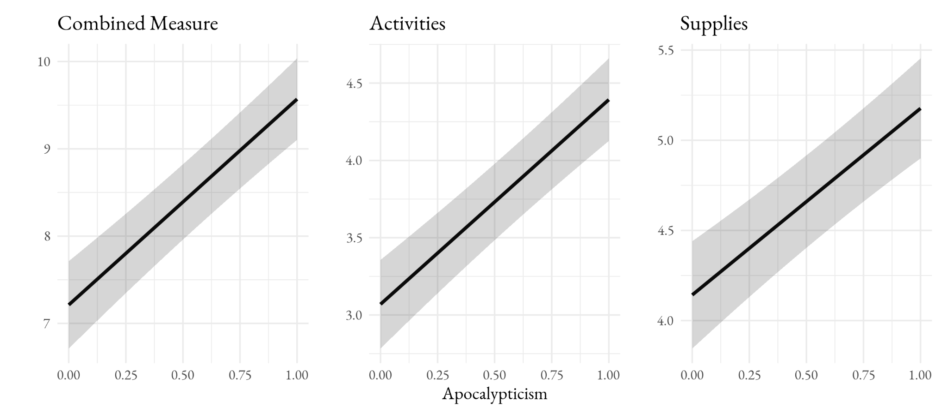
Source: March 2021 Survey.
Note: The model followed the specification provided in Table A2.

Table A1 – Demographic Distributions by High and Low Preparedness
Variable | Low Preparedness  (bottom third) | High Preparedness  (top third)
College + | 27% | 49%
Men | 43% | 58%
Age | 45 years old | 44
South | 38% | 34%
West | 23% | 28%
Northeast | 19% | 20%
Midwest | 20% | 18%
Income | 2.9 (35-50k) | 4.4 (~75k)
Denominational evangelical | 8% | 10%
Non-denominational | 6% | 6%
Mainline | 5% | 7%
Catholic | 18% | 26%
Nones | 33% | 18%
Source: March 2021 Survey.

Figure A2 – Apocalypticism and Christian Nationalism Effects on a Long-term Preparedness Measure
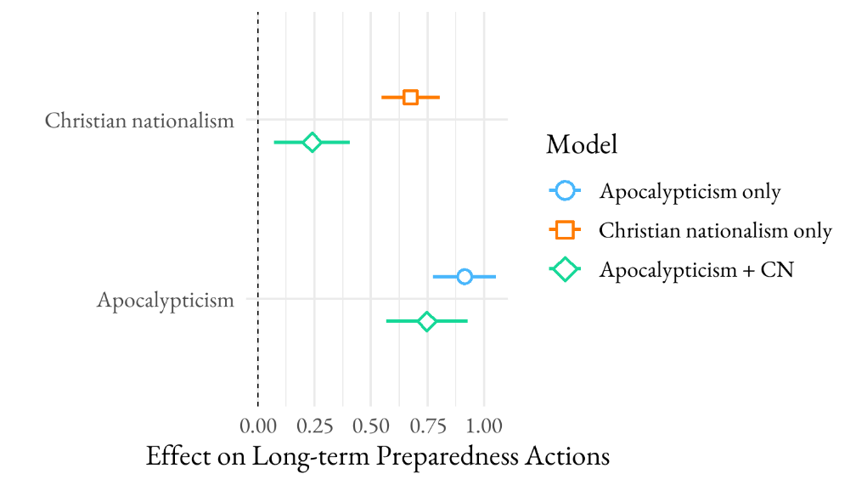
Figure A3 – The Distribution of Apocalypticism Across Religious Traditions
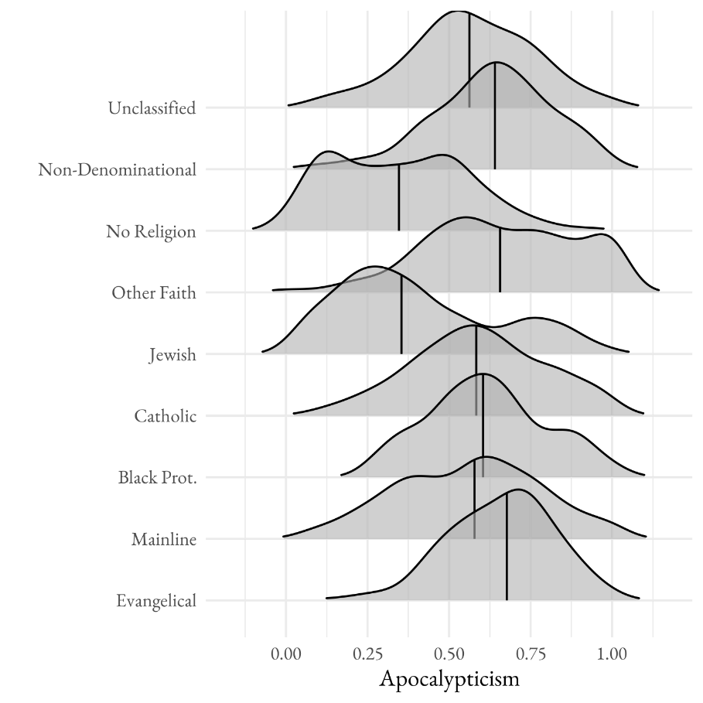
Source: March 2021 Survey. Lines shown are medians.

Table A2 – OLS Estimates of the Effect of Apocalypticism on Preparedness Behavior With and Without Christian Nationalism in the Model (see Figure 3); p values in parentheses
 | Just CN | Just Apoc | CN + Apoc
Unclassified | 0.14 | 0.16 | 0.17
 | (0.56) | (0.50) | (0.46)
Non-denominational | -0.18 | -0.21 | -0.19
 | (0.55) | (0.49) | (0.52)
No religion | 0.12 | 0.28 | 0.32
 | (0.62) | (0.25) | (0.20)
Other faith | -0.15 | -0.11 | -0.11
 | (0.63) | (0.71) | (0.72)
Jewish | 0.10 | 0.19 | 0.23
 | (0.83) | (0.68) | (0.61)
Catholic | 0.04 | 0.08 | 0.09
 | (0.87) | (0.73) | (0.69)
Black Protestant | 1.49 | 1.44 | 1.45
 | (0.01) | (0.01) | (0.01)
Mainline | 0.28 | 0.40 | 0.39
 | (0.35) | (0.19) | (0.19)
Attendance | 0.35 | 0.32 | 0.30
 | (0.00) | (0.00) | (0.00)
Political Interest | 0.56 | 0.55 | 0.55
 | (0.00) | (0.00) | (0.00)
Black | -0.55 | -0.64 | -0.65
 | (0.06) | (0.03) | (0.03)
Hispanic | 0.18 | 0.12 | 0.12
 | (0.52) | (0.66) | (0.67)
Asian | 1.42 | 1.37 | 1.36
 | (0.00) | (0.00) | (0.00)
Other race | 0.69 | 0.66 | 0.65
 | (0.01) | (0.01) | (0.01)
Age | -0.01 | -0.01 | -0.01
 | (0.03) | (0.14) | (0.12)
Family income | 0.33 | 0.34 | 0.34
 | (0.00) | (0.00) | (0.00)
Education | 0.19 | 0.19 | 0.19
 | (0.00) | (0.00) | (0.00)
Women | -0.12 | -0.13 | -0.13
 | (0.32) | (0.26) | (0.28)
Partisanship | -0.09 | -0.06 | -0.07
 | (0.01) | (0.05) | (0.02)
Christian nationalism | 1.67 |  | 0.53
 | (0.00) |  | (0.15)
Apocalypticism |  | 2.29 | 1.97
 |  | (0.00) | (0.00)
Intercept | 3.80 | 3.26 | 3.22
 | (0.00) | (0.00) | (0.00)
N | 3,476 | 3,476 | 3,476
R² | 0.20 | 0.21 | 0.21
Source: March 2021 Survey.

Figure A4 – The Effect of Apocalypticism on Preparedness Conditional on Christian Nationalism and Race (i.e., Figure 8 conditional on race)
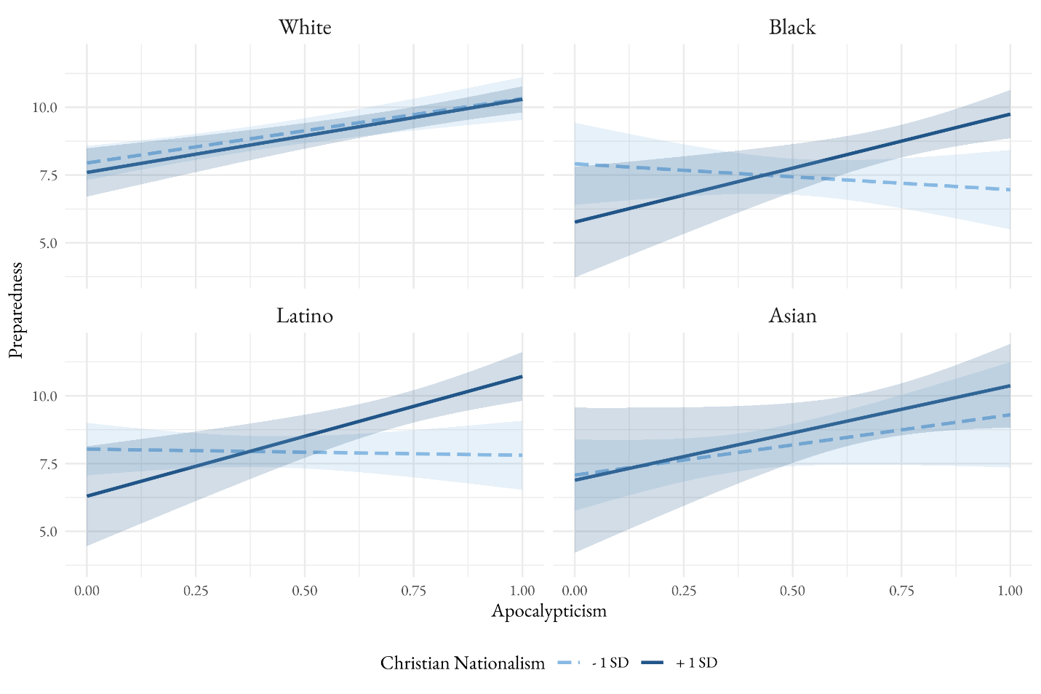
Source: March 2021 Survey.

