Appendix 2 – Minority Stress Model, (Meyer, 2003)
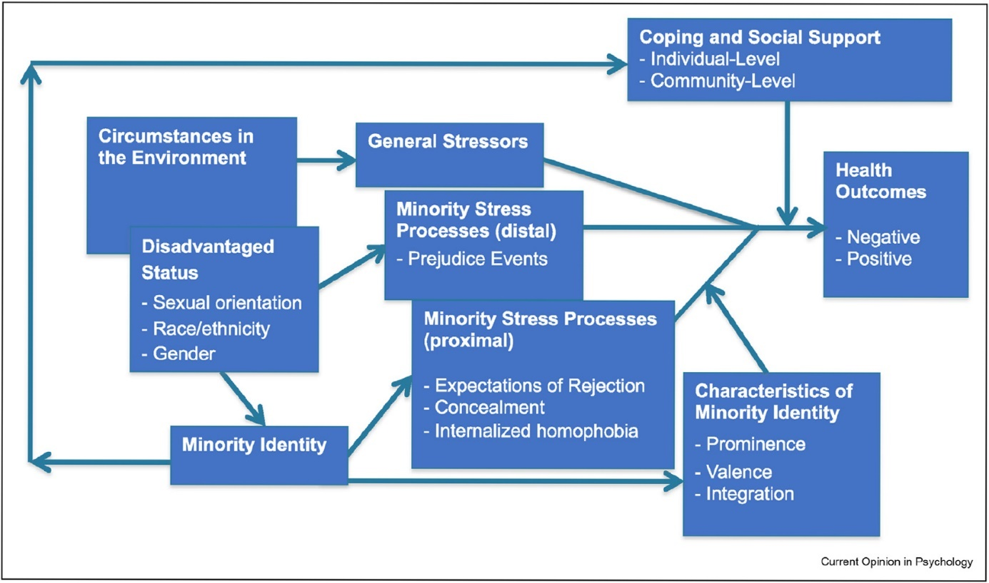
This is figure is reused from Frost, D. M., & Meyer, I. H. (2023). Minority stress theory: Application, critique, and continued relevance. Current opinion in psychology, 51, 101579. Image reprinted with permission from the publisher.
Gender Minority Stress model (Testa et al., 2015)
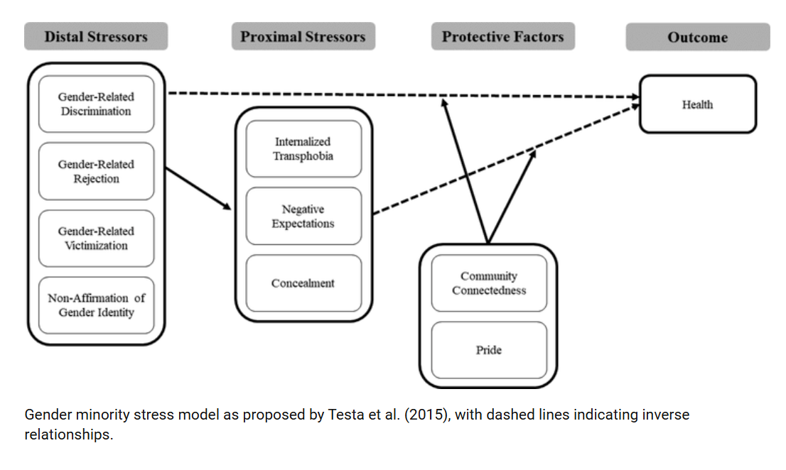
Scandurra, C., Bochicchio, V., Dolce, P., Caravà, C., Vitelli, R., Testa, R. J., & Balsam, K. F. (2020). The Italian validation of the gender minority stress and resilience measure. Psychology of Sexual Orientation and Gender Diversity, 7(2), 208. Reused under CC-BY licence.

