# Supplemental Material

## Flowcharts of Attrition

**Figure 1**

Flowchart of Attrition.

n = 3 dropouts because patients discontinued therapy (2) or withdrew consent (1).

N = 80 supervisees, currently enrolled in post-graduate CBT training, were invited

n = 27 consented (33.8%)

n = 24 completed and included in analysis (88.9 %)

## Descriptive Analysis of Supervisor-Level Differences

**Figure 3**

Supervisor-level Differences between SEQ Depth Ratings.

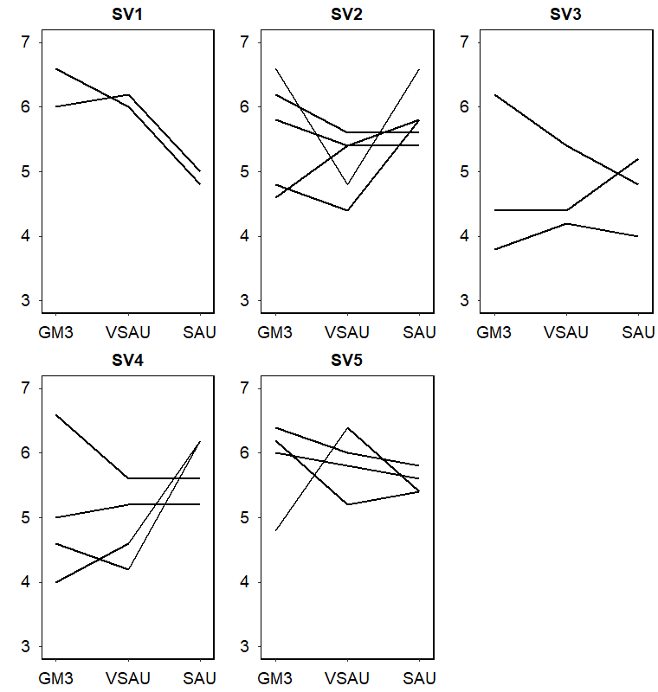

*Note*. GM3: Give me 3, VSAU: Video supervision as usual, SAU: Supervision as usual; Order of supervision conditions varied randomly. Figure includes only supervisors with > 1 supervisee; Number of supervisees per supervisor (*n)*: SV1: 2, SV2: 5, SV3: 3, SV4: 4, SV5: 4.