ONLINE Appendix
Figure A1. Distribution of const_compliance in democratic countries
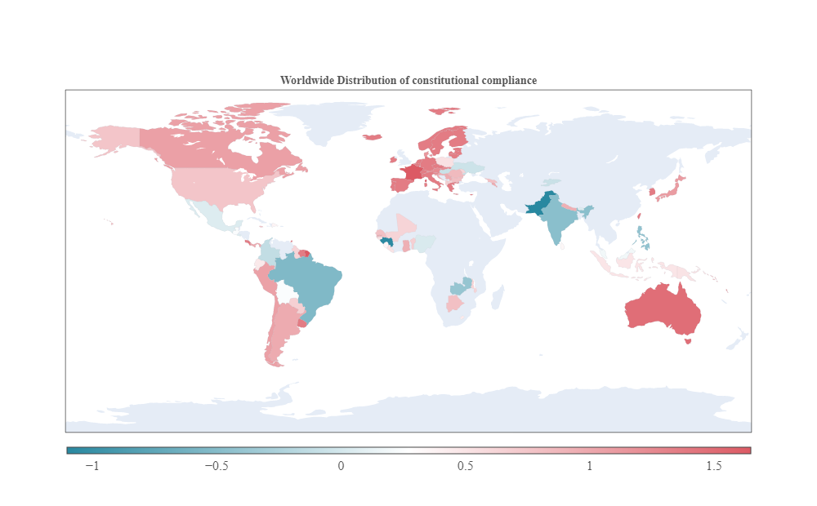
Source: Own elaboration based on data from (Gutmann et al., 2024). Higher value corresponds to higher constitutional compliance.
Figure A2. Distribution of polarity in democratic countries
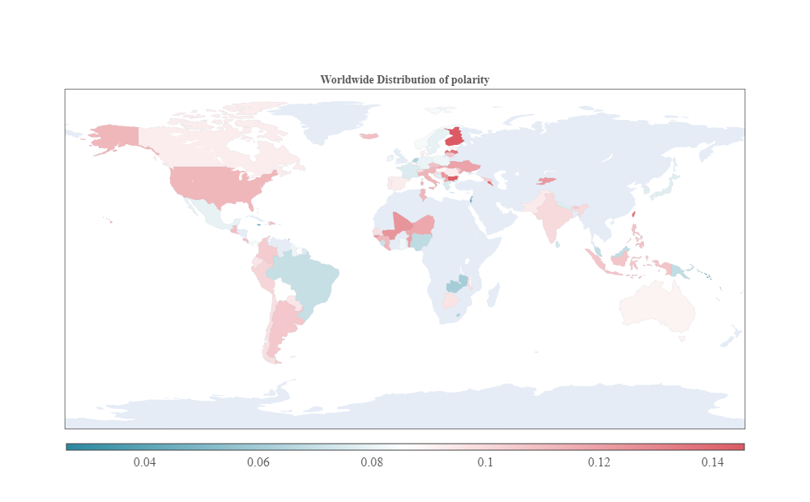
Source: Own calculation and elaboration based on text from the Comparative Constitutions Project. Higher value corresponds to more positive expressions.

Figure A3. Distribution of subjectivity in democratic countries
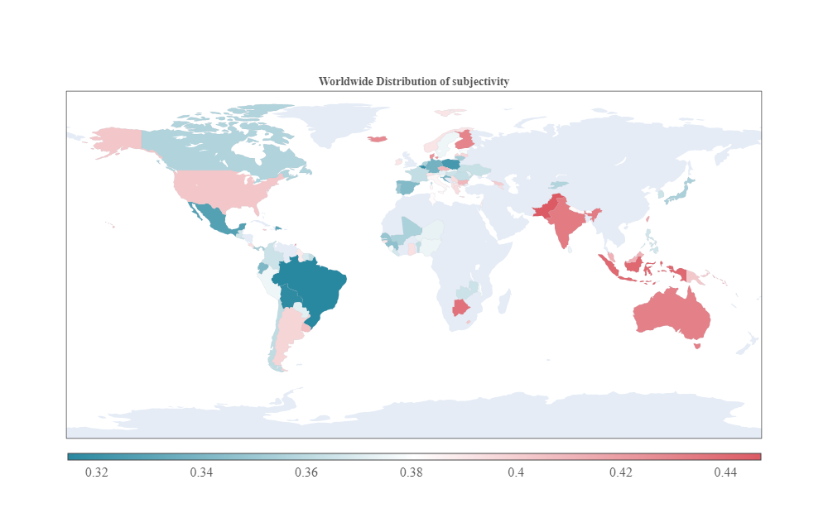

Source: Own calculation and elaboration based on text from the Comparative Constitutions Project. Higher value corresponds to more subjective expressions.

Figure A4. Distribution of agg_read in democratic countries
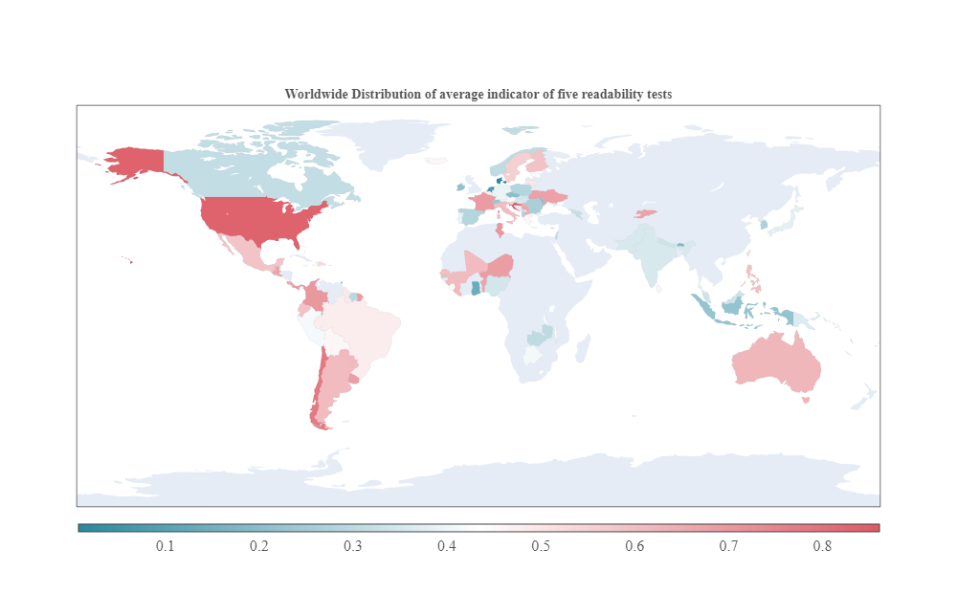
Source: Own calculation and elaboration based on text from the Comparative Constitutions Project. Higher value corresponds to less readable expressions.

Figure A5. Distributions of the indicators measuring the structure of constitutional texts
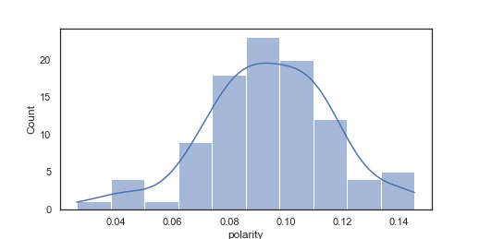 | 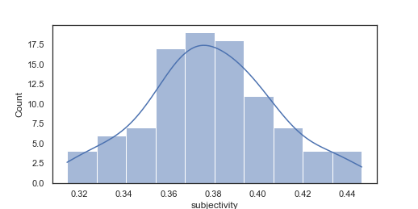
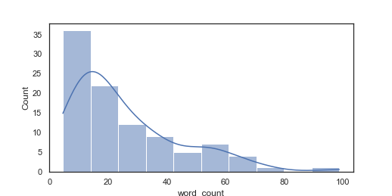 | 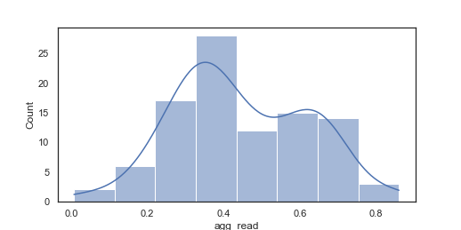
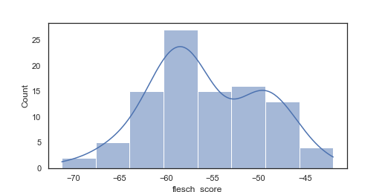 | 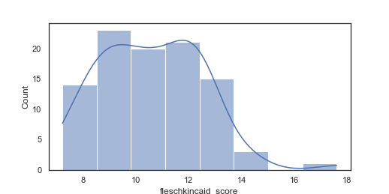
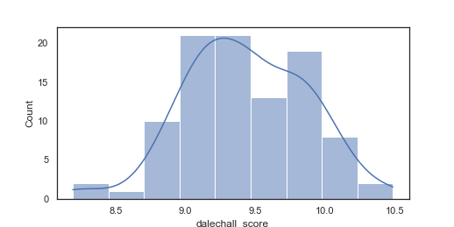 | 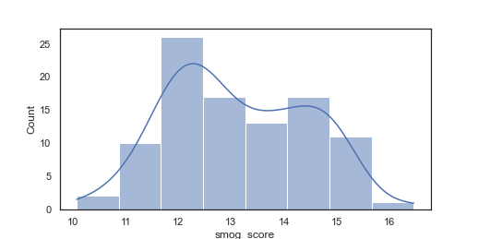
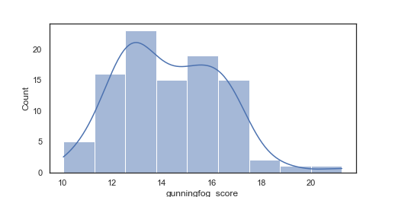
Source: Own calculation.

Figure A6. Indicators measuring the structure of constitutional texts vs const_compliance
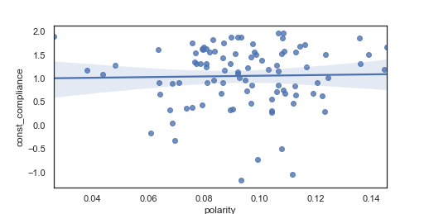 | 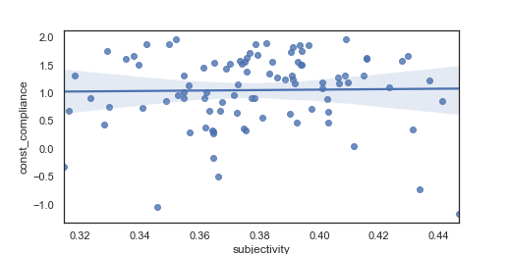
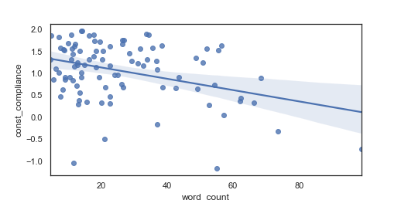 | 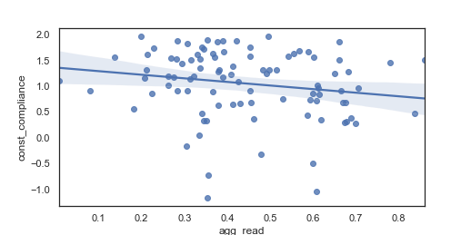
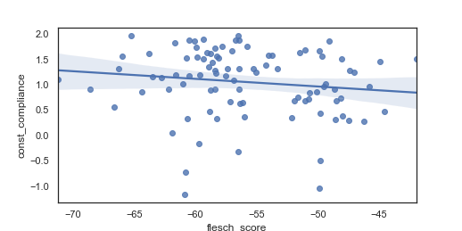 | 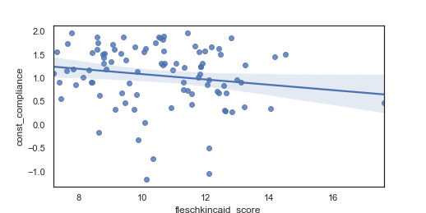
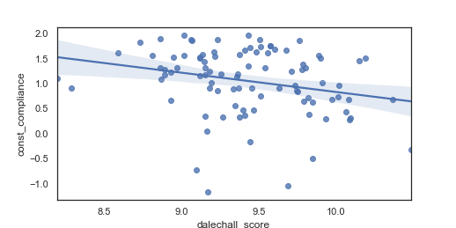 | 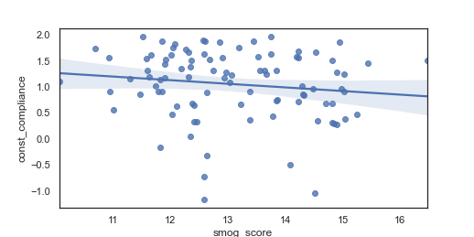
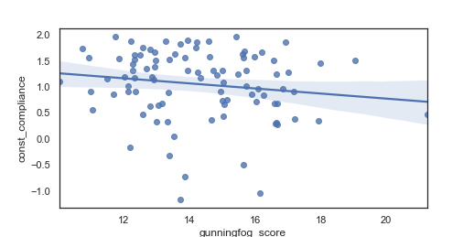
Source: Own calculation.

Figure A7. Distributions of indicators measuring the longevity of constitutions
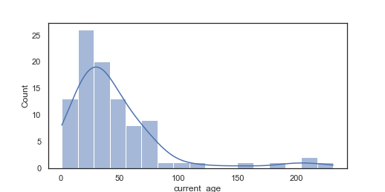 | 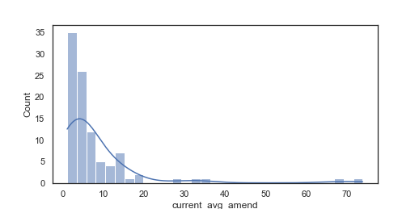
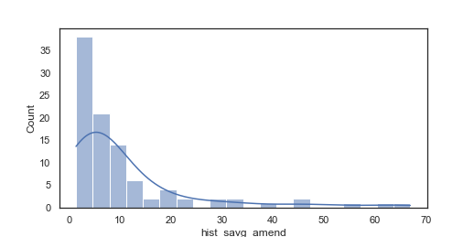 | 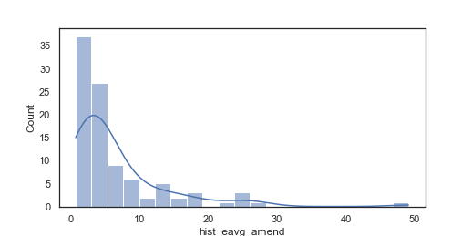
Source: Own calculation.

Figure A8. polarity, subjectivity and agg_read vs the length of the constitution
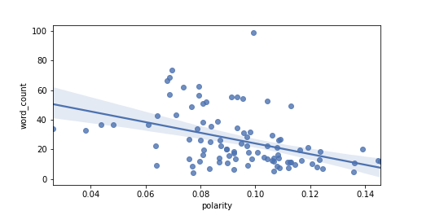 | 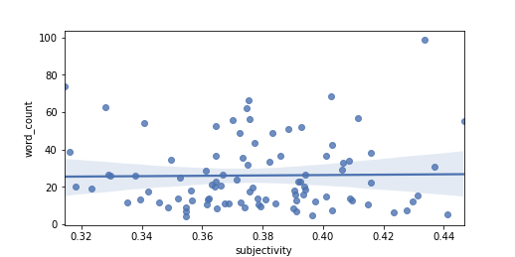
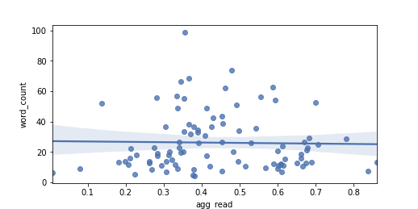 | 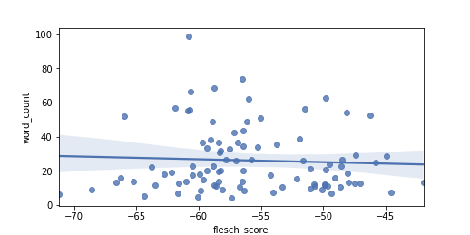
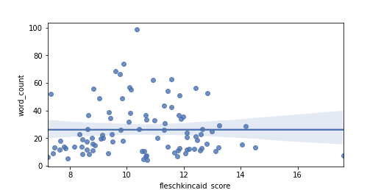 | 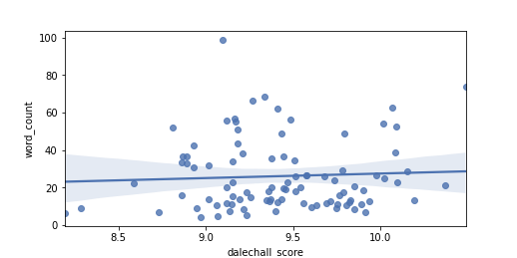
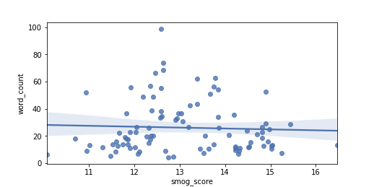 | 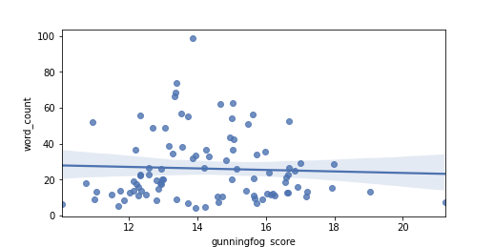
Source: Own calculation.

Table A1. List of variables
Variable name | Description | Source
const_compliance | A continuous indicator measuring to what extent the top representatives of the various government branches respect the constitution | (Gutmann et al., 2024)
polarity | A continuous indicator measuring the sentiment of the given text  - -1: very negative  - 1: very positive | Own calculation based on the Constitute Project
subjectivity | A continuous indicator measuring the subjectivity of the given text  - 0: very objective  - 1: very subjective | Own calculation based on the Constitute Project
flesch_score | Readability measured by Flesch test | Own calculation based on texts scraped from the Constitute Project
fleschkincaid_score | Readability measured by Flesch-Kincaid test | Own calculation based on texts scraped from the Constitute Project
gunningfog_score | Readability measured by Gunning Fox test | Own calculation based on texts scraped from the Constitute Project
smog_score | Readability measured by SMOG test | Own calculation based on texts scraped from the Constitute Project
dalechall_score | Readability measured by Dale-Chall test | Own calculation based on texts scraped from the Constitute Project
agg_read | An average indicator of above five readability tests | Own calculation based on texts scraped from the Constitute Project
word_count | Length of the constitution per 1,000 words | Own calculation based on the Constitute Project
current_age | Age of current constitutions | Own calculation based on the Constitute Project
current_avg_amend | Age of current constitutions divided by number of amendments received | Own calculation based on the Constitute Project
hist_savg_amend | A simple weighted average of age of historical constitutions divided by number of constitutional amendments received during corresponding period | Own calculation based on the Constitute Project
hist_eavg_amend | An exponential weighted average of age of historical constitutions divided by number of constitutional amendments received during corresponding period | Own calculation based on the Constitute Project
legal_origin | A categorical variable indicating the legal origin of a country | (La Porta et al., 2008)
former_socialist | A dummy variable indicating whether the country was formerly socialist | -
Source: Own compilation.
Note on const_compliance: Gutmann et al. (2024) start with using the data from the Comparative Constitutions Project (CCP) (Elkins et al., 2009), which covers information on the de jure rules present in national constitutions. Data on the de facto constitutional compliance comes from the Varieties of Democracy project (V-Dem) (Coppedge et al., 2022), which contains information on political, social or legal institutions (coded by over 3,500 country experts) and these indicators are meant to be comparable across time and countries. After matching the information from CCP and V-Dem, the authors distinguished 14 constitutional rules, covered consistently by at least one indicator in each dataset. In case there are more than one de jure indicators for a given constitutional rule, it is sufficient if one of them is coded as present, to speak about a constitutional promise. When there are more than one de facto indicators, in turn, then each one has to indicate a sufficient level of constitutional compliance to assess the constitutional promise as kept. It can be stated that these indicators operationalize constitutional compliance as the lack of a de jure-de facto gap. An important advantage of this measurement approach is that to evaluate (non)compliance with a constitutional rule, such rule has to be included in the constitution. Thus, constitutional standards vary over time and over countries. The main coding rule used by the authors was that a constitutional rule takes the value 1 in case that rule is protected both in de jure and de facto dimensions. Otherwise, the indicator of compliance is coded 0 in case that rule is protected de jure and not de facto, as it would translate into a de jure-de facto gap (constitutional underperformance). A value of 0.5 is assigned when a constitutional right is not protected de jure, whatever the de facto indicator is. Gutmann et al. (2024) argue that the coding rule here means that countries start from the level of 0.5 and can deviate from this upwards and downwards only if they have constitutional commitments. When it comes to de jure indicators, it is coded based on the presence of a rule in the constitution. The de facto coding, in turn, relies on ordered categorical indicators, typically based on a five-point scale. The highest category implies full compliance with the given rule. Then, the second highest category indicates somehow weaker enforcement of the rule, but no intentional or systematic disregard by the government. The authors comment that they consider government falling into one of the two top categories as de facto enforcing the rule, and the government ranked in lower categories as not complying with the rule. They also presented a convincing list of the exact criteria for the de jure and de facto coding of each of the 14 constitutional rules. The commented 14 individual indicators of de jure-de facto gaps were then grouped into 4 legal areas: i) property rights and the rule of law (private property rights, judicial independence, equality before the law, and rule of law) [cc_prop], ii) political rights (freedom of association, freedom of assembly, and the right to form parties) [cc_polit], iii) civil rights (free media, free speech, free movement, and religious freedom) [cc_civil], and iv) basic human rights (right to life, freedom from slavery, and protection from torture) [cc_basic]. In order to aggregate the individual 14 indicators within each of the 4 categories, the authors used factors analysis and extracted the first factor as the indicator of constitutional compliance in the respective legal category. Thanks to using factor analysis it was possible to check whether there is one dominating factor representing a latent variable of constitutional compliance in each category. Then, the mean value of the commented four legal domain-specific indicators is calculated (cc_total). This is the indicator, which we use in our models as the dependent variable (const_compliance). Importantly, all the indicators mentioned above have been also standardized (mean of zero and standard deviation of one), which is relevant for comparing the indicators. In general, the indicator has higher values in case of better constitutional compliance. Importantly, it is higher in case if one de jure rule exists and that rule is not complied with, compared to a situation where five constitutional rules exist but none of them are complied with. Also, the indicator would be lower if one right is promised and complied with, compared to a situation where five rights are promised and all of them are complied with.
Table A2. List of constitutions considered
Continent | # | Constitutions
America | 22 | Argentina, Barbados, Bolivia, Brazil, Canada, Chile, Colombia, Costa Rica, Dominican Republic, Ecuador, El Salvador, Guatemala, Guyana, Jamaica, Mexico, Panama, Paraguay, Peru, Surinam, Trinidad and Tobago, U.S.A., Uruguay
Europe | 33 | Albania, Austria, Belgium, Bulgaria, Croatia, Czech Republic, Denmark, Estonia, Finland, France, Germany, Greece, Hungary, Iceland, Ireland, Italy, Latvia, Lithuania, Malta, Moldova, Netherlands, North Macedonia, Norway, Poland, Portugal, Romania, Serbia, Slovakia, Slovenia, Spain, Sweden, Switzerland, Ukraine
Africa | 18 | Benin, Botswana, Cape Verde, Gambia, Ghana, Guinea, Guinea-Bissau, Lesotho, Liberia, Malawi, Mali, Mauritius, Nigeria, Sao Tome and Principe, Senegal, Seychelles, Sierra Leone, Zambia
Asia | 17 | Armenia, Bhutan, Cyprus, East Timor, Georgia, India, Indonesia, Japan, Kyrgyzstan, Malaysia, Maldives, Nepal, Pakistan, Philippines, South Korea, Sri Lanka, Taiwan
Oceania | 4 | Australia, Papua New Guinea, Solomon Islands, Vanuatu
Source: Own calculation and elaboration based on data from the Comparative Constitutions Project.

Table A3. Comparison between two weighted averages
 | Dependent variable:
 | const_compliance
 | (1) | (2)
polarity | $-$7.568$​^{**}$ | $-$7.499$​^{**}$
 | (3.482) | (3.496)
subjectivity | 0.368 | 0.406
 | (2.496) | (2.512)
word_count | $-$0.015$​^{***}$ | $-$0.016$​^{***}$
 | (0.004) | (0.004)
current_age | $-$0.001 | $-$0.001
 | (0.002) | (0.002)
current_avg_amend | $-$0.017$​^{**}$ | $-$0.013$​^{*}$
 | (0.009) | (0.008)
hist_eavg_amend | 0.010
 | (0.014)
hist_savg_amend |  | 0.0001
 |  | (0.007)
legal_originge | 0.292 | 0.304
 | (0.193) | (0.194)
legal_originscand | 0.679$​^{**}$ | 0.656$​^{**}$
 | (0.316) | (0.317)
legal_originuk | $-$0.066 | $-$0.058
 | (0.184) | (0.186)
former_socialist | 0.067 | 0.077
 | (0.200) | (0.200)
Constant | 2.041$​^{**}$ | 2.059$​^{**}$
 | (0.942) | (0.954)
Observations | 94 | 94
R$​^{2}$ | 0.270 | 0.266
Adjusted R$​^{2}$ | 0.182 | 0.177
Residual Std. Error (df = 83) | 0.599 | 0.601
F Statistic (df = 10; 83) | 3.075$​^{***}$ | 3.001$​^{***}$
Note: | $​^{*}$p$<$0.1; $​^{**}$p$<$0.05; $​^{***}$p$<$0.01
Source: Own calculation. The regression model with hist_eavg_amend has better performance compared to the one with hist_savg_amend, in terms of higher R², lower AIC and BIC values.

