Supplement 2
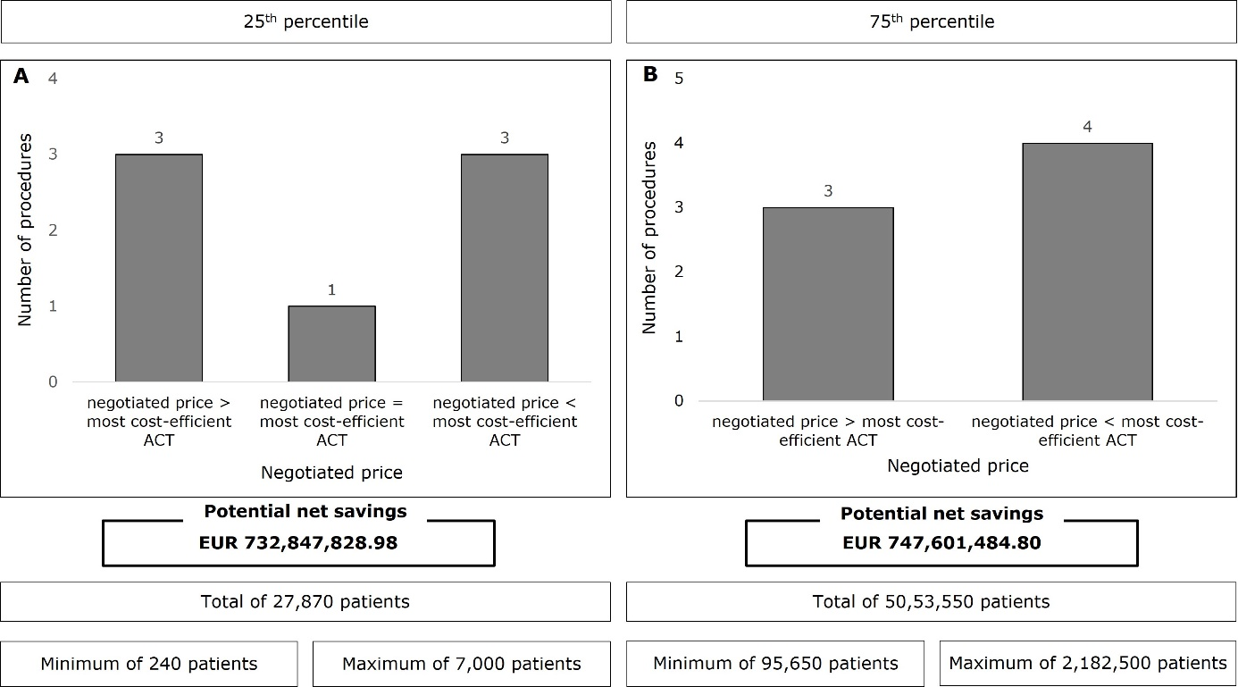
Supplement 2: Deviations of the negotiated price from the most cost-efficient ACT depending on patient population size (A) using the 25th percentile; (B) for large patient populations using the 75th percentile: Deduction of double counting.

