APPENDIX A. Composition of Governing Coalitions in Germany in 2023*

State Legislature | Governing Parties | Party of Head of Government
Bundestag | SPD, B90/Greens, FDP | SPD (Olaf Scholz)
Baden-Württemberg | B90/Greens, CDU | B90/Greens (Winfried Kretschmann)
Bavaria* | CSU, Free Voters of Bavaria | CSU (Markus Söder)
Berlin | CDU, SPD | CDU (Kai Wegner)
Brandenburg | CDU, SPD, B90/Greens | SPD (Dietmar Woidke)
Bremen | SPD, B90/Greens, LINKE | SPD (Andreas Bovenschulte)
Hamburg | SPD, B90/Greens | SPD (Peter Tschentscher)
Hesse* | CDU, SPD | CDU (Boris Rhein)
Lower Saxony | SPD, B90/Greens | SPD (Stephan Weil)
Mecklenburg-Vorpommern | SPD, LINKE | SPD (Manuela Schwesig)
North Rhine-Westphalia | CDU, B90/Greens | CDU (Hendrik Wüst)
Rhineland-Palatinate | SPD, B90/Greens, FDP | SPD (Alexander Schweitzer)
Saarland | SPD | SPD (Anke Rehlinger)
Saxony | CDU, B90/Greens, SPD | CDU (Michael Kretschmer)
Saxony-Anhalt | CDU, SPD, FDP | CDU (Reiner Haseloff)
Schleswig-Holstein | CDU, B90/Greens | CDU (Daniel Günther)
Thuringia | LINKE, SPD, B90/Greens | LINKE (Bodo Ramelow)
*We distributed our survey in Summer-Fall 2023. Two states (Bavaria and Hesse) held legislative elections that fall; we distributed our survey to these states after MPs in the new term had taken office.

APPENDIX B. SURVEY INVITATION AND QUESTIONNAIRE (English Translation)
This study was approved by the Ethics Board of the University of Calgary.

Invitation message:

Subject: Survey on Parliaments and Parenthood

Dear NAME,

We would like to invite you to complete a survey about politics and parenthood. The survey includes questions about your parental status and attitudes towards making parliament more hospitable for parents. We encourage your participation whether or not you have children. The survey should take about five minutes to complete. All information provided is confidential.

Please {click here} to take the survey.

If you have questions about this survey, you may reply to this email or contact the Research Services Office at the University of Calgary at +1 403-220-6289, +1 403-220-8640, or cfreb@ucalgary.ca.

Thank you,
Susan Franceschet (University of Calgary) and Christina Xydias (Bucknell University)

Full questionnaire:
For verification purposes, please provide your name and the constituency or state (as appropriate) you represent. All information collected will be kept confidential by the researchers. Results will only be reported in the aggregate to ensure individual responses cannot be linked to participants.

- What is your name?

- What is the name of the constituency or state (as appropriate) you currently represent or previously represented?

- How difficult do you think it is to be both a good parent and a good politician? (not difficult at all, slightly difficult, somewhat difficult, moderately difficult, very difficult)

- Do you agree, disagree or neither agree nor disagree with the following statement:
It is easy to balance a political career with family life.
(strongly agree, agree, neither agree or disagree, disagree, strongly disagree)

- What do you think are the biggest challenges facing parents who serve as parliamentarians?

- There has been much discussion lately about making parliament more “family-friendly.” Please indicate how much you agree or disagree with the following statements. (strongly agree, somewhat agree, neither agree nor disagree, somewhat disagree, strongly disagree)
  - Parliamentarians should be permitted to take parental leave when they have a new baby
  - Parliamentarians on parental leave should be permitted to designate a colleague to vote on their behalf.
  - Parliamentarians on parental leave should be able to vote remotely
  - Parliamentarians should be permitted to bring their young children (under 12 months) into the chamber with them
  - Parliamentarians who are nursing should be able to breastfeed in the chamber
  - Parliament should offer free, flexible (drop-in) childcare to all parliamentarians with pre-school aged children.

- Are there other measures that should be considered to make the Parliament more family-friendly?

- On average, how long did/does it take you to commute from home to your parliamentary office (at the federal/state parliament)?
  - 0-1 hour
  - Between 1 and 3 hours
  - Between 3 hours and 5 hours
  - More than 5 hours
  - Prefer not to say

- Do you have children?
  - Yes
  - No
  - Prefer not to say

- When you were first elected into a full-time political position, into which age category did your youngest child fall?
  - Not yet born when I was first elected
  - 0 – 1 year
  - 2 – 5 years
  - 6 – 12 years
  - 13 – 17 years
  - 18 years or older
  - Prefer not to say

- If you were in parliamentary office when your children were young, or if you still have young children, did/do they reside in…
  - Your constituency/state
  - Berlin/Bonn
  - Other
  - Prefer not to say

- Is there anything you’d like to tell us about parenting and politics?
APPENDIX C. ATTITUDES DISAGGREGATED BY GENDER AND PARTY
Figure 1. Gender and Party Differences in Perceptions of Difficulty: Parenting as an Elected Officeholder
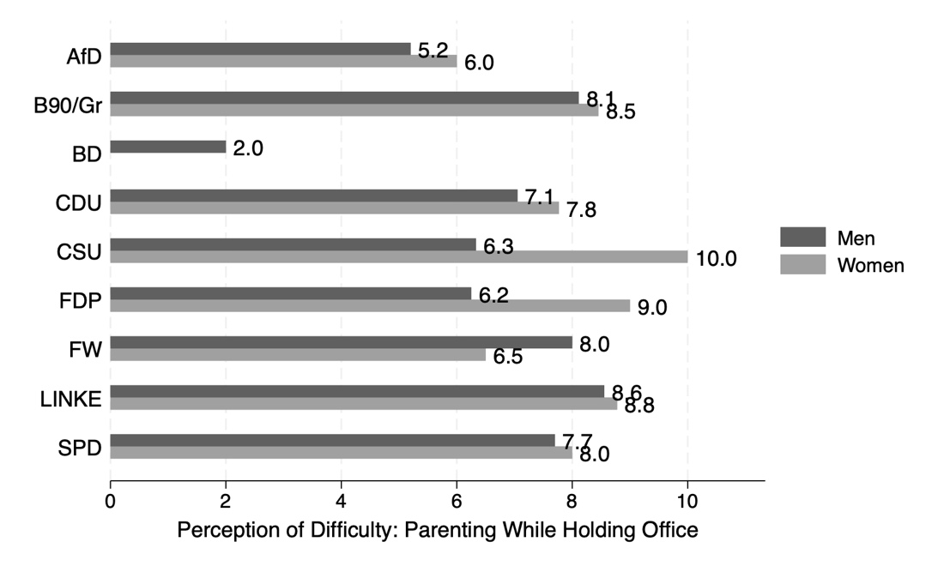

Notes: This composite measure of perceptions of difficulty is composed of two variables. Each survey question offered options 1-5, where 1 is the perception of least difficulty. This DV therefore has a theoretical range of 2-10. Respondents who did not answer all questions that are part of the composite DV are excluded. Pooling all parties together, gendered differences in perceptions of difficulty are statistically significant (two-tailed t-test, p < 0.000). Within-party gendered differences are not possible to calculate consistently due to low sample sizes across numerous parties; see Table 2 in the main text.

Figure 2. Gender and Party Differences in Policy Attitudes
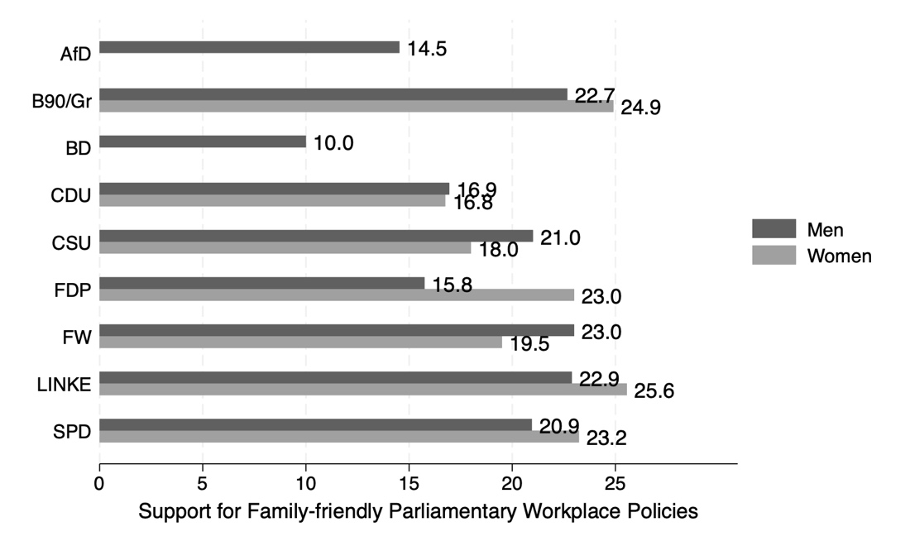

Notes: This composite measure of policy attitudes is composed of six variables. Each survey question offered answer options 1-5, where 1 is least supportive. This DV therefore has a theoretical range of 6-30. Respondents who did not answer all questions that are part of the composite DV are excluded, e.g., there is one AfD woman respondent but she skipped some survey questions. Pooling all parties together, gendered differences in perceptions of difficulty are statistically significant (two-tailed t-test, p < 0.000). Within-party gendered differences are not possible to calculate consistently due to low sample sizes across numerous parties; see Table 2 in the main text.

