APPENDICES

APPENDIX A. DESCRIPTIVE STATISTICS

Variable Obs Mean Std. dev. Min Max

Won reelection 502 .58 .49 0 1
Ran for reelection 640 .78 .41 0 1
Female 640 .07 .26 0 1
Direct election 640 .20 .40 0 1
Entered by election 635 .60 .49 0 1
Party vote % 600 35.16 14.41 1.56 90.50
Legis. % female
(t-3) 594 13.53 11.10 0 48.33
Decade 640 4.10 1.63 1 7
GDP per capita growth 616 2.41 4.10 -21.79 24.00
Inflation, logged 586 2.51 .66 .84 6.97
Executive corruption 607 .26 .25 .003 .93
Domestic conflict
index, logged 603 3.79 3.54 0 11.10
Bicameral 640 .48 .50 9 1

APPENDIX B: PROPENSITY SCORE MATCHING

Table B1. Treatment Effect of Female Leader on Leader Won

 | Coefficient | AI robust standard error | p | N
Average treatment effect on the treated (ATET) | .05 | .09 | .61 | 436

Table B2. Cases Matched
 | Raw | Matched
N of observations | 436 | 84
Treated observations | 42 | 42
Control observations | 394 | 42

Table B3. Covariate Balance

 | Standardized differences of means |  | Variance ratio
 | Raw | Matched | Raw | Matched
Entered by election | -.28 | -.11 | 1.11 | 1.01
Direct election | .01 | .01 | 1.03 | 1.02
Decade | .42 | -.00 | .94 | .97
Female % legislature | .69 | -.05 | 1.25 | .78
Party vote % | -.06 | -.01 | .63 | .68

Figure B1. Balance Plot: Leader Won

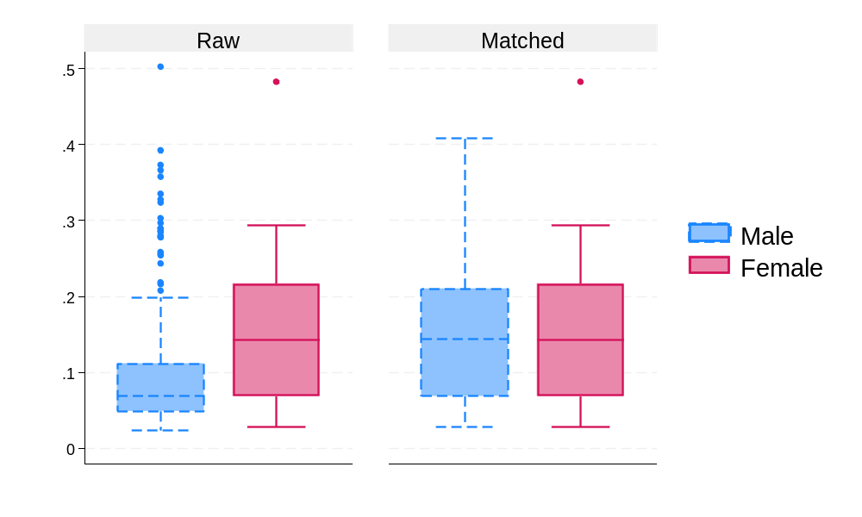

APPENDIX C. KERNEL MATCHING ANALYSIS

Multivariate (Mahalanobis) distance nearest-neighbor matching, with up to 4 nearest male neighbors per female leader.

Table C1. Treatment effect of female leader on: Leader won
 | Coefficient | Robust standard error | P | N
Average treatment effect on the treated (ATET) | .07 | .09 | .44 | 436

Table C2. Cases Matched
 | Raw | Matched
N of observations | 436 | 160
Treated observations | 42 | 42
Control observations | 394 | 118

Table C3. Raw vs. Matched Differences in Means
Means | Raw |  |  | Matched
 | Treated | Control | Std. diff. | Treated | Control | Std. diff.
Entry by election | .50 | .64 | -.28 | .50 | .51 | -.02
Direct election | .21 | .21 | .01 | .21 | .21 | .00
Decade | 4.76 | 4.09 | .42 | 4.76 | 4.66 | .06
Female % legis. | 21.11 | 13.12 | .69 | 21.11 | 19.77 | .12
Party vote % | 34.89 | 35.72 | -.06 | 34.89 | 34.81 | .01

Table C4. Raw vs. Matched Variance Ratios
Variances | Raw |  |  | Matched
 | Treated | Control | Ratio | Treated | Control | Ratio
Entry by election | .26 | .23 | 1.11 | .26 | .25 | 1.02
Direct election | .17 | .17 | 1.03 | .17 | .17 | 1.02
Decade | 2.53 | 2.68 | .94 | 2.53 | 2.44 | 1.04
Female % legis. | 148.52 | 118.55 | 1.25 | 148.52 | 148.36 | 1.00
Party vote % | 141.55 | 223.54 | .63 | 141.55 | 135.29 | 1.05

APPENDIX D

Table D1. Equality of Means Test for Male vs. Female Leaders on Performance Measures
 |  | Levene’s Test for Equality of Variances* |  | T-test for Equality of Means
 |  | F | Prob. | T | Df | One-sided p | Two-sided p
GDP per capita growth | Equal variances assumed | .52 | .47 | -.04 | 614 | .49 | .97
GDP per capita growth | Equal variances not assumed |  |  | -.04 | 50.5 | .48 | .97
Inflation, logged | Equal variances assumed | .25 | .62 | -.74 | 584 | .23 | .46
Inflation, logged | Equal variances not assumed |  |  | -.83 | 52.61 | .21 | .41
Exec.  branch corruption | Equal variances assumed | .05 | .83 | 1.38 | 605 | .09 | .17
Exec.  branch corruption | Equal variances not assumed |  |  | 1.38 | 52.69 | .09 | .17
Domestic conflict index, logged | Equal variances assumed | 3.54 | .06 | -.43 | 601 | .33 | .67
 | Equal variances not assumed |  |  | -.40 | 51.44 | .35 | .69

Figure D1. Female and family tie
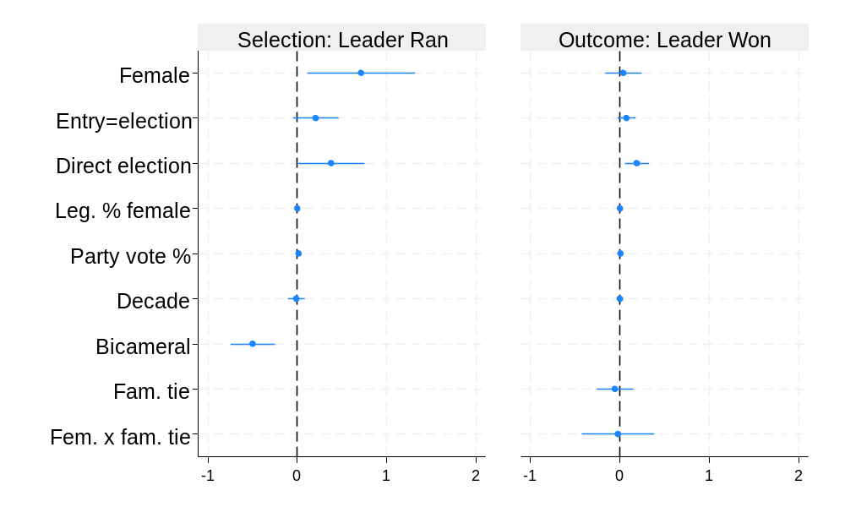
Figure D2. Female and family tie: predicted probabilities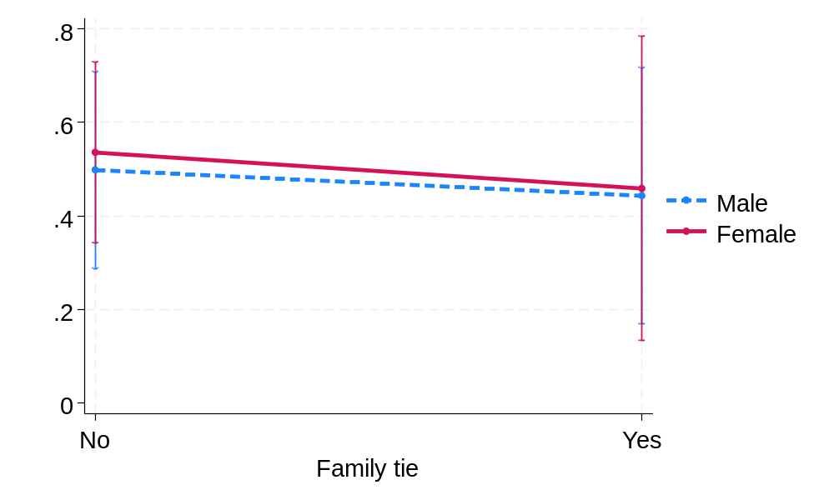

Figure D3. Female and prior female leader
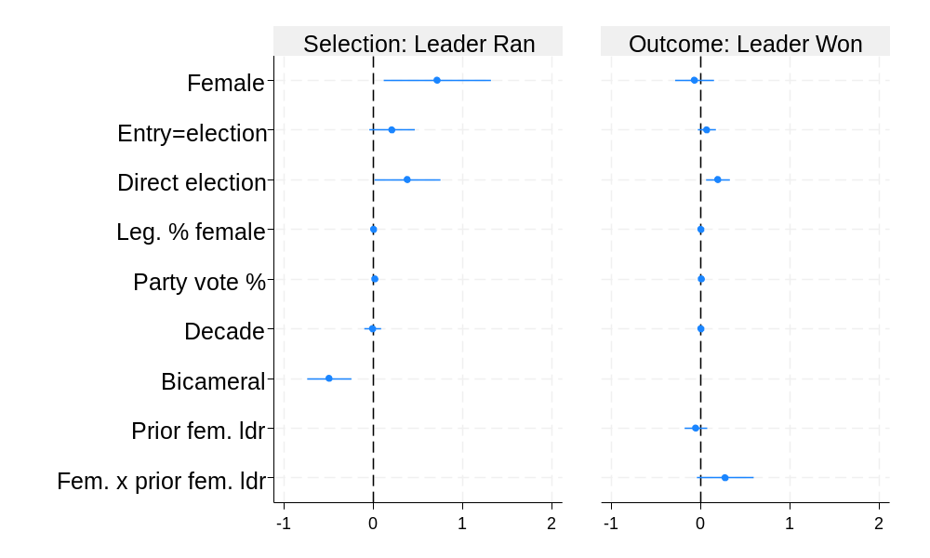
Figure D4. Female and prior female leader: predicted probabilities 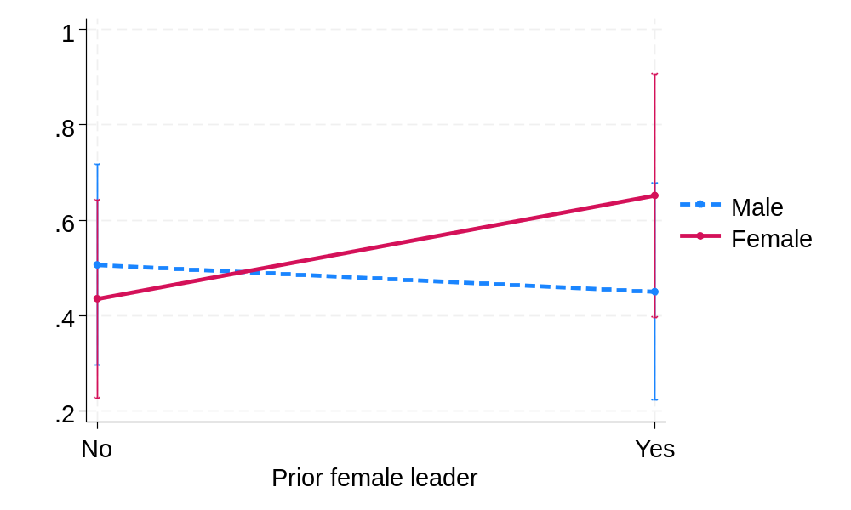
Figure D5. Female and GDP PC
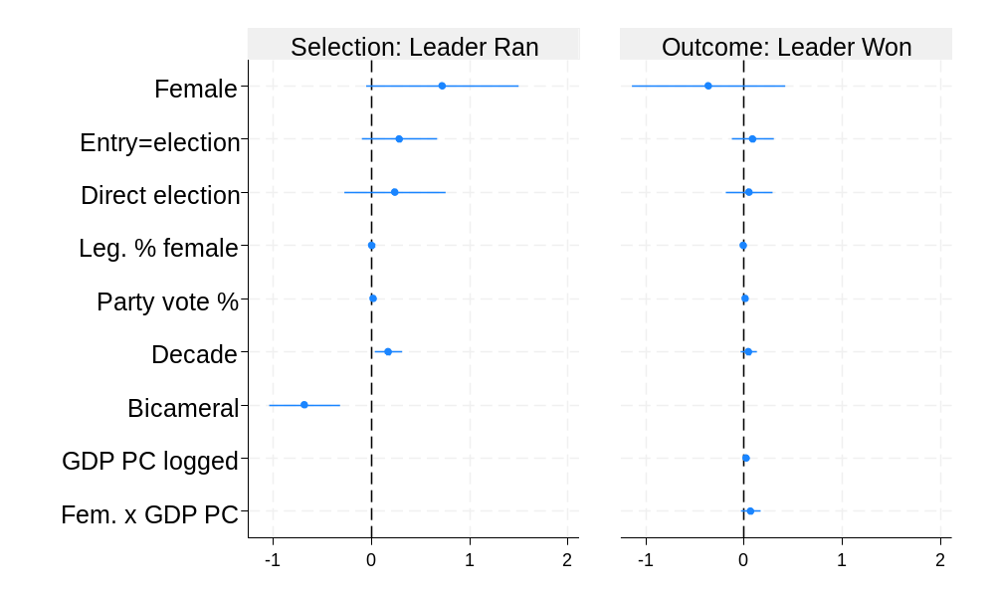
Figure D6. Female and GDP PC: predicted probabilities 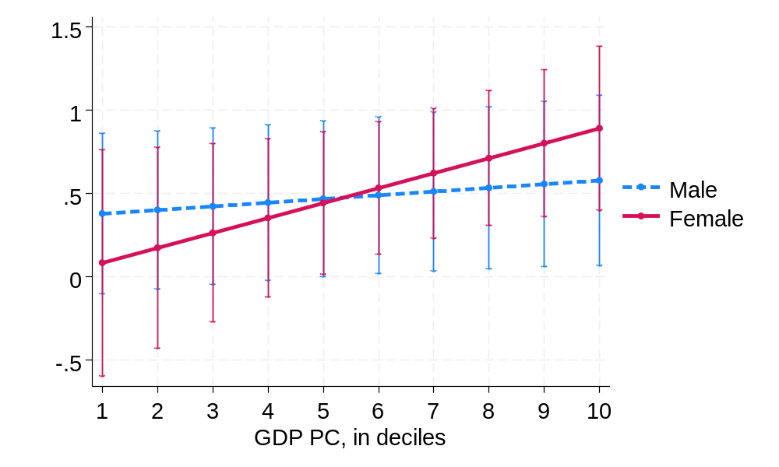

Figure D7. Female and previous high posts
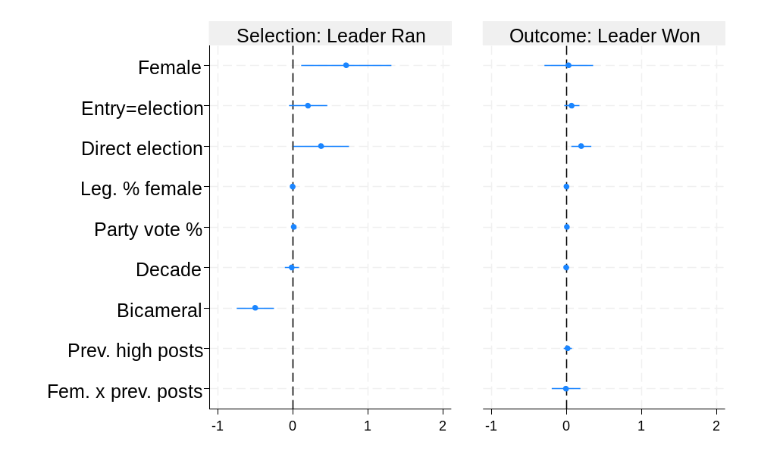
Figure D8. Female x previous high posts: predicted probabilities
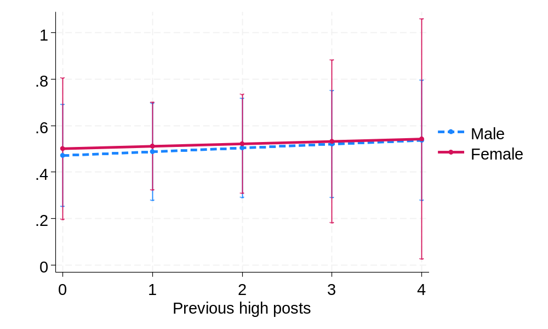

Figure D9. Female and index of executive power

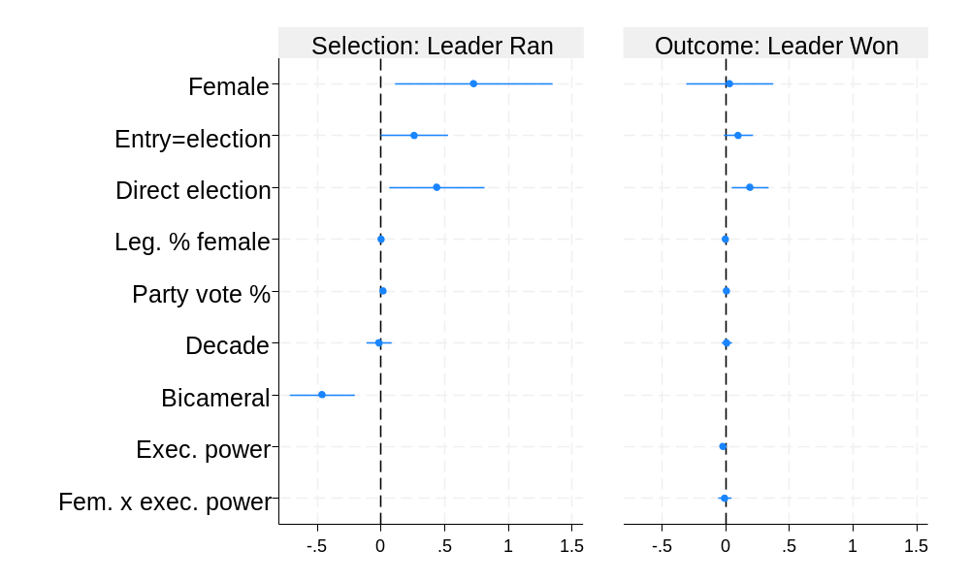
Figure D10. Female and index of executive power: predicted probabilities
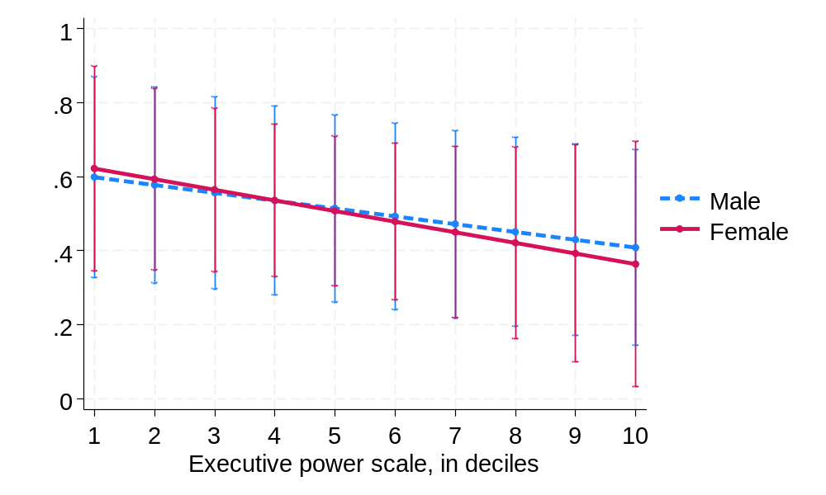

APPENDIX E: LEADERS IN OFFICE ON ELECTION DAY

Table E1. Propensity score matching with up to 4 nearest neighbors

 | Coefficient | AI robust standard error | p | N
Average treatment effect on the treated (ATET) | -.04 | .08 | .67 | 398

Table E2. Cases matched
 | Raw | Matched
N of observations | 398 | 82
Treated observations | 41 | 41
Control observations | 357 | 41

Table E3. Covariate balance

 | Standardized differences of means |  | Variance ratio
 | Raw | Matched | Raw | Matched
Entered by election | -.24 | -.10 | 1.10 | 1.02
Direct election | -.03 | -.11 | .98 | .88
Decade | .46 | .03 | .95 | .97
Female % legislature | .71 | -.02 | 1.31 | .86
Party vote % | -.13 | -.05 | .63 | .58

Figure E1. Balance Plot
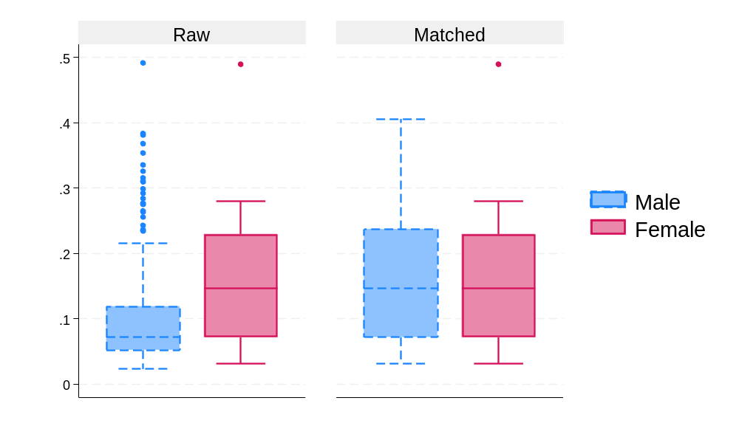

Table E4. Kernel Matching for Leader Won

Multivariate (Mahalanobis) distance nearest-neighbor matching, with up to 4 nearest male neighbors per female
leader.

 | Coefficient | Robust standard error | P | N
Average treatment effect on the treated (ATET) | .04 | .09 | .70 | 398

Table E5. Cases Matched
 | Raw | Matched (ATET)
N of observations | 398 | 157
Treated observations | 41 | 41
Control observations | 357 | 116

Table E6. Raw vs. Matched Differences in Means
Means | Raw |  |  | Matched
 | Treated | Control | Std. diff. | Treated | Control | Std. diff.
Entry by election | .51 | .63 | -.24 | .51 | .52 | -.02
Direct election | .22 | .23 | -.03 | .22 | .22 | .00
Decade | 4.80 | 4.07 | .46 | 4.80 | 4.66 | .09
Female % legis. | 21.05 | 12.87 | .71 | 21.05 | 19.58 | .13
Party vote % | 34.84 | 36.59 | -.13 | 34.84 | 34.95 | -.01

Table E7. Raw vs. Matched Variance Ratios
Variances | Raw |  |  | Matched
 | Treated | Control | Ratio | Treated | Control | Ratio
Entry by election | .26 | .23 | 1.10 | .26 | .25 | 1.02
Direct election | .18 | .18 | .98 | .18 | .17 | 1.02
Decade | 2.51 | 2.63 | .95 | 2.51 | 2.34 | 1.07
Female % legis. | 152.10 | 116.23 | 1.31 | 152.10 | 145.19 | 1.05
Party vote % | 144.95 | 229.21 | .63 | 144.95 | 141.06 | 1.03

Figure E2. Election day leaders: Female and direct vote
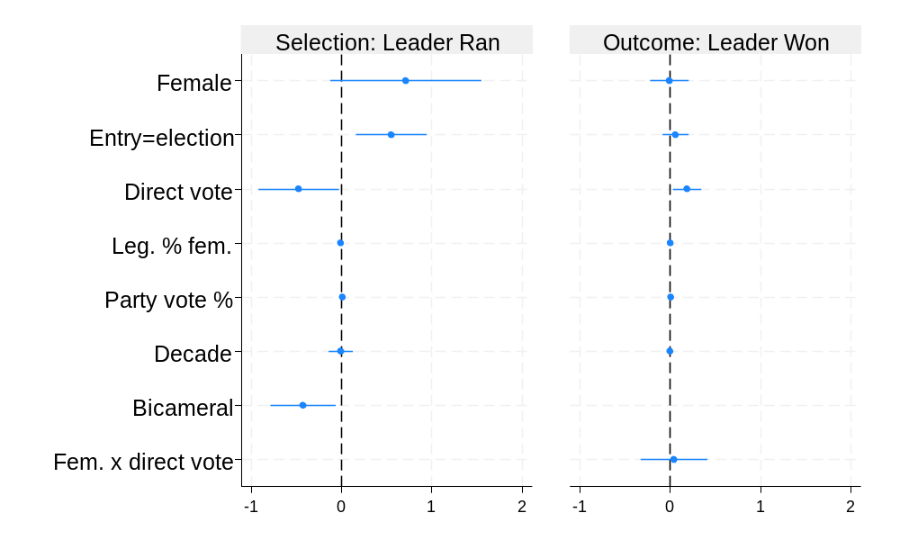
Figure E3. Election day leaders predicted probabilities: Female and direct vote
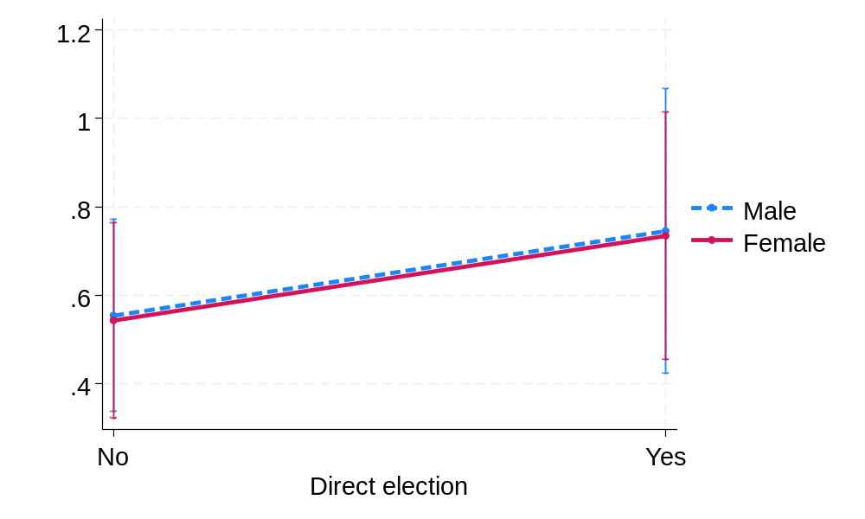

Figure E4. Election day leaders: Female and entry type
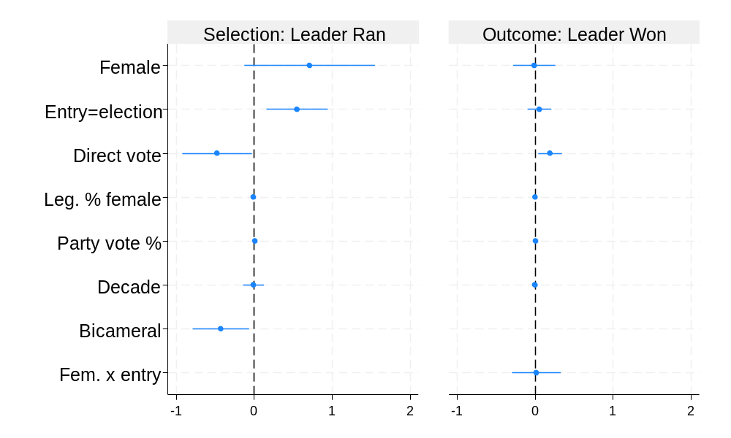
Figure E5. Election day leaders: Predicted probabilities for female and entry type

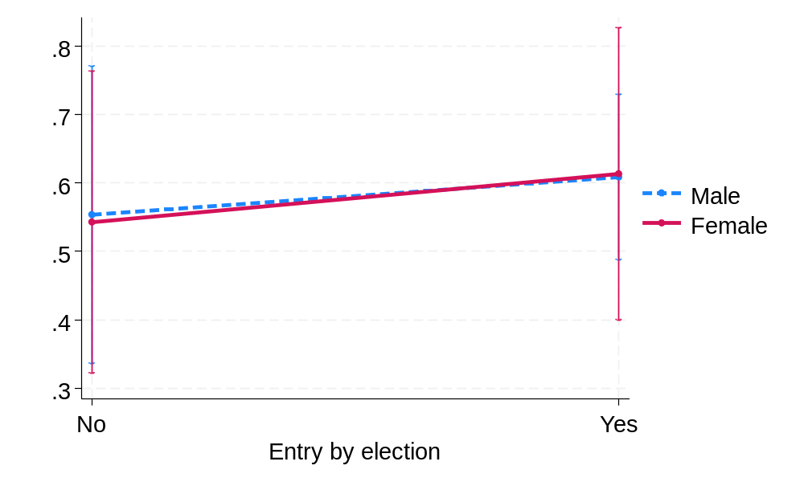

Figure E6. Election day leaders: Female and GDP per capita growth 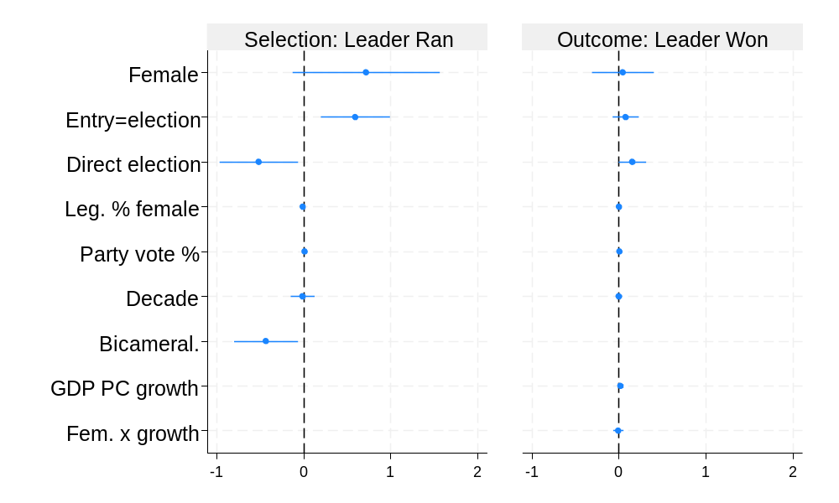
Figure E7. Election day leaders: Predicted probabilities for female and GDP per capita growth

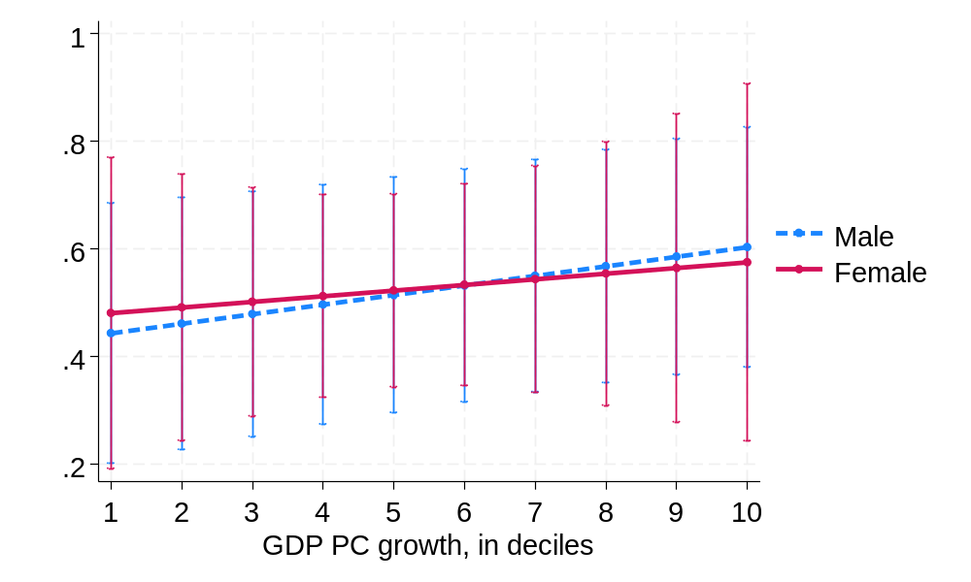
Figure E8. Election day leaders: Female and inflation
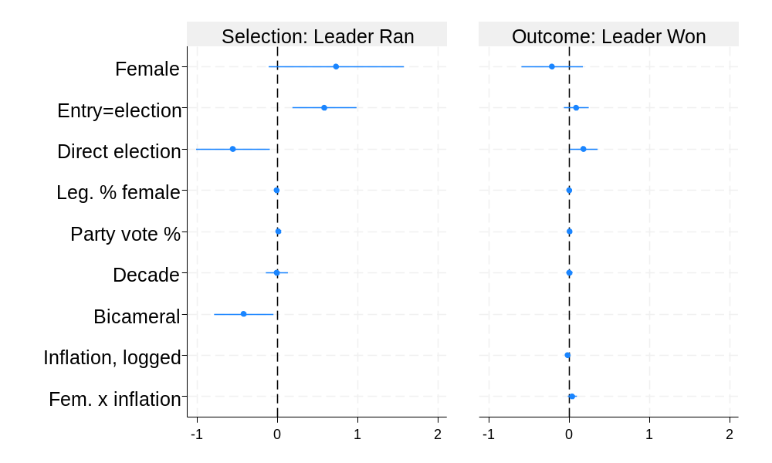
Figure E9. Election day leaders: Predicted probabilities for female and inflation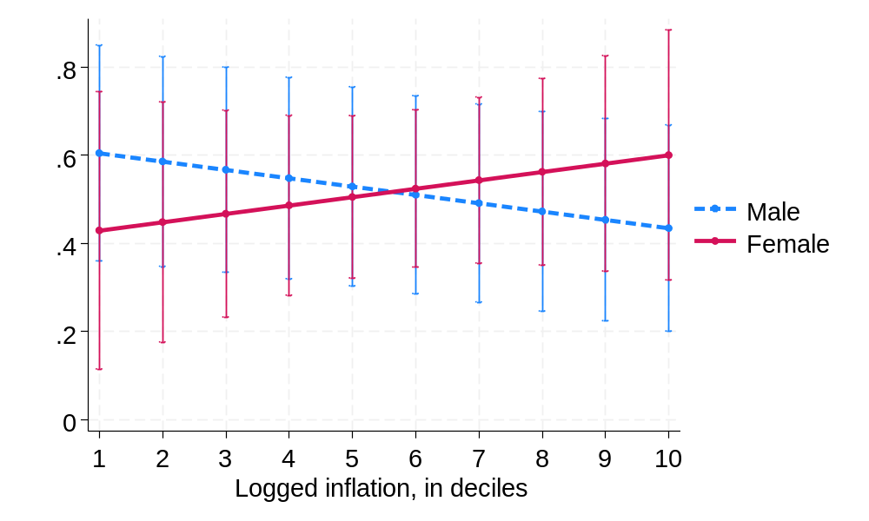

Figure E10. Election day leaders: Female and executive branch corruption
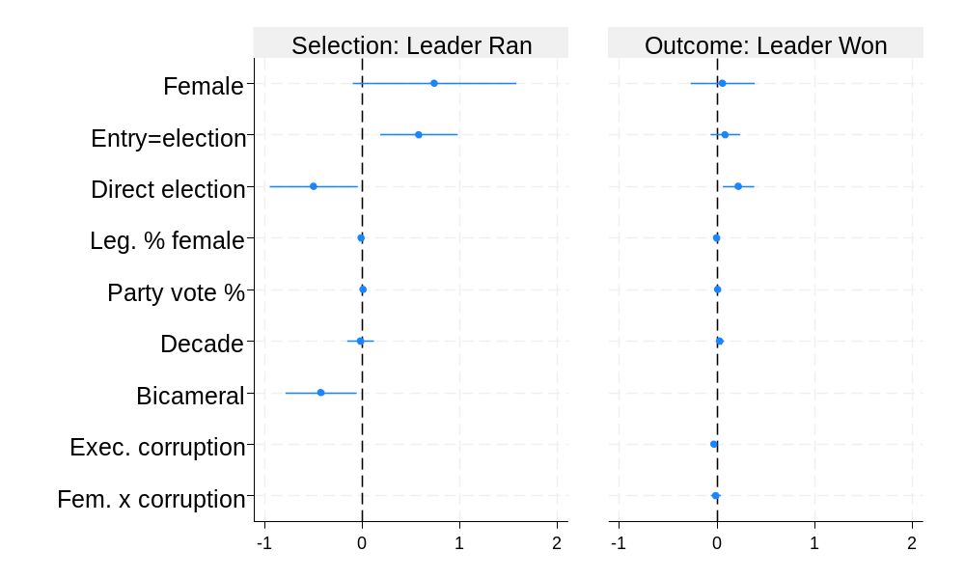

Figure E11. Election day leaders: Predicted probabilities: Female and exec. branch corruption

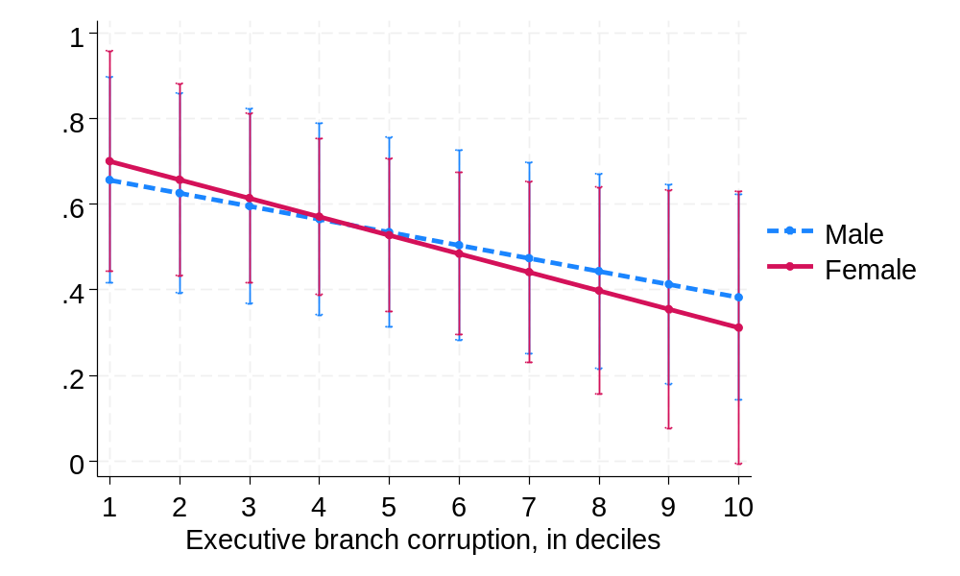
Figure E12. Election day leaders: Female and domestic conflict
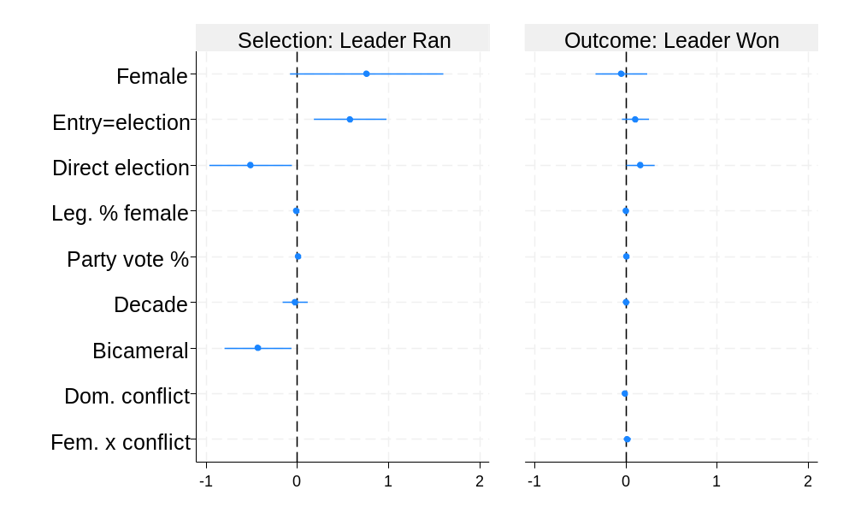
Figure E13. Election day leaders: Predicted probabilities for female and domestic conflict
