Appendix A: Coding

Table A1: Classification of commission members’ affiliation
Category | Operational definition
Academics | Academic staff at universities and university colleges and researchers at independent research institutes.
Civil servants | Employees of ministries.
Public employees | Employees of other public bodies, including government agencies/directorates, local and regional administrations, and other public bodies such as public hospitals and public schools. (This category excludes academics working for public universities, who are classified as Academics.)
Interest groups and civil society representatives | Representatives of interest groups such as labor unions, business associations, professional associations and other non-governmental organizations.
Private sector | Representatives of private firms.
Judges | Judges in national and sub-national courts.
Private lawyers | Lawyers in private practice.
Consultants | Employees of consultancy firms.
Politicians | Members of parliament (including deputy members), politicians at the regional and local level, under-secretaries of state, political advisors.
Others | E.g. foreign members, priests, members of other public commissions, artists and authors, fishermen, etc.

Table A2: Grouping of academic disciplines
Disciplines,  9 groups | N | Percentage of academics | Disciplines, as coded in commission data | Disciplines, as coded in register data  (3-digit code from NUS2000)
1: Economics | 397 | 23.18 | 1. Economics  2. Business economics | 834 Economics  841 Business and administration  842 Wholesale and retail sales and marketing
2: Law | 343 | 20.02 | 9. Law | 837 Law
3: Medicine, psychology, and nursing | 206 | 12.03 | 7. Psychology  23. Medicine  24. Odontology, veterinary, nursing sciences | 836 Psychology  861 Nursing and caring  863 Medicine  864 Dental health  865 Therapy  866 Pharmacy  867 Veterinary medicine  868 Sport and physical education  869 Health, welfare and sport, other
4: Education and social work | 88 | 5.14 | 10. Education/social work | 821 Pre-school-/kindergarten teacher education  822 General-/primary and lower secondary teacher education  823 Specific subject and vocational teacher training  824 Pedagogy  825 Supplementary education for teachers  829 Teacher training and pedagogy, other  862 Social services
5: Political and social sciences | 286 | 16.70 | 3. Political science  4. Sociology  5. Anthropology  6. Human geography  11. Social science unspecified  8. Criminology | 831 Political science  832 Sociology  833 Social geography  838 Social anthropology  839 Social sciences and law, other
6: Natural sciences | 141 | 8.23 | 18. Physics, chemistry, biology  19. Mathematics  20. Natural sciences unspecified | 851 Biology  852 Physics and chemistry  853 Mathematics and statistics  856 Earth sciences  859 Natural sciences, vocational and technical subjects, other  871 Fisheries and aquaculture  872 Agriculture  873 Horticulture  874 Forestry  879 Primary industries, other
7: Humanities | 143 | 8.35 | 12. History  13. Literature, linguistics  14. Communication, media science  15. Philosophy  16. Religion, theology  17. Humanities unspecified  25. Arts, unspecified | 811 Languages  812 Literature and librarianship  813 History and philosophy  814 Religion  815 Music, dance and drama  816 Visual art and crafts  819 Humanities and arts, other  835 Media and information
8: Engineering and computer sciences | 64 | 3.74 | 21. Engineering  22. Computer Sciences | 854 Information and computer technology  855 Electrical, electronic, mechanical and machine subjects
9: Other sciences and missing | 44 | 2.57 | 26. Other sciences  27. Missing information about discipline | 881 Transport and communications  882 Safety and security  883 Other services  889 Transport and communications, safety and security and other services, other  849 Business and administration, other  843 Secretarial and office skills  844 Hotel, travel and tourism  857 Building and construction  858 Manufacturing and extraction  899 Unspecified subject group

Appendix B: Gender composition over time

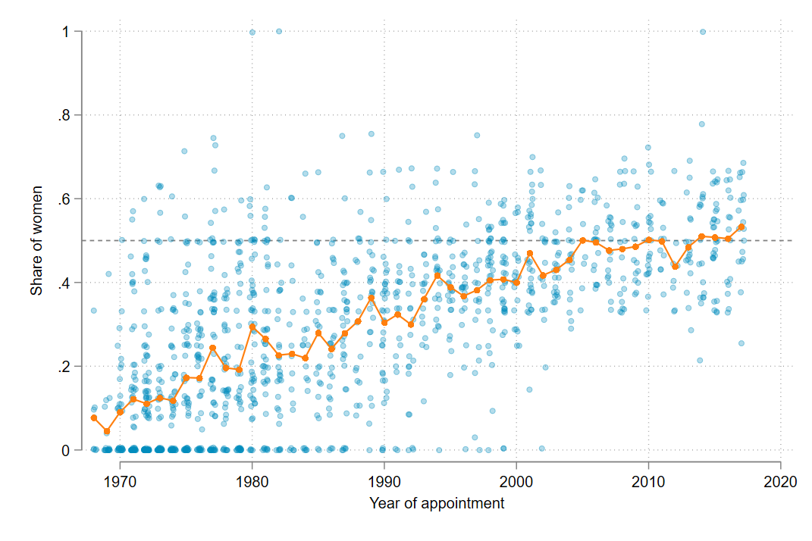
Figure B1: Commissions scattered by proportion women and year of submission. Secretaries included.

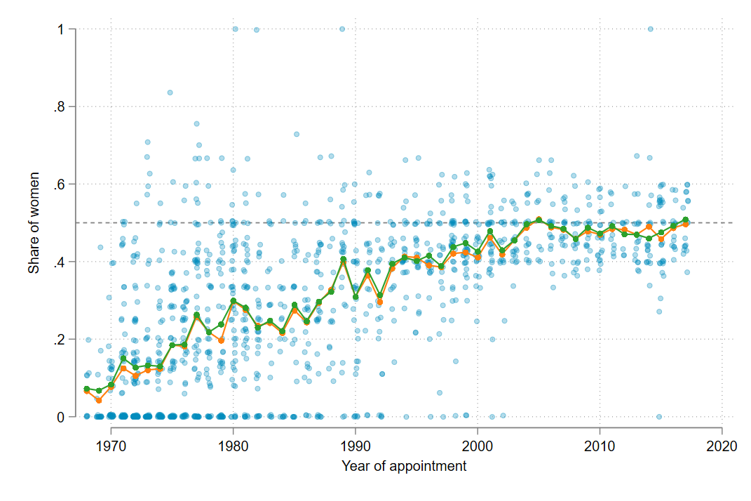
Figure B2: Commissions scattered by proportion women and year of submission. Secretaries excluded. The orange line represents the average commission in a given year, while the green line represents the share of females in a given year.

Appendix C: Difference in gender composition and gender composition time trends across roles in commission

Table C1: Likelihood that a woman is appointed estimated by regressing gender on role in commission
 | Model 1 | Model 2
Regular member ª | 0.205*** | 0.109***
 | (0.0156) | (0.0176)
Secretaries ª | 0.203*** | 0.0180
 | (0.0198) | (0.0263)
Year appointed |  | 0.00511***
 |  | (0.000770)
Regular member # Year appointed |  | 0.00409***
 |  | (0.000908)
Secretaries # Year appointed |  | 0.00568***
 |  | (0.000924)
Observations | 14894 | 14894
Note: (a) reference category is Chairpersons.
Cluster robust standard errors in parentheses, clustered on year of appointment.
* p < 0.05, ** p < 0.01, *** p < 0.001

The estimates in Model 1 show the likelihood that a woman is appointed for regular members and secretaries, compared to chairpersons. That is, the likelihood that a woman is appointed is about 20 percent higher for regular members and secretaries than for chairpersons. The interaction terms in Model 2 provide estimations of whether the likelihood that a woman is appointed has changed more or less over time for regular members and secretaries, compared to chairpersons. With a linear assumption, the interactions shows that the likelihood that a woman is appointed increases significantly more over time for both regular members and secretaries than for chairpersons.

Appendix D: Affiliation of commission members over time

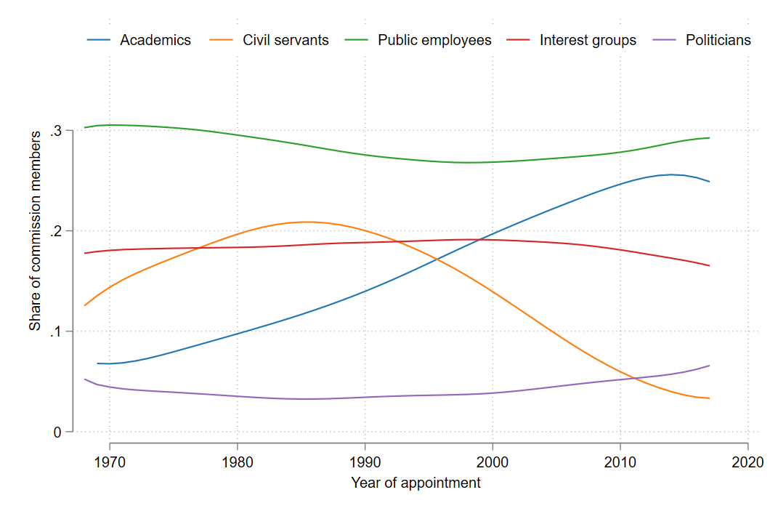
Figure D1: Share of commission members from different affiliations, 1968-2017

Appendix E: Gender composition among members with different affiliations
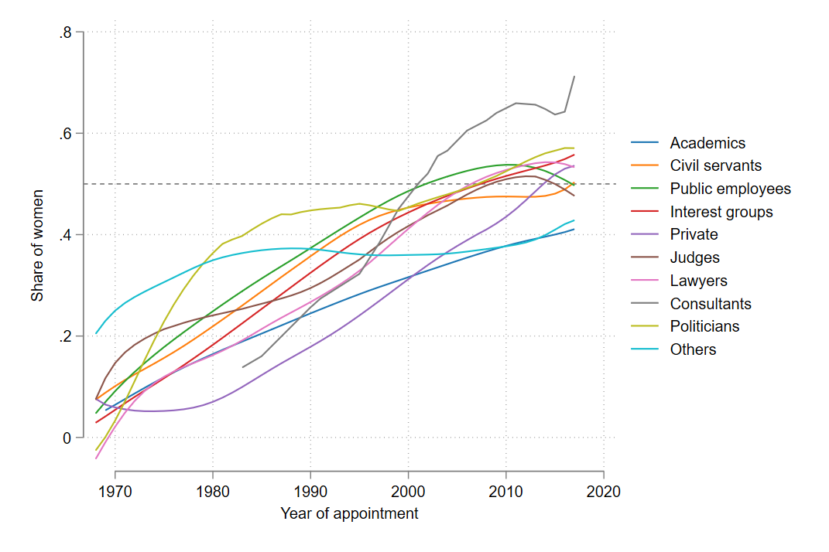
Figure E1: Gender composition among members with given affiliations, shown by locally weighted scatterplot smoothing (lowess) with a 0.8 bandwidth.

Appendix F: Difference in gender composition and gender composition time trends across affiliations

Table F1: Likelihood that a woman is appointed estimated by regressing gender on affiliation
 | Model 1 | Model 2
Civil servants ª | 0.0137 | 0.0131
 | (0.0216) | (0.0225)
Public employees ª | 0.0502** | 0.0585*
 | (0.0187) | (0.0254)
Interest groups and civil society ª | 0.0141 | -0.0349
 | (0.0211) | (0.0280)
Private ª | -0.0686* | -0.125***
 | (0.0268) | (0.0328)
Judges ª | 0.0652 | 0.112
 | (0.0351) | (0.0685)
Lawyers ª | 0.0565 | -0.0543
 | (0.0298) | (0.0400)
Consultants ª | 0.191* | -0.0477
 | (0.0764) | (0.263)
Politicians ª | 0.0417 | 0.0836
 | (0.0365) | (0.0451)
Others ª | 0.0965** | 0.259***
 | (0.0301) | (0.0410)
Missing ª | 0.0527 | 0.0950*
 | (0.0318) | (0.0363)
Year appointed |  | 0.00750***
 |  | (0.000628)
Civil servants # Year appointed |  | 0.00434***
 |  | (0.00100)
Public employees # Year appointed |  | 0.00234*
 |  | (0.000982)
Interest groups and civil society # Year appointed |  | 0.00461***
 |  | (0.000946)
Private # Year appointed |  | 0.00360*
 |  | (0.00136)
Judges # Year appointed |  | -0.000137
 |  | (0.00217)
Lawyers # Year appointed |  | 0.00424**
 |  | (0.00148)
Consultants # Year appointed |  | 0.00467
 |  | (0.00618)
Politicians # Year appointed |  | 0.00205
 |  | (0.00174)
Others # Year appointed |  | -0.00518**
 |  | (0.00186)
Missing # Year appointed |  | 0.00628*
 |  | (0.00236)
Observations | 11907 | 11907
Note: (a) reference category is Academics.
Cluster robust standard errors in parentheses, clustered on year of appointment.
* p < 0.05, ** p < 0.01, *** p < 0.001

The estimates in Model 1 show the likelihood that a woman is appointed for members from each specific affiliation, compared to academics. The interaction terms in Model 2 provide estimations of whether the likelihood that a woman is appointed has changed more or less over time for each of the affiliation groups, compared to academics.

Appendix G: Difference in gender composition and gender composition time trends across commission roles and across academic / non-academic affiliation

Table G1: Likelihood that a woman is appointed estimated by regressing gender on role in commission, separate for academic and non-academic members.
 |  | Academic members |  |  | Non-academic members
 |  | Model 1 | Model 2 |  | Model 1 | Model 2
Chairperson ª |  | -0.236*** | -0.0699 |  | -0.193*** | -0.121***
 |  | (0.0237) | (0.0443) |  | (0.0160) | (0.0197)
Year appointed |  |  | 0.00814*** |  |  | 0.00978***
 |  |  | (0.000802) |  |  | (0.000571)
Chairperson # Year appointed |  |  | -0.00558** |  |  | -0.00267*
 |  |  | (0.00167) |  |  | (0.00118)
Constant |  | 0.336*** | 0.104*** |  | 0.341*** | 0.142***
 |  | (0.0210) | (0.0250) |  | (0.0230) | (0.0136)
Observations |  | 1689 | 1689 |  | 10218 | 10218
Note: (a) reference category is Regular members.
Cluster robust standard errors in parentheses, clustered on year of appointment.
* p < 0.05, ** p < 0.01, *** p < 0.001

The estimates for chairperson in Model 1 give the likelihood of a chairperson being female compared to the likelihood of a regular member being female, for academic members and for non-academic members. Thus, a smaller estimate tells us that the gender gap is the more similar among chairpersons and regular members. For academic members, there is a larger gap than among non-academic members.
The negative and statistically significant interaction terms from Model 2 tell us that the gender gap among chairpersons has closed at a slower pace for chairpersons compared to regular members, both for academic and non-academic members. However, the gender gap among chairpersons has closed even more slowly for academics than for non-academics.

Appendix H: The academic discipline of academic commission members and chairpersons

Table H1: Number and share of academic members from different academic disciplines.
 | Economics | Law | Medicine | Educ. | Political | Natural | Human. | Engin. | Other |  | Total
1968-1977 | 38 | 52 | 30 | 9 | 37 | 43 | 22 | 19 | 9 |  | 259
 | 14.67 | 20.08 | 11.58 | 3.47 | 14.29 | 16.6 | 8.49 | 7.34 | 3.47 |  | 100
1978-1987 | 42 | 46 | 41 | 8 | 34 | 42 | 27 | 12 | 13 |  | 265
 | 15.85 | 17.36 | 15.47 | 3.02 | 12.83 | 15.85 | 10.19 | 4.53 | 4.91 |  | 100
1988-1997 | 86 | 67 | 43 | 11 | 37 | 15 | 23 | 6 | 5 |  | 293
 | 29.35 | 22.87 | 14.68 | 3.75 | 12.63 | 5.12 | 7.85 | 2.05 | 1.71 |  | 100
1998-2007 | 98 | 91 | 57 | 22 | 82 | 22 | 41 | 16 | 7 |  | 436
 | 22.48 | 20.87 | 13.07 | 5.05 | 18.81 | 5.05 | 9.4 | 3.67 | 1.61 |  | 100
2008-2017 | 133 | 87 | 35 | 38 | 96 | 19 | 30 | 11 | 10 |  | 459
 | 28.98 | 18.95 | 7.63 | 8.28 | 20.92 | 4.14 | 6.54 | 2.4 | 2.18 |  | 100
Total | 397 | 343 | 206 | 88 | 286 | 141 | 143 | 64 | 44 |  | 1,712
 | 23.19 | 20.04 | 12.03 | 5.14 | 16.71 | 8.24 | 8.35 | 3.74 | 2.57 |  | 100

Table H2: Number and share of academic chairpersons from different academic disciplines.
 | Economics | Law | Medicine | Educ. | Political | Natural | Human. | Engin. | Other | Total
1968-1977 | 12 | 22 | 4 | 2 | 4 | 15 | 1 | 4 | 0 | 64
 | 18.75 | 34.38 | 6.25 | 3.12 | 6.25 | 23.44 | 1.56 | 6.25 | 0 | 100
1978-1987 | 6 | 19 | 9 | 2 | 6 | 8 | 5 | 1 | 2 | 58
 | 10.34 | 32.76 | 15.52 | 3.45 | 10.34 | 13.79 | 8.62 | 1.72 | 3.45 | 100
1988-1997 | 19 | 31 | 6 | 1 | 2 | 1 | 3 | 2 | 0 | 65
 | 29.23 | 47.69 | 9.23 | 1.54 | 3.08 | 1.54 | 4.62 | 3.08 | 0 | 100
1998-2007 | 17 | 41 | 8 | 5 | 6 | 1 | 3 | 3 | 3 | 87
 | 19.54 | 47.13 | 9.2 | 5.75 | 6.9 | 1.15 | 3.45 | 3.45 | 3.45 | 100
2008-2017 | 21 | 28 | 3 | 5 | 11 | 2 | 0 | 2 | 1 | 73
 | 28.77 | 38.36 | 4.11 | 6.85 | 15.07 | 2.74 | 0 | 2.74 | 1.37 | 100
Total | 75 | 141 | 30 | 15 | 29 | 27 | 12 | 12 | 6 | 347
 | 21.61 | 40.63 | 8.65 | 4.32 | 8.36 | 7.78 | 3.46 | 3.46 | 1.73 | 100

Appendix I: Gender composition and gender composition time trends across disciplines

Table I1: Likelihood that a woman is appointed estimated by regressing gender on discipline
 | Model 1 | Model 2
 | gender | gender
Law ª | 0.00608 | -0.0894
 | (0.0304) | (0.0544)
Medicine, psychology, and nursing ª | 0.0679 | 0.00158
 | (0.0385) | (0.0642)
Education and social work ª | 0.250*** | 0.334**
 | (0.0530) | (0.119)
Political and social sciences ª | 0.222*** | 0.109
 | (0.0462) | (0.0931)
Natural sciences ª | 0.0513 | -0.00430
 | (0.0429) | (0.0699)
Humanities ª | 0.124** | 0.0869
 | (0.0414) | (0.0924)
Engineering and computer sciences ª | -0.0990* | -0.103
 | (0.0468) | (0.0709)
Other sciences and missing ª | 0.0477 | 0.0269
 | (0.0588) | (0.0812)
Year appointed |  | 0.00470**
 |  | (0.00149)
Law # Year appointed |  | 0.00404
 |  | (0.00211)
Medicine, psychology, and nursing # Year appointed |  | 0.00349
 |  | (0.00284)
Education and social work # Year appointed |  | -0.00284
 |  | (0.00384)
Political and social sciences # Year appointed |  | 0.00373
 |  | (0.00285)
Natural sciences # Year appointed |  | 0.00519
 |  | (0.00306)
Humanities # Year appointed |  | 0.00221
 |  | (0.00326)
Engineering and computer sciences # Year appointed |  | 0.00231
 |  | (0.00397)
Other sciences and missing # Year appointed |  | 0.00275
 |  | (0.00307)
Constant | 0.212*** | 0.0674
 | (0.0216) | (0.0390)
Observations | 1853 | 1853
Note: (a) reference category is Economics.
Cluster robust standard errors in parentheses, clustered on year of appointment.
* p < 0.05, ** p < 0.01, *** p < 0.001

The estimates in Model 1 give the likelihood that a woman is appointed for academics from each specific discipline, compared to academics from economics. The interaction terms in Model 2 give estimations of whether the likelihood that a woman is appointed has changed more or less over time for each of the disciplines, compared to economics.

Appendix J: Gender composition time trends for academic members, by commission role and discipline

Figure J1: Gender composition among regular members and chairpersons for separate academic disciplines (lowess trend lines)

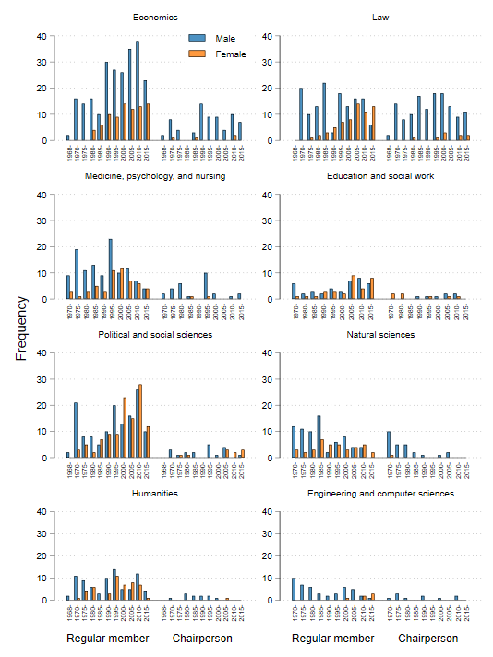
Figure J2: Frequencies of male and female chairpersons and regular members, separate for academic discipline

